**CS 5200 Homework 3**

This assignment provides an opportunity to explore the functionality provided by MySQL workbench. In particular:

Use MySQL Workbench to import databases that will be used in class for demonstration purposes

* Answer questions on the results of the commands in the script as well as some simple queries.
* Build a model from an existing database.
* Export an existing database.

This assignment ensures that the MySQL server and the MySQL Workbench are working on your laptop. If you are having trouble with MySQL Server or the Workbench please use the TA office hours to solve the issues. **After this assignment, you are responsible for MySQL administration on your laptop.**

1. Create a collection of databases from the **create_databases.sql** script. This script creates the databases that are used in Murach's MySQL book. Load the .sql script into the SQL workbench editor window using the File menu (File -> Open SQL Script).

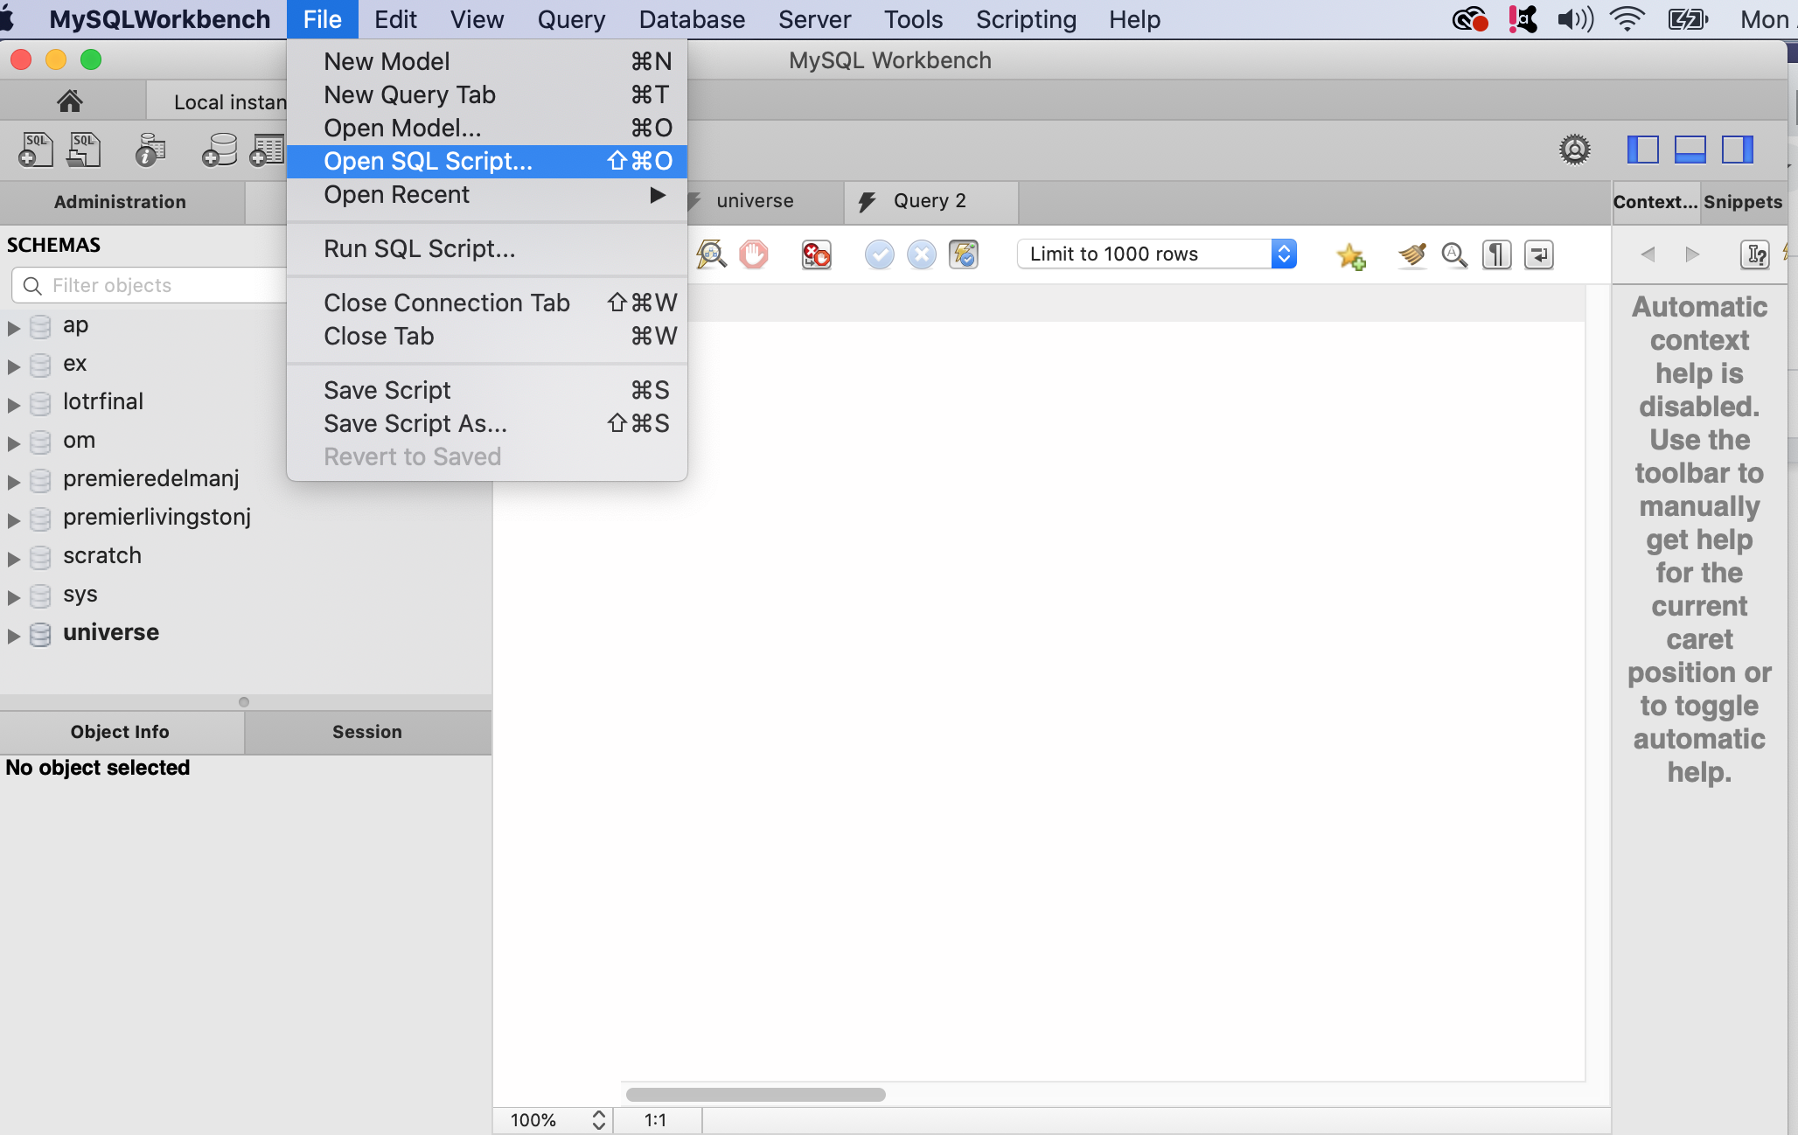

This will give you an opportunity to read the create_database.sql script as well as execute the script. Execute the script by hitting the lightning rod icon in the MySQL workbench.

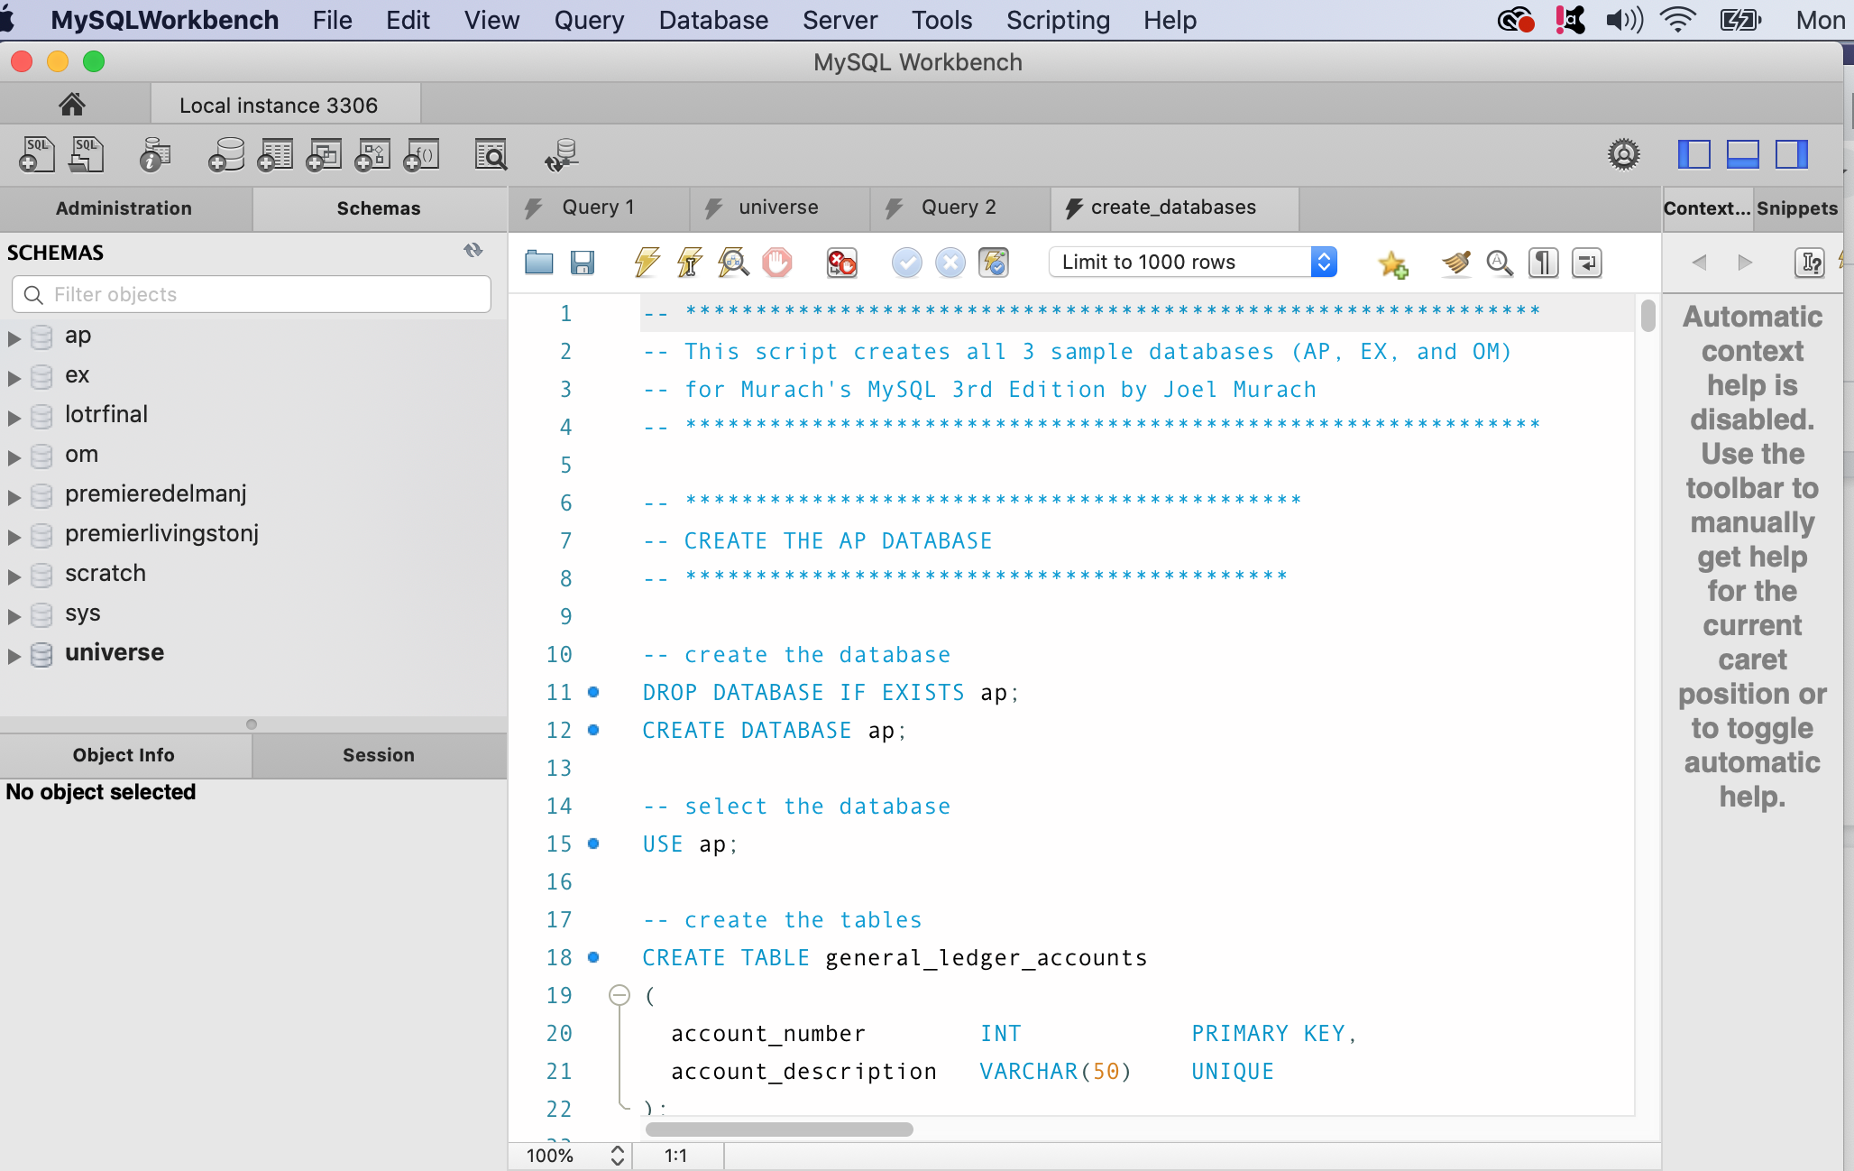

Review the action output response to verify that the multiple commands ran successfully. T*he response is written to the panel underneath the editor SQL script panel*. Make sure you can differentiate between success messages, warnings, and error messages. If you do not have enough memory to load the script into the editor, import the script using the import tool (Server → Data Import). While importing, specify that the script is a self-contained import file. **Read** the script using your favorite editor. Familiarize yourself with the database names, the table names, and the table structures. Identify the SQL commands, CREATE, USE, INSERT, DROP **(0 Points)**.

1. Answer the following questions on the newly created databases. These answers can be determined by reading the results in the Output window, investigating the tables using the *i* icon listed in the navigator panel next to the table, or by writing simple queries. Include the answers to questions a-h inside a comment within a file called hwk3problem2and5lastnamefi.sql, where lastname is your last name and fi is the initial for your first name. For i and j, write SQL queries to answer the following questions on the om database. Include a comment that specifies the problem number before each SQL statement i.e. 2.e, 2.f (**30 points**)
   1. How many databases are created by the script?
   2. List the *database names* and the *tables* created for each database.
   3. How many *records* does the script insert into the *om.order_details* table?
   4. How many *records* does the script insert into the *ap.invoices* table?
   5. How many *records* does the script insert into the *ap.vendors* table?
   6. Is there a *foreign key* between the *ap.invoices* and the *ap.vendors* table?
   7. How many *foreign keys* does the *ap.vendors* table have?
   8. What is the *primary key* for the *om.customers* table?
   9. Write a SQL command that will *retrieve all values for all fields* from the *orders* table
   10. Write a SQL command that will retrieve the fields: title and artist from the om.items table
2. Create a model for the ap database. You can access the modeling tool from either the ‘Database → Reverse Engineer’ menu item or from the main home window on My SQL workbench. Familiarize yourself with the different shapes found within the model diagram. For example, the different lines and endpoints to the lines. Move the rectangles that represent the tables to eliminate line crossings. Once you are satisfied with the image, save the model to a file named hwk3problem3lastnamefi.mwb and export the model as a pdf file named hwk3problem3lastnamefi.pdf. (**20 points**)
3. Export the om database as a self-contained file using the tool (‘Server→ Data Export’). Make sure you include the ‘Create Schema’ as part of the dump as well as to make the dump a self-contained file. Name the file hwk3problem4lastnamefi.sql (**20 points**)
4. Import the chinook database (follow the same procedure from 1 for chinook.sql file). Answer the following questions on the newly created chinook database. These answers can be determined by reading the results in the Output window, investigating the tables using the *i* icon listed in the navigator panel next to the table, or by writing simple queries. Include the answers to questions a-d inside a comment within a file called hwk3problem2and5lastnamefi.sql, where lastname is your lastname and fi is the initial for your firstname. For e and f, write SQL queries to answer the following questions on the chinook database. Include a comment that specifies the problem number before each SQL statement i.e. 5.e, 5.f (**30 points**)
   1. How many tables are created by the script?
   2. List the names of the tables created for the Chinook database.
   3. How many records does the script insert into the Album table?
   4. What is the primary key for the Album table?
   5. Write a SQL SELECT command to retrieve all data from all columns and rows in the Artist table.
   6. Write a SQL SELECT command to retrieve the fields FirstName, LastName and Title from the Employee table

**Homework submission**

Submit the following files to canvas :

· hwk3problem2and5lastnamefi.sql

· hwk3problem3lastnamefi.pdf

· hw3kproblem4lastnamefi.sql