配置ssh方式连接github

1. 生成ssh公钥以及私钥

命令: ssh-keygen -t rsa -C "你的github帐号(email)"

Step1:输入生成密钥的文件名

Step2:输入密码，可以输入空

示例:

$ ssh-keygen -t rsa -C "xxx@126.com"

Generating public/private rsa key pair.

Enter file in which to save the key (/c/Users/zgy\_c/.ssh/id\_rsa): id\_rsa

Enter passphrase (empty for no passphrase):

Enter same passphrase again:

Your identification has been saved in id\_rsa.

Your public key has been saved in id\_rsa.pub.

The key fingerprint is:

SHA256:s5sQEMtnadBJpvewWW+pW2kzJZmT4NGQKrds+CD8JQk xxx@126.com

The key's randomart image is:

+---[RSA 2048]----+

| ooo... |

| . \*o..o |

| = B.+ . |

| E .\*oB + = |

| . . \*+.S X . |

| o = =. = = |

| o \*. o \* |

| . .. \* o |

| + |

+----[SHA256]-----+

1. 在本机配置私钥

在上方标红的路径处找到.ssh文件夹，若不存在，使用mkdir .ssh 创建此文件夹

将刚刚生成的id\_rsa和id\_rsa.pub文件拷贝到.ssh文件夹下。

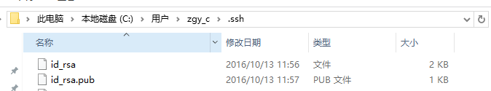

3.配置github公钥

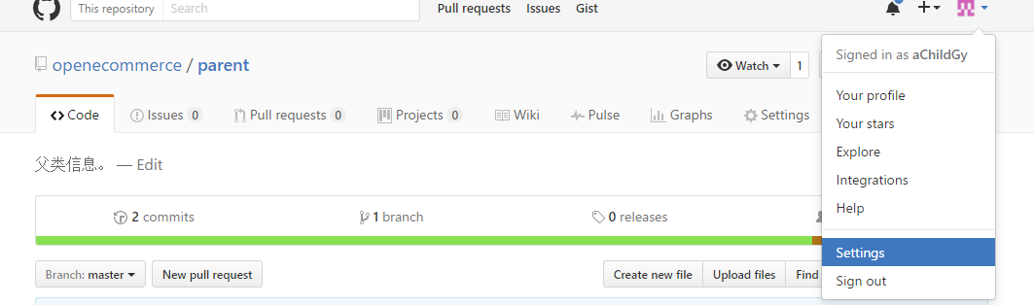

点击settings

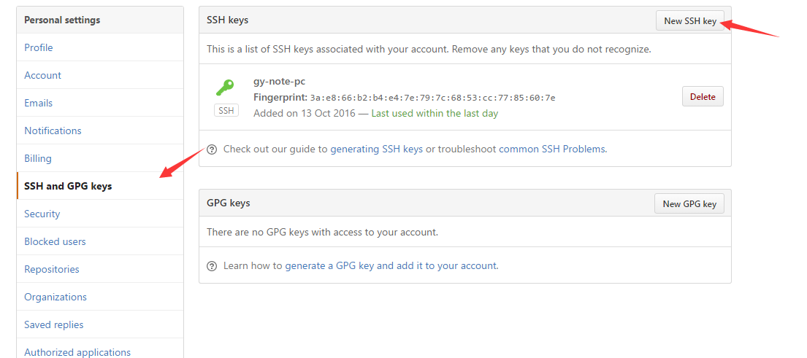

点击增加new SSH key

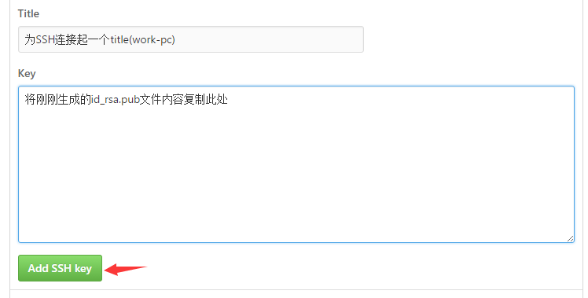

点击add sshkey保存公钥

1. 在git bash中测试配置ssh是否成功

ssh -T git@github.com

IMG_256