1、人员审核界面：ajax

url为${ctx}/user/listCheckUser

从前端传值为currentPage

后端返回的json，为pages，可处理为

pages.previousPage 上一页

pages.nextPage 下一页

pages.pageBar[] 中间的页数1 2 3 4 5

pages. startIndex 获取到每页的开始记录下标

pages. endIndex 获取到每页的最后记录下标

pages.list 所有的记录

单条记录的获取 如下图 例如：姓名：pages.list[？].name

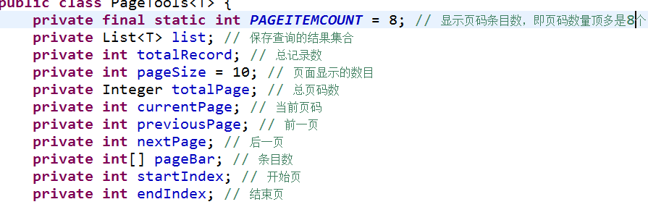

{"listName":"pages","pages":{"list":[{"id":1,"name":"郭佳殷","pass":null,"phone":"18732850775","check":1,"group":"信息中心","type":"管理员"},{"id":2,"name":"李航天","pass":null,"phone":"15350831515","check":1,"group":"信息中心","type":"维修员"},{"id":3,"name":"李婵婵","pass":null,"phone":"13253221265","check":1,"group":"信息中心","type":"管理员"},{"id":4,"name":"刘明阳","pass":null,"phone":"18631855370","check":1,"group":"信息中心","type":"维修员"},{"id":5,"name":"刘畅","pass":null,"phone":"18732878989","check":1,"group":"信息中心","type":"维修员"},{"id":6,"name":"王佳博","pass":null,"phone":"15503211578","check":1,"group":"信息中心","type":"维修员"},{"id":7,"name":"郭佳殷","pass":null,"phone":"17332850775","check":1,"group":"信息中心","type":"维修员"},{"id":8,"name":"AA","pass":null,"phone":"11111111111","check":1,"group":"心血管内科","type":"普通用户"}],"totalRecord":11,"pageSize":8,"totalPage":2,"currentPage":1,"previousPage":1,"nextPage":2,"pageBar":[1,2],"startIndex":0,"endIndex":8}}

2、人员审核操作：（ajax）

url为 ${ctx}/user/checkUser

从前端传值为 ：id 用户的id号码

如果提交审核成功的话，审核处则变为**审核通过或审核不通过**

Json：

{"errInfo":"1","msg":"该用户已经审核，无需再次审核！！"}

{"errInfo":"1","msg":"审核失败！"}

{"errInfo":"0","msg":"提交审核成功！"}