1、点击 我的维修单（分页处理，json）：

url：${ctx}/order/myOrder

传值为

1. currentPage:（当前页，可以无值，可以有值）
2. status：（维修状态，可以无值，可以有值）

从后端传到前端pages，json数据处理，图1为order的属性，图2位pages的属性

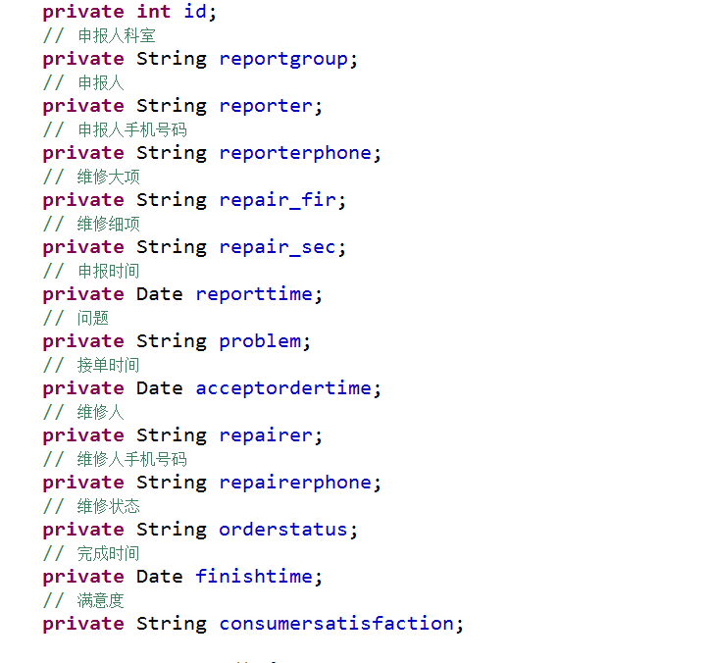

图1

Json为：

{"listName":"pages","pages":{"list":[{"id":40,"reportgroup":"心血管内科","pic":"刘明阳","reporter":"AA","reporterphone":"11111111111","repair_fir":"硬件","repair_sec":"计算机主机","reporttime":1551253955000,"problem":"测试计算机主机测试心血管内科申请单","acceptordertime":1551253981000,"repairer":"李航天","repairerphone":"15350831515","orderstatus":"已完成","status_id":3,"finishtime":1551254073000,"consumersatisfaction":"非常满意","cs_id":5},{"id":41,"reportgroup":"心血管内科","pic":"刘明阳","reporter":"AA","reporterphone":"11111111111","repair_fir":"软件","repair_sec":"LIS","reporttime":1551254185000,"problem":"LIS测试","acceptordertime":1551254202000,"repairer":"李航天","repairerphone":"15350831515","orderstatus":"未完成","status_id":4,"finishtime":null,"consumersatisfaction":null,"cs_id":null},{"id":42,"reportgroup":"心血管内科","pic":"刘明阳","reporter":"AA","reporterphone":"11111111111","repair_fir":"网络","repair_sec":"外网","reporttime":1551254419000,"problem":"外网不能联通","acceptordertime":1551254434000,"repairer":"李航天","repairerphone":"15350831515","orderstatus":"维修中","status_id":2,"finishtime":null,"consumersatisfaction":null,"cs_id":null},{"id":43,"reportgroup":"心血管内科","pic":"刘明阳","reporter":"AA","reporterphone":"11111111111","repair_fir":"软件","repair_sec":"LIS","reporttime":1551327197000,"problem":"萨达啊大大","acceptordertime":null,"repairer":null,"repairerphone":null,"orderstatus":"未接单","status_id":1,"finishtime":null,"consumersatisfaction":null,"cs_id":null},{"id":44,"reportgroup":"心血管内科","pic":"刘明阳","reporter":"AA","reporterphone":"11111111111","repair_fir":"软件","repair_sec":"LIS","reporttime":1551327336000,"problem":"阿达哇飒飒大","acceptordertime":null,"repairer":null,"repairerphone":null,"orderstatus":"未接单","status_id":1,"finishtime":null,"consumersatisfaction":null,"cs_id":null},{"id":45,"reportgroup":"心血管内科","pic":"刘明阳","reporter":"AA","reporterphone":"11111111111","repair_fir":"硬件","repair_sec":"打印机","reporttime":1551327365000,"problem":"wdasda","acceptordertime":null,"repairer":null,"repairerphone":null,"orderstatus":"未接单","status_id":1,"finishtime":null,"consumersatisfaction":null,"cs_id":null},{"id":46,"reportgroup":"心血管内科","pic":"刘明阳","reporter":"AA","reporterphone":"11111111111","repair_fir":"网络","repair_sec":"外网","reporttime":1551327826000,"problem":"aaa","acceptordertime":null,"repairer":null,"repairerphone":null,"orderstatus":"未接单","status_id":1,"finishtime":null,"consumersatisfaction":null,"cs_id":null},{"id":47,"reportgroup":"心血管内科","pic":"刘明阳","reporter":"AA","reporterphone":"11111111111","repair_fir":"网络","repair_sec":"外网","reporttime":1551327839000,"problem":"aaa","acceptordertime":null,"repairer":null,"repairerphone":null,"orderstatus":"未接单","status_id":1,"finishtime":null,"consumersatisfaction":null,"cs_id":null}],"totalRecord":37,"pageSize":8,"totalPage":5,"currentPage":1,"previousPage":1,"nextPage":2,"pageBar":[1,2,3,4,5],"startIndex":0,"endIndex":8}}

2、点击新建维修单：${ctx}/order/initOrder，此处不用ajax，我用request把维修大项传过去

选好维修大项之后

ajax获取到二级菜单的维修细项，url为 ${ctx}/order/ getRepairSecond此处为

json：

{"listName":"pages","pages":[{"id":4,"repair_sec":"HIS","repair_fir_id":2},{"id":5,"repair_sec":"LIS","repair_fir_id":2},{"id":6,"repair_sec":"PACS","repair_fir_id":2}]}

传值为：

1. repair_fir:维修大项
2. repair_sec：维修细项
3. problem：问题说明

新建维修单界面 ，其他字段必须必填，提交之后则重新刷新我的维修单界面即可

Json:

{"errInfo":"1","msg":"提交失败！"}

{"errInfo":"0","msg":"提交成功！在您之前有" + waitting + "个维修单待接单，" + repairing + "个维修单正在维修中！"}