**Completed the Key Generation :**

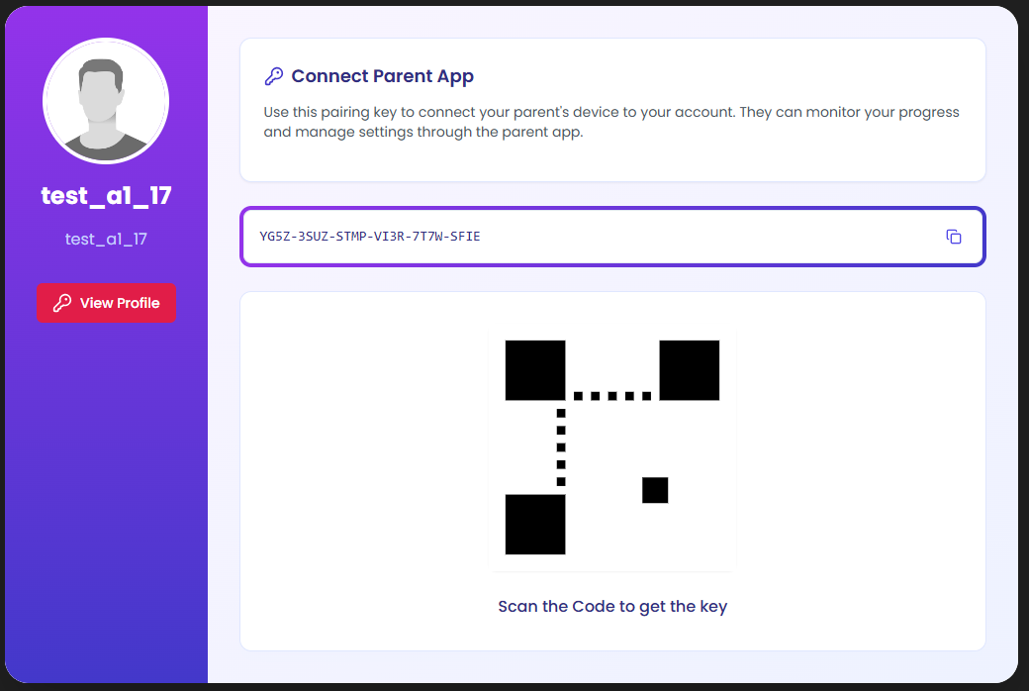

* In the profile section of xortlist app now we can view the Key and copy from it.
* The qr code is just an sample qr , I will make that to a working one.

Created a next js project setup with the latest version

**Sign Up:** Created the Signup section. With that now user can add their keys in to it .

**Career Page:** Careers page to display the Roadmaps, Challenges , Feedback etc same as the Xortlist