- Lire
We attempted to see encodage et decodage
Cree may not always have the lenght of 6
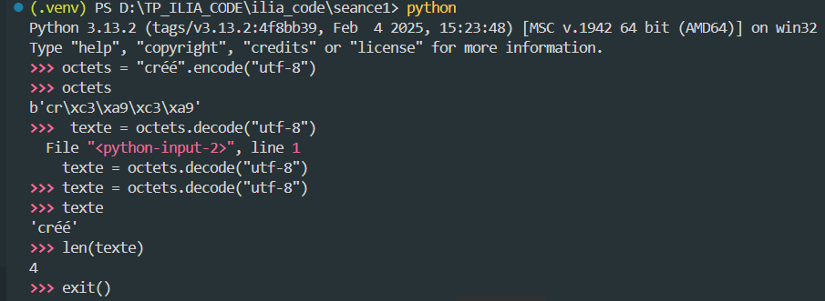
Test sur lire
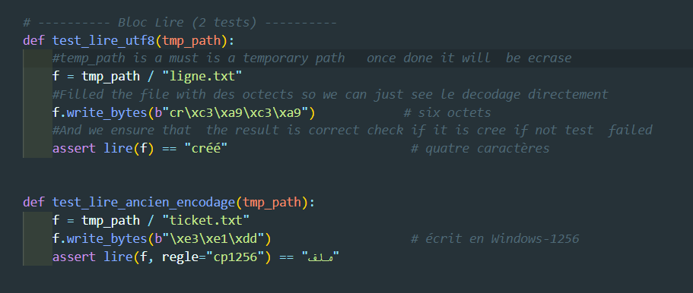
We attempt to see if the test are correct
Pytest will execute all files that starts with test_
Pytest –v –k lire
-v is for verbose to hsow detailed reponses
-k lire means test all functions that contain the key word lire
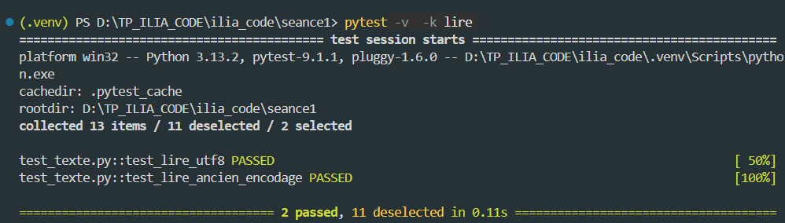
- Réparer
Comment savoir l’encodage du mot ?
On a d’abord utiliser un decodage pour afficher en binaire le mot we used « rb »read binary
Use the right encodage va nous permettre d’obtenir decodage correcte

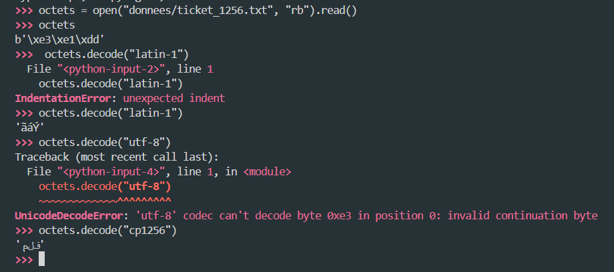
Encodage par default de la machine est utf c est pour ca il ne s affiche pas corerctement
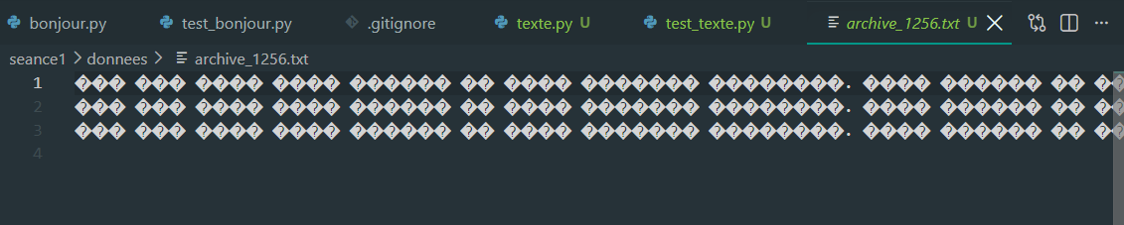

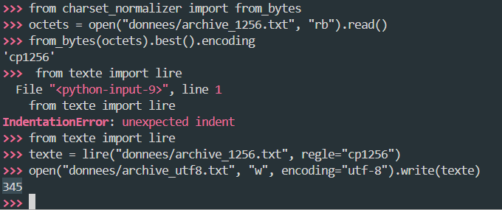
On a chercher quel est la regle d’encodage correcte
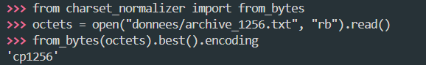
Function lire prend le chemin et la regle d encodage correct qu on a obtenue
Créer un nouveau fichier pour enregistrer le resultat using write et pas ecraser le resultat
We can now access to it cuz its was saved decoded correctely

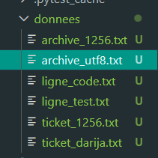
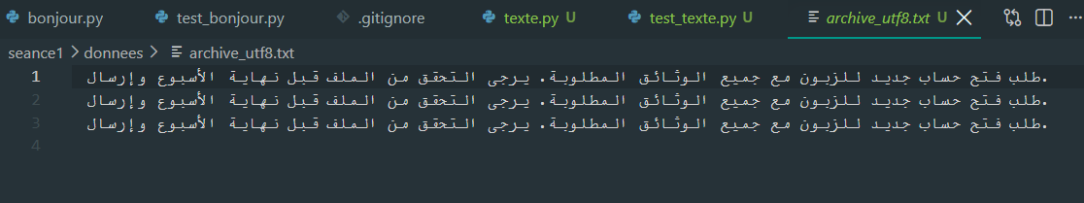

- Réparer :
Va fixe étapes incorrecte lors de l’encodage
Mojibak mot corrumpu lors de décodage
Encoder dune manière et decoder dune autre manière
Reparer c’est remove them mojibaks

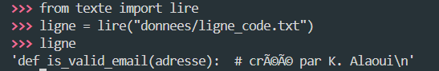
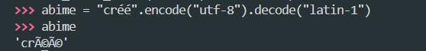
Pour resoudre mojibak must encoder encore avec la maniree qui créer le probleme in the first place
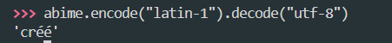
We cannot now what method caused teh probleme in the first place
We’ll just leave it to ftfy to know what caused the problem and apply the solution
Ftfy fix that for you

Test on reparer
Must ensure that given a text sain must remains sain meaning test
Sentence has mojibak and anathor without mojibak still gave the results right then test passed
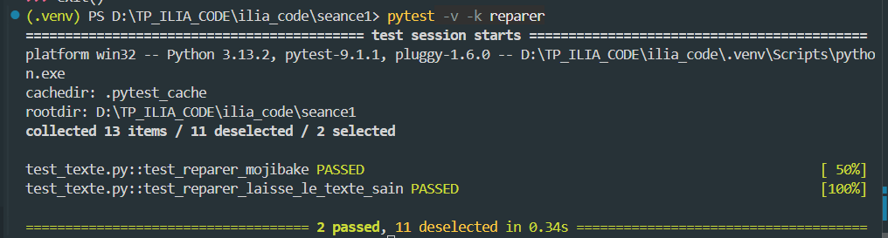
- Normaliser :
Words in different forms must have a Unicode
Two main problems :
Visible y o can tell the word has different format
Unvisible stocke de maniere different
Combinaisaon et compatibilite

Secodn method rights as is a human wrote but is dangerous

We used different encoding of the word we got still the same results donc stocke de maniere different
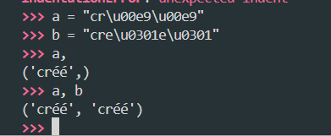
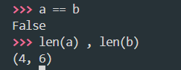
We attempt to use normalizations
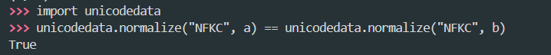

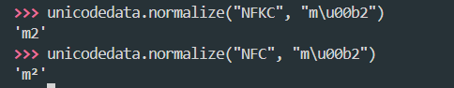

For Arabic we remove tchkilll :
Gotta use regex look up code of tchkil on internet :
Real length without tchkil is 3 with it it is 6
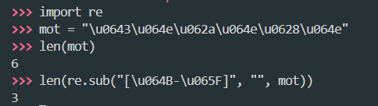

Forme de normalisation nfc or nfkc
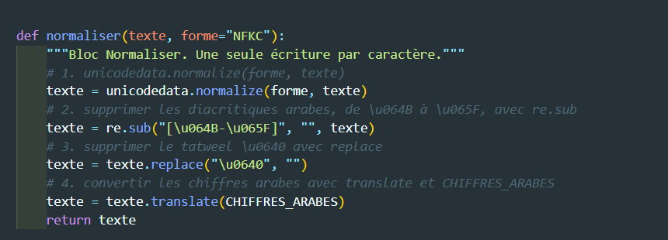

Test sur la normalisation :
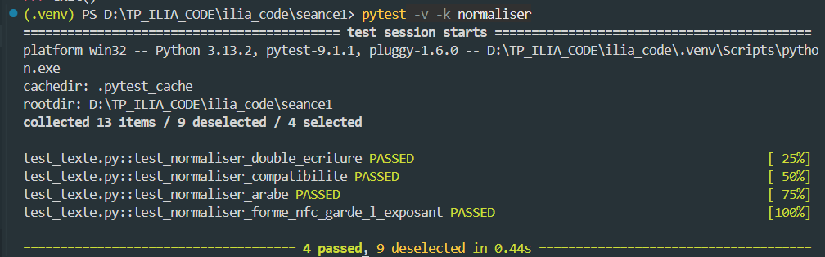

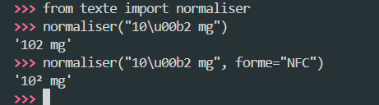
- Tokenizer :
Probleme faut proteger avant de couper
For that we ll use regex
Splitting a sentence
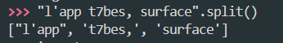
Finding all digits one or more
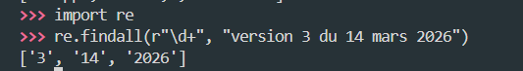
Find all words
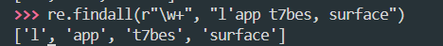
First attept with first rule
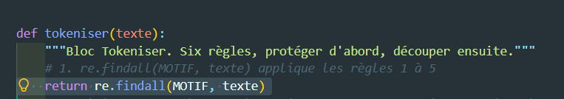
Find all words space and special caraters
Epic fail so we ll need the athor rule
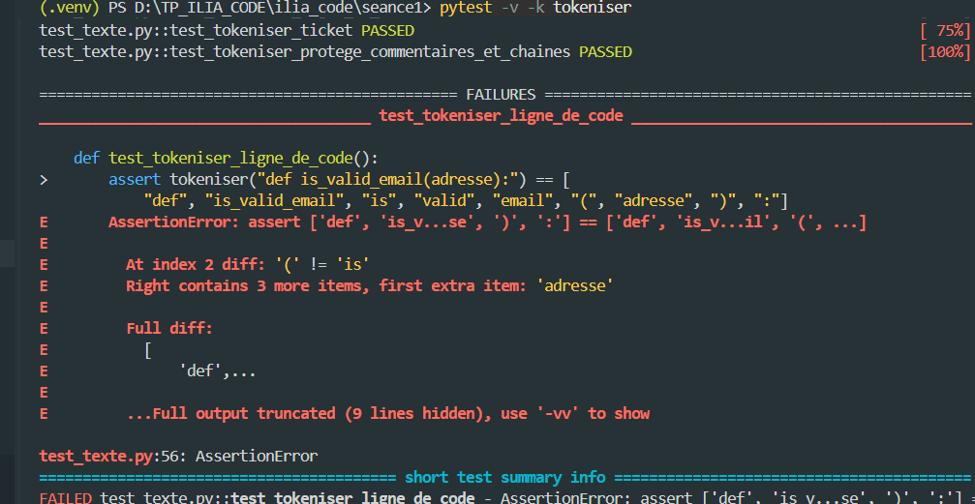
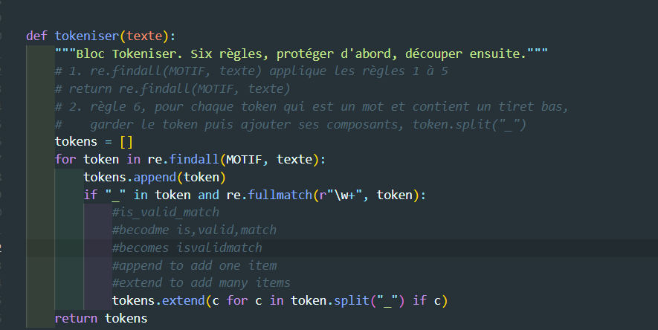
Now that we added the rules all works
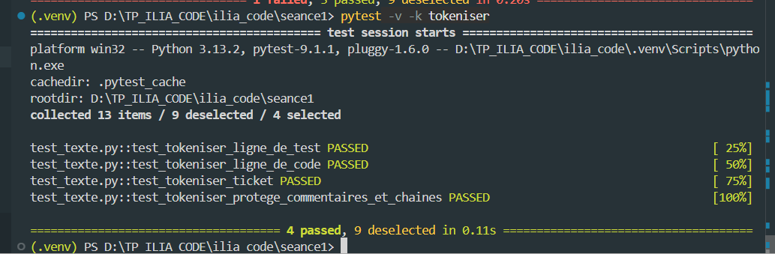
We assmbeled everryting in a chain
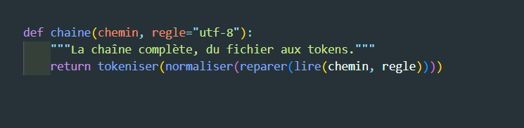
Test chain :
Returned sentence that has underscores and caraters of a fonction and a comment
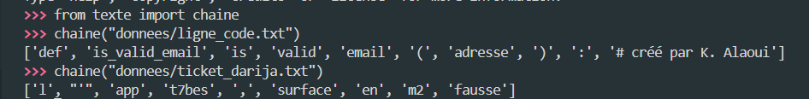
- Mesurer :
Gotta counts occurrences of tokens : unique tokens and commun tokens
Test mesurer
We checked for the most commun
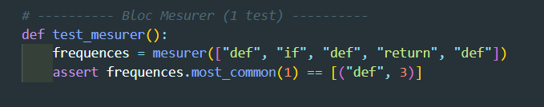
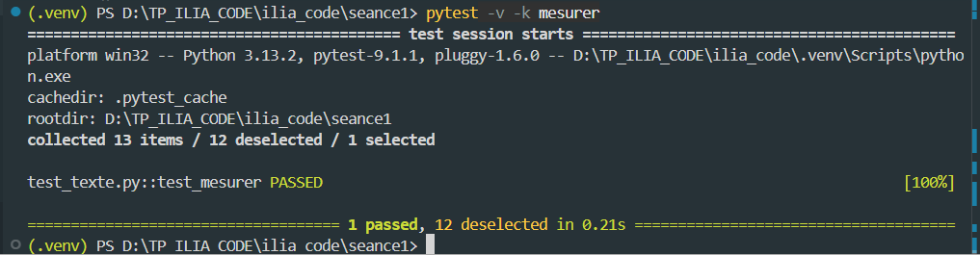
We tested everything all at once
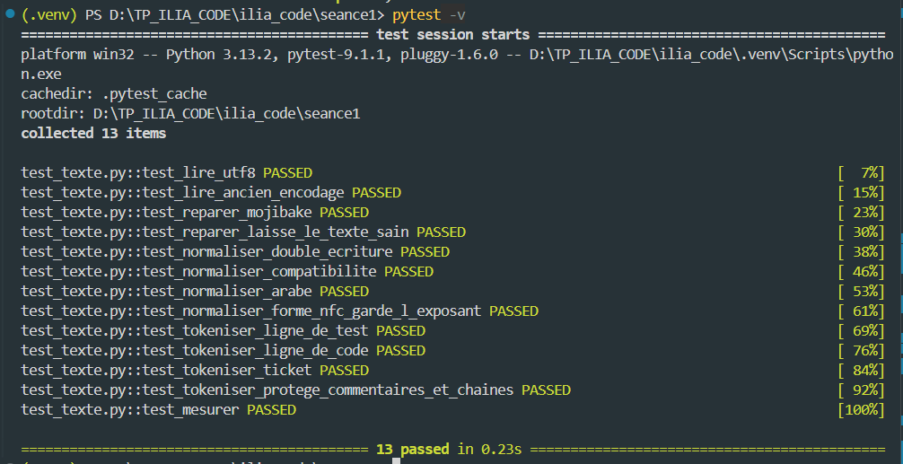
- Publier :

