Weights Distribution

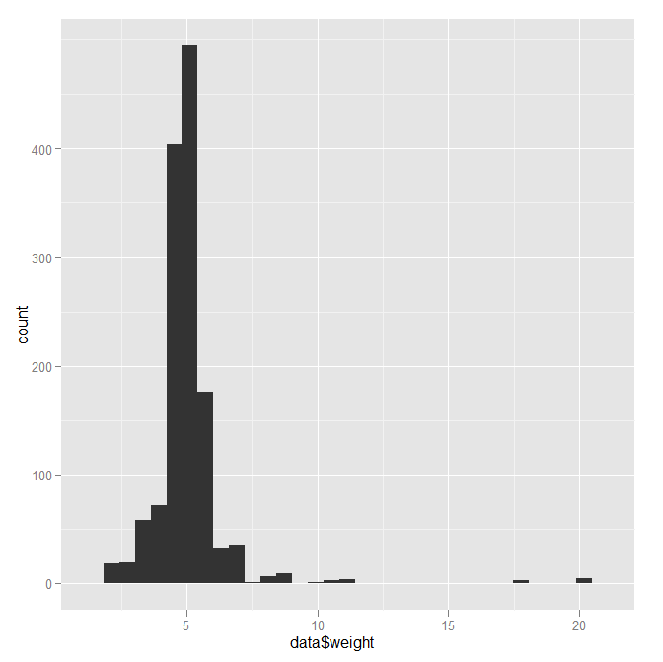

Looks pretty normal, just one or two weights that are extremely high. The one around 20 is 4 values from 1989, not important, there are two from 1990 that weighted around 18, but I think that is fine.

Year Distribution:

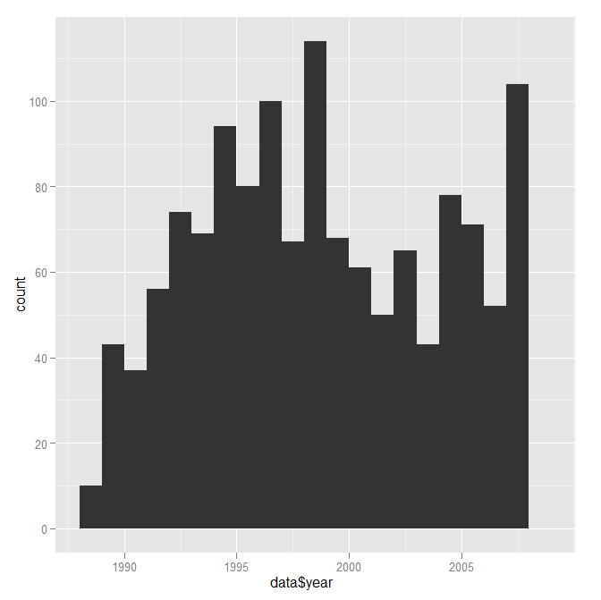

> table(data$year)

1989 1990 1991 1992 1993 1994 1995 1996 1997 1998 1999 2000 2001 2002 2003 2004

10 43 37 56 74 69 94 80 100 67 114 68 61 50 65 43

2005 2006 2007 2008

78 71 52 104

Age distribution:

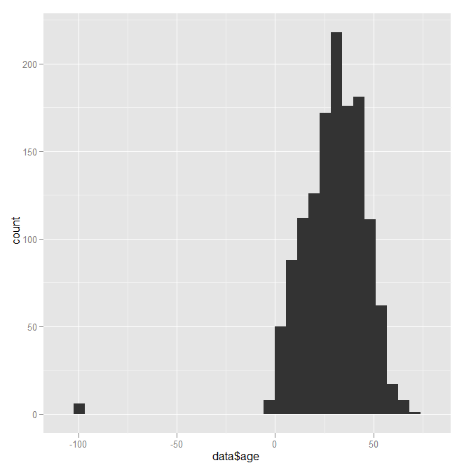

Approximately normal distribution from age 0 – 72. 6 patients did not have age information.

> table(data$age)

-99 0 1 2 3 4 5 6 7 8 9 10 11 12 13 14 15 16 17 18

6 8 9 9 12 10 10 18 16 18 13 13 10 17 15 21 17 24 18 24

19 20 21 22 23 24 25 26 27 28 29 30 31 32 33 34 35 36 37 38

20 21 22 39 17 30 25 30 43 27 29 31 36 40 41 41 32 40 37 35

39 40 41 42 43 44 45 46 47 48 49 50 51 52 53 54 55 56 57 58

32 30 32 41 31 20 27 24 25 16 18 16 12 22 7 7 9 6 11 4

59 60 61 62 63 64 65 66 67 68 72

2 5 2 4 2 1 1 1 2 1 1

Deaths

> table(data$died)

0 1

1335 1

There is one death. 1/1336 is approximately 0.08%

Primary Payer

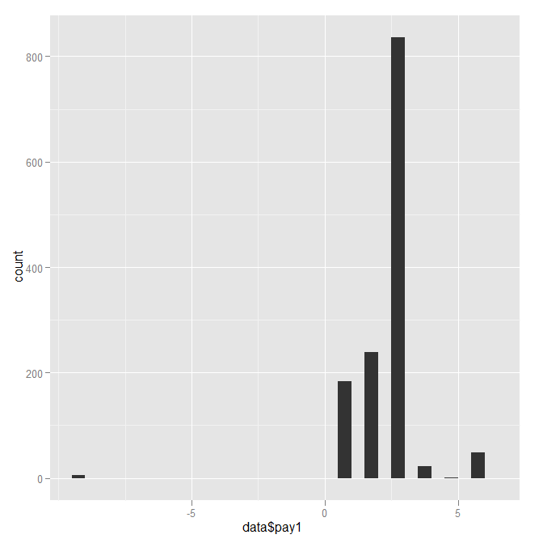

> table(data$pay1)

-9 1 2 3 4 5 6

5 184 239 836 22 1 49

Only 5 values where primary payer not recorded

Sex

> table(data$sex)

-9 0 1

13 619 704

Approximately 1% of patients do not have a sex recorded

Length Of Stay

Appears to be a Poisson distribution. Only 2 values not recorded.

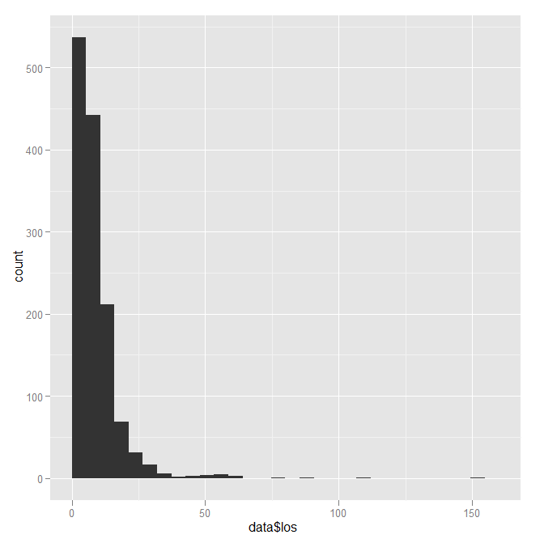

> table(data$los)

-6666 1 2 3 4 5 6 7 8 9 10 11 12

2 3 48 163 179 144 125 103 90 56 68 67 43

13 14 15 16 17 18 19 20 21 22 23 24 25

28 23 22 29 15 20 11 10 13 7 13 3 5

26 27 28 29 30 31 32 33 34 37 40 43 47

3 2 2 2 6 2 2 4 1 1 2 2 1

49 50 53 54 57 59 61 64 79 90 107 151

1 1 2 3 2 1 1 1 1 1 1 1

Charges

40 values were not recorded, similar Poisson distribution, max charge of $518549.

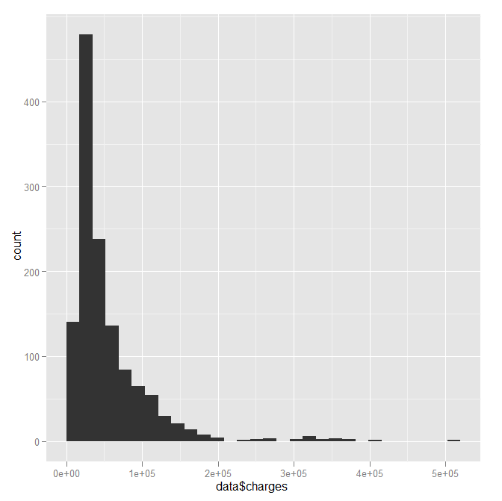

Hospital Information

> table(data$region)

0 1 2 3 4

22 247 288 425 354

> table(data$size)

0 1 2 3

22 125 261 928

>

There are 22 hospitals in the list that is lacking all information. I will see if I can plug them in.