Temporal lobe epilepsy surgery trends
from a nationwide database:
Clinical practice lagging behind class I evidence

Dario J. Englot, M.D., Ph.D., David Ouyang, B.S.,
Nicholas M. Barbaro, M.D., and Edward F. Chang, M.D.

Department of Neurological Surgery, University of California, San Francisco, California

Correspondence to: Edward F. Chang, M.D.
Department of Neurological Surgery
University of California, San Francisco
505 Parnassus Avenue, Box 0112
San Francisco, California 94143-0112
Phone: (415) 353-3489 Email: ChangED@neurosurg.ucsf.edu

Key words: epilepsy, outcomes, seizures, surgery
Running title: National trends of TLE surgery
Word count: Title characters:
Author Contributions
Study design and final manuscript editing was performed by all authors. Statistical analysis was performed by Mr. Ouyang and Dr. Englot.

Author Disclosures and Support
All authors report no disclosures or financial support.
Abstract
Background:
Methods:
Results:
Conclusions:
Introduction
Epilepsy is a debilitating neurological disorder affecting nearly 1% of the world’s population.(Devinsky, 2004) Seizures are uncontrolled by anti-epileptic medication (AEDs) in 20-40% of patients, resulting in cognitive impairment, neuropsychological sequelae, and diminished quality-of-life.(Engel, 2008, Englot & Blumenfeld, 2009, Helmstaedter & Kockelmann, 2006) In the United States, there are over one-half of a million individuals with medically-refractory epilepsy, resulting in a tremendous sociological and financial burden.(Engel, 2001, Hauser & Hesdorffer, 1990) Among defined epileptic disorders, temporal lobe epilepsy (TLE) is the most common, in which seizures frequently originate in limbic structures of the medial temporal lobe. (Engel, 1987, Williamson et al., 1993) Anterior temporal lobectomy (ATL) is a safe and effective surgical treatment for medically-refractory TLE, resulting in seizure-freedom in about two-thirds of patients, with a low 2% risk of significant morbidity.(Spencer & Huh, 2008, Wiebe, 2004, Wiebe et al., 2001) However, ATL has been remarkable underutilized in intractable TLE patients, with providers instead opting to trial new AED regimens, despite evidence that patients who fail two AEDs are unlikely to respond to additional medications.(Kwan & Brodie, 2000, Kwan & Sperling, 2009)
A survey in 1990 found that while 100,000 to 300,000 patients with intractable epilepsy in the U.S. were potential candidates for surgical treatment, only 1,500 therapeutic procedures were performed that year.(Engel, 2001, Engel & Shewman, 1993) While this discrepancy was perplexing, the epilepsy treatment community was considerably encouraged when in 2001, the first randomized, controlled trial of ATL for intractable TLE convincingly demonstrated the superior efficacy of ATL over continued medical treatment.(Wiebe et al., 2001) This study found that while 58% of patients in the surgical group became seizure-free, only 8% of individuals in the group randomized to continued medications achieved this outcome after one year of treatment.(Wiebe et al., 2001) In the aftermath of this trial, and with an increasing preponderance of evidence demonstrating the efficacy and safety of ATL for TLE, it remains unknown whether clinical practice has appropriately increased the utilization of surgical treatment for intractable TLE among suitable candidates.
Here we analyzed a national inpatient database to examine whether or not utilization of ATL for TLE has changed from 1992 to 2008, particularly in light of class I evidence demonstrating the efficacy of this surgical treatment. Specifically, is the use of ATL for suitable TLE candidates appropriately expanding, or does medical practice continue to lag behind high-quality clinical evidence?

Materials and Methods
Data identification and extraction
Data were obtained from the Nationwide Inpatient Sample (NIS) hospital discharge database (online at http://www.hcup-us.ahrq.gov/nisoverview.jsp), part of the Healthcare Cost and Utilization Project (HCUP), which is a Federal-State-Industry partnership sponsored by the Agency for Healthcare Research and Quality (Rockville, Maryland).(Steiner et al., 2002) These data include 100% of inpatient admissions from a stratified random sample of approximately 20% of community hospitals in the United States. All available data from 1992 through 2008 were searched. Our goal was to identify patients admitted for temporal lobectomy for intractable TLE, and to track these data by year along with 1) the overall number of admissions for TLE, 2) the total number of admissions for any reason, and 3) the number of hospitals included in the database. Patients were identified using the diagnosis codes 345.41 (intractable partial epilepsy with impairment of consciousness) or 345.51 (intractable partial epilepsy with mention of impairment of consciousness), and temporal lobectomies were indentified within this subpopulation using the procedure code 01.53 (brain lobectomy).

Results
epilepsy (47.8 ± 1.9%).

Discussion
Our
Conclusions

Disclaimer
The authors have no conflicts of interest to disclose.

References
Devinsky O. (2004) Diagnosis and treatment of temporal lobe epilepsy. Rev Neurol Dis 1:2-9.
Engel J, Jr. (1987) Outcome with respect to epileptic seizures. In Engel J, Jr., (ed) Surgical treatment of the epilepsies. Raven Press, New York, NY, pp. 553–571.
Engel J, Jr. (2001) Finally, a randomized, controlled trial of epilepsy surgery. N Engl J Med 345:365-367.
Engel J, Jr. (2008) Surgical treatment for epilepsy: too little, too late? JAMA 300:2548-2550.
Engel J, Jr., Shewman D. (1993) Overview: who should be considered a surgical candidate? In Engel J, Jr., (ed) Surgical treatment of the epilepsies. 2nd ed. Raven Press, New York, pp. 23-34.
Englot DJ, Blumenfeld H. (2009) Consciousness and epilepsy: why are complex-partial seizures complex? Prog Brain Res 177:147-170.
Hauser W, Hesdorffer D. (1990) Epilepsy: frequency, causes and consequences. Demos Press, New York.
Helmstaedter C, Kockelmann E. (2006) Cognitive outcomes in patients with chronic temporal lobe epilepsy. Epilepsia 47 Suppl 2:96-98.
Kwan P, Brodie MJ. (2000) Early identification of refractory epilepsy. N Engl J Med 342:314-319.
Kwan P, Sperling MR. (2009) Refractory seizures: try additional antiepileptic drugs (after two have failed) or go directly to early surgery evaluation? Epilepsia 50 Suppl 8:57-62.
Spencer S, Huh L. (2008) Outcomes of epilepsy surgery in adults and children. Lancet Neurol 7:525-537.
Steiner C, Elixhauser A, Schnaier J. (2002) The healthcare cost and utilization project: an overview. Eff Clin Pract 5:143-151.
Wiebe S. (2004) Effectiveness and safety of epilepsy surgery: what is the evidence? CNS Spectr 9:120-122, 126-132.
Wiebe S, Blume WT, Girvin JP, Eliasziw M. (2001) A randomized, controlled trial of surgery for temporal-lobe epilepsy. N Engl J Med 345:311-318.
Williamson PD, French JA, Thadani VM, Kim JH, Novelly RA, Spencer SS, Spencer DD, Mattson RH. (1993) Characteristics of medial temporal lobe epilepsy: II. Interictal and ictal scalp electroencephalography, neuropsychological testing, neuroimaging, surgical results, and pathology. Ann Neurol 34:781-787.

Tables
Table 1: TLE patients receiving ATL by race
Race | Received ATL (%) |  | Did not receive ATL (%)
White | 815 (81) |  | 11520 (75)
Black | 52 (5) |  | 1138 (10)
Hispanic | 83 (8) |  | 1365 (9)
Asian/Pacific islander | 9 (1) |  | 218 (1)
Native American | 4 (1) |  | 143 (1)
Other | 40 (4) |  | 587 (4)
Χ² (overall) = 14.8, P = 0.011. Χ² (white vs. black) = 9.1, P = 0.003, OR = 0.65 (95% CI: 0.48 – 0.86).

Table 2: TLE patients receiving ATL by payer
Race | Received ATL (%) |  | Did not receive ATL (%)
Private insurance | 828 (63) |  | 10358 (50)
Medicare | 184 (14) |  | 4468 (22)
Medicaid | 238 (18) |  | 4464 (22)
Self-pay | 22 (2) |  | 403 (2)
No charge | 1 (0) |  | 56 (0)
Other | 48 (4) |  | 798 (4)
Overall: Chi-square =82.3, P < 0.0001
Private v Medicare/caid: Chi-square = 74.0, P < 0.0001; OR 0.59 (0.52 – 0.67)
Figures
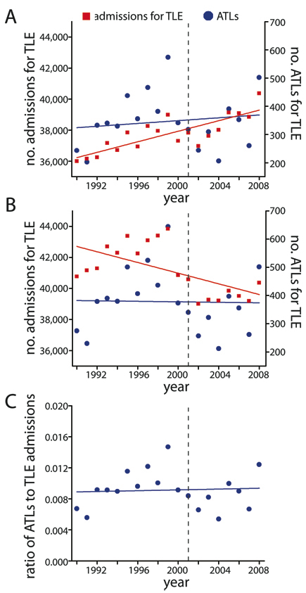 | Figure 1.  Slope 2.64 x 10⁻⁵. General linear model adjusted R-squared, 0.03995, F-statistic: 1.79, p-value: 0.1975.  Welch Two Sample t-test, comparing before 2001, to after and including 2001. t = 0.1586, p-value = 0.8746

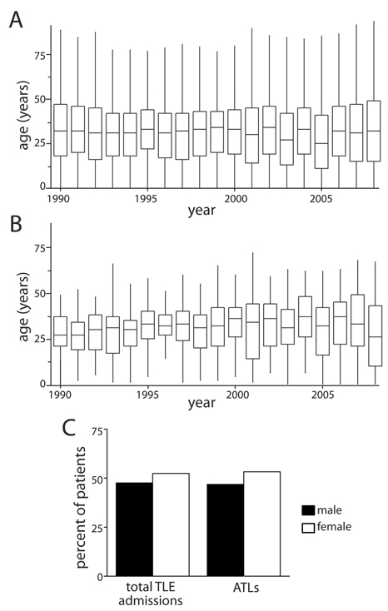 | Figure 2.

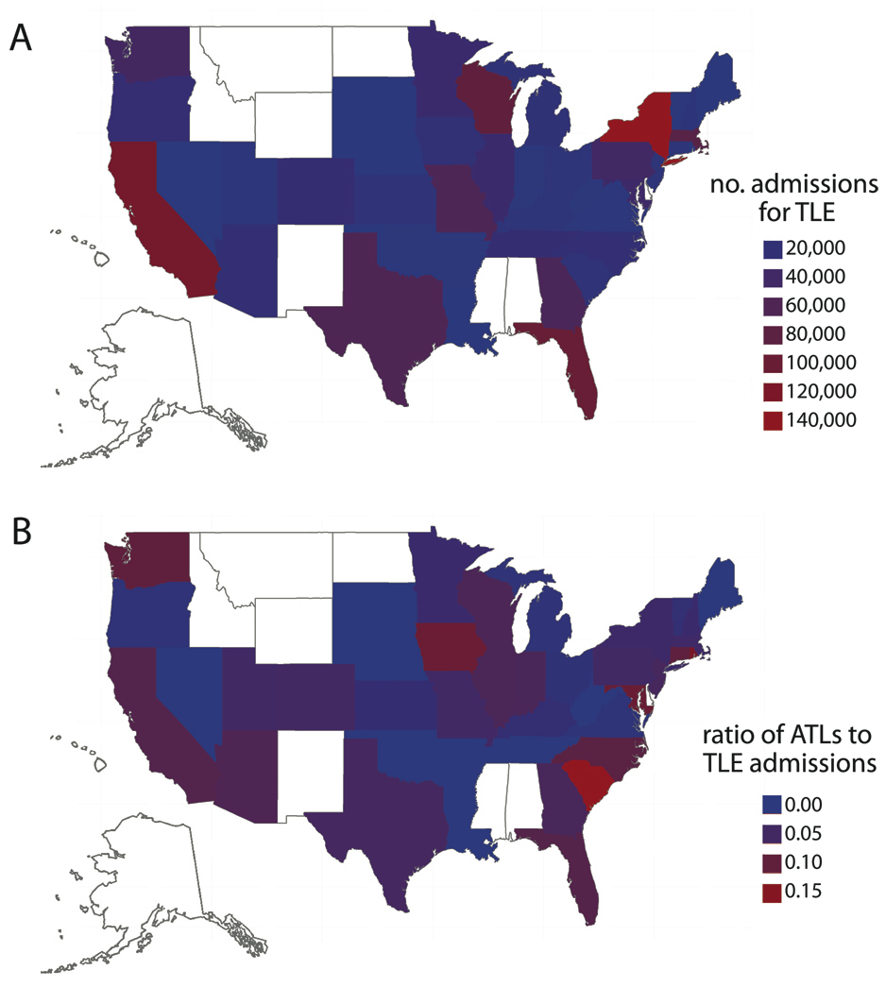
Figure 3.

