Temporal lobe epilepsy surgery trends
from a nationwide database:
Clinical practice lagging behind class I evidence

Dario J. Englot, M.D., Ph.D., David Ouyang, B.S.,
Nicholas M. Barbaro, M.D., and Edward F. Chang, M.D.

Department of Neurological Surgery, University of California, San Francisco, California

Correspondence to: Edward F. Chang, M.D.
Department of Neurological Surgery
University of California, San Francisco
505 Parnassus Avenue, Box 0112
San Francisco, California 94143-0112
Phone: (415) 353-3489 Email: ChangED@neurosurg.ucsf.edu

Key words: epilepsy, seizures, surgery, temporal lobectomy, trends
Running title: National trends of TLE surgery
Word count: Title characters:
Author Contributions
Study conception and design was performed by Drs. Englot and Chang. Statistical analysis was performed by Mr. Ouyang and Dr. Englot. Final manuscript editing was performed by all authors.

Author Disclosures
All authors report no financial disclosures or conflicts of interest.
Abstract
Background:
Methods:
Results:
Conclusions:
Introduction
Epilepsy is a debilitating neurological disorder affecting nearly 1% of the world’s population.(Devinsky, 2004) In 20-40% of epilepsy patients, seizures are poorly controlled by anti-epileptic drugs (AEDs), resulting in cognitive impairment, neuropsychological sequelae, and diminished quality-of-life.(Engel, 2008, Englot & Blumenfeld, 2009, Helmstaedter & Kockelmann, 2006) In the United States, there are over one-half of a million individuals with medically-refractory epilepsy, resulting in a tremendous sociological and financial burden.(Engel, 2001, Hauser & Hesdorffer, 1990) Temporal lobe epilepsy (TLE) is the most common defined epileptic disorder, in which seizures frequently originate in limbic structures of the medial temporal lobe. (Engel, 1987, Williamson et al., 1993) Anterior temporal lobectomy (ATL) is a safe and effective surgical treatment for medically-refractory TLE, resulting in seizure-freedom in about two-thirds of patients, with a low 2% risk of significant morbidity.(Spencer & Huh, 2008, Wiebe, 2004, Wiebe et al., 2001) However, ATL has been remarkable underutilized in intractable TLE patients, with providers instead opting to trial new AED regimens, despite evidence that patients who fail two AEDs are unlikely to respond to additional medications.(Kwan & Brodie, 2000, Kwan & Sperling, 2009)
A survey in 1990 found that while 100,000 to 300,000 patients with intractable epilepsy in the U.S. were potential candidates for surgical treatment, only 1,500 therapeutic procedures were performed that year.(Engel, 2001, Engel & Shewman, 1993) While this discrepancy was perplexing, the epilepsy treatment community was considerably encouraged when in 2001, the first randomized, controlled trial of ATL for intractable TLE convincingly demonstrated the superior efficacy of ATL over continued medical treatment.(Wiebe et al., 2001) This study found that while 58% of patients in the surgical group became seizure-free, only 8% of individuals in the group randomized to continued medications achieved this outcome after one year of treatment.(Wiebe et al., 2001) In the aftermath of this trial, and with an increasing preponderance of evidence demonstrating the efficacy and safety of ATL for TLE, it remains unknown whether clinical practice has appropriately increased the utilization of surgical treatment for intractable TLE among suitable candidates.
Here we analyzed a national inpatient database to examine whether or not utilization of ATL for TLE has changed from 1992 to 2008, particularly in light of class I evidence demonstrating the efficacy of this surgical treatment. Specifically, is the use of ATL for suitable TLE candidates appropriately expanding, or does medical practice continue to lag behind high-quality clinical evidence?

Materials and Methods
Data identification and extraction
Data were obtained from the Nationwide Inpatient Sample (NIS) hospital discharge database (online at http://www.hcup-us.ahrq.gov/nisoverview.jsp), part of the Healthcare Cost and Utilization Project (HCUP), which is a Federal-State-Industry partnership sponsored by the Agency for Healthcare Research and Quality (Rockville, Maryland).(Steiner et al., 2002) These data include 100% of inpatient admissions from a stratified random sample of approximately 20% of community hospitals in the United States. All available data from 1990 through 2008 were searched. Our goal was to identify patients with intractable TLE admitted for temporal lobectomy, and to track these data by year along with the overall number of admissions for TLE. Patients who received temporal lobectomy for TLE during their hospital admission were identified by searching for the procedure code 01.53 (brain lobectomy) within a population of patients with a primary diagnosis code of either 345.41 (intractable partial epilepsy with impairment of consciousness) or 345.51 (intractable partial epilepsy with mention of impairment of consciousness). Data related to age, gender, race, geographical location, payer, and the hospital type (teaching versus non-teaching) and location (urban versus rural) were also extracted for all patients.
In addition to raw data, we examined weighted values recorded in the database, which accounts for expansion of the dataset over time and extrapolates results to the U.S. population. These weighted data were developed using the American Hospital Association (AHA) universe as the standard. The NIS calculates each sample admission’s universe weight as:
DW_{is}(universe) = [DN_{s}(universe) ÷ ADN_{s}(sample)] * (4 ÷ Q_{i})
where DW_{is}(universe) represents the discharge weight; DN_{s}(universe) signifies the number of discharges from community hospitals in the universe within stratum s; ADN_{s}(sample) is the number of adjusted discharges from sample hospitals selected for the NIS; and Q_{i} signifies the number of quarters of discharge data contributed by hospital i to the NIS (usually Q_{i} = 4). As discharges from 20% of hospitals in each stratum were sampled when possible, most discharge weights are approximately equal to 5. Further details regarding NIS data weighting are available online (http://www.hcup-us.ahrq.gov/nisoverview.jsp).

Statistical analysis
Raw and weighted data for TLE admissions, number of ATLs performed, and ratio of ATLs to TLE admissions were trended over time, and weighted data were examined using a general linear model with analysis of variance (ANOVA). ATL:TLE ratios prior to 2001 were compared to those after 2001 using Welch’s two-sample t-test. Prior to utilizing parametric tests, normality of data was verified. Raw data for categorical variables including race, payer, hospital location, and hospital type were examined comparing TLE admissions with ATL to those without ATL using Pearson’s chi-square (Χ²). Odds ratios (ORs) were calculated with a 95% confidence interval (CI). Statistical significance was assessed at P < 0.05, and analyses were performed using SPSS version 17 (IBM, Somers, NY) and R version 2.13 (open source software, www.r-project.org).

Results
We indentified 20,807 patients admitted to U.S. hospitals for TLE from 1990 to 2008, aged 0 to 101 years, of whom 1,326 (6%) received ATL during their admission. Overall, TLE was the admitting diagnosis for approximately 1.5 out of every 10,000 admissions across all 136,987,806 admissions in the database during this time. Data were provided by 758 to 1,056 hospitals per year, representing approximately 20% of registered community hospitals in the U.S.
In examining yearly hospitalizations for TLE, a relatively linear increase in number of admissions is observed from 1990 to 2008 (Fig. 1A). A small, less notable, increase in the number of ATLs performed is also seen over time (Fig. 1A). To account for expansion of database size during this period, and to extrapolate findings to the U.S. population, weighted statistics were also investigated. While a statistically significant increase in TLE admissions was observed during the study period (adjusted R² = 0.65, P < 0.0001), a smaller increase in the number of ATLs performed was not significant (adjusted R² = 0.04, P = 0.56) (Fig. 1B). Overall, no significant change in the fraction of TLE patients receiving ATL was found over time (adjusted R² = 0.05, F = 0.06, P = 0.80) (Fig 1C). Also, overall rates of ATL after 2001 were not significantly different from those before 2001 (t = 0.16, P = 0.87). These data suggest that while an increasing number of patients have been hospitalized for TLE since 1990, the proportion of these patients receiving ATL has not changed appreciably.
We next investigated the demographics of these patients. The median age of individuals who received ATL was 32.0 years, mirroring the median age (32.0 years) of all hospitalized TLE patients (Fig. 2A,B). No change was observed in the age of either population over time (Fig. 2A,B). Also, we found no gender differences between the populations, both of which were 53% female (Fig. 2C). Notably, however, there were large race-based differences related to the likelihood of receiving ATL (Table 1). While 6.6% of white and 5.7% of Hispanic patients underwent surgery during hospitalization, only 2.7 to 4.0% of patients who were Black, Asian/Pacific Islander, or Native American had the procedure, resulting in a statistically significant discrepancy (Χ² = 32.8, P < 0.0001). Overall, white and Hispanic individuals were more likely to receive ATL than other racial minorities combined with an odds ratio of 2.04 (95% CI 1.59 – 2.63, P < 0.0001). Furthermore, we found considerable inconsistencies in treatment rates related to patient payer status (Table 2). While 7.4% of patients with private insurance received ATL, only 4.0 to 4.9% of individuals with Medicare or Medicaid underwent the procedure (OR = 1.69, 95% CI 1.52 – 1.92, P < 0.0001). These results suggest that the likelihood of undergoing ATL is not measurably influenced by age or gender, but non-Hispanic racial minorities and patients with Medicare or Medicaid are significantly less likely to receive the procedure than other individuals.
We also examined rates of ATL stratified by geographical and hospital-related factors. Across U.S. states, the total number of weighted TLE admissions closely mirrored overall population (Fig. 3A). From 1990 to 2008, the greatest numbers of hospitalizations were recorded in California and New York – the first and third more populous states, respectively (Fig. 3A). Interestingly, however, the fraction of patients receiving ATL was highest in South Carolina and Rhode Island, followed by Maryland and Iowa (Fig. 3B). Next, patients hospitalized in urban regions were significantly more likely to have surgery (6.1%) than those in non-urban communities (2.8%) (OR = 2.27, 95% CI: 1.52 – 3.33, P < 0.0001) (Table 3A). Finally, while 6.6% of patients at teaching hospitals received ATL, significantly fewer (3.6%) individuals at non-teaching hospitals had surgery (OR = 1.89, 95% CI 1.59 – 2.22, P < 0.0001). Thus, U.S. teaching institutions and those in urban locations are considerably more likely to perform ATL than other hospitals, but receiving surgery is not necessarily predicated by treatment in a populous states.

Discussion
Our
Conclusions

Disclaimer
The authors have no conflicts of interest to disclose.

References
Devinsky O. (2004) Diagnosis and treatment of temporal lobe epilepsy. Rev Neurol Dis 1:2-9.
Engel J, Jr. (1987) Outcome with respect to epileptic seizures. In Engel J, Jr., (ed) Surgical treatment of the epilepsies. Raven Press, New York, NY, pp. 553–571.
Engel J, Jr. (2001) Finally, a randomized, controlled trial of epilepsy surgery. N Engl J Med 345:365-367.
Engel J, Jr. (2008) Surgical treatment for epilepsy: too little, too late? JAMA 300:2548-2550.
Engel J, Jr., Shewman D. (1993) Overview: who should be considered a surgical candidate? In Engel J, Jr., (ed) Surgical treatment of the epilepsies. 2nd ed. Raven Press, New York, pp. 23-34.
Englot DJ, Blumenfeld H. (2009) Consciousness and epilepsy: why are complex-partial seizures complex? Prog Brain Res 177:147-170.
Hauser W, Hesdorffer D. (1990) Epilepsy: frequency, causes and consequences. Demos Press, New York.
Helmstaedter C, Kockelmann E. (2006) Cognitive outcomes in patients with chronic temporal lobe epilepsy. Epilepsia 47 Suppl 2:96-98.
Kwan P, Brodie MJ. (2000) Early identification of refractory epilepsy. N Engl J Med 342:314-319.
Kwan P, Sperling MR. (2009) Refractory seizures: try additional antiepileptic drugs (after two have failed) or go directly to early surgery evaluation? Epilepsia 50 Suppl 8:57-62.
Spencer S, Huh L. (2008) Outcomes of epilepsy surgery in adults and children. Lancet Neurol 7:525-537.
Steiner C, Elixhauser A, Schnaier J. (2002) The healthcare cost and utilization project: an overview. Eff Clin Pract 5:143-151.
Wiebe S. (2004) Effectiveness and safety of epilepsy surgery: what is the evidence? CNS Spectr 9:120-122, 126-132.
Wiebe S, Blume WT, Girvin JP, Eliasziw M. (2001) A randomized, controlled trial of surgery for temporal-lobe epilepsy. N Engl J Med 345:311-318.
Williamson PD, French JA, Thadani VM, Kim JH, Novelly RA, Spencer SS, Spencer DD, Mattson RH. (1993) Characteristics of medial temporal lobe epilepsy: II. Interictal and ictal scalp electroencephalography, neuropsychological testing, neuroimaging, surgical results, and pathology. Ann Neurol 34:781-787.

Tables
Table 1: Rates of ATL for TLE stratified by race
Race | Received ATL, n (%) |  | Did not receive ATL, n (%)
White | 815 (6.6) |  | 11520 (93.4)
Black | 52 (3.3) |  | 1138 (96.7)
Hispanic | 83 (5.7) |  | 1365 (94.3)
Asian/Pacific islander | 9 (4.0) |  | 218 (96.0)
Native American | 4 (2.7) |  | 143 (97.3)
Other/Not recorded | 363 (5.7) |  | 6023 (94.3)
Total | 1326 (6.0) |  | 20807 (94.0)
Data are raw, unweighted values.

Table 2: Rates of ATL for TLE stratified by payer status
Race | Received ATL, n (%) |  | Did not receive ATL, n (%)
Private insurance | 828 (7.4) |  | 10358 (92.6)
Medicare | 184 (4.0) |  | 4468 (96.0)
Medicaid | 238 (4.9) |  | 4464 (95.1)
Self-pay | 22 (5.2) |  | 403 (94.8)
No charge | 1 (1.8) |  | 56 (98.2)
Other/Not recorded | 53 (5.8) |  | 858 (94.2)
Total | 1326 (6.0) |  | 20807 (94.0)
Data are raw, unweighted values.

Table 3: Rates of ATL for TLE stratified by hospital location and type
 | Received ATL, n (%) |  | Did not receive ATL, n (%)
A. Hospital location
Urban | 1289 (6.1) |  | 19683 (93.9)
Non-urban | 25 (2.8) |  | 863 (97.2)
Not recorded | 12 (4.4) |  | 261 (95.6)
B. Hospital type
Teaching | 1160 (6.6) |  | 16432 (93.4)
Non-teaching | 154 (3.6) |  | 4114 (96.4
Not recorded | 12 (4.4) |  | 261 (95.6)
Total | 1326 (6.0) |  | 20807 (94.0)
Data are raw, unweighted values.
Figures
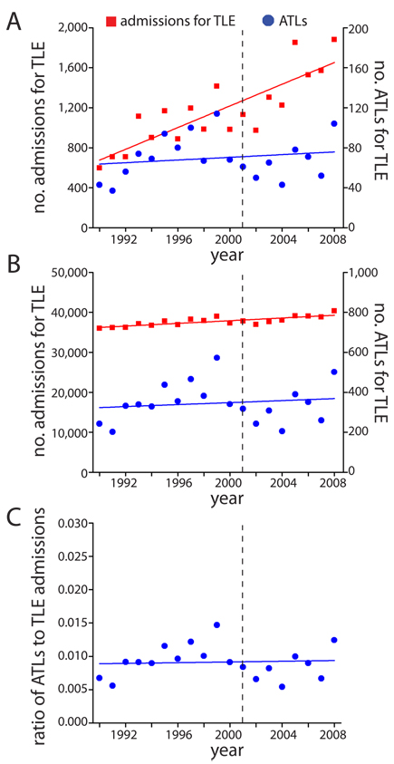 | Figure 1. Admissions for TLE and rates of ATL over time. A. Raw data representing total admissions for TLE and total ATLs by year. B. Weighted data from (A). A significant increase in TLE admissions is observed over time (adjusted R² = 0.65, F = 34.9, P < 0.0001), while a slight increase in ATLs is not significant (adjusted R² = 0.04, F = 0.36, P = 0.56). C. Fraction of TLE patients receiving ATL using weighted data. No significant trend is observed (adjusted R² = 0.05, F = 0.06, P = 0.80). Dashed line represents publication year (2001) of randomized, controlled trial. ATL = anterior temporal lobectomy; TLE = temporal lobe epilepsy.

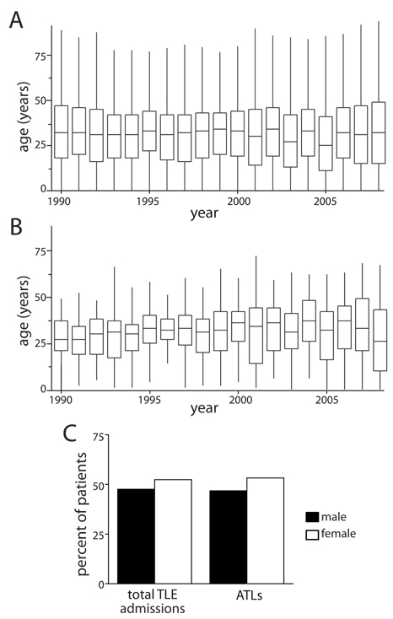
Figure 2. Age and gender of patients admitted for TLE and receiving ATL. A. Median age of all patients admitted for TLE over time, with interquartile range (box) and two standard deviations (error bars). No overall trend is observed. B. Age of patients receiving ATL over time. Median age of patients receiving ATL (32.0 years) is equivalent to the age of all patients admitted for TLE (32.0 years). No overall trend is observed over time. C. Gender of all admitted TLE patients and those receiving ATL from 1990-2008. The percentage of females was slightly higher in both populations (53%), with no differences between populations observed. Data (A-C) are raw, unweighted values. ATL = anterior temporal lobectomy; TLE = temporal lobe epilepsy.

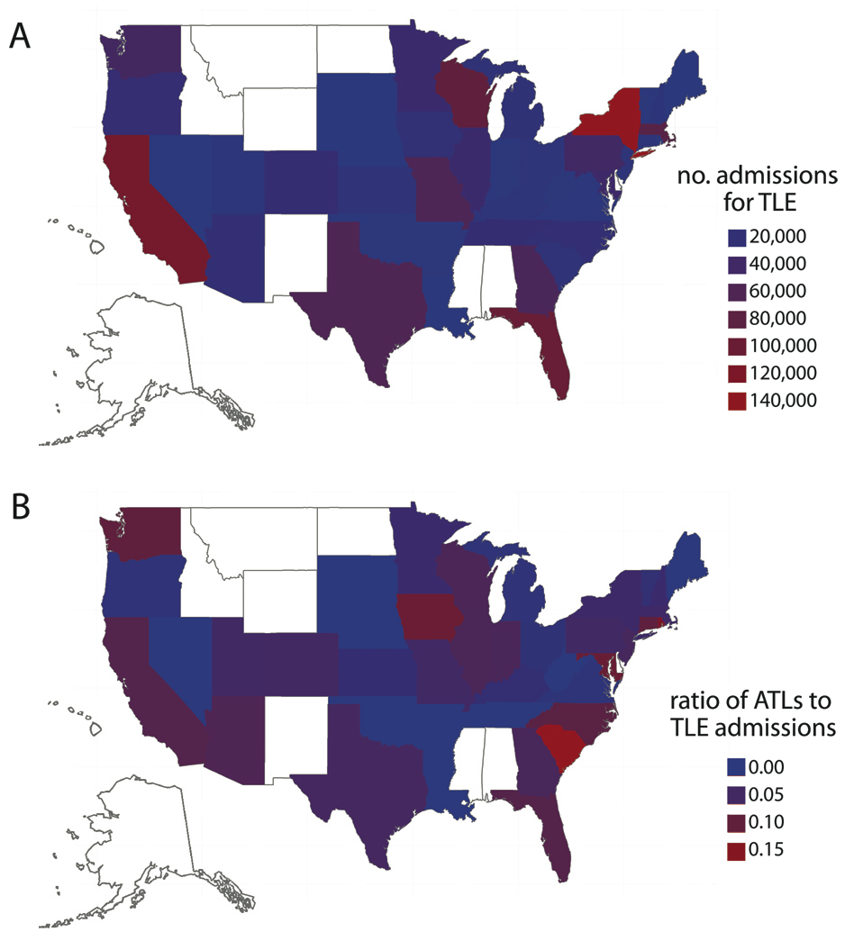
Figure 3. Geographical representation of TLE patient admissions and the fraction receiving ATL. A. Total number of patient admissions for TLE by U.S. state. California and New York, the first and third most populous states, respectively, had the highest number of TLE admissions. B. Fraction of patients receiving ATL among total TLE admissions by state. The highest rates of ATL were observed in South Carolina and Rhode Island, followed by Maryland and Iowa. Data are cumulative, weighted values from 1990-2008, and were not available for the 9 states shown in white. ATL = anterior temporal lobectomy; TLE = temporal lobe epilepsy.

