Temporal lobe epilepsy surgery trends
from a nationwide database:
Clinical practice lagging behind class I evidence

Dario J. Englot, M.D., Ph.D., David Ouyang, B.S.,
Nicholas M. Barbaro, M.D., and Edward F. Chang, M.D.

Department of Neurological Surgery, University of California, San Francisco, California

Correspondence to: Edward F. Chang, M.D.
Department of Neurological Surgery
University of California, San Francisco
505 Parnassus Avenue, Box 0112
San Francisco, California 94143-0112
Phone: (415) 353-3489 Email: ChangED@neurosurg.ucsf.edu

Key words: epilepsy, seizures, surgery, temporal lobectomy, trends
Running title: National trends of TLE surgery
Word count: Title characters:
Author Contributions
Study conception and design was performed by Drs. Englot and Chang. Statistical analysis was performed by Mr. Ouyang and Dr. Englot. Final manuscript editing was performed by all authors.

Author Disclosures
All authors report no financial disclosures or conflicts of interest.
Abstract
Background:
Methods:
Results:
Conclusions:
Introduction
Epilepsy is a debilitating neurological disorder affecting nearly 1% of the world’s population.(Devinsky, 2004) In 20-40% of epilepsy patients, seizures are poorly controlled by anti-epileptic drugs (AEDs), resulting in cognitive impairment, neuropsychological sequelae, and diminished quality-of-life.(Engel, 2008, Englot & Blumenfeld, 2009, Helmstaedter & Kockelmann, 2006) In the United States, there are over one-half of a million individuals with medically-refractory epilepsy, resulting in a tremendous sociological and financial burden.(Engel, 2001, Hauser & Hesdorffer, 1990) Temporal lobe epilepsy (TLE) is the most common defined epileptic disorder, in which seizures frequently originate in limbic structures of the medial temporal lobe. (Engel, 1987, Williamson et al., 1993) Anterior temporal lobectomy (ATL) is a safe and effective surgical treatment for medically-refractory TLE, resulting in seizure-freedom in about two-thirds of patients, with a low 2% risk of significant morbidity.(Spencer & Huh, 2008, Wiebe, 2004, Wiebe et al., 2001) However, ATL has been remarkably underutilized in intractable TLE patients, with providers instead opting to trial new AED regimens, despite evidence that patients who fail two AEDs are unlikely to respond to additional medications.(Kwan & Brodie, 2000, Kwan & Sperling, 2009)
A survey in 1990 found that while 100,000 to 300,000 patients with intractable epilepsy in the U.S. were potential candidates for surgical treatment, only 1,500 therapeutic procedures were performed that year.(Engel, 2001, Engel & Shewman, 1993) While this discrepancy was perplexing, the epilepsy treatment community was considerably encouraged when in 2001, the first randomized, controlled trial of ATL for intractable TLE convincingly demonstrated the superior efficacy of ATL over continued medical treatment.(Wiebe et al., 2001) This study found that while 58% of patients in the surgical group became seizure-free, only 8% of individuals in the group randomized to continued medications achieved this outcome after one year of treatment.(Wiebe et al., 2001) In the aftermath of this trial, and with an increasing preponderance of evidence demonstrating the efficacy and safety of ATL for TLE, it remains unknown whether clinical practice has appropriately increased the utilization of surgical treatment for intractable TLE among suitable candidates.
Here we analyzed a national inpatient database to examine whether or not utilization of ATL for TLE has changed from 1990 to 2008, particularly in light of class I evidence demonstrating the efficacy of this surgical treatment. Specifically, is the use of ATL for suitable TLE candidates appropriately expanding, or does medical practice continue to lag behind class I clinical evidence?

Materials and Methods
Data identification and extraction
Data were obtained from the Nationwide Inpatient Sample (NIS) hospital discharge database (online at http://www.hcup-us.ahrq.gov/nisoverview.jsp), part of the Healthcare Cost and Utilization Project (HCUP), which is a Federal-State-Industry partnership sponsored by the Agency for Healthcare Research and Quality (Rockville, Maryland).(Steiner et al., 2002) These data include 100% of inpatient admissions from a stratified random sample of approximately 20% of community hospitals in the United States. All available data from 1990 through 2008 were searched. Our goal was to identify patients with intractable TLE admitted for temporal lobectomy, and to track these data by year along with the overall number of admissions for TLE. Patients who received temporal lobectomy for TLE during their hospital admission were identified by searching for the procedure code 01.53 (brain lobectomy) within a population of patients with a primary diagnosis code of either 345.41 (intractable partial epilepsy with impairment of consciousness) or 345.51 (intractable partial epilepsy with mention of impairment of consciousness). Data related to age, gender, race, geographical location, payer, and the hospital type (teaching versus non-teaching) and location (urban versus rural) were also extracted for all patients.
In addition to raw data, we examined weighted values recorded in the database, which accounts for expansion of the dataset over time and extrapolates results to the U.S. population. These weighted data were developed using the American Hospital Association (AHA) universe as the standard. The NIS calculates each sample admission’s universe weight as:
DW_{is}(universe) = [DN_{s}(universe) ÷ ADN_{s}(sample)] * (4 ÷ Q_{i})
where DW_{is}(universe) represents the discharge weight; DN_{s}(universe) signifies the number of discharges from community hospitals in the universe within stratum s; ADN_{s}(sample) is the number of adjusted discharges from sample hospitals selected for the NIS; and Q_{i} signifies the number of quarters of discharge data contributed by hospital i to the NIS (usually Q_{i} = 4). As discharges from 20% of hospitals in each stratum were sampled when possible, most discharge weights are approximately equal to 5. Further details regarding NIS data weighting are available online (http://www.hcup-us.ahrq.gov/nisoverview.jsp).

Statistical analysis
Raw and weighted data for TLE admissions, number of ATLs performed, and fraction of TLE admissions receiving ATL were trended over time, and weighted data were examined using a general linear model with analysis of variance (ANOVA). The fractions of TLE patients receiving ATL prior to 2001 were compared to those after 2001 using Welch’s two-sample t-test. Prior to utilizing parametric tests, normality of data was verified. Raw data for categorical variables including race, payer, hospital location, and hospital type were examined comparing TLE admissions with ATL to those without ATL using Pearson’s chi-square (Χ²). Odds ratios (ORs) were calculated with a 95% confidence interval (CI). Statistical significance was assessed at P < 0.05, and analyses were performed using SPSS version 17 (IBM, Somers, NY) and R version 2.13 (open source software, www.r-project.org).

Results
We indentified 20,807 patients admitted to U.S. hospitals for TLE from 1990 to 2008, aged 0 to 101 years, of whom 1,326 (6%) received ATL during their admission. Overall, TLE was the admitting diagnosis for approximately 1.5 out of every 10,000 admissions across all 136,987,806 admissions in the database during this time. Data were provided by 758 to 1,056 hospitals per year, representing approximately 20% of registered community hospitals in the U.S.
In examining yearly hospitalizations for TLE, a relatively linear increase in number of admissions is observed from 1990 to 2008 (Fig. 1A). A small, less notable, increase in the number of ATLs performed is also seen over time (Fig. 1A). To account for expansion of database size during this period, and to extrapolate findings to the U.S. population, weighted statistics were also investigated. While a statistically significant increase in TLE admissions was observed during the study period (adjusted R² = 0.65, P < 0.0001), a smaller increase in the number of ATLs performed was not significant (adjusted R² = 0.04, P = 0.56) (Fig. 1B). Overall, no significant change in the fraction of TLE patients receiving ATL was found over time (adjusted R² = 0.05, F = 0.06, P = 0.80) (Fig 1C). Also, overall rates of ATL after 2001 were not significantly different from those before 2001 (t = 0.16, P = 0.87). These data suggest that while an increasing number of patients have been hospitalized for TLE since 1990, the proportion of these patients receiving ATL has not changed appreciably.
We next investigated the demographics of these patients. The median age of individuals who received ATL was 32.0 years, mirroring the median age (32.0 years) of all hospitalized TLE patients (Fig. 2A,B). No change was observed in the age of either population over time (Fig. 2A,B). Also, we found no gender differences between the populations, both of which were 53% female (Fig. 2C). Notably, however, there were large race-based differences related to the likelihood of receiving ATL (Table 1). While 6.6% of white and 5.7% of Hispanic patients underwent surgery during hospitalization, only 2.7 to 4.0% of patients who were Black, Asian/Pacific Islander, or Native American had the procedure, resulting in a statistically significant discrepancy (Χ² = 32.8, P < 0.0001). Overall, white and Hispanic individuals were more likely to receive ATL than other racial minorities combined with an odds ratio of 2.04 (95% CI 1.59 – 2.63, P < 0.0001). Furthermore, we found considerable inconsistencies in treatment rates related to patient payer status (Table 2). While 7.4% of patients with private insurance received ATL, only 4.0 to 4.9% of individuals with Medicare or Medicaid underwent the procedure (OR = 1.69, 95% CI 1.52 – 1.92, P < 0.0001). These results suggest that the likelihood of undergoing ATL is not measurably influenced by age or gender, but non-Hispanic racial minorities and patients with Medicare or Medicaid are significantly less likely to receive the procedure than other individuals.
We also examined rates of ATL stratified by geographical and hospital-related factors. Across U.S. states, the total number of weighted TLE admissions closely mirrored overall population (Fig. 3A). From 1990 to 2008, the greatest numbers of hospitalizations for TLE were recorded in New York and California – the third and first more populous states, respectively (Fig. 3A). However, the fraction of patients receiving ATL was highest in Rhode Island and Iowa, followed by Maryland and Connecticut (Fig. 3B). Finally, we stratified results by hospital location (urban versus non-urban), teaching status, and size (Table 3). Patients hospitalized in urban regions were also significantly more likely to have surgery (6.1%) than those in non-urban communities (2.8%) (OR = 2.27, 95% CI: 1.52 – 3.33, P < 0.0001) (Table 3A). Also, while 6.6% of patients at teaching hospitals received ATL, significantly fewer (3.6%) individuals at non-teaching hospitals had surgery (OR = 1.89, 95% CI 1.59 – 2.22, P < 0.0001) (Table 3B). There was also a somewhat greater rate of ATL among admissions to large hospitals than those to small or medium hospitals (OR 1.17, 95% CI 1.01 – 1.35, P = 0.04) (Table 3C). Thus, U.S. teaching institutions and those in urban locations are considerably more likely to perform ATL than other hospitals, but rates of surgery are not necessarily higher in the most populous states.

Discussion
TLE is a devastating neurological condition leading to severe neurocognitive sequelae and diminished quality-of-life, particularly when seizures are poorly controlled by medication.(Engel, 2008, Helmstaedter & Kockelmann, 2006) ATL results in seizure-freedom in approximately two-thirds of patients with intractable TLE,(Spencer & Huh, 2008) is associated with low morbidity,(Wiebe, 2004) and leads to improvement in both overall and quality-adjusted life span compared to continued pharmacological therapy. (Choi et al., 2008, Sperling et al., 1999) The improved efficacy of ATL in producing seizure-freedom was confirmed by Class I evidence from a randomized controlled trial in 2001,(Wiebe et al., 2001) leading to a joint position by the American Academy of Neurology, the American Epilepsy Society, and the American Association of Neurological surgeons that these patients should be referred to an epilepsy center for surgical evaluation.(Engel et al., 2003) Despite this practice parameter, our present results suggest that no significant change in the proportion of TLE patients receiving ATL has occurred from 1990 to 2008, notwithstanding a parallel increase in hospital admissions for TLE. These findings validate on a larger scale the relatively stagnant referral rate recently described by one large epilepsy center,(Haneef et al., 2010) and confirm recent indications by the president of the National Association of Epilepsy Centers that the number of surgeries for TLE has not appreciably changed from 1990 to 2008.(Engel, 2008)
In addition to an overall under-utilization of ATL for TLE, we also found dramatic disparities in treatment rates by both race and level of insurance coverage. Non-Hispanic minorities were significantly less likely to receive the procedure than white and Hispanic individuals, and patients with private insurance had surgery at notably higher rates than those with Medicare or Medicaid. Previous studies have also found similar inequalities in the surgical treatment of TLE, noting in the particular the under-utilization of ATL among black patients,(McClelland et al., 2007, McClelland et al., 2010, Szaflarski et al., 2006), as well as treatment disparities by socioeconomic status.(Begley et al., 2009, Burneo et al., 2009, McClelland et al., 2010) This lower level of care received by racial minorities and economically disadvantaged patients is concerning, and should drive members of the epilepsy treatment community to push for governmental and private-sector reform focused on achieving full equality in medical care.
While the persistent under-utilization of ATL for TLE is disappointing, continually expanding bodies of evidence related to epilepsy treatment provide reason for optimism, and a large multicentered, randomized trial of epilepsy surgical currently underway may positively influence practice patterns.(Engel et al., 2010) However, scientific paradigm shifts often take time,(Kuhn, 1962, Sehon & Stanley, 2003), and in planning the best way forward, it is important to reflect on the broader question of how evidence-based parameters typically influence clinical practice. Revisiting Aristolean principles of rhetorical persuasion, Van de Ven and Schomaker (2002) argue that while evidence-based medicine proponents expect the clarity and logic of an argument (logos) to alone drive its successful implementation, often overlooked is the audience’s pathos, or deep-seated beliefs and emotions.(Dopson et al., 2003, Van de Ven & Schomaker, 2002) Indeed, deep-seated beliefs regarding potential harms associated with surgery continue to influence practitioner decisions, as evidenced by one author’s rebuttal to the 2001 ATL trial, promising to “continue to consider this kind of surgery a final, if not desperate, option.”(Richards, 2002) Practitioner assumptions persisting alongside contradictory evidence must not be discounted, but acknowledged, and used to precipitate further dialog. More critical, however, is acknowledging the beliefs and expectations of the epilepsy patient, which represent the foundation of medical decision-making. Quality-of-life issues, including the ability to drive and enjoy clear cognition, are the most often cited treatment goals among epilepsy patients, and thus must represent the goals of the practitioner.

results of radiosurgical treatment for temporal lobe epilepsy have been quite promising,(Barbaro et al., 2009, Chang et al., 2010)

Advice for neurologists, refer, refer early, large academic epilepsy centers found study more
(Engel, 2008)
In the meantime, however,
the best approach to facilitate early surgical treatment,
when appropriate, would be for primary care physicians
and general neurologists to refer patients who continue to
have disabling seizures after a few antiepileptic drugs have
failed to an epilepsy center for additional evaluation.
(Engel et al., 2010) trial underway

Patients with pharmacoresistant epilepsy are generally
referred for surgical treatment an average of two decades
after onset of seizures, often too late to avoid irreversible
disability. ERSET was designed to assess the safety and
efficacy of early surgical intervention compared to continued
pharmacotherapy.
Primary outcome measure is seizure freedom in the second year of a 2-year
follow-up period. Health-related quality of life (HRQOL),
neurocognitive function, ancillary outcomes, and adverse
events were also measured.
(Baca et al., 2009)We assessed the nature and frequency of preoperative expectations among patients with refractory epilepsy who were enrolled in a seven-center observational study of epilepsy surgery outcomes. At enrollment, patients responded to open-ended questions about expectations for surgical outcome. With the use of an iterative cutting-and-sorting technique, expectation themes were identified and rank-ordered. Associations of expectations with race/ethnicity were evaluated. Among 391 respondents, the two most frequently endorsed expectations (any rank order) were driving (62%) and job/school (43%). When only the most important (first-ranked) expectation was analyzed, driving (53%) and cognition (17%) were most frequently offered. Nonwhites endorsed job/school and cognition more frequently and driving less frequently than whites (all P0.05), whether expectations of any order or only first-ranked expectations were included. Elucidating the reason for these differences can aid in the clinical decision-making process for resective surgery and potentially address disparities in its utilization.

(Engel, 2008)
unpublished data from the National Association of Epilepsy Centers indicate that the number of anterior temporal resection for epilepsy performed in the United States is not appreciably greater in 2008 than it was in 1990 (Robert J. Gumnit, MD, president, National Association of Epilepsy Centers, written communication, November 2, 2008).
Furthermore, those who eventually undergo surgery are not referred until an average of 22 years after onset.10 Not only are most surgical candidates never referred for surgery but those who are often undergo surgery too late to prevent irreversible disabling psychological and social consequences of epilepsy.11​ In theory, for many of these patients early surgical intervention could prevent a lifetime of disability, as well as premature death.12
Conclusions

Disclaimer
The authors have no conflicts of interest to disclose.

References
Baca CB, Cheng EM, Spencer SS, Vassar S, Vickrey BG. (2009) Racial differences in patient expectations prior to resective epilepsy surgery. Epilepsy Behav 15:452-455.
Barbaro NM, Quigg M, Broshek DK, Ward MM, Lamborn KR, Laxer KD, Larson DA, Dillon W, Verhey L, Garcia P, Steiner L, Heck C, Kondziolka D, Beach R, Olivero W, Witt TC, Salanova V, Goodman R. (2009) A multicenter, prospective pilot study of gamma knife radiosurgery for mesial temporal lobe epilepsy: seizure response, adverse events, and verbal memory. Ann Neurol 65:167-175.
Begley CE, Basu R, Reynolds T, Lairson DR, Dubinsky S, Newmark M, Barnwell F, Hauser A, Hesdorffer D, Hernandez N, Karceski SC, Shih T. (2009) Sociodemographic disparities in epilepsy care: Results from the Houston/New York City health care use and outcomes study. Epilepsia 50:1040-1050.
Burneo JG, Jette N, Theodore W, Begley C, Parko K, Thurman DJ, Wiebe S. (2009) Disparities in epilepsy: report of a systematic review by the North American Commission of the International League Against Epilepsy. Epilepsia 50:2285-2295.
Chang EF, Quigg M, Oh MC, Dillon WP, Ward MM, Laxer KD, Broshek DK, Barbaro NM. (2010) Predictors of efficacy after stereotactic radiosurgery for medial temporal lobe epilepsy. Neurology 74:165-172.
Choi H, Sell RL, Lenert L, Muennig P, Goodman RR, Gilliam FG, Wong JB. (2008) Epilepsy surgery for pharmacoresistant temporal lobe epilepsy: a decision analysis. JAMA 300:2497-2505.
Devinsky O. (2004) Diagnosis and treatment of temporal lobe epilepsy. Rev Neurol Dis 1:2-9.
Dopson S, Locock L, Gabbay J, Ferlie E, Fitzgerald L. (2003) Evidence-based medicine and the implementation gap. Health 7:311-330.
Engel J, Jr. (1987) Outcome with respect to epileptic seizures. In Engel J, Jr., (ed) Surgical treatment of the epilepsies. Raven Press, New York, NY, pp. 553–571.
Engel J, Jr. (2001) Finally, a randomized, controlled trial of epilepsy surgery. N Engl J Med 345:365-367.
Engel J, Jr. (2008) Surgical treatment for epilepsy: too little, too late? JAMA 300:2548-2550.
Engel J, Jr., McDermott MP, Wiebe S, Langfitt JT, Erba G, Gardiner I, Stern J, Dewar S, Sperling MR, Jacobs M, Kieburtz K. (2010) Design considerations for a multicenter randomized controlled trial of early surgery for mesial temporal lobe epilepsy. Epilepsia 51:1978-1986.
Engel J, Jr., Shewman D. (1993) Overview: who should be considered a surgical candidate? In Engel J, Jr., (ed) Surgical treatment of the epilepsies. 2nd ed. Raven Press, New York, pp. 23-34.
Engel J, Jr., Wiebe S, French J, Sperling M, Williamson P, Spencer D, Gumnit R, Zahn C, Westbrook E, Enos B. (2003) Practice parameter: temporal lobe and localized neocortical resections for epilepsy: report of the Quality Standards Subcommittee of the American Academy of Neurology, in association with the American Epilepsy Society and the American Association of Neurological Surgeons. Neurology 60:538-547.
Englot DJ, Blumenfeld H. (2009) Consciousness and epilepsy: why are complex-partial seizures complex? Prog Brain Res 177:147-170.
Haneef Z, Stern J, Dewar S, Engel J, Jr. (2010) Referral pattern for epilepsy surgery after evidence-based recommendations: a retrospective study. Neurology 75:699-704.
Hauser W, Hesdorffer D. (1990) Epilepsy: frequency, causes and consequences. Demos Press, New York.
Helmstaedter C, Kockelmann E. (2006) Cognitive outcomes in patients with chronic temporal lobe epilepsy. Epilepsia 47 Suppl 2:96-98.
Kuhn T. (1962) The Structure of Scientific Revolutions. University of Chicago Press, Chicago.
Kwan P, Brodie MJ. (2000) Early identification of refractory epilepsy. N Engl J Med 342:314-319.
Kwan P, Sperling MR. (2009) Refractory seizures: try additional antiepileptic drugs (after two have failed) or go directly to early surgery evaluation? Epilepsia 50 Suppl 8:57-62.
McClelland S, 3rd, Curran CC, Davey CS, Okuyemi KS. (2007) Intractable pediatric temporal lobe epilepsy in the United States: examination of race, age, sex, and insurance status as factors predicting receipt of resective treatment. J Neurosurg 107:469-473.
McClelland S, 3rd, Guo H, Okuyemi KS. (2010) Racial disparities in the surgical management of intractable temporal lobe epilepsy in the United States: a population-based analysis. Arch Neurol 67:577-583.
Richards TA. (2002) Comment on: Surgery for temporal-lobe epilepsy. N Engl J Med 346:292-295.
Sehon SR, Stanley DE. (2003) A philosophical analysis of the evidence-based medicine debate. BMC Health Serv Res 3:14.
Spencer S, Huh L. (2008) Outcomes of epilepsy surgery in adults and children. Lancet Neurol 7:525-537.
Sperling MR, Feldman H, Kinman J, Liporace JD, O'Connor MJ. (1999) Seizure control and mortality in epilepsy. Ann Neurol 46:45-50.
Steiner C, Elixhauser A, Schnaier J. (2002) The healthcare cost and utilization project: an overview. Eff Clin Pract 5:143-151.
Szaflarski M, Szaflarski JP, Privitera MD, Ficker DM, Horner RD. (2006) Racial/ethnic disparities in the treatment of epilepsy: what do we know? What do we need to know? Epilepsy Behav 9:243-264.
Van de Ven A, Schomaker M. (2002) The rhetoric of evidence-based medicine. Health Care Management Review 27:89-91.
Wiebe S. (2004) Effectiveness and safety of epilepsy surgery: what is the evidence? CNS Spectr 9:120-122, 126-132.
Wiebe S, Blume WT, Girvin JP, Eliasziw M. (2001) A randomized, controlled trial of surgery for temporal-lobe epilepsy. N Engl J Med 345:311-318.
Williamson PD, French JA, Thadani VM, Kim JH, Novelly RA, Spencer SS, Spencer DD, Mattson RH. (1993) Characteristics of medial temporal lobe epilepsy: II. Interictal and ictal scalp electroencephalography, neuropsychological testing, neuroimaging, surgical results, and pathology. Ann Neurol 34:781-787.

Tables
Table 1: Rates of ATL for TLE stratified by race
Race | Received ATL, n (%) |  | Did not receive ATL, n (%)
White | 815 (6.6) |  | 11520 (93.4)
Black | 52 (3.3) |  | 1138 (96.7)
Hispanic | 83 (5.7) |  | 1365 (94.3)
Asian/Pacific islander | 9 (4.0) |  | 218 (96.0)
Native American | 4 (2.7) |  | 143 (97.3)
Other/Not recorded | 363 (5.7) |  | 6023 (94.3)
Total | 1326 (6.0) |  | 20807 (94.0)
Data are unweighted cumulative number of admissions, 1990-2008.

Table 2: Rates of ATL for TLE stratified by payer status
Race | Received ATL, n (%) |  | Did not receive ATL, n (%)
Private insurance | 828 (7.4) |  | 10358 (92.6)
Medicare | 184 (4.0) |  | 4468 (96.0)
Medicaid | 238 (4.9) |  | 4464 (95.1)
Self-pay | 22 (5.2) |  | 403 (94.8)
No charge | 1 (1.8) |  | 56 (98.2)
Other/Not recorded | 53 (5.8) |  | 858 (94.2)
Total | 1326 (6.0) |  | 20807 (94.0)
Data are unweighted cumulative number of admissions, 1990-2008.

Table 3: Rates of ATL for TLE stratified by hospital location, type, and size
 | Received ATL, n (%) |  | Did not receive ATL, n (%)
A. Hospital location
Urban | 1289 (6.1) |  | 19683 (93.9)
Non-urban | 25 (2.8) |  | 863 (97.2)
Not recorded | 12 (4.4) |  | 261 (95.6)
B. Hospital type
Teaching | 1160 (6.6) |  | 16432 (93.4)
Non-teaching | 154 (3.6) |  | 4114 (96.4
Not recorded | 12 (4.4) |  | 261 (95.6)
C. Hospital size
Small | 78 (5.2) |  | 1410 (94.8)
Medium | 152 (5.4) |  | 2647 (94.6)
Large | 1016 (6.2) |  | 15343 (93.8)
Not recorded | 90 (6.0) |  | 1407 (94.0)
Total | 1326 (6.0) |  | 20807 (94.0)
Data are unweighted cumulative number of admissions, 1990-2008. Hospital size designation dependent on both number of beds and hospital type. Eg., for urban, teaching hospitals, “small” signifies < 300 and “large” signifies > 500 beds.
Figures
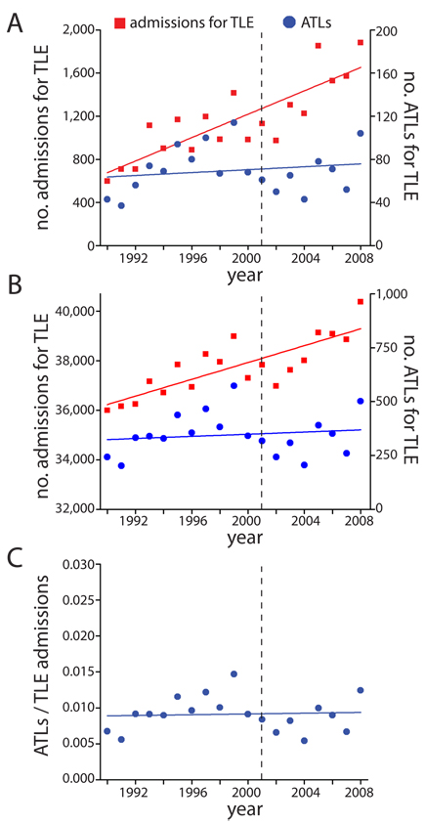 | Figure 1. Admissions for TLE and ATLs from 1990 to 2008. A. Raw data representing total admissions for TLE and total ATLs by year. B. Weighted data from (A). A significant increase in TLE admissions is observed over time (adjusted R² = 0.65, F = 34.9, P < 0.0001), while a slight increase in ATLs is not significant (adjusted R² = 0.04, F = 0.36, P = 0.56). C. Fraction of TLE patients receiving ATL, using weighted data. No significant trend is observed (adjusted R² = 0.05, F = 0.06, P = 0.80). Dashed line represents publication year (2001) of randomized, controlled trial. ATL = anterior temporal lobectomy; TLE = temporal lobe epilepsy.

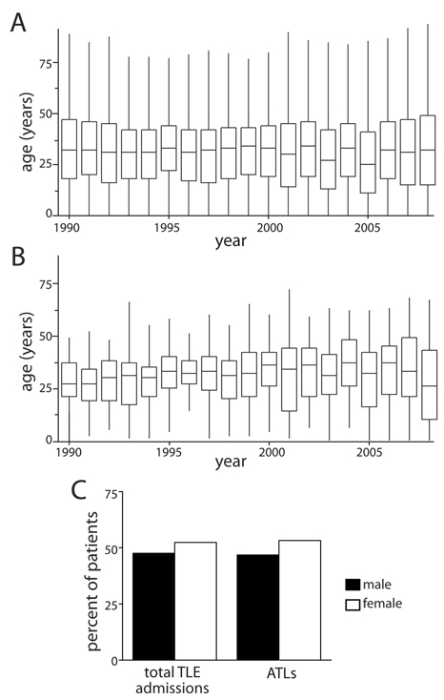
Figure 2. Age and gender of TLE patients receiving ATL. A. Median age of all patients admitted for TLE over time, with interquartile range (box) and two standard deviations (error bars). No overall trend is observed. B. Age of patients receiving ATL over time. Median age of patients receiving ATL (32.0 years) is equivalent to the age of all patients admitted for TLE (32.0 years). No overall trend is observed over time. C. Gender of all admitted TLE patients and those receiving ATL from 1990-2008. The percentage of females was slightly higher in both populations (53%), with no differences between populations observed. Data (A-C) are raw, unweighted values. ATL = anterior temporal lobectomy; TLE = temporal lobe epilepsy.

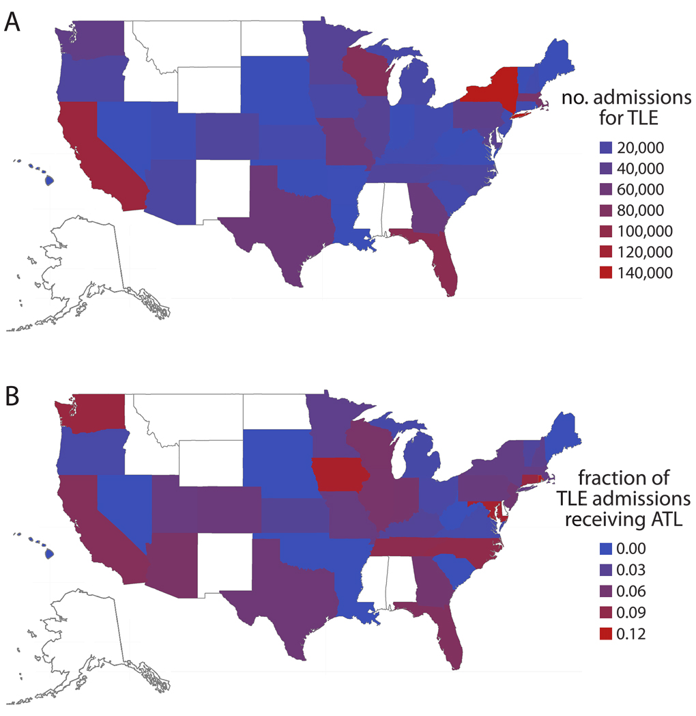
Figure 3. Geographical representation of TLE admissions and ATLs. A. Total number of patient admissions for TLE by U.S. state. New York and California and, the third and first most populous states, respectively, had the highest number of TLE admissions. B. Fraction of patients receiving ATL among total TLE admissions by state. The highest rates of ATL were observed in Rhode Island and Iowa, followed by Maryland and Connecticut. Data present cumulative, weighted values from 1990-2008, and were not available for states shown in white. ATL = anterior temporal lobectomy; TLE = temporal lobe epilepsy.

