

**HIGHTECH STORE PROJECT**

Software Requirements Specification

Version 3

20/6/2023

Đỗ Văn Đạt

Leader Software Engineer

* Hanoi,Summer 2023 -

# Revision History

| **Date** | **Description** | **Author** | **Comments** |
| --- | --- | --- | --- |
| 23/05/2023 | Version 1 | Đỗ Văn Đạt, Hoàng Công Hiệp,  Lê Ngọc Tuấn Minh,  Trần Văn Phi,  Đặng Văn Thanh Tùng. | <First Revision> |
| 1/06/2023 | Version 2 | Hoàng Công Hiệp,  Lê Ngọc Tuấn Minh,  Trần Văn Phi,  Đặng Văn Thanh Tùng. |  |
| 20/06/2023 | Version 3 | Hoàng Công Hiệp,  Lê Ngọc Tuấn Minh,  Trần Văn Phi,  Đặng Văn Thanh Tùng. |  |

# Document Approval

The following Software Requirements Specification has been accepted and approved by the following:

| **Signature** | **Printed Name** | **Title** | **Date** |
| --- | --- | --- | --- |
|  | Nguyễn Thành Ý | Instructor, SWP 391 |  |
|  | Đỗ Văn Đạt | Leader |  |
|  | Lê Ngọc Tuấn Minh | Member |  |
|  | Trần Văn Phi | Member |  |
|  | Hoàng Công Hiệp | Member |  |
|  | Đặng Văn Thanh Tùng | Member |  |

# Table of content

**REVISION HISTORY II**

**DOCUMENT APPROVAL II**

**TABLE OF CONTENT III**

**1. INTRODUCTION 1**

1.1 Overview 1

1.2 Purpose 1

1.3 Scope 1

1.4 Definitions, Acronyms, and Abbreviations 1

1.5 Environment 2

**2. GENERAL DESCRIPTION 2**

2.1 Product Perspective 2

2.2 Product Functions 2

2.3 User Characteristics 2

**3. SPECIFIC REQUIREMENTS 3**

3.1 External Interface Requirements 4

*3.1.1 User Interfaces 4*

*3.1.2 Hardware Interfaces 4*

*3.1.3 Software Interfaces 4*

*3.1.4 Communications Interfaces 5*

3.2 Use Cases 5

*3.2.1 Use Case Admin 6*

*3.2.2 Use Case Staff 6*

*3.2.3 Use Case Guest 7*

*3.2.4 Use Case Customer 7*

3.3 Functional Requirements 8

*3.3.1 System Functional Overview 9*

*3.3.1.1 Screens Flow 9*

*3.3.1.2 Screen Descriptions 9*

*3.3.1.3 Screen Authorization 9*

*3.3.1.4 Non-Screen Functions 9*

*3.3.1.5 Entity Relationship Diagram 9*

*3.3.1.6 Entities Description 9*

*3.3.1 View Home 9*

*3.3.2 Register account 10*

*3.3.3 Login 11*

*3.3.4 Logout 11*

*3.3.5 Forgot password 12*

*3.3.6 Change password 13*

*3.3.7 Update profile 13*

*3.3.8 View List Customer 14*

*3.3.9 Update Customer 15*

*3.3.10 Delete customer 15*

*3.3.11 Create customer 16*

*3.3.12 View list admin 16*

*3.3.13 Update admin 17*

*3.3.14 Delete admin 17*

*3.3.15 Create admin 18*

*3.3.16 View list product 18*

*3.3.17 Update product 19*

*3.3.18 Delete product 19*

*3.3.19 Create product 20*

*3.3.20 View list order and Order detail 20*

*3.3.21 Update order 21*

*3.3.22 Create order 22*

*3.3.23 View list warranty 22*

*3.3.24 Update warranty 23*

*3.3.25 Create warranty 24*

*3.3.26 View list brand 24*

*3.3.27 Update brand 25*

*3.3.28 Delete brand 25*

*3.3.29 Create brand 26*

*3.3.30 View list category 26*

*3.3.31 Update category 27*

*3.3.32 Create category 27*

*3.3.33 Delete category 2*8

*3.3.34 Create news 2*8

*3.3.35 List view news 29*

*3.3.36 Update news 30*

*3.3.37 Delete news 30*

*3.3.38 Create newsgroup 31*

*3.3.39 List view new group 31*

*3.3.40 Update newsgroup 32*

*3.3.41 Delete newsgroup 32*

*3.3.42 Create comment 33*

*3.3.45 List view comment 34*

*3.3.46 Create contact 35*

*3.3.47 List contact 36*

*3.3.48 Delete contact 36*

*3.3.49 Checkout cart 37*

*3.3.50 Edit profile 38*

*3.3.51 List view related product and news 38*

*3.3.52 View dashboard 39*

*3.3.53 View chart 39*

*3.3.54 Search admin 40*

*3.3.55 Search customer 40*

*3.3.56 Search product 41*

*3.3.57 Search news 41*

*3.3.58 Search newsgroup 42*

*3.3.59 Search category 43*

*3.3.60 Search brand 43*

*3.3.61 Search contact 44*

*3.3.62 Search comment 44*

*3.3.63 Search chart total income 45*

*3.3.64 Download Excel 45*

*3.3.65 Download warranty 46*

3.4 Non-Functional Requirements 46

*3.4.1 Availability 47*

*3.4.2 Security 47*

3.5 Design Constraints 47

3.6 Other Requirements 48

**A. APPENDICES 48**

A.1 Business Rule 48

A.2 Appendix 2 48

A.3 References 48

# 1. Introduction

## 1.1 Overview

Hightech Store System is a place where users can find high quality products at reasonable prices. This website offers a wide range of products, including laptops, tablets, smartphones, home appliances and many other technology-related products.

Users can easily browse through product categories to find what they are looking for. The site also provides detailed information about the products, including configurations, features, customer reviews and more.

In addition, the website also provides professional and dedicated customer support services, helping customers find the right product for their needs. If you encounter any problems during the purchase or use of the product, you can also contact the customer service team for timely answers and support.

In short, the website that sells laptops and electronics is a great place to shop for high-quality tech products, with the best customer support.

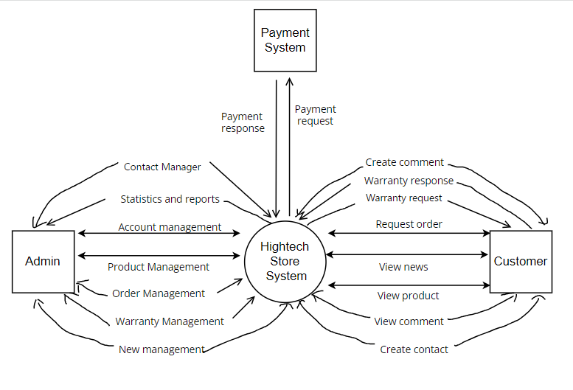 Image1.1: Context Diagram

## 1.2 Purpose

HighTechStore is an exciting and convenient software designed to provide an excellent electronic shopping experience. With the primary goal of delivering convenience and customer satisfaction, we proudly introduce this platform as a reliable online store for purchasing electronic products.

With HighTechStore, customers will discover a diverse range of high-quality electronic products. From smartphones, tablets, laptops, cameras, and audio equipment to smart home devices, we offer a comprehensive collection to meet various customer needs.

The main purpose of HighTechStore is to provide customers with a memorable and convenient shopping experience. With a user-friendly and easy-to-navigate interface, customers can effortlessly search and compare products, read user reviews, and select the most suitable products according to their needs and budgets. Additionally, we are committed to providing attentive customer care and ensuring that all transactions are conducted safely and reliably.

## 1.3 Scope

The scope of the HighTechStore software product encompasses the entire online shopping process for electronic products. It includes the browsing, searching, comparison, selection, and purchase of products, as well as the provision of customer support services. The software focuses on the user interface, product catalog, secure payment processing, and order management aspects to ensure a smooth and satisfying shopping experience.

The specifications mentioned here are consistent with the higher-level specifications outlined in the System Requirement Specification, ensuring coherence throughout the software development process.

## 1.4 Definitions, Acronyms, and Abbreviations

| SRS | Software Requirements Specifications |
| --- | --- |
| BR | Business Rule |
| UI | User Interface |
| N/A | Not applicable, not available |
| Use Case(s) | Diagrams describe system requirements |

## 1.5 Environment

| **Software** | **Version** |
| --- | --- |
| Microsoft SQL Server Management | 2019 |
| Visual Studio Code | 2022 |
| NetBeans | 13 |
| Google Chrome | 69.0.3497.100 |
| Microsoft Edge | 94 |

# 2. General Description

## 2.1 Product Perspective

The HighTechStore software product is designed to provide a seamless and efficient online shopping experience for electronic products. It encompasses the following perspectives:

1. Quality Products:

HighTechStore aims to offer high-quality electronic products to its customers. The platform collaborates with trusted and reputable manufacturers and suppliers to ensure that the products available meet stringent quality standards. Through rigorous product vetting and selection processes, HighTechStore strives to provide customers with reliable and durable electronic devices.

2. Product Management:

The software includes an administrative panel that allows the store's administrators to effectively manage the product catalog. Admins can easily add new products, update existing ones, and remove discontinued items from the inventory. This feature ensures that the store offers up-to-date and relevant electronic products to customers.

3. Statistical Product Risk Analysis:

HighTechStore provides a feature that enables administrators to analyze and assess the risk associated with different products. This functionality helps in identifying potential issues, such as product recalls, safety concerns, or performance problems. By conducting statistical product risk analysis, the software assists administrators in making informed decisions regarding product availability, highlighting potential risks to both the store and its customers.

In summary, the HighTechStore software product focuses on delivering quality products, empowering administrators to effectively manage the product catalog, and facilitating statistical product risk analysis to ensure a safe and reliable shopping experience for customers.

## 2.2 Product Functions

1. Client site:

* Edit profile
* Create order
* View order
* Create warranty
* View warranty
* View news
* Payment
* View product
* Create comment
* Create contact
* Register

2. Admin site:

* Account Manager
* Product Manager
* OrderManager
* Warranty Manager
* News Manager
* Contact Manager
* ChartsManager
* Dashboard Manager

3. Both site:

* Login
* Logout
* Changes Password
* Forget Password
* Edit Profile

## 2.3 User Characteristics

1. Admin:

Role: Administrators have full control over the HighTechStore software product and its operations.

Responsibilities:

* Login and logout: Admins can securely log in and log out of the system to access their administrative privileges.
* Account Manager: Admins can manage user accounts, including creating new admin accounts and managing their permissions.
* Product Manager: Admins can manage the product catalog, including adding, updating, and removing products.
* Order Manager: Admins can manage customer orders, track their status, and handle any order-related issues.
* Warranty Manager: Admins can handle warranty claims and manage warranty-related information for products.
* News Manager: Admins can manage news articles and announcements for the HighTechStore platform.
* Contact Manager: Admins can manage customer inquiries and messages received through the contact form.
* Charts Manager: Admins can generate and analyze various charts and reports related to sales, product performance, and customer behavior.
* Dashboard Manager: Admins can configure and customize the dashboard view for an overview of the store's key metrics.
* Change Password: Admins can change their account password for security purposes.
* Forget Password: Admins can recover their account password if forgotten.
* Edit Profile: Admins can update their profile information and preferences.

2. Customer:

Role: Customers are individuals who use the HighTechStore software product to browse and purchase electronic products.

Responsibilities:

* Edit Profile: Customers can update their profile information, such as name, contact details, and preferences.
* Forgot Password: Customers can recover their account password if forgotten.
* Create Order: Customers can create new orders for electronic products they wish to purchase.
* View Order: Customers can view and track the status of their orders.
* Create Warranty: Customers can register and create warranty claims for the purchased products.
* View Warranty: Customers can view the details and status of their registered warranties.
* Logout: Customers can securely log out of their accounts.
* Login: Customers can log in to their accounts to access their profile and order information.
* Change Password: Customers can change their account password for security purposes.
* View News: Customers can read news articles and announcements published on the HighTechStore platform.
* Search: Customers can search for specific products or information within the HighTechStore platform.
* Send Message: Customers can send messages or inquiries to the HighTechStore team.
* Payment: Customers can make secure online payments for their orders.
* View Product: Customers can view detailed information and specifications of electronic products.
* Create Comment: Customers can leave comments and reviews for products they have purchased.
* Create Contact: Customers can reach out to the HighTechStore team by submitting a contact form.

3. Guest:

Role: Guests are users who visit the HighTechStore platform without creating an account.

Responsibilities:

* Create Account: Guests can create a new account to become registered customers.
* View Product: Guests can browse and view detailed information about electronic products.
* View News: Guests can read news articles and announcements published on the HighTechStore platform.
* Create Order: Guests can create new orders for electronic products.
* Create Contact: Guests can reach out to the HighTechStore team by submitting a contact form.
* Search: Guests can search for specific products or information within the HighTechStore platform.
* Send Message: Guests can send messages or inquiries to the HighTechStore team.

## 2.4 General Constraints

* Model-View-Controller architecture was employed during coding.
* Words are combined without spaces and are lowercased starting with the first letter when using camelcase variables.
* Methods and functions must have comments so that maintenance programmers can readily comprehend the code. Comments should come before methods, before loops, and before lengthy sections of code.
* The Oracle Java code convention must be followed when writing code.
* Designing with Web Standards requires that HTML and CSS be coded in a specific way (read about them in reference).
* Ensure that the hosting system meets the hardware and software requirements for SQL Server.

# 3. Specific Requirements

- Logo part: main white-red integrated with bearing image.

- Slogan: always bring real value to customers (both product value and warranty) in the system.

- Interface:

+ Banner:

3 interchangeable slides - company photo, main product photos (bearings stand out, bigger than others).

+ Body page:

* Top best-selling products,new products ,flash sale products.
* Product category: customers can choose the order (may change over time).
* Contact section: including address information, email and map integration right on the website, phone calls via hotline number, integrated chat box.
* Intro: break it down into sections
* Each product: includes basic information, has a public price (supports online ordering), includes many images (multiple views of the product, can zoom photos).
* One row will contain 3-4 products.

+ Footer:

Detailed division of the system (introduction to Hightech Store,

Customer Service, Contact and Social Media).

- Purchase:

+ Buy now at the shopage.

+ Show related products

+ Customer can pay in two ways (customers can pay online by e-wallet or can ship COD)

- Warranty part:

+ Compulsory warranty package:

* When you buy any product in the shop, it comes with a one-year warranty.
* When the product is still in the warranty period, the shop will bear the 100% warranty fee, if the warranty period expires, the customer must bear the warranty fee depending on the status of the product.

- Standard SEO principles:

+ Friendly URL.

+ Display structure from H1 to H3, in each page there is only one H1 tag.

+ Display product title name on browser.

+ Hierarchy of the path structure.

+ Integrated google analytics.

- Main function:

+ Admin:

* Add and edit products.
* Manage orders: Process and fulfill customer orders, update order status, and handle order-related inquiries.
* Generate reports: Generate sales reports, inventory reports, and other relevant reports for analysis and decision-making.

+ Buyer:

* View company profile information.
* View products, receive order details by email.
* Place an order and place an order (just have a phone number to order).
* Send a request to the site manager.

## 3.1 External Interface Requirements

### 3.1.1 User Interfaces

* *UI-1: The website header will include the website's logo, address, phone number, and main categories; The middle of the page displays the products, the bottom of the page is divided into newsgroups (warranty policy, promotions...)*
* *UI-2: The interface is suitable for display on computers and phones.*
* *UI-3: Use icons to provide more detail to users.*
* *UI-4: The main color of the website is red, white in one, and sometimes black.*

### 3.1.2 Hardware Interfaces

* *No hardware interfaces have been identified.*

### 3.1.3 Software Interfaces

* Payment Gateway Integration Interface:

- Request Payment: This interface enables the HighTechStore software to send a payment request to the VNPAY payment gateway. It includes the necessary parameters, such as the order total, currency, and customer information.

- Redirect to VNPAY: Once the payment request is sent, the HighTechStore software interface redirects the user to the VNPAY payment gateway's secure page for payment processing.

- Handle Callback: After the payment is processed by VNPAY, the payment gateway sends a callback response to the HighTechStore software. This interface handles the callback response and updates the order status accordingly.

- Confirm Payment: This interface allows the HighTechStore software to verify the payment status with VNPAY by sending a confirmation request. It includes the transaction ID and other relevant details to ensure the payment's validity.

* User Interface:

- Payment Method Selection: On the checkout or payment page, users are presented with the option to choose VNPAY as their preferred payment method. This interface provides a user-friendly selection mechanism.

- Billing Information: Users are prompted to enter their billing information, including name, address, and contact details. This interface collects the required information for payment processing and order fulfillment.

- Secure Payment Page: Users are seamlessly redirected to the VNPAY payment gateway's secure page, where they can enter their payment details, such as credit card information or select alternative payment methods.

- Payment Confirmation: Once the payment is successfully processed by VNPAY, the HighTechStore software interface displays a payment confirmation message to the user, acknowledging the completion of the transaction.

- Error Handling: In case of any errors or unsuccessful payment attempts, the interface provides appropriate error messages and options for users to retry or choose alternative payment methods.

## 3.2 Use Cases

| **#** | **Actor** | **Description** |
| --- | --- | --- |
| 1 | Administrator | The Administrator is a person or a designated role within the system who holds the highest level of authority and control over the system. They have privileged access and are responsible for managing and overseeing the system's operations, configurations, and settings. The Administrator ensures the system functions properly, enforces security measures, and resolves any technical issues that may arise. |
| 2 | Customer | A customer is a person or entity that purchases goods or services from a business or organization. In the context of a system, a customer is typically a user who interacts with the system to perform specific actions or tasks, making a purchase or accessing certain information. |
| 3 | Guest | A user who does not have an account or login credentials for the system but is still allowed to access certain features or content. Guests may be able to browse products or view information, but they may not be able to perform certain actions that require a user account. |

### 3.2.1 Use Case Admin

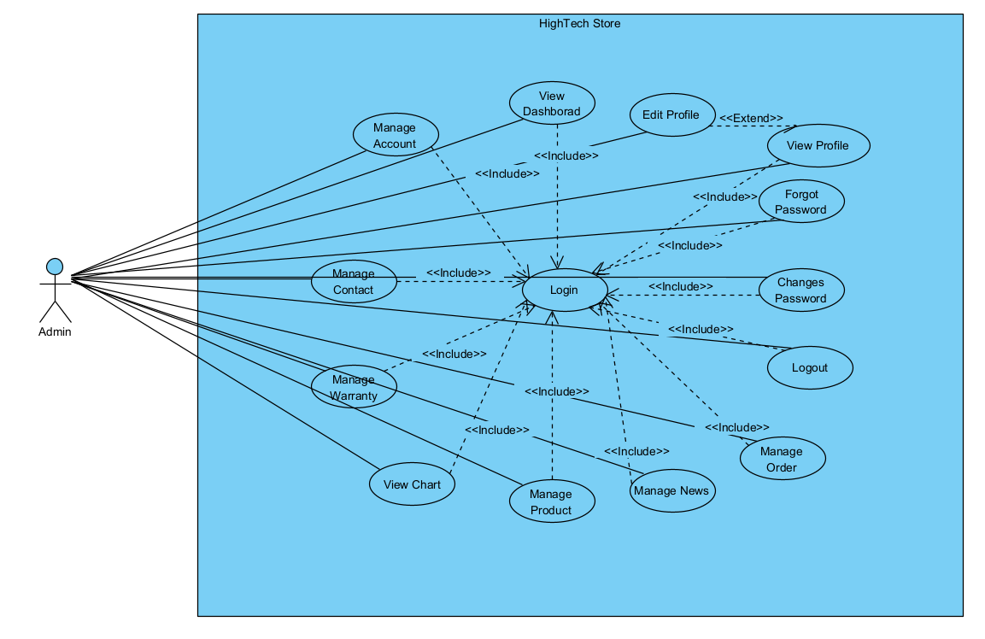

### 3.2.2 Use Case Guest

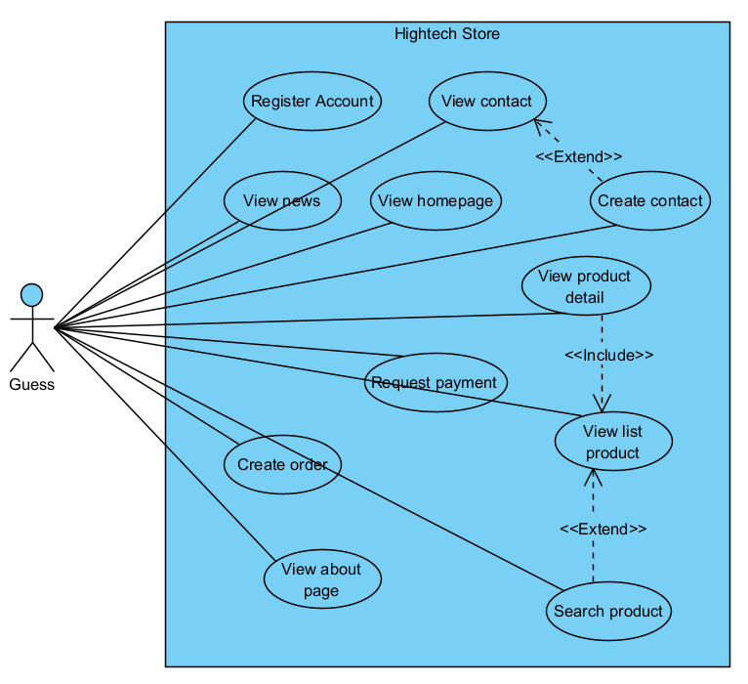

### 3.2.3 Use Case Customer

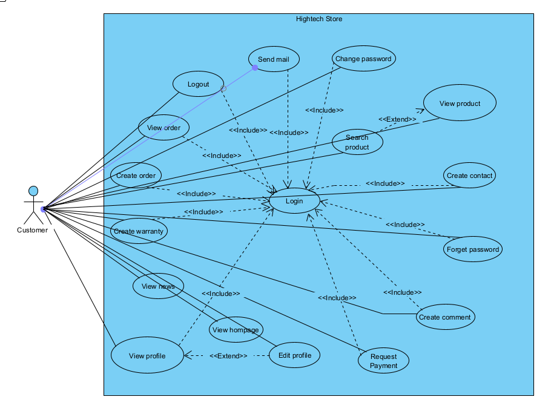

## 3.3 Functional Requirements

### 3.3.1 System Functional Overview

#### 3.3.1.1 Screens Flow

**- CUSTOMER:**

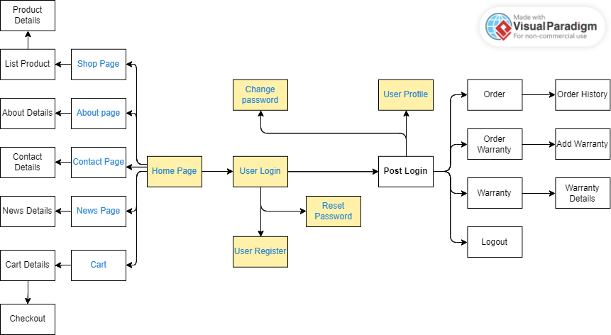

**- GUEST:**

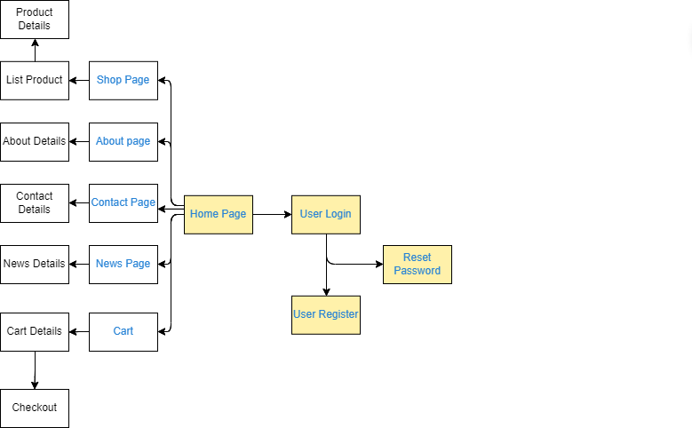

**- ADMIN:**

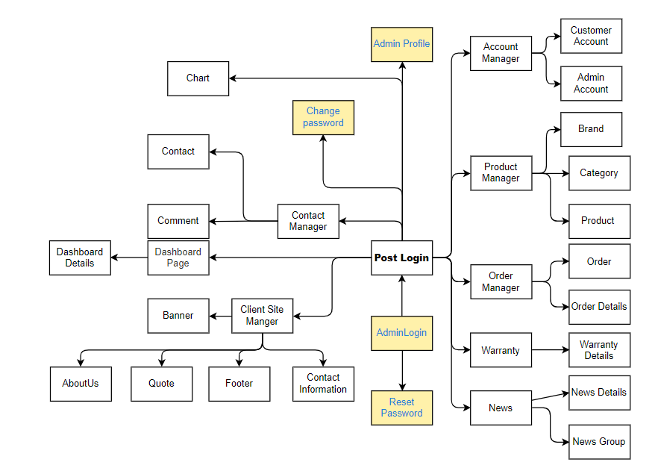

#### 3.3.1.2 Screen Descriptions

| **#** | **Feature** | **Screen** | | **Description** | |
| --- | --- | --- | --- | --- | --- |
| 1 | Account management | Login | | Log in to the system with your registered username and password | |
| 2 | Account management | Register | | Register an account with all necessary information | |
| 3 | Account management | Forgot Password | | Enter your account email and a random code will be sent to your email to confirm, if matched will allow to generate a new password | |
| 4 | Account management | Change Password | | Change the password used to log in | |
| 5 | Account management | Profile | | Views profile and update information profile | |
| 6 | User interface | Home Page | | Home page is the starting page:  - Home: views banner, some product, some news, footer…  - Shop page: view all list product and product details  - About page: about details  - Contact page: contact details  - News page: new details  - Cart: cart details | |
| 7 | Order | Order product | | Create product orders, change orders, view order history | |
| 8 | Order | Order warranty | | After the user places an order successfully and changes the status to done, if there is a problem with the product, the warranty can be | |
| 9 | Order | Warranty | | Views list product warranty | |
| 10 | Admin manager | Dashboard | | View all information and manager about the web of admin | |
| 11 | Admin manager | Customer manager | | Views list all information customer: add customer, update status, delete, search customer, export data | |
| 12 | Admin manager | Product manager | | Views all information product, category, brand: add, update, delete,search and export data | |
| 13 | Admin manager | Order manager | | Views all information order and order details: update order status and export data | |
| 14 | Admin manager | Warranty manager | | Views all information warranty: update warranty status and export data | |
| 15 | Admin manager | News manager | | Views all news and news group: add, update, delete, search and export data | |
| 16 | Admin manager | Contact manager | | Views all contact and comment: delete ,search and export data | |
| 17 | Admin manager | Client manager | | Show all client sites:  - Banners: update information  - About us: update information  - Quotes: add, update and delete  - Footer title: update information  - Footer Content: update information  - Contact information: update information  And all have export data | |
| 18 | Admin manager | Charts | | Views total warranty status, order in 7 days, total income 7 day, total order status | |
|  |  |  |  |  |  |

#### 3.3.1.3 Screen Authorization

| **Screen** | **Admin** | **User** | **Guest** |
| --- | --- | --- | --- |
| Home Page |  | x | x |
| Regiters |  | x | x |
| Login | x | x | x |
| Forgot password | x | x | x |
| Changes password | x | x | x |
| Profile | x | x |  |
| Update profile | x | x |  |
| SendOTP | x | x |  |
| VerifyOTP | x | x |  |
| Views list Customers | x |  |  |
| Update Customers | x | x |  |
| Delete Customers | x |  |  |
| Create Customers | x | x |  |
| Update Admin | x |  |  |
| Views list Product | x | x | x |
| Update Product | x |  |  |
| Delete Product | x |  |  |
| Create Product | x |  |  |
| Cart |  | x | x |
| Check out Cart |  | x | x |
| Views list Order and Order Details | x | x |  |
| Update Order | x | x |  |
| Create Order | x | x |  |
| Views list Warranty | x | x |  |
| Update Warranty | x | x |  |
| Create Warranty | x | x |  |
| Views list Brand | x | x | x |
| Update Brand | x |  |  |
| Create Brand | x |  |  |
| Delete Brand | x |  |  |
| Views list Category | x | x | x |
| Update Category | x |  |  |
| Create Category | x |  |  |
| Delete Category | x |  |  |
| Views list NewsGroup | x | x | x |
| Update NewsGroup | x |  |  |
| Create NewsGroup | x |  |  |
| Delete NewsGroup | x |  |  |
| Views list News | x | x | x |
| Update News | x |  |  |
| Create News | x |  |  |
| Delete News | x |  |  |
| Views list Comment | x | x |  |
| Delete Comment | x |  |  |
| Views list Contact | x | x | x |
| Delete Contact | x |  |  |
| Create Contact | x |  |  |
| Dashboard | x |  |  |
| Charts | x |  |  |
| Search Customer account | x |  |  |
| Search News | x | x | x |
| Search NewsGroup | x | x | x |
| Search Product | x | x | x |
| Search Category | x | x | x |
| Search Brand | x | x | x |
| Search Contact | x |  |  |
| Search Comment | x |  |  |
| Download Excel export data | x |  |  |
| Download Word Warranty | x | x |  |
| Payment |  | x |  |
| Send message |  | x | x |

#### 3.3.1.4 Non-Screen Functions

| **#** | **Feature** | **System Function** | **Description** |
| --- | --- | --- | --- |
| 1 | Login | Password Encryption | When logging into the system, users will enter their password, the system will convert it to SHA-256 and compare it with the code in the database. |
| 2 | Changes Password | Password Encryption | When you change your password, the system will let you enter a new password and re-enter the new password, when you enter two matching passwords, the system will convert it to SHA-256 and put it in the database. |
| 3 | Forget Password | Password Encryption | When you forget your password, the system will let you enter a new password and re-enter the new password, when you enter two matching passwords, the system will convert it to SHA-256 and put it in the database. |
| 4 | Contact | Send Mail | When the user wants to contact the admin, the meeting will enter the form, after entering the form, the system will send a thank you email. |
| 5 | Forget Password | Send Mail (OTP) | When the user forgets the password, the system will send an OTP code to their email, if they enter it correctly, they will change the new password. |
| 6 | Register (Guest Order) | Send Mail (username and password) | When the guest makes a successful purchase, the system will automatically take their email as the username and password will be random and then sent to their email account to login to the system. |
| 7 | Warranty Manager | Docs Google and Google Apps Script | When admins go to the warranty manager they can download the 'Warranty' docs via Google Docs and Google Apps Script and they can modify it. |

#### 3.3.1.5 Entity Relationship Diagram

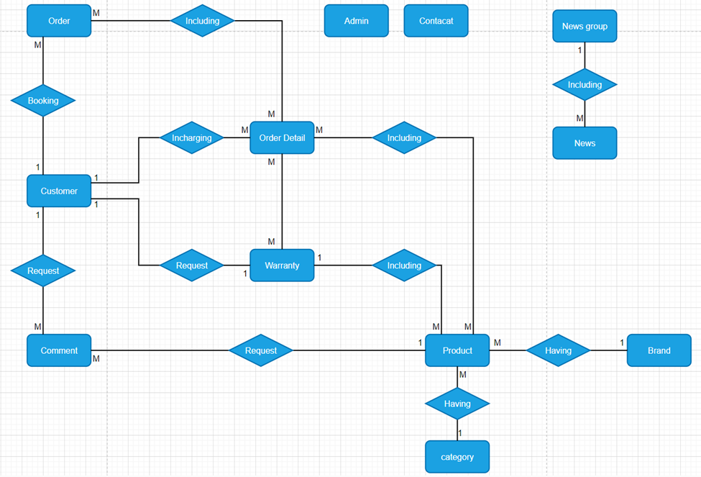

#### 3.3.1.6 Entities Description

| **#** | **Entity** | **Description** |
| --- | --- | --- |
| 1 | Customer | Name, phone, image, date of birth, gmail, gender, address, username, password, status. |
| 2 | Admin | role, name, phone, gmail, user name, password, status. |
| 3 | Order | name receiver, phone receiver, address receiver, total price, order date, payment, status. |
| 4 | Order Detail | product name, image, list price, quantity order. |
| 5 | Product | product name, sub_description, description, image, list price, discount, status, code. |
| 6 | Warranty | name, phone, product name, image, image product, product status, warranty date, warranty status, warranty quantity, status, product status admin, image product admin, warranty date |
| 7 | Contact | name, mail, contact content, contact date |
| 8 | Comment | comment date, comment content |
| 9 | News | image, tittle, content, create by, create date, modify by, modify date |
| 10 | News Detail | news group name |
| 11 | Brand | brand name |
| 12 | Category | category name |

### 3.3.1 View Homepage

| UC ID and Name: | View Home Page | | |
| --- | --- | --- | --- |
| Created By: | PhiTV | Date Created: | 1/06/2023 |
| Primary Actor: | User | Others Actors: | N/A |
| Trigger: | Actor come to the home page | | |
| Description: | Actors can read overviews about products in shops. | | |
| Preconditions: | Access the website | | |
| Postconditions: | Display information of home page | | |
| Normal Flow: | Display:  - the best selling product  - the featured products  - the flash sales product  - news. | | |
| Alternative Flows: | N/A | | |
| Exception Flow: | N/A | | |
| Priority: | Normal | | |
| Frequency of Use: | Usually | | |
| Business Rules: | N/A | | |
| Other Information: | N/A | | |
| Assumptions: | N/A | | |

### 3.3.2 Register account

| UC ID and Name: | Register account | | |
| --- | --- | --- | --- |
| Created By: | PhiTV | Date Created: | 23/05/2023 |
| Primary Actor: | Guest | Others actor: | N/A |
| Trigger: | Click on the register button on the title bar | | |
| Description: | The actor logs into the system to use system functions | | |
| Preconditions: | Access the website | | |
| Postconditions: | Actor can login to the system | | |
| Normal Flow: | 1. Guest select Register function 2. The system displays the registration interface 3. Guest Enter account information 4. Guest Requires registration 5. System Check if guest entered required fields enter or not 6. System Check if guest email address is valid 7. System Check password is enough level of security 8. System Saves account information | | |
| Alternative Flows: | 1. When the Guest selects the "Register" function to create a new account. 2. The system checks the information provided by the Guest and detects that the entered email address is already associated with an existing account. 3. The system displays an error message, instructing the Guest to either use a different email address for registration or log in to the existing account. | | |
| Exceptions: | 1. System Error Message: Required fields to enter if the information is missing  2. System Error Message: Invalid email address if only invalid email  3. System Error message: Password needs to be secure if the password does not guarantee the security attributed specified by the system (with at least 6 characters, containing uppercase letters, special characters) | | |
| Priority: | Normal | | |
| Frequency of Use: | Usually | | |
| Business Rules: | BR-01, BR-02, BR-03, BR-04, BR-05, BR-09, BR-11, BR-13 | | |
| Other Information: | N/A | | |
| Assumptions: | N/A | | |

### 3.3.3 Login

| UC ID and Name: | Login | | |
| --- | --- | --- | --- |
| Created By: | TungDVT | Date Created: | 23/05/2023 |
| Primary Actor: | Admin, Customer | Secondary Actors: | N/A |
| Trigger: | Click on the login button in the head of the website interface | | |
| Description: | The actor logs into the system to use system functions | | |
| Preconditions: | After register account  Type url to access website | | |
| Postconditions: | The actor can log in to system | | |
| Normal Flow: | 1. Type url of website on Internet browser and enter 2. Software: Display Login screen with the following fields: User name, Password, Login button, Close button 3. Actor enter username and password then click login button 4. Software: Validate username and password | | |
| Alternative Flows: | 1. If the Actor (Customer or Admin) enters the wrong username or password multiple times, the system detects this as a potential security threat. 2. After a certain number of failed login attempts (e.g., three attempts), the system locks the account to prevent further login attempts. 3. The system displays an error message informing the Actor that their account has been temporarily locked due to too many failed login attempts. 4. The Actor is provided with instructions on how to unlock their account, which may include waiting for a specified time period or contacting customer support for assistance. 5. Once the lockout period is over or the Actor has successfully followed the account recovery process, the account is unlocked, and the Actor can attempt to log in again. | | |
| Exceptions: | 4a. Error message: Required fields need to be entered if the customer is missing  4b. Error message: Invalid email and/or password if the email and password are not found in the system | | |
| Priority: | Normal | | |
| Frequency of Use: | Usually | | |
| Business Rules: | BR-01, BR-02, BR-03 | | |
| Other Information: | N/A | | |
| Assumptions: | N/A | | |

### 3.3.4 Logout

| UC ID and Name: | Logout | | |
| --- | --- | --- | --- |
| Created By: | TungDVT | Date Created: | 23/05/2023 |
| Primary Actor: | Admin, Customer | Secondary Actors: | Customer |
| Trigger: | Click on the logout button in the head of the website interface | | |
| Description: | Click on the sign out. Admin, Customer will be signed out the page. | | |
| Preconditions: | After customer, admin have account and login successfully | | |
| Postconditions: | The actor can log out of system | | |
| Normal Flow: | 1. User Clicks the logout button 2. Software Displays Login Screen after system logout | | |
| Alternative Flows: | N/A | | |
| Exception Flow: | N/A | | |
| Priority: | Normal | | |
| Frequency of Use: | Usually | | |
| Business Rules: | N/A | | |
| Other Information: | N/A | | |
| Assumptions: | N/A | | |

### 3.3.5 Forgot password

| UC ID and Name: | Forgot password | | |
| --- | --- | --- | --- |
| Created By: | MinhLNT | Date Created: | 23/05/2023 |
| Primary Actor: | Customer | Other  Actors: | N/A |
| Trigger: | Click on the Forgot password button on the Login screen | | |
| Description: | The actor will be redirected to the Forgot password page to retrieve a new password. | | |
| Preconditions: | The actor must have a valid account and associated email address. | | |
| Postconditions: | The actor can log into the system using the new password. | | |
| Normal Flow: | 1. Actor clicks on the "Forgot password" button: System displays the Forgot password page with the following fields:  - Username  - Email  2. Actor enters username and email:  - System validates the entered account and email.  - System sends a verification code to the provided email address.  - System redirects the actor to the "Get New Password" screen.  3. Actor enters the verification code and a new password  - System validates the entered verification code.  - System updates the password associated with the actor's account.  - System displays a success message indicating the password has been updated. | | |
| Alternative Flows: | 1. The customer enters the wrong account or email. 2. The "Forgot password" use case does not proceed to the OTP (One-Time Password) entry screen. | | |
| Exceptions: | 4a. When the actor enters a wrong account or a wrong email, the system shall display an error message on the screen.  6a. When the actor enter a wrong code, the system shall not update new password | | |
| Priority: | Normal | | |
| Frequency of Use: | Usually | | |
| Business Rules: | N/A | | |
| Other Information: | N/A | | |
| Assumptions: | N/A | | |

### 3.3.6 Changes password

| UC ID and Name: | Changes password | | |
| --- | --- | --- | --- |
| Created By: | HiepHC | Date Created: | 23/05/2023 |
| Primary Actor: | Customer, Admin | Other  Actors: | N/A |
| Trigger: | Click on the Changes password button on the Home screen | | |
| Description: | The user will redirect to the Change password page to update the new password | | |
| Preconditions: | Successfully logged into the system | | |
| Postconditions: | 1. Display screen login  2. Actor can access with new password | | |
| Normal Flow: | 1. User click on Change password button Software  2. Software Display Change password screen with the following fields:  + Create New Password  + Re-Enter Password  3. User enters new password, re - enter password and click on "Change Password" button  4. Software: if check correct information then update new password for customer in to database | | |
| Alternative Flows: | Alternative Flow 1: Invalid New Password Format   1. After the user enters the new password and re-enters the password on the "Change password" screen. 2. The system checks the format of the new password to ensure it meets the required criteria (e.g., minimum length, containing uppercase letters, special characters, etc.). 3. If the new password does not meet the required format, the system displays an error message on the screen, indicating the specific password requirements that were not met. 4. The user is prompted to enter a new password that adheres to the specified format. 5. The user re-enters the new password, ensuring it now meets the required criteria. 6. Upon successful validation of the new password format, the system proceeds to update the new password in the database. 7. The user can now access the system using the updated password.   Alternative Flow 2: Passwords Do Not Match   1. After the user enters the new password and re-enters the password on the "Change password" screen. 2. The system compares the two password fields to ensure they match. 3. If the re-entered password does not match the new password, the system displays an error message on the screen, indicating that the passwords do not match. 4. The user is prompted to re-enter both the new password and the re-entered password to ensure they are the same. 5. The user re-enters both passwords, ensuring they now match. 6. Upon successful validation that both passwords match, the system proceeds to update the new password in the database. 7. The user can now access the system using the updated password. | | |
| Exceptions: | When the user enters the wrong format of the new password and re-enters the password that does not match the new password, a message will appear on the screen and the password will not be changed to the system and database. Shall not update new password | | |
| Priority: | Normal | | |
| Frequency of Use: | Usually | | |
| Business Rules: | BR-08  BR-09 | | |
| Other Information: | N/A | | |
| Assumptions: | N/A | | |

### 3.3.7 Update profile

| UC ID and Name: | Update profile | | |
| --- | --- | --- | --- |
| Created By: | HiepHC | Date Created: | 24/05/2023 |
| Primary Actor: | Customer, Admin | Secondary Actors: | N/A |
| Trigger: | Click on “Profile” in the head | | |
| Description: | Actor change personal information | | |
| Preconditions: | After actor have account and login successfully | | |
| Postconditions: | Information have been updated and save in system  Display screen all information profile users | | |
| Normal Flow: | 1. Click button “Profile” to display information of user 2. Change photo by selecting photo from avatar folder 3. Click button “Edit Profile” 4. Display the interface to update personal information 5. Fill in the information you need to update and request to change 6. The system will receive the updated information and save it to the system and database | | |
| Alternative Flows: | Not fill in the information you need to update and request to change  message will be displayed message, back to step 4 | | |
| Exception Flow: | User disconnect internet User not click radio button | | |
| Priority: | Normal | | |
| Frequency of Use: | Usually | | |
| Business Rules: | BR-05 BR-11 | | |
| Other Information: | N/A | | |
| Assumptions: | N/A | | |

### 

### 3.3.8 View list Customer

| UC ID and Name: | View list customer | | |
| --- | --- | --- | --- |
| Created By: | DATDV | Date Created: | 23/05/2023 |
| Primary Actor: | Admin | Other Actors: | N/A |
| Trigger: | Admin clicks on view list user information after on website by admin | | |
| Description: | Admin can view read information | | |
| Preconditions: | After admin have account and login successfully | | |
| Postconditions: | Information has been shown on screen. | | |
| Normal Flow: | 1. Request view list account 2. Show list accounts and information | | |
| Alternative Flows: | Notice if there is not at least one customer | | |
| Exception Flow: |  | | |
| Priority: | Normal | | |
| Frequency of Use: | Usually | | |
| Business Rules: | N/A | | |
| Other Information: | N/A | | |
| Assumptions: | N/A | | |

### 3.3.9 Update Customer

| UC ID and Name: | Update customer | | |
| --- | --- | --- | --- |
| Created By: | DATDV | Date Created: | 23/05/2023 |
| Primary Actor: | Admin | Other Actors: | N/A |
| Trigger: | Actor clicks on update customer | | |
| Description: | Actor can edit and update all customer information | | |
| Preconditions: | After login successfully | | |
| Postconditions: | Information of customer have been updated and save in system | | |
| Normal Flow: | 1. Actor Select the update button. 2. The system displays all forms with that customer's attribute. 3. Actors can edit the attributes in the update form. 4. Actor presses the update request button. 5. The system displays the customer display list again and the actor can check if the customer's information has been updated or not. | | |
| Alternative Flows: | Alternative Flow: Updating Specific Customer Attribute   1. After the Admin clicks on the "Update Customer" button. 2. Instead of displaying all customer attributes in a single form, the system provides options for the Admin to select specific attributes they want to update. 3. The Admin selects the specific attribute they want to update (e.g., phone number, email address, shipping address). 4. The system displays a form with the selected attribute for the Admin to edit. 5. The Admin makes the necessary changes to the selected attribute. 6. The Admin presses the update request button for the specific attribute. 7. The system saves the updated attribute information and displays the customer's display list again, allowing the Admin to check if the selected attribute has been updated or not. | | |
| Exception Flow: | Notify if you can't update | | |
| Priority: | Normal | | |
| Frequency of Use: | Usually | | |
| Business Rules: | N/A | | |
| Other Information: | N/A | | |
| Assumptions: | N/A | | |

### 3.3.10 Delete Customer

| UC ID and Name: | Update customer | | |
| --- | --- | --- | --- |
| Created By: | DATDV | Date Created: | 23/05/2023 |
| Primary Actor: | Admin | Other Actors: | N/A |
| Trigger: | Actor clicks on view Delete customer | | |
| Description: | Admin can delete customer | | |
| Preconditions: | After admin login successfully | | |
| Postconditions: | A customer account is deleted. | | |
| Normal Flow: | 1. Actor clicks the Delete button. 2. The system switches back to the controller to execute the delete customer. 3. The system displays the customer display list again and the actor can check if the customer's information has been deleted or not. | | |
| Alternative Flows: | Alternative Flow: Deleting Customer with Associated Data   1. After the Admin clicks on the "Delete Customer" button. 2. The system checks if the customer to be deleted has any associated data in other tables, indicated by foreign keys. 3. If the customer has associated data in other tables (i.e., foreign key references), the system displays a warning message to the Admin. 4. The warning message informs the Admin that the customer cannot be deleted directly due to the existence of associated data in other parts of the system. 5. The Admin is provided with options to either: 6. a. Cancel the delete operation and retain the customer's data, or 7. b. Proceed with a cascading delete operation, which will automatically remove the customer and all associated data in other tables. 8. If the Admin chooses option (b) for cascading delete, the system performs a series of delete operations to remove the customer and all associated data in a controlled manner. 9. After the delete operation is completed, the system displays the customer display list again, allowing the Admin to check if the customer's information has been deleted successfully. | | |
| Exception Flow: | The system will check the foreign key of the table, if the customer does not have a foreign key of another table, it will be deleted. | | |
| Priority: | Normal | | |
| Frequency of Use: | Usually | | |
| Business Rules: | N/A | | |
| Other Information: | N/A | | |
| Assumptions: | N/A | | |

### 3.3.11 Create Customer

| UC ID and Name: | Create customer | | |
| --- | --- | --- | --- |
| Created By: | DATDV | Date Created: | 23/05/2023 |
| Primary Actor: | Admin | Other Actors: | N/A |
| Trigger: | Actor clicks on Add customer. | | |
| Description: | Actors create an account customer. | | |
| Preconditions: | After login successfully | | |
| Postconditions: | A customer account is created. | | |
| Normal Flow: | 1. Actors click on to create customers. 2. The system displays the add customer form. 3. Actors enter all the customer information. 4. Actor clicks on the “Submit button”. 5. System validation all information that are entered . | | |
| Alternative Flows: | Alternative Flow: Creating Customer with Optional Fields   1. After the Admin clicks on the "Add Customer" button. 2. Instead of requiring all customer information to be entered, the system allows for optional fields that can be left blank during the creation process. 3. The system displays the add customer form with both required and optional fields. 4. The Admin enters the required information for the customer account. 5. The Admin has the option to leave some of the optional fields blank if the information is not readily available or not essential for account creation. 6. After entering the necessary information, the Admin clicks on the "Submit" button. 7. The system validates the required fields and ensures they are filled out. 8. The system then proceeds to create the customer account with the provided information, including both the required and optional fields. | | |
| Exception Flow: | System Error Message: Required fields to enter if the Actor is missing.  System Error Message: Invalid if system check attribute is validation. | | |
| Priority: | Normal | | |
| Frequency of Use: | Usually | | |
| Business Rules: | N/A | | |
| Other Information: | N/A | | |
| Assumptions: | N/A | | |

### 3.3.12 View list Admin

| UC ID and Name: | View list admin | | |
| --- | --- | --- | --- |
| Created By: | DATDV | Date Created: | 29/05/2023 |
| Primary Actor: | Admin | Other Actors: | N/A |
| Trigger: | Admin clicks on view list admin information after on website by admin | | |
| Description: | Admin can view read information | | |
| Preconditions: | After admin have account and login successfully | | |
| Postconditions: | Information has been shown on screen. | | |
| Normal Flow: | 1. Request view list account  2. Show list accounts and information | | |
| Alternative Flows: | Notice if there is not at least one admin | | |
| Exception Flow: |  | | |
| Priority: | Normal | | |
| Frequency of Use: | Usually | | |
| Business Rules: | N/A | | |
| Other Information: | N/A | | |
| Assumptions: | N/A | | |

### 3.3.13 Update Admin

| UC ID and Name: | Update admin | | |
| --- | --- | --- | --- |
| Created By: | DATDV | Date Created: | 29/05/2023 |
| Primary Actor: | Admin | Other Actors: | N/A |
| Trigger: | Actor clicks on update admin | | |
| Description: | Actor can edit and update all admin information | | |
| Preconditions: | After login successfully | | |
| Postconditions: | Information of admin have been updated and save in system | | |
| Normal Flow: | 1. Actor Select the update button. 2. The system displays all forms with that admin’s attribute. 3. Actors can edit the attributes in the update form. 4. Actor presses the update request button. 5. The system displays the customer display list again and the actor can check if the admin’s information has been updated or not. | | |
| Alternative Flows: | Alternative Flow: Partial Update of Admin Information   1. After the Admin clicks on the "Update Admin" button. 2. The system displays all the forms with the Admin's attributes for updating. 3. Instead of updating all attributes, the Admin decides to perform a partial update, choosing only specific attributes to edit. 4. The Admin edits the selected attributes in the update form. 5. The Admin leaves other attributes unchanged or blank, indicating that no updates are required for those fields. 6. The Admin presses the update request button. 7. The system receives the updated information and attempts to save the changes to the system and database. 8. The system validates the provided data to ensure that required fields are filled and any other business rules are met. 9. The system performs the partial update, saving only the changed attributes while keeping the unaltered attributes intact in the system and database. 10. The system displays the customer display list again, and the Admin can check if the updated information has been applied correctly. | | |
| Exception Flow: | Notify if you can't update | | |
| Priority: | Normal | | |
| Frequency of Use: | Usually | | |
| Business Rules: | N/A | | |
| Other Information: | N/A | | |
| Assumptions: | N/A | | |

### 3.3.14 Delete Admin

| UC ID and Name: | Update admin | | |
| --- | --- | --- | --- |
| Created By: | DATDV | Date Created: | 29/05/2023 |
| Primary Actor: | Admin | Other Actors: | N/A |
| Trigger: | Actor clicks on view Delete admin | | |
| Description: | Admin can delete admin | | |
| Preconditions: | After login successfully | | |
| Postconditions: | An admin account is deleted. | | |
| Normal Flow: | 1. Actor clicks the Delete button. 2. The system switches back to the controller to execute the delete admin. 3. The system displays the admin display list again and the actor can check if the admin’s information has been deleted or not. | | |
| Alternative Flows: | Alternative Flow: Admin with Associated Data   1. After the Admin clicks on the "Delete Admin" button. 2. The system checks if the admin to be deleted has any associated data in other tables, indicated by foreign keys. 3. If the admin has associated data in other tables (i.e., foreign key references), the system displays a warning message to the Admin. 4. The warning message informs the Admin that the admin cannot be deleted directly due to the existence of associated data in other parts of the system. 5. The Admin is provided with options to either: 6. a. Reassign the associated data to another admin, ensuring data integrity, or 7. b. Proceed with a cascading delete operation, which will automatically remove the admin and all associated data in other tables. 8. If the Admin chooses option (a) to reassign associated data, the system provides a mechanism to select another admin to take over the responsibilities and data of the admin to be deleted. 9. The system then updates the foreign key references in the associated tables to reflect the reassignment. 10. If the Admin chooses option (b) for cascading delete, the system performs a series of delete operations to remove the admin and all associated data in a controlled manner. 11. After the delete operation is completed, the system displays the admin display list again, allowing the Admin to check if the admin's information has been deleted successfully. | | |
| Exception Flow: | The system will check the foreign key of the table, if the admin does not have a foreign key of another table, it will be deleted. | | |
| Priority: | Normal | | |
| Frequency of Use: | Usually | | |
| Business Rules: | N/A | | |
| Other Information: | N/A | | |
| Assumptions: | N/A | | |

### 3.3.15 Create Admin

| UC ID and Name: | Create admin | | |
| --- | --- | --- | --- |
| Created By: | DATDV | Date Created: | 23/05/2023 |
| Primary Actor: | Admin | Other Actors: | N/A |
| Trigger: | Actor clicks on Add admin. | | |
| Description: | Actors create an account admin. | | |
| Preconditions: | After login successfully | | |
| Postconditions: | An admin account is created. | | |
| Normal Flow: | 1. Actor clicks on the admin. 2. The system displays the add admin form. 3. Actors enter all information admin. 4. Actor clicks on the “Submit” button. 5. System validation all information that are entered. | | |
| Alternative Flows: | Alternative Flow: Creating Admin with Additional Information   1. After the Admin clicks on the "Add Admin" button. 2. The system displays the add admin form with all the required fields for creating an admin account. 3. In addition to the required fields, the system allows the Admin to enter additional information about the admin, such as contact number, department, or role. 4. The Admin enters all the necessary information for the admin account, including both the required fields and any optional additional information they choose to provide. 5. The Admin clicks on the "Submit" button to proceed with the admin account creation. 6. The system validates all the entered information to ensure that the required fields are filled and any additional information provided follows any specified validation rules. 7. The system proceeds with creating the admin account, including both the required fields and any optional additional information. | | |
| Exception Flow: | System Error Message: Required fields to enter if the Actor is missing.  System Error Message: Invalid if system check attribute is validation. | | |
| Priority: | Normal | | |
| Frequency of Use: | Usually | | |
| Business Rules: | N/A | | |
| Other Information: | N/A | | |
| Assumptions: | N/A | | |

### 3.3.16 View list Product

| UC ID and Name: | View list product | | |
| --- | --- | --- | --- |
| Created By: | DATDV | Date Created: | 29/05/2023 |
| Primary Actor: | Admin | Other Actors: | N/A |
| Trigger: | Admin clicks on view list product information after on website by admin | | |
| Description: | Admin can view read information | | |
| Preconditions: | After admin have account and login successfully | | |
| Postconditions: | Information has been shown on screen. | | |
| Normal Flow: | 1.Request view list account  2.Show list product information | | |
| Alternative Flows: | Notice if there is not at least one product | | |
| Exception Flow: |  | | |
| Priority: | Normal | | |
| Frequency of Use: | Usually | | |
| Business Rules: | N/A | | |
| Other Information: | N/A | | |
| Assumptions: | N/A | | |

### 3.3.17 Update Product

| UC ID and Name: | Update product | | |
| --- | --- | --- | --- |
| Created By: | DATDV | Date Created: | 23/05/2023 |
| Primary Actor: | Admin | Other Actors: | N/A |
| Trigger: | Actor clicks on update product | | |
| Description: | Actor can edit and update all product information | | |
| Preconditions: | After login successfully | | |
| Postconditions: | Information of product have been updated and save in system | | |
| Normal Flow: | 1. Actor Select the update button. 2. The system displays all forms with that product’s attribute. 3. Actors can edit the attributes in the update form. 4. Actor presses the update request button. 5. The system displays the customer display list again and the actor can check if the product’s information has been updated or not. | | |
| Alternative Flows: | N/A | | |
| Exception Flow: | Notify if you can't update | | |
| Priority: | Normal | | |
| Frequency of Use: | Usually | | |
| Business Rules: | N/A | | |
| Other Information: | N/A | | |
| Assumptions: | N/A | | |

### 3.3.18 Delete Product

| UC ID and Name: | Update product | | |
| --- | --- | --- | --- |
| Created By: | DATDV | Date Created: | 30/05/2023 |
| Primary Actor: | Admin | Other Actors: | N/A |
| Trigger: | Actor clicks on view Delete product | | |
| Description: | Admin can delete product | | |
| Preconditions: | After login successfully | | |
| Postconditions: | An product is deleted | | |
| Normal Flow: | 1. Actor clicks the Delete button. 2. The system switches back to the controller to execute the delete product. 3. The system displays the customer display list again and the actor can check if the product’s information has been deleted or not. | | |
| Alternative Flows: | N/A | | |
| Exception Flow: | The system will check the foreign key of the table, if the product does not have a foreign key of another table, it will be deleted. | | |
| Priority: | Normal | | |
| Frequency of Use: | Usually | | |
| Business Rules: | N/A | | |
| Other Information: | N/A | | |
| Assumptions: | N/A | | |

### 3.3.19 Create Product

| UC ID and Name: | Create product | | |
| --- | --- | --- | --- |
| Created By: | DATDV | Date Created: | 23/05/2023 |
| Primary Actor: | Admin | Other Actors: | N/A |
| Trigger: | Actor clicks on the Add product. | | |
| Description: | Actors create a product. | | |
| Preconditions: | After login successfully | | |
| Postconditions: | A product is created. | | |
| Normal Flow: | 1. Actor clicks on the product. 2. The system displays the add product form. 3. Actors enter all information products. 4. Actor clicks on the “Submit” button. 5. System validation all information that are entered | | |
| Alternative Flows: |  | | |
| Exception Flow: | System Error Message: Required fields to enter if the Actor is missing.  System Error Message: Invalid if system check attribute is validation. | | |
| Priority: | Normal | | |
| Frequency of Use: | Usually | | |
| Business Rules: | N/A | | |
| Other Information: | N/A | | |
| Assumptions: | N/A | | |

### 3.3.20 View list Order and Order Detail

| UC ID and Name: | View list order, order detail | | |
| --- | --- | --- | --- |
| Created By: | DATDV | Date Created: | 30/05/2023 |
| Primary Actor: | Admin, Customer | Other Actors: | N/A |
| Trigger: | Actors clicks on view list order information after on website by actors | | |
| Description: | Actors can view read information | | |
| Preconditions: | After actors have account and login successfully | | |
| Postconditions: | Information has been shown on screen. | | |
| Normal Flow: | 1.Request view list order and status of order.  2.When they click in Detail 🡪 System list Order Detail of Order  3.Show list information and status product.  4. System display all status, if an actor click in this the system will call the list product of status. | | |
| Alternative Flows: | Notice if there is not at least one order. | | |
| Exception Flow: |  | | |
| Priority: | Normal | | |
| Frequency of Use: | Usually | | |
| Business Rules: | N/A | | |
| Other Information: | N/A | | |
| Assumptions: | N/A | | |

### 3.3.21 Update Order

| UC ID and Name: | Update order | | |
| --- | --- | --- | --- |
| Created By: | DATDV | Date Created: | 30/05/2023 |
| Primary Actor: | Admin, Customer | Other Actors: | N/A |
| Trigger: | Actor choose the option of update status | | |
| Description: | Actor can update status of order | | |
| Preconditions: | After login successfully | | |
| Postconditions: | Information of customer have been updated and save in system | | |
| Normal Flow: | Admin:   1. When admin in ‘Wait’ status, the system allows update status as ‘Process’ and ‘Cancel’. 2. When admin in ‘Process’ status, the system allows update status as ‘Wait’ ‘Done’. 3. When admin in ‘Done’ or ‘Cancel’ status, admin can view order and order detail as Detail.   Customer:   1. When admin in ‘Wait’ status, the system allows update status as ‘Cancel’. 2. When admin in ‘Process’, ‘Done’ or ‘Cancel’ status, admin can view order and order detail as Detail. | | |
| Alternative Flows: | N/A | | |
| Exception Flow: | User disconnect internet | | |
| Priority: | High | | |
| Frequency of Use: | Usually | | |
| Business Rules: | N/A | | |
| Other Information: | N/A | | |
| Assumptions: | N/A | | |

### 3.3.22 Create Order

| UC ID and Name: | Create order | | |
| --- | --- | --- | --- |
| Created By: | DATDV | Date Created: | 30/05/2023 |
| Primary Actor: | Customer | Other Actors: | N/A |
| Trigger: | Actor clicks on Check out. | | |
| Description: | Actors create an order. | | |
| Preconditions: | After login successfully | | |
| Postconditions: | An Order is created. | | |
| Normal Flow: | 1. Actor clicks on Check out. 2. The system displays the form to fill information of order choose. 3. Actors enter all information order and status payment ‘Ship COD’ or ‘Payment Online’. 4. Actor clicks on the “Submit button”. 5. System validation all information that is entered. 6. System adds order and order detail. | | |
| Alternative Flows: | 1. Actors not fill information order and no choose status payment ‘Ship COD’ or ‘Payment Online’. back to step 2 | | |
| Exception Flow: | System Error Message: Required fields to enter if the Actor is missing.  System Error Message: Invalid if system check attribute is validation. | | |
| Priority: | Normal | | |
| Frequency of Use: | Usually | | |
| Business Rules: | BR-5 | | |
| Other Information: | N/A | | |
| Assumptions: | N/A | | |

### 3.3.23 View list Warranty

| UC ID and Name: | View list Warranty | | |
| --- | --- | --- | --- |
| Created By: | DATDV | Date Created: | 7/06/2023 |
| Primary Actor: | Admin, Customer | Other Actors: | N/A |
| Trigger: | Actors clicks on view list warranty | | |
| Description: | Actos can view read information | | |
| Preconditions: | After actors have account and login successfully | | |
| Postconditions: | Information has been shown on screen. | | |
| Normal Flow: | 1. Request view list warranty. 2. Show list warranty and information. 3. Show all status of warranty. | | |
| Alternative Flows: | Notice if there is not at least one warranty. | | |
| Exception Flow: | If there is no data, there is a message | | |
| Priority: | Normal | | |
| Frequency of Use: | Usually | | |
| Business Rules: | N/A | | |
| Other Information: | N/A | | |
| Assumptions: | N/A | | |

### 3.3.24 Update Warranty

| UC ID and Name: | Update Warranty | | |
| --- | --- | --- | --- |
| Created By: | DATDV | Date Created: | 7/06/2023 |
| Primary Actor: | Admin | Other Actors: | N/A |
| Trigger: | Actor clicks on update status | | |
| Description: | Actor can edit and update all warranty information | | |
| Preconditions: | After login successfully | | |
| Postconditions: | Information of customer have been updated and save in system | | |
| Normal Flow: | 1. Actor Select the option to update status.   2. When the status ‘Wait’, Admin can update it to 1 option as ‘Process’.  3. When the status ‘Process’, Admin can update it to 2 options ‘Wait’ and ‘Done’.  4. When status ‘Done’ they just can view it.  5.The system displays the customer display list again and the actor can check if the warranty’s information has been updated or not. | | |
| Alternative Flows: | Actor not select the option to update status, back to | | |
| Exception Flow: | Notify if you can't update | | |
| Priority: | Normal | | |
| Frequency of Use: | Usually | | |
| Business Rules: | N/A | | |
| Other Information: | N/A | | |
| Assumptions: | N/A | | |

### 3.3.25 Create Warranty

| UC ID and Name: | Create Warranty | | |
| --- | --- | --- | --- |
| Created By: | DATDV | Date Created: | 7/06/2023 |
| Primary Actor: | Customer | Other Actors: | N/A |
| Trigger: | Actor clicks on Add Warranty. | | |
| Description: | Actor create a Warranty. | | |
| Preconditions: | After login successfully | | |
| Postconditions: | A Warranty is created. | | |
| Normal Flow: | 1. When the order is ‘Done’, Customers can add Warranty. 2. The system displays the information of warranty and input of quantity warranty. 3. Actor clicks on the “Submit” button. 4. System validation all information that is entered (quantity warranty <= quantity order). | | |
| Alternative Flows: | Actor not clicks on the “Submit” button, back to step 2 | | |
| Exception Flow: | System Error Message: Required fields to enter if the Actor is missing.  System Error Message: Invalid if system check attribute is validation. | | |
| Priority: | Normal | | |
| Frequency of Use: | Usually | | |
| Business Rules: | N/A | | |
| Other Information: | N/A | | |
| Assumptions: | N/A | | |

### 3.3.26 View list Brand

| UC ID and Name: | View list Brand | | |
| --- | --- | --- | --- |
| Created By: | DATDV | Date Created: | 7/06/2023 |
| Primary Actor: | Admin | Other Actors: | N/A |
| Trigger: | Admin clicks on view list brand information after on website by admin | | |
| Description: | Admin can view read information | | |
| Preconditions: | After admin have account and login successfully | | |
| Postconditions: | Information has been shown on screen. | | |
| Normal Flow: | 1. Request view list account 2. Show list brand and information | | |
| Alternative Flows: | Notice if there is not at least one customer | | |
| Exception Flow: | If there is no data, there is a message | | |
| Priority: | Normal | | |
| Frequency of Use: | Usually | | |
| Business Rules: | N/A | | |
| Other Information: | N/A | | |
| Assumptions: | N/A | | |

### 3.3.27 Update Brand

| UC ID and Name: | Update Brand | | |
| --- | --- | --- | --- |
| Created By: | DATDV | Date Created: | 7/06/2023 |
| Primary Actor: | Admin | Other Actors: | N/A |
| Trigger: | Actor clicks on update brand | | |
| Description: | Actor can edit and update all brand information | | |
| Preconditions: | After login successfully | | |
| Postconditions: | Customer information has been updated and saved in the system. | | |
| Normal Flow: | 1.Actor Select the update button.  2.The system displays all forms with that brand’s attribute.  3.Actors can edit the attributes in the update form.  4.Actor presses update request button.  5.The system displays the display brand list again and the actor can check if the brand’s information has been updated or not. | | |
| Alternative Flows: | Actors not click submit fill information news edit the attributes in the update form, back to step 2 | | |
| Exception Flow: | Notify if you can't update | | |
| Priority: | Normal | | |
| Frequency of Use: | Usually | | |
| Business Rules: | N/A | | |
| Other Information: | N/A | | |
| Assumptions: | N/A | | |

### 3.3.28 Delete Brand

| UC ID and Name: | Delete Brand | | |
| --- | --- | --- | --- |
| Created By: | DATDV | Date Created: | 7/06/2023 |
| Primary Actor: | Admin | Other Actors: | N/A |
| Trigger: | Actor clicks on view Delete Brand | | |
| Description: | Admin can delete brand | | |
| Preconditions: | After login successfully | | |
| Postconditions: | A Brand is deleted. | | |
| Normal Flow: | 1.Actor clicks the Delete button.  2.The system switches back to the controller to execute the delete brand.  3.The system displays the display delete list again and the actor can check if the brand’s information has been deleted or not. | | |
| Alternative Flows: | N/A | | |
| Exception Flow: | The system will check the foreign key of the table, if the brand does not have a foreign key of another table, it will be deleted. | | |
| Priority: | Normal | | |
| Frequency of Use: | Usually | | |
| Business Rules: | N/A | | |
| Other Information: | N/A | | |
| Assumptions: | N/A | | |

### 3.3.29 Create Brand

| UC ID and Name: | Create Brand | | |
| --- | --- | --- | --- |
| Created By: | DATDV | Date Created: | 7/06/2023 |
| Primary Actor: | Admin | Other Actors: | N/A |
| Trigger: | Actor clicks on Add Brand. | | |
| Description: | Actors create a brand. | | |
| Preconditions: | After login successfully | | |
| Postconditions: | A brand is created. | | |
| Normal Flow: | 1.Actor click on create brand  2.The system displays the add brand form  3.Actor enter all information brand  4.Actor clicks on the “Submit” button.  5.System validation of all information that are entered. | | |
| Alternative Flows: | Actor not fill all information brand, back to step 2 | | |
| Exception Flow: | System Error Message: Required fields to enter if the Actor is missing.  System Error Message: Invalid if system check attribute is validation. | | |
| Priority: | Normal | | |
| Frequency of Use: | Usually | | |
| Business Rules: | N/A | | |
| Other Information: | N/A | | |
| Assumptions: | N/A | | |

### 3.3.30 View list Category

| UC ID and Name: | View list Category | | |
| --- | --- | --- | --- |
| Created By: | DATDV | Date Created: | 7/06/2023 |
| Primary Actor: | Admin | Other Actors: | N/A |
| Trigger: | Admin clicks on view list category information after on website by admin | | |
| Description: | Admin can view read information | | |
| Preconditions: | After admin have account and login successfully | | |
| Postconditions: | Information has been shown on screen. | | |
| Normal Flow: | 1.Request view list category  2.Show list category information | | |
| Alternative Flows: | Notice if there is not at least one category | | |
| Exception Flow: | If there is no data, there is a message | | |
| Priority: | Normal | | |
| Frequency of Use: | Usually | | |
| Business Rules: | N/A | | |
| Other Information: | N/A | | |
| Assumptions: | N/A | | |

### 3.3.31 Update Category

| UC ID and Name: | Update Category | | |
| --- | --- | --- | --- |
| Created By: | DATDV | Date Created: | 7/06/2023 |
| Primary Actor: | Admin | Other Actors: | N/A |
| Trigger: | Actor clicks on update category | | |
| Description: | Actor can edit and update all category information | | |
| Preconditions: | After login successfully | | |
| Postconditions: | Information of customer have been updated and save in system | | |
| Normal Flow: | 1.Actor Select the update button.  2.The system displays all forms with that category’s attribute.  3.Actors can edit the attributes in the update form.  4.Actor presses update request button.  5.The system displays the category display list again and the actor can check if the category’s information has been updated or not. | | |
| Alternative Flows: |  | | |
| Exception Flow: | Notify if you can't update | | |
| Priority: | Normal | | |
| Frequency of Use: | Usually | | |
| Business Rules: | N/A | | |
| Other Information: | N/A | | |
| Assumptions: | N/A | | |

### 3.3.32 Create Category

| UC ID and Name: | Create Category | | |
| --- | --- | --- | --- |
| Created By: | DATDV | Date Created: | 7/06/2023 |
| Primary Actor: | Admin | Other Actors: | N/A |
| Trigger: | Actor clicks on the Add category. | | |
| Description: | Actors create a new Category. | | |
| Preconditions: | After login successfully | | |
| Postconditions: | A Category is created. | | |
| Normal Flow: | 1.Actor click on create category.  2.The system displays the add category form.  3.Actor enters all information.  4.Actor clicks on “Submit button”  5.System validation all information that are entered | | |
| Alternative Flows: | Actor not fill all information Category, back to step 2 | | |
| Exception Flow: | System Error Message: Required fields to enter if the Actor is missing.  System Error Message: Invalid if system check attribute is validation. | | |
| Priority: | Normal | | |
| Frequency of Use: | Usually | | |
| Business Rules: | N/A | | |
| Other Information: | N/A | | |
| Assumptions: | N/A | | |

### 3.3.33 Delete Category

| UC ID and Name: | Delete Category | | |
| --- | --- | --- | --- |
| Created By: | DATDV | Date Created: | 8/06/2023 |
| Primary Actor: | Admin | Other Actors: | N/A |
| Trigger: | Actor clicks on view Delete Category | | |
| Description: | Admin can delete category | | |
| Preconditions: | After login successfully | | |
| Postconditions: | A Category is deleted. | | |
| Normal Flow: | 1.Actor clicks the Delete button.  2.The system switches back to the controller to execute the delete brand.  3.The system displays the display category list again and the actor can check if the category information has been deleted or not. | | |
| Alternative Flows: | N/A | | |
| Exception Flow: | The system will check the foreign key of the table, if the brand does not have a foreign key of another table, it will be deleted. | | |
| Priority: | Normal | | |
| Frequency of Use: | Usually | | |
| Business Rules: | N/A | | |
| Other Information: | N/A | | |
| Assumptions: | N/A | | |

### 3.3.34 Create News

| UC ID and Name: | Create News | | |
| --- | --- | --- | --- |
| Created By: | DATDV | Date Created: | 8/06/2023 |
| Primary Actor: | Admin | Other Actors: | N/A |
| Trigger: | Actor clicks on Create News | | |
| Description: | Admin can create a new News | | |
| Preconditions: | After login successfully | | |
| Postconditions: | A News is created. | | |
| Normal Flow: | 1.Actor click on create news.  2.The system displays the ad news form.  3.Actor enters all information.  4.Actor clicks on “Submit button”  5.System validation all information that are entered | | |
| Alternative Flows: | Actor not fill all information News, back to step 2 | | |
| Exception Flow: | System Error Message: Required fields to enter if the Actor is missing.  System Error Message: Invalid if system check attribute is validation. | | |
| Priority: | Normal | | |
| Frequency of Use: | Usually | | |
| Business Rules: | N/A | | |
| Other Information: | N/A | | |
| Assumptions: | N/A | | |

### 3.3.35 List view News

| UC ID and Name: | List News | | |
| --- | --- | --- | --- |
| Created By: | DATDV | Date Created: | 8/06/2023 |
| Primary Actor: | Admin | Other Actors: | Customer |
| Trigger: | Actor clicks on view list News information after on website by Actor | | |
| Description: | Actor can view read information | | |
| Preconditions: | After actor have account and login successfully | | |
| Postconditions: | Information has been shown on screen. | | |
| Normal Flow: | Admin:    1.Request view list News  2.Show list News information  Customer:  1.Request view list News  2.Show list News information  3. Display the related News | | |
| Alternative Flows: | Notice if there is not at least one news | | |
| Exception Flow: | If there is no data, there is a message | | |
| Priority: | Normal | | |
| Frequency of Use: | Usually | | |
| Business Rules: | N/A | | |
| Other Information: | N/A | | |
| Assumptions: | N/A | | |

### 3.3.36 Update News

| UC ID and Name: | Update News | | |
| --- | --- | --- | --- |
| Created By: | DATDV | Date Created: | 8/06/2023 |
| Primary Actor: | Admin | Other Actors: | N/A |
| Trigger: | Actor clicks on update News | | |
| Description: | Actor can edit and update all News information | | |
| Preconditions: | After login successfully | | |
| Postconditions: | Information of customer have been updated and save in system | | |
| Normal Flow: | 1.Actor Select the update button.  2.The system displays all forms with that News’s attribute.  3.Actors can edit the attributes in the update form.  4.Actor presses update request button.  5.The system displays the News display list again and the actor can check if the news’s information has been updated or not. | | |
| Alternative Flows: | Actors not click or fill information news can edit the attributes in the update form, back to step 2 | | |
| Exception Flow: | Notify if you can't update | | |
| Priority: | Normal | | |
| Frequency of Use: | Usually | | |
| Business Rules: | N/A | | |
| Other Information: | N/A | | |
| Assumptions: | N/A | | |

### 3.3.37 Delete News

| UC ID and Name: | Delete News | | |
| --- | --- | --- | --- |
| Created By: | DATDV | Date Created: | 13/06/2023 |
| Primary Actor: | Admin | Other Actors: | N/A |
| Trigger: | Actor clicks on view Delete News | | |
| Description: | Admin can delete category | | |
| Preconditions: | After login successfully | | |
| Postconditions: | The News is deleted. | | |
| Normal Flow: | 1.Actor clicks the Delete button.  2.The system switches back to the controller to execute the delete News.  3.The system displays the Newslist again and the actor can check if the News information has been deleted or not. | | |
| Alternative Flows: | N/A | | |
| Exception Flow: | The system will check the foreign key of the table, if the News doesn't have a foreign key of another table, it will be deleted. | | |
| Priority: | Normal | | |
| Frequency of Use: | Usually | | |
| Business Rules: | N/A | | |
| Other Information: | N/A | | |
| Assumptions: | N/A | | |

### 3.3.38 Create NewsGroup

| UC ID and Name: | Create News | | |
| --- | --- | --- | --- |
| Created By: | DATDV | Date Created: | 13/06/2023 |
| Primary Actor: | Admin | Other Actors: | N/A |
| Trigger: | Actor clicks on Create News | | |
| Description: | Admin can create a new News | | |
| Preconditions: | After login successfully | | |
| Postconditions: | Display the button Create | | |
| Normal Flow: | 1.Actor click on create news.  2.The system displays the created news form.  3.Actor enters all information.  4.Actor clicks on “Submit button”  5.System validation all information that are entered | | |
| Alternative Flows: | Actor not fill all information Newsgroup, back to step 2 | | |
| Exception Flow: | System Error Message: Required fields to enter if the Actor is missing.  System Error Message: Invalid if system check attribute is validation. | | |
| Priority: | Normal | | |
| Frequency of Use: | Usually | | |
| Business Rules: | N/A | | |
| Other Information: | N/A | | |
| Assumptions: | N/A | | |

### 3.3.39 List view News Group

| UC ID and Name: | List News Group | | |
| --- | --- | --- | --- |
| Created By: | DATDV | Date Created: | 13/06/2023 |
| Primary Actor: | Admin | Other Actors: |  |
| Trigger: | Actor clicks on view list News Group information after on website by Actor | | |
| Description: | Actor can view read information | | |
| Preconditions: | After actor have account and login successfully | | |
| Postconditions: | Information has been shown on screen. | | |
| Normal Flow: | 1.Request view list News Group  2.Show list News Group information | | |
| Alternative Flows: | If there is no data, there is a message | | |
| Exception Flow: | N/A | | |
| Priority: | Normal | | |
| Frequency of Use: | Usually | | |
| Business Rules: | N/A | | |
| Other Information: | N/A | | |
| Assumptions: | N/A | | |

### 3.3.40 Update NewsGroup

| UC ID and Name: | Update Category | | |
| --- | --- | --- | --- |
| Created By: | DATDV | Date Created: | 13/06/2023 |
| Primary Actor: | Admin | Other Actors: | N/A |
| Trigger: | Actor clicks on update category | | |
| Description: | Actor can edit and update all category information | | |
| Preconditions: | After login successfully | | |
| Postconditions: | Information of product have been updated and save in system | | |
| Normal Flow: | 1.Actor Select the update button.  2.The system displays all forms with that category’s attribute.  3.Actors can edit the attributes in the update form.  4.Actor presses update request button.  5.The system displays the category display list again and the actor can check if the category’s information has been updated or not. | | |
| Alternative Flows: | Actors not click or fill information news can edit the attributes in the update form, back to step 2 | | |
| Exception Flow: | Notify if you can't update | | |
| Priority: | Normal | | |
| Frequency of Use: | Usually | | |
| Business Rules: | N/A | | |
| Other Information: | N/A | | |
| Assumptions: | N/A | | |

### 3.3.41 Delete NewsGroup

| UC ID and Name: | Delete News Group | | |
| --- | --- | --- | --- |
| Created By: | DATDV | Date Created: | 13/06/2023 |
| Primary Actor: | Admin | Other Actors: | N/A |
| Trigger: | Actor clicks on view Delete News Group | | |
| Description: | Admin can delete News Group | | |
| Preconditions: | After login successfully | | |
| Postconditions: | A newsgroup is deleted. | | |
| Normal Flow: | 1.Actor clicks the Delete button.  2.The system switches back to the controller to execute the delete News Group.  3.The system displays the display News Group list again and the actor can check if the News Group information has been deleted or not. | | |
| Alternative Flows: | N/A | | |
| Exception Flow: | The system will check the foreign key of the table, if the News Group doesn't have a foreign key of another table, it will be deleted. | | |
| Priority: | Normal | | |
| Frequency of Use: | Usually | | |
| Business Rules: | N/A | | |
| Other Information: | N/A | | |
| Assumptions: | N/A | | |

### 3.3.45 List view Comment

| UC ID and Name: | List Comment | | |
| --- | --- | --- | --- |
| Created By: | DATDV | Date Created: | 13/06/2023 |
| Primary Actor: | Admin | Other Actors: | Customer |
| Trigger: | Actor clicks on view list comment information after on website by Actor | | |
| Description: | Actor can view read information | | |
| Preconditions: | After actor have account and login successfully | | |
| Postconditions: | Information has been shown on screen. | | |
| Normal Flow: | Admin:  1.Request view list Comment  2.Show list Comment information  Customer:  1.Clip on random product  2.System show all the comment of product | | |
| Alternative Flows: | Notice if there is not at least one comment | | |
| Exception Flow: | If there is no data, there is a message | | |
| Priority: | Normal | | |
| Frequency of Use: | Usually | | |
| Business Rules: | N/A | | |
| Other Information: | N/A | | |
| Assumptions: | N/A | | |

### 3.3.46 Create Contact

| UC ID and Name: | Create Contact | | |
| --- | --- | --- | --- |
| Created By: | DATDV | Date Created: | 13/06/2023 |
| Primary Actor: | Customer | Other Actors: | Guest |
| Trigger: | Actor clicks on contact area | | |
| Description: | Actor can create a new contact | | |
| Preconditions: | After connecting to the page. | | |
| Postconditions: | A Contact is created. | | |
| Normal Flow: | Guest:  1.Actor click on the contact area.  2. Actor enter the name, email and content of contact  3.System validation all information that are entered  4. Send mail to Actor  5. Add to database  Customer:  1.Actor click on the contact area.  2. Actor enter the content of contact  3.System validation all information that are entered  4. Send mail to Actor  5. Add to database | | |
| Alternative Flows: | N/A | | |
| Exception Flow: | System Error Message: Required fields to enter if the Actor is missing.  System Error Message: Invalid if system check attribute is validation. | | |
| Priority: | Normal | | |
| Frequency of Use: | Usually | | |
| Business Rules: | N/A | | |
| Other Information: | N/A | | |
| Assumptions: | N/A | | |

### 3.3.47 List Contact

| UC ID and Name: | List Contact | | |
| --- | --- | --- | --- |
| Created By: | DATDV | Date Created: | 13/06/2023 |
| Primary Actor: | Admin | Other Actors: | N/A |
| Trigger: | Actor clicks on view list contact information after on website by actor | | |
| Description: | Actor can view read information | | |
| Preconditions: | After actor have account and login successfully | | |
| Postconditions: | Information has been shown on screen. | | |
| Normal Flow: | 1.Request view list content  2.Show list content information | | |
| Alternative Flows: | Notice if there is not at least one Contact | | |
| Exception Flow: | If there is no data, there is a message | | |
| Priority: | Normal | | |
| Frequency of Use: | Usually | | |
| Business Rules: | N/A | | |
| Other Information: | N/A | | |
| Assumptions: | N/A | | |

### 3.3.48 Delete Contact

| UC ID and Name: | Delete Contact | | |
| --- | --- | --- | --- |
| Created By: | DATDV | Date Created: | 13/06/2023 |
| Primary Actor: | Admin | Other Actors: | N/A |
| Trigger: | Actor clicks on Delete contact | | |
| Description: | Admin can delete contact | | |
| Preconditions: | After login successfully | | |
| Postconditions: | A contact is deleted | | |
| Normal Flow: | 1.Actor clicks the Delete button.  2.The system switches back to the controller to execute the delete contact.  3.The system displays the display contact list again and the actor can check if the contact information has been deleted or not. | | |
| Alternative Flows: | N/A | | |
| Exception Flow: | The system will check the foreign key of the table, if the contact does not have a foreign key of another table, it will be deleted. | | |
| Priority: | Normal | | |
| Frequency of Use: | Usually | | |
| Business Rules: | N/A | | |
| Other Information: | N/A | | |
| Assumptions: | N/A | | |

### 3.3.49 Checkout Cart

| UC ID and Name: | Checkout Cart | | |
| --- | --- | --- | --- |
| Created By: | DATDV | Date Created: | 13/06/2023 |
| Primary Actor: | Customer | Other Actors: | Guest |
| Trigger: | Actor clicks on Check out | | |
| Description: | Actor can buy all product in the Cart | | |
| Preconditions: | After connecting to the page. | | |
| Postconditions: | An order and orderdetail to create. | | |
| Normal Flow: | Customer:  1. Actor click on the ‘Checkout’ button  2. System display and fill all the information of customers on input detail order.  3. Actor can choose the option payment Ship COD or VNPAY  4. Actor clip on the ‘Submit button’  5. If payment is VNPAY , the system switches to VNPAY to pay for orders.  If payment is Ship COD, system to add order.  6. System check the order to added  7. Display the message status of order.  Guest:  1. Actor click on the ‘Checkout’ button  2. System display forms input detail order.  3. Actors fill all the input.  4. Actor can choose the option payment Ship COD or VNPAY  5. Actor clip on the ‘Submit button’  6. If payment is VNPAY , the system switches to VNPAY to pay for orders.  If payment is Ship COD, system to add order.  7. System check the order to added  8. Display the message status of order. | | |
| Alternative Flows: | N/A | | |
| Exception Flow: | N/A | | |
| Priority: | Normal | | |
| Frequency of Use: | Usually | | |
| Business Rules: | N/A | | |
| Other Information: | N/A | | |
| Assumptions: | N/A | | |

### 

### 3.3.51 List view Related Product And News

| UC ID and Name: | List view related product and news | | |
| --- | --- | --- | --- |
| Created By: | DATDV | Date Created: | 19/06/2023 |
| Primary Actor: | Customer | Other Actors: | N/A |
| Trigger: | Actor clicks on view Related Product and News | | |
| Description: | Admin can view Related Product and News | | |
| Preconditions: | After login successfully | | |
| Postconditions: | Display the related products and news | | |
| Normal Flow: | 1.Actor in the Product Detail or News Detail  2.The system gets the category of product and news.  3.The system displays all products and news in the category same to product and news detail. | | |
| Alternative Flows: | Notice if there is not at least one News and Related Product | | |
| Exception Flow: | If there is no data, there is a message | | |
| Priority: | Normal | | |
| Frequency of Use: | Usually | | |
| Business Rules: | N/A | | |
| Other Information: | N/A | | |
| Assumptions: | N/A | | |

### 3.3.52 View Dashboard

| UC ID and Name: | View Dashboard | | |
| --- | --- | --- | --- |
| Created By: | DATDV | Date Created: | 19/06/2023 |
| Primary Actor: | Admin | Other Actors: | N/A |
| Trigger: | Admin clicks on view dashboard after on website by admin | | |
| Description: | Admin can view read information | | |
| Preconditions: | After admin have account and login successfully | | |
| Postconditions: | Information dashboard to show in system. | | |
| Normal Flow: | 1.Admin click on the Dashboard or after admin login on the system.  2.The system gets all information analysis such as Total Order, Total Product Sold, Total Income,Total Product,Total Customer, Chart Market Overview,Order Status,Chart Top Category,Top Loyal Customers,Chart  Status Order Report.  3. The system displays and shows to the admin all this. | | |
| Alternative Flows: | Notice if there is not at least one Dasboard | | |
| Exception Flow: | If there is no data, there is a message | | |
| Priority: | Normal | | |
| Frequency of Use: | Usually | | |
| Business Rules: | N/A | | |
| Other Information: | N/A | | |
| Assumptions: | N/A | | |

### 

### 3.3.53 View Chart

| UC ID and Name: | View Chart | | |
| --- | --- | --- | --- |
| Created By: | DATDV | Date Created: | 19/06/2023 |
| Primary Actor: | Admin | Other Actors: | N/A |
| Trigger: | Actor clicks on Chart | | |
| Description: | Admin can view All table of chart | | |
| Preconditions: | After login successfully | | |
| Postconditions: | Display the all chart | | |
| Normal Flow: | 1.Actor click to Chart icon.  2.The system switches back to the controller to get all the information of a chart such as Total Warranty Status,otal Order 7 Days,Total Income 7 Days,Total Order Status…  3.The system displays the information of the chart. | | |
| Alternative Flows: | Notice if there is not at least one chart | | |
| Exception Flow: | The system will check the foreign key of the table, if the brand does not have a foreign key of another table, it will be deleted. | | |
| Priority: | Normal | | |
| Frequency of Use: | Usually | | |
| Business Rules: | N/A | | |
| Other Information: | N/A | | |
| Assumptions: | N/A | | |

### 3.3.54 Search Admin

| UC ID and Name: | Search Admin | | |
| --- | --- | --- | --- |
| Created By: | TungDVT | Date Created: | 23/05/2023 |
| Primary Actor: | Admin | Other Actors: | N/A |
| Trigger: | Actor clicks on view list admin | | |
| Description: | Actor can view all admin information | | |
| Preconditions: | After login successfully | | |
| Postconditions: | Display the customers corresponding to the information to be searched | | |
| Normal Flow: | 1. Actor select search function  2. The system displays the search function interface  3. Actor enter name, phone of people who actors want to find  4. Actor search request  5. The system finds and shows information about admin who meet the criteria search . | | |
| Alternative Flows: | N/A | | |
| Exception Flow: | Notice if there is not at least one customer who meet search request | | |
| Priority: | Normal | | |
| Frequency of Use: | Usually | | |
| Business Rules: | N/A | | |
| Other Information: | N/A | | |
| Assumptions: | N/A | | |

### 3.3.55 Search Customer

| UC ID and Name: | Search Customer | | |
| --- | --- | --- | --- |
| Created By: | TungDVT | Date Created: | 23/05/2023 |
| Primary Actor: | Admin | Other Actors: | N/A |
| Trigger: | Actor clicks on view list customer | | |
| Description: | Actor can view all customer information | | |
| Preconditions: | After login successfully | | |
| Postconditions: | Display the customers corresponding to the information to be searched | | |
| Normal Flow: | 1. Actor select search function  2. The system displays the search function interface  3. Actor enter name, phone of people who actors want to find  4. Actor search request  5. The system finds and shows information about customer who meet the criteria search . | | |
| Alternative Flows: | The user enters the search criteria to find specific customers in the system. | | |
| Exception Flow: | Notice if there is not at least one customer who meet search request | | |
| Priority: | Normal | | |
| Frequency of Use: | Usually | | |
| Business Rules: | N/A | | |
| Other Information: | N/A | | |
| Assumptions: | N/A | | |

### 3.3.56 Search Product

| UC ID and Name: | Search Product | | |
| --- | --- | --- | --- |
| Created By: | TungDVT | Date Created: | 23/05/2023 |
| Primary Actor: | Admin | Other Actors: | N/A |
| Trigger: | Actor clicks box search on web main | | |
| Description: | The actor can use box search for search information about product | | |
| Preconditions: | Actor click on search icon on the screen | | |
| Postconditions: | Display the product corresponding to the information to be searched | | |
| Normal Flow: | 1.Actor enter keyword to search or choose material, then click on search icon  2. Software: Get information and handle to get all products include keyword entered, then show for user  3. Actor can view all need products | | |
| Alternative Flows: | The user enters the search criteria to find specific customers in the system | | |
| Exception Flow: | Can not find anything from keyword, then system will show an error message | | |
| Priority: | Normal | | |
| Frequency of Use: | Usually | | |
| Business Rules: | N/A | | |
| Other Information: | N/A | | |
| Assumptions: | N/A | | |

### 3.3.57 Search News

| UC ID and Name: | Search News | | |
| --- | --- | --- | --- |
| Created By: | TungDVT | Date Created: | 23/05/2023 |
| Primary Actor: | Admin | Other Actors: | N/A |
| Trigger: | Actor clicks box search on web main | | |
| Description: | The actor can use box search for search information about news | | |
| Preconditions: | Actor click on search icon on the screen | | |
| Postconditions: | Display the news corresponding to the information to be searched | | |
| Normal Flow: | 1.Actor enter keyword to search or choose material, then click on search icon  2. Software: Get information of news  3. Actor can view all news | | |
| Alternative Flows: | The user enters the search criteria to find specific customers in the system | | |
| Exception Flow: | Can not find anything from keyword, then system will show an error message | | |
| Priority: | Normal | | |
| Frequency of Use: | Usually | | |
| Business Rules: | N/A | | |
| Other Information: | N/A | | |
| Assumptions: | N/A | | |

### 3.3.58 Search NewsGroup

| UC ID and Name: | Search Newsgroup | | |
| --- | --- | --- | --- |
| Created By: | TungDVT | Date Created: | 23/05/2023 |
| Primary Actor: | Admin | Other Actors: | N/A |
| Trigger: | Actor clicks box search on web main | | |
| Description: | The actor can use box search for search information about news | | |
| Preconditions: | Actor click on search icon on the screen | | |
| Postconditions: | Display the newsgroup corresponding to the information to be searched | | |
| Normal Flow: | 1.Actor enter keyword to search or choose material, then click on search icon  2. Software: Get information of news  3. Actor can view all news | | |
| Alternative Flows: | The user enters the search criteria to find specific customers in the system | | |
| Exception Flow: | Can not find anything from keyword, then system will show an error message | | |
| Priority: | Normal | | |
| Frequency of Use: | Usually | | |
| Business Rules: | N/A | | |
| Other Information: | N/A | | |
| Assumptions: | N/A | | |

### 3.3.59 Search Category

| UC ID and Name: | Search Category | | |
| --- | --- | --- | --- |
| Created By: | TungDVT | Date Created: | 23/05/2023 |
| Primary Actor: | Admin | Other Actors: | N/A |
| Trigger: | Actor clicks box search on web main | | |
| Description: | The actor can use box search for search information about category | | |
| Preconditions: | Actor click on search icon on the screen | | |
| Postconditions: | Display the category corresponding to the information to be searched | | |
| Normal Flow: | 1. Actor enter keyword to search or choose material, then click on search icon  2. Software: Get information and handle to get all category  3. Actor can view all need category | | |
| Alternative Flows: | The user enters the search criteria to find specific customers in the system | | |
| Exception Flow: | Can not find anything from keyword, then system will show an error message | | |
| Priority: | Normal | | |
| Frequency of Use: | Usually | | |
| Business Rules: | N/A | | |
| Other Information: | N/A | | |
| Assumptions: | N/A | | |

### 3.3.60 Search Brand

| UC ID and Name: | Search Brand | | |
| --- | --- | --- | --- |
| Created By: | TungDVT | Date Created: | 23/05/2023 |
| Primary Actor: | Admin | Other Actors: | N/A |
| Trigger: | Actor clicks box search on web main | | |
| Description: | The actor can use box search for search information about brand | | |
| Preconditions: | Actor click on search icon on the screen | | |
| Postconditions: | Display the brand corresponding to the information to be searched | | |
| Normal Flow: | 1. Actor enter keyword to search or choose material, then click on search icon  2. Software: Get information and handle to get all brand  3. Actor can view all need brand | | |
| Alternative Flows: | The user enters the search criteria to find specific customers in the system | | |
| Exception Flow: | Can not find anything from keyword, then system will show an error message | | |
| Priority: | Normal | | |
| Frequency of Use: | Usually | | |
| Business Rules: | N/A | | |
| Other Information: | N/A | | |
| Assumptions: | N/A | | |

### 3.3.61 Search Contact

| UC ID and Name: | Search Contact | | |
| --- | --- | --- | --- |
| Created By: | TungDVT | Date Created: | 23/05/2023 |
| Primary Actor: | Admin | Other Actors: | N/A |
| Trigger: | Actor clicks box search on web main | | |
| Description: | The actor can use box search for search information about contact | | |
| Preconditions: | Actor click on search icon on the screen | | |
| Postconditions: | Display the contact corresponding to the information to be searched | | |
| Normal Flow: | 1. Actor enter keyword to search or choose material, then click on search icon  2. Software: Get information and handle to get all contact  3. Actor can view all need contact | | |
| Alternative Flows: | The user enters the search criteria to find specific customers in the system | | |
| Exception Flow: | Can not find anything from keyword, then system will show an error message | | |
| Priority: | Normal | | |
| Frequency of Use: | Usually | | |
| Business Rules: | N/A | | |
| Other Information: | N/A | | |
| Assumptions: | N/A | | |

### 3.3.62 Search Comment

| UC ID and Name: | Search Comment | | |
| --- | --- | --- | --- |
| Created By: | TungDVT | Date Created: | 23/05/2023 |
| Primary Actor: | Admin | Other Actors: | N/A |
| Trigger: | Actor clicks box search on web main | | |
| Description: | The actor can use box search for search information about comment | | |
| Preconditions: | Actor click on search icon on the screen | | |
| Postconditions: | Display the comment corresponding to the information to be searched | | |
| Normal Flow: | 1. Actor enter keyword to search or choose material, then click on search icon  2. Software: Get information and handle to get all comment  3. Actor can view all need comment | | |
| Alternative Flows: | The user enters the search criteria to find specific customers in the system | | |
| Exception Flow: | Can not find anything from keyword, then system will show an error message | | |
| Priority: | Normal | | |
| Frequency of Use: | Usually | | |
| Business Rules: | N/A | | |
| Other Information: | N/A | | |
| Assumptions: | N/A | | |

### 3.3.63 Search Chart Total Income (Dashboard)

| UC ID and Name: | Delete Chart Total Income | | |
| --- | --- | --- | --- |
| Created By: | DatDV | Date Created: | 23/05/2023 |
| Primary Actor: | Admin | Other Actors: | N/A |
| Trigger: | Actor clicks and choose the option off year | | |
| Description: | Admin can search chart total income for the year | | |
| Preconditions: | After login successfully | | |
| Postconditions: | The information off chart year to show | | |
| Normal Flow: | 1.Actor choose the select Year  2.The system switches back to the controller and gets all the information.  3. The system returns and displays all information about the chart. | | |
| Alternative Flows: | The user enters the search criteria to find specific customers in the system | | |
| Exception Flow: | The user initiates a search to generate a chart representing the total income over a specific period | | |
| Priority: | Normal | | |
| Frequency of Use: | Usually | | |
| Business Rules: | N/A | | |
| Other Information: | N/A | | |
| Assumptions: | N/A | | |

### 3.3.64 Download Excel

| UC ID and Name: | Download Excel | | |
| --- | --- | --- | --- |
| Created By: | DatDV | Date Created: | 23/05/2023 |
| Primary Actor: | Admin | Other Actors: | Customer |
| Trigger: | Actor clicks on Export | | |
| Description: | Actor can download file excel in table | | |
| Preconditions: | After login successfully | | |
| Postconditions: | A excel file is downloaded | | |
| Normal Flow: | 1.Actor clicks the Export button.  2.The system takes all the information from the table to export a file excel. | | |
| Alternative Flows: | The user selects specific data or a dataset from the application to be downloaded as an Excel file. | | |
| Exception Flow: | if Actor losses internet, actor can’t download | | |
| Priority: | Normal | | |
| Frequency of Use: | Usually | | |
| Business Rules: | N/A | | |
| Other Information: | N/A | | |
| Assumptions: | N/A | | |

### 3.3.65 Download Warranty

| UC ID and Name: | Download Warranty | | |
| --- | --- | --- | --- |
| Created By: | DatDV | Date Created: | 23/05/2023 |
| Primary Actor: | Admin | Other Actors: | N/A |
| Trigger: | Actor clicks on Export | | |
| Description: | Actor can download file docs warranty | | |
| Preconditions: | After login successfully | | |
| Postconditions: | A docs file is downloaded | | |
| Normal Flow: | 1.Actor clicks the Export button.  2.The system takes all the information from the warranty for the customer.  3. The system call to Google Apps Script to make a new docs  4. The system return the file docs of Warranty | | |
| Alternative Flows: | The user selects specific data or a dataset from the application to be downloaded as an Excel file. | | |
| Exception Flow: | if Actor losses internet, actor can’t download | | |
| Priority: | Normal | | |
| Frequency of Use: | Usually | | |
| Business Rules: | N/A | | |
| Other Information: | N/A | | |
| Assumptions: | N/A | | |

## 3.4 Non-Functional Requirements

### 3.4.1 Availability

* Web will be available at least 95% of the time from 5:00 am to midnight local time and at least 80% of the time from midnight to 5:00 a.m. local time, except scheduled maintenance servers.

### 3.4.2 Security

1. Authentication and Access Control:

- Manage user permissions and restrict access to sensitive functionality or data based on user roles.

- Enforce strong password policies, including complexity requirements and regular password expiration.

2. Data Protection:

- Encrypt sensitive data, both during transit and at rest, to prevent unauthorized access or data breaches.

- Implement secure protocols (e.g., HTTPS) for communication between the HighTechStore software and external systems, such as payment gateways or databases.

3.Secure Payment Processing:

* Integrate with trusted and PCI DSS (Payment Card Industry Data Security Standard) compliant payment gateways, such as VNPAY, to ensure secure handling of payment information.

## 3.5 Design Constraints

Design Constraints based on the mentioned software components:

1. SQL Server:

* The software project needs to be designed to work with SQL Server as the database management system. This includes considering SQL Server-specific features, data types, and query optimization techniques.
* The design should adhere to SQL Server's performance limitations and scalability constraints, such as the maximum number of concurrent connections or the maximum database size.

2. Apache NetBeans 13 and JDK 1.8:

* The software project should be designed to be compatible with Apache NetBeans 13 as the integrated development environment (IDE) and JDK 1.8 as the Java Development Kit. This includes using compatible libraries, frameworks, and APIs that are supported by these versions.
* Design constraints may include restrictions or recommendations on code syntax, language features, and compilation options provided by JDK 1.8.

3. Tomcat 10:

* The software project needs to be designed to deploy and run on Tomcat 10 as the web server or servlet container. This includes designing the software to be compatible with Tomcat's configuration, deployment descriptors, and web application structure.
* Design constraints may include considerations for Tomcat's threading model, resource usage, and security features.

4. JavaMail:

* If JavaMail is used for email functionality, the software project needs to be designed to integrate and work with JavaMail. This includes designing email sending, receiving, and processing features based on JavaMail's API and capabilities.
* Design constraints may include limitations on email attachment sizes, authentication methods, or supported email protocols.

5. JSTL (JavaServer Pages Standard Tag Library):

* If JSTL is used for server-side templating or tag-based programming, the software project needs to be designed to incorporate JSTL tags and syntax. This includes designing JSP pages and custom tags based on JSTL's specifications.
* Design constraints may include restrictions on JSTL tag usage, compatible expression languages, or tag library configurations.

6. TinyMCE:

* If TinyMCE is used for rich text editing, the software project needs to be designed to integrate and utilize TinyMCE's features. This includes designing text input fields, content formatting, and HTML rendering based on TinyMCE's API and configuration options.
* Design constraints may include limitations on supported browser versions, available plugins or features, or customizations to the TinyMCE editor.

7.Google Apps Script:

* If Google Apps Script is used for extending the functionality of Google Workspace applications (such as Google Sheets, Google Docs, or Google Forms), the software project needs to be designed to integrate and work with Google Apps Script.
* Design constraints may include using Google Apps Script APIs, following coding conventions, and leveraging the available services and triggers provided by Google Apps Script.

8.Google Docs:

* If Google Docs is used for document processing or collaboration, the software project needs to be designed to integrate and work with Google Docs.
* Design constraints may include using Google Docs API to read, create, or update documents, handling document formatting, and ensuring compatibility with Google Docs' file format and features.

## 3.6 Other Requirements

*Catchall section for any additional requirements.*

# A. Appendices

## A.1 Business Rule

* BR-01 Users can only access information that belongs to them, except administrators.
* BR-02 Content manager only signs in with the account provided by the administrator.
* BR-03 Each user has exactly one role.
* BR-04 Each email is only registered for an account.
* BR-05 Email must be in the correct format: “abc123@gmail.com”.
* BR-06 Username must be unique.
* BR-07 Username does not contain spaces and special characters.
* BR-8 Password must be encrypted.
* BR-9 Password length must be at least 6 characters and contain no spaces, least one number, one special chars and one uppercase chars.
* BR-10 When a user resetting the password, the user must enter the old password.
* BR-11 Phone must be digits.
* BR-12 All managed lists must be displayed with pagination.
* BR-13 Fields marked with an asterisk (*) cannot be left blank.
* BR-14 When resetting the password, the user must enter the email so that system can send a verification code.
* BR-15 Must have order when successfully created

## A.2 Appendix 2

## A.3 References

* IEEE Recommended Practice for Software Requirements Specifications," in IEEE Std 830-1998, vol., no., pp.1-40, 20 Oct. 1998
* IEEE Guide for Developing System Requirements Specifications," in IEEE Std 1233-1996, vol., no., pp.1-30, 22 Dec. 1996.