Plug into a new world of customers ... FREE!


INSTANTLY INCREASE

YOUR SALES

by plugging your products & services into TripleClicks.com

How It Works
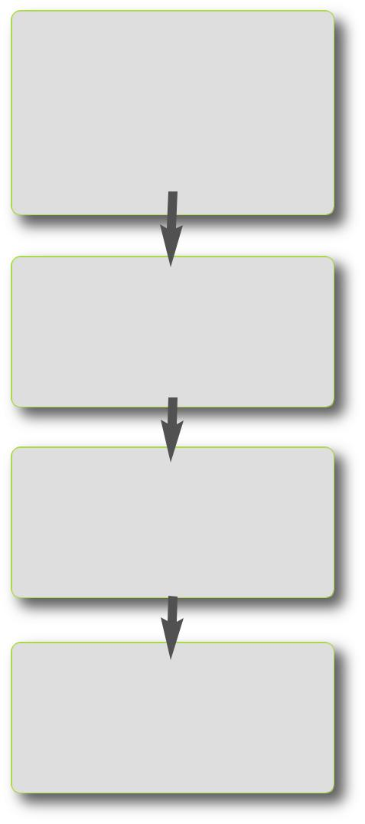

1.
List your products and/or services at TripleClicks.com

2.
Shoppers see your listings

3.
We forward orders to you to fulfill

- We take you global! Reach millions of potential customers world-wide on TripleClicks.com–one of the fastest growing, international e-commerce sites on the Web!

- We put the marketing muscle of over 100,000 SFI affiliates to work for you, promoting and selling your products and services in over 20,000 cities in over 190 countries!

- There are no listing fees and no risk. Simply sign up, submit the information on your products and services, and start taking orders! We retain a nominal amount only when you make a sale.

- We facilitate further sales growth by providing you with your own, customized "TConnect" Website, a multitude of payment options for your customers, wish lists, and much more!

READY TO SELL MORE?

2/26/10

4. | For more information or to get started FREE, go to:
Payment is | For more information or to get started FREE, go to:
Payment is | www.tripleclicks.com/ECA
transferred to you | www.tripleclicks.com/ECA
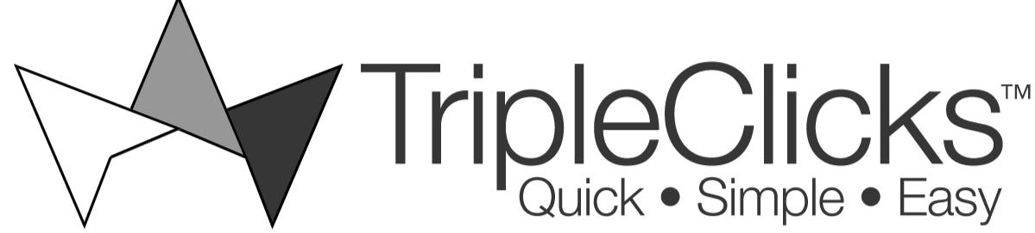
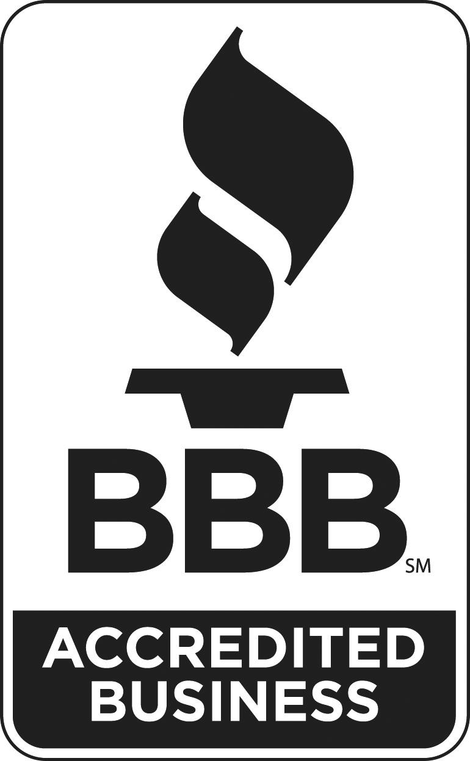

Referring SFI Affiliate:

© 2010 Carson Services, Inc. rev.

F R E Q U E N T L Y A S K E D Q U E S T I O N S

Q: What is it?
A: The E-Commerce Associates (ECA) Program is a new pro-gram that allows commercial sellers to market their products and services at TripleClicks.com and also from their own, separate TripleClicks "TConnect" Website.
Q: How does it work?

A: In short, you'll list your products and/or services and they will become viewable by shoppers at TripleClicks.com. Shop-pers may purchase your products and/or services by placing it in the Tripleclicks shopping cart and checking out. We take care of all payment processing on your behalf and then for-ward you the order for fulfillment.

Q: How much does it cost to participate in this program?

A: There is no cost to get started. Once accepted, you can list as many products and/or services as you'd like at no cost. TripleClicks simply retains a nominal percentage (minimum 15% of your retail price) whenever you make a sale. That's it!
Q: How long has TripleClicks been in business?

A: TripleClicks was launched in January 2009. The parent company, Carson Services, Inc., is in its 25th year and is a long-time member of the Better Business Bureau serving Southeast Nebraska.

Q: How can I become an ECA?
A: Apply at www.tripleclicks.com/ECA. Approvals typically take just 1-2 business days. Once approved, you can immedi-ately begin listing your products and services on TripleClicks.
Q: When/how do I get paid when a sale occurs?
A: You can choose to be paid weekly via check or daily via electronic transfer of funds.

Q: How do I list PRODUCTS at TripleClicks?
A: You can enter the product information for your products one at a time via a special ECA Webpage. Or, if you have many products to list, you can quickly and easily upload all of your information in a simple text file.

Q: How do I list SERVICES at TripleClicks?
A: We provide you with a special Website where you can enter complete information on your service(s) and in a format that will allow online ordering.

Q: How are prices determined?
A: You set all prices. You can also adjust your prices when-ever you need to.

Q: How are shipping costs determined on product sales?

A: If your company resides in the United States, TripleClicks software can automatically determine the shipping cost (which will be paid to you) for each of your products, based on weight and destination. If your company resides in an-other country, you will submit your required shipping fees when you submit your product's retail pricing information.

Q: For product orders placed at TripleClicks by local cus-tomers, can the customer choose to pick up the order at my store?
A: Yes, you can choose this option for any or all of your prod-ucts and eliminate shipping costs for your local customers.

Q: Are there any restrictions on what kind of products and services I can sell at TripleClicks?
A: Yes. See our list at www.tripleclicks.com/ECA.

Q: Who is responsible for product returns and refunds?

A: You will be responsible for processing and notifying us of all returned products. TripleClicks will then take care of all re-funds to customers.

Q: Does TripleClicks offer fraud protection?
A: Yes, we carefully monitor all orders for fraud.

Q: How do I manage orders?
A: Provided to you at our ECA Center is an Order Manager that allows you to view all open and completed orders. You can easily process open orders by printing out order sum-maries. Or you can download a tab-delimited file that pro-vides a summary of all of your open orders for quick and easy fulfillment.

Q: What if I need to make changes or remove a product or service?
A: Provided to you at our ECA Center is a Listings Manager that allows you to quickly and easily choose and edit any of your products or services as needed. The Listings Manager also allows you to designate products and services as inac-tive or active, which is instantly reflected at TripleClicks.com and on your "TConnect" Website.
Q: What is the "TConnect" Website?
A: When you apply to become an ECA, we'll ask you to choose a domain name (e.g. yourcompany.tripleclicks.com). This URL becomes yours to use as you like in your own pro-motions and is a special TripleClicks Website that features JUST your products, plus special features that allow you to connect with customers more deeply and grow your cus-tomer base in exciting new ways! As with our standard pro-gram, for any orders, we'll take care of all payment processing for you and forward orders on to you for fulfill-ment. If you currently don't have a Website for your products or services, you'll now have one, ready for you to use as soon as you've uploaded your product and service information!
Q: What is the cost of the "TConnect" Website?

A: There is no cost. It is provided to you 100% free as part of our ECA program.
✓Get Started today...FREE!

See reverse side for more details

© 2010 Carson Services, Inc.

