Лабораторна робота №2
Завдання №1
Код програми:
Point.java (використовується в усіх завданнях нижче):

public class Point {
private double x;
private double y;

public Point(double x, double y) {
this.x = x;
this.y = y;
}

public double getX() {
return x;
}

public double getY() {
return y;
}

@Override
public String toString() {
return "(" + x + ";" + y + ")";
}
}

Line.java:

public class Line {
private double k;
private double b;

public Line(double k, double b) {
this.k = k;
this.b = b;
}

public Point intersection(Line other) {
if (this.k == other.k) {
return null;
}
double x = (other.b - this.b) / (this.k - other.k);
double y = this.k * x + this.b;
return new Point(x, y);
}
}

task1Test.java:
public class task1Test {
public static void main(String[] args) {
Line line1 = new Line(1, 1);
Line line2 = new Line(-1, 3);
Point intersectionPoint = line1.intersection(line2);
System.out.println(intersectionPoint);
}
}
Результат роботи програми: 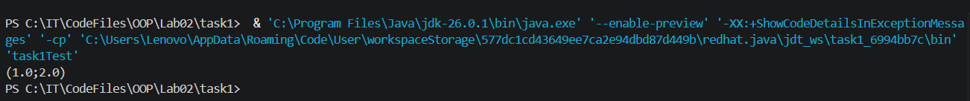
Скрін з GitHub:


Завдання №2
Код програми:

Segment.java:

public class Segment {
private Point start;
private Point end;

public Segment(Point start, Point end) {
if (start.getX() == end.getX() && start.getY() == end.getY()) {
throw new IllegalArgumentException("Відрізок не може бути виродженим (початок і кінець збігаються)");
}
this.start = start;
this.end = end;
}

public double length() {
double dx = end.getX() - start.getX();
double dy = end.getY() - start.getY();
return Math.sqrt(dx * dx + dy * dy);
}

public Point middle() {
double midX = (start.getX() + end.getX()) / 2;
double midY = (start.getY() + end.getY()) / 2;
return new Point(midX, midY);
}

public Point intersection(Segment other) {
double x1 = this.start.getX(), y1 = this.start.getY();
double x2 = this.end.getX(), y2 = this.end.getY();
double x3 = other.start.getX(), y3 = other.start.getY();
double x4 = other.end.getX(), y4 = other.end.getY();

double denom = (x1 - x2) * (y3 - y4) - (y1 - y2) * (x3 - x4);
if (denom == 0) {
return null;
}

double t = ((x1 - x3) * (y3 - y4) - (y1 - y3) * (x3 - x4)) / denom;
double u = -((x1 - x2) * (y1 - y3) - (y1 - y2) * (x1 - x3)) / denom;

if (t >= 0 && t <= 1 && u >= 0 && u <= 1) {
double x = x1 + t * (x2 - x1);
double y = y1 + t * (y2 - y1);
return new Point(x, y);
}
return null;
}
}

task2Test.java:

public class task2Test {
public static void main(String[] args) {
Segment s1 = new Segment(new Point(0, 0), new Point(2, 2));
Segment s2 = new Segment(new Point(0, 2), new Point(2, 0));
Point inter = s1.intersection(s2);
System.out.println("Довжина s1: " + s1.length());
System.out.println("Середина s1: " + s1.middle());
System.out.println("Перетин: " + inter);
}
}

Результат роботи програми:
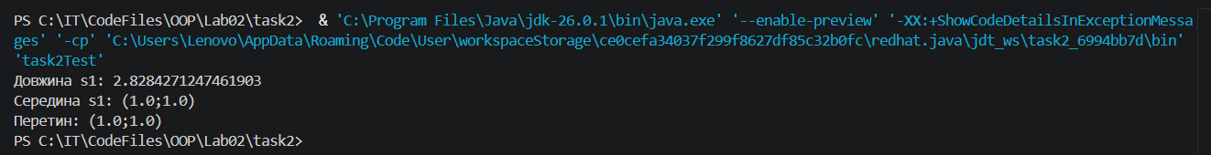
Скрін з GitHub:


Завдання №3
Код програми:

Triangle.java:
public class Triangle {
private Point a, b, c;

public Triangle(Point a, Point b, Point c) {
if (!isTriangle(a, b, c)) {
throw new IllegalArgumentException("Точки не утворюють невироджений трикутник");
}
this.a = a;
this.b = b;
this.c = c;
}

private boolean isTriangle(Point a, Point b, Point c) {
double side1 = sideLength(a, b);
double side2 = sideLength(b, c);
double side3 = sideLength(c, a);
return (side1 + side2 > side3) && (side1 + side3 > side2) && (side2 + side3 > side1);
}

private double sideLength(Point p1, Point p2) {
double dx = p1.getX() - p2.getX();
double dy = p1.getY() - p2.getY();
return Math.sqrt(dx * dx + dy * dy);
}

public double area() {
return Math.abs((a.getX() * (b.getY() - c.getY()) +
b.getX() * (c.getY() - a.getY()) +
c.getX() * (a.getY() - b.getY())) / 2.0);
}

public Point centroid() {
double x = (a.getX() + b.getX() + c.getX()) / 3;
double y = (a.getY() + b.getY() + c.getY()) / 3;
return new Point(x, y);
}
}

task3Test.java:
public class task3Test {
public static void main(String[] args) {
Triangle t = new Triangle(new Point(0, 0), new Point(4, 0), new Point(0, 3));
System.out.println("Площа: " + t.area());
System.out.println("Центроїд: " + t.centroid());
}
}

Результат роботи програми:
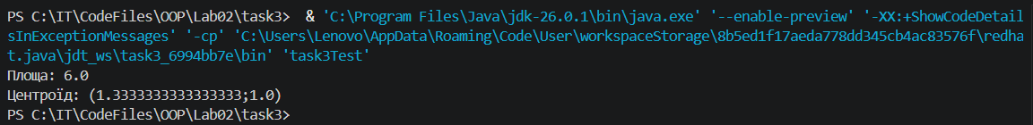
Скрін з GitHub:
