Лабораторна робота №3
Код програми:

Ticket.java:
public class Ticket {
private final int id;
private final String name;
private final int estimate;
private boolean completed = false;

public Ticket(int id, String name, int estimate) {
this.id = id;
this.name = name;
this.estimate = estimate;
}

public int getId() {
return id;
}

public String getName() {
return name;
}

public int getEstimate() {
return estimate;
}

public boolean isCompleted() {
return completed;
}

public void complete() {
this.completed = true;
}
}

UserStory.java:
import java.util.Arrays;

public class UserStory extends Ticket {
private final UserStory[] dependencies;

public UserStory(int id, String name, int estimate, UserStory[] dependencies) {
super(id, name, estimate);
this.dependencies = dependencies != null ? dependencies : new UserStory[0];
}

@Override
public void complete() {
for (UserStory dep : dependencies) {
if (!dep.isCompleted()) {
return;
}
}
super.complete();
}

public UserStory[] getDependencies() {
return Arrays.copyOf(dependencies, dependencies.length);
}

@Override
public String toString() {
return "[US " + getId() + "] " + getName();
}
}

Bug.java:
public class Bug extends Ticket {
private final UserStory userStory;

private Bug(int id, String name, int estimate, UserStory userStory) {
super(id, name, estimate);
this.userStory = userStory;
}

public static Bug createBug(int id, String name, int estimate, UserStory userStory) {
if (userStory == null || !userStory.isCompleted()) {
return null;
}
return new Bug(id, name, estimate, userStory);
}

@Override
public String toString() {
return "[Bug " + getId() + "] " + userStory.getName() + ": " + getName();
}
}

Sprint.java:
import java.util.Arrays;

public class Sprint {
private final int capacity;
private final int maxTickets;

private final Ticket[] tickets;
private int size = 0;
private int totalEstimate = 0;

public Sprint(int capacity, int maxTickets) {
this.capacity = capacity;
this.maxTickets = maxTickets;
this.tickets = new Ticket[maxTickets];
}

public boolean addUserStory(UserStory us) {
return addTicket(us);
}

public boolean addBug(Bug bug) {
return addTicket(bug);
}

private boolean addTicket(Ticket ticket) {
if (ticket == null) return false;
if (ticket.isCompleted()) return false;
if (size >= maxTickets) return false;
if (totalEstimate + ticket.getEstimate() > capacity) return false;

tickets[size++] = ticket;
totalEstimate += ticket.getEstimate();
return true;
}

public Ticket[] getTickets() {
return Arrays.copyOf(tickets, size);
}

public int getTotalEstimate() {
return totalEstimate;
}
}

Lab3Test.java:
public class Lab3Test {
public static void main(String[] args) {

UserStory us1 = new UserStory(1, "Реєстрація", 5, null);
UserStory us2 = new UserStory(2, "Логін", 3, new UserStory[]{us1});

us1.complete();
us2.complete();

Bug bug = Bug.createBug(1, "Фікс пароля", 2, us2);

Sprint sprint = new Sprint(10, 5);

sprint.addUserStory(us1);
sprint.addUserStory(us2);
sprint.addBug(bug);

for (Ticket t : sprint.getTickets()) {
System.out.println(t);
}

System.out.println("Total estimate: " + sprint.getTotalEstimate());
}
}

Результат роботи програми:
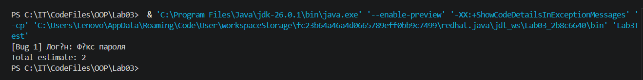
Скрін з GitHub:
