Лабораторна робота №4
Код програми:
Poin.java:
public class Point {
private double x;
private double y;

public Point(double x, double y) {
this.x = x;
this.y = y;
}

public double getX() {
return x;
}

public double getY() {
return y;
}

@Override
public String toString() {
return "(" + x + ";" + y + ")";
}
}
Figure.java:
public abstract class Figure {
public abstract double area();
public abstract Point centroid();
}
Triangle.java:
public class Triangle extends Figure {
private Point A, B, C;

public Triangle(Point A, Point B, Point C) {
this.A = A;
this.B = B;
this.C = C;

if (area() == 0) {
throw new IllegalArgumentException("Triangle is degenerate");
}
}

@Override
public double area() {
return Math.abs(
A.getX() * (B.getY() - C.getY()) +
B.getX() * (C.getY() - A.getY()) +
C.getX() * (A.getY() - B.getY())
) / 2.0;
}

@Override
public Point centroid() {
double x = (A.getX() + B.getX() + C.getX()) / 3;
double y = (A.getY() + B.getY() + C.getY()) / 3;
return new Point(x, y);
}

@Override
public String toString() {
return "Triangle[A" + A + " B" + B + " C" + C + "]";
}
}

Quadrilateral.java:
public class Quadrilateral extends Figure {
private Point A, B, C, D;

public Quadrilateral(Point A, Point B, Point C, Point D) {
this.A = A;
this.B = B;
this.C = C;
this.D = D;

if (area() == 0) {
throw new IllegalArgumentException("Quadrilateral is degenerate");
}
}

@Override
public double area() {
// розбиваємо на 2 трикутники
Triangle t1 = new Triangle(A, B, C);
Triangle t2 = new Triangle(A, C, D);
return t1.area() + t2.area();
}

@Override
public Point centroid() {
// середнє по вершинах (спрощено, зазвичай приймають)
double x = (A.getX() + B.getX() + C.getX() + D.getX()) / 4;
double y = (A.getY() + B.getY() + C.getY() + D.getY()) / 4;
return new Point(x, y);
}

@Override
public String toString() {
return "Quadrilateral[A" + A + " B" + B + " C" + C + " D" + D + "]";
}
}

Circle.java:
public class Circle extends Figure {
private Point center;
private double radius;

public Circle(Point center, double radius) {
if (radius <= 0) {
throw new IllegalArgumentException("Circle is degenerate");
}
this.center = center;
this.radius = radius;
}

@Override
public double area() {
return Math.PI * radius * radius;
}

@Override
public Point centroid() {
return center;
}

@Override
public String toString() {
return "Circle[" + center + " " + radius + "]";
}
}

Lab4Test.java:
public class Lab4Test {
public static void main(String[] args) {

Triangle t = new Triangle(
new Point(0, 0),
new Point(4, 0),
new Point(0, 3)
);

Quadrilateral q = new Quadrilateral(
new Point(0, 0),
new Point(4, 0),
new Point(4, 3),
new Point(0, 3)
);

Circle c = new Circle(new Point(0, 0), 5);

System.out.println(t);
System.out.println("Area: " + t.area());
System.out.println("Centroid: " + t.centroid());

System.out.println();

System.out.println(q);
System.out.println("Area: " + q.area());
System.out.println("Centroid: " + q.centroid());

System.out.println();

System.out.println(c);
System.out.println("Area: " + c.area());
System.out.println("Centroid: " + c.centroid());
}
}

Робота програми:
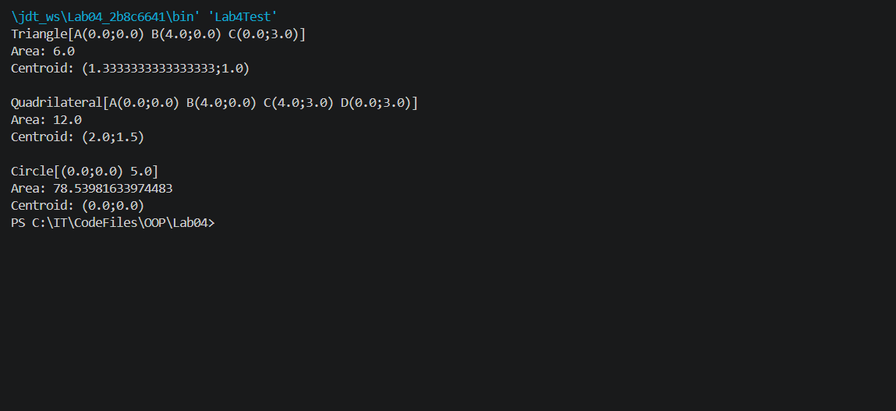
Скрін з GitHub:
