Do Lyrics Make a Top 50 Hit? Analyzing the Spotify Global Top 200
Technical Report: Backend Pipeline, Predictive Modeling & Canvas Reflection
Dataset: 53 Weekly Spotify Global Top 200 Charts | Cohort: N = 582 Unique English Songs (228 Top 50 Hits vs. 354 Ranks 51–200)

1. Project Motivation, Target Audience & Problem Formulation
In commercial music, independent songwriters and emerging artists (our predefined target audience) are frequently told that streaming success demands a specific "lyric formula"—heavy chorus repetition, shorter song length, simple words, or specific breakup topics. We designed this data science project to test whether written lyrics actually separate songs that break into the Spotify Global Top 50 (our binary target: best_rank_this_year <= 50, y = 1, n = 228) from songs peaking in the lower tiers of the chart (Ranks 51–200, y = 0, n = 354).
While our web application ("The Lyric Myth") translates these findings into practical creative advice for creators without technical jargon, this technical report details our backend engineering, validation safeguards against data leakage, statistical testing, and reflections on our project canvas.

2. Data Collection & Preprocessing Pipeline (885 → 582 Songs)
Because lyrics are static text, retaining 53 weekly chart entries for a long-running song would duplicate identical lyrics 53 times, causing massive data leakage. We aggregated the 53 weekly CSVs into a unique song-level cross-sectional dataset, retrieved full lyrics via the Genius API, and fetched release years and primary genres via the Apple iTunes Search API:
Preprocessing Step | Song Count | Script / Source | Backend Logic & Engineering Details
1. Weekly Chart Aggregation | 885 URIs | 02_aggregate_chart_stats.py | Collapsed 53 weekly charts into unique songs; tracked best_rank_this_year (min), all_time_peak_rank, and total_streams.
2. NLP Language Filter | 709 songs | build_dataset.py | Filtered for native English lyrics (language == 'en'); stripped section tags ([Chorus], [Verse]); normalized fan translations; created cleaned_lyrics_transformer and lemmatized tokens.
3. Track Deduplication | 669 songs | build_dataset.py | Merged duplicate album, single, and deluxe releases by (artist_names, track_name), retaining the highest peak chart rank.
4. Initial Holiday Filter | 596 songs | EDA_spotify_lyrics.ipynb | Excluded 72 seasonal tracks flagged as track_type == 'holiday' and 1 global event anthem recurring annually every December.
5. Final Clean Modeling Cohort | 582 songs | m1_bertopic_model.py | Removed 14 leftover Christmas tracks exposed during BERTopic clustering (e.g. Fairytale of New York). Final split: 228 Top 50 hits (39.2%) vs. 354 Ranks 51–200 (60.8%).

3. Exploratory Data Analysis: Surface Lyric Statistics
We tested whether Top 50 Hits (n = 228) and Ranks 51–200 Songs (n = 354) differ across three quantitative surface features: Chorus Line Repetition Rate (1 - unique_lines / total_lines), Total Word Count, and Vocabulary Diversity (Type-Token Ratio). Because lyric features have heavily skewed distributions (e.g. rap tracks exceeding 800 words), we compared medians and ran non-parametric Mann-Whitney U tests alongside Spearman rank correlation (rs) against continuous peak rank:
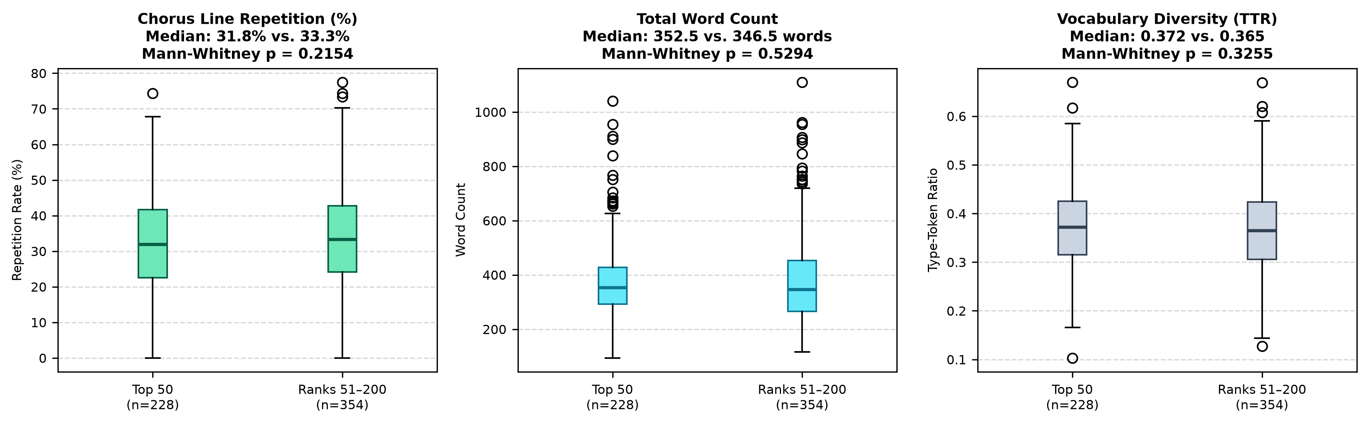
Figure 1: Boxplot Distributions of Surface Lyric Features (N = 582). Neither chorus repetition, word count, nor vocabulary diversity shows a statistically significant difference between Top 50 Hits and Ranks 51–200 (all Mann-Whitney p > 0.20).
Lyric Metric | Top 50 Hits (n = 228) | Ranks 51–200 (n = 354) | Mann-Whitney U | Spearman r (vs. Rank) | Statistical Conclusion
Chorus Line Repetition Rate | Median: 31.8%  (Mean: 32.2%) | Median: 33.3%  (Mean: 33.9%) | p = 0.2154 | rs = +0.044  (p = 0.2842) | Not Significant: Top 50 songs actually repeat lines slightly less.
Total Word Count | Median: 352.5 words  (Mean: 376.7 words) | Median: 346.5 words  (Mean: 374.0 words) | p = 0.5294 | rs = -0.030  (p = 0.4735) | Not Significant: Negligible 6-word median difference across groups.
Vocabulary Diversity (TTR) | Median: 0.372  (Mean: 0.374) | Median: 0.365  (Mean: 0.367) | p = 0.3255 | rs = -0.023  (p = 0.5807) | Not Significant: Identical ratio of unique words (~37%) per song.

Key Statistical Takeaway: All three p-values exceed the standard alpha = 0.05 threshold. Written surface metrics do not distinguish major Top 50 hits from lower-charting tracks. This provided our first empirical proof that traditional "lyric rules" are ungrounded.

4. Predictive Modeling: Can Machine Learning Predict Top 50 Hits?
To test whether deep contextual language representations contain subtle hit patterns missed by count statistics, we trained L2-regularized Logistic Regression classifiers (class_weight="balanced") to predict Top 50 placement. To prevent artist identity leakage (prolific stars like Taylor Swift or Drake appearing in both training and test sets), we clustered connected collaborations into 191 independent artist groups and evaluated models using 5-Fold StratifiedGroupKFold. Within each fold, numeric variables were scaled strictly on training folds.
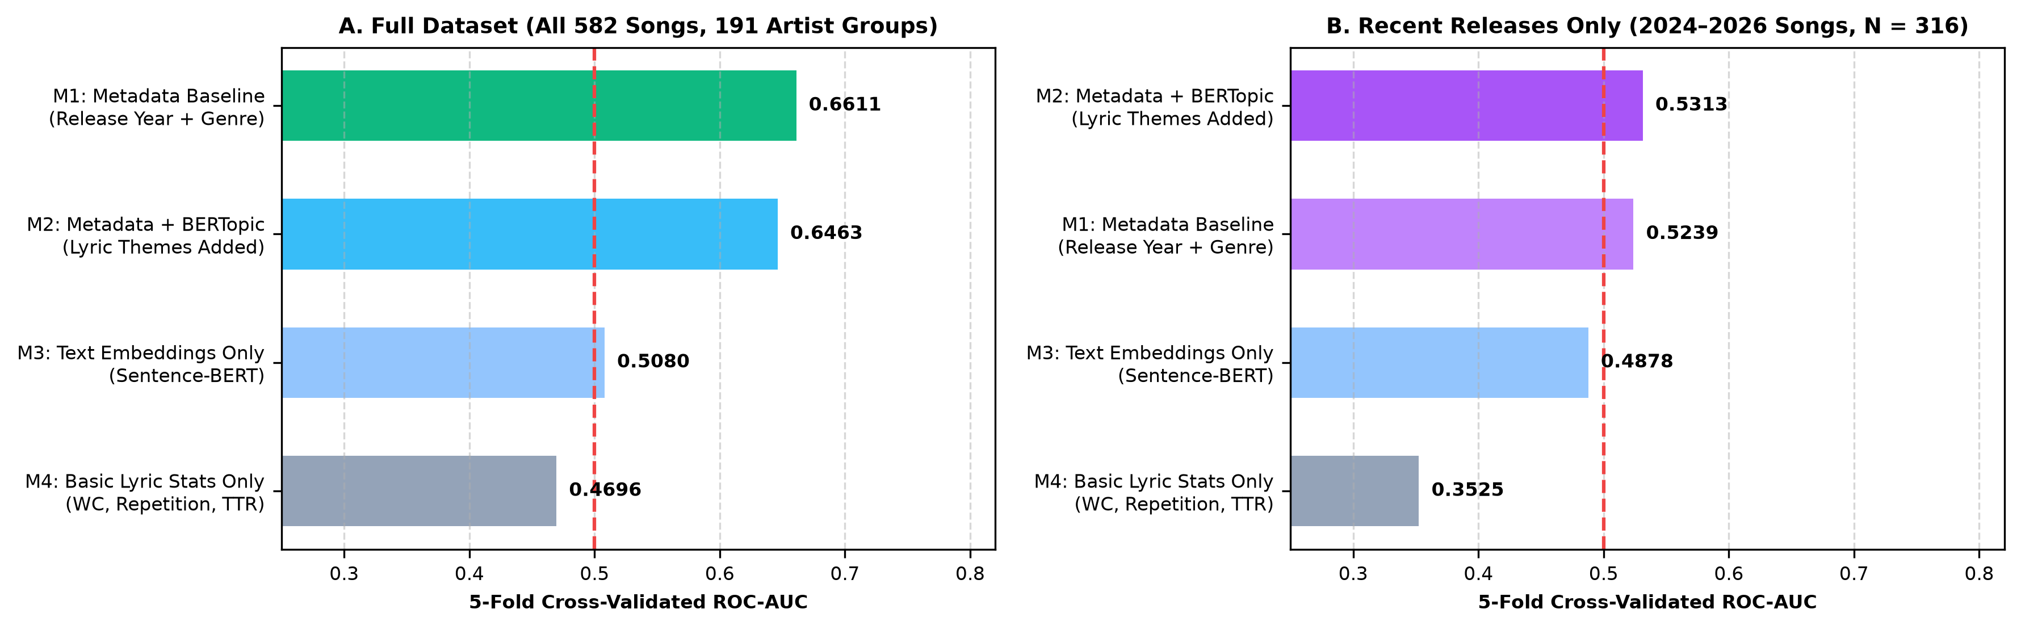
Figure 2: 5-Fold Artist-Grouped Cross-Validation ROC-AUC Scores. Dashed red line indicates 0.50 (random coin flip). Pure lyric models (M3: 0.5080, M4: 0.4696) perform like a coin toss. Adding lyric themes (M2: 0.6463) does not improve over metadata alone (M1: 0.6611).
Model & Input Features | Full (N=582)  ROC-AUC (±SD) | Full  Macro F1 | 2024+ (N=316)  ROC-AUC (±SD) | 2024+  Macro F1 | Engineering & Empirical Conclusion
M1: Metadata Baseline  Release Year + One-Hot Genre | 0.6611  (± 0.1000) | 0.5845 | 0.5239  (± 0.1087) | 0.5440 | Moderate signal on full cohort driven by recency; collapses near 0.52 on recent releases.
M2: Metadata + BERTopic Themes  M1 + Fold-Internal Topic Probabilities | 0.6463  (± 0.0566) | 0.5861 | 0.5313  (± 0.1190) | 0.5234 | Adding lyric topic probabilities provides zero improvement over metadata alone.
M3: Text Embeddings Only  384-dim Sentence-BERT (MiniLM) | 0.5080  (± 0.0450) | 0.5090 | 0.4878  (± 0.1186) | 0.4820 | Performs identically to a 50/50 coin flip across unseen artists.
M4: Basic Lyric Stats Only  Word Count + Repetition + TTR | 0.4696  (± 0.0394) | 0.4686 | 0.3525  (± 0.0372) | 0.3957 | Count-based lyric statistics fail to beat random chance.

Why did metadata work in the full dataset? Older catalog classics (1970s–2022) sit in ranks 51–200, while new 2025–2026 songs debut in the Top 50 (Mann-Whitney p < 0.0001). Once older songs are filtered out (2024–2026 releases only, N = 316), metadata collapses to 0.5239. Chart rank is driven by market release timing, not lyrics.

5. Unsupervised Topic Modeling: Deconstructing the Superstar Illusion
To evaluate whether thematic categories influence streaming success, we applied BERTopic (Sentence-BERT + UMAP + HDBSCAN + c-TF-IDF). 459 songs (78.9%) were assigned to 24 distinct topic clusters, while 123 songs (21.1%) were categorized as Topic -1 (Formula-Free Tracks). A global Chi-Square test across all 24 topics yields chi^2 = 33.48 (df = 23, p = 0.0731), confirming topic differences are not statistically significant:
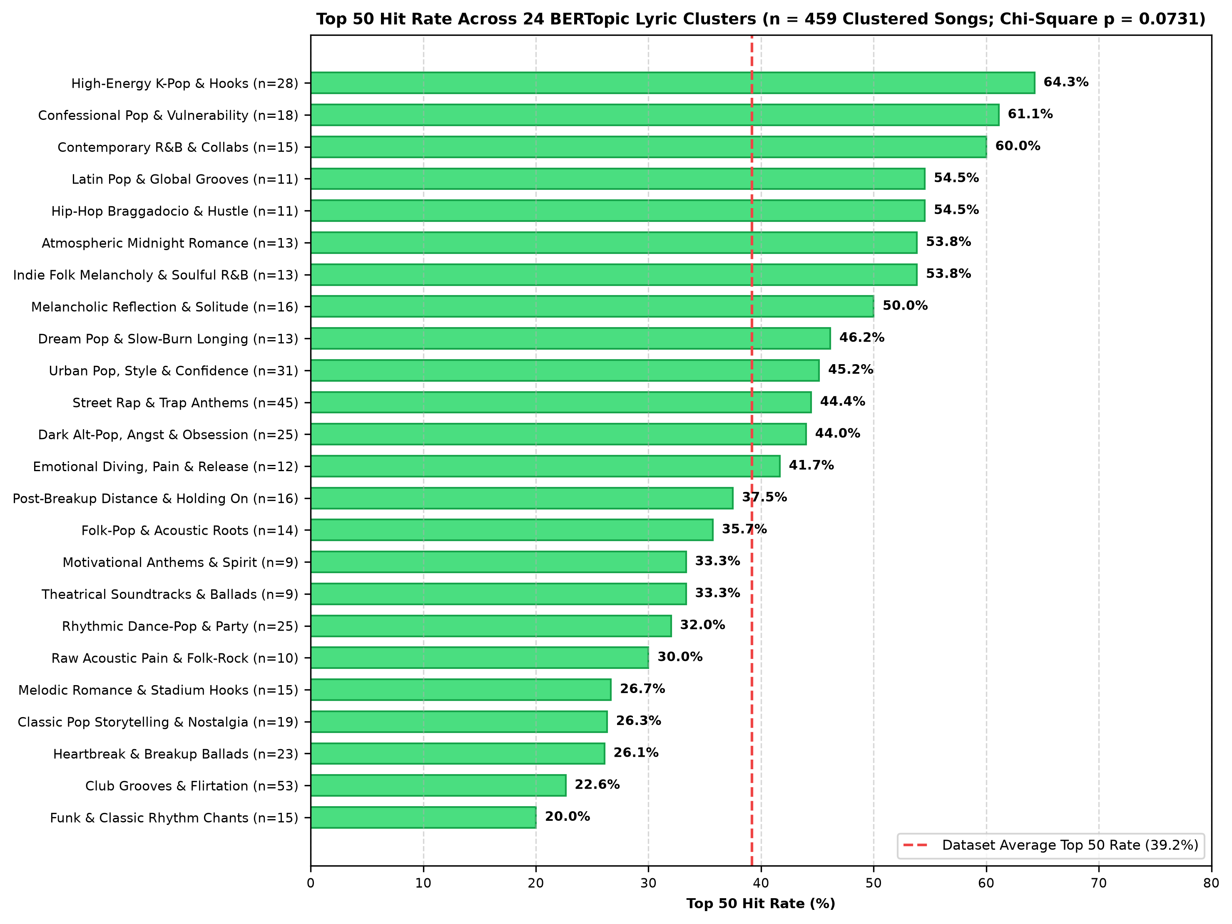
Figure 3: Top 50 Hit Rates across 24 BERTopic Clusters (n = 459). Dashed line marks overall average (39.2%). Overall differences are statistically non-significant (p = 0.0731).
The Crowded Cliché Trap (Topic 0: 22.6%) | The Superstar Illusion in High Clusters | The Formula-Free Reality (Topic -1: 34.1%)
The largest cluster on the chart is Topic 0 (Nightlife Flirtation & Club Clichés, n = 53), built around repetitive party words (tonight, turn, stop). Despite being the most common songwriting template, only 22.6% (12/53) reached the Top 50. Writing generic club party lyrics simply buries emerging artists in a crowded lower tier. | Clusters appearing to have high conversion—such as Topic 8 (Confessional Pop, 61.1%, n = 18), Topic 3 (K-Pop Hooks, 64.3%, n = 28), or Topic 19 (Hip-Hop Hustle, 54.5%, n = 11)—are driven by Olivia Rodrigo, Ariana Grande, BTS, and Drake dropping entire albums into those clusters. Their high hit rate reflects artist fame, not lyric topics. | 123 songs (21.1% of the chart) refused to fit standard cluster templates. Yet this unclustered group achieved 42 Top 50 hits (34.1% hit rate), including #1 smashes like Djo's End of Beginning, Taylor Swift's The Fate of Ophelia, and Harry Styles' American Girls. Writing distinctive, formula-free lyrics lets new artists stand out.

6. Canvas Reflections: What Worked, Lessons Learned & Limitations
Reflecting on our initial Mini-Project Canvas, our primary objective was to investigate whether commercial songwriting formulas predict streaming performance. Below is our critical assessment of what worked, what failed, and what we learned:
Canvas Dimension | Initial Plan vs. Actual Execution | Critical Reflection & What Worked / Failed
1. Target & Data Leakage  (What Worked) | Initial plan: Use raw weekly chart rows (N=10,600).  Actual: Collapsed into cross-sectional song dataset (N=582). | WORKED: Deduplicating by (artist, track) prevented copying identical static lyrics 53 times, eliminating severe artificial inflation of model metrics.
2. Cross-Validation Setup  (What Worked) | Initial plan: Standard random 80/20 train/test split.  Actual: 5-Fold StratifiedGroupKFold on 191 artist clusters. | WORKED: Blocked artist identity leakage. Models could not memorize Taylor Swift's or Drake's vocabulary across folds, giving a fair test on unseen creators.
3. Lyric Predictability  (What Failed) | Initial hypothesis: S-BERT embeddings and chorus repetition would predict Top 50 placement.  Actual: M3 achieved 0.5080 ROC-AUC (coin flip). | FAILED (Informative Null Result): Proved definitively that written lyrics alone have no predictive relationship with chart rank. Taught us not to force formulas where no signal exists.
4. Audience Communication  (What Changed) | Initial plan: Present ML classification metrics directly to songwriters.  Actual: Built an interactive, non-technical Streamlit app. | CHANGED: Technical terms (ROC-AUC, p-values) alienate creators. We pivoted our web app into 'The Lyric Myth', busting songwriting myths and delivering creative liberation.

Methodological Limitations, Data Hygiene Discovery & Future Work
1. Fixed 1-Year Window & Bias  Because best_rank_this_year was observed during Sept 2025–Sept 2026, older pre-2024 catalog songs were captured past their peak (45.1% all-time Top 50 vs. 23.7% in-window), artificially inflating Release Year. Furthermore, all 582 songs reached the Top 200 (survivorship bias); we cannot test whether lyrics help unknown songs chart initially. | 2. Catching 14 Christmas Songs  Running unsupervised BERTopic clustering on our initial 596 EDA tracks surfaced a cluster containing residual holiday songs that bypassed title filters—such as Little Saint Nick (1991 Remix) and Fairytale of New York. This allowed us to refine our exclusion regex in m1_bertopic_model.py and establish our clean 582 cohort. | 3. Future Work: Audio & Virality  Because Spotify deprecated its public Audio Features API, acoustic features (tempo, energy, vocal dynamic range) and short-form social engagement metrics (TikTok/Reels video creations) were absent. Combining audio stem analysis with viral social metrics represents the natural next step for commercial music analytics.

