**4COSCO11C.2 Web Design and Development**

**Tutorial 5**

### Task 1 - Create your Web Page content

Create a file and save it as tutorial5.html.

#### **HTML**

Your Web Pages should follow the following specifications.

* Tutorial 5 for the title.
* 'Lottery Simulator' as the page heading.
* A paragraph with 'Your chosen Numbers' to your page followed by placeholders for the user numbers 1 to 6. You should use spans for this with the <span id="displayUserNum1"></span> for the first user number, and repeat this for the 6 numbers, making sure to change the id for each number.
* Another paragraph for the lottery draw numbers. This time we will use a div with the id="draw". Your html code should now look like this:

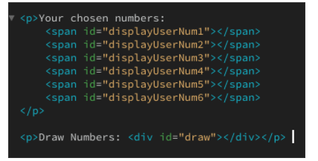

* A ruler acting as a separator
* Your email address inside an address element
* The last modified date (just as hard coded date)

### Task 2 - Add some Styling

#### **CSS**

* Add a background colour, text colour and font family to the body of your page using an embedded style sheet.
* Add styling for three separate highlighting classes that you will use to highlight:
  + your matching numbers if your numbers match the main lottery numbers. You can for example name this class "highlightWin".
  + your matching bonus number if your number matches the bonus lottery numbers. You can for example name this class "highlightBonusWin".
  + the lottery bonus number, to separate it from the main numbers. You can for example name this class "highlightBonus".

I would recommend adding a background colour, and changing the text colour also if necessary.

### Task 3 - Add some Functionality

#### **JavaScript**

* Declare 6 user numbers and 7 lottery numbers. You can for example use var userNumber1 to declare your first userNumber.
* Assign values to your 6 user numbers. If you have time at the end of this tutorial, you will replace this by asking the user for numbers using prompts.
* Display your number numbers in the placeholders you prepared in the HTML section. You should use the innerHTML() method for this.
* Assign a randomly generated number between 1 and 59 to each of your lottery numbers. Note that you can use lotteryNum1 = Math.floor(Math.random() * 59) + 1; to generate a random number btween 1 and 59 and assign it to lotteryNum1. Each number must be unique so each time you draw a new number, you must make sure this number hasn't been drawn before, or you will need to draw a new one again.
* Display your lottery numbers in the "draw" div. You can again use the innerHTML() method. Remeber to add the class highlightBonus to the seventh number which represents the Bonus number.
* Compare each of your user numbers to each of the lottery numbers. If there is a match, add the class "highlightWin" if it matches the main numbers, and the class "highlightBonusWin" if it matches the bonus number. You can use document.getElementById("displayUserNum1").classList.add("highlightWin"); to add the highlightWin class to the element with the id displayUserNum1

See Below for examples of your page layout:

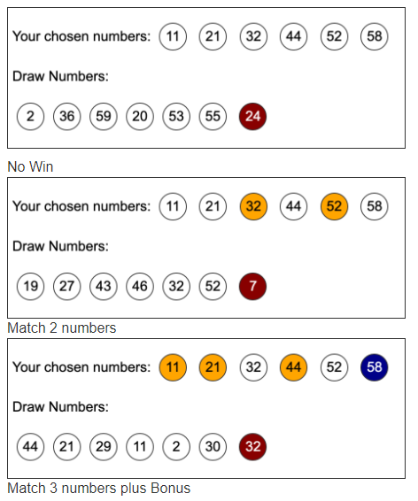

### Task 4 - Check your work

• Remember, you can check if your markup is syntactically valid using the Validator at: <https://validator.w3.org/>

* Use the ‘Validate by File Upload’ or ‘Validate by Direct Input’.

### Tutorial Extension

* Prompt the user for their chosen numbers. Remember that you will need to turn the input into an integer. You will also need to make sure they do not give the same number more than once, and that the numbers must be between 1 and 59.

### Task 5 - Complete the Tutorial 3 Test on Blackboard

* Go to Assessment -> Tutorial Tests -> Tutorial 3 Test and complete the test. You can have up to five attempts to get the maximum score of 2 marks