Regresinės analizės projektinis darbas

Vainius Gataveckas, Matas Gaulia, Dovydas Martinkus

### Cleaning the data

library(tidyverse)  
library(janitor)  
library(countrycode)  
  
  
pop_natural <- read_csv("natural-population-growth.csv") %>%  
 filter(Year == 2017) %>%  
 dplyr::select(1, 4) %>%  
 set_names(c("country", "natural_growth")) %>%  
 mutate(country = countryname(country))  
  
pop_total <- read_csv("population-growth-rates.csv") %>%  
 filter(Year == 2017) %>%  
 dplyr::select(1, 4) %>%  
 set_names(c("country", "total_growth")) %>%  
mutate(country = countryname(country))  
  
  
country_stats <- read_csv("country_profile_variables.csv") %>%  
 clean_names() %>%  
 dplyr::select(-c(2, 3, 4, 5, 6, 7)) %>%  
 mutate(country = countryname(country))  
  
happiness <- read_csv("2017.csv") %>%  
 clean_names() %>%  
 dplyr::select(-c(2), -starts_with("whisker"), -c("dystopia_residual", "happiness_score", "family")) %>%  
 mutate(country = countryname(country))

x <- reduce(list(pop_natural, pop_total, country_stats, happiness), inner_join, by = "country")  
  
  
x <- x %>%  
 dplyr::select(  
 -starts_with("gdp"),  
 -starts_with("labour"),  
 -starts_with("international"),  
 -starts_with("balance"),  
 -starts_with("population"),  
 -starts_with("fertility"),  
 -starts_with("net"),  
 -starts_with("energy_prod"),  
 -starts_with("forest"),  
 -starts_with("threatened"),  
 -starts_with("seats"),  
 -starts_with("urban_population_growth"),  
 -starts_with("refugees"),  
 -starts_with("infant"),  
 -starts_with("life_expectancy"),  
 -starts_with("co2"),  
 -starts_with("economy"),  
 -starts_with("education_government"),  
 -starts_with("energy"),  
 -health_physicians_per_1000_pop,  
 -individuals_using_the_internet_per_100_inhabitants,  
 -mobile_cellular_subscriptions_per_100_inhabitants_40,  
 -pop_using_improved_sanitation_facilities_urban_rural_percent  
 ) %>%  
 mutate(across(everything(), ~ replace(., . %in% c("...", "-99", ".../..."), NA))) %>%  
 mutate(across(starts_with("education"), ~ str_split(., "/") %>% map(~ mean(as.numeric(.)))))  
  
  
pop <- x$pop_using_improved_drinking_water_urban_rural_percent  
f1 <- possibly(~`[[`(.x,1),1)  
x$pop_using_improved_drinking_water_urban <- pop %>% str_split("/") %>% map(f1)  
f2 <- possibly(~`[[`(.x,2),1)  
x$pop_using_improved_drinking_water_rural <- pop %>% str_split("/") %>% map(f2)  
  
  
x <- x %>%  
 dplyr::select(-pop_using_improved_drinking_water_urban_rural_percent) %>%  
 mutate(across(-country, as.numeric)) %>%  
 mutate(migration_growth = total_growth - natural_growth) %>%  
 drop_na() %>%  
 dplyr::select(-total_growth)

library(rsample)  
  
set.seed(123)  
  
x <- x %>% mutate(  
 category = factor(case_when(  
 migration_growth >= 0 & natural_growth >= 0 ~ 0, # "P migation, P natural",  
 migration_growth >= 0 & natural_growth < 0 ~ 1, # "P migation, N natural",  
 migration_growth < 0 & natural_growth >= 0 ~ 2, # "N migation, P natural",  
 TRUE ~ 3 # "N migration, N natural"  
 ))  
)   
  
  
train_test_split <- initial_split(x,prop = 0.8)  
train <- training(train_test_split)  
test <- testing(train_test_split)  
  
country_train <- train$country  
country_test <- test$country  
  
train <- train %>% dplyr::select(-country)

library(recipes)  
  
correlated_recipe <- recipe(natural_growth ~ ., data=train) %>%  
 add_role(migration_growth, new_role = "outcome") %>%  
 add_role(category, new_role = "outcome") %>%   
 step_corr(all_numeric_predictors(), threshold = 0.7) %>%  
 step_nzv(all_numeric_predictors())  
  
  
correlated_recipe <- prep(correlated_recipe, training = train)  
  
train <- bake(correlated_recipe, NULL)

### Regression models

library(corrplot)  
  
  
regression_train <- train %>% dplyr::select(-category)  
  
correlation <- function(name, name2) {  
 correlation_matrix <- regression_train %>%  
 dplyr::select(1:5, {{ name }}, {{ name2 }}) %>%  
 set_names(., str_trunc(names(.), 15)) %>%  
 cor()  
  
 corrplot(correlation_matrix, order = "original", method = "color", type = "upper", diag = FALSE, tl.col = "black", addCoef.col = "black")  
  
  
  
 correlation_matrix <- regression_train %>%  
 dplyr::select(6:length(regression_train), {{ name }}, {{ name2 }}) %>%  
 set_names(., str_trunc(names(.), 15)) %>%  
 cor()  
  
 corrplot(correlation_matrix, order = "original", method = "color", type = "upper", diag = FALSE, tl.col = "black", addCoef.col = "black")  
}  
  
  
correlation(migration_growth, natural_growth)

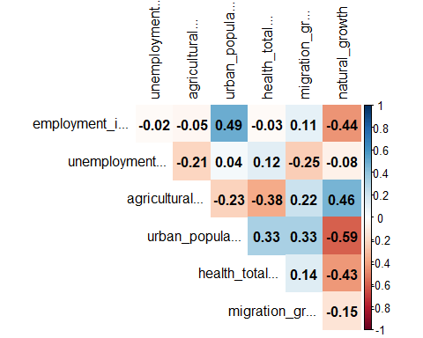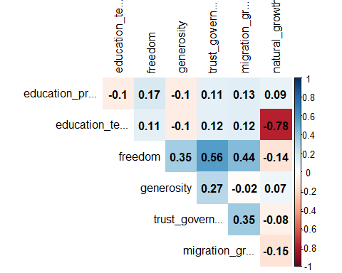

scatterplot <- function(name, name2, main) {  
 a<- regression_train %>%  
 dplyr::select(1:5, {{ name }}, -{{ name2 }}) %>%  
 pivot_longer(-{{ name }}) %>%  
 ggplot(aes(x = value, y = {{ name }})) +  
 facet_wrap(vars(name), scales = "free") +  
 geom_point() +  
 geom_smooth(method = "lm") +  
 theme_minimal() + labs(title=main)  
  
  
 b <- regression_train %>%  
 dplyr::select(6:length(regression_train), {{ name }}, -{{ name2 }}) %>%  
 pivot_longer(-{{ name }}) %>%  
 ggplot(aes(x = value, y = {{ name }})) +  
 facet_wrap(vars(name), scales = "free") +  
 geom_point() +  
 geom_smooth(method = "lm") +  
 theme_minimal() + labs(title=main)  
   
 plot(a)  
   
 plot(b)  
}  
  
  
scatterplot(migration_growth, natural_growth,"Migracijos prieaugis pagal kovariantes")

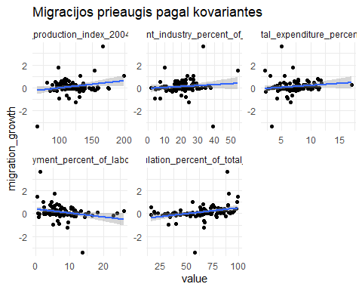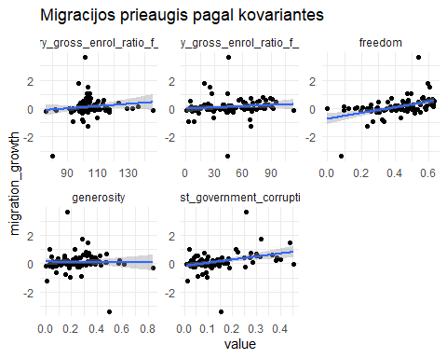

scatterplot(natural_growth, migration_growth,"Natūralus prieaugis pagal kovariantes")

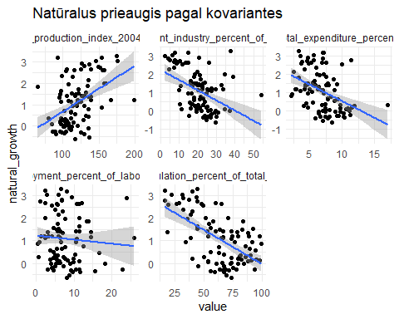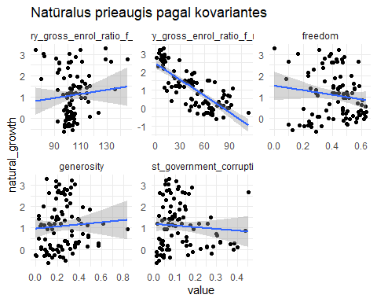

library(car)  
library(effects)  
library(lm.beta)  
  
  
linear_fit <- function(formula) {  
 model_linear <- lm(formula, data=data)  
  
 crPlots(model_linear)  
 plot(model_linear)  
 plot(cooks.distance(model_linear))  
   
  
 model_linear <- MASS::stepAIC(model_linear, direction = "both",trace=0)  
  
 plot(predictorEffects(model_linear))  
 print(summary(model_linear))  
  
  
 stand_coeffs <- lm.beta(model_linear)  
  
 coeff_plot <- tibble(x = names(stand_coeffs$standardized.coefficients), y = stand_coeffs$standardized.coefficients) %>%  
 cbind(confint(stand_coeffs)) %>%  
 set_names(c("variable", "coeff", "low", "high")) %>%  
 ggplot(aes(variable, coeff)) +  
 geom_pointrange(aes(ymin = low, ymax = high), color = "blue") +  
 scale_x_discrete() +  
 coord_flip() +  
 theme_minimal() + labs(x="Kovariantė",y="Standartizuotos koeficientų reikšmės")  
   
 plot(coeff_plot)  
  
 model_linear  
}

print("Tiesinės regresijos modelis migracijos prieaugiui")

## [1] "Tiesinės regresijos modelis migracijos prieaugiui"

outlier_indices <- which(abs(regression_train$migration_growth) %in% (regression_train$migration_growth %>%  
 abs %>% sort(.,decreasing = TRUE) %>% `[`(1:4)))  
data <- regression_train %>% dplyr::select(-natural_growth) %>% slice(-outlier_indices)  
model_linear_migration <- linear_fit(migration_growth ~ .)

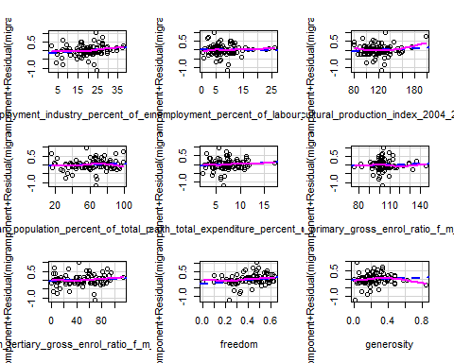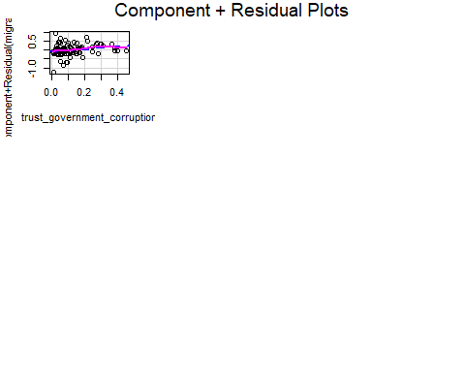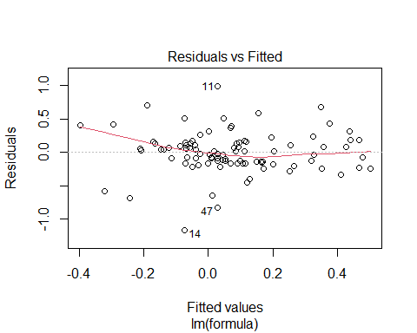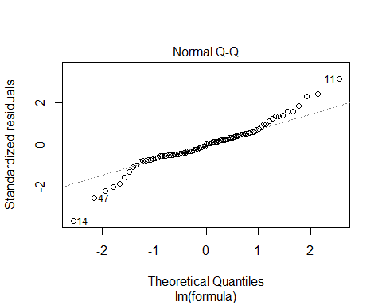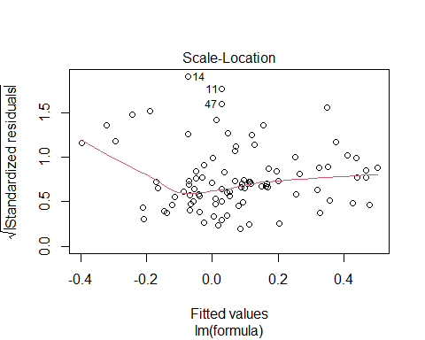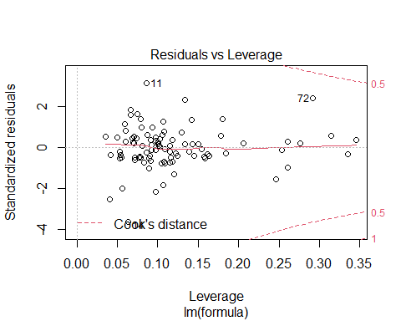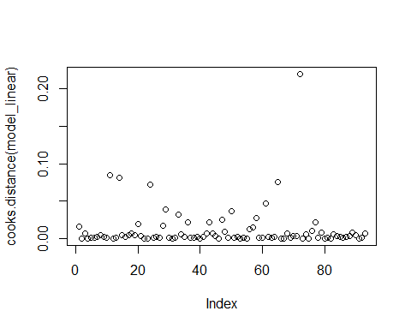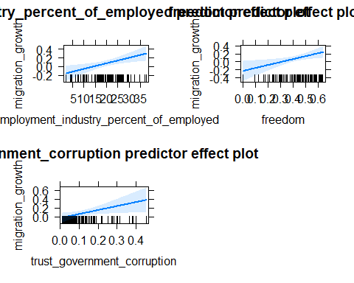

##   
## Call:  
## lm(formula = migration_growth ~ employment_industry_percent_of_employed +   
## freedom + trust_government_corruption, data = data)  
##   
## Residuals:  
## Min 1Q Median 3Q Max   
## -1.13656 -0.15860 0.00083 0.15623 0.94305   
##   
## Coefficients:  
## Estimate Std. Error t value Pr(>|t|)  
## (Intercept) -0.59866 0.14753 -4.058 0.000106  
## employment_industry_percent_of_employed 0.01279 0.00449 2.848 0.005457  
## freedom 0.74118 0.29276 2.532 0.013105  
## trust_government_corruption 0.91015 0.40864 2.227 0.028451  
##   
## (Intercept) ***  
## employment_industry_percent_of_employed **   
## freedom *   
## trust_government_corruption *   
## ---  
## Signif. codes: 0 '***' 0.001 '**' 0.01 '*' 0.05 '.' 0.1 ' ' 1  
##   
## Residual standard error: 0.324 on 89 degrees of freedom  
## Multiple R-squared: 0.247, Adjusted R-squared: 0.2216   
## F-statistic: 9.733 on 3 and 89 DF, p-value: 1.28e-05

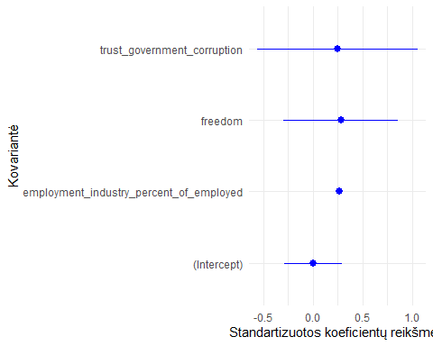

print("Tiesinės regresijos modelis natūraliam prieaugiui")

## [1] "Tiesinės regresijos modelis natūraliam prieaugiui"

data <- regression_train %>% dplyr::select(-migration_growth)  
model_linear_natural <- linear_fit(natural_growth ~ .)

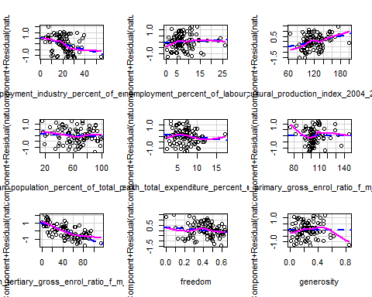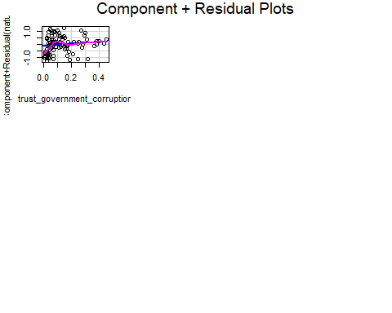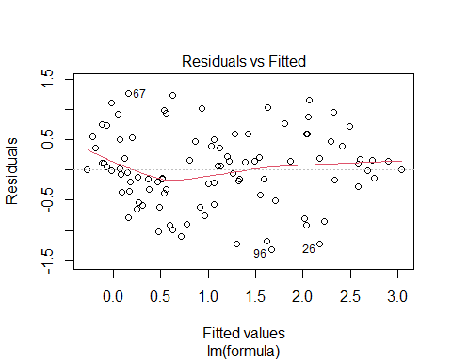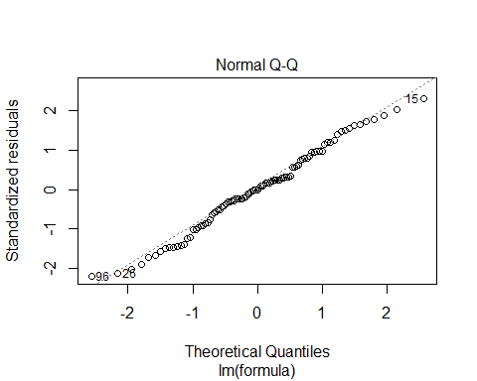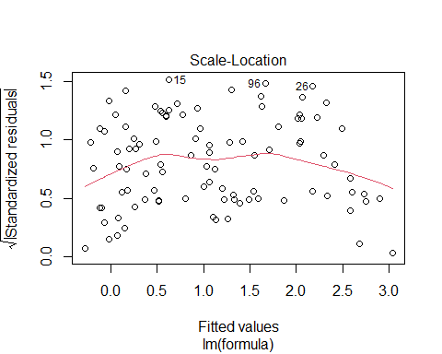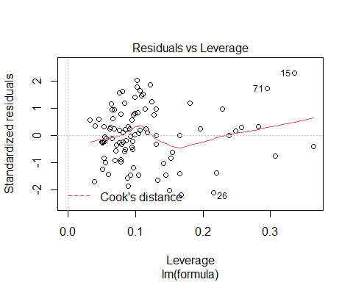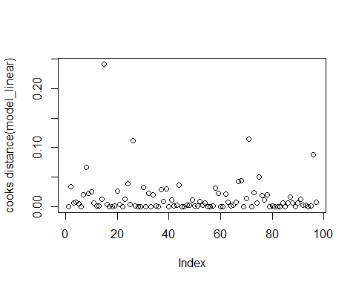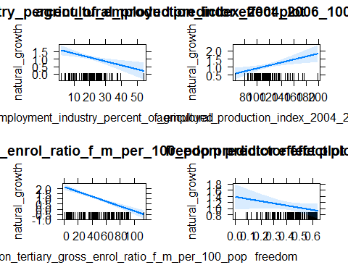

##   
## Call:  
## lm(formula = natural_growth ~ employment_industry_percent_of_employed +   
## agricultural_production_index_2004_2006_100 + education_tertiary_gross_enrol_ratio_f_m_per_100_pop +   
## freedom, data = data)  
##   
## Residuals:  
## Min 1Q Median 3Q Max   
## -1.29210 -0.41415 0.04378 0.36362 1.48870   
##   
## Coefficients:  
## Estimate Std. Error  
## (Intercept) 1.900127 0.475964  
## employment_industry_percent_of_employed -0.026640 0.008437  
## agricultural_production_index_2004_2006_100 0.009170 0.003157  
## education_tertiary_gross_enrol_ratio_f_m_per_100_pop -0.023327 0.002852  
## freedom -0.706028 0.468160  
## t value Pr(>|t|)   
## (Intercept) 3.992 0.000132 ***  
## employment_industry_percent_of_employed -3.158 0.002151 **   
## agricultural_production_index_2004_2006_100 2.904 0.004607 **   
## education_tertiary_gross_enrol_ratio_f_m_per_100_pop -8.180 1.52e-12 ***  
## freedom -1.508 0.134958   
## ---  
## Signif. codes: 0 '***' 0.001 '**' 0.01 '*' 0.05 '.' 0.1 ' ' 1  
##   
## Residual standard error: 0.6421 on 92 degrees of freedom  
## Multiple R-squared: 0.6663, Adjusted R-squared: 0.6518   
## F-statistic: 45.92 on 4 and 92 DF, p-value: < 2.2e-16

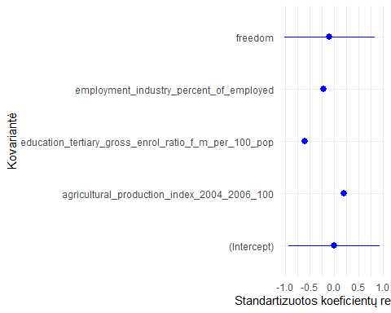

library(quantreg)  
  
quantile_fit <- function() {  
 model_quantile <- rq(formula, data = data, tau = tau)  
  
 print(summary(model_quantile, se = "boot"))  
 plot(summary(model_quantile))  
 print(anova(model_quantile, test = "Wald", joint = TRUE))  
  
 model_quantile  
}

print("Kvantilių regresija migracijos prieaugiui")

## [1] "Kvantilių regresija migracijos prieaugiui"

data <- regression_train %>% dplyr::select(-natural_growth) %>% slice(-outlier_indices)  
tau <- seq(0.1,0.9,0.1)  
formula <- migration_growth ~ .  
  
model_quantile_migration <- quantile_fit()

##   
## Call: rq(formula = formula, tau = tau, data = data)  
##   
## tau: [1] 0.1  
##   
## Coefficients:  
## Value Std. Error  
## (Intercept) -1.97977 0.90227   
## employment_industry_percent_of_employed 0.02605 0.01207   
## unemployment_percent_of_labour_force 0.01170 0.01252   
## agricultural_production_index_2004_2006_100 -0.00040 0.00398   
## urban_population_percent_of_total_population -0.00027 0.00457   
## health_total_expenditure_percent_of_gdp 0.04745 0.03094   
## education_primary_gross_enrol_ratio_f_m_per_100_pop 0.00366 0.00698   
## education_tertiary_gross_enrol_ratio_f_m_per_100_pop -0.00200 0.00494   
## freedom 0.96911 0.75716   
## generosity 0.37700 0.50482   
## trust_government_corruption 0.68231 0.63346   
## t value Pr(>|t|)  
## (Intercept) -2.19422 0.03105  
## employment_industry_percent_of_employed 2.15928 0.03375  
## unemployment_percent_of_labour_force 0.93451 0.35278  
## agricultural_production_index_2004_2006_100 -0.10131 0.91955  
## urban_population_percent_of_total_population -0.06008 0.95224  
## health_total_expenditure_percent_of_gdp 1.53338 0.12903  
## education_primary_gross_enrol_ratio_f_m_per_100_pop 0.52469 0.60122  
## education_tertiary_gross_enrol_ratio_f_m_per_100_pop -0.40471 0.68674  
## freedom 1.27991 0.20418  
## generosity 0.74680 0.45732  
## trust_government_corruption 1.07711 0.28459  
##   
## Call: rq(formula = formula, tau = tau, data = data)  
##   
## tau: [1] 0.2  
##   
## Coefficients:  
## Value Std. Error  
## (Intercept) -1.44516 0.72374   
## employment_industry_percent_of_employed 0.01645 0.00964   
## unemployment_percent_of_labour_force 0.00953 0.00956   
## agricultural_production_index_2004_2006_100 0.00175 0.00237   
## urban_population_percent_of_total_population 0.00055 0.00256   
## health_total_expenditure_percent_of_gdp 0.03359 0.01678   
## education_primary_gross_enrol_ratio_f_m_per_100_pop 0.00010 0.00438   
## education_tertiary_gross_enrol_ratio_f_m_per_100_pop -0.00095 0.00267   
## freedom 0.83431 0.49915   
## generosity 0.31753 0.33972   
## trust_government_corruption 0.41345 0.41754   
## t value Pr(>|t|)  
## (Intercept) -1.99678 0.04917  
## employment_industry_percent_of_employed 1.70615 0.09177  
## unemployment_percent_of_labour_force 0.99600 0.32218  
## agricultural_production_index_2004_2006_100 0.74127 0.46065  
## urban_population_percent_of_total_population 0.21494 0.83035  
## health_total_expenditure_percent_of_gdp 2.00105 0.04869  
## education_primary_gross_enrol_ratio_f_m_per_100_pop 0.02210 0.98242  
## education_tertiary_gross_enrol_ratio_f_m_per_100_pop -0.35688 0.72210  
## freedom 1.67145 0.09844  
## generosity 0.93470 0.35269  
## trust_government_corruption 0.99020 0.32499  
##   
## Call: rq(formula = formula, tau = tau, data = data)  
##   
## tau: [1] 0.3  
##   
## Coefficients:  
## Value Std. Error  
## (Intercept) -0.82193 0.53511   
## employment_industry_percent_of_employed 0.00713 0.00780   
## unemployment_percent_of_labour_force -0.00008 0.00869   
## agricultural_production_index_2004_2006_100 0.00080 0.00200   
## urban_population_percent_of_total_population 0.00093 0.00251   
## health_total_expenditure_percent_of_gdp 0.01587 0.01265   
## education_primary_gross_enrol_ratio_f_m_per_100_pop 0.00081 0.00243   
## education_tertiary_gross_enrol_ratio_f_m_per_100_pop 0.00149 0.00177   
## freedom 0.27256 0.33727   
## generosity 0.27022 0.24381   
## trust_government_corruption 0.34574 0.45371   
## t value Pr(>|t|)  
## (Intercept) -1.53600 0.12839  
## employment_industry_percent_of_employed 0.91456 0.36310  
## unemployment_percent_of_labour_force -0.00971 0.99228  
## agricultural_production_index_2004_2006_100 0.40039 0.68991  
## urban_population_percent_of_total_population 0.37119 0.71146  
## health_total_expenditure_percent_of_gdp 1.25452 0.21322  
## education_primary_gross_enrol_ratio_f_m_per_100_pop 0.33184 0.74085  
## education_tertiary_gross_enrol_ratio_f_m_per_100_pop 0.84424 0.40099  
## freedom 0.80814 0.42135  
## generosity 1.10830 0.27097  
## trust_government_corruption 0.76203 0.44823  
##   
## Call: rq(formula = formula, tau = tau, data = data)  
##   
## tau: [1] 0.4  
##   
## Coefficients:  
## Value Std. Error  
## (Intercept) -0.57636 0.56840   
## employment_industry_percent_of_employed 0.00564 0.00692   
## unemployment_percent_of_labour_force -0.00007 0.00858   
## agricultural_production_index_2004_2006_100 0.00031 0.00231   
## urban_population_percent_of_total_population 0.00131 0.00254   
## health_total_expenditure_percent_of_gdp 0.00893 0.01326   
## education_primary_gross_enrol_ratio_f_m_per_100_pop 0.00056 0.00282   
## education_tertiary_gross_enrol_ratio_f_m_per_100_pop 0.00059 0.00162   
## freedom 0.06948 0.30149   
## generosity 0.33949 0.28474   
## trust_government_corruption 0.60781 0.50568   
## t value Pr(>|t|)  
## (Intercept) -1.01401 0.31356  
## employment_industry_percent_of_employed 0.81462 0.41765  
## unemployment_percent_of_labour_force -0.00769 0.99388  
## agricultural_production_index_2004_2006_100 0.13352 0.89411  
## urban_population_percent_of_total_population 0.51569 0.60746  
## health_total_expenditure_percent_of_gdp 0.67364 0.50243  
## education_primary_gross_enrol_ratio_f_m_per_100_pop 0.19915 0.84263  
## education_tertiary_gross_enrol_ratio_f_m_per_100_pop 0.36680 0.71471  
## freedom 0.23047 0.81830  
## generosity 1.19228 0.23659  
## trust_government_corruption 1.20197 0.23284  
##   
## Call: rq(formula = formula, tau = tau, data = data)  
##   
## tau: [1] 0.5  
##   
## Coefficients:  
## Value Std. Error  
## (Intercept) -0.31291 0.57125   
## employment_industry_percent_of_employed 0.00508 0.00678   
## unemployment_percent_of_labour_force -0.00010 0.00687   
## agricultural_production_index_2004_2006_100 0.00061 0.00243   
## urban_population_percent_of_total_population -0.00049 0.00317   
## health_total_expenditure_percent_of_gdp 0.01038 0.01590   
## education_primary_gross_enrol_ratio_f_m_per_100_pop -0.00180 0.00350   
## education_tertiary_gross_enrol_ratio_f_m_per_100_pop 0.00202 0.00220   
## freedom 0.21212 0.39054   
## generosity 0.16229 0.30505   
## trust_government_corruption 1.07603 0.57945   
## t value Pr(>|t|)  
## (Intercept) -0.54777 0.58533  
## employment_industry_percent_of_employed 0.74943 0.45574  
## unemployment_percent_of_labour_force -0.01401 0.98886  
## agricultural_production_index_2004_2006_100 0.24949 0.80361  
## urban_population_percent_of_total_population -0.15578 0.87659  
## health_total_expenditure_percent_of_gdp 0.65323 0.51544  
## education_primary_gross_enrol_ratio_f_m_per_100_pop -0.51309 0.60927  
## education_tertiary_gross_enrol_ratio_f_m_per_100_pop 0.91653 0.36208  
## freedom 0.54315 0.58850  
## generosity 0.53202 0.59615  
## trust_government_corruption 1.85698 0.06690  
##   
## Call: rq(formula = formula, tau = tau, data = data)  
##   
## tau: [1] 0.6  
##   
## Coefficients:  
## Value Std. Error  
## (Intercept) -0.50698 0.58915   
## employment_industry_percent_of_employed 0.00571 0.00628   
## unemployment_percent_of_labour_force -0.00321 0.00852   
## agricultural_production_index_2004_2006_100 0.00093 0.00247   
## urban_population_percent_of_total_population 0.00119 0.00295   
## health_total_expenditure_percent_of_gdp 0.00551 0.01651   
## education_primary_gross_enrol_ratio_f_m_per_100_pop -0.00003 0.00332   
## education_tertiary_gross_enrol_ratio_f_m_per_100_pop 0.00128 0.00256   
## freedom 0.31027 0.39715   
## generosity -0.06600 0.36750   
## trust_government_corruption 1.33704 0.61688   
## t value Pr(>|t|)  
## (Intercept) -0.86052 0.39201  
## employment_industry_percent_of_employed 0.90842 0.36632  
## unemployment_percent_of_labour_force -0.37655 0.70748  
## agricultural_production_index_2004_2006_100 0.37506 0.70859  
## urban_population_percent_of_total_population 0.40441 0.68697  
## health_total_expenditure_percent_of_gdp 0.33361 0.73952  
## education_primary_gross_enrol_ratio_f_m_per_100_pop -0.00929 0.99261  
## education_tertiary_gross_enrol_ratio_f_m_per_100_pop 0.50108 0.61766  
## freedom 0.78124 0.43691  
## generosity -0.17960 0.85791  
## trust_government_corruption 2.16742 0.03310  
##   
## Call: rq(formula = formula, tau = tau, data = data)  
##   
## tau: [1] 0.7  
##   
## Coefficients:  
## Value Std. Error  
## (Intercept) -0.30792 0.58541   
## employment_industry_percent_of_employed 0.00515 0.00806   
## unemployment_percent_of_labour_force 0.00206 0.00820   
## agricultural_production_index_2004_2006_100 -0.00001 0.00279   
## urban_population_percent_of_total_population 0.00158 0.00397   
## health_total_expenditure_percent_of_gdp 0.00527 0.01947   
## education_primary_gross_enrol_ratio_f_m_per_100_pop -0.00039 0.00357   
## education_tertiary_gross_enrol_ratio_f_m_per_100_pop 0.00040 0.00292   
## freedom 0.32363 0.43927   
## generosity -0.13481 0.42459   
## trust_government_corruption 1.29229 0.67253   
## t value Pr(>|t|)  
## (Intercept) -0.52600 0.60031  
## employment_industry_percent_of_employed 0.63963 0.52420  
## unemployment_percent_of_labour_force 0.25159 0.80199  
## agricultural_production_index_2004_2006_100 -0.00534 0.99576  
## urban_population_percent_of_total_population 0.39694 0.69245  
## health_total_expenditure_percent_of_gdp 0.27091 0.78714  
## education_primary_gross_enrol_ratio_f_m_per_100_pop -0.10967 0.91294  
## education_tertiary_gross_enrol_ratio_f_m_per_100_pop 0.13816 0.89045  
## freedom 0.73674 0.46338  
## generosity -0.31752 0.75166  
## trust_government_corruption 1.92154 0.05814  
##   
## Call: rq(formula = formula, tau = tau, data = data)  
##   
## tau: [1] 0.8  
##   
## Coefficients:  
## Value Std. Error  
## (Intercept) -0.33370 0.72616   
## employment_industry_percent_of_employed -0.00085 0.00838   
## unemployment_percent_of_labour_force 0.00359 0.01181   
## agricultural_production_index_2004_2006_100 -0.00053 0.00320   
## urban_population_percent_of_total_population 0.00202 0.00529   
## health_total_expenditure_percent_of_gdp -0.01676 0.02555   
## education_primary_gross_enrol_ratio_f_m_per_100_pop 0.00263 0.00480   
## education_tertiary_gross_enrol_ratio_f_m_per_100_pop 0.00286 0.00336   
## freedom 0.48868 0.55980   
## generosity -0.26734 0.60380   
## trust_government_corruption 1.10049 0.81349   
## t value Pr(>|t|)  
## (Intercept) -0.45953 0.64707  
## employment_industry_percent_of_employed -0.10168 0.91926  
## unemployment_percent_of_labour_force 0.30414 0.76179  
## agricultural_production_index_2004_2006_100 -0.16695 0.86782  
## urban_population_percent_of_total_population 0.38079 0.70434  
## health_total_expenditure_percent_of_gdp -0.65594 0.51370  
## education_primary_gross_enrol_ratio_f_m_per_100_pop 0.54913 0.58441  
## education_tertiary_gross_enrol_ratio_f_m_per_100_pop 0.85237 0.39649  
## freedom 0.87297 0.38523  
## generosity -0.44277 0.65910  
## trust_government_corruption 1.35280 0.17984  
##   
## Call: rq(formula = formula, tau = tau, data = data)  
##   
## tau: [1] 0.9  
##   
## Coefficients:  
## Value Std. Error  
## (Intercept) -0.10133 1.00813   
## employment_industry_percent_of_employed -0.00090 0.00947   
## unemployment_percent_of_labour_force -0.01768 0.01645   
## agricultural_production_index_2004_2006_100 0.00134 0.00352   
## urban_population_percent_of_total_population 0.00759 0.00540   
## health_total_expenditure_percent_of_gdp 0.00203 0.03004   
## education_primary_gross_enrol_ratio_f_m_per_100_pop -0.00229 0.00764   
## education_tertiary_gross_enrol_ratio_f_m_per_100_pop 0.00018 0.00375   
## freedom 0.85962 0.70606   
## generosity -0.35119 0.90622   
## trust_government_corruption 0.25762 0.94724   
## t value Pr(>|t|)  
## (Intercept) -0.10051 0.92018  
## employment_industry_percent_of_employed -0.09492 0.92461  
## unemployment_percent_of_labour_force -1.07466 0.28568  
## agricultural_production_index_2004_2006_100 0.37927 0.70547  
## urban_population_percent_of_total_population 1.40671 0.16329  
## health_total_expenditure_percent_of_gdp 0.06747 0.94637  
## education_primary_gross_enrol_ratio_f_m_per_100_pop -0.29987 0.76503  
## education_tertiary_gross_enrol_ratio_f_m_per_100_pop 0.04904 0.96101  
## freedom 1.21748 0.22691  
## generosity -0.38753 0.69937  
## trust_government_corruption 0.27197 0.78633

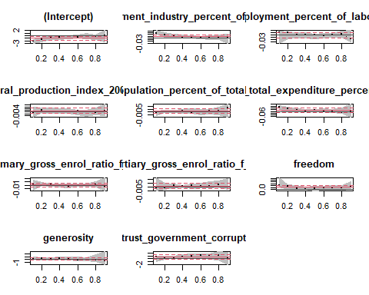

## Quantile Regression Analysis of Deviance Table  
##   
## Model: migration_growth ~ employment_industry_percent_of_employed + unemployment_percent_of_labour_force + agricultural_production_index_2004_2006_100 + urban_population_percent_of_total_population + health_total_expenditure_percent_of_gdp + education_primary_gross_enrol_ratio_f_m_per_100_pop + education_tertiary_gross_enrol_ratio_f_m_per_100_pop + freedom + generosity + trust_government_corruption  
## Joint Test of Equality of Slopes: tau in { 0.1 0.2 0.3 0.4 0.5 0.6 0.7 0.8 0.9 }  
##   
## Df Resid Df F value Pr(>F)  
## 1 80 757 0.8318 0.8495

print("Kvantilių regresija natūraliam prieaugiui")

## [1] "Kvantilių regresija natūraliam prieaugiui"

data <- regression_train %>% dplyr::select(-migration_growth)  
tau <- seq(0.1,0.9,0.1)  
formula <- natural_growth ~ .  
  
model_quantile_migration <- quantile_fit()

##   
## Call: rq(formula = formula, tau = tau, data = data)  
##   
## tau: [1] 0.1  
##   
## Coefficients:  
## Value Std. Error  
## (Intercept) -0.42120 1.93842   
## employment_industry_percent_of_employed -0.02665 0.02579   
## unemployment_percent_of_labour_force 0.01321 0.02721   
## agricultural_production_index_2004_2006_100 0.01077 0.00613   
## urban_population_percent_of_total_population -0.00122 0.00949   
## health_total_expenditure_percent_of_gdp 0.02983 0.06051   
## education_primary_gross_enrol_ratio_f_m_per_100_pop 0.00152 0.01523   
## education_tertiary_gross_enrol_ratio_f_m_per_100_pop -0.01904 0.00720   
## freedom 1.39068 1.05332   
## generosity -0.27885 0.72989   
## trust_government_corruption -0.28614 1.40898   
## t value Pr(>|t|)  
## (Intercept) -0.21729 0.82850  
## employment_industry_percent_of_employed -1.03361 0.30422  
## unemployment_percent_of_labour_force 0.48548 0.62857  
## agricultural_production_index_2004_2006_100 1.75561 0.08272  
## urban_population_percent_of_total_population -0.12885 0.89778  
## health_total_expenditure_percent_of_gdp 0.49295 0.62331  
## education_primary_gross_enrol_ratio_f_m_per_100_pop 0.09996 0.92061  
## education_tertiary_gross_enrol_ratio_f_m_per_100_pop -2.64570 0.00969  
## freedom 1.32029 0.19024  
## generosity -0.38205 0.70337  
## trust_government_corruption -0.20308 0.83955  
##   
## Call: rq(formula = formula, tau = tau, data = data)  
##   
## tau: [1] 0.2  
##   
## Coefficients:  
## Value Std. Error  
## (Intercept) 1.68145 1.77738   
## employment_industry_percent_of_employed -0.06124 0.02171   
## unemployment_percent_of_labour_force 0.00899 0.02277   
## agricultural_production_index_2004_2006_100 0.01031 0.00659   
## urban_population_percent_of_total_population -0.00178 0.00785   
## health_total_expenditure_percent_of_gdp 0.01368 0.06180   
## education_primary_gross_enrol_ratio_f_m_per_100_pop -0.00350 0.01390   
## education_tertiary_gross_enrol_ratio_f_m_per_100_pop -0.02107 0.00750   
## freedom 0.75076 1.17501   
## generosity -0.64089 0.81195   
## trust_government_corruption 0.35721 1.26013   
## t value Pr(>|t|)  
## (Intercept) 0.94603 0.34679  
## employment_industry_percent_of_employed -2.82111 0.00594  
## unemployment_percent_of_labour_force 0.39483 0.69394  
## agricultural_production_index_2004_2006_100 1.56533 0.12118  
## urban_population_percent_of_total_population -0.22684 0.82109  
## health_total_expenditure_percent_of_gdp 0.22145 0.82527  
## education_primary_gross_enrol_ratio_f_m_per_100_pop -0.25180 0.80179  
## education_tertiary_gross_enrol_ratio_f_m_per_100_pop -2.80816 0.00616  
## freedom 0.63894 0.52456  
## generosity -0.78933 0.43209  
## trust_government_corruption 0.28347 0.77750  
##   
## Call: rq(formula = formula, tau = tau, data = data)  
##   
## tau: [1] 0.3  
##   
## Coefficients:  
## Value Std. Error  
## (Intercept) 2.52828 1.64688   
## employment_industry_percent_of_employed -0.04821 0.01813   
## unemployment_percent_of_labour_force 0.00704 0.02186   
## agricultural_production_index_2004_2006_100 0.00941 0.00567   
## urban_population_percent_of_total_population 0.00282 0.00699   
## health_total_expenditure_percent_of_gdp -0.08034 0.06018   
## education_primary_gross_enrol_ratio_f_m_per_100_pop -0.00526 0.01286   
## education_tertiary_gross_enrol_ratio_f_m_per_100_pop -0.02103 0.00639   
## freedom -0.07925 1.16353   
## generosity -0.79698 0.75777   
## trust_government_corruption 1.73131 1.29610   
## t value Pr(>|t|)  
## (Intercept) 1.53519 0.12841  
## employment_industry_percent_of_employed -2.65968 0.00933  
## unemployment_percent_of_labour_force 0.32209 0.74816  
## agricultural_production_index_2004_2006_100 1.65938 0.10068  
## urban_population_percent_of_total_population 0.40244 0.68836  
## health_total_expenditure_percent_of_gdp -1.33495 0.18542  
## education_primary_gross_enrol_ratio_f_m_per_100_pop -0.40920 0.68341  
## education_tertiary_gross_enrol_ratio_f_m_per_100_pop -3.29161 0.00145  
## freedom -0.06811 0.94585  
## generosity -1.05173 0.29587  
## trust_government_corruption 1.33579 0.18514  
##   
## Call: rq(formula = formula, tau = tau, data = data)  
##   
## tau: [1] 0.4  
##   
## Coefficients:  
## Value Std. Error  
## (Intercept) 2.54139 1.51997   
## employment_industry_percent_of_employed -0.04577 0.01538   
## unemployment_percent_of_labour_force 0.00159 0.02049   
## agricultural_production_index_2004_2006_100 0.00996 0.00623   
## urban_population_percent_of_total_population 0.00128 0.00687   
## health_total_expenditure_percent_of_gdp -0.07234 0.05775   
## education_primary_gross_enrol_ratio_f_m_per_100_pop -0.00404 0.01126   
## education_tertiary_gross_enrol_ratio_f_m_per_100_pop -0.01986 0.00626   
## freedom -0.25945 1.20921   
## generosity -0.88157 1.01058   
## trust_government_corruption 1.42596 1.04033   
## t value Pr(>|t|)  
## (Intercept) 1.67200 0.09816  
## employment_industry_percent_of_employed -2.97487 0.00380  
## unemployment_percent_of_labour_force 0.07765 0.93829  
## agricultural_production_index_2004_2006_100 1.59724 0.11388  
## urban_population_percent_of_total_population 0.18702 0.85209  
## health_total_expenditure_percent_of_gdp -1.25257 0.21376  
## education_primary_gross_enrol_ratio_f_m_per_100_pop -0.35868 0.72071  
## education_tertiary_gross_enrol_ratio_f_m_per_100_pop -3.17096 0.00211  
## freedom -0.21456 0.83062  
## generosity -0.87234 0.38545  
## trust_government_corruption 1.37068 0.17404  
##   
## Call: rq(formula = formula, tau = tau, data = data)  
##   
## tau: [1] 0.5  
##   
## Coefficients:  
## Value Std. Error  
## (Intercept) 1.60165 1.53934   
## employment_industry_percent_of_employed -0.03852 0.01733   
## unemployment_percent_of_labour_force 0.00790 0.02425   
## agricultural_production_index_2004_2006_100 0.01169 0.00596   
## urban_population_percent_of_total_population -0.00193 0.00741   
## health_total_expenditure_percent_of_gdp -0.04795 0.05238   
## education_primary_gross_enrol_ratio_f_m_per_100_pop 0.00247 0.01184   
## education_tertiary_gross_enrol_ratio_f_m_per_100_pop -0.01954 0.00642   
## freedom -0.42602 1.09216   
## generosity -0.23533 1.19019   
## trust_government_corruption 0.90956 0.85438   
## t value Pr(>|t|)  
## (Intercept) 1.04048 0.30104  
## employment_industry_percent_of_employed -2.22251 0.02887  
## unemployment_percent_of_labour_force 0.32554 0.74556  
## agricultural_production_index_2004_2006_100 1.96369 0.05280  
## urban_population_percent_of_total_population -0.25981 0.79563  
## health_total_expenditure_percent_of_gdp -0.91535 0.36257  
## education_primary_gross_enrol_ratio_f_m_per_100_pop 0.20858 0.83527  
## education_tertiary_gross_enrol_ratio_f_m_per_100_pop -3.04432 0.00309  
## freedom -0.39007 0.69745  
## generosity -0.19772 0.84373  
## trust_government_corruption 1.06459 0.29004  
##   
## Call: rq(formula = formula, tau = tau, data = data)  
##   
## tau: [1] 0.6  
##   
## Coefficients:  
## Value Std. Error  
## (Intercept) 2.44890 1.57908   
## employment_industry_percent_of_employed -0.03048 0.01895   
## unemployment_percent_of_labour_force 0.00573 0.01908   
## agricultural_production_index_2004_2006_100 0.00955 0.00612   
## urban_population_percent_of_total_population -0.00482 0.00867   
## health_total_expenditure_percent_of_gdp -0.04561 0.05396   
## education_primary_gross_enrol_ratio_f_m_per_100_pop 0.00009 0.01059   
## education_tertiary_gross_enrol_ratio_f_m_per_100_pop -0.01851 0.00659   
## freedom -0.93331 1.04947   
## generosity 0.02964 1.43427   
## trust_government_corruption 0.56498 1.02814   
## t value Pr(>|t|)  
## (Intercept) 1.55084 0.12461  
## employment_industry_percent_of_employed -1.60868 0.11135  
## unemployment_percent_of_labour_force 0.30044 0.76457  
## agricultural_production_index_2004_2006_100 1.56042 0.12233  
## urban_population_percent_of_total_population -0.55630 0.57945  
## health_total_expenditure_percent_of_gdp -0.84540 0.40023  
## education_primary_gross_enrol_ratio_f_m_per_100_pop 0.00863 0.99314  
## education_tertiary_gross_enrol_ratio_f_m_per_100_pop -2.81017 0.00613  
## freedom -0.88932 0.37631  
## generosity 0.02067 0.98356  
## trust_government_corruption 0.54952 0.58407  
##   
## Call: rq(formula = formula, tau = tau, data = data)  
##   
## tau: [1] 0.7  
##   
## Coefficients:  
## Value Std. Error  
## (Intercept) 2.25692 1.56131   
## employment_industry_percent_of_employed -0.02120 0.01728   
## unemployment_percent_of_labour_force 0.00136 0.01798   
## agricultural_production_index_2004_2006_100 0.01055 0.00656   
## urban_population_percent_of_total_population -0.00528 0.00848   
## health_total_expenditure_percent_of_gdp -0.06905 0.05209   
## education_primary_gross_enrol_ratio_f_m_per_100_pop 0.00299 0.01070   
## education_tertiary_gross_enrol_ratio_f_m_per_100_pop -0.01698 0.00680   
## freedom -1.99306 1.01761   
## generosity 1.72148 1.37841   
## trust_government_corruption 0.51851 0.98507   
## t value Pr(>|t|)  
## (Intercept) 1.44552 0.15194  
## employment_industry_percent_of_employed -1.22652 0.22335  
## unemployment_percent_of_labour_force 0.07556 0.93995  
## agricultural_production_index_2004_2006_100 1.60813 0.11147  
## urban_population_percent_of_total_population -0.62276 0.53509  
## health_total_expenditure_percent_of_gdp -1.32563 0.18847  
## education_primary_gross_enrol_ratio_f_m_per_100_pop 0.27931 0.78068  
## education_tertiary_gross_enrol_ratio_f_m_per_100_pop -2.49789 0.01440  
## freedom -1.95858 0.05340  
## generosity 1.24889 0.21509  
## trust_government_corruption 0.52637 0.59998  
##   
## Call: rq(formula = formula, tau = tau, data = data)  
##   
## tau: [1] 0.8  
##   
## Coefficients:  
## Value Std. Error  
## (Intercept) 3.51817 1.27208   
## employment_industry_percent_of_employed -0.01913 0.01792   
## unemployment_percent_of_labour_force -0.00572 0.02489   
## agricultural_production_index_2004_2006_100 0.00997 0.00587   
## urban_population_percent_of_total_population -0.00870 0.00842   
## health_total_expenditure_percent_of_gdp -0.04272 0.05163   
## education_primary_gross_enrol_ratio_f_m_per_100_pop -0.00499 0.00875   
## education_tertiary_gross_enrol_ratio_f_m_per_100_pop -0.01648 0.00706   
## freedom -1.81640 1.04281   
## generosity 0.78080 1.18301   
## trust_government_corruption 0.32198 1.16655   
## t value Pr(>|t|)  
## (Intercept) 2.76568 0.00695  
## employment_industry_percent_of_employed -1.06735 0.28880  
## unemployment_percent_of_labour_force -0.22994 0.81869  
## agricultural_production_index_2004_2006_100 1.69901 0.09293  
## urban_population_percent_of_total_population -1.03305 0.30448  
## health_total_expenditure_percent_of_gdp -0.82732 0.41035  
## education_primary_gross_enrol_ratio_f_m_per_100_pop -0.57055 0.56979  
## education_tertiary_gross_enrol_ratio_f_m_per_100_pop -2.33439 0.02191  
## freedom -1.74184 0.08511  
## generosity 0.66001 0.51101  
## trust_government_corruption 0.27601 0.78321  
##   
## Call: rq(formula = formula, tau = tau, data = data)  
##   
## tau: [1] 0.9  
##   
## Coefficients:  
## Value Std. Error  
## (Intercept) 4.66105 1.43052   
## employment_industry_percent_of_employed -0.02358 0.01870   
## unemployment_percent_of_labour_force -0.00163 0.02782   
## agricultural_production_index_2004_2006_100 0.00310 0.00545   
## urban_population_percent_of_total_population -0.00424 0.00823   
## health_total_expenditure_percent_of_gdp -0.07877 0.05170   
## education_primary_gross_enrol_ratio_f_m_per_100_pop -0.00377 0.00853   
## education_tertiary_gross_enrol_ratio_f_m_per_100_pop -0.01734 0.00628   
## freedom -1.87499 1.10334   
## generosity 0.59091 1.07216   
## trust_government_corruption 0.21857 1.15676   
## t value Pr(>|t|)  
## (Intercept) 3.25829 0.00161  
## employment_industry_percent_of_employed -1.26125 0.21063  
## unemployment_percent_of_labour_force -0.05866 0.95336  
## agricultural_production_index_2004_2006_100 0.56818 0.57139  
## urban_population_percent_of_total_population -0.51528 0.60768  
## health_total_expenditure_percent_of_gdp -1.52374 0.13124  
## education_primary_gross_enrol_ratio_f_m_per_100_pop -0.44259 0.65917  
## education_tertiary_gross_enrol_ratio_f_m_per_100_pop -2.76400 0.00698  
## freedom -1.69937 0.09286  
## generosity 0.55114 0.58297  
## trust_government_corruption 0.18895 0.85058

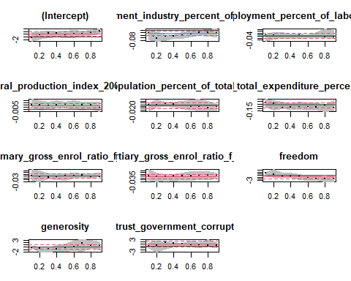

## Quantile Regression Analysis of Deviance Table  
##   
## Model: natural_growth ~ employment_industry_percent_of_employed + unemployment_percent_of_labour_force + agricultural_production_index_2004_2006_100 + urban_population_percent_of_total_population + health_total_expenditure_percent_of_gdp + education_primary_gross_enrol_ratio_f_m_per_100_pop + education_tertiary_gross_enrol_ratio_f_m_per_100_pop + freedom + generosity + trust_government_corruption  
## Joint Test of Equality of Slopes: tau in { 0.1 0.2 0.3 0.4 0.5 0.6 0.7 0.8 0.9 }  
##   
## Df Resid Df F value Pr(>F)   
## 1 80 793 2.2304 2.768e-08 ***  
## ---  
## Signif. codes: 0 '***' 0.001 '**' 0.01 '*' 0.05 '.' 0.1 ' ' 1

library(mgcv)  
library(gratia)  
  
fit_gam <- function(formula, data) {  
 model_gam <- gam(formula, data = data, select = TRUE)  
 gam.check(model_gam)  
 summary(model_gam)  
 draw(model_gam)  
 k.check(model_gam)  
 model_gam  
}

print("GAM migracijos prieaugiui")

## [1] "GAM migracijos prieaugiui"

data <- regression_train %>% dplyr::select(-natural_growth) %>% slice(-outlier_indices)  
  
# model_gam_migration <- fit_gam(migration_growth ~ employment_industry_percent_of_employed +  
# s(unemployment_percent_of_labour_force,k=15) +   
# s(agricultural_production_index_2004_2006_100,k=15) +   
# urban_population_percent_of_total_population +  
# health_total_expenditure_percent_of_gdp +   
# education_primary_gross_enrol_ratio_f_m_per_100_pop +   
# education_tertiary_gross_enrol_ratio_f_m_per_100_pop +   
# freedom +   
# s(generosity,k=15) +  
# s(trust_government_corruption,k=15), data)  
#   
#   
# draw(model_gam_migration)  
# k.check(model_gam_migration)  
# summary(model_gam_migration)  
  
  
model_gam_migration <- fit_gam(migration_growth ~ employment_industry_percent_of_employed +  
 s(agricultural_production_index_2004_2006_100,k=15) +   
 urban_population_percent_of_total_population +  
 health_total_expenditure_percent_of_gdp +   
 education_primary_gross_enrol_ratio_f_m_per_100_pop +   
 education_tertiary_gross_enrol_ratio_f_m_per_100_pop +   
 freedom +   
 s(generosity,k=15) +  
 s(trust_government_corruption,k=15), data)

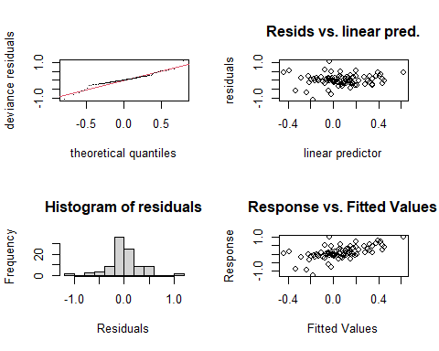

##   
## Method: GCV Optimizer: magic  
## Smoothing parameter selection converged after 15 iterations.  
## The RMS GCV score gradient at convergence was 4.587417e-08 .  
## The Hessian was positive definite.  
## Model rank = 49 / 49   
##   
## Basis dimension (k) checking results. Low p-value (k-index<1) may  
## indicate that k is too low, especially if edf is close to k'.  
##   
## k' edf k-index p-value  
## s(agricultural_production_index_2004_2006_100) 14.000 1.797 1.26 0.98  
## s(generosity) 14.000 1.580 0.88 0.12  
## s(trust_government_corruption) 14.000 0.495 1.03 0.61

draw(model_gam_migration)

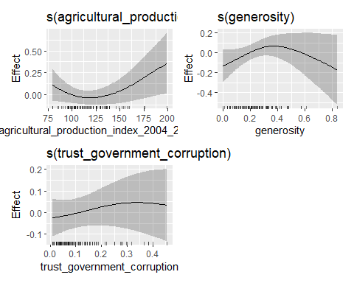

k.check(model_gam_migration)

## k' edf k-index p-value  
## s(agricultural_production_index_2004_2006_100) 14 1.7972446 1.2597192 0.9925  
## s(generosity) 14 1.5804495 0.8750931 0.1000  
## s(trust_government_corruption) 14 0.4952306 1.0329735 0.5800

summary(model_gam_migration)

##   
## Family: gaussian   
## Link function: identity   
##   
## Formula:  
## migration_growth ~ employment_industry_percent_of_employed +   
## s(agricultural_production_index_2004_2006_100, k = 15) +   
## urban_population_percent_of_total_population + health_total_expenditure_percent_of_gdp +   
## education_primary_gross_enrol_ratio_f_m_per_100_pop + education_tertiary_gross_enrol_ratio_f_m_per_100_pop +   
## freedom + s(generosity, k = 15) + s(trust_government_corruption,   
## k = 15)  
##   
## Parametric coefficients:  
## Estimate Std. Error  
## (Intercept) -0.872661 0.374593  
## employment_industry_percent_of_employed 0.009393 0.005496  
## urban_population_percent_of_total_population 0.001737 0.002512  
## health_total_expenditure_percent_of_gdp 0.006767 0.016331  
## education_primary_gross_enrol_ratio_f_m_per_100_pop 0.001940 0.003343  
## education_tertiary_gross_enrol_ratio_f_m_per_100_pop 0.001423 0.001907  
## freedom 0.802932 0.289687  
## t value Pr(>|t|)   
## (Intercept) -2.330 0.0223 *   
## employment_industry_percent_of_employed 1.709 0.0912 .   
## urban_population_percent_of_total_population 0.691 0.4914   
## health_total_expenditure_percent_of_gdp 0.414 0.6797   
## education_primary_gross_enrol_ratio_f_m_per_100_pop 0.580 0.5632   
## education_tertiary_gross_enrol_ratio_f_m_per_100_pop 0.746 0.4577   
## freedom 2.772 0.0069 **  
## ---  
## Signif. codes: 0 '***' 0.001 '**' 0.01 '*' 0.05 '.' 0.1 ' ' 1  
##   
## Approximate significance of smooth terms:  
## edf Ref.df F p-value   
## s(agricultural_production_index_2004_2006_100) 1.7972 14 0.323 0.0689 .  
## s(generosity) 1.5804 14 0.273 0.0805 .  
## s(trust_government_corruption) 0.4952 13 0.064 0.1808   
## ---  
## Signif. codes: 0 '***' 0.001 '**' 0.01 '*' 0.05 '.' 0.1 ' ' 1  
##   
## R-sq.(adj) = 0.275 Deviance explained = 35.3%  
## GCV = 0.11067 Scale est. = 0.097731 n = 93

print("GAM natūraliam prieaugiui")

## [1] "GAM natūraliam prieaugiui"

# model_gam_natural <- fit_gam(natural_growth ~ employment_industry_percent_of_employed +  
# s(unemployment_percent_of_labour_force) +   
# agricultural_production_index_2004_2006_100 +   
# urban_population_percent_of_total_population +  
# s(health_total_expenditure_percent_of_gdp) +   
# s(education_primary_gross_enrol_ratio_f_m_per_100_pop) +   
# education_tertiary_gross_enrol_ratio_f_m_per_100_pop +   
# freedom +   
# s(generosity) +  
# s(trust_government_corruption), regression_train %>% dplyr::select(-migration_growth))  
#   
#   
# draw(model_gam_natural)  
# k.check(model_gam_natural)  
# summary(model_gam_natural)  
  
  
model_gam_natural <- fit_gam(natural_growth ~ employment_industry_percent_of_employed +   
 agricultural_production_index_2004_2006_100 +   
 urban_population_percent_of_total_population +  
 s(health_total_expenditure_percent_of_gdp) +   
 s(education_primary_gross_enrol_ratio_f_m_per_100_pop) +   
 education_tertiary_gross_enrol_ratio_f_m_per_100_pop +   
 freedom +   
 s(trust_government_corruption), regression_train %>% dplyr::select(-migration_growth))

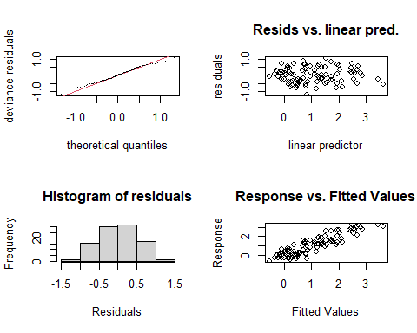

##   
## Method: GCV Optimizer: magic  
## Smoothing parameter selection converged after 22 iterations.  
## The RMS GCV score gradient at convergence was 3.986037e-08 .  
## The Hessian was positive definite.  
## Model rank = 33 / 33   
##   
## Basis dimension (k) checking results. Low p-value (k-index<1) may  
## indicate that k is too low, especially if edf is close to k'.  
##   
## k' edf k-index  
## s(health_total_expenditure_percent_of_gdp) 9.00 0.15 0.93  
## s(education_primary_gross_enrol_ratio_f_m_per_100_pop) 9.00 6.82 1.07  
## s(trust_government_corruption) 9.00 6.17 1.06  
## p-value  
## s(health_total_expenditure_percent_of_gdp) 0.24  
## s(education_primary_gross_enrol_ratio_f_m_per_100_pop) 0.72  
## s(trust_government_corruption) 0.64

draw(model_gam_natural)

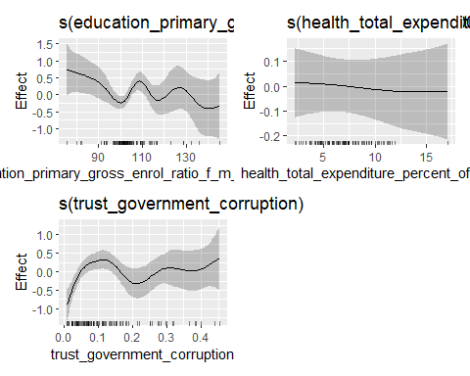

k.check(model_gam_natural)

## k' edf k-index  
## s(health_total_expenditure_percent_of_gdp) 9 0.1502352 0.9280672  
## s(education_primary_gross_enrol_ratio_f_m_per_100_pop) 9 6.8163434 1.0676728  
## s(trust_government_corruption) 9 6.1733842 1.0570000  
## p-value  
## s(health_total_expenditure_percent_of_gdp) 0.2200  
## s(education_primary_gross_enrol_ratio_f_m_per_100_pop) 0.7200  
## s(trust_government_corruption) 0.6275

summary(model_gam_natural)

##   
## Family: gaussian   
## Link function: identity   
##   
## Formula:  
## natural_growth ~ employment_industry_percent_of_employed + agricultural_production_index_2004_2006_100 +   
## urban_population_percent_of_total_population + s(health_total_expenditure_percent_of_gdp) +   
## s(education_primary_gross_enrol_ratio_f_m_per_100_pop) +   
## education_tertiary_gross_enrol_ratio_f_m_per_100_pop + freedom +   
## s(trust_government_corruption)  
##   
## Parametric coefficients:  
## Estimate Std. Error  
## (Intercept) 1.664170 0.459710  
## employment_industry_percent_of_employed -0.019568 0.008166  
## agricultural_production_index_2004_2006_100 0.010253 0.002860  
## urban_population_percent_of_total_population -0.006251 0.004304  
## education_tertiary_gross_enrol_ratio_f_m_per_100_pop -0.015914 0.003159  
## freedom -0.664638 0.498042  
## t value Pr(>|t|)   
## (Intercept) 3.620 0.000522 ***  
## employment_industry_percent_of_employed -2.396 0.018955 *   
## agricultural_production_index_2004_2006_100 3.585 0.000585 ***  
## urban_population_percent_of_total_population -1.452 0.150403   
## education_tertiary_gross_enrol_ratio_f_m_per_100_pop -5.037 2.99e-06 ***  
## freedom -1.335 0.185929   
## ---  
## Signif. codes: 0 '***' 0.001 '**' 0.01 '*' 0.05 '.' 0.1 ' ' 1  
##   
## Approximate significance of smooth terms:  
## edf Ref.df F  
## s(health_total_expenditure_percent_of_gdp) 0.1502 9 0.019  
## s(education_primary_gross_enrol_ratio_f_m_per_100_pop) 6.8163 9 2.314  
## s(trust_government_corruption) 6.1734 9 2.959  
## p-value   
## s(health_total_expenditure_percent_of_gdp) 0.293332   
## s(education_primary_gross_enrol_ratio_f_m_per_100_pop) 0.004824 **   
## s(trust_government_corruption) 0.000346 ***  
## ---  
## Signif. codes: 0 '***' 0.001 '**' 0.01 '*' 0.05 '.' 0.1 ' ' 1  
##   
## R-sq.(adj) = 0.768 Deviance explained = 81.2%  
## GCV = 0.34189 Scale est. = 0.27443 n = 97

library(yardstick)  
  
  
regression_eval <- function(column, model_linear, model_gam) {  
 print(AIC(model_linear))  
 print(AIC(model_gam))  
  
  
 regression_test <- test %>%  
 mutate(  
 predicted_linear = predict(model_linear, test),  
 predicted_gam = predict(model_gam, test)  
 )  
  
 set <- metric_set(rmse, mae)  
   
 print("Tiesinis modelis")  
 print(set(regression_test, {{ column }}, predicted_linear))  
 print("GAM modelis")  
 print(set(regression_test, {{ column }}, predicted_gam))  
  
 regression_test %>%  
 pivot_longer(c(predicted_gam, predicted_linear)) %>%  
 mutate(name = factor(name, levels = c("predicted_linear", "predicted_gam"))) %>%  
 ggplot(aes({{ column }}, value)) +  
 geom_point(size = 2) +  
 facet_wrap(vars(name)) +  
 geom_abline(color = "red", size = 2.25) +  
 labs(x = "Tikros reikšmės", y = "Prognozuotos reikmšės",  
 title = "Prognozuotos ir tikros reikšmės testavimo aibei") +  
 theme_minimal()  
}

print("Regresija migracijos prieaugiui")

## [1] "Regresija migracijos prieaugiui"

regression_eval(migration_growth, model_linear_migration, model_gam_migration)

## [1] 60.18487  
## [1] 59.83029  
## [1] "Tiesinis modelis"  
## # A tibble: 2 x 3  
## .metric .estimator .estimate  
## <chr> <chr> <dbl>  
## 1 rmse standard 0.368  
## 2 mae standard 0.260  
## [1] "GAM modelis"  
## # A tibble: 2 x 3  
## .metric .estimator .estimate  
## <chr> <chr> <dbl>  
## 1 rmse standard 0.351  
## 2 mae standard 0.264

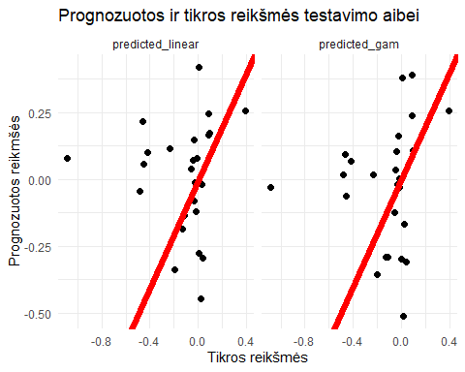

print("Regresija natūraliam prieaugiui")

## [1] "Regresija natūraliam prieaugiui"

regression_eval(natural_growth, model_linear_natural, model_gam_natural)

## [1] 196.1966  
## [1] 168.8067  
## [1] "Tiesinis modelis"  
## # A tibble: 2 x 3  
## .metric .estimator .estimate  
## <chr> <chr> <dbl>  
## 1 rmse standard 0.593  
## 2 mae standard 0.509  
## [1] "GAM modelis"  
## # A tibble: 2 x 3  
## .metric .estimator .estimate  
## <chr> <chr> <dbl>  
## 1 rmse standard 0.676  
## 2 mae standard 0.567

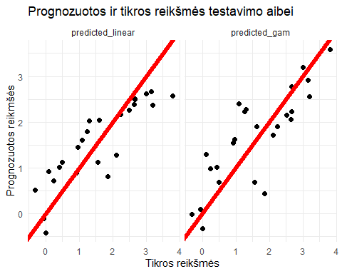

### Classification model

classification_train <- train %>% dplyr::select(-migration_growth,-natural_growth)

classification_train %>%  
 dplyr::select(1:6, category) %>%  
 pivot_longer(-category) %>%  
 ggplot(aes(x = category, y = value, fill = category)) +  
 facet_wrap(vars(name), scales = "free") +  
 geom_boxplot() +  
 theme_minimal() + labs(title="Kovariančių reikšmių pasiskirstymas pagal klases")

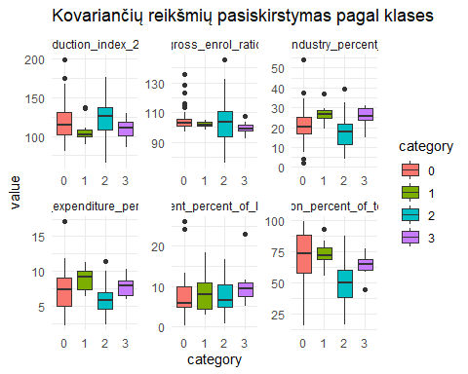

classification_train %>%  
 dplyr::select(7:length(classification_train), category) %>%  
 pivot_longer(-category) %>%  
 ggplot(aes(x = category, y = value, fill = category)) +  
 facet_wrap(vars(name), scales = "free") +  
 geom_boxplot() +  
 theme_minimal() + labs(title="Kovariančių reikšmių pasiskirstymas pagal klases")

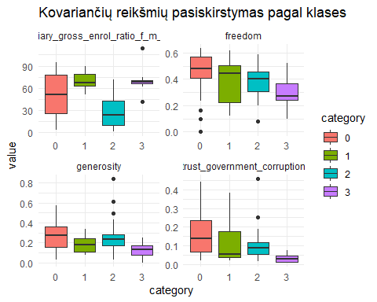

summary(model_logistic)

## Call:  
## nnet::multinom(formula = category ~ urban_population_percent_of_total_population +   
## education_tertiary_gross_enrol_ratio_f_m_per_100_pop + generosity +   
## trust_government_corruption, data = classification_train,   
## trace = FALSE)  
##   
## Coefficients:  
## (Intercept) urban_population_percent_of_total_population  
## 1 -1.839977 -0.02292679  
## 2 2.578573 -0.01467582  
## 3 5.840115 -0.19858260  
## education_tertiary_gross_enrol_ratio_f_m_per_100_pop generosity  
## 1 0.05915418 -6.961649  
## 2 -0.03401824 -1.223110  
## 3 0.15242683 -10.951204  
## trust_government_corruption  
## 1 -0.8558754  
## 2 -4.2532490  
## 3 -39.8926077  
##   
## Std. Errors:  
## (Intercept) urban_population_percent_of_total_population  
## 1 2.137231 0.03566644  
## 2 1.017057 0.01748405  
## 3 3.858561 0.09723409  
## education_tertiary_gross_enrol_ratio_f_m_per_100_pop generosity  
## 1 0.02581411 3.790026  
## 2 0.01560751 1.809865  
## 3 0.06443421 6.041646  
## trust_government_corruption  
## 1 4.031785  
## 2 3.078319  
## 3 22.929942  
##   
## Residual Deviance: 154.4864   
## AIC: 184.4864

plot(predictorEffects(model_logistic))

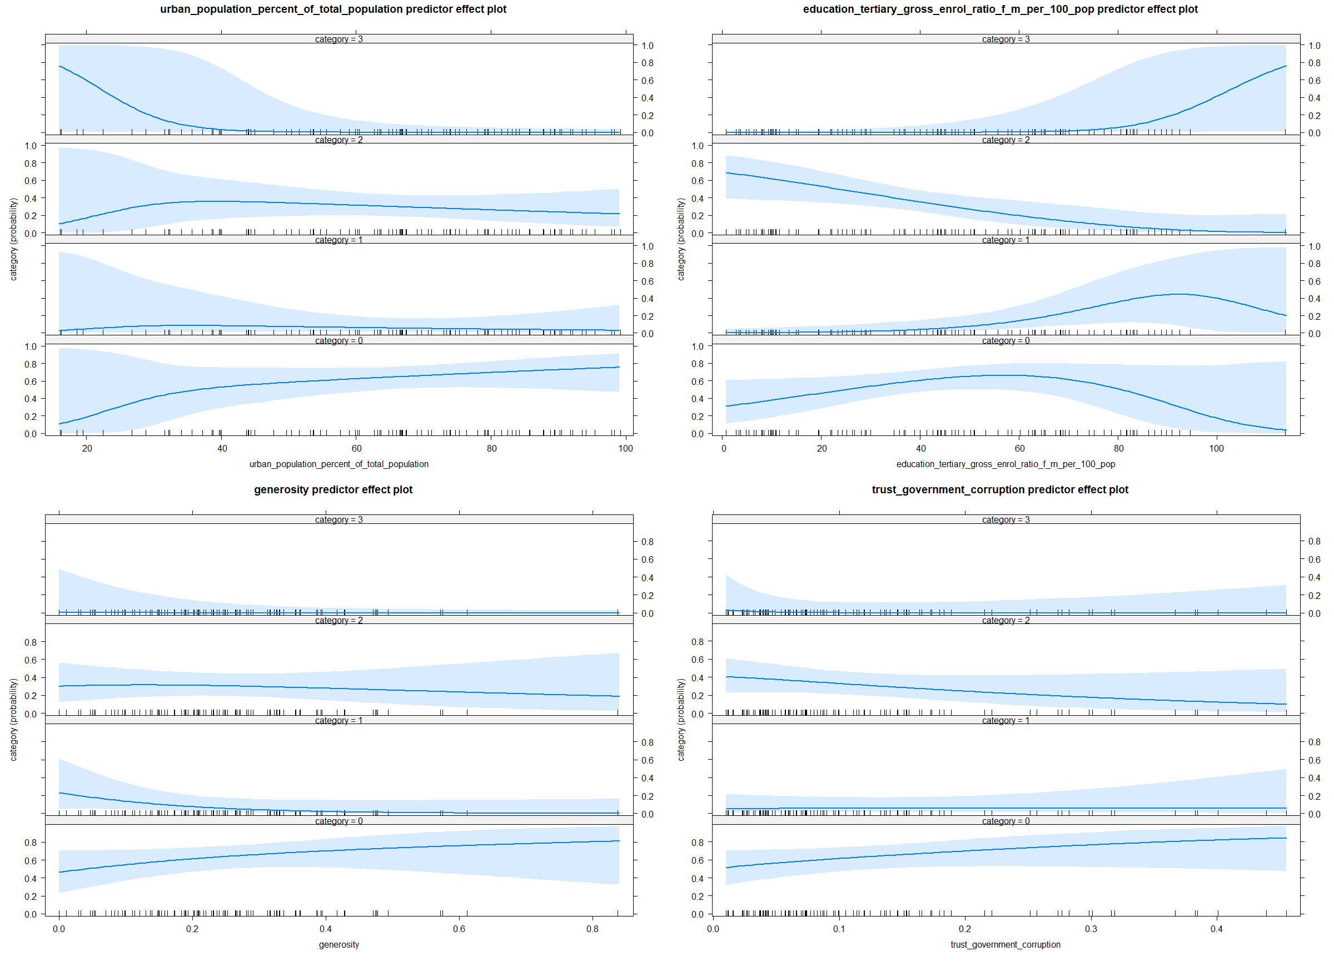

eval_classification <- function(model, classification_train) {  
 df_pred_truth <- tibble(  
 predicted = factor(predict(model, classification_train)),  
 truth = classification_train$category  
 ) %>% cbind(as.data.frame(model$fitted.values))  
  
  
 classification_metrics <- metric_set(accuracy, f_meas)  
  
 print("Maišos matrica")  
 print(conf_mat(df_pred_truth,  
 truth = truth,  
 estimate = predicted  
 ))  
  
 print("Modelio kokybės metrikos")  
 print(classification_metrics(df_pred_truth,  
 truth = truth,  
 estimate = predicted  
 ))  
  
 print(roc_auc(df_pred_truth, truth = truth, c("0", "1", "2", "3"), estimator = "macro"))  
  
 roc_curve(df_pred_truth, truth = truth, c("0", "1", "2", "3")) %>%  
 autoplot()  
}  
  
eval_classification(model_logistic, classification_train)

## [1] "Maišos matrica"  
## Truth  
## Prediction 0 1 2 3  
## 0 30 8 12 1  
## 1 3 1 0 0  
## 2 11 0 19 0  
## 3 3 1 1 7  
## [1] "Modelio kokybės metrikos"  
## # A tibble: 2 x 3  
## .metric .estimator .estimate  
## <chr> <chr> <dbl>  
## 1 accuracy multiclass 0.588  
## 2 f_meas macro 0.517  
## # A tibble: 1 x 3  
## .metric .estimator .estimate  
## <chr> <chr> <dbl>  
## 1 roc_auc macro 0.844

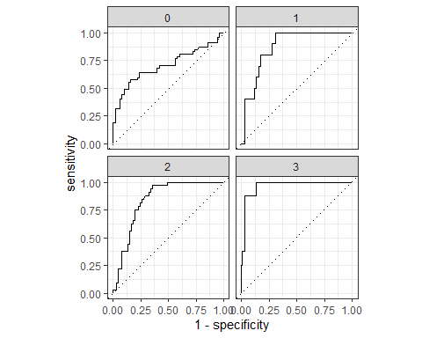

library(themis)  
  
smote_recipe <- recipe(category ~ .,  
 data = classification_train) %>%  
 step_smote(category)  
  
  
smote_recipe <- prep(smote_recipe, training = classification_train)  
  
classification_train2 <- bake(smote_recipe, NULL)

model_logistic2 <- nnet::multinom(category ~ ., data = classification_train2, trace = FALSE)  
  
model_logistic2 <- stats::step(model_logistic2, direction = "both")

summary(model_logistic2)

## Call:  
## nnet::multinom(formula = category ~ employment_industry_percent_of_employed +   
## urban_population_percent_of_total_population + health_total_expenditure_percent_of_gdp +   
## education_primary_gross_enrol_ratio_f_m_per_100_pop + education_tertiary_gross_enrol_ratio_f_m_per_100_pop +   
## freedom + generosity + trust_government_corruption, data = classification_train2,   
## trace = FALSE)  
##   
## Coefficients:  
## (Intercept) employment_industry_percent_of_employed  
## 1 -6.295933 0.39787698  
## 2 4.595093 0.04300743  
## 3 74.492451 -0.07552054  
## urban_population_percent_of_total_population  
## 1 -0.04776432  
## 2 -0.02732569  
## 3 -0.39809329  
## health_total_expenditure_percent_of_gdp  
## 1 0.87038067  
## 2 -0.06712819  
## 3 -0.00655054  
## education_primary_gross_enrol_ratio_f_m_per_100_pop  
## 1 -0.102712767  
## 2 -0.008330562  
## 3 -0.653960075  
## education_tertiary_gross_enrol_ratio_f_m_per_100_pop freedom generosity  
## 1 0.16003676 -13.289007 -20.283564  
## 2 -0.03058926 -1.290685 -1.207539  
## 3 0.38449203 8.981803 -24.912800  
## trust_government_corruption  
## 1 13.905642  
## 2 -4.067271  
## 3 -73.941779  
##   
## Std. Errors:  
## (Intercept) employment_industry_percent_of_employed  
## 1 10.049979 0.10592725  
## 2 3.140942 0.03994047  
## 3 9.246259 0.10612713  
## urban_population_percent_of_total_population  
## 1 0.04656784  
## 2 0.01938735  
## 3 0.10839517  
## health_total_expenditure_percent_of_gdp  
## 1 0.2342012  
## 2 0.1363112  
## 3 0.3032902  
## education_primary_gross_enrol_ratio_f_m_per_100_pop  
## 1 0.08337851  
## 2 0.02667869  
## 3 0.09284426  
## education_tertiary_gross_enrol_ratio_f_m_per_100_pop freedom generosity  
## 1 0.04193313 4.998406 4.781439  
## 2 0.01562352 2.451155 1.900708  
## 3 0.06801832 5.319684 7.748705  
## trust_government_corruption  
## 1 6.534729  
## 2 3.062060  
## 3 5.658675  
##   
## Residual Deviance: 209.9142   
## AIC: 263.9142

plot(predictorEffects(model_logistic2))

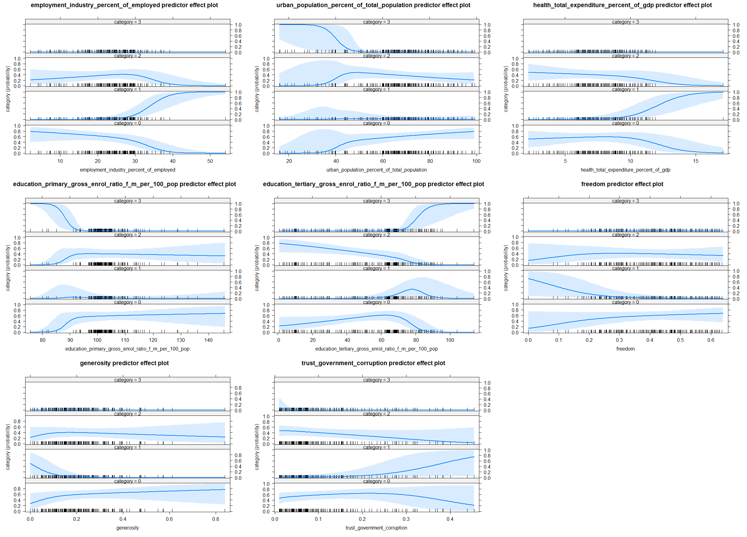

eval_classification(model_logistic2, classification_train2)

## [1] "Maišos matrica"  
## Truth  
## Prediction 0 1 2 3  
## 0 26 0 9 0  
## 1 7 46 0 0  
## 2 12 0 37 0  
## 3 2 1 1 47  
## [1] "Modelio kokybės metrikos"  
## # A tibble: 2 x 3  
## .metric .estimator .estimate  
## <chr> <chr> <dbl>  
## 1 accuracy multiclass 0.830  
## 2 f_meas macro 0.821  
## # A tibble: 1 x 3  
## .metric .estimator .estimate  
## <chr> <chr> <dbl>  
## 1 roc_auc macro 0.925

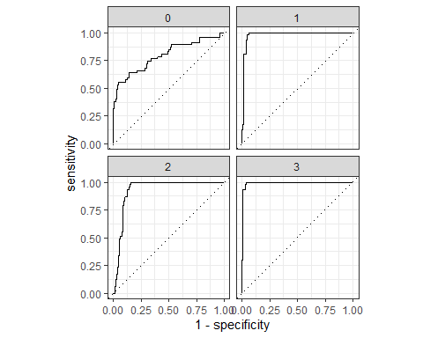

class_predictions <- function() {  
 tibble(  
 migration_growth = predict(model_gam_migration, test),  
 natural_growth = predict(model_gam_natural, test)  
 ) %>%  
 mutate(category = factor(case_when(  
 migration_growth >= 0 & natural_growth >= 0 ~ 0, # "P migration, P natural",  
 migration_growth >= 0 & natural_growth < 0 ~ 1, # "P migration, N natural",  
 migration_growth < 0 & natural_growth >= 0 ~ 2, # "N migration, P natural",  
 TRUE ~ 3  
 ))) %>%  
 pull(category) %>%  
 factor(levels = c(0, 1, 2, 3))  
}  
  
  
df_pred_truth <- tibble(  
 predicted_1 =  
 factor(predict(model_logistic, test),levels=c(0,1,2,3)),  
 predicted_2 =  
 factor(predict(model_logistic2, test),levels=c(0,1,2,3)),  
 predicted_3 = class_predictions(),  
 truth = test$category  
)  
  
  
classification_metrics <- metric_set(accuracy, f_meas)  
  
  
print("Pradinis modelis")

## [1] "Pradinis modelis"

conf_mat(df_pred_truth,  
 truth = truth,  
 estimate = predicted_1  
)

## Truth  
## Prediction 0 1 2 3  
## 0 2 0 3 0  
## 1 0 1 0 0  
## 2 5 0 10 0  
## 3 0 1 2 1

classification_metrics(df_pred_truth, truth, estimate = predicted_1)

## # A tibble: 2 x 3  
## .metric .estimator .estimate  
## <chr> <chr> <dbl>  
## 1 accuracy multiclass 0.56   
## 2 f_meas macro 0.517

print("SMOTE modelis")

## [1] "SMOTE modelis"

conf_mat(df_pred_truth,  
 truth = truth,  
 estimate = predicted_2  
)

## Truth  
## Prediction 0 1 2 3  
## 0 2 0 2 0  
## 1 0 1 0 0  
## 2 4 0 11 0  
## 3 1 1 2 1

classification_metrics(df_pred_truth, truth, estimate = predicted_2)

## # A tibble: 2 x 3  
## .metric .estimator .estimate  
## <chr> <chr> <dbl>  
## 1 accuracy multiclass 0.6   
## 2 f_meas macro 0.524

print("Naudojant du regresijos modelius")

## [1] "Naudojant du regresijos modelius"

conf_mat(df_pred_truth,  
 truth = truth,  
 estimate = predicted_3  
)

## Truth  
## Prediction 0 1 2 3  
## 0 3 1 7 0  
## 1 0 1 0 1  
## 2 4 0 8 0  
## 3 0 0 0 0

classification_metrics(df_pred_truth, truth, estimate = predicted_3)

## # A tibble: 2 x 3  
## .metric .estimator .estimate  
## <chr> <chr> <dbl>  
## 1 accuracy multiclass 0.48   
## 2 f_meas macro 0.475