Regresinės analizės projektinis darbas

Vainius Gataveckas, Matas Gaulia, Dovydas Martinkus

### Duomenų apdorojimas

library(tidyverse)  
library(janitor)  
library(countrycode)  
  
# Natūralaus gyventojų prieaugio duomenys  
pop_natural <- read_csv("natural-population-growth.csv") %>%  
 filter(Year == 2017) %>%  
 dplyr::select(1, 4) %>%  
 set_names(c("country", "natural_growth")) %>%  
 mutate(country = countryname(country))  
  
# Bendras gyventojų prieaugis iš kurio bus gaunamas migracijos prieaugis  
pop_total <- read_csv("population-growth-rates.csv") %>%  
 filter(Year == 2017) %>%  
 dplyr::select(1, 4) %>%  
 set_names(c("country", "total_growth")) %>%  
 mutate(country = countryname(country))  
  
  
# UNData duomenys  
country_stats <- read_csv("country_profile_variables.csv") %>%  
 clean_names() %>%  
 dplyr::select(-c(2, 3, 4, 5, 6, 7)) %>%  
 mutate(country = countryname(country))  
  
  
# World Happiness Report duomenys  
happiness <- read_csv("2017.csv") %>%  
 clean_names() %>%  
 dplyr::select(-c(2), -starts_with("whisker"), -c("dystopia_residual", "happiness_score", "family")) %>%  
 mutate(country = countryname(country))

x <- reduce(list(pop_natural, pop_total, country_stats, happiness), inner_join, by = "country")  
  
  
# Išfiltruojami nenaudinti kintamieji  
x <- x %>%  
 dplyr::select(  
 -starts_with("gdp"),  
 -starts_with("labour"),  
 -starts_with("international"),  
 -starts_with("balance"),  
 -starts_with("population"),  
 -starts_with("fertility"),  
 -starts_with("net"),  
 -starts_with("energy_prod"),  
 -starts_with("forest"),  
 -starts_with("threatened"),  
 -starts_with("seats"),  
 -starts_with("urban_population_growth"),  
 -starts_with("refugees"),  
 -starts_with("infant"),  
 -starts_with("life_expectancy"),  
 -starts_with("co2"),  
 -starts_with("economy"),  
 -starts_with("education_government"),  
 -starts_with("energy"),  
 -health_physicians_per_1000_pop,  
 -individuals_using_the_internet_per_100_inhabitants,  
 -mobile_cellular_subscriptions_per_100_inhabitants_40,  
 -pop_using_improved_sanitation_facilities_urban_rural_percent  
 ) %>%  
 mutate(across(everything(), ~ replace(., . %in% c("...", "-99", ".../..."), NA))) %>%  
 mutate(across(starts_with("education"), ~ str_split(., "/") %>% map(~ mean(as.numeric(.)))))  
  
  
pop <- x$pop_using_improved_drinking_water_urban_rural_percent  
f1 <- possibly(~ `[[`(.x, 1), 1)  
x$pop_using_improved_drinking_water_urban <- pop %>%  
 str_split("/") %>%  
 map(f1)  
f2 <- possibly(~ `[[`(.x, 2), 1)  
x$pop_using_improved_drinking_water_rural <- pop %>%  
 str_split("/") %>%  
 map(f2)  
  
  
x <- x %>%  
 dplyr::select(-pop_using_improved_drinking_water_urban_rural_percent) %>%  
 mutate(across(-country, as.numeric)) %>%  
 mutate(migration_growth = total_growth - natural_growth) %>%  
 drop_na() %>%  
 dplyr::select(-total_growth)

library(rsample)  
  
set.seed(123)  
  
# sudaramos kategorijos pagal tai ar migracijos/natūralus prieaugiai yra teigiami ar neigiami  
x <- x %>% mutate(  
 category = factor(case_when(  
 migration_growth >= 0 & natural_growth >= 0 ~ 0, # "P migation, P natural",  
 migration_growth >= 0 & natural_growth < 0 ~ 1, # "P migation, N natural",  
 migration_growth < 0 & natural_growth >= 0 ~ 2, # "N migation, P natural",  
 TRUE ~ 3 # "N migration, N natural"  
 ))  
)  
  
  
# padalijimas į mokymo ir testavimo aibes  
train_test_split <- initial_split(x, prop = 0.8)  
train <- training(train_test_split)  
test <- testing(train_test_split)  
  
country_train <- train$country  
country_test <- test$country  
  
train <- train %>% dplyr::select(-country)

library(recipes)  
  
# iš anksto panaikinami kintamieji, kurie labai stipriai koreliuoja su kitais  
correlated_recipe <- recipe(natural_growth ~ ., data = train) %>%  
 add_role(migration_growth, new_role = "outcome") %>%  
 add_role(category, new_role = "outcome") %>%  
 step_corr(all_numeric_predictors(), threshold = 0.8) %>%  
 step_nzv(all_numeric_predictors())  
  
  
correlated_recipe <- prep(correlated_recipe, training = train)  
  
train <- bake(correlated_recipe, NULL)

### Regresijos modeliai

library(corrplot)  
  
# koreliacijų grafikai  
regression_train <- train %>% dplyr::select(-category)  
  
correlation <- function(name, name2) {  
 correlation_matrix <- regression_train %>%  
 dplyr::select(1:5, {{ name }}, {{ name2 }}) %>%  
 set_names(., str_trunc(names(.), 15)) %>%  
 cor()  
  
 corrplot(correlation_matrix, order = "original", method = "color", type = "upper", diag = FALSE, tl.col = "black", addCoef.col = "black")  
  
  
  
 correlation_matrix <- regression_train %>%  
 dplyr::select(6:length(regression_train), {{ name }}, {{ name2 }}) %>%  
 set_names(., str_trunc(names(.), 15)) %>%  
 cor()  
  
 corrplot(correlation_matrix, order = "original", method = "color", type = "upper", diag = FALSE, tl.col = "black", addCoef.col = "black")  
}  
  
  
correlation(migration_growth, natural_growth)

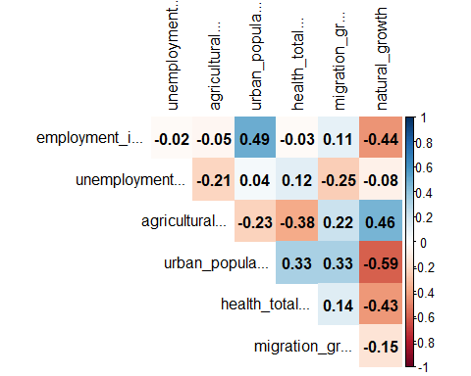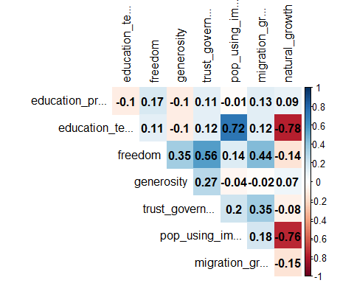

# sklaidos diagramos su kiekviena kovariante  
scatterplot <- function(name, name2, main, ylab) {  
 a <- regression_train %>%  
 dplyr::select(1:5, {{ name }}, -{{ name2 }}) %>%  
 pivot_longer(-{{ name }}) %>%  
 ggplot(aes(x = value, y = {{ name }})) +  
 facet_wrap(vars(name), scales = "free") +  
 geom_point() +  
 geom_smooth(method = "lm") +  
 theme_minimal() +  
 labs(title = main) + xlab("Kovariantės reikšmė") + ylab(ylab)  
  
  
 b <- regression_train %>%  
 dplyr::select(6:length(regression_train), {{ name }}, -{{ name2 }}) %>%  
 pivot_longer(-{{ name }}) %>%  
 ggplot(aes(x = value, y = {{ name }})) +  
 facet_wrap(vars(name), scales = "free") +  
 geom_point() +  
 geom_smooth(method = "lm") +  
 theme_minimal() +  
 labs(title = main) + xlab("Kovariantės reikšmė") + ylab(ylab)  
  
 plot(a)  
  
 plot(b)  
}  
  
  
scatterplot(migration_growth, natural_growth, "Migracijos prieaugis pagal kovariantes","Migracijos prieaugis")

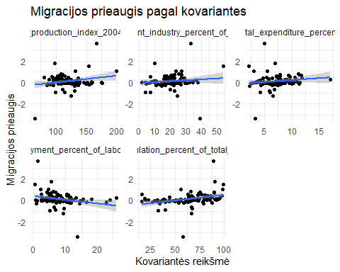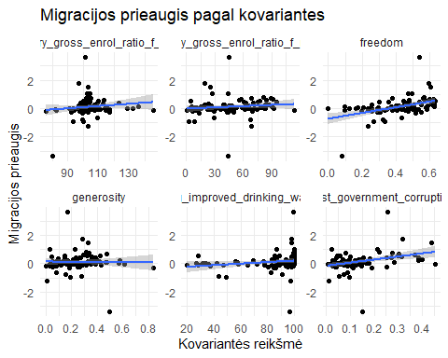

scatterplot(natural_growth, migration_growth, "Natūralus prieaugis pagal kovariantes","Natūralus prieaugis")

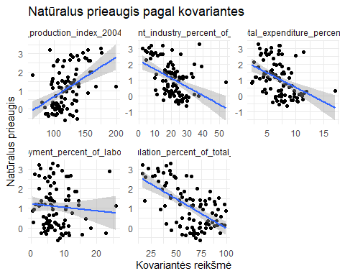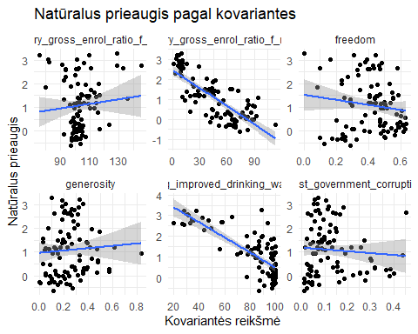

library(ggrepel)  
# migracijos ir natūralaus prieaugio sklaidos grafikas  
ggplot(regression_train, aes(natural_growth, migration_growth)) +  
 geom_point() +  
 theme_minimal() +  
 xlab("Natūralus prieaugis") +  
 ylab("Migracijos prieaugis") + labs(main="Migracijos ir natūralus prieaugis") +  
 geom_text_repel(data=(regression_train %>% cbind(country_train))[abs(regression_train$migration_growth)>2,]  
 ,aes(label=country_train))

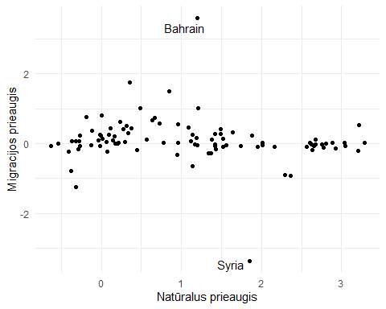

# matomos dvi labai stiprios išskirtys  
outlier_indices <- regression_train$migration_growth %>%  
 abs() %>%  
 order(decreasing = TRUE) %>%  
 `[`(1:2)

library(car)  
library(effects)  
library(lm.beta)  
library(broom)  
  
  
# sudaromas paprastos regresijos modelis, atliekama pažingsninė regresija  
linear_fit <- function(formula) {  
 model_linear <- lm(formula, data = data)  
  
 # diagnostiniai grafikai  
 crPlots(model_linear)  
 plot(model_linear)  
 plot(cooks.distance(model_linear))  
  
 # pažingsninė regresija  
 model_linear_small <- MASS::stepAIC(model_linear, direction = "both", trace = 0)  
  
 # ar yra statistiškai reikšmingas skirtumas  
 print(anova(model_linear, model_linear_small))  
  
 # kovariančių efektų grafikas  
 plot(predictorEffects(model_linear_small))  
 print(summary(model_linear_small))  
  
  
 stand <- lm.beta(model_linear_small)  
 # standartizuotų koeficientų grafikas  
 coeff_plot <- tidy(stand) %>%  
 filter(term != "(Intercept)") %>%  
 ggplot(aes(term, estimate)) +  
 geom_pointrange(aes(ymin = estimate - std.error, ymax = estimate + std.error), color = "blue") +  
 scale_x_discrete() +  
 coord_flip() +  
 theme_minimal() +  
 labs(x = "Kovariantė", y = "Standartizuotos koeficientų reikšmės")  
  
 plot(coeff_plot)  
  
 model_linear_small  
}

# Atskirai apmokomi modeliai migracijos ir natūraliam prieaugiui  
print("Tiesinės regresijos modelis migracijos prieaugiui")

## [1] "Tiesinės regresijos modelis migracijos prieaugiui"

data <- regression_train %>%  
 dplyr::select(-natural_growth) %>%  
 slice(-outlier_indices)  
model_linear_migration <- linear_fit(migration_growth ~ .)

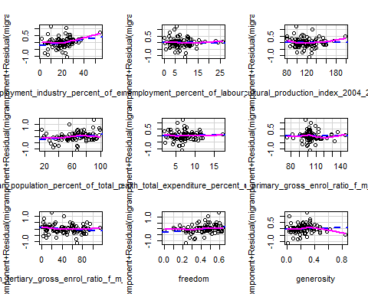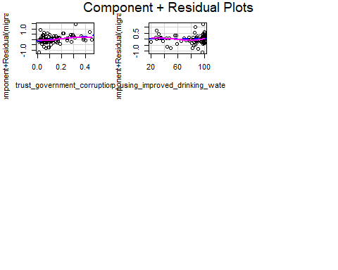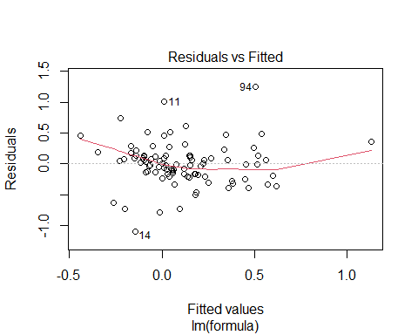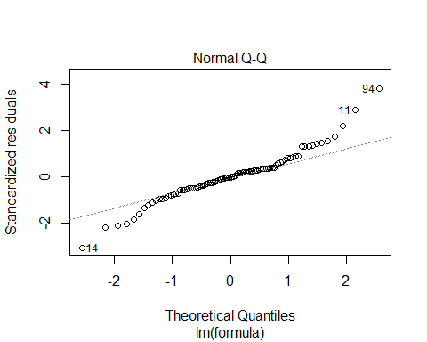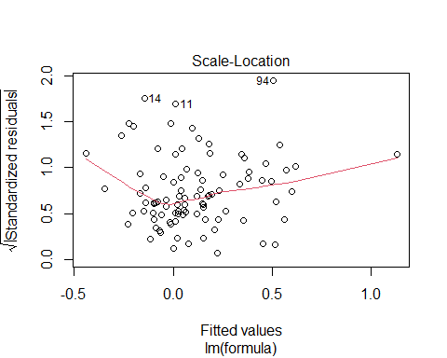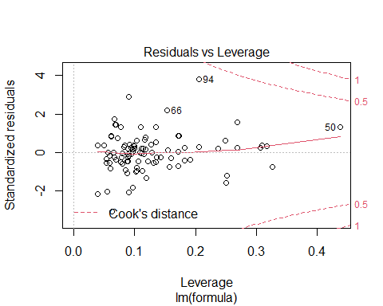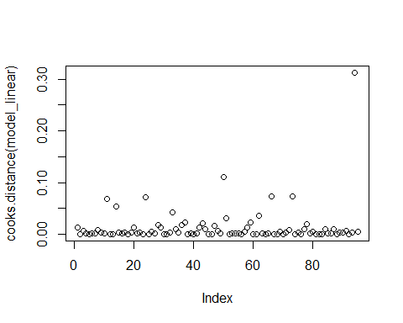

## Analysis of Variance Table  
##   
## Model 1: migration_growth ~ employment_industry_percent_of_employed +   
## unemployment_percent_of_labour_force + agricultural_production_index_2004_2006_100 +   
## urban_population_percent_of_total_population + health_total_expenditure_percent_of_gdp +   
## education_primary_gross_enrol_ratio_f_m_per_100_pop + education_tertiary_gross_enrol_ratio_f_m_per_100_pop +   
## freedom + generosity + trust_government_corruption + pop_using_improved_drinking_water_urban  
## Model 2: migration_growth ~ employment_industry_percent_of_employed +   
## urban_population_percent_of_total_population + freedom +   
## trust_government_corruption  
## Res.Df RSS Df Sum of Sq F Pr(>F)  
## 1 83 11.211   
## 2 90 11.356 -7 -0.1452 0.1536 0.9931

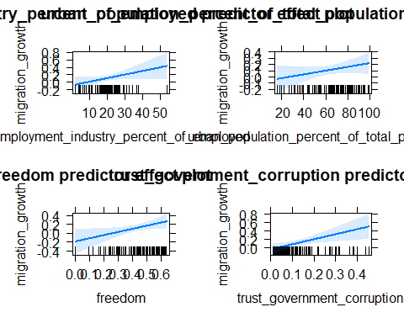

##   
## Call:  
## lm(formula = migration_growth ~ employment_industry_percent_of_employed +   
## urban_population_percent_of_total_population + freedom +   
## trust_government_corruption, data = data)  
##   
## Residuals:  
## Min 1Q Median 3Q Max   
## -1.13140 -0.17003 0.01515 0.13945 1.30339   
##   
## Coefficients:  
## Estimate Std. Error t value  
## (Intercept) -0.720036 0.160058 -4.499  
## employment_industry_percent_of_employed 0.009551 0.005220 1.830  
## urban_population_percent_of_total_population 0.003024 0.002161 1.399  
## freedom 0.703689 0.323155 2.178  
## trust_government_corruption 1.184538 0.434899 2.724  
## Pr(>|t|)   
## (Intercept) 2.04e-05 ***  
## employment_industry_percent_of_employed 0.07062 .   
## urban_population_percent_of_total_population 0.16517   
## freedom 0.03205 *   
## trust_government_corruption 0.00775 **   
## ---  
## Signif. codes: 0 '***' 0.001 '**' 0.01 '*' 0.05 '.' 0.1 ' ' 1  
##   
## Residual standard error: 0.3552 on 90 degrees of freedom  
## Multiple R-squared: 0.3368, Adjusted R-squared: 0.3074   
## F-statistic: 11.43 on 4 and 90 DF, p-value: 1.518e-07

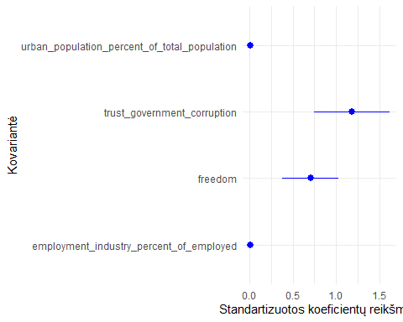

print("Tiesinės regresijos modelis natūraliam prieaugiui")

## [1] "Tiesinės regresijos modelis natūraliam prieaugiui"

data <- regression_train %>% dplyr::select(-migration_growth)  
model_linear_natural <- linear_fit(natural_growth ~ .)

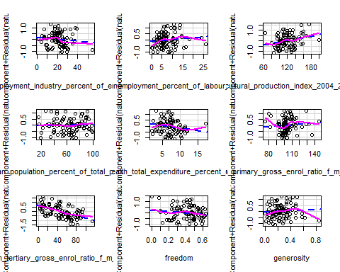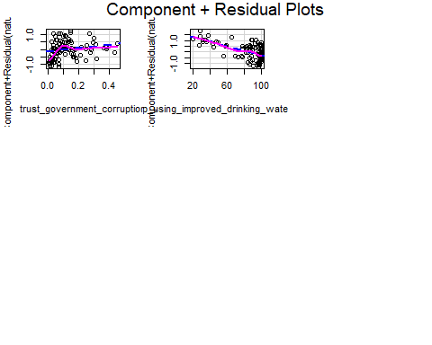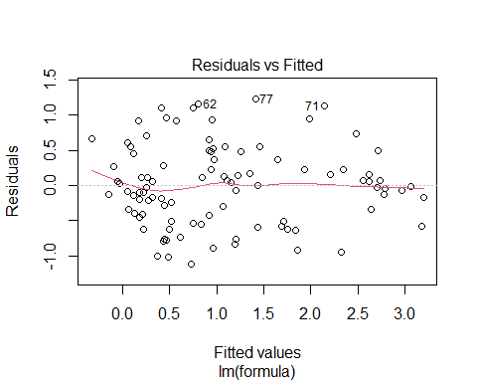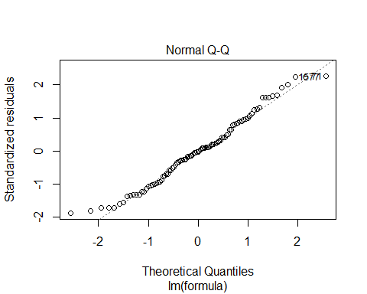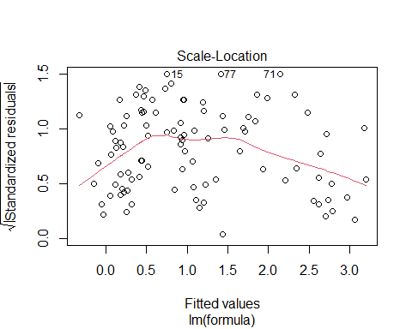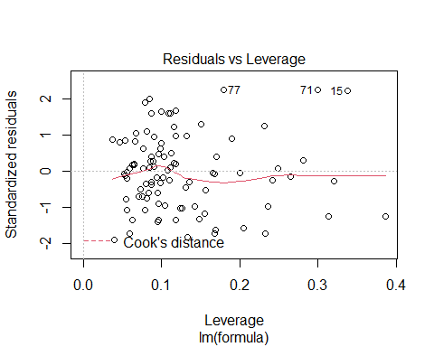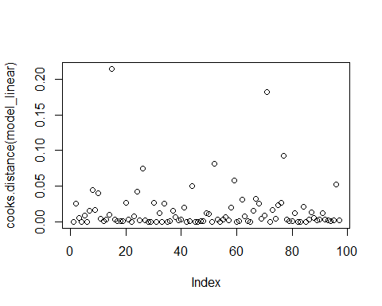

## Analysis of Variance Table  
##   
## Model 1: natural_growth ~ employment_industry_percent_of_employed + unemployment_percent_of_labour_force +   
## agricultural_production_index_2004_2006_100 + urban_population_percent_of_total_population +   
## health_total_expenditure_percent_of_gdp + education_primary_gross_enrol_ratio_f_m_per_100_pop +   
## education_tertiary_gross_enrol_ratio_f_m_per_100_pop + freedom +   
## generosity + trust_government_corruption + pop_using_improved_drinking_water_urban  
## Model 2: natural_growth ~ agricultural_production_index_2004_2006_100 +   
## education_tertiary_gross_enrol_ratio_f_m_per_100_pop + pop_using_improved_drinking_water_urban  
## Res.Df RSS Df Sum of Sq F Pr(>F)  
## 1 85 30.826   
## 2 93 33.392 -8 -2.5665 0.8846 0.533

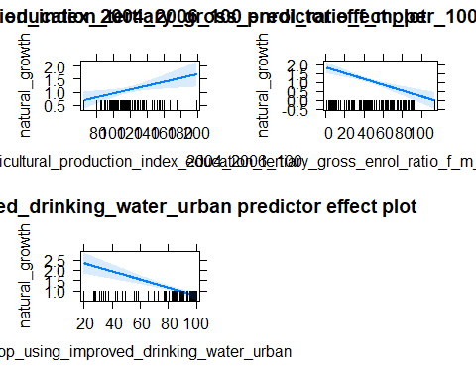

##   
## Call:  
## lm(formula = natural_growth ~ agricultural_production_index_2004_2006_100 +   
## education_tertiary_gross_enrol_ratio_f_m_per_100_pop + pop_using_improved_drinking_water_urban,   
## data = data)  
##   
## Residuals:  
## Min 1Q Median 3Q Max   
## -1.17333 -0.52663 0.02113 0.33529 1.40262   
##   
## Coefficients:  
## Estimate Std. Error  
## (Intercept) 2.579233 0.468106  
## agricultural_production_index_2004_2006_100 0.007448 0.002911  
## education_tertiary_gross_enrol_ratio_f_m_per_100_pop -0.016088 0.003293  
## pop_using_improved_drinking_water_urban -0.019777 0.003939  
## t value Pr(>|t|)   
## (Intercept) 5.510 3.18e-07 ***  
## agricultural_production_index_2004_2006_100 2.559 0.0121 *   
## education_tertiary_gross_enrol_ratio_f_m_per_100_pop -4.885 4.29e-06 ***  
## pop_using_improved_drinking_water_urban -5.021 2.47e-06 ***  
## ---  
## Signif. codes: 0 '***' 0.001 '**' 0.01 '*' 0.05 '.' 0.1 ' ' 1  
##   
## Residual standard error: 0.5992 on 93 degrees of freedom  
## Multiple R-squared: 0.7062, Adjusted R-squared: 0.6968   
## F-statistic: 74.52 on 3 and 93 DF, p-value: < 2.2e-16

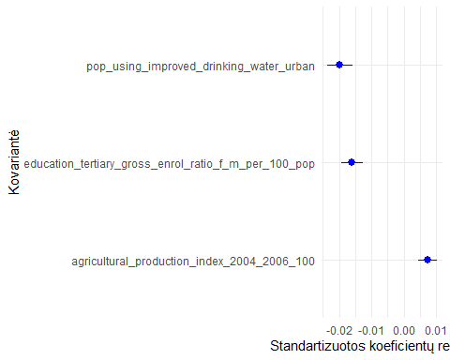

# Matoma, kad migracijos prieaugiui tiesiniu modeliu gaunami daug prastesni rezultatai negu  
 # natūraliam prieaugiui

# Kvantilių regresija  
library(quantreg)  
  
quantile_fit <- function() {  
 model_quantile <- rq(formula, data = data, tau = tau)  
  
 print(summary(model_quantile, se = "boot"))  
 plot(summary(model_quantile))  
 print(anova(model_quantile, test = "Wald", joint = FALSE))  
  
 model_quantile  
}

print("Kvantilių regresija migracijos prieaugiui")

## [1] "Kvantilių regresija migracijos prieaugiui"

data <- regression_train %>%  
 dplyr::select(-natural_growth) %>%  
 slice(-outlier_indices)  
tau <- seq(0.1, 0.9, 0.1)  
formula <- migration_growth ~ .  
  
model_quantile_migration <- quantile_fit()

##   
## Call: rq(formula = formula, tau = tau, data = data)  
##   
## tau: [1] 0.1  
##   
## Coefficients:  
## Value Std. Error  
## (Intercept) -1.92648 0.86451   
## employment_industry_percent_of_employed 0.02580 0.01321   
## unemployment_percent_of_labour_force 0.00798 0.01387   
## agricultural_production_index_2004_2006_100 0.00187 0.00413   
## urban_population_percent_of_total_population -0.00024 0.00471   
## health_total_expenditure_percent_of_gdp 0.05893 0.03334   
## education_primary_gross_enrol_ratio_f_m_per_100_pop 0.00062 0.00664   
## education_tertiary_gross_enrol_ratio_f_m_per_100_pop -0.00165 0.00590   
## freedom 1.14056 0.84652   
## generosity 0.27141 0.46390   
## trust_government_corruption 0.61266 0.68705   
## pop_using_improved_drinking_water_urban -0.00149 0.00603   
## t value Pr(>|t|)  
## (Intercept) -2.22841 0.02856  
## employment_industry_percent_of_employed 1.95290 0.05420  
## unemployment_percent_of_labour_force 0.57562 0.56643  
## agricultural_production_index_2004_2006_100 0.45241 0.65216  
## urban_population_percent_of_total_population -0.05026 0.96004  
## health_total_expenditure_percent_of_gdp 1.76741 0.08084  
## education_primary_gross_enrol_ratio_f_m_per_100_pop 0.09405 0.92530  
## education_tertiary_gross_enrol_ratio_f_m_per_100_pop -0.28049 0.77980  
## freedom 1.34736 0.18153  
## generosity 0.58508 0.56008  
## trust_government_corruption 0.89173 0.37512  
## pop_using_improved_drinking_water_urban -0.24659 0.80584  
##   
## Call: rq(formula = formula, tau = tau, data = data)  
##   
## tau: [1] 0.2  
##   
## Coefficients:  
## Value Std. Error  
## (Intercept) -1.67072 0.69183   
## employment_industry_percent_of_employed 0.01984 0.01037   
## unemployment_percent_of_labour_force 0.00332 0.01043   
## agricultural_production_index_2004_2006_100 0.00257 0.00244   
## urban_population_percent_of_total_population 0.00153 0.00271   
## health_total_expenditure_percent_of_gdp 0.04143 0.01907   
## education_primary_gross_enrol_ratio_f_m_per_100_pop 0.00100 0.00382   
## education_tertiary_gross_enrol_ratio_f_m_per_100_pop -0.00087 0.00339   
## freedom 0.65556 0.46671   
## generosity 0.35233 0.30143   
## trust_government_corruption 0.50116 0.48716   
## pop_using_improved_drinking_water_urban -0.00087 0.00383   
## t value Pr(>|t|)  
## (Intercept) -2.41492 0.01794  
## employment_industry_percent_of_employed 1.91260 0.05925  
## unemployment_percent_of_labour_force 0.31797 0.75131  
## agricultural_production_index_2004_2006_100 1.05429 0.29481  
## urban_population_percent_of_total_population 0.56558 0.57320  
## health_total_expenditure_percent_of_gdp 2.17225 0.03269  
## education_primary_gross_enrol_ratio_f_m_per_100_pop 0.26261 0.79350  
## education_tertiary_gross_enrol_ratio_f_m_per_100_pop -0.25549 0.79897  
## freedom 1.40463 0.16386  
## generosity 1.16885 0.24581  
## trust_government_corruption 1.02874 0.30659  
## pop_using_improved_drinking_water_urban -0.22598 0.82177  
##   
## Call: rq(formula = formula, tau = tau, data = data)  
##   
## tau: [1] 0.3  
##   
## Coefficients:  
## Value Std. Error  
## (Intercept) -1.05588 0.67939   
## employment_industry_percent_of_employed 0.01177 0.00946   
## unemployment_percent_of_labour_force -0.00229 0.00921   
## agricultural_production_index_2004_2006_100 0.00174 0.00268   
## urban_population_percent_of_total_population 0.00090 0.00266   
## health_total_expenditure_percent_of_gdp 0.01587 0.01574   
## education_primary_gross_enrol_ratio_f_m_per_100_pop 0.00186 0.00317   
## education_tertiary_gross_enrol_ratio_f_m_per_100_pop 0.00212 0.00251   
## freedom 0.21495 0.38890   
## generosity 0.30400 0.28415   
## trust_government_corruption 0.53938 0.57532   
## pop_using_improved_drinking_water_urban -0.00135 0.00270   
## t value Pr(>|t|)  
## (Intercept) -1.55417 0.12395  
## employment_industry_percent_of_employed 1.24452 0.21681  
## unemployment_percent_of_labour_force -0.24877 0.80415  
## agricultural_production_index_2004_2006_100 0.64880 0.51826  
## urban_population_percent_of_total_population 0.34025 0.73453  
## health_total_expenditure_percent_of_gdp 1.00771 0.31652  
## education_primary_gross_enrol_ratio_f_m_per_100_pop 0.58733 0.55858  
## education_tertiary_gross_enrol_ratio_f_m_per_100_pop 0.84494 0.40057  
## freedom 0.55272 0.58194  
## generosity 1.06983 0.28780  
## trust_government_corruption 0.93754 0.35120  
## pop_using_improved_drinking_water_urban -0.50001 0.61839  
##   
## Call: rq(formula = formula, tau = tau, data = data)  
##   
## tau: [1] 0.4  
##   
## Coefficients:  
## Value Std. Error  
## (Intercept) -0.78905 0.62453   
## employment_industry_percent_of_employed 0.01353 0.00834   
## unemployment_percent_of_labour_force 0.00385 0.00802   
## agricultural_production_index_2004_2006_100 0.00171 0.00231   
## urban_population_percent_of_total_population 0.00090 0.00278   
## health_total_expenditure_percent_of_gdp 0.01508 0.01501   
## education_primary_gross_enrol_ratio_f_m_per_100_pop -0.00002 0.00366   
## education_tertiary_gross_enrol_ratio_f_m_per_100_pop 0.00193 0.00231   
## freedom 0.18594 0.34368   
## generosity 0.36225 0.31018   
## trust_government_corruption 1.05988 0.56770   
## pop_using_improved_drinking_water_urban -0.00283 0.00266   
## t value Pr(>|t|)  
## (Intercept) -1.26343 0.20997  
## employment_industry_percent_of_employed 1.62243 0.10850  
## unemployment_percent_of_labour_force 0.47925 0.63302  
## agricultural_production_index_2004_2006_100 0.73741 0.46295  
## urban_population_percent_of_total_population 0.32584 0.74536  
## health_total_expenditure_percent_of_gdp 1.00469 0.31796  
## education_primary_gross_enrol_ratio_f_m_per_100_pop -0.00521 0.99586  
## education_tertiary_gross_enrol_ratio_f_m_per_100_pop 0.83347 0.40697  
## freedom 0.54102 0.58994  
## generosity 1.16789 0.24619  
## trust_government_corruption 1.86699 0.06543  
## pop_using_improved_drinking_water_urban -1.06377 0.29052  
##   
## Call: rq(formula = formula, tau = tau, data = data)  
##   
## tau: [1] 0.5  
##   
## Coefficients:  
## Value Std. Error  
## (Intercept) -0.70883 0.62031   
## employment_industry_percent_of_employed 0.00868 0.00830   
## unemployment_percent_of_labour_force -0.00092 0.00800   
## agricultural_production_index_2004_2006_100 0.00160 0.00265   
## urban_population_percent_of_total_population 0.00243 0.00289   
## health_total_expenditure_percent_of_gdp 0.01011 0.01460   
## education_primary_gross_enrol_ratio_f_m_per_100_pop -0.00033 0.00419   
## education_tertiary_gross_enrol_ratio_f_m_per_100_pop 0.00091 0.00259   
## freedom 0.22736 0.35053   
## generosity 0.15808 0.35722   
## trust_government_corruption 1.44830 0.58068   
## pop_using_improved_drinking_water_urban -0.00114 0.00282   
## t value Pr(>|t|)  
## (Intercept) -1.14270 0.25645  
## employment_industry_percent_of_employed 1.04623 0.29849  
## unemployment_percent_of_labour_force -0.11501 0.90872  
## agricultural_production_index_2004_2006_100 0.60567 0.54639  
## urban_population_percent_of_total_population 0.83999 0.40333  
## health_total_expenditure_percent_of_gdp 0.69240 0.49062  
## education_primary_gross_enrol_ratio_f_m_per_100_pop -0.07900 0.93722  
## education_tertiary_gross_enrol_ratio_f_m_per_100_pop 0.34953 0.72757  
## freedom 0.64862 0.51838  
## generosity 0.44253 0.65925  
## trust_government_corruption 2.49414 0.01461  
## pop_using_improved_drinking_water_urban -0.40334 0.68774  
##   
## Call: rq(formula = formula, tau = tau, data = data)  
##   
## tau: [1] 0.6  
##   
## Coefficients:  
## Value Std. Error  
## (Intercept) -0.57342 0.61038   
## employment_industry_percent_of_employed 0.01109 0.00846   
## unemployment_percent_of_labour_force -0.00069 0.00785   
## agricultural_production_index_2004_2006_100 0.00052 0.00258   
## urban_population_percent_of_total_population 0.00361 0.00368   
## health_total_expenditure_percent_of_gdp 0.00595 0.01674   
## education_primary_gross_enrol_ratio_f_m_per_100_pop -0.00018 0.00398   
## education_tertiary_gross_enrol_ratio_f_m_per_100_pop 0.00018 0.00255   
## freedom 0.37166 0.35996   
## generosity 0.12338 0.43834   
## trust_government_corruption 1.48083 0.59655   
## pop_using_improved_drinking_water_urban -0.00213 0.00304   
## t value Pr(>|t|)  
## (Intercept) -0.93945 0.35022  
## employment_industry_percent_of_employed 1.31017 0.19375  
## unemployment_percent_of_labour_force -0.08854 0.92966  
## agricultural_production_index_2004_2006_100 0.20257 0.83997  
## urban_population_percent_of_total_population 0.98168 0.32911  
## health_total_expenditure_percent_of_gdp 0.35552 0.72310  
## education_primary_gross_enrol_ratio_f_m_per_100_pop -0.04564 0.96370  
## education_tertiary_gross_enrol_ratio_f_m_per_100_pop 0.06958 0.94469  
## freedom 1.03248 0.30485  
## generosity 0.28147 0.77905  
## trust_government_corruption 2.48234 0.01507  
## pop_using_improved_drinking_water_urban -0.70163 0.48487  
##   
## Call: rq(formula = formula, tau = tau, data = data)  
##   
## tau: [1] 0.7  
##   
## Coefficients:  
## Value Std. Error  
## (Intercept) -0.55428 0.65403   
## employment_industry_percent_of_employed 0.00963 0.00949   
## unemployment_percent_of_labour_force 0.00224 0.00890   
## agricultural_production_index_2004_2006_100 -0.00001 0.00293   
## urban_population_percent_of_total_population 0.00429 0.00480   
## health_total_expenditure_percent_of_gdp 0.00480 0.01834   
## education_primary_gross_enrol_ratio_f_m_per_100_pop 0.00052 0.00402   
## education_tertiary_gross_enrol_ratio_f_m_per_100_pop 0.00023 0.00332   
## freedom 0.25461 0.41303   
## generosity 0.07785 0.50986   
## trust_government_corruption 1.65563 0.74975   
## pop_using_improved_drinking_water_urban -0.00195 0.00364   
## t value Pr(>|t|)  
## (Intercept) -0.84748 0.39917  
## employment_industry_percent_of_employed 1.01541 0.31286  
## unemployment_percent_of_labour_force 0.25143 0.80210  
## agricultural_production_index_2004_2006_100 -0.00288 0.99771  
## urban_population_percent_of_total_population 0.89337 0.37424  
## health_total_expenditure_percent_of_gdp 0.26188 0.79406  
## education_primary_gross_enrol_ratio_f_m_per_100_pop 0.12935 0.89740  
## education_tertiary_gross_enrol_ratio_f_m_per_100_pop 0.07062 0.94387  
## freedom 0.61646 0.53928  
## generosity 0.15270 0.87901  
## trust_government_corruption 2.20825 0.02998  
## pop_using_improved_drinking_water_urban -0.53485 0.59418  
##   
## Call: rq(formula = formula, tau = tau, data = data)  
##   
## tau: [1] 0.8  
##   
## Coefficients:  
## Value Std. Error  
## (Intercept) -0.68182 0.86952   
## employment_industry_percent_of_employed 0.00546 0.01085   
## unemployment_percent_of_labour_force -0.00259 0.01391   
## agricultural_production_index_2004_2006_100 -0.00005 0.00362   
## urban_population_percent_of_total_population 0.00592 0.00584   
## health_total_expenditure_percent_of_gdp -0.01712 0.02741   
## education_primary_gross_enrol_ratio_f_m_per_100_pop 0.00073 0.00589   
## education_tertiary_gross_enrol_ratio_f_m_per_100_pop -0.00213 0.00434   
## freedom 0.61071 0.52841   
## generosity 0.12248 0.73599   
## trust_government_corruption 1.47967 0.92107   
## pop_using_improved_drinking_water_urban 0.00258 0.00501   
## t value Pr(>|t|)  
## (Intercept) -0.78413 0.43520  
## employment_industry_percent_of_employed 0.50357 0.61590  
## unemployment_percent_of_labour_force -0.18606 0.85285  
## agricultural_production_index_2004_2006_100 -0.01388 0.98896  
## urban_population_percent_of_total_population 1.01394 0.31356  
## health_total_expenditure_percent_of_gdp -0.62440 0.53408  
## education_primary_gross_enrol_ratio_f_m_per_100_pop 0.12467 0.90109  
## education_tertiary_gross_enrol_ratio_f_m_per_100_pop -0.49109 0.62466  
## freedom 1.15574 0.25110  
## generosity 0.16642 0.86823  
## trust_government_corruption 1.60647 0.11197  
## pop_using_improved_drinking_water_urban 0.51529 0.60772  
##   
## Call: rq(formula = formula, tau = tau, data = data)  
##   
## tau: [1] 0.9  
##   
## Coefficients:  
## Value Std. Error  
## (Intercept) 0.68367 1.08774   
## employment_industry_percent_of_employed 0.00037 0.01348   
## unemployment_percent_of_labour_force -0.02508 0.01941   
## agricultural_production_index_2004_2006_100 -0.00229 0.00433   
## urban_population_percent_of_total_population 0.00528 0.00728   
## health_total_expenditure_percent_of_gdp -0.00231 0.03505   
## education_primary_gross_enrol_ratio_f_m_per_100_pop -0.00417 0.00821   
## education_tertiary_gross_enrol_ratio_f_m_per_100_pop -0.00289 0.00458   
## freedom 1.04742 0.74337   
## generosity -0.84280 0.90656   
## trust_government_corruption 1.21270 1.27195   
## pop_using_improved_drinking_water_urban 0.00246 0.00669   
## t value Pr(>|t|)  
## (Intercept) 0.62852 0.53139  
## employment_industry_percent_of_employed 0.02754 0.97810  
## unemployment_percent_of_labour_force -1.29218 0.19988  
## agricultural_production_index_2004_2006_100 -0.52764 0.59916  
## urban_population_percent_of_total_population 0.72559 0.47013  
## health_total_expenditure_percent_of_gdp -0.06590 0.94762  
## education_primary_gross_enrol_ratio_f_m_per_100_pop -0.50830 0.61259  
## education_tertiary_gross_enrol_ratio_f_m_per_100_pop -0.62930 0.53088  
## freedom 1.40902 0.16256  
## generosity -0.92967 0.35524  
## trust_government_corruption 0.95342 0.34315  
## pop_using_improved_drinking_water_urban 0.36836 0.71354

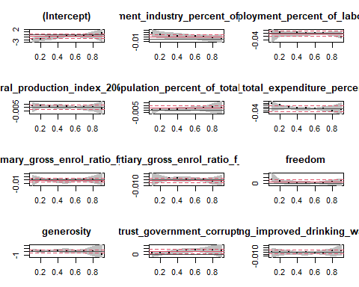

## Quantile Regression Analysis of Deviance Table  
##   
## Model: migration_growth ~ employment_industry_percent_of_employed + unemployment_percent_of_labour_force + agricultural_production_index_2004_2006_100 + urban_population_percent_of_total_population + health_total_expenditure_percent_of_gdp + education_primary_gross_enrol_ratio_f_m_per_100_pop + education_tertiary_gross_enrol_ratio_f_m_per_100_pop + freedom + generosity + trust_government_corruption + pop_using_improved_drinking_water_urban  
## Tests of Equality of Distinct Slopes: tau in { 0.1 0.2 0.3 0.4 0.5 0.6 0.7 0.8 0.9 }  
##   
## Df Resid Df F value Pr(>F)  
## employment_industry_percent_of_employed 8 847 0.4387 0.8980  
## unemployment_percent_of_labour_force 8 847 0.8835 0.5298  
## agricultural_production_index_2004_2006_100 8 847 0.3063 0.9638  
## urban_population_percent_of_total_population 8 847 0.2722 0.9749  
## health_total_expenditure_percent_of_gdp 8 847 0.4797 0.8711  
## education_primary_gross_enrol_ratio_f_m_per_100_pop 8 847 0.2504 0.9808  
## education_tertiary_gross_enrol_ratio_f_m_per_100_pop 8 847 0.4294 0.9037  
## freedom 8 847 0.5251 0.8382  
## generosity 8 847 1.4714 0.1636  
## trust_government_corruption 8 847 0.7046 0.6877  
## pop_using_improved_drinking_water_urban 8 847 0.4466 0.8931

print("Kvantilių regresija natūraliam prieaugiui")

## [1] "Kvantilių regresija natūraliam prieaugiui"

data <- regression_train %>% dplyr::select(-migration_growth)  
tau <- seq(0.1, 0.9, 0.1)  
formula <- natural_growth ~ .  
  
model_quantile_migration <- quantile_fit()

##   
## Call: rq(formula = formula, tau = tau, data = data)  
##   
## tau: [1] 0.1  
##   
## Coefficients:  
## Value Std. Error  
## (Intercept) 2.50971 1.29872   
## employment_industry_percent_of_employed -0.01501 0.01689   
## unemployment_percent_of_labour_force -0.00088 0.02202   
## agricultural_production_index_2004_2006_100 0.00645 0.00503   
## urban_population_percent_of_total_population 0.00862 0.00653   
## health_total_expenditure_percent_of_gdp -0.01162 0.04948   
## education_primary_gross_enrol_ratio_f_m_per_100_pop -0.00344 0.01059   
## education_tertiary_gross_enrol_ratio_f_m_per_100_pop -0.01472 0.00763   
## freedom 0.36074 0.78272   
## generosity -0.08716 0.56891   
## trust_government_corruption 0.96367 0.99080   
## pop_using_improved_drinking_water_urban -0.02608 0.00707   
## t value Pr(>|t|)  
## (Intercept) 1.93244 0.05664  
## employment_industry_percent_of_employed -0.88842 0.37682  
## unemployment_percent_of_labour_force -0.04016 0.96806  
## agricultural_production_index_2004_2006_100 1.28112 0.20364  
## urban_population_percent_of_total_population 1.31967 0.19049  
## health_total_expenditure_percent_of_gdp -0.23485 0.81489  
## education_primary_gross_enrol_ratio_f_m_per_100_pop -0.32493 0.74604  
## education_tertiary_gross_enrol_ratio_f_m_per_100_pop -1.92997 0.05695  
## freedom 0.46088 0.64606  
## generosity -0.15321 0.87860  
## trust_government_corruption 0.97262 0.33350  
## pop_using_improved_drinking_water_urban -3.68870 0.00040  
##   
## Call: rq(formula = formula, tau = tau, data = data)  
##   
## tau: [1] 0.2  
##   
## Coefficients:  
## Value Std. Error  
## (Intercept) 2.49146 1.12678   
## employment_industry_percent_of_employed -0.02191 0.01515   
## unemployment_percent_of_labour_force 0.00818 0.01766   
## agricultural_production_index_2004_2006_100 0.00668 0.00422   
## urban_population_percent_of_total_population 0.00742 0.00541   
## health_total_expenditure_percent_of_gdp -0.01192 0.04305   
## education_primary_gross_enrol_ratio_f_m_per_100_pop -0.00060 0.00914   
## education_tertiary_gross_enrol_ratio_f_m_per_100_pop -0.01397 0.00601   
## freedom 0.44285 0.81340   
## generosity -0.29519 0.61286   
## trust_government_corruption 1.02961 0.92154   
## pop_using_improved_drinking_water_urban -0.02668 0.00629   
## t value Pr(>|t|)  
## (Intercept) 2.21113 0.02971  
## employment_industry_percent_of_employed -1.44604 0.15184  
## unemployment_percent_of_labour_force 0.46318 0.64442  
## agricultural_production_index_2004_2006_100 1.58464 0.11676  
## urban_population_percent_of_total_population 1.37030 0.17420  
## health_total_expenditure_percent_of_gdp -0.27696 0.78249  
## education_primary_gross_enrol_ratio_f_m_per_100_pop -0.06531 0.94808  
## education_tertiary_gross_enrol_ratio_f_m_per_100_pop -2.32402 0.02251  
## freedom 0.54445 0.58756  
## generosity -0.48167 0.63128  
## trust_government_corruption 1.11727 0.26703  
## pop_using_improved_drinking_water_urban -4.24196 0.00006  
##   
## Call: rq(formula = formula, tau = tau, data = data)  
##   
## tau: [1] 0.3  
##   
## Coefficients:  
## Value Std. Error  
## (Intercept) 3.18479 1.15878   
## employment_industry_percent_of_employed -0.02824 0.01566   
## unemployment_percent_of_labour_force 0.00925 0.01998   
## agricultural_production_index_2004_2006_100 0.00427 0.00437   
## urban_population_percent_of_total_population 0.00618 0.00597   
## health_total_expenditure_percent_of_gdp -0.04808 0.04404   
## education_primary_gross_enrol_ratio_f_m_per_100_pop 0.00120 0.01006   
## education_tertiary_gross_enrol_ratio_f_m_per_100_pop -0.01305 0.00643   
## freedom 0.41716 0.90677   
## generosity -0.50126 0.66770   
## trust_government_corruption 1.02811 0.90837   
## pop_using_improved_drinking_water_urban -0.02631 0.00676   
## t value Pr(>|t|)  
## (Intercept) 2.74839 0.00731  
## employment_industry_percent_of_employed -1.80308 0.07492  
## unemployment_percent_of_labour_force 0.46285 0.64465  
## agricultural_production_index_2004_2006_100 0.97719 0.33125  
## urban_population_percent_of_total_population 1.03570 0.30328  
## health_total_expenditure_percent_of_gdp -1.09181 0.27800  
## education_primary_gross_enrol_ratio_f_m_per_100_pop 0.11921 0.90539  
## education_tertiary_gross_enrol_ratio_f_m_per_100_pop -2.02982 0.04550  
## freedom 0.46005 0.64666  
## generosity -0.75073 0.45489  
## trust_government_corruption 1.13182 0.26089  
## pop_using_improved_drinking_water_urban -3.89476 0.00020  
##   
## Call: rq(formula = formula, tau = tau, data = data)  
##   
## tau: [1] 0.4  
##   
## Coefficients:  
## Value Std. Error  
## (Intercept) 3.22425 1.26827   
## employment_industry_percent_of_employed -0.03079 0.01845   
## unemployment_percent_of_labour_force 0.00781 0.02044   
## agricultural_production_index_2004_2006_100 0.00564 0.00530   
## urban_population_percent_of_total_population 0.00613 0.00643   
## health_total_expenditure_percent_of_gdp -0.05890 0.04501   
## education_primary_gross_enrol_ratio_f_m_per_100_pop -0.00084 0.01053   
## education_tertiary_gross_enrol_ratio_f_m_per_100_pop -0.01623 0.00623   
## freedom 0.49441 1.07752   
## generosity -1.01588 0.87830   
## trust_government_corruption 1.03362 0.93994   
## pop_using_improved_drinking_water_urban -0.02019 0.00816   
## t value Pr(>|t|)  
## (Intercept) 2.54225 0.01283  
## employment_industry_percent_of_employed -1.66902 0.09879  
## unemployment_percent_of_labour_force 0.38212 0.70333  
## agricultural_production_index_2004_2006_100 1.06435 0.29018  
## urban_population_percent_of_total_population 0.95404 0.34277  
## health_total_expenditure_percent_of_gdp -1.30846 0.19424  
## education_primary_gross_enrol_ratio_f_m_per_100_pop -0.07942 0.93689  
## education_tertiary_gross_enrol_ratio_f_m_per_100_pop -2.60435 0.01086  
## freedom 0.45884 0.64752  
## generosity -1.15663 0.25066  
## trust_government_corruption 1.09967 0.27458  
## pop_using_improved_drinking_water_urban -2.47497 0.01531  
##   
## Call: rq(formula = formula, tau = tau, data = data)  
##   
## tau: [1] 0.5  
##   
## Coefficients:  
## Value Std. Error  
## (Intercept) 2.64220 1.27213   
## employment_industry_percent_of_employed -0.02361 0.01944   
## unemployment_percent_of_labour_force 0.00352 0.02022   
## agricultural_production_index_2004_2006_100 0.00596 0.00547   
## urban_population_percent_of_total_population 0.00228 0.00764   
## health_total_expenditure_percent_of_gdp -0.05480 0.05369   
## education_primary_gross_enrol_ratio_f_m_per_100_pop 0.00591 0.01174   
## education_tertiary_gross_enrol_ratio_f_m_per_100_pop -0.01463 0.00662   
## freedom -0.27038 1.09466   
## generosity 0.08732 1.10537   
## trust_government_corruption 0.54026 0.95658   
## pop_using_improved_drinking_water_urban -0.01822 0.00865   
## t value Pr(>|t|)  
## (Intercept) 2.07700 0.04082  
## employment_industry_percent_of_employed -1.21476 0.22782  
## unemployment_percent_of_labour_force 0.17418 0.86214  
## agricultural_production_index_2004_2006_100 1.09062 0.27852  
## urban_population_percent_of_total_population 0.29875 0.76586  
## health_total_expenditure_percent_of_gdp -1.02079 0.31025  
## education_primary_gross_enrol_ratio_f_m_per_100_pop 0.50337 0.61600  
## education_tertiary_gross_enrol_ratio_f_m_per_100_pop -2.21061 0.02975  
## freedom -0.24700 0.80551  
## generosity 0.07900 0.93722  
## trust_government_corruption 0.56478 0.57371  
## pop_using_improved_drinking_water_urban -2.10564 0.03819  
##   
## Call: rq(formula = formula, tau = tau, data = data)  
##   
## tau: [1] 0.6  
##   
## Coefficients:  
## Value Std. Error  
## (Intercept) 2.67065 1.34267   
## employment_industry_percent_of_employed -0.01716 0.02279   
## unemployment_percent_of_labour_force -0.00052 0.02420   
## agricultural_production_index_2004_2006_100 0.00910 0.00607   
## urban_population_percent_of_total_population 0.00075 0.00914   
## health_total_expenditure_percent_of_gdp -0.06036 0.05025   
## education_primary_gross_enrol_ratio_f_m_per_100_pop 0.00418 0.01081   
## education_tertiary_gross_enrol_ratio_f_m_per_100_pop -0.01143 0.00636   
## freedom -0.80734 1.08215   
## generosity 0.55063 1.26643   
## trust_government_corruption 0.64507 1.18465   
## pop_using_improved_drinking_water_urban -0.01932 0.00922   
## t value Pr(>|t|)  
## (Intercept) 1.98906 0.04991  
## employment_industry_percent_of_employed -0.75294 0.45357  
## unemployment_percent_of_labour_force -0.02151 0.98289  
## agricultural_production_index_2004_2006_100 1.49968 0.13740  
## urban_population_percent_of_total_population 0.08228 0.93462  
## health_total_expenditure_percent_of_gdp -1.20126 0.23299  
## education_primary_gross_enrol_ratio_f_m_per_100_pop 0.38656 0.70005  
## education_tertiary_gross_enrol_ratio_f_m_per_100_pop -1.79730 0.07584  
## freedom -0.74606 0.45769  
## generosity 0.43479 0.66482  
## trust_government_corruption 0.54452 0.58751  
## pop_using_improved_drinking_water_urban -2.09568 0.03908  
##   
## Call: rq(formula = formula, tau = tau, data = data)  
##   
## tau: [1] 0.7  
##   
## Coefficients:  
## Value Std. Error  
## (Intercept) 2.49104 1.32608   
## employment_industry_percent_of_employed 0.00521 0.01985   
## unemployment_percent_of_labour_force 0.00872 0.02144   
## agricultural_production_index_2004_2006_100 0.01234 0.00511   
## urban_population_percent_of_total_population -0.00763 0.00929   
## health_total_expenditure_percent_of_gdp -0.05014 0.04859   
## education_primary_gross_enrol_ratio_f_m_per_100_pop 0.00250 0.01258   
## education_tertiary_gross_enrol_ratio_f_m_per_100_pop -0.00892 0.00702   
## freedom -1.53524 0.91369   
## generosity 1.65925 1.17447   
## trust_government_corruption 0.04818 1.12163   
## pop_using_improved_drinking_water_urban -0.01733 0.00740   
## t value Pr(>|t|)  
## (Intercept) 1.87849 0.06374  
## employment_industry_percent_of_employed 0.26243 0.79363  
## unemployment_percent_of_labour_force 0.40676 0.68521  
## agricultural_production_index_2004_2006_100 2.41565 0.01785  
## urban_population_percent_of_total_population -0.82108 0.41390  
## health_total_expenditure_percent_of_gdp -1.03185 0.30507  
## education_primary_gross_enrol_ratio_f_m_per_100_pop 0.19871 0.84296  
## education_tertiary_gross_enrol_ratio_f_m_per_100_pop -1.27109 0.20717  
## freedom -1.68026 0.09658  
## generosity 1.41276 0.16138  
## trust_government_corruption 0.04296 0.96584  
## pop_using_improved_drinking_water_urban -2.34208 0.02151  
##   
## Call: rq(formula = formula, tau = tau, data = data)  
##   
## tau: [1] 0.8  
##   
## Coefficients:  
## Value Std. Error  
## (Intercept) 2.95674 1.32939   
## employment_industry_percent_of_employed 0.00432 0.02293   
## unemployment_percent_of_labour_force 0.00196 0.02798   
## agricultural_production_index_2004_2006_100 0.00964 0.00569   
## urban_population_percent_of_total_population -0.01207 0.00940   
## health_total_expenditure_percent_of_gdp -0.03853 0.04307   
## education_primary_gross_enrol_ratio_f_m_per_100_pop 0.00273 0.01013   
## education_tertiary_gross_enrol_ratio_f_m_per_100_pop -0.00947 0.00655   
## freedom -1.20774 0.88318   
## generosity 1.17463 1.13971   
## trust_government_corruption -0.16246 1.12714   
## pop_using_improved_drinking_water_urban -0.01415 0.00714   
## t value Pr(>|t|)  
## (Intercept) 2.22413 0.02879  
## employment_industry_percent_of_employed 0.18861 0.85085  
## unemployment_percent_of_labour_force 0.07021 0.94419  
## agricultural_production_index_2004_2006_100 1.69388 0.09395  
## urban_population_percent_of_total_population -1.28382 0.20269  
## health_total_expenditure_percent_of_gdp -0.89460 0.37353  
## education_primary_gross_enrol_ratio_f_m_per_100_pop 0.26939 0.78829  
## education_tertiary_gross_enrol_ratio_f_m_per_100_pop -1.44487 0.15217  
## freedom -1.36750 0.17507  
## generosity 1.03064 0.30563  
## trust_government_corruption -0.14413 0.88574  
## pop_using_improved_drinking_water_urban -1.98202 0.05071  
##   
## Call: rq(formula = formula, tau = tau, data = data)  
##   
## tau: [1] 0.9  
##   
## Coefficients:  
## Value Std. Error  
## (Intercept) 3.89000 1.55280   
## employment_industry_percent_of_employed -0.03758 0.02328   
## unemployment_percent_of_labour_force 0.01485 0.03086   
## agricultural_production_index_2004_2006_100 0.01209 0.00617   
## urban_population_percent_of_total_population -0.00221 0.00831   
## health_total_expenditure_percent_of_gdp -0.08659 0.05139   
## education_primary_gross_enrol_ratio_f_m_per_100_pop 0.00013 0.00836   
## education_tertiary_gross_enrol_ratio_f_m_per_100_pop -0.01034 0.00667   
## freedom -2.13962 1.13958   
## generosity 1.38785 0.95999   
## trust_government_corruption -0.46356 1.17877   
## pop_using_improved_drinking_water_urban -0.01180 0.00850   
## t value Pr(>|t|)  
## (Intercept) 2.50515 0.01415  
## employment_industry_percent_of_employed -1.61443 0.11014  
## unemployment_percent_of_labour_force 0.48113 0.63166  
## agricultural_production_index_2004_2006_100 1.95935 0.05335  
## urban_population_percent_of_total_population -0.26601 0.79088  
## health_total_expenditure_percent_of_gdp -1.68501 0.09566  
## education_primary_gross_enrol_ratio_f_m_per_100_pop 0.01504 0.98804  
## education_tertiary_gross_enrol_ratio_f_m_per_100_pop -1.55070 0.12469  
## freedom -1.87755 0.06387  
## generosity 1.44570 0.15194  
## trust_government_corruption -0.39326 0.69511  
## pop_using_improved_drinking_water_urban -1.38755 0.16890

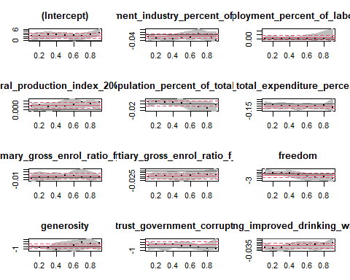

## Quantile Regression Analysis of Deviance Table  
##   
## Model: natural_growth ~ employment_industry_percent_of_employed + unemployment_percent_of_labour_force + agricultural_production_index_2004_2006_100 + urban_population_percent_of_total_population + health_total_expenditure_percent_of_gdp + education_primary_gross_enrol_ratio_f_m_per_100_pop + education_tertiary_gross_enrol_ratio_f_m_per_100_pop + freedom + generosity + trust_government_corruption + pop_using_improved_drinking_water_urban  
## Tests of Equality of Distinct Slopes: tau in { 0.1 0.2 0.3 0.4 0.5 0.6 0.7 0.8 0.9 }  
##   
## Df Resid Df F value  
## employment_industry_percent_of_employed 8 865 1.7082  
## unemployment_percent_of_labour_force 8 865 0.3304  
## agricultural_production_index_2004_2006_100 8 865 0.9534  
## urban_population_percent_of_total_population 8 865 1.7414  
## health_total_expenditure_percent_of_gdp 8 865 0.7544  
## education_primary_gross_enrol_ratio_f_m_per_100_pop 8 865 0.2721  
## education_tertiary_gross_enrol_ratio_f_m_per_100_pop 8 865 0.5841  
## freedom 8 865 1.7266  
## generosity 8 865 2.7101  
## trust_government_corruption 8 865 0.6416  
## pop_using_improved_drinking_water_urban 8 865 0.7526  
## Pr(>F)   
## employment_industry_percent_of_employed 0.092640 .   
## unemployment_percent_of_labour_force 0.954457   
## agricultural_production_index_2004_2006_100 0.471410   
## urban_population_percent_of_total_population 0.085268 .   
## health_total_expenditure_percent_of_gdp 0.643271   
## education_primary_gross_enrol_ratio_f_m_per_100_pop 0.974933   
## education_tertiary_gross_enrol_ratio_f_m_per_100_pop 0.791577   
## freedom 0.088479 .   
## generosity 0.005959 **  
## trust_government_corruption 0.743013   
## pop_using_improved_drinking_water_urban 0.644911   
## ---  
## Signif. codes: 0 '***' 0.001 '**' 0.01 '*' 0.05 '.' 0.1 ' ' 1

library(mgcv)  
library(gratia)  
  
# siekiant tiksliau prognozuoti reikšmes naudinga sudaryti apibendrintus adityvius modelius,  
# kuriais galima įtraukti netiesinius sąryšius tarp kovariančių ir atsako  
fit_gam <- function(formula, data) {  
 model_gam <- gam(formula, data = data, select = FALSE)  
 gam.check(model_gam)  
 summary(model_gam)  
 draw(model_gam)  
 k.check(model_gam)  
 model_gam  
}

print("GAM migracijos prieaugiui")

## [1] "GAM migracijos prieaugiui"

data <- regression_train %>%  
 dplyr::select(-natural_growth) %>%  
 slice(-outlier_indices)  
  
# model_gam_migration <- fit_gam(migration_growth ~ s(employment_industry_percent_of_employed) +  
# s(unemployment_percent_of_labour_force) +  
# s(agricultural_production_index_2004_2006_100) +  
# s(urban_population_percent_of_total_population) +  
# s(health_total_expenditure_percent_of_gdp) +  
# s(education_primary_gross_enrol_ratio_f_m_per_100_pop) +  
# s(education_tertiary_gross_enrol_ratio_f_m_per_100_pop) +  
# s(freedom) +  
# s(generosity) +  
# s(trust_government_corruption), data)  
#  
#  
# draw(model_gam_migration)  
# k.check(model_gam_migration)  
# summary(model_gam_migration)  
  
  
  
model_gam_migration <- fit_gam(migration_growth ~ s(employment_industry_percent_of_employed) +  
 unemployment_percent_of_labour_force +  
 agricultural_production_index_2004_2006_100 +  
 s(urban_population_percent_of_total_population) +  
 health_total_expenditure_percent_of_gdp +  
 education_primary_gross_enrol_ratio_f_m_per_100_pop +  
 s(education_tertiary_gross_enrol_ratio_f_m_per_100_pop) +  
 s(freedom) +  
 s(generosity) +  
 s(trust_government_corruption), data)

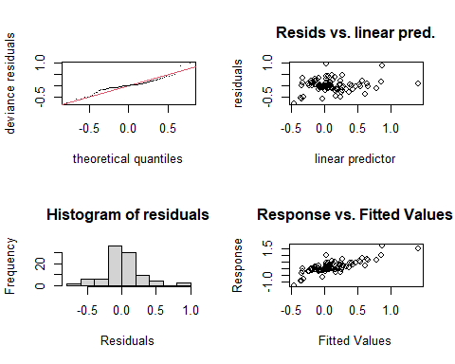

##   
## Method: GCV Optimizer: magic  
## Smoothing parameter selection converged after 7 iterations.  
## The RMS GCV score gradient at convergence was 6.213085e-07 .  
## The Hessian was positive definite.  
## Model rank = 59 / 59   
##   
## Basis dimension (k) checking results. Low p-value (k-index<1) may  
## indicate that k is too low, especially if edf is close to k'.  
##   
## k' edf k-index  
## s(employment_industry_percent_of_employed) 9.00 1.82 0.99  
## s(urban_population_percent_of_total_population) 9.00 3.62 1.00  
## s(education_tertiary_gross_enrol_ratio_f_m_per_100_pop) 9.00 6.24 0.97  
## s(freedom) 9.00 2.55 0.84  
## s(generosity) 9.00 3.20 1.03  
## s(trust_government_corruption) 9.00 3.57 1.02  
## p-value   
## s(employment_industry_percent_of_employed) 0.370   
## s(urban_population_percent_of_total_population) 0.525   
## s(education_tertiary_gross_enrol_ratio_f_m_per_100_pop) 0.385   
## s(freedom) 0.055 .  
## s(generosity) 0.640   
## s(trust_government_corruption) 0.560   
## ---  
## Signif. codes: 0 '***' 0.001 '**' 0.01 '*' 0.05 '.' 0.1 ' ' 1

draw(model_gam_migration)

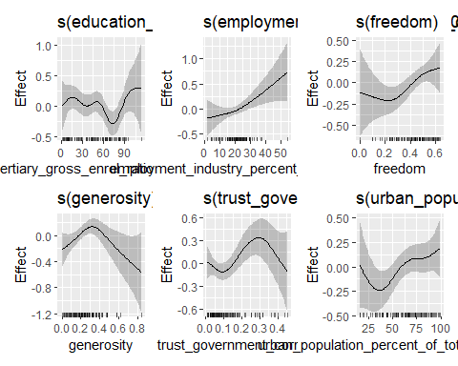

k.check(model_gam_migration)

## k' edf k-index  
## s(employment_industry_percent_of_employed) 9 1.816777 0.9868366  
## s(urban_population_percent_of_total_population) 9 3.617499 0.9980236  
## s(education_tertiary_gross_enrol_ratio_f_m_per_100_pop) 9 6.243436 0.9668621  
## s(freedom) 9 2.549298 0.8395376  
## s(generosity) 9 3.197427 1.0346404  
## s(trust_government_corruption) 9 3.565093 1.0191396  
## p-value  
## s(employment_industry_percent_of_employed) 0.4075  
## s(urban_population_percent_of_total_population) 0.4275  
## s(education_tertiary_gross_enrol_ratio_f_m_per_100_pop) 0.3300  
## s(freedom) 0.0600  
## s(generosity) 0.6125  
## s(trust_government_corruption) 0.5575

summary(model_gam_migration)

##   
## Family: gaussian   
## Link function: identity   
##   
## Formula:  
## migration_growth ~ s(employment_industry_percent_of_employed) +   
## unemployment_percent_of_labour_force + agricultural_production_index_2004_2006_100 +   
## s(urban_population_percent_of_total_population) + health_total_expenditure_percent_of_gdp +   
## education_primary_gross_enrol_ratio_f_m_per_100_pop + s(education_tertiary_gross_enrol_ratio_f_m_per_100_pop) +   
## s(freedom) + s(generosity) + s(trust_government_corruption)  
##   
## Parametric coefficients:  
## Estimate Std. Error  
## (Intercept) 0.3740994 0.4853808  
## unemployment_percent_of_labour_force -0.0038517 0.0084051  
## agricultural_production_index_2004_2006_100 -0.0001339 0.0019064  
## health_total_expenditure_percent_of_gdp -0.0040872 0.0170518  
## education_primary_gross_enrol_ratio_f_m_per_100_pop -0.0018611 0.0040183  
## t value Pr(>|t|)  
## (Intercept) 0.771 0.443  
## unemployment_percent_of_labour_force -0.458 0.648  
## agricultural_production_index_2004_2006_100 -0.070 0.944  
## health_total_expenditure_percent_of_gdp -0.240 0.811  
## education_primary_gross_enrol_ratio_f_m_per_100_pop -0.463 0.645  
##   
## Approximate significance of smooth terms:  
## edf Ref.df F  
## s(employment_industry_percent_of_employed) 1.817 2.302 3.959  
## s(urban_population_percent_of_total_population) 3.617 4.454 1.942  
## s(education_tertiary_gross_enrol_ratio_f_m_per_100_pop) 6.243 7.357 1.702  
## s(freedom) 2.549 3.196 2.817  
## s(generosity) 3.197 3.944 2.867  
## s(trust_government_corruption) 3.565 4.370 2.615  
## p-value   
## s(employment_industry_percent_of_employed) 0.0262 *  
## s(urban_population_percent_of_total_population) 0.1076   
## s(education_tertiary_gross_enrol_ratio_f_m_per_100_pop) 0.1230   
## s(freedom) 0.0366 *  
## s(generosity) 0.0310 *  
## s(trust_government_corruption) 0.0392 *  
## ---  
## Signif. codes: 0 '***' 0.001 '**' 0.01 '*' 0.05 '.' 0.1 ' ' 1  
##   
## R-sq.(adj) = 0.472 Deviance explained = 61.2%  
## GCV = 0.13236 Scale est. = 0.096153 n = 95

print("GAM natūraliam prieaugiui")

## [1] "GAM natūraliam prieaugiui"

# model_gam_natural <- fit_gam(natural_growth ~ s(employment_industry_percent_of_employed) +  
# s(unemployment_percent_of_labour_force) +  
# s(agricultural_production_index_2004_2006_100) +  
# s(urban_population_percent_of_total_population) +  
# s(health_total_expenditure_percent_of_gdp) +  
# s(education_primary_gross_enrol_ratio_f_m_per_100_pop) +  
# s(education_tertiary_gross_enrol_ratio_f_m_per_100_pop) +  
# s(freedom) +  
# s(generosity) +  
# s(trust_government_corruption), regression_train %>% dplyr::select(-migration_growth))  
#  
#  
# draw(model_gam_natural)  
# k.check(model_gam_natural)  
# summary(model_gam_natural)  
  
  
model_gam_natural <- fit_gam(natural_growth ~ s(employment_industry_percent_of_employed) +  
 unemployment_percent_of_labour_force +  
 s(agricultural_production_index_2004_2006_100) +  
 urban_population_percent_of_total_population +  
 health_total_expenditure_percent_of_gdp +  
 s(education_primary_gross_enrol_ratio_f_m_per_100_pop) +  
 s(education_tertiary_gross_enrol_ratio_f_m_per_100_pop) +  
 s(freedom) +  
 s(generosity) +  
 trust_government_corruption, regression_train %>% dplyr::select(-migration_growth))

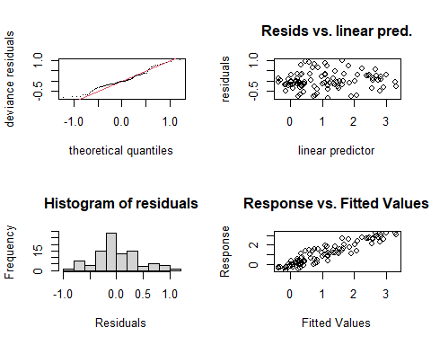

##   
## Method: GCV Optimizer: magic  
## Smoothing parameter selection converged after 7 iterations.  
## The RMS GCV score gradient at convergence was 1.371315e-07 .  
## The Hessian was positive definite.  
## Model rank = 59 / 59   
##   
## Basis dimension (k) checking results. Low p-value (k-index<1) may  
## indicate that k is too low, especially if edf is close to k'.  
##   
## k' edf k-index  
## s(employment_industry_percent_of_employed) 9.00 5.16 0.96  
## s(agricultural_production_index_2004_2006_100) 9.00 4.12 1.00  
## s(education_primary_gross_enrol_ratio_f_m_per_100_pop) 9.00 3.34 1.07  
## s(education_tertiary_gross_enrol_ratio_f_m_per_100_pop) 9.00 4.83 1.33  
## s(freedom) 9.00 2.68 1.05  
## s(generosity) 9.00 2.41 0.99  
## p-value  
## s(employment_industry_percent_of_employed) 0.31  
## s(agricultural_production_index_2004_2006_100) 0.38  
## s(education_primary_gross_enrol_ratio_f_m_per_100_pop) 0.73  
## s(education_tertiary_gross_enrol_ratio_f_m_per_100_pop) 1.00  
## s(freedom) 0.66  
## s(generosity) 0.42

draw(model_gam_natural)

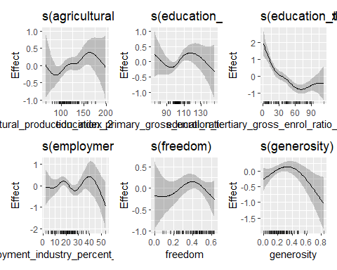

k.check(model_gam_natural)

## k' edf k-index  
## s(employment_industry_percent_of_employed) 9 5.159902 0.9649547  
## s(agricultural_production_index_2004_2006_100) 9 4.123495 0.9987737  
## s(education_primary_gross_enrol_ratio_f_m_per_100_pop) 9 3.340290 1.0692858  
## s(education_tertiary_gross_enrol_ratio_f_m_per_100_pop) 9 4.832763 1.3262088  
## s(freedom) 9 2.682792 1.0504460  
## s(generosity) 9 2.413316 0.9858652  
## p-value  
## s(employment_industry_percent_of_employed) 0.3300  
## s(agricultural_production_index_2004_2006_100) 0.4350  
## s(education_primary_gross_enrol_ratio_f_m_per_100_pop) 0.7600  
## s(education_tertiary_gross_enrol_ratio_f_m_per_100_pop) 0.9975  
## s(freedom) 0.6775  
## s(generosity) 0.4150

summary(model_gam_natural)

##   
## Family: gaussian   
## Link function: identity   
##   
## Formula:  
## natural_growth ~ s(employment_industry_percent_of_employed) +   
## unemployment_percent_of_labour_force + s(agricultural_production_index_2004_2006_100) +   
## urban_population_percent_of_total_population + health_total_expenditure_percent_of_gdp +   
## s(education_primary_gross_enrol_ratio_f_m_per_100_pop) +   
## s(education_tertiary_gross_enrol_ratio_f_m_per_100_pop) +   
## s(freedom) + s(generosity) + trust_government_corruption  
##   
## Parametric coefficients:  
## Estimate Std. Error t value  
## (Intercept) 1.253958 0.311162 4.030  
## unemployment_percent_of_labour_force 0.001227 0.013146 0.093  
## urban_population_percent_of_total_population 0.001981 0.004159 0.476  
## health_total_expenditure_percent_of_gdp -0.049611 0.028255 -1.756  
## trust_government_corruption 0.316856 0.779622 0.406  
## Pr(>|t|)   
## (Intercept) 0.000141 ***  
## unemployment_percent_of_labour_force 0.925931   
## urban_population_percent_of_total_population 0.635351   
## health_total_expenditure_percent_of_gdp 0.083527 .   
## trust_government_corruption 0.685681   
## ---  
## Signif. codes: 0 '***' 0.001 '**' 0.01 '*' 0.05 '.' 0.1 ' ' 1  
##   
## Approximate significance of smooth terms:  
## edf Ref.df F  
## s(employment_industry_percent_of_employed) 5.160 6.148 2.391  
## s(agricultural_production_index_2004_2006_100) 4.123 5.082 1.848  
## s(education_primary_gross_enrol_ratio_f_m_per_100_pop) 3.340 4.130 2.309  
## s(education_tertiary_gross_enrol_ratio_f_m_per_100_pop) 4.833 5.874 8.740  
## s(freedom) 2.683 3.333 1.310  
## s(generosity) 2.413 3.019 3.228  
## p-value   
## s(employment_industry_percent_of_employed) 0.0363 *   
## s(agricultural_production_index_2004_2006_100) 0.1225   
## s(education_primary_gross_enrol_ratio_f_m_per_100_pop) 0.0636 .   
## s(education_tertiary_gross_enrol_ratio_f_m_per_100_pop) 9.15e-07 ***  
## s(freedom) 0.2198   
## s(generosity) 0.0276 *   
## ---  
## Signif. codes: 0 '***' 0.001 '**' 0.01 '*' 0.05 '.' 0.1 ' ' 1  
##   
## R-sq.(adj) = 0.808 Deviance explained = 86.1%  
## GCV = 0.31706 Scale est. = 0.227 n = 97

library(yardstick)  
  
# regresijos modelių įvertinimas  
regression_test <- function(column, model_linear, model_gam, data, title) {  
 print(AIC(model_linear))  
 print(AIC(model_gam))  
  
  
 regression_test <- data %>%  
 mutate(  
 predicted_linear = predict(model_linear, data),  
 predicted_gam = predict(model_gam, data)  
 )  
  
 set <- metric_set(rmse, mae)  
  
 print("Tiesinis modelis")  
 print(set(regression_test, {{ column }}, predicted_linear))  
 print("GAM modelis")  
 print(set(regression_test, {{ column }}, predicted_gam))  
  
 regression_test %>%  
 pivot_longer(c(predicted_gam, predicted_linear)) %>%  
 mutate(name = factor(name, levels = c("predicted_linear", "predicted_gam"))) %>%  
 ggplot(aes({{ column }}, value)) +  
 geom_point(size = 2) +  
 facet_wrap(vars(name)) +  
 geom_abline(color = "red", size = 2.25) +  
 labs(  
 x = "Tikros reikšmės", y = "Prognozuotos reikmšės",  
 title = title  
 ) +  
 theme_minimal()  
}

# GAM modeliu gaunami nežymiai geresni rezultatai su mokymo duomeninis  
# , tačiau naudojant testavimo aibe pagerėjimo negaunama  
# Apskritai abu modeliai netinkami prognozuoti migracijos prieaugį  
print("Regresija migracijos prieaugiui")

## [1] "Regresija migracijos prieaugiui"

AIC(model_linear_migration)

## [1] 79.80556

AIC(model_gam_migration)

## [1] 70.74101

regression_test(  
 migration_growth, model_linear_migration, model_gam_migration, regression_train,  
 "Prognozuotos ir tikros reikšmės mokymo aibei (migracijos prieaugis)"  
)

## [1] 79.80556  
## [1] 70.74101  
## [1] "Tiesinis modelis"  
## # A tibble: 2 x 3  
## .metric .estimator .estimate  
## <chr> <chr> <dbl>  
## 1 rmse standard 0.578  
## 2 mae standard 0.303  
## [1] "GAM modelis"  
## # A tibble: 2 x 3  
## .metric .estimator .estimate  
## <chr> <chr> <dbl>  
## 1 rmse standard 0.529  
## 2 mae standard 0.240

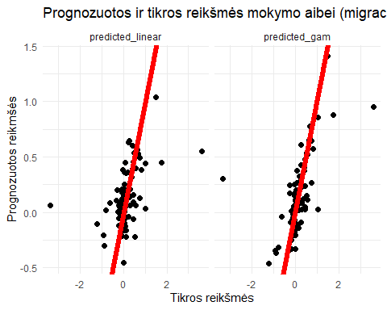

regression_test(  
 migration_growth, model_linear_migration, model_gam_migration, test,  
 "Prognozuotos ir tikros reikšmės testavimo aibei (migracijos prieaugis)"  
)

## [1] 79.80556  
## [1] 70.74101  
## [1] "Tiesinis modelis"  
## # A tibble: 2 x 3  
## .metric .estimator .estimate  
## <chr> <chr> <dbl>  
## 1 rmse standard 0.345  
## 2 mae standard 0.244  
## [1] "GAM modelis"  
## # A tibble: 2 x 3  
## .metric .estimator .estimate  
## <chr> <chr> <dbl>  
## 1 rmse standard 0.381  
## 2 mae standard 0.279

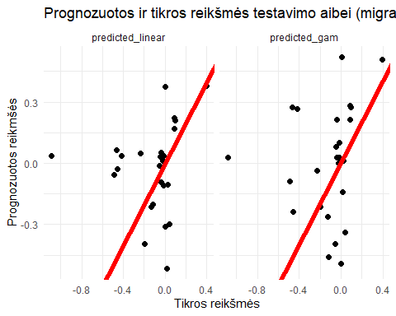

# Prognozuojant natūralų prieaugi gaunami geresni rezultatai negu prognozuojant migracijos prieaugį  
# mokymo aibėje matomas stiprus GAM modeliu gautas rezultatų pagerėjimas, tačiau testavimo aibėje skirtumai  
 # tik minimalūs  
print("Regresija natūraliam prieaugiui")

## [1] "Regresija natūraliam prieaugiui"

AIC(model_linear_natural)

## [1] 181.8344

AIC(model_gam_natural)

## [1] 156.1355

regression_test(  
 natural_growth, model_linear_natural, model_gam_natural, regression_train,  
 "Prognozuotos ir tikros reikšmės mokymo aibei (natūralus prieaugis)"  
)

## [1] 181.8344  
## [1] 156.1355  
## [1] "Tiesinis modelis"  
## # A tibble: 2 x 3  
## .metric .estimator .estimate  
## <chr> <chr> <dbl>  
## 1 rmse standard 0.587  
## 2 mae standard 0.470  
## [1] "GAM modelis"  
## # A tibble: 2 x 3  
## .metric .estimator .estimate  
## <chr> <chr> <dbl>  
## 1 rmse standard 0.403  
## 2 mae standard 0.309

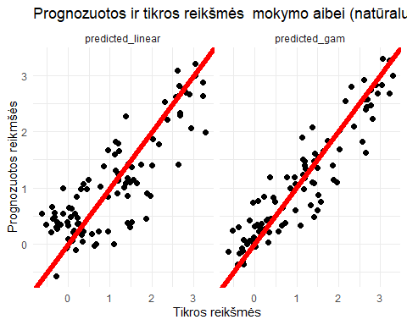

regression_test(  
 natural_growth, model_linear_natural, model_gam_natural, test,  
 "Prognozuotos ir tikros reikšmės testavimo aibei (natūralus prieaugis)"  
)

## [1] 181.8344  
## [1] 156.1355  
## [1] "Tiesinis modelis"  
## # A tibble: 2 x 3  
## .metric .estimator .estimate  
## <chr> <chr> <dbl>  
## 1 rmse standard 0.660  
## 2 mae standard 0.574  
## [1] "GAM modelis"  
## # A tibble: 2 x 3  
## .metric .estimator .estimate  
## <chr> <chr> <dbl>  
## 1 rmse standard 0.662  
## 2 mae standard 0.561

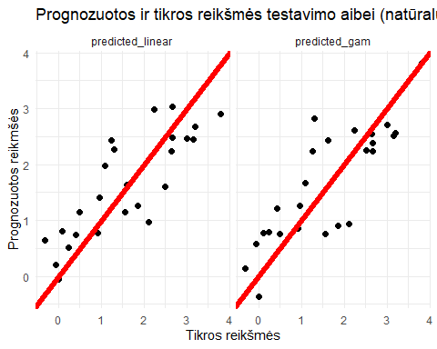

### Multinominė logistinė regresija

classification_train <- train %>% dplyr::select(-migration_growth, -natural_growth)

# Kadangi gautos prastos migracijos prieaugio prognozės, vietoje tikslios   
 # prieaugio reikšmės prognozuojama tik ar tam tikro tipo gyventojų prieaugis teigiamas  
 # ar neigiamas (naudojamos prieš tai sudarytos klasės)  
  
# Stačiakampės diagramos pagal kiekvieną kovariantę  
classification_train %>%  
 dplyr::select(1:6, category) %>%  
 pivot_longer(-category) %>%  
 ggplot(aes(x = category, y = value, fill = category)) +  
 facet_wrap(vars(name), scales = "free") +  
 geom_boxplot() +  
 theme_minimal() +  
 labs(title = "Kovariančių reikšmių pasiskirstymas pagal klases") +   
 xlab("Kateogrija") + ylab("Kovariantės reikšmė")

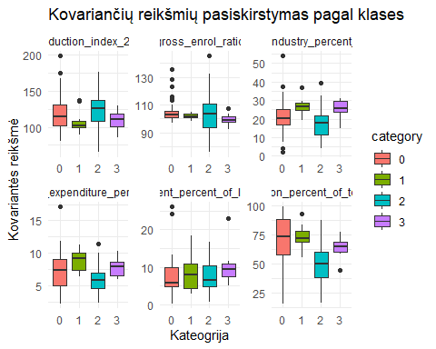

classification_train %>%  
 dplyr::select(7:length(classification_train), category) %>%  
 pivot_longer(-category) %>%  
 ggplot(aes(x = category, y = value, fill = category)) +  
 facet_wrap(vars(name), scales = "free") +  
 geom_boxplot() +  
 theme_minimal() +  
 labs(title = "Kovariančių reikšmių pasiskirstymas pagal klases") +  
 xlab("Kateogrija") + ylab("Kovariantės reikšmė")

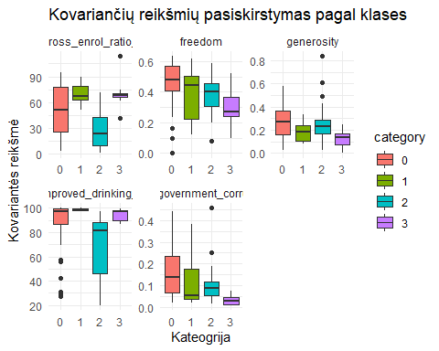

# Pažingsnine regresija sumažintas modelis statistiškai reikšmingai nesiskiria   
anova(model_logistic, model_logistic_small)

## Likelihood ratio tests of Multinomial Models  
##   
## Response: category  
## Model  
## 1 urban_population_percent_of_total_population + education_tertiary_gross_enrol_ratio_f_m_per_100_pop + generosity + trust_government_corruption + pop_using_improved_drinking_water_urban  
## 2 employment_industry_percent_of_employed + unemployment_percent_of_labour_force + agricultural_production_index_2004_2006_100 + urban_population_percent_of_total_population + health_total_expenditure_percent_of_gdp + education_primary_gross_enrol_ratio_f_m_per_100_pop + education_tertiary_gross_enrol_ratio_f_m_per_100_pop + freedom + generosity + trust_government_corruption + pop_using_improved_drinking_water_urban  
## Resid. df Resid. Dev Test Df LR stat. Pr(Chi)  
## 1 273 145.8441   
## 2 255 125.9399 1 vs 2 18 19.90425 0.3382363

summary(model_logistic_small)

## Call:  
## nnet::multinom(formula = category ~ urban_population_percent_of_total_population +   
## education_tertiary_gross_enrol_ratio_f_m_per_100_pop + generosity +   
## trust_government_corruption + pop_using_improved_drinking_water_urban,   
## data = classification_train, trace = FALSE)  
##   
## Coefficients:  
## (Intercept) urban_population_percent_of_total_population  
## 1 -39.8819145 -0.04607011  
## 2 2.2575147 -0.01676782  
## 3 -0.7546367 -0.20816219  
## education_tertiary_gross_enrol_ratio_f_m_per_100_pop generosity  
## 1 0.03716542 -8.362663  
## 2 -0.03755632 -1.258363  
## 3 0.14190074 -11.776205  
## trust_government_corruption pop_using_improved_drinking_water_urban  
## 1 -2.163034 0.427085643  
## 2 -4.428862 0.007482486  
## 3 -41.363126 0.086422684  
##   
## Std. Errors:  
## (Intercept) urban_population_percent_of_total_population  
## 1 0.2959585 0.03887555  
## 2 1.1680728 0.01799239  
## 3 7.7821840 0.09635350  
## education_tertiary_gross_enrol_ratio_f_m_per_100_pop generosity  
## 1 0.02967933 4.347576  
## 2 0.01890919 1.815050  
## 3 0.06040160 6.360179  
## trust_government_corruption pop_using_improved_drinking_water_urban  
## 1 4.2367679 0.02636595  
## 2 3.1372343 0.01702100  
## 3 0.2589815 0.08187579  
##   
## Residual Deviance: 145.8441   
## AIC: 181.8441

plot(predictorEffects(model_logistic_small))

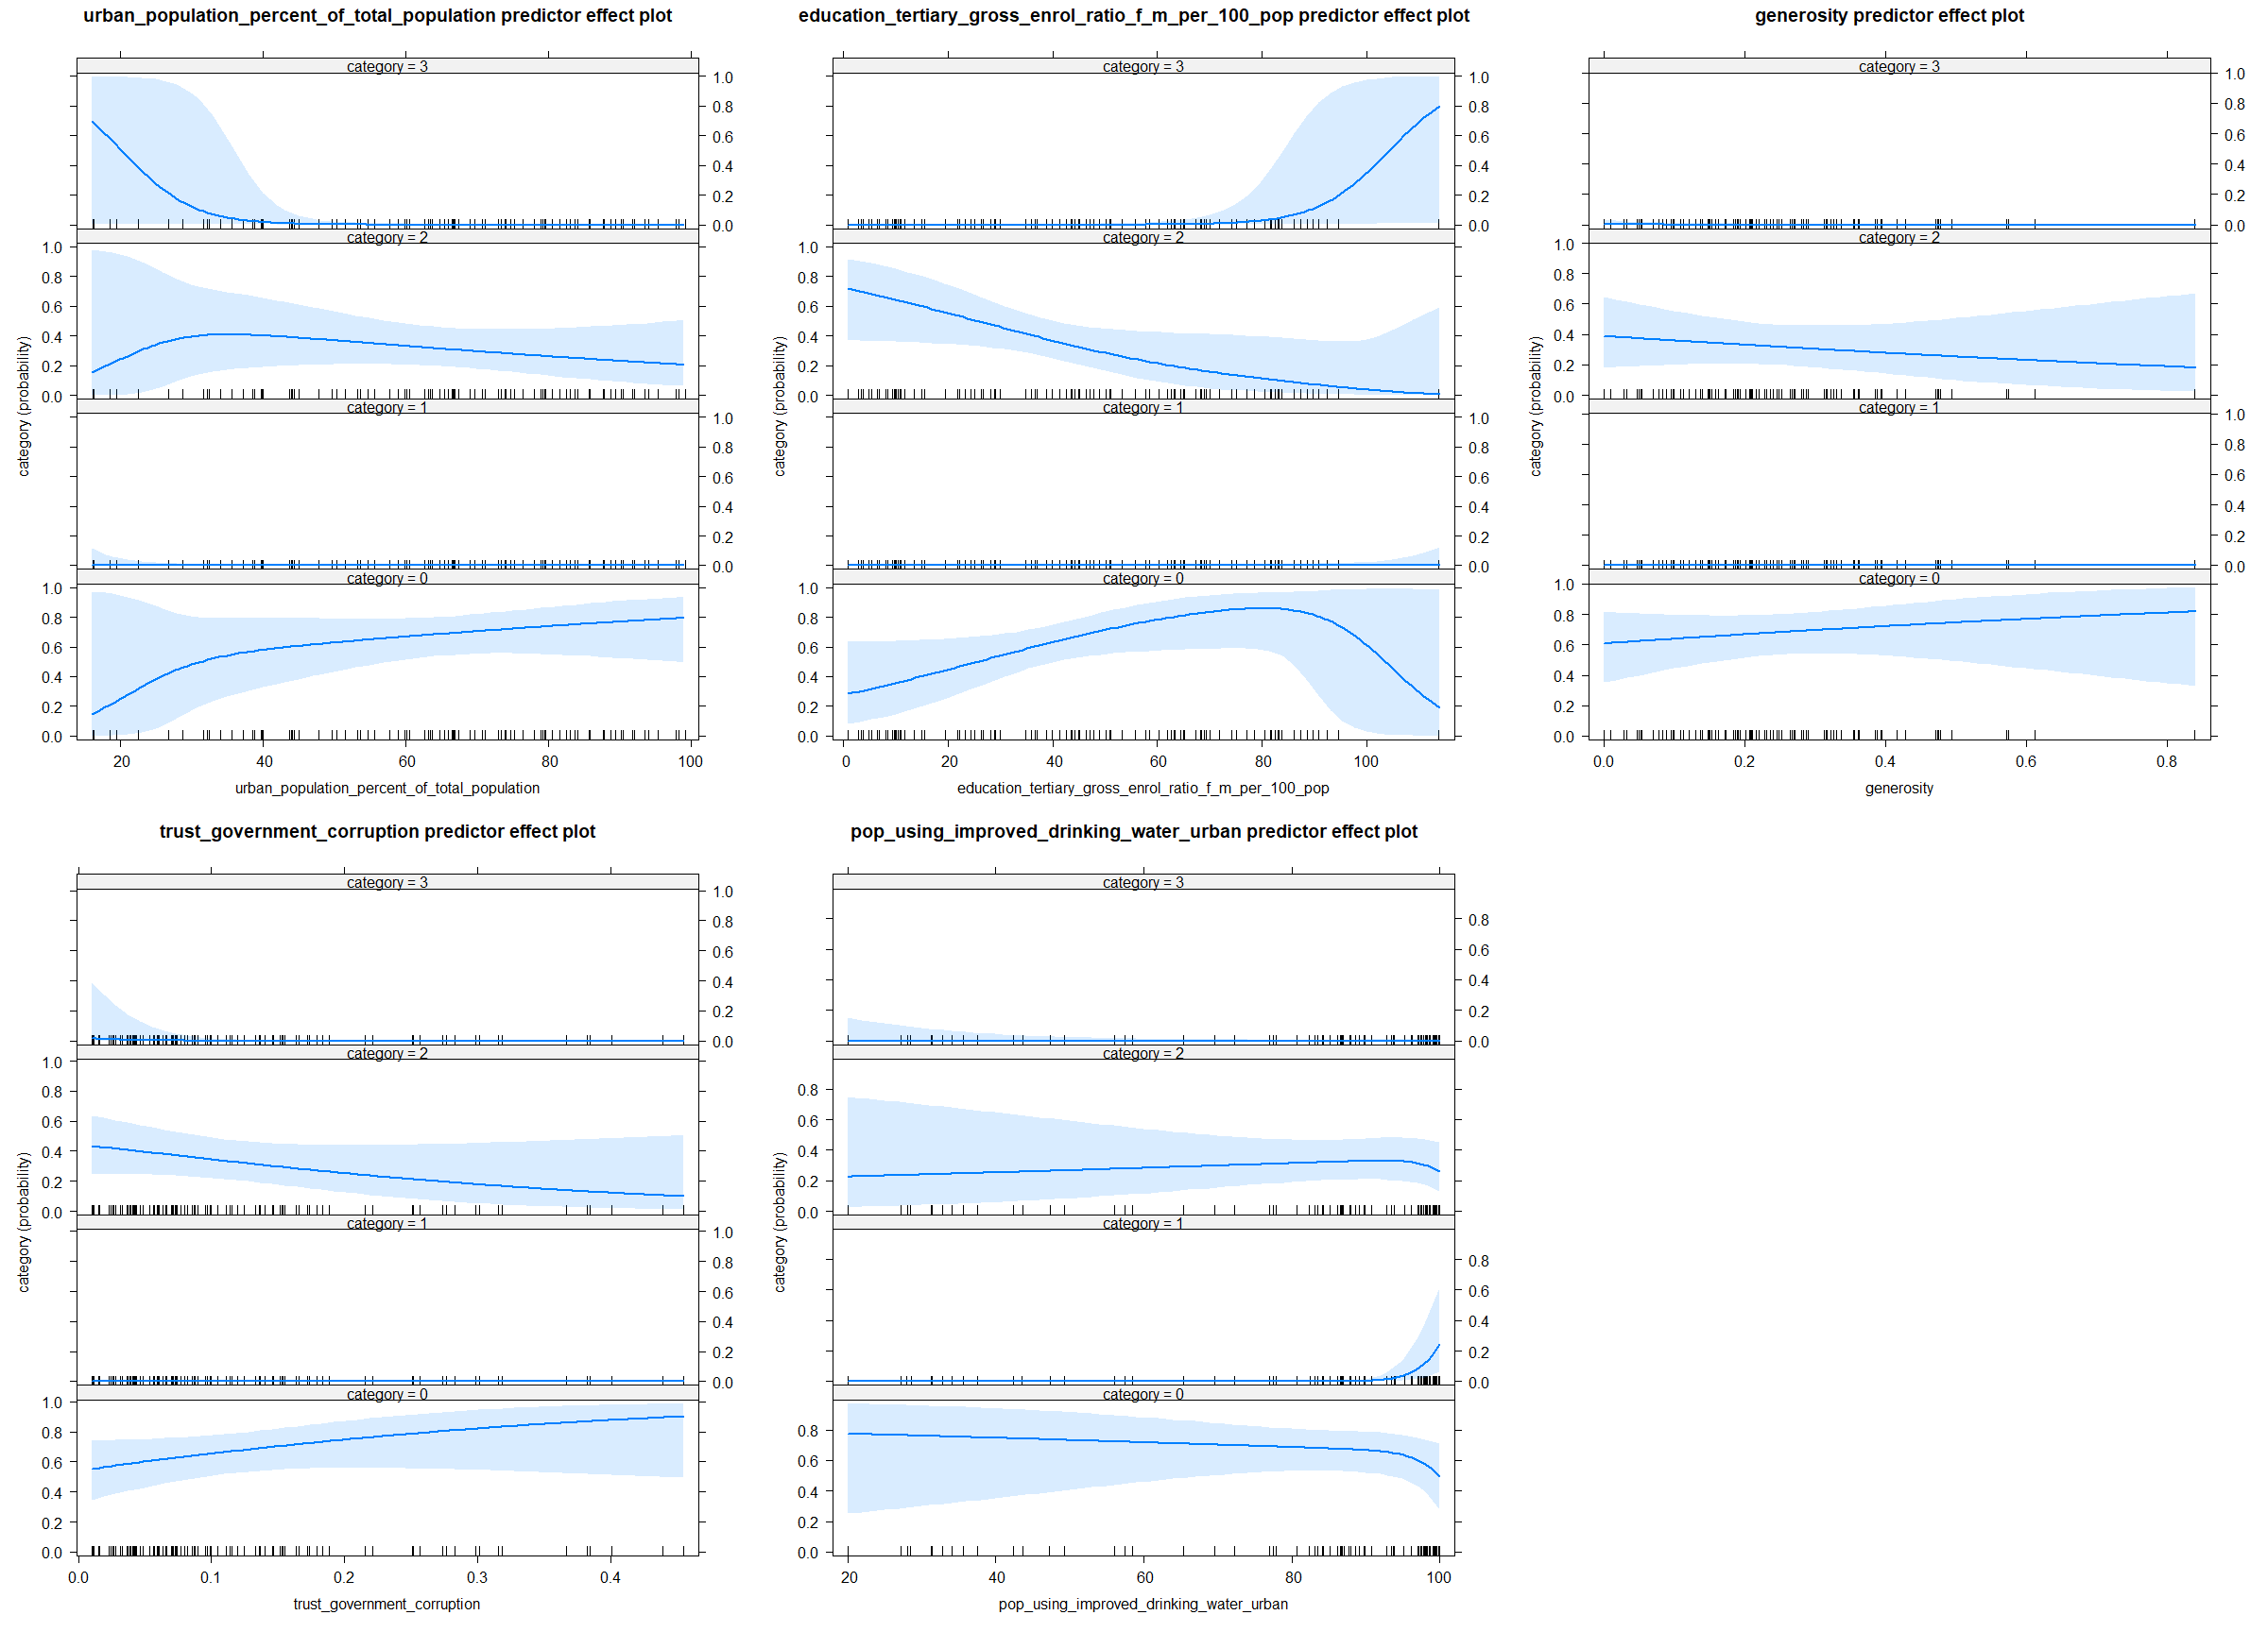

# multinominės logistinės regresijos modelio koeficientų grafikas  
plot_coefficients <- function(model) {  
 tidy(model) %>%  
 filter(term != "(Intercept)") %>%  
 mutate(greater_than_one = if_else(estimate > 0, "Yes", "No")) %>%  
 ggplot(aes(term, exp(estimate), color = y.level, shape = greater_than_one)) +  
 geom_pointrange(aes(ymin = exp(estimate - std.error), ymax = exp(estimate + std.error)), ) +  
 scale_x_discrete() +  
 coord_flip() +  
 theme_minimal() +  
 geom_hline(yintercept = 1, linetype = "dashed") +  
 scale_y_continuous(oob = scales::squish, limits = c(-1, 16)) +  
 facet_grid(cols = vars(y.level), scales = "free") +  
 labs(x = "Kovariantė", y = "Eksponentinės keficientų reikšmės")  
}  
  
plot_coefficients(model_logistic_small)

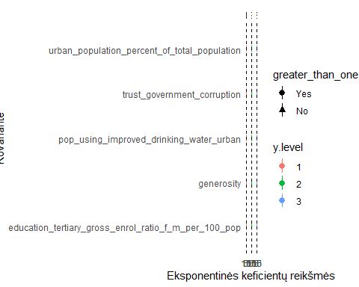

# pačių sudaryta modelio kokybės metrika, kuri "pataiso" bendrą tikslumą  
# priskirdama 0.5 - jeigu teisingai prognozuotas vieno tipo prieaugis  
# 1 - jeigu teisingi abu prieaugiai  
# 0 - jeigu abiejų tipų prieaugiai neteisingi  
  
custom_metric <- function(y_true, y_pred) {  
 c(  
 "custom_metric", "multiclass",  
 case_when(  
 y_true %in% c(0, 3) & y_pred %in% c(1, 2) ~ 0.5,  
 y_true %in% c(1, 2) & y_pred %in% c(0, 3) ~ 0.5,  
 y_true == y_pred ~ 1,  
 TRUE ~ 0  
 ) %>%  
 mean()  
 )  
}  
  
# Multinominės logistinės regresijos modelio įvertinimas  
classification_eval <- function(model, data) {  
 df_pred_truth <- tibble(  
 predicted = factor(predict(model, data)),  
 truth = data$category  
 ) %>%  
 cbind(as.data.frame(model$fitted.values))  
  
  
  
 classification_metrics <- metric_set(accuracy, j_index, f_meas)  
  
 print("Maišos matrica")  
 print(conf_mat(df_pred_truth,  
 truth = truth,  
 estimate = predicted  
 ))  
  
 print("Modelio kokybės metrikos")  
 print(classification_metrics(df_pred_truth,  
 truth = truth,  
 estimate = predicted  
 ) %>%  
 rbind(custom_metric(df_pred_truth$truth, df_pred_truth$predicted)))  
  
  
  
 print(roc_auc(df_pred_truth, truth = truth, c("0", "1", "2", "3"), estimator = "macro"))  
  
 roc_curve(df_pred_truth, truth = truth, c("0", "1", "2", "3")) %>%  
 autoplot()  
}  
  
print("Pradinis multinominės logistinės regresijos modelis")

## [1] "Pradinis multinominės logistinės regresijos modelis"

classification_eval(model_logistic_small, classification_train)

## [1] "Maišos matrica"  
## Truth  
## Prediction 0 1 2 3  
## 0 32 4 10 1  
## 1 2 4 0 0  
## 2 12 0 22 0  
## 3 1 2 0 7  
## [1] "Modelio kokybės metrikos"  
## # A tibble: 4 x 3  
## .metric .estimator .estimate   
## <chr> <chr> <chr>   
## 1 accuracy multiclass 0.670103092783505  
## 2 j_index macro 0.525509827074684  
## 3 f_meas macro 0.656323877068558  
## 4 custom_metric multiclass 0.824742268041237  
## # A tibble: 1 x 3  
## .metric .estimator .estimate  
## <chr> <chr> <dbl>  
## 1 roc_auc macro 0.856

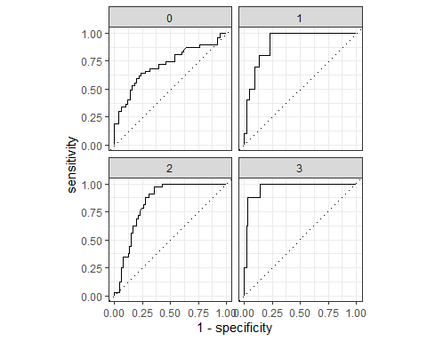

# Turimas ne itin ryškus klasių išbalasavimas  
# (daugumos klasės stebėjimų beveik 6 kartus daugiau nei mažiausios)   
# Todėl rezultatai gali pagerėti sugeneravus dirbtinius papildomus stebėjimus  
classification_train %>% count(category)

## # A tibble: 4 x 2  
## category n  
## <fct> <int>  
## 1 0 47  
## 2 1 10  
## 3 2 32  
## 4 3 8

library(themis)  
  
smote_recipe <- recipe(category ~ .,  
 data = classification_train  
) %>%  
 step_smote(category, over_ratio = 1)  
  
  
smote_recipe <- prep(smote_recipe, training = classification_train)  
  
classification_train2 <- bake(smote_recipe, NULL)

model_logistic2 <- nnet::multinom(category ~ ., data = classification_train2, trace = FALSE)  
  
model_logistic2_small <- stats::step(model_logistic2, direction = "both")

anova(model_logistic2, model_logistic2_small)

## Likelihood ratio tests of Multinomial Models  
##   
## Response: category  
## Model  
## 1 employment_industry_percent_of_employed + urban_population_percent_of_total_population + health_total_expenditure_percent_of_gdp + education_primary_gross_enrol_ratio_f_m_per_100_pop + education_tertiary_gross_enrol_ratio_f_m_per_100_pop + freedom + generosity + trust_government_corruption + pop_using_improved_drinking_water_urban  
## 2 employment_industry_percent_of_employed + unemployment_percent_of_labour_force + agricultural_production_index_2004_2006_100 + urban_population_percent_of_total_population + health_total_expenditure_percent_of_gdp + education_primary_gross_enrol_ratio_f_m_per_100_pop + education_tertiary_gross_enrol_ratio_f_m_per_100_pop + freedom + generosity + trust_government_corruption + pop_using_improved_drinking_water_urban  
## Resid. df Resid. Dev Test Df LR stat. Pr(Chi)  
## 1 534 180.2015   
## 2 528 175.6232 1 vs 2 6 4.578352 0.5989112

summary(model_logistic2_small)

## Call:  
## nnet::multinom(formula = category ~ employment_industry_percent_of_employed +   
## urban_population_percent_of_total_population + health_total_expenditure_percent_of_gdp +   
## education_primary_gross_enrol_ratio_f_m_per_100_pop + education_tertiary_gross_enrol_ratio_f_m_per_100_pop +   
## freedom + generosity + trust_government_corruption + pop_using_improved_drinking_water_urban,   
## data = classification_train2, trace = FALSE)  
##   
## Coefficients:  
## (Intercept) employment_industry_percent_of_employed  
## 1 -82.56939 0.4258807  
## 2 5.70080 -0.0116691  
## 3 92.81018 -0.2041168  
## urban_population_percent_of_total_population  
## 1 -0.05943872  
## 2 -0.02051866  
## 3 -0.51990696  
## health_total_expenditure_percent_of_gdp  
## 1 0.74220698  
## 2 -0.19739614  
## 3 0.03267364  
## education_primary_gross_enrol_ratio_f_m_per_100_pop  
## 1 -0.04120533  
## 2 -0.01072513  
## 3 -1.04980535  
## education_tertiary_gross_enrol_ratio_f_m_per_100_pop freedom generosity  
## 1 0.12485108 -13.934443 -20.910237  
## 2 -0.03129278 -1.030607 -2.348438  
## 3 0.39886697 14.382368 -31.583264  
## trust_government_corruption pop_using_improved_drinking_water_urban  
## 1 12.028641 0.754354905  
## 2 -3.201743 0.008499684  
## 3 -83.873611 0.326507763  
##   
## Std. Errors:  
## (Intercept) employment_industry_percent_of_employed  
## 1 0.9382478 0.12418061  
## 2 3.0079846 0.04331525  
## 3 2.5050944 0.11138284  
## urban_population_percent_of_total_population  
## 1 0.04737429  
## 2 0.01952951  
## 3 0.09579285  
## health_total_expenditure_percent_of_gdp  
## 1 0.2687616  
## 2 0.1428908  
## 3 0.4182192  
## education_primary_gross_enrol_ratio_f_m_per_100_pop  
## 1 0.09746081  
## 2 0.02512582  
## 3 0.10697038  
## education_tertiary_gross_enrol_ratio_f_m_per_100_pop freedom generosity  
## 1 0.04534927 6.080630 6.239774  
## 2 0.01963119 2.465082 1.871969  
## 3 0.06976496 6.006716 7.726796  
## trust_government_corruption pop_using_improved_drinking_water_urban  
## 1 7.627677 0.13619649  
## 2 3.019814 0.01851975  
## 3 2.069105 0.11631511  
##   
## Residual Deviance: 180.2015   
## AIC: 240.2015

plot(predictorEffects(model_logistic2_small))

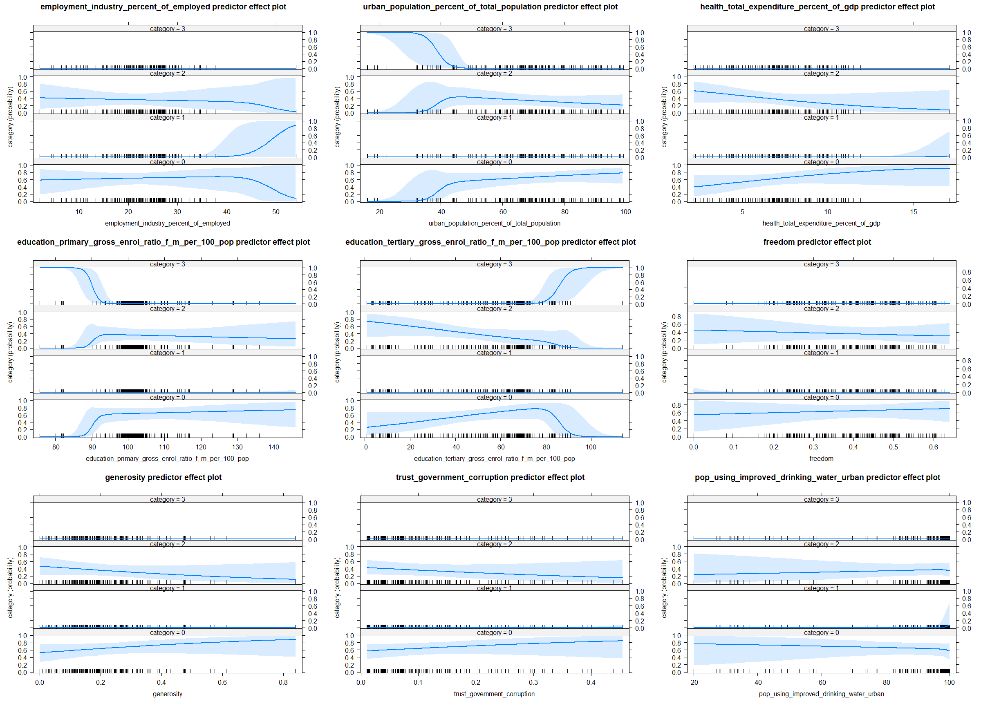

plot_coefficients(model_logistic2_small)

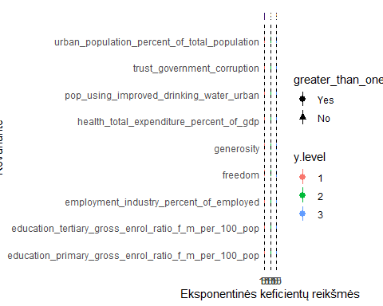

print("Multinominės logistinės regresijos modelis su SMOTE")

## [1] "Multinominės logistinės regresijos modelis su SMOTE"

classification_eval(model_logistic2_small, classification_train2)

## [1] "Maišos matrica"  
## Truth  
## Prediction 0 1 2 3  
## 0 26 0 10 1  
## 1 6 47 0 0  
## 2 13 0 37 0  
## 3 2 0 0 46  
## [1] "Modelio kokybės metrikos"  
## # A tibble: 4 x 3  
## .metric .estimator .estimate   
## <chr> <chr> <chr>   
## 1 accuracy multiclass 0.829787234042553  
## 2 j_index macro 0.773049645390071  
## 3 f_meas macro 0.822588817404336  
## 4 custom_metric multiclass 0.906914893617021  
## # A tibble: 1 x 3  
## .metric .estimator .estimate  
## <chr> <chr> <dbl>  
## 1 roc_auc macro 0.936

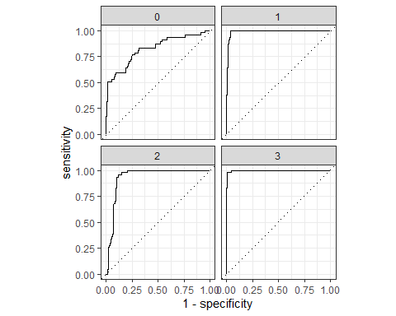

# apskaičiuoja kiek kartų teisingai prognozuotas kiekvieno tipo prieaugis  
# (lengviau interpretuoti negu maišos matricą)  
custom_confusion <- function(y_true, y_pred) {  
 case_when(  
 y_true == y_pred ~ "Correct both",  
 (y_true %in% c(0, 2) & y_pred %in% c(0, 2)) | (y_true %in% c(1, 3) & y_pred %in% c(1, 3)) ~ "Correct natural",  
 (y_true %in% c(0, 1) & y_pred %in% c(0, 1)) | (y_true %in% c(2, 3) & y_pred %in% c(2, 3)) ~ "Correct migration",  
 TRUE ~ "Correct none"  
 ) %>%  
 tibble(results = .) %>%  
 count(results)  
}  
  
  
# palyginimui jeigu butų naudojami prieš tai sudaryti 2 regresijos modeliai prognozuoti klases  
class_predictions <- function() {  
 tibble(  
 migration_growth = predict(model_gam_migration, test),  
 natural_growth = predict(model_gam_natural, test)  
 ) %>%  
 mutate(category = factor(case_when(  
 migration_growth >= 0 & natural_growth >= 0 ~ 0, # "P migration, P natural",  
 migration_growth >= 0 & natural_growth < 0 ~ 1, # "P migration, N natural",  
 migration_growth < 0 & natural_growth >= 0 ~ 2, # "N migration, P natural",  
 TRUE ~ 3  
 ))) %>%  
 pull(category)  
}  
  
  
classification_test <- function(model, data, name) {  
 df_pred_truth <- tibble(truth = data$category)  
 classification_metrics <- metric_set(accuracy, j_index, f_meas)  
  
 if (name == "Naudojant du regresijos modelius") {  
 df_pred_truth$predicted <- factor(class_predictions(), levels = c(0, 1, 2, 3))  
 } else {  
 df_pred_truth$predicted <- factor(predict(model, test), levels = c(0, 1, 2, 3))  
 }  
  
  
 print("Maišos matrica")  
 conf_mat(df_pred_truth,  
 truth = truth,  
 estimate = predicted  
 ) %>% print()  
  
  
 print(custom_confusion(df_pred_truth$truth, df_pred_truth$predicted))  
  
 print("Modelio kokybės metrikos")  
 classification_metrics(df_pred_truth, truth, estimate = predicted) %>%  
 rbind(custom_metric(df_pred_truth$truth, df_pred_truth$predicted)) %>%  
 print()  
  
 cat("\n\n")  
}

# Naudojant testavimo aibę.  
# Geriausi rezultatai gauti su modeliu, kuriam naudotas SMOTE algoritmas  
# blogiausi - panaudojus regresijos modelius  
  
# Vėl matoma, kad geresni rezultatai gaunami prognozuojant natūralų gyventojų prieaugį  
print("Naudojant pradinį multinominės logistinės regresijos modelį")

## [1] "Naudojant pradinį multinominės logistinės regresijos modelį"

classification_test(model_logistic, test, "Pradinis")

## [1] "Maišos matrica"  
## Truth  
## Prediction 0 1 2 3  
## 0 2 1 2 0  
## 1 0 0 0 0  
## 2 5 0 12 0  
## 3 0 1 1 1  
## # A tibble: 3 x 2  
## results n  
## <chr> <int>  
## 1 Correct both 15  
## 2 Correct migration 2  
## 3 Correct natural 8  
## [1] "Modelio kokybės metrikos"  
## # A tibble: 4 x 3  
## .metric .estimator .estimate   
## <chr> <chr> <chr>   
## 1 accuracy multiclass 0.6   
## 2 j_index macro 0.333928571428571  
## 3 f_meas macro 0.527777777777778  
## 4 custom_metric multiclass 0.8

print("Naudojant multinomės logistinės regresijos modelį su SMOTE")

## [1] "Naudojant multinomės logistinės regresijos modelį su SMOTE"

classification_test(model_logistic2_small, test, "SMOTE")

## [1] "Maišos matrica"  
## Truth  
## Prediction 0 1 2 3  
## 0 2 0 2 0  
## 1 0 1 0 0  
## 2 4 0 13 0  
## 3 1 1 0 1  
## # A tibble: 3 x 2  
## results n  
## <chr> <int>  
## 1 Correct both 17  
## 2 Correct natural 7  
## 3 Correct none 1  
## [1] "Modelio kokybės metrikos"  
## # A tibble: 4 x 3  
## .metric .estimator .estimate   
## <chr> <chr> <chr>   
## 1 accuracy multiclass 0.68   
## 2 j_index macro 0.514484126984127  
## 3 f_meas macro 0.585700757575758  
## 4 custom_metric multiclass 0.82

classification_test(model_logistic, test, "Naudojant du regresijos modelius")

## [1] "Maišos matrica"  
## Truth  
## Prediction 0 1 2 3  
## 0 4 1 8 1  
## 1 0 1 0 0  
## 2 3 0 7 0  
## 3 0 0 0 0  
## # A tibble: 4 x 2  
## results n  
## <chr> <int>  
## 1 Correct both 12  
## 2 Correct migration 1  
## 3 Correct natural 11  
## 4 Correct none 1  
## [1] "Modelio kokybės metrikos"  
## # A tibble: 4 x 3  
## .metric .estimator .estimate   
## <chr> <chr> <chr>   
## 1 accuracy multiclass 0.48   
## 2 j_index macro 0.170634920634921  
## 3 f_meas macro 0.535873015873016  
## 4 custom_metric multiclass 0.72

u