Žirmūnai
The most populated district in Vilnius (it does not mean it is crowded). Most of the apparent buildings are Soviet-era, but some newly built apartments exist. It is a quite peaceful neibhourhood surounded by green areas.

Pros | Cons
- Quite peaceful  - Has lots of surrounding nature  - Is near Nėris river  - Has its own beach (Žirmūnai beach)  - Reasonable rent price | - Very bad traffic jams during rush hours (at Kareivių and Žirmūnų streets)  - Car parking in most of the public yards is quite limited  - Distance to Auriga office is significant 9-10 km

Šiaurės Miestelis
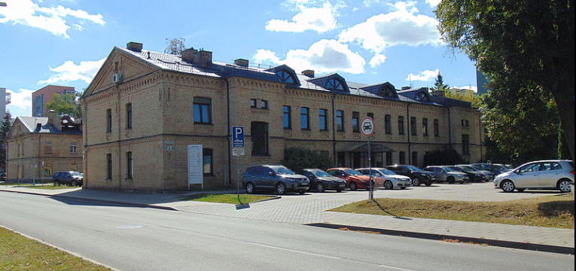
One of the sub-districts of Žirmūnai. Quite simple and nice to live place, most of the appartaments are soviet-era, but more recently built ones are available.

Pros | Cons
- Lots of stores and restaurants in “Ogmijos Miestas” shopping area  - Good public transport options  - Good bicycle roads  - Reasonable rent price | - Very bad traffic jams during rush hours (at Zirmunu street)  - Car parking in most of the public yards is quite limited

Antakalnis
Second largest district by area in Vilnius. Reasonable amount of area in this district is taken up by green places such as forests and parks. Antakalnis is located near Žirmūnai and they are are separated by the Nėris river. Antakalnis also suffers heavy traffic issues during rush hours. Although, it is a quite large district it does not have that many stores or areas for shopping, this means you will have to visit other districts such as Šiaurės Miestelis or Šeškinė. Although it is a large district it is not really well developed and most of the flats for living are situated around Antakalnis street.
Pros | Cons
- Lots of green areas for recreation  - Reasonably priced rent  - Has largest poly-clinic in Vilnius  - Decent public transport to the city center. | - Very bad traffic jams during rush hours (at Antkalnis street)  - Far away from Auriga office 9-11 km.  - During rush hours trips take extra 30 min longer with a car or public transport.  - Poor bicycle route infrastructure.

Justiniškės
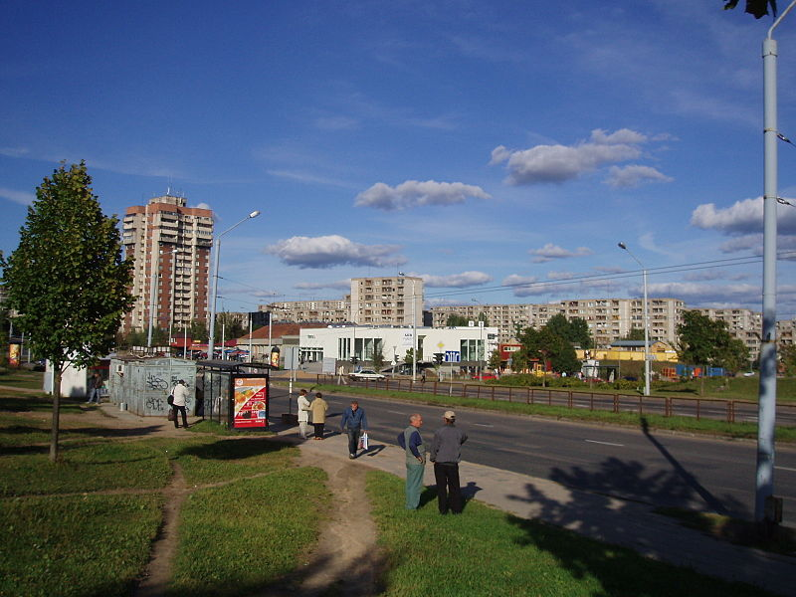
Built around 1980 up to this day it is the most depressing district in Vilnius. Some could say that it is almost like a separate city inside a city. It feels really soviet and the demographics living there reflect that mostly older people. Additionally it is really far away from the city itself.

Pros | Cons
- Cheap rent | - Far away from the city  - Quite gray and depressing place to live  - Lacks bigger food stores

Pašilaičiai
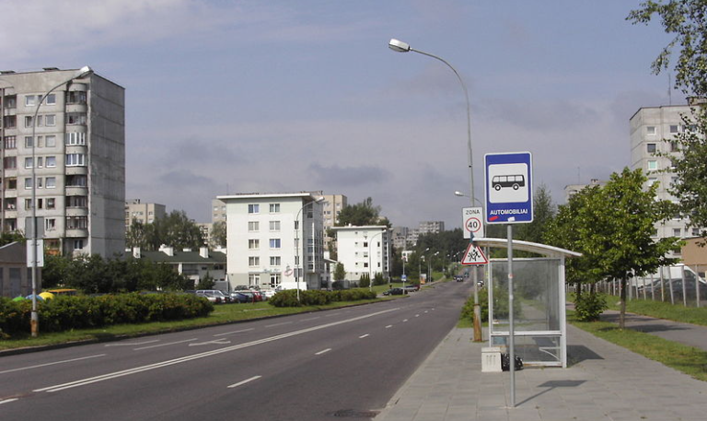
Quite large district with sometimes odd buildings and appartament complexes that are very different from one another. Since Pašilaičiai is quite large and was built during different time periods it is hard to generalyze the whole district. What is true about it is that it is really far away from the city center, but close to Auriga office. If you are looking for an appartament there make sure you avoid appartaments in the Ukmergės g., because it is the busiest street in Vilnius and this street is very noisy. Since this part of Vilnius is still developed very actively there are new sub-districts appearing such as Perkūnkiemis with lots of newly built appartaments.
Pros | Cons
- Relatively close to Auriga office  - Multiple hardware stores  - Decent bicycle roads  - Relatively safe | - Far away from the city center  - Public transport may be problematic, make sure to check out your options.  - No bars or cafes  - Lack of green spaces  - Parking situation is very bad in newly built appartaments.

Fabijoniškės
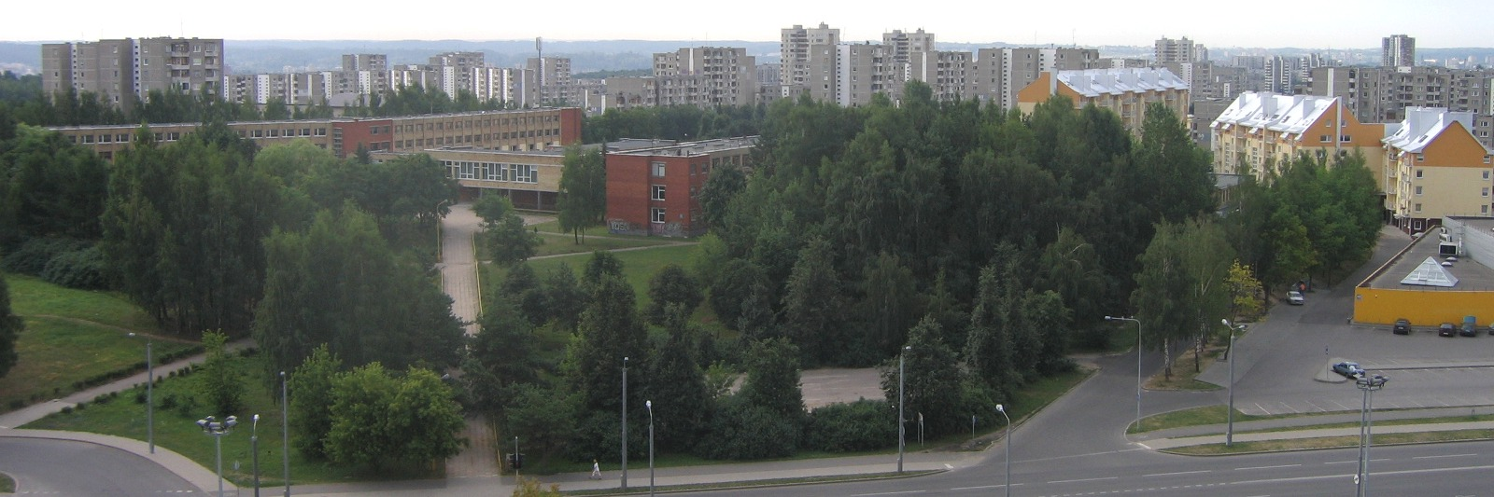
Built from 1980 to 1990. Is a quite gray and boring neibhourhood. It has plenty of grocery stores and has quite good public transportation. This district was filmed in Netflix series Chernobyl as a fake Pripyat movie set. Although, it is quite gray and boring it has some private houses located between the apartments. The district is very Russian friendly most of the people here speak Russian. You can often find people drinking in public places here (which is illegal in Lithuania). If you think about living here make sure you choose apartments situated around the Fabijoniškių g. or Ateities g. or where city bus 3G rides (this bus is a very quick way to reach the city center)
Fabijoniškės has quite a few of gyms also at the outskirts of it you can find a few small forests.
Pros | Cons
- Reasonable amount of grocery stores and shopping centers  - Cheaper priced rent  - Decent public transport to the city center. | - Close to Auriga office  - Lots of public drinking  - Quite gray and depressing place to live

Jeruzalė
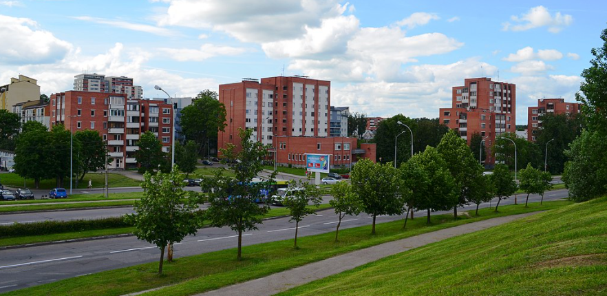
A nice district to live at is surrounded by a regional park and quite tranquil green areas. Alltough it is a little further away from a city center in terms of travel times it is okay. There are various sorts of appartament buildings in there ones built in the soviet-era, others after 1991. Jeruzalės g. can be quite busy and noisy during rush hours, so I would avoid houses facing this Jeruzalės street.
Pros | Cons
- Green areas and regional Park  - Decent public transport to the city center  - Relatively close to Auriga office  - Decent bicycle roads | - Few grocery stores  - Appartaments for rent may be hard to find

Santariškės
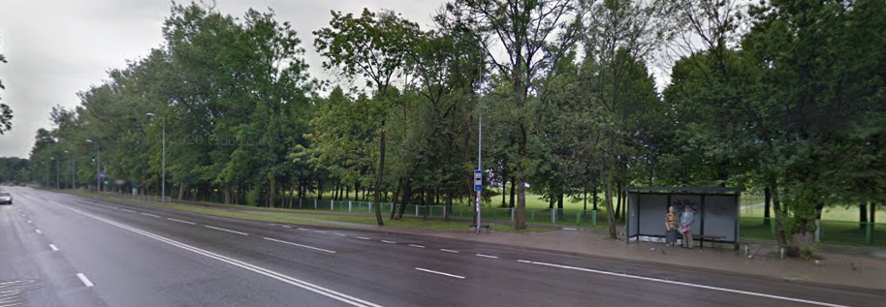
Relatively small district with little number of appartaments available. This district is located near few beautiful green areas and forests and is quite calm and a safe place to live. Santariškės a large hospital so if you want a more quite place to live there make sure it is little further away from the Santaros hospital.
Pros | Cons
- Good public transport  - Cheaper priced rent  - Beautiful green areas  - Quite a calm place | - Appartaments may be hard to find  - Far away from the city center

Karoliniškės
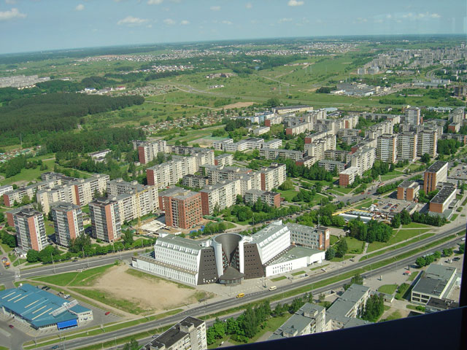
Mostly developed during 1971 – 1986. This district similarly to Fabijoniškės is quite gray and depressing. Very wide streets in some parts of the street give you an impression that humans are not welcomed there. One notable highlight of this district is the Television tower which gives this district a distinct feel. The public transportation is quite okay and due to mentioned wide streets traffic during rush hours is not that bad, but some major streets can get jammed up.
Pros | Cons
- Reasonable public transport  - Cheaper priced rent  - Large russian population | - Gray and depressing place  - Parking may be an issue

Šeškinė
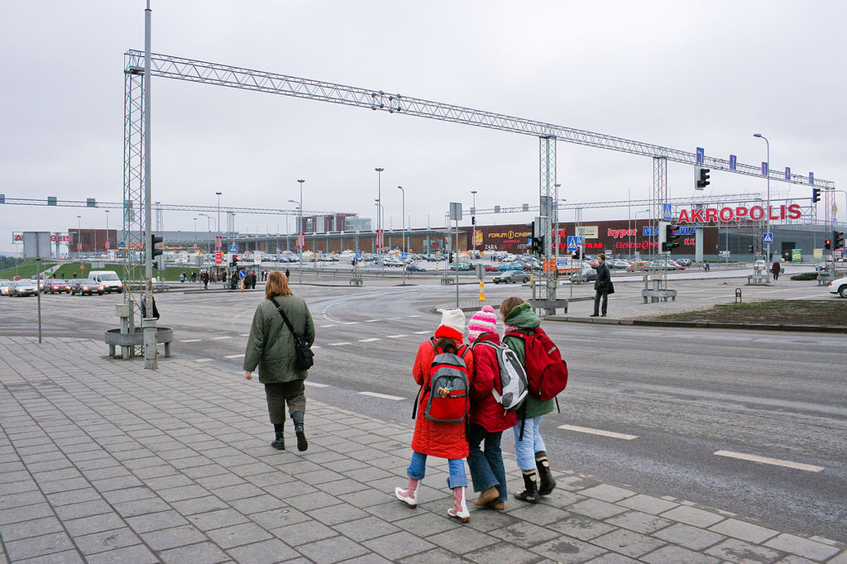
Built in 1977 as a micro-district. Šeškinė became the district where whole Vilnius comes to shop. Šeškinė has two biggest shopping centers in Vilnius: „Ozas“ and „Akropolis“. If you decide on looking for an appartament I would suggest ones found in Gelvonų g. it is a quite calm street with decent public transport.
Pros | Cons
- Good public transport  - Two biggest shopping centers  - Decent bicycle routes | - Severe traffic during rush hours or weekends  - Parking may be an issue

Lazdynai and Lazdynėliai
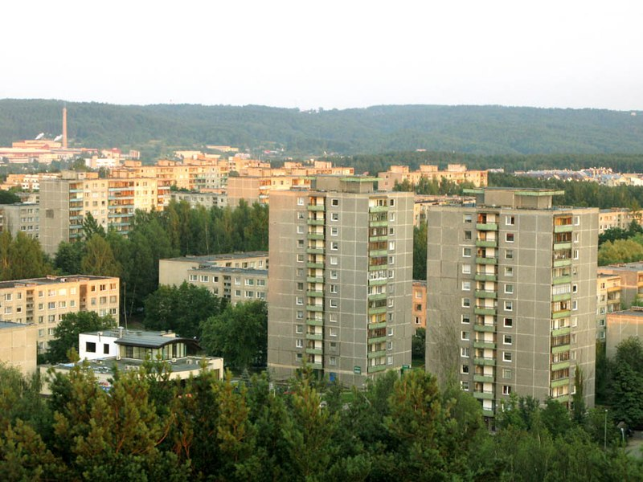
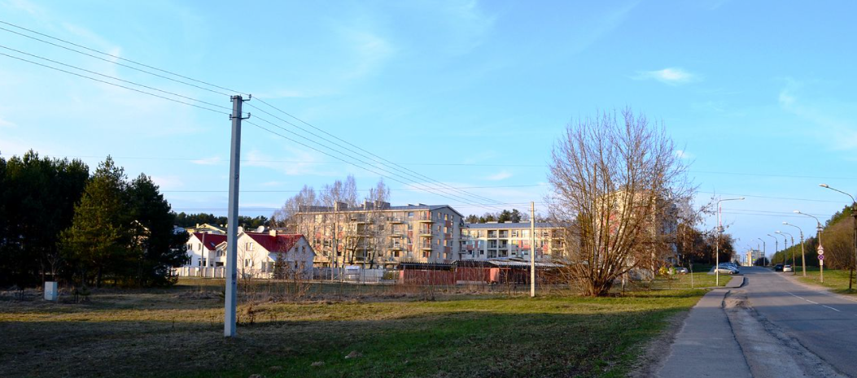
Decent districts to live if you have a car altough it feels that it may be situated further away from the city. The public transport is great and getting where you want with a car is even better. These districts have lots of green spaces and are situated near the Vingis Park one of the most beautiful green space in Vilnius. Most of the appartaments here are soviet-era and large amount of people living there speak Russian.
Pros | Cons
- Good public transport  - Great green spaces  - Large russian population  - Good car parking situation  - Good rent price | - Quite far away from the city  - Relatively far away from the Auriga office unless you drive with a car.

Žvėrynas
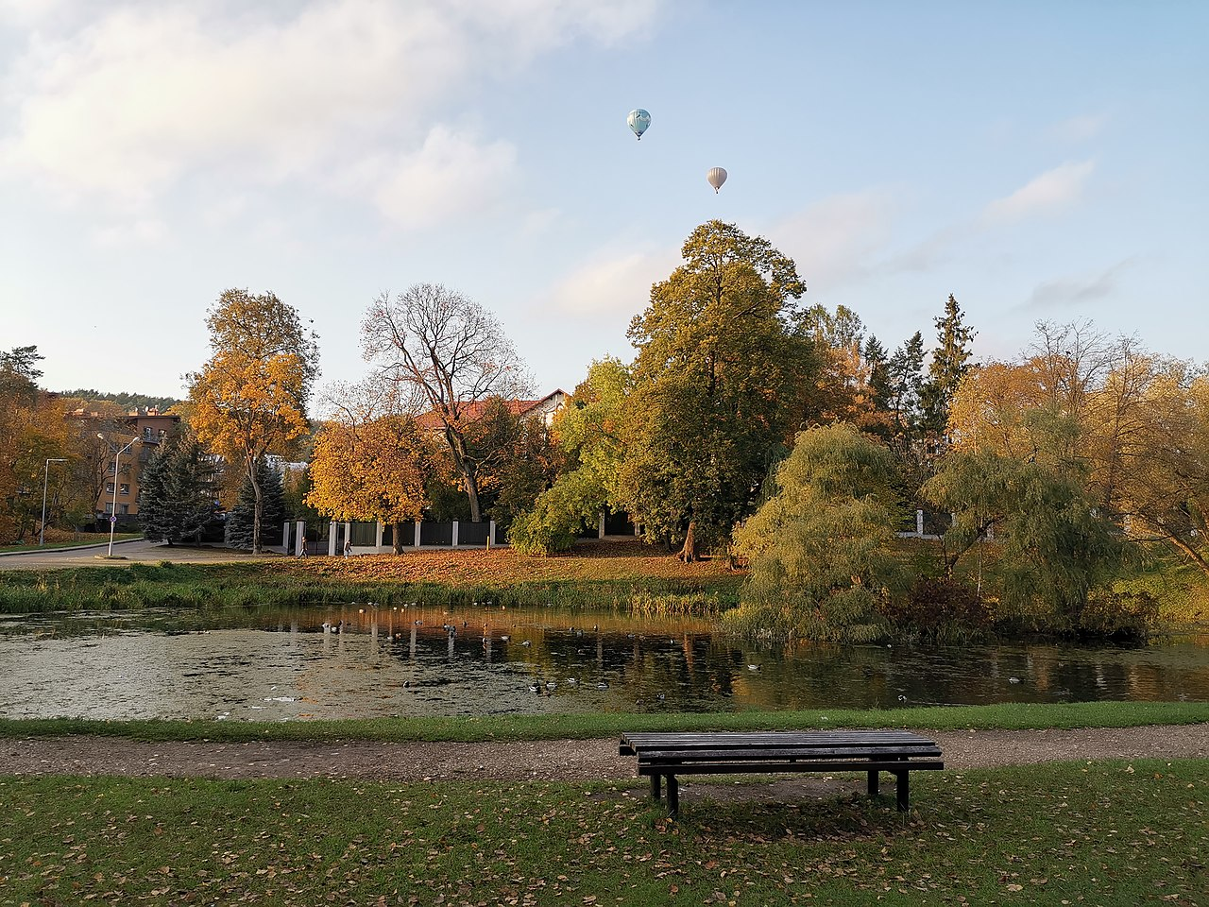
In Lithuanian „žvėrynas“ means place of wild animals it is known as the rich-people district in Vilnius. There is plenty of private homes as well as apartament buildings. Whole district is surrounded by large green areas and forests. Some parts of Žvėrynas are at the walking distance of the Vingis Park.
Pros | Cons
- Nice place to live at  - Low crime  - Expesive rent | - Poor public transport  - Far away from the Auriga office

Šnipiškės
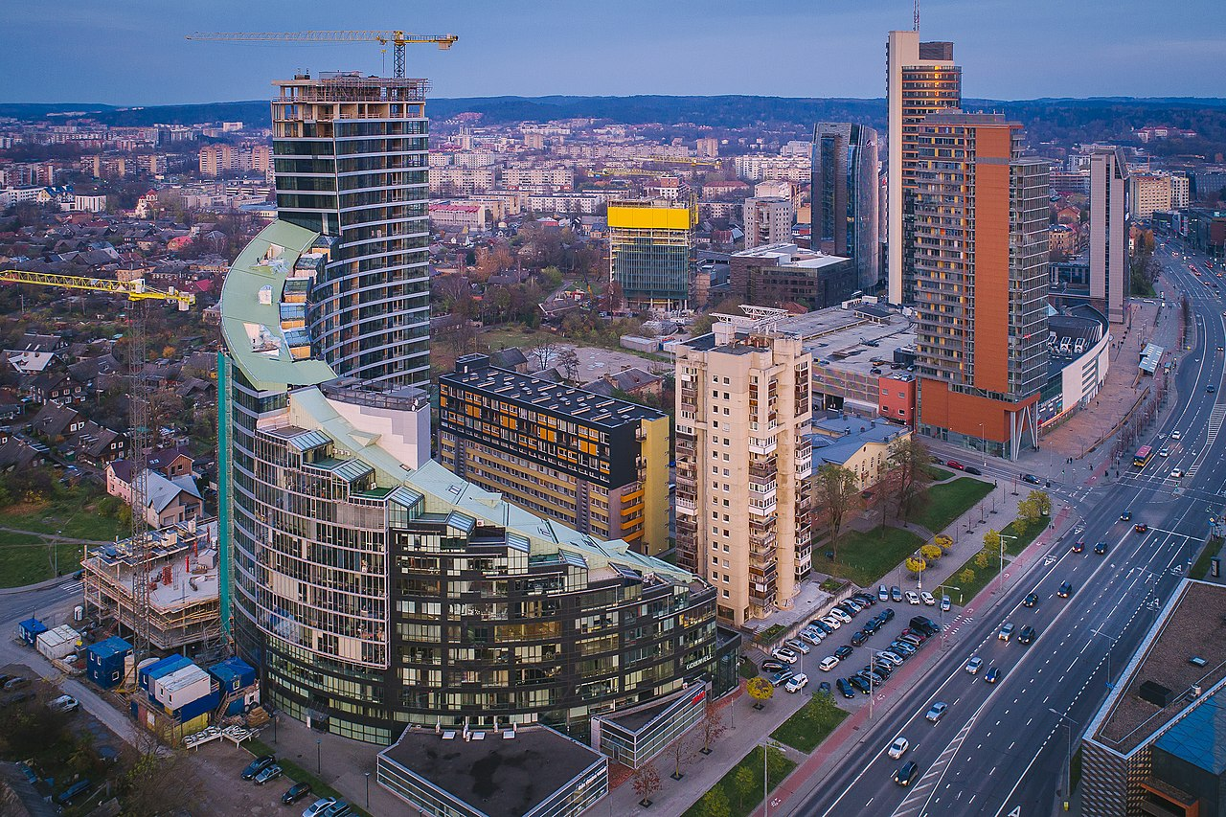
Mixed bag of appartaments and other buildings. You can find old wooden houses with chickens running around. Big 16 story soviet block apartments and brand new and shiny buildings. Šnipiškės has a bussines focused sky-scraper area unoficially called „Shanghai“. Depending on the where you find a place to live Šnipiškės can be a great place. If you are looking for an appartament here make sure you choose appartaments located around Rinktinės g..
Pros | Cons
- Good public transport  - Near the city center  - Reasonable distance to Auriga office  - Two large shopping centers „CUP“ and „Europa“ | - Appartaments may be hard to find  - The area around Kalvarijų market has lots of crime

Naujamiestis
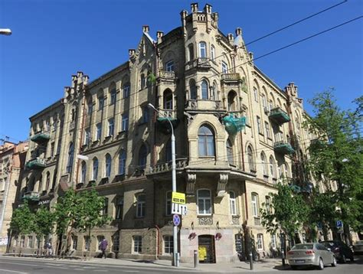
Naujamiestis means „new city“ in Lithuanian. And you could say it is relatively new. It was built during WW-I and WW-II. Most of the houses there have a distinct look to them some of the were built by the Germans and others by Soviets. The German built appartaments need lots of heating so living there may be expensive during the winter season. There were lots of factories in this district most of those factories are closeddown and either became loft-appartaments or just abandoned areas. It is a unique place to live at but the rent may be quite pricey and the district may not feel that safe at times.
Pros | Cons
- Near the train and bus stations  - Diverse selection of appartaments | - Far away from the Auriga office  - Parking may be a problem  - Public transport may not be that great  - Lack of green areas

Useful links:
- Appartaments for rent (no agent fees)
- Biggest appartament portal
- Expat Facebook group

