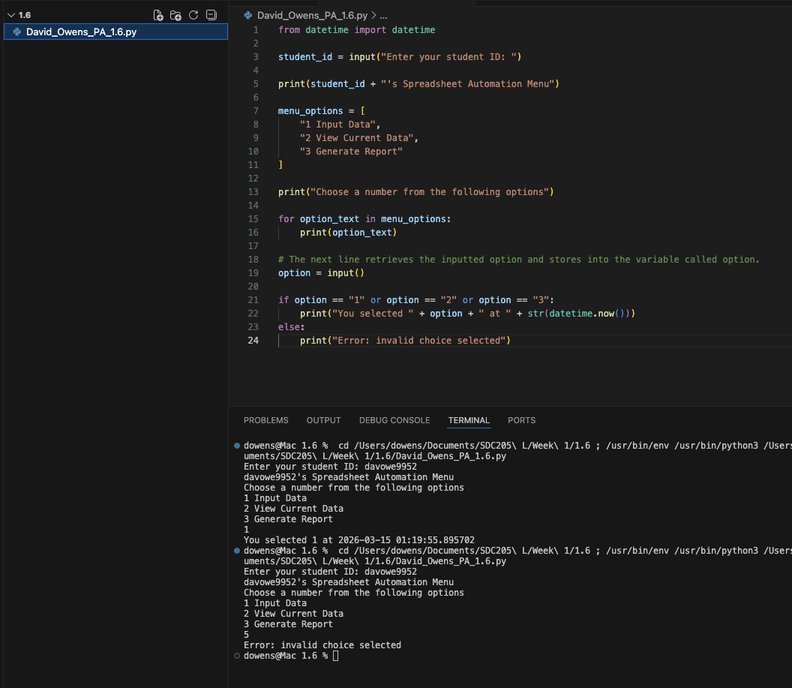

https://github.com/dowens412/SDC205L_Project

