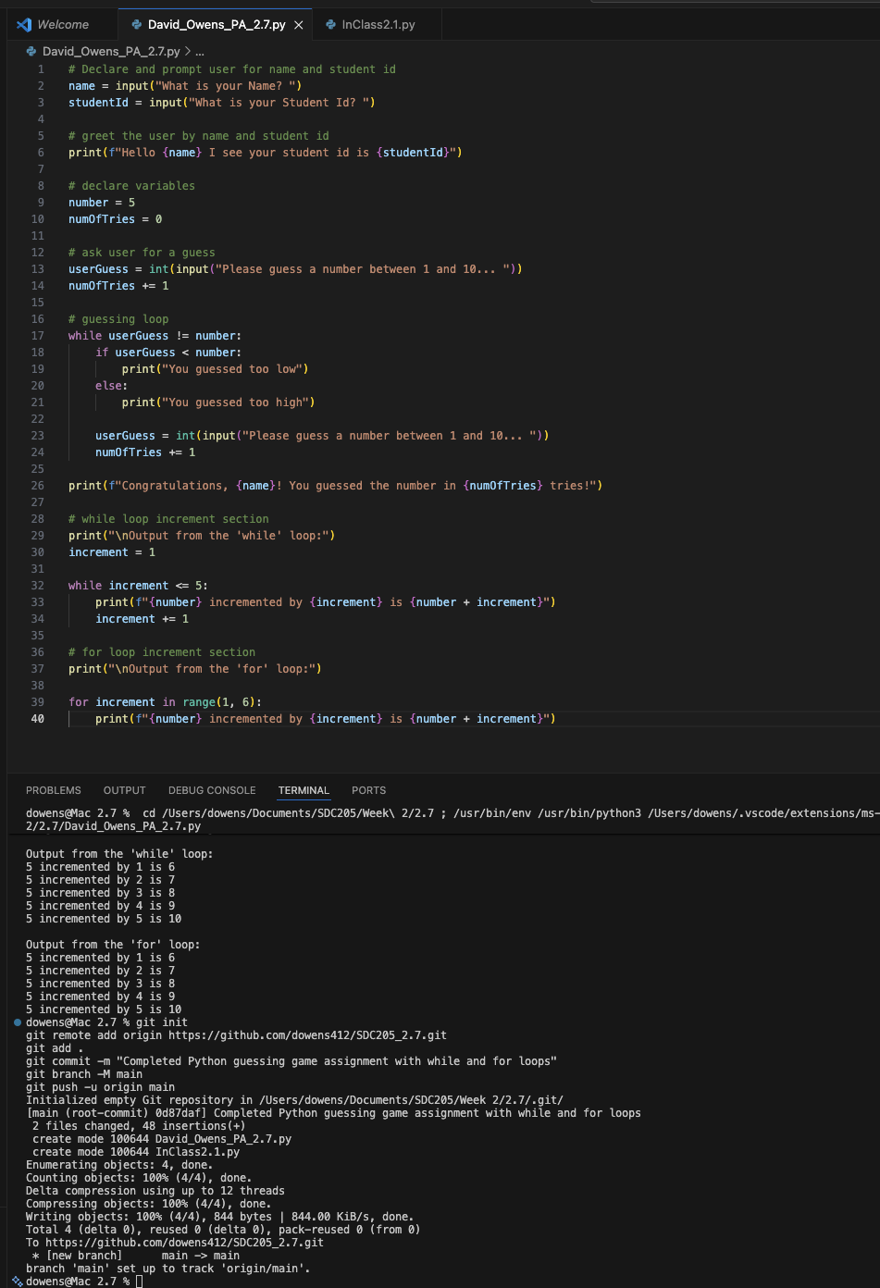
https://github.com/dowens412/SDC205_2.7

