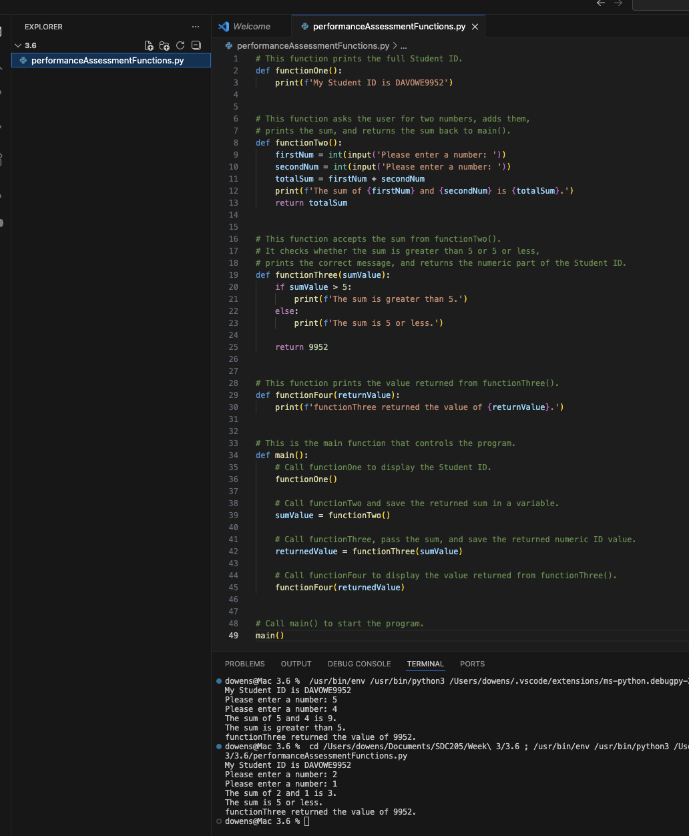
Questions
- What is the purpose of a function?
The purpose of a function is to group code together to perform a specific task. Functions help keep programs organized and make it easier to reuse code without writing the same thing over and over.
- Why might you pass more than one parameter to a function?
You might pass more than one parameter when the function needs more than one value to complete its task. For example, if a function is adding two numbers, it needs both numbers passed into it.
- If a function returns a value, what do you do with that value in the calling function?
In the calling function, you can store the returned value in a variable, display it, or use it in another calculation. It depends on what the program needs to do next.
- Explain this line of code: print(f'I am sending output to the console showing the value {num1}.')
This line prints a message to the console using an f-string. The value stored in the variable num1 is inserted into the string where {num1} appears.
- You have code that calls a function named myFunction() from main. After myFunction() executes, what is the next step in the program flow?
After myFunction() finishes running, the program returns to main() and continues with the next line of code after the function call.

https://github.com/dowens412/SDC_3.6

