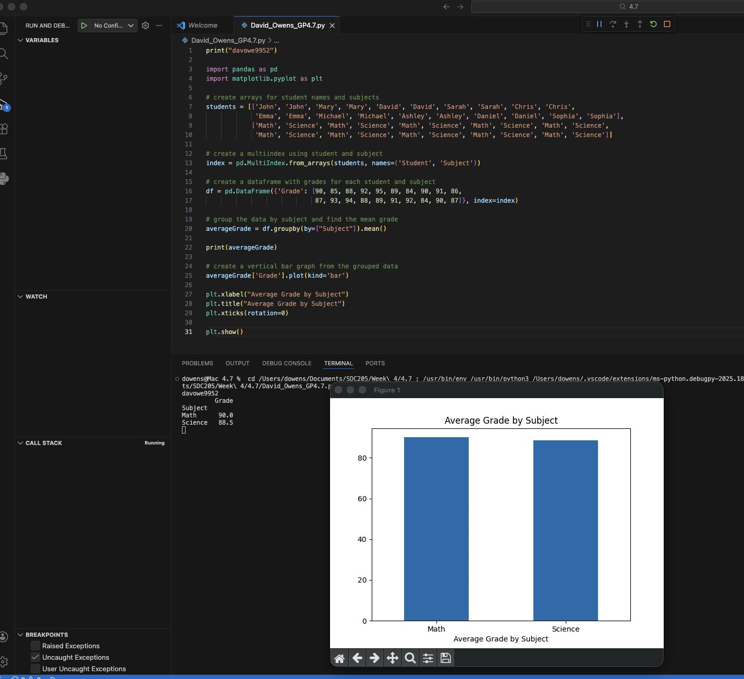
https://github.com/dowens412/sdc205_4.7

