6.1 Path integration results

To verify, if we implemented the pathintegrator correctly, we let the ants do the same experiment as described in the “paper 88 fussnote einfügen”

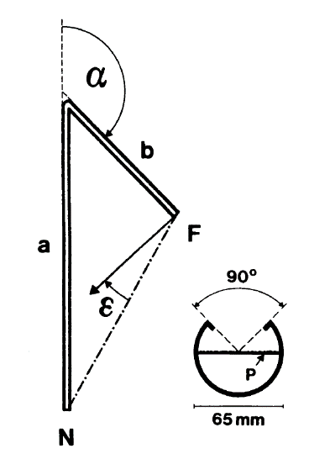

The ant starts at the Nest (N) and walks 12 meter from the nest in a fixed direction. After that it turns an angle alpha and walks another 5 meters in this direction, where it finds Food (F). At this point Wehner and Müller measured the angle the ants would take to find home and calculated the error in comparison to the exact position of the nest.

Our results look exactly the same, what proves, that we implemented the pathintegrator in the way Wehner and Müller thinks it is correct.

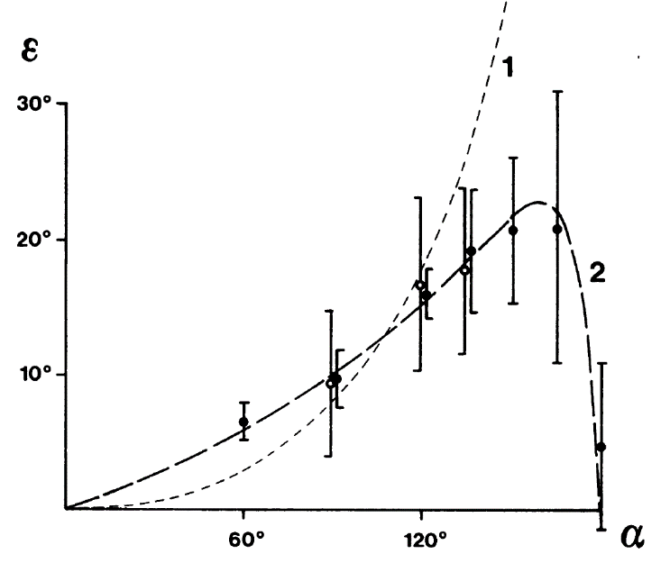

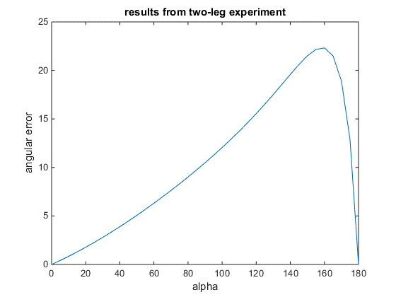

In the left picture, we see the angular error of our Matlab simulations and on the right hand side we see the plot out of the paper

Our implementation of the Path integrator varies in the following points to the implementation of „Team Gordon“

\begin{itemize}

\item $\delta$ is meant as the angle between the angle of the global vector and the actual direction instead of the actual change in direction

\item the fitting constant k has to be changed if we use angles from $0 $to $2 \pi$ instead of 0$^\circ$ to $360^\circ$

\item they miscalculated the end of the second leg in the two-leg experiment.

\end{itemize}