**Discussion of the Path Integrator**

According to Rüdiger Wehner, Cataglyphis Fortis doesn’t use any kind of pheromones for orientation because they would evaporate too quickly in the desert. Therefore, the performance of the ant’s path integrator is crucial for the survival of Cataglyphis Fortis in the desert.

The model we used in our project was based on the work of Rüdiger Wehner. His formulas for updating the global vector, i.e. angle phi and distance l from the ant’s location to the nest, are the following for any time instant n:

phi(n+1) = phi(n) + k*(pi+delta)*(pi-delta)*delta/l(n)

l(n+1) = l(n) + 1 – abs(delta)/pi

where k is a normalization constant, delta is the angle with which the ant is turning its current direction and the step width is assumed to be 1.

In the following we will discuss the quality of this specific path integrator model.

Let’s assume that the ant is currently at a position l = L and phi = 0 (we can assume phi = 0 without loss of generality because if phi ~= 0 we would simply rotate our coordinate system to obtain phi’ = 0 again). Furthermore, the global vector at this point is assumed to be perfect, which means that it directly points from the nest to the ant’s position.

Now the ant does one step with a specific step width l. The direction is given by the turning angle delta which is assumed to be normal distributed with expectation value mu and standard deviation sigma = pi/16 where mu corresponds to the direction the ant has been walking in the previous step. Of course, the path integrator critically depends on this mu as can be seen in the figure below (plots for mu=0,40,80,120 degrees). In this figure, the first row illustrates the absolute expected error of the path integrator while the second row illustrates the expected error relative to the step width l.

To improve the performance of the path integrator as well as to make to walk of the ant more detailed one would be able to vary the step width l.

But by varying l we end up with a new problem. The path the ant walks along is strongly influenced by the choice of l. What we would like to have though is that the ant walks in a similar way no matter what the step size is.

To address this problem we set the variance in the distribution of the turning angle theta in relation to dt (step width l of the ant is determined by l = dt*antSpeed) .

We made the following ansatz: sigma(dt) = dt^c * sigma0 with c element of (0,1] and sigma0 the standard deviation for dt = 1.

Then we let the ant do n1=1 steps with dt=1 and n2=1/dt steps with some dt element of (0,1]. Finally we correlated the resulting positions of the two situations and looked for the best correlation, i.e. c such that the difference between the two situations is lowest.

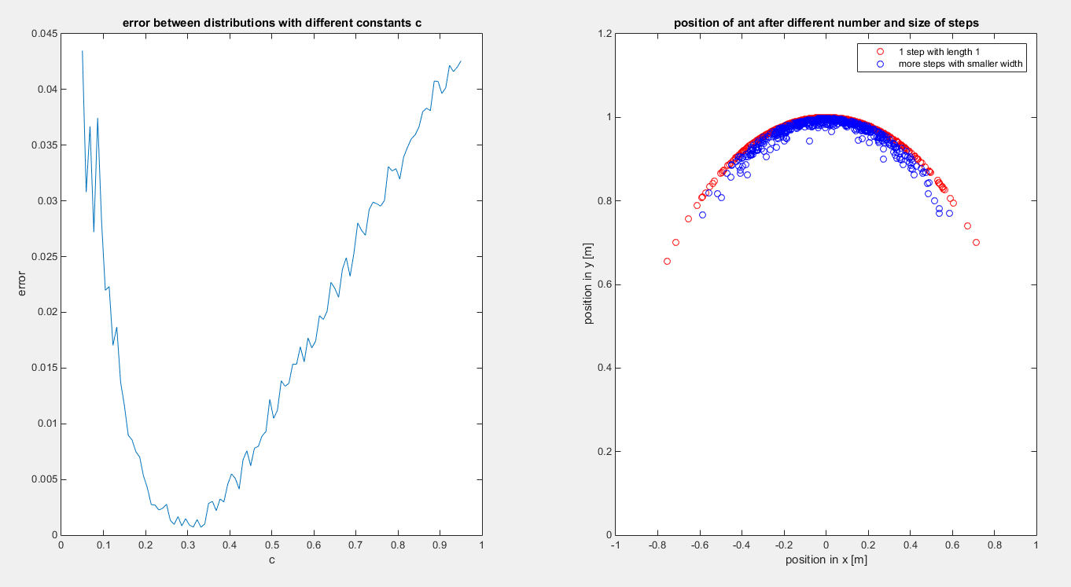The result for a normal distribution with mu = 0 and sigma0 = pi/12 and dt = 0.1 can be seen in the figure below.

Afterwards, we tried out several different dt’s and sigma0’s but the result for c was always similar to the one in the left side of the figure. The value for the best fitting c can be read off as being approximately 0.3.