Table 5. feature set
Feature | Definition | Description
Panel A. Single-asset price and volatility features
vola_t_k | σ(k) = sd( rᵢ,ₜ ), t ∈ Wₖ | Realised volatility of daily log-returns before onset; k = 5, 10, 15, 20, 30.
vola_ratio | σ(5) / σ(30) | Short- over long-window volatility; values above unity indicate accelerating volatility into the shock.
momentum_t-k | m(k) = ln( Pᵢ,ₜ₀₋₁ / Pᵢ,ₜ₀₋ₖ₋₁ ) | Cumulative log-return, i.e. directional drift into the episode; k = 5, 10, 15, 20, 30.
max_drawdown_t-k | MDD(k) = min [ Pᵢ,ₜ / max( Pᵢ,ₛ : s ≤ t ) − 1 ], t ∈ Wₖ | Peak-to-trough decline within the window; captures stress a cumulative return nets out; k = 5, 10, 15, 20, 30.
onset_return | rᵢ,ₜ₀ = ln( Pᵢ,ₜ₀ / Pᵢ,ₜ₀₋₁ ) | Magnitude and sign of the triggering move on the onset day.
intra_day_range | ( Hᵢ,ₜ₀ − Lᵢ,ₜ₀ ) / Cᵢ,ₜ₀ | Normalised high-low range on the onset day; intraday disagreement beyond the close-to-close return.
Panel B. Cross-asset features
asset_panic_t-k | (1/N) Σⱼ [ (1/k) Σ πⱼ,ₜ ], t ∈ Wₖ | Basket-wide panic probability already prevailing before the shock; k = 5, 10, 15, 20, 30.
asset_correl_t-k | mean of { ρ(j,l) : j < l }, ρ estimated on Wₖ | Mean pairwise return correlation across the basket, upper triangle only. Assets with fewer than 0.9k observations are dropped; k = 10, 15, 20, 30.
Panel C. Regime features (Markov regime-switching model)
p-onset | πᵢ,ₜ₀ = P( Sᵢ,ₜ₀ = panic | ℱₜ₀ ) | Filtered probability of the high-volatility regime at onset. Filtered, not smoothed, to avoid post-onset information.
max_panic_t-k | max( πᵢ,ₜ ), t ∈ Wₖ | Highest panic probability before onset; whether the asset had already touched the stressed regime; k = 5, 10, 15, 20, 30.
mean_panic_onset | (1/N) Σⱼ πⱼ,ₜ₀ | Mean filtered panic probability across the basket at onset; how widespread stress is when the episode begins.
Panel D. Macroeconomic features (as of the onset date)
^VIX | closing level on t₀ | CBOE implied volatility index for the S&P 500; expected near-term equity volatility.
BAA10Y | closing level on t₀ | Moody's Baa corporate yield over the 10-year Treasury; proxy for credit and funding stress.
T10Y2Y | closing level on t₀ | Yield-curve slope, 10-year minus 2-year Treasury; negative values indicate inversion.
GPR | index level on t₀ | Geopolitical Risk index of Caldara and Iacoviello (2022), based on newspaper coverage.
Notes: For an episode of asset i with onset date t₀, Pᵢ,ₜ is the closing price and rᵢ,ₜ = ln(Pᵢ,ₜ / Pᵢ,ₜ₋₁) the daily log-return; H, L and C are the daily high, low and close. Wₖ = { t₀−k, …, t₀−1 } is the look-back window of the k trading days strictly before onset, so that no feature other than the explicitly onset-dated ones uses information from t₀ or later. πᵢ,ₜ is the filtered probability of the high-volatility (panic) regime and N the number of assets in the basket.

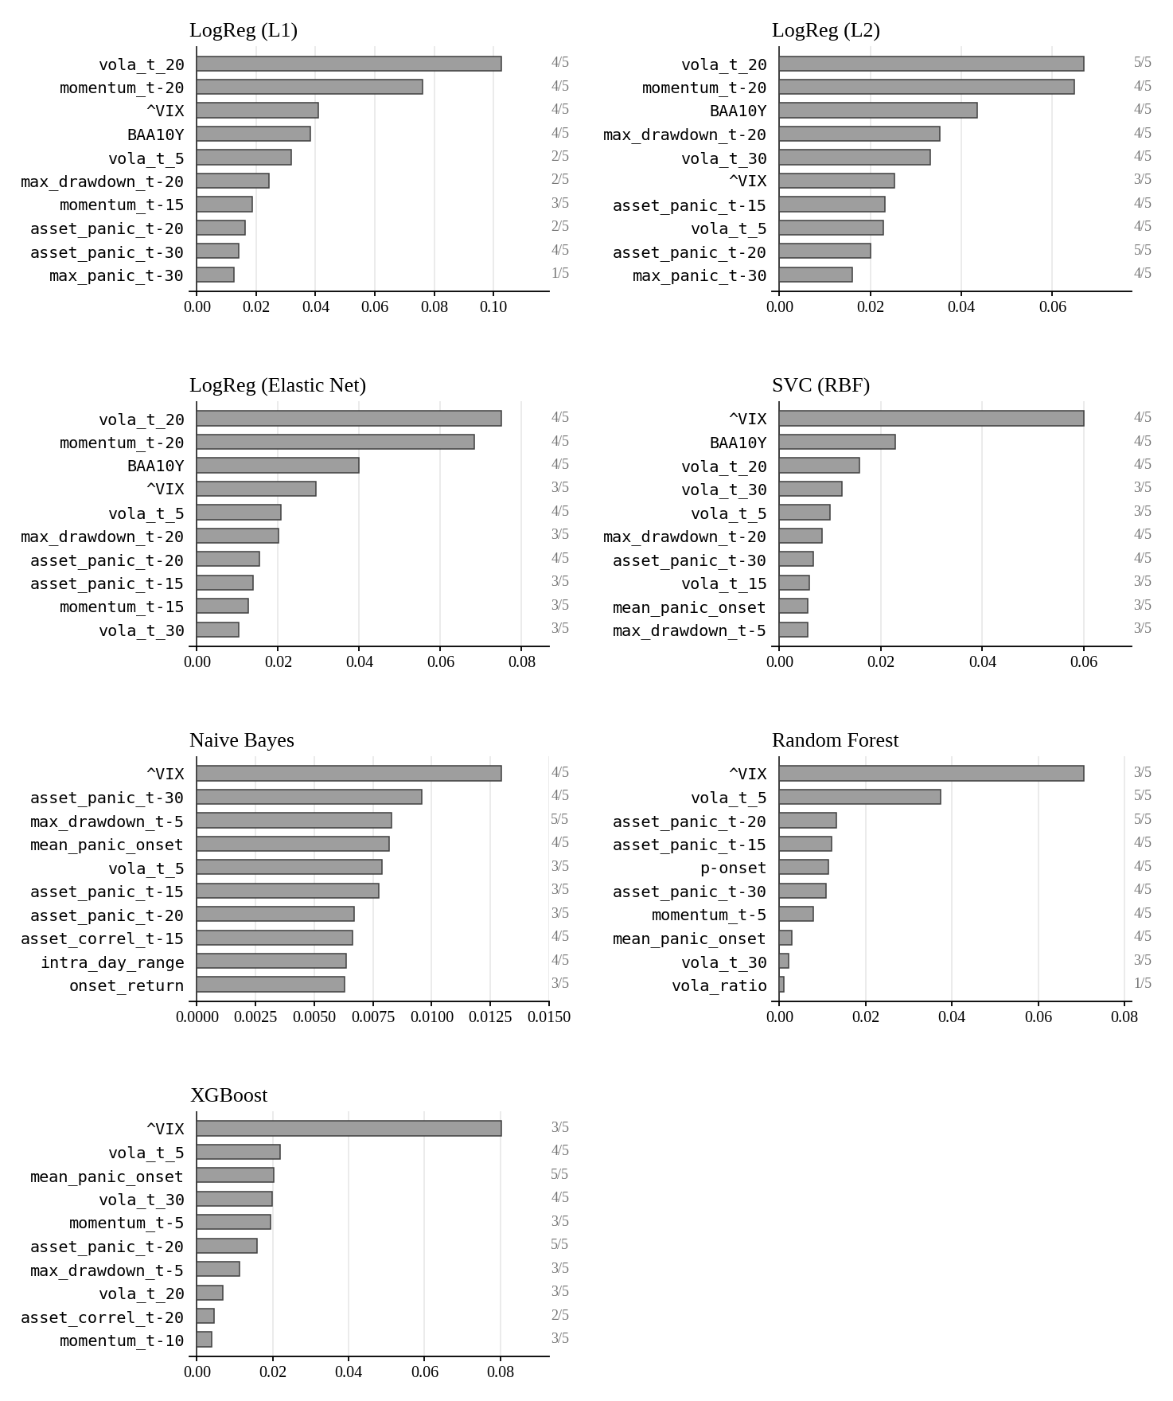
Figure Y. Feature ranks across models. Cells report the rank of each feature within a model's top ten, with darker shading indicating a higher rank; empty cells indicate the feature falls outside that model's top ten. Bars on the right give the number of models in which the feature appears, which determines the row ordering, with ties broken by mean rank. A dot marks features with a positive importance in all five folds.
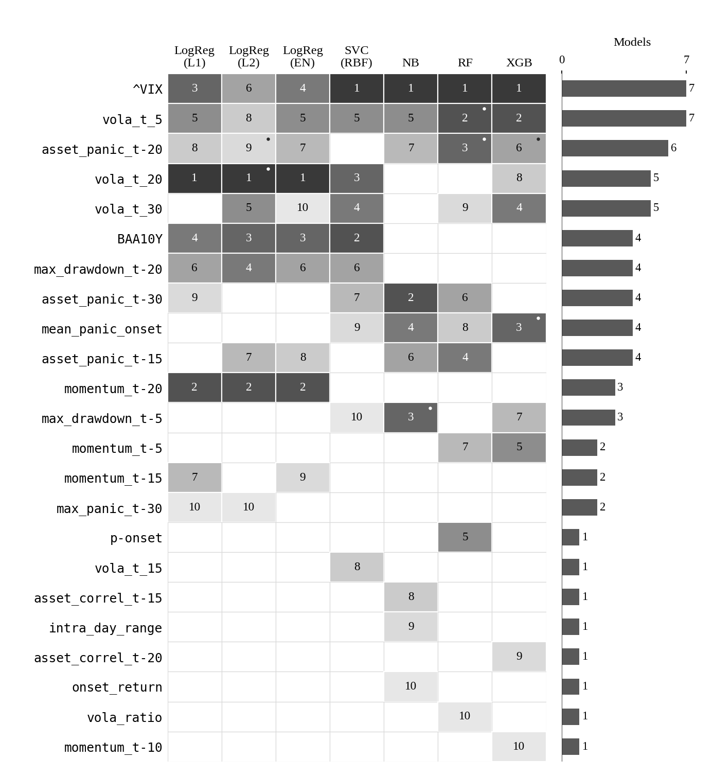
Figure Y. Feature ranks across models. Cells report the rank of each feature within a model's top ten, with darker shading indicating a higher rank; empty cells indicate the feature falls outside that model's top ten. Bars on the right give the number of models in which the feature appears, which determines the row ordering, with ties broken by mean rank. A dot marks features with a positive importance in all five cross-validation folds.

