Autonomous Research System — Stage 1
A controlled, reproducible system with explicit execution boundaries and upgradeable architecture.
Harness-Mediated Autoresearch Runtime · April 2026 · Internal One-Pager

What Was Built
A control-plane governed system for autonomous experimentation, where a planning model supervises bounded local execution under explicit lifecycle and memory constraints.
Target application: optimizing a ResNet-based binary trigger in a near-threshold, high-noise regime where performance is sensitive to small hyperparameter changes.

Why this matters
Turns experimentation into a controlled, auditable, repeatable process — required for reproducible and controlled experimentation.
Designed for local / private execution (no data leaves the machine), multi-node scaling, and model-agnostic orchestration.
Stabilizes experimentation under noisy regimes through controlled iteration — each run is bounded, reproducible, and comparable.
Prevents data leakage and protects code / IP via local bounded execution — no external API, no uncontrolled file access.
Architectural direction: a reusable system abstraction for controlled experimentation, not a single-task agent.

Campaign Result — 3 Manager Rounds × 5 Worker Experiments
Metric | Value | Notes
Baseline AUC | 0.7799 | Starting point
Best AUC | 0.7876 | R3W4: LR=5e-4, WD=3e-5, dropout=0.02
Improvement | +0.77% | Fully autonomous — no manual intervention
Kept / discarded | 5 / 10 | Every decision logged with rationale
Execution | Local CPU only | Ollama + Qwen 2.5 7B Coder — no external API

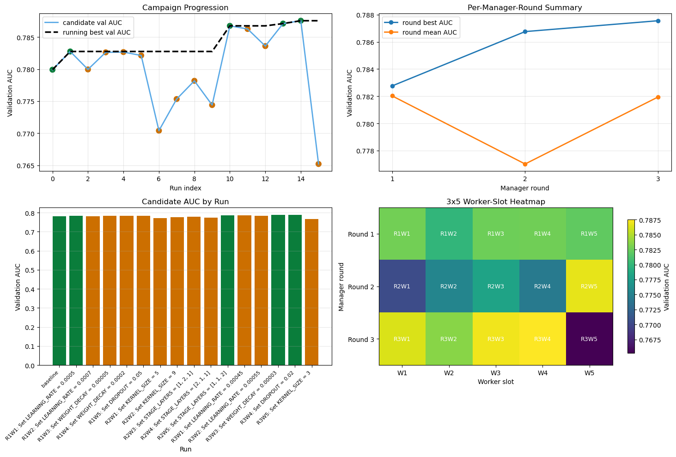
Figure 1. Campaign progression, per-round summary, per-run bar chart, and worker-slot heatmap.

Architecture (3-Layer Harness)
Layer | Role | Key property
Control Plane | Governance / harness runtime | Owns state machine, memory, keep/discard lifecycle — no agent acts unsupervised
Manager | Planning / reasoning | Reads memory, proposes bounded experiment, issues keep/discard with rationale
Worker | Execution (bounded) | Edits only train.py — hard assertion at commit; every perf change attributable to one diff

Next Steps
Stage 2: Automated /loop execution — 5-round × 10-worker overnight campaign.
Stage 3: Multi-node and parallel branch execution using the same control plane API.
Stage 4: Domain integration — detector filter tuning, EMPCA basis, threshold optimization.

The key contribution is demonstrating that a governed, harness-mediated system can produce reliable and auditable research progress under strict execution constraints — forming the foundation for a scalable and controlled research workflow.

