APM1110 - FA 2 - Dacanay

Jordan Dacanay

2024-02-19

### 1) Use R to illustrate that the probability of getting:

###(a) a head is 0.5 if a fair coin is tossed repeatedly; #### Probability Table

# Simulate 100 coin tosses  
print('Let Head = 1 and Tail = 0')

## [1] "Let Head = 1 and Tail = 0"

y <- sample (c(1, 0), 50, replace = TRUE)  
  
# Probability Table  
fair_coin_probability <- table(y)/50  
fair_coin_probability

## y  
## 0 1   
## 0.52 0.48

#### Probability Plot

num <- 1:50  
# Partial Probability  
partial_events <- cumsum(y)  
partial_probability <- partial_events / num  
  
# Plot  
plot(num, partial_probability, type = "o",  
xlab = "Number of Toss", ylab = "Probability",  
main = "Head Probability in Coin Toss")  
abline(h=0.5)

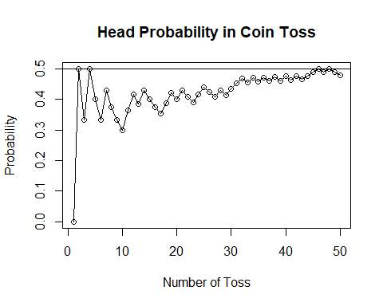

###(b) a red card is 0.5 if cards are drawn repeatedly with replacement from a well-shuffled deck; ####Probability Table

# Simulate 50 card draws  
print('Let Red = 1 and Black = 0')

## [1] "Let Red = 1 and Black = 0"

# Define the deck  
deck <- c(rep(1, 26), rep(0, 26))  
draws <- sample(deck, 50, replace = TRUE)  
  
# Probability Table  
red_card_probability <- table(draws)/50  
red_card_probability

## draws  
## 0 1   
## 0.54 0.46

#### Probability Plot

num <- 1:50  
# Partial Probability  
partial_events <- cumsum(draws)  
partial_probability <- partial_events / num  
  
# Plot  
plot(num, partial_probability, type = "o",  
xlab = "Number of Draws", ylab = "Probability",  
main = "Red Card Probability in Drawing Cards")  
abline(h=0.5)

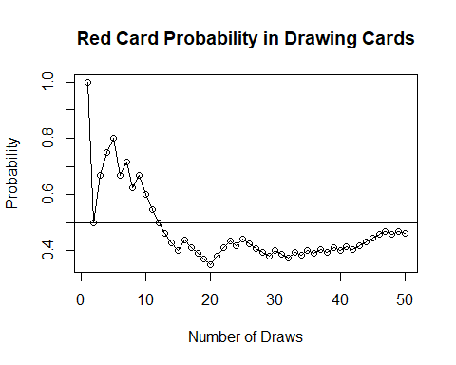

###(c) an even number is 0.5 if a fair die is rolled repeatedly. ####Probability Table

# Simulate 50 die rolls  
print('Let Even Numbers (2, 4, 6) = 1 and Odd Numbers (1, 3, 5) = 0')

## [1] "Let Even Numbers (2, 4, 6) = 1 and Odd Numbers (1, 3, 5) = 0"

# Define the deck  
dice <- c(rep(1, 3), rep(0, 3))  
rolls <- sample(dice, 50, replace = TRUE)  
  
# Probability Table  
fair_die_probability <- table(rolls)/50  
fair_die_probability

## rolls  
## 0 1   
## 0.46 0.54

####Probability Plot

num <- 1:50  
# Partial Probability  
partial_events <- cumsum(rolls)  
partial_probability <- partial_events / num  
  
# Plot  
plot(num, partial_probability, type = "o",  
xlab = "Number of Rolls", ylab = "Probability",  
main = "Probability of Even Number in Rolling a Die")  
abline(h=0.5)

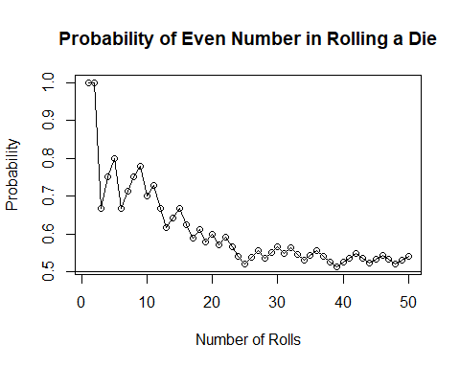

### 2) An experiment consists of tossing two fair coins. Use R to simulate this experiment 100 times and obtain the relative frequency of each possible outcome. Hence, estimate the probability of getting one head and one tail in any order.

# Generate Sample Spaces  
states <- c("H", "T")  
S <- expand.grid(states, states)  
sample_spaces <- apply(S, 1, paste, collapse = "")  
  
# Simulate 100 coin tosses  
x <- sample(sample_spaces, 100, replace = TRUE)  
  
# Calculate relative frequencies  
coin_toss_probability <- table(x) / 100  
print('Coin Toss Probability Table')

## [1] "Coin Toss Probability Table"

coin_toss_probability

## x  
## HH HT TH TT   
## 0.26 0.22 0.24 0.28

# Probability of one head and one tail  
probability_HT_TH <- coin_toss_probability["HT"] + coin_toss_probability["TH"]  
  
# Print the combined probability  
print('Probability of One Head and One tail')

## [1] "Probability of One Head and One tail"

probability_HT_TH

## HT   
## 0.46

# Probability in percentage  
print('Probability of One Head and One Tail in Percentage:')

## [1] "Probability of One Head and One Tail in Percentage:"

print(sprintf("%.2f%%", probability_HT_TH * 100))

## [1] "46.00%"