An Internship Report
of
Siemens Data Science Master

Submitted
To
School of Computer Science and Engineering
IILM University, Greater Noida, U.P.

In partial fulfilment of the requirement of degree of
B-Tech (CSE)



By

Roll Number of Student: 25SCS1003001249
Name of Student: KRISHNA SINGH

Batch: 2026-27

CANDIDATE'S DECLARATION
I, KRISHNA SINGH, do hereby declare that the internship report titled “Siemens Data Science Master” has been completed by me to fulfil the requirement for the award of the degree of Bachelor of Technology in Computer Science and Engineering. All the references have been quoted and I have not taken as such any material from any other source. I affirm that this report is my own and has not been submitted to any other institute for any degree/diploma requirement, and further I shall be solely responsible for any kind of copyright violation in this regard.
Signature:-

Student Name: KRISHNA SINGH

Roll No.: 25SCS1003001249

ACKNOWLEDGEMENT
I am using this opportunity to express my gratitude to everyone who supported me throughout the Internship Program. I am thankful for their aspiring guidance, invaluably constructive criticism and friendly advice during this work. I am sincerely grateful to them for sharing their truthful and illuminating views on a number of issues related to this work.
I would like to thank the AICTE – EduSkills Virtual Internship Program team and EduSkills Academy for providing me the opportunity and the structured platform to learn and gain hands-on exposure in the domain of Siemens Data Science Master. I am also thankful to my institute, IILM University, Greater Noida, and the faculty of the School of Computer Science and Engineering for their continuous support and encouragement.
I express my gratitude to my parents for their blessings.
Signature:

Student Name: KRISHNA SINGH

Roll No.: 25SCS1003001249

TABLE OF CONTENTS
1. Candidate's Declaration i
2. Acknowledgement ii
3. Internship Completion Certificate -
4. Project Description 1
4.1 Introduction 1
4.2 Organization Profile 2
4.3 Problem Statement 3
4.4 Project Objectives 3
4.5 Scope of the Project 4
4.6 Technologies and Tools Used 4
4.7 System Architecture 5
4.8 Methodology 6
4.9 Expected Outcomes 7
4.10 Certificates of Completion and Communication Proof 8
5. Bibliography/References 9

3. INTERNSHIP COMPLETION CERTIFICATE

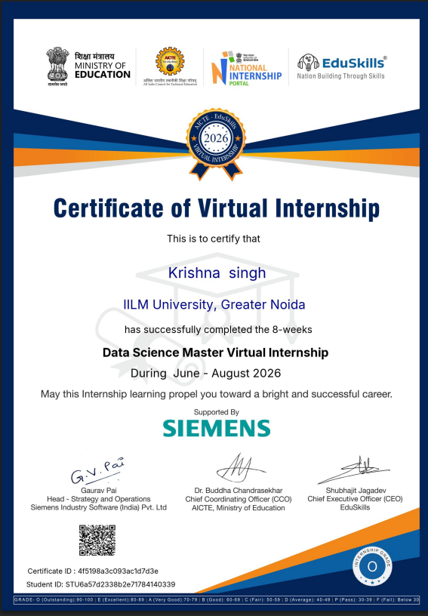
zzz

Ref No: C17Y2026M071503798

 | Internship Offer Letter
Student Name | : Krishna singh
Stream | : B.Tech
Branch | : B.Tech(Computer Science and Engineering)
Institute Name | : IILM University, Greater Noida
Internship Domain | : Siemens Data Science Master
Internship Duration | : June 2026 - August 2026
AICTE Student ID | : STU6a57d2338b2e71784140339
We are pleased to inform you that you have been selected for the 8-Week AICTE – EduSkills Virtual Internship Program.
During this internship, you will learn and demonstrate industry-relevant skills that will enhance your employability and strengthen your confidence in the subject area.
The program is designed to provide structured learning combined with practical exposure.
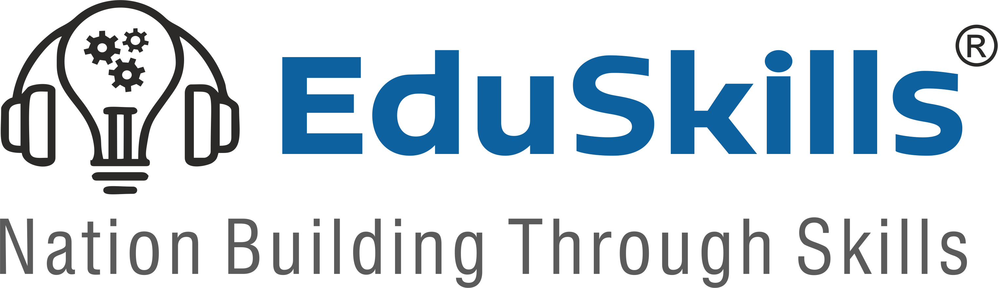



Internship Structure & Evaluation:
- The internship will follow a week-wise structured learning plan.
- You will be required to complete weekly assessments to track your progress and understanding.
- Certain modules will require submission of project documentation and assignments.
- In the final week, you must appear for a Final Assessment Test.
- The final grade will be based on your overall performance, including weekly assessments, projectsubmissions, and the final test.
Upon successful completion of all required steps and assessments, you will be awarded a Virtual Internship Certificate.
Please note that this offer letter will be considered valid only after the successful completion of the internship program and fulfillment of all assessment requirements, including obtaining the final completion certificate. Without the final completion certificate, this offer letter shall not be treated as a valid document for any official purpose.
Browser: Chrome | Downloaded on: 16-Jul-2026 05:14:24 PM IST Page 1
IP: 35.154.152.119 | Device: Desktop
The week wise Structure of the Internship is as Follows:
Week | Module | Description
Week 1 | Applications & Use Cases  Professional | Learn to identify business problems suitable for AI and machine learning.
Week 2 | Data Engineering Professional | Learn to access, load, transform, and calculate data.
Week 3 | Machine Learning Professional | Build foundational machine learning skills.
Week 4 | Data Preparation Master | Master advanced data handling and automation.
Week 5 | Machine Learning Master | Learn advanced machine learning techniques.
Week 6 | Applications & Use Cases  Master | Deploy and monitor ML models.
Week 7 | Platform Administration Master | Configure and manage RapidMiner AI Hub.
Week 8 | Platform Administration Master | Enterprise-level platform operations.
Final Credential Validation / Internship Grade Point Assessment
Note: There is no stipend associated with this internship.
We congratulate you on your selection and wish you a successful learning journey.





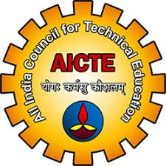
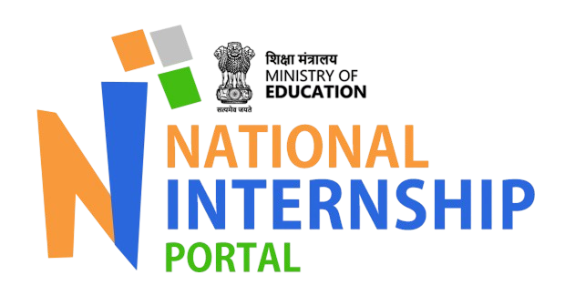
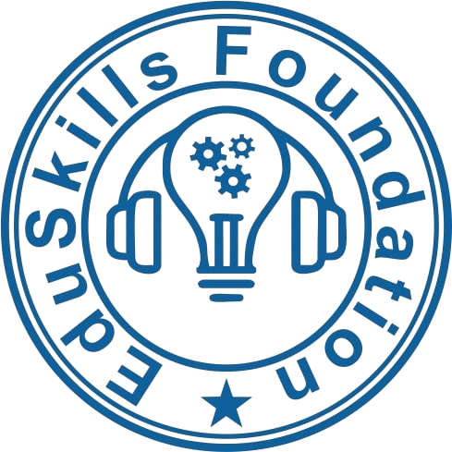 Scan to Verify Supported by Under the Patronage of
Bibek Ranjan 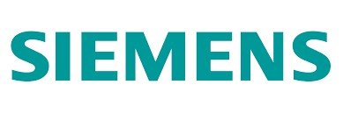
Director, EduSkills
Browser: Chrome | Downloaded on: 16-Jul-2026 05:14:24 PM IST | Page 2
IP: 35.154.152.119 | Device: Desktop

4. PROJECT DESCRIPTION

4.1 Introduction
This report presents a detailed account of the 8-week Virtual Internship undertaken under the AICTE – EduSkills Virtual Internship Program, in the domain of “Siemens Data Science Master”. The internship was carried out from June 2026 to August 2026 as part of the requirement of the Bachelor of Technology (Computer Science and Engineering) programme at IILM University, Greater Noida. The primary aim of this internship was to bridge the gap between theoretical understanding of Data Science and its real-world application, production-grade applications. Over the course of the programme, the learner was exposed to industry-relevant tools and practices used to collect, process, analyze, and visualize data, develop statistical and machine learning models, and transform data-driven insights into scalable solutions for real-world business and engineering problems.
.
The internship followed a structured, week-wise curriculum that combined conceptual learning with hands-on assignments, weekly assessments, project documentation, and a final capstone project. On successful completion of all the requirements, including the final assessment test, a Virtual Internship Certificate was awarded by EduSkills Academy.

4.2 Organization Profile
EduSkills Academy is an ISO 9001:2015 and ISO 20000-1:2018 certified organization working under the theme “Nation Building Through Skills”. EduSkills partners with the All India Council for Technical Education (AICTE) to run the AICTE – EduSkills Virtual Internship Program under the patronage of the AICTE National Internship Portal. The organization collaborates with leading technology companies and academic institutions to design industry-aligned virtual internship curricula that help engineering students strengthen their employability and gain practical exposure to emerging technology domains such as Data Science, Machine Learning, Artificial Intelligence, Data Analytics, Statistical Modelling, Data Visualization, and MLOps, among others.
.

4.3 Problem Statement
Although a large number of engineering students learn the fundamentals of data analysis, statistics, and machine learning during their academic coursework, relatively few get practical exposure to the end-to-end processes involved in solving real-world data science problems. Developing a model or performing an analysis is only one part of the data science lifecycle; collecting and preprocessing data, identifying meaningful patterns, building reliable models, evaluating their performance, and communicating insights effectively are equally important skills. The problem addressed by this programme was to understand and practically implement the complete data science lifecycle – from data collection and preprocessing to exploratory data analysis, statistical analysis, machine learning, data visualization, model evaluation, and interpretation of results for real-world applications.

4.4 Programme Objectives
● To understand the complete data science lifecycle and the terminology, methodologies, and best practices used in the industry.
● To develop practical skills in data collection, cleaning, preprocessing, transformation, and exploratory data analysis.
● To apply statistical and mathematical techniques to identify patterns, relationships, and trends within datasets.
● To gain hands-on experience in developing and evaluating machine learning models for real-world data-driven problems.
● To use industry-relevant tools and programming technologies such as Python, NumPy, Pandas, Matplotlib, Seaborn, and Scikit-learn for data analysis and modelling.
● To develop effective data visualizations and dashboards for communicating analytical findings and supporting data-driven decision-making.
● To understand model evaluation, feature engineering, performance optimization, and the interpretation of machine learning results.
● To work with real-world datasets and apply data science techniques to identify actionable insights and solve practical engineering and business problems.
● To understand the importance of data quality, data security, ethical data handling, and responsible use of data in professional environments.
● To apply the concepts and techniques learned throughout the programme in an end-to-end data science project.

4.5 Scope of the Project
The scope of this programme spans the complete data science lifecycle – starting from data collection, cleaning, preprocessing, and exploratory data analysis, followed by statistical analysis, feature engineering, machine learning model development, evaluation, and visualization of results. It also covers the application of data science techniques to real-world engineering and business use cases, with emphasis on extracting meaningful insights and supporting data-driven decision-making. The programme was primarily focused on practical learning through datasets, analytical exercises, and project-based applications, and was limited to the learning and training environment provided through the Siemens Data Science Master programme. It did not involve deployment or implementation within any live organizational production system.
4.6 Technologies and Tools Used
● Programming & Data Analysis: Python, Jupyter Notebook, NumPy, Pandas
● Data Visualization: Matplotlib, Seaborn, Plotly
● Statistical Analysis: Python Statistical Libraries, Descriptive Statistics, Inferential Statistics
● Machine Learning: Scikit-learn, Regression, Classification, Clustering, Feature Engineering
● Data Preprocessing: Data Cleaning, Data Transformation, Missing Value Handling, Feature Scaling, Encoding
● Exploratory Data Analysis: Pandas, Matplotlib, Seaborn, Statistical Analysis Techniques
● Model Evaluation & Optimization: Cross-Validation, Confusion Matrix, Accuracy, Precision, Recall, F1-Score, Hyperparameter Tuning
● Data Management: Structured Datasets, CSV Files, DataFrames, SQL
● Development Environment: Jupyter Notebook, Python IDEs, Google Colab
● Project & Analytical Applications: Real-world datasets, data-driven problem solving, predictive modelling, and insight generation
4.7 System Architecture
The general architecture followed during the Siemens Data Science Master programme can be summarized in the following layers:
● Data Collection Layer: Raw data is collected from structured datasets and other relevant data sources. The collected data serves as the foundation for subsequent analysis and modelling.
● Data Preprocessing Layer: The raw data is cleaned and transformed by handling missing values, removing inconsistencies, encoding categorical variables, and applying appropriate feature scaling and transformation techniques.
● Exploratory Data Analysis Layer: Statistical techniques and visualization tools such as Pandas, Matplotlib, and Seaborn are used to identify patterns, trends, correlations, distributions, and relationships within the data.
● Feature Engineering Layer: Relevant features are selected, transformed, or created to improve the quality of the dataset and enhance the performance of machine learning models.
● Machine Learning Layer: Appropriate supervised or unsupervised machine learning algorithms are developed using tools such as Scikit-learn to address the defined problem and generate predictions or identify patterns.
● Model Evaluation Layer: The developed models are evaluated using suitable performance metrics such as accuracy, precision, recall, F1-score, mean squared error, and cross-validation, dependin g on the problem type.
● Visualization & Insights Layer: Analytical results and model outcomes are presented through effective visualizations and reports to communicate meaningful insights and support data-driven decision-making.
● Application Layer: The final analytical findings and predictive models are applied to real-world engineering and business use cases, demonstrating how data science can be used to solve practical problems.
● Output Layer: The final output consists of evaluated models, visualizations, analytical insights, and recommendations derived from the data, providing a complete end-to-end data science solution.
4.8 Methodology
The internship followed a structured, week-wise methodology combining conceptual learning, hands-on labs, weekly assessments, and project submissions, as summarized in the table below.

Week | Module | Description
Week 1 | Applications & Use Cases  Professional | Learn to identify business problems suitable for AI and machine learning.
Week 2 | Data Engineering Professional | Learn to access, load, transform, and calculate data.
Week 3 | Machine Learning Professional | Build foundational machine learning skills.
Week 4 | Data Preparation Master | Master advanced data handling and automation.
Week 5 | Machine Learning Master | Learn advanced machine learning techniques.
Week 6 | Applications & Use Cases  Master | Deploy and monitor ML models.
Week 7 | Platform Administration Master | Configure and manage RapidMiner AI Hub.
Week 8 | Platform Administration Master | Enterprise-level platform operations.
Final Credential Validation / Internship Grade Point Assessment

Each week concluded with a weekly assessment to evaluate conceptual understanding, and selected modules required submission of project documentation and assignments. In the final week, a Final Assessment Test was conducted, and the overall grade was based on performance across weekly assessments, project submissions, and the final test.

4.9 Expected Outcomes
● Ability to independently perform data collection, cleaning, preprocessing, and exploratory data analysis using industry-relevant data science tools and techniques.
● Practical understanding of statistical analysis and machine learning methodologies for solving real-world data-driven problems.
● Hands-on experience in developing, training, evaluating, and optimizing machine learning models using Python and Scikit-learn.
● Capability to identify meaningful patterns, trends, and relationships within datasets and convert them into actionable insights.
● Understanding of effective data visualization techniques for presenting complex analytical findings in a clear and meaningful manner.
● Skill to evaluate model performance using appropriate metrics and apply techniques such as feature engineering, cross-validation, and hyperparameter tuning to improve results.
● Awareness of data quality, security, privacy, and responsible data-handling practices in real-world data science applications.
● A completed, end-to-end data science project demonstrating the ability to apply data preprocessing, exploratory analysis, statistical methods, machine learning, visualization, and interpretation to a practical problem.

4.10 Certificates of Completion and Communication Proof
The Internship Offer Letter and the Internship Completion Certificate issued by EduSkills Academy, confirming successful completion of the 10-weeks AICTE – EduSkills Virtual Internship Program in AI Deployment & Automation, are attached in Chapter 3 of this report.

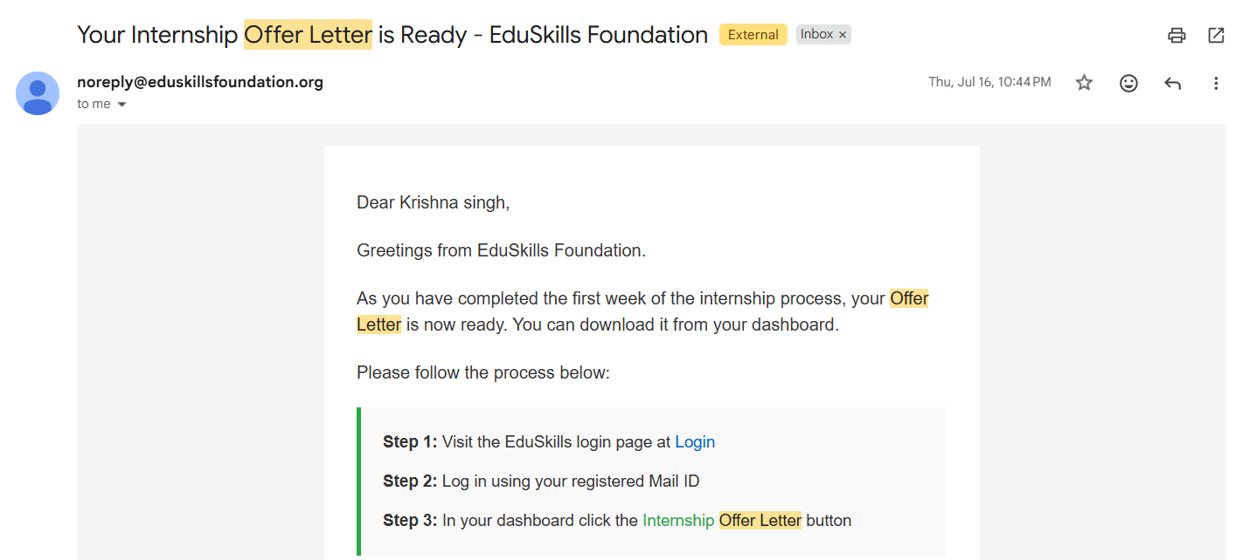
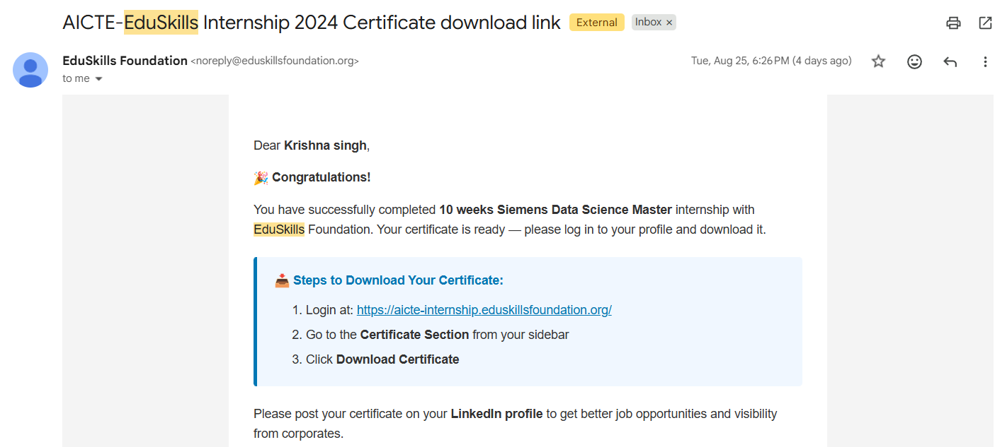

5. BIBLIOGRAPHY/REFERENCES
1. EduSkills Academy, “AICTE – EduSkills Virtual Internship Program – AI Deployment & Automation,” Internship Offer Letter, Ref No. C17Y2026M081511743, 2026.
2. EduSkills Academy, “Certificate of Internship – AI Deployment & Automation,” Certificate ID: 2026-E38A24E157, Issued on July 27, 2026.
3. FastAPI Documentation, https://fastapi.tiangolo.com/
4. Docker Documentation, https://docs.docker.com/
5. Kubernetes Documentation, https://kubernetes.io/docs/
6. LangChain Documentation, https://python.langchain.com/
7. AWS SageMaker, Google Vertex AI, and Microsoft Azure Machine Learning official documentation.

