Analyzing GitHub Developer Activity  
and its correlation with the token price

Written by  
Aleksandr Lazutin

Table of contents

Table of contents 2

Report images structure 4

Projects 4

Developers activity 4

Repositories activity 4

Most active developers 4

Correlations 4

Heatmaps 4

Rolling correlation 4

Correlation time lags 4

Introduction 5

Projects 6

BitTensor 6

Description 6

Developer activity 6

Repositories activity 7

Most active developers 8

Fetch.AI 10

Description 10

Developer activity 10

Repositories activity 11

Most active developers 12

Numer.AI 14

Description 14

Developer activity 14

Repositories activity 15

Most active developers 16

Ocean Protocol 18

Description 18

Developer activity 18

Repositories activity 19

Most active developers 20

Orachain 22

Description 22

Developer activity 22

Repositories activity 23

Most active developers 24

SingularityNET 26

Description 26

Developer activity 26

Repositories activity 27

Most active developers 28

Project activity rating 30

Correlations 31

Heatmaps 31

Rolling Correlations 32

BitTensor 32

Fetch.AI 32

Numer.AI 33

Ocean Protocol 33

Orachain 34

SingularityNET 34

Correlation time lags 35

Conclusion 36

Additional data sources 37

BitTensor 37

Fetch.AI 37

Numer.AI 37

Ocean Protocol 38

Orachain 38

SingularityNET 38

Report images structure

Projects

The dataset used for this report includes similar types of data for 6 crypto projects: commit histories, issue records, repository information, and pricing details. In this section, I will outline key details regarding similar visualizations that have been used.

Developers activity

Data for “developer activity over time” visualisations aggregated weekly. Algorithm used for smooth line is LOESS (Locally Estimated Scatterplot Smoothing) with a span = 0.5.

Repositories activity

“Top 20” is based on the amount of commits and include all repositories, even cloned ones.

“Top 5” shows 5 important metrics: number of commits, forks, issues, watchers and the size of repository in kilobytes (KB). All of them are scaled to the max value in the metrics through all dataset.

Most active developers

Bots like "dependabot[bot]", "greenkeeper[bot]" were excluded from the rating of the most active developers.

“Top 5” developers graph shows an evolution of commit count. Bar chart shows monthly commit count, while the line shows total number of commits.

Correlations

Heatmaps

Heatmaps are created by aggregating data on a weekly and monthly basis, as daily commits and issue counts fluctuate too rapidly and do not provide useful information for predicting price movements.

Rolling correlation

The rolling window correlation is calculated over a 180-day period, illustrating the changes in correlation values over time. This approach helps in identifying trends and shifts in the relationship between variables across different time frames.

Correlation time lags

The highest and lowest correlations are indicated by specific points, and the highest correlations also include time markers on the bottom to show the delay.

Introduction

In the crypto world, it's important to understand the link between developer activity and project success. This report analyzes developer activity across six crypto projects: BitTensor, Fetch.AI, Numer.AI, Ocean Protocol, Orachain, and SingularityNET.

I looked at data sources like commit histories, issues, repositories, and pricing details. The goal was to find trends, patterns, and relationships between developer contributions and token prices.

The main objectives were to identify activity trends over time, rank projects and developers based on their activity levels, analyze potential price correlations with developer work, and explore any time lags between activity and price movements.

Projects

BitTensor

Description

Bittensor is an open-source protocol that powers a decentralized, blockchain-based machine learning network. It allows machine learning models to train collaboratively and rewards them in TAO tokens according to the informational value they offer the collective. Bittensor aims to create a peer-to-peer marketplace that incentivizes the production of machine intelligence and facilitates knowledge sharing among researchers, encouraging the development of more powerful AI models.

Developer activity

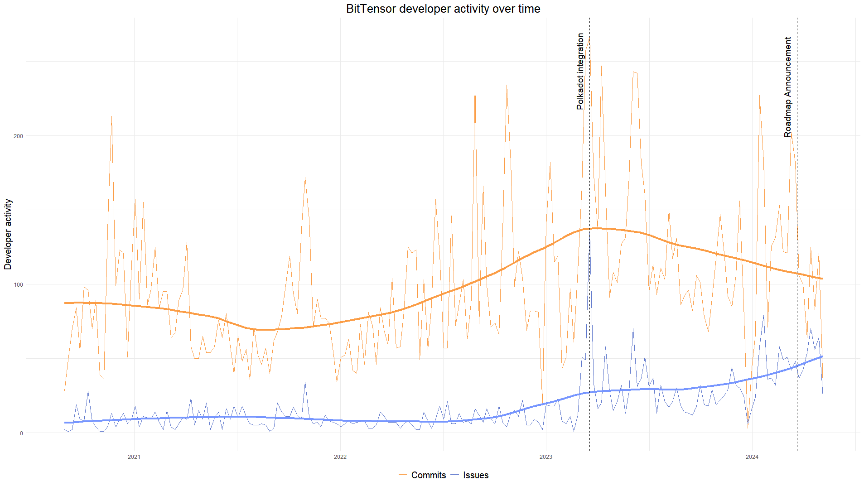

The highest number of commits and issues was recorded following the announcement of BitTensor winning the Polkadot Auction on March 19, 2023. In contrast, the Roadmap Announcement appeared to have minimal impact on developer activity.

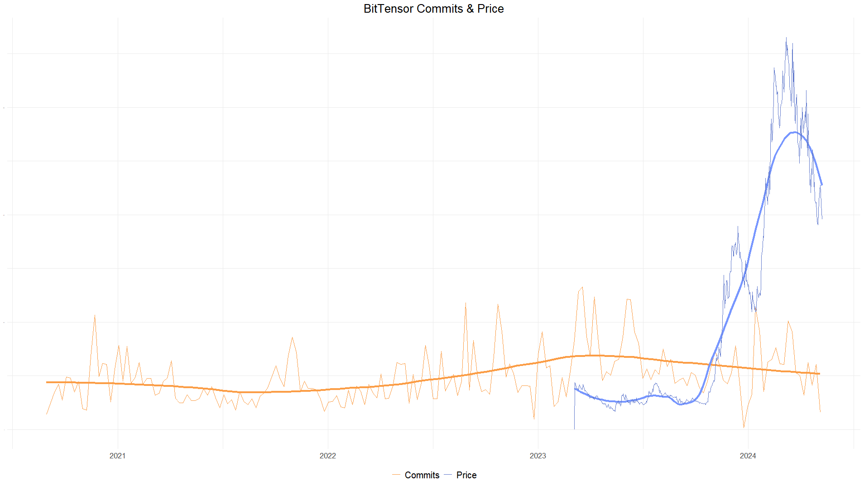

Despite the recent surge in TAO prices, it hasn't had a significant impact on developer activity.

Repositories activity

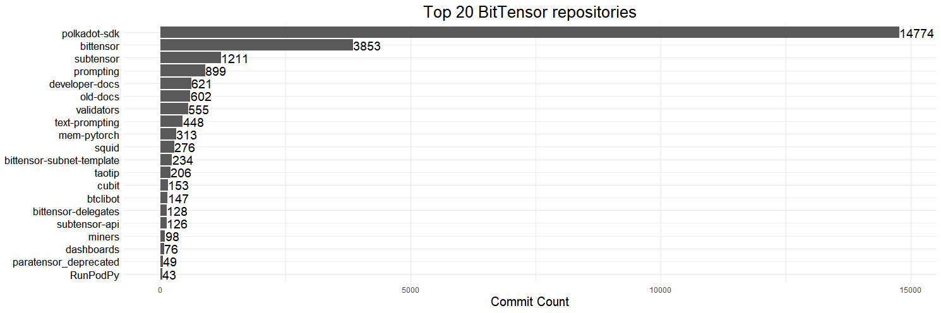

The first repository in this ranking, "polkadot-sdk," is primarily cloned for integration with Polkadot. Therefore, the most active repository is "bittensor," as shown in the image below, which has the highest number of watchers, issues, and forks.

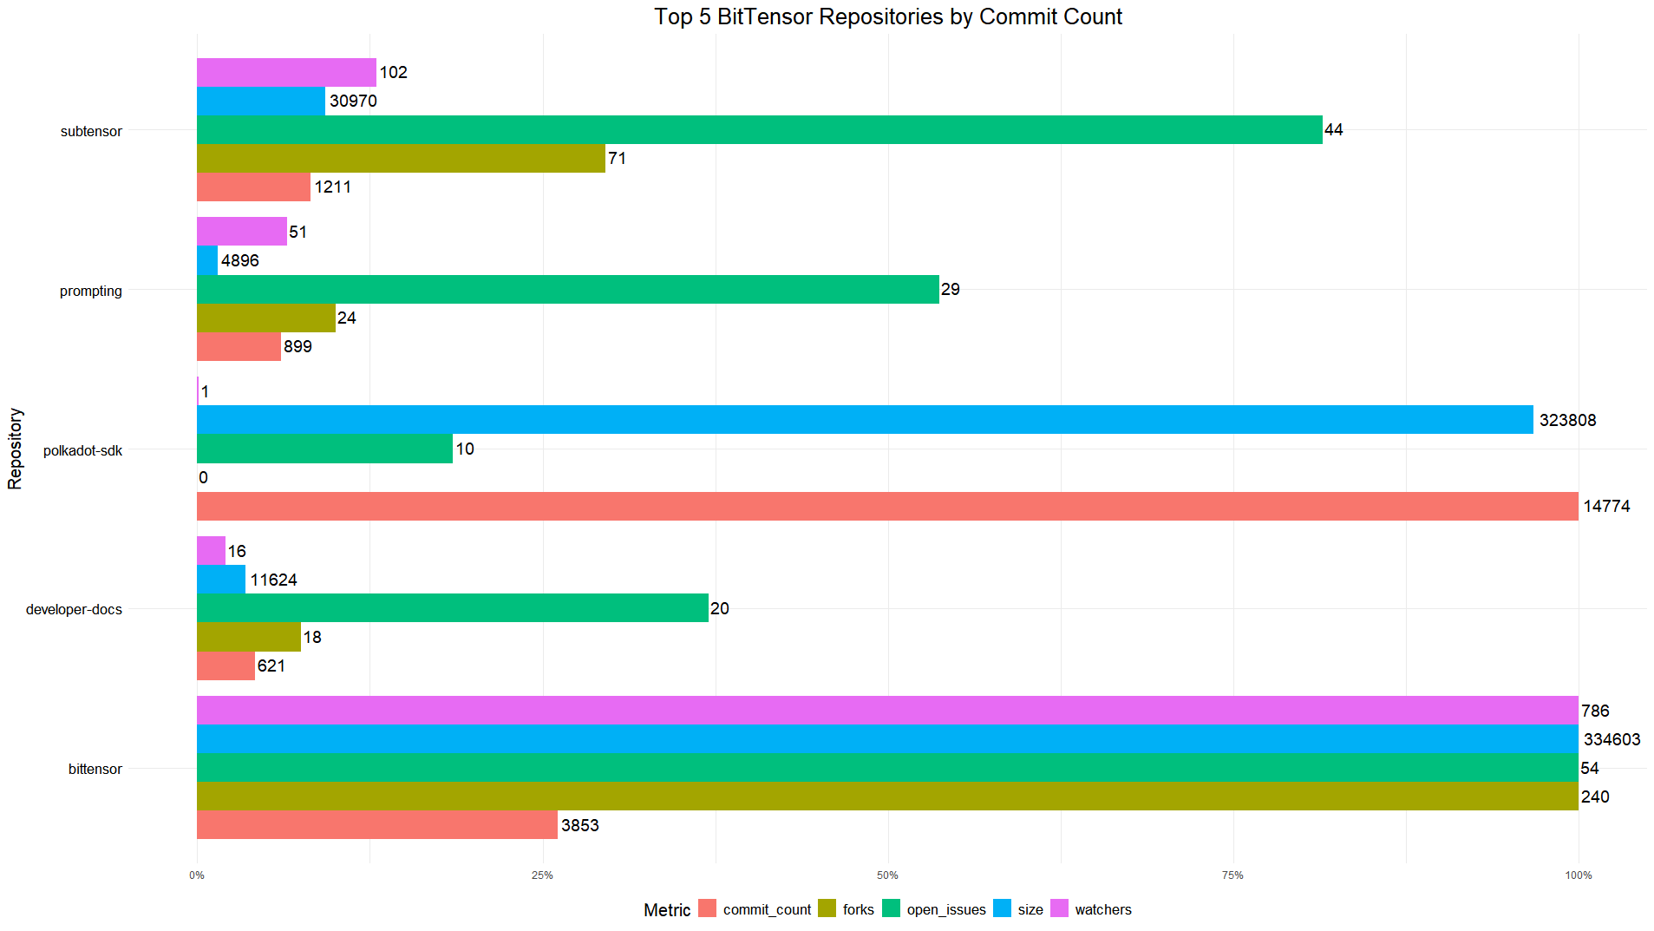

Most active developers

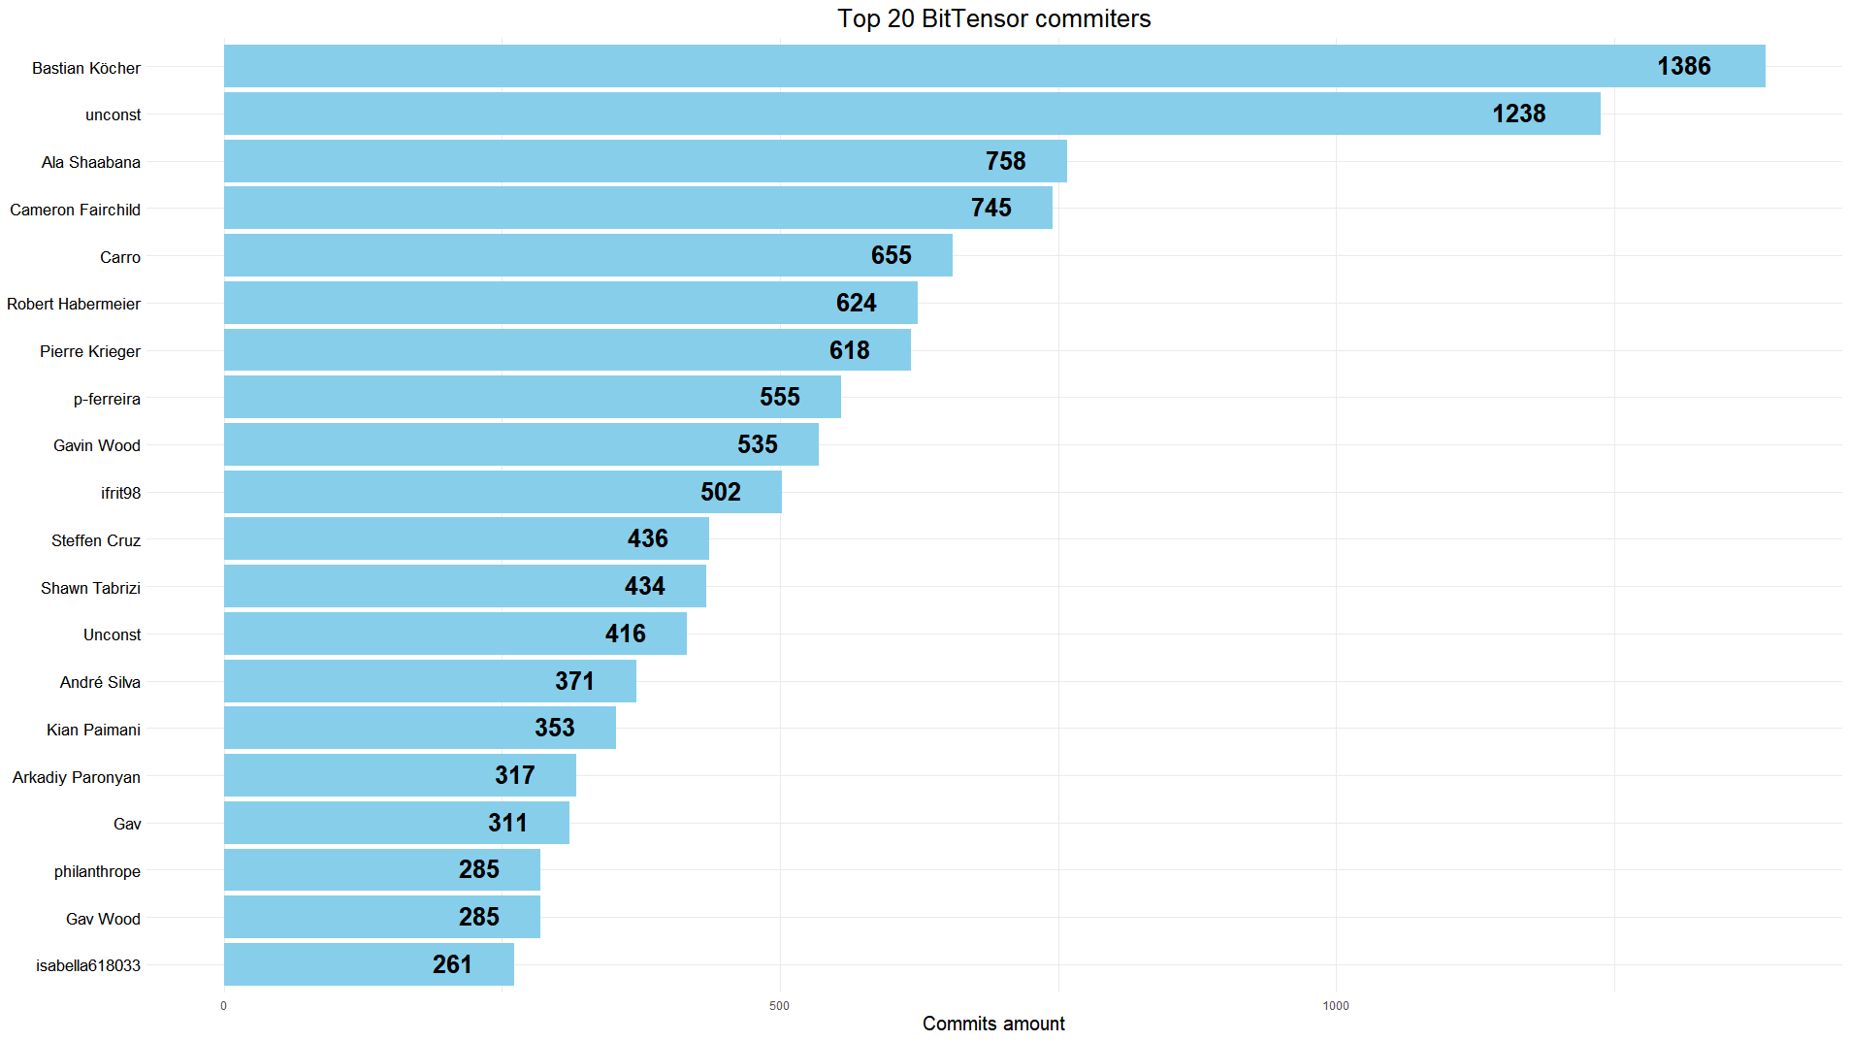

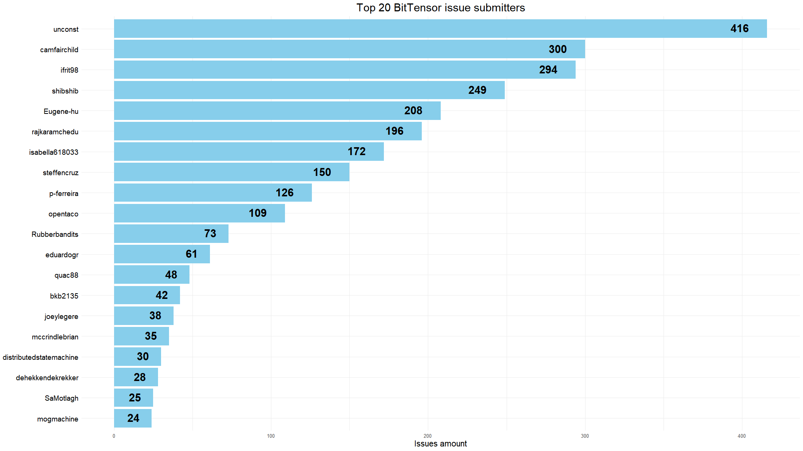

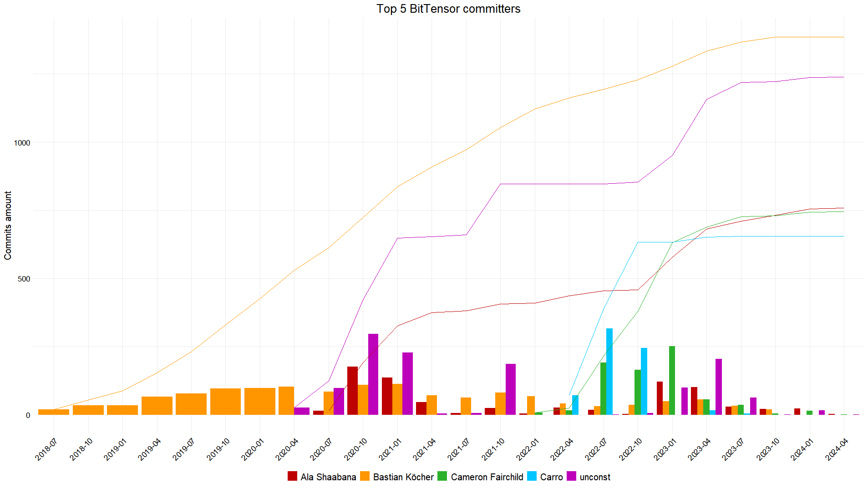

Fetch.AI

Description

Fetch.AI is a decentralized project that combines artificial intelligence (AI) and blockchain technology to create an open economic framework powered by autonomous AI agents. These AI agents can perform a variety of tasks across different industries, such as finance, supply chain, and smart cities, without human intervention. The project aims to revolutionize the digital economy by enabling machine learning models to autonomously execute processes, transactions, and decision-making on behalf of individuals, organizations, and devices.

Developer activity

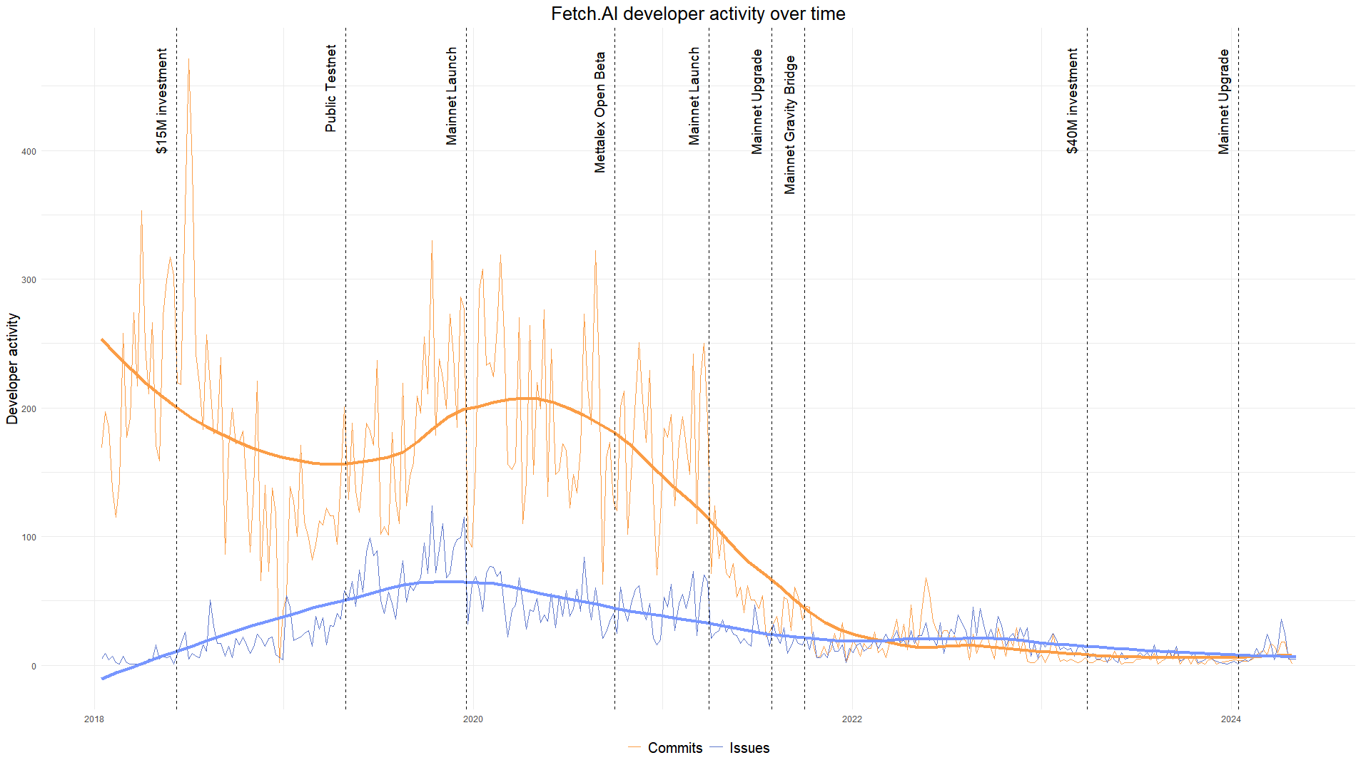

The peak in the number of commits can be attributed to a [$15M investment](https://fetchai.wordpress.com/wp-content/uploads/2018/06/fetch-ai-raises-15-million3.pdf) received earlier. Although development was active in 2020, averaging 200 commits and 50 issues per week, it has now significantly declined to 10-20 commits and issues per week. Even a [$40M investment](https://www.coindesk.com/business/2023/03/29/ai-focused-crypto-protocol-fetchai-raises-40m-to-deploy-decentralized-machine-learning/) appears to have had no impact on the activity, while [Mainnet Upgrade](https://x.com/Fetch_ai/status/1743671107423502767) could lead to increase in issue numbers.

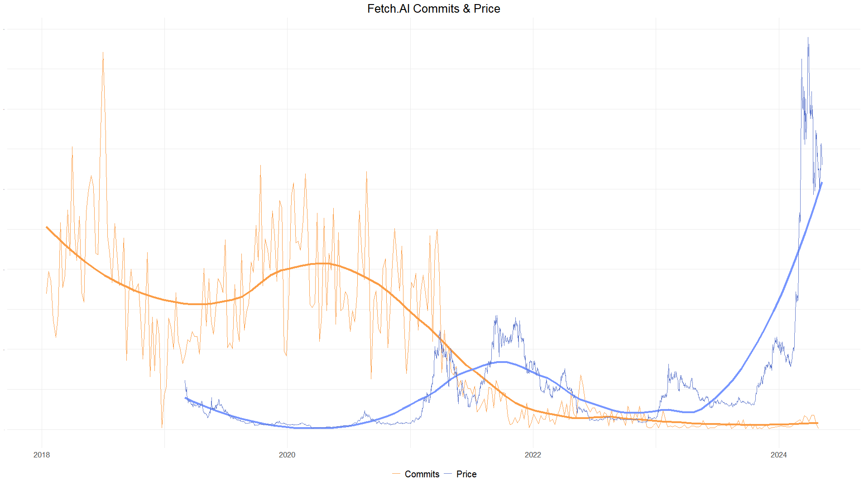

Despite the recent surge in FET prices, it hasn't had a significant impact on developer activity.

Repositories activity

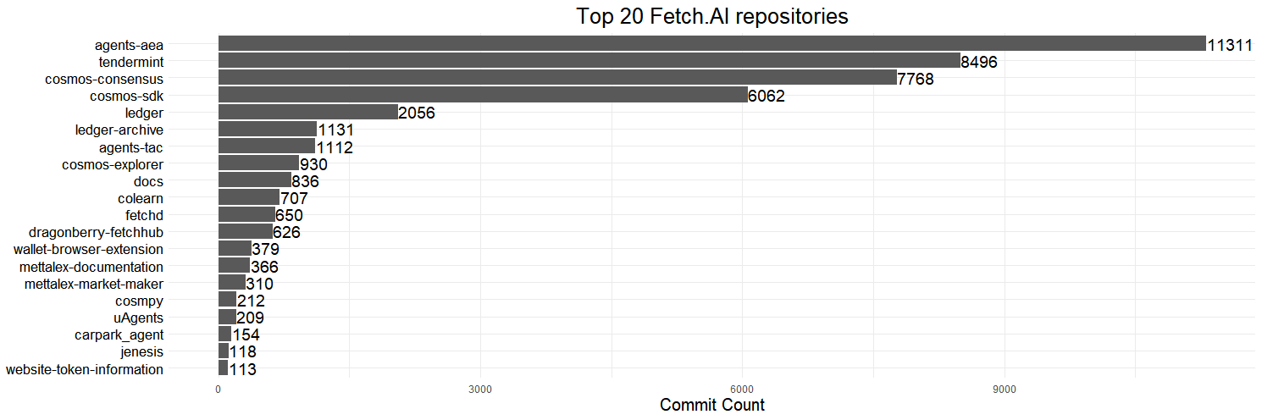

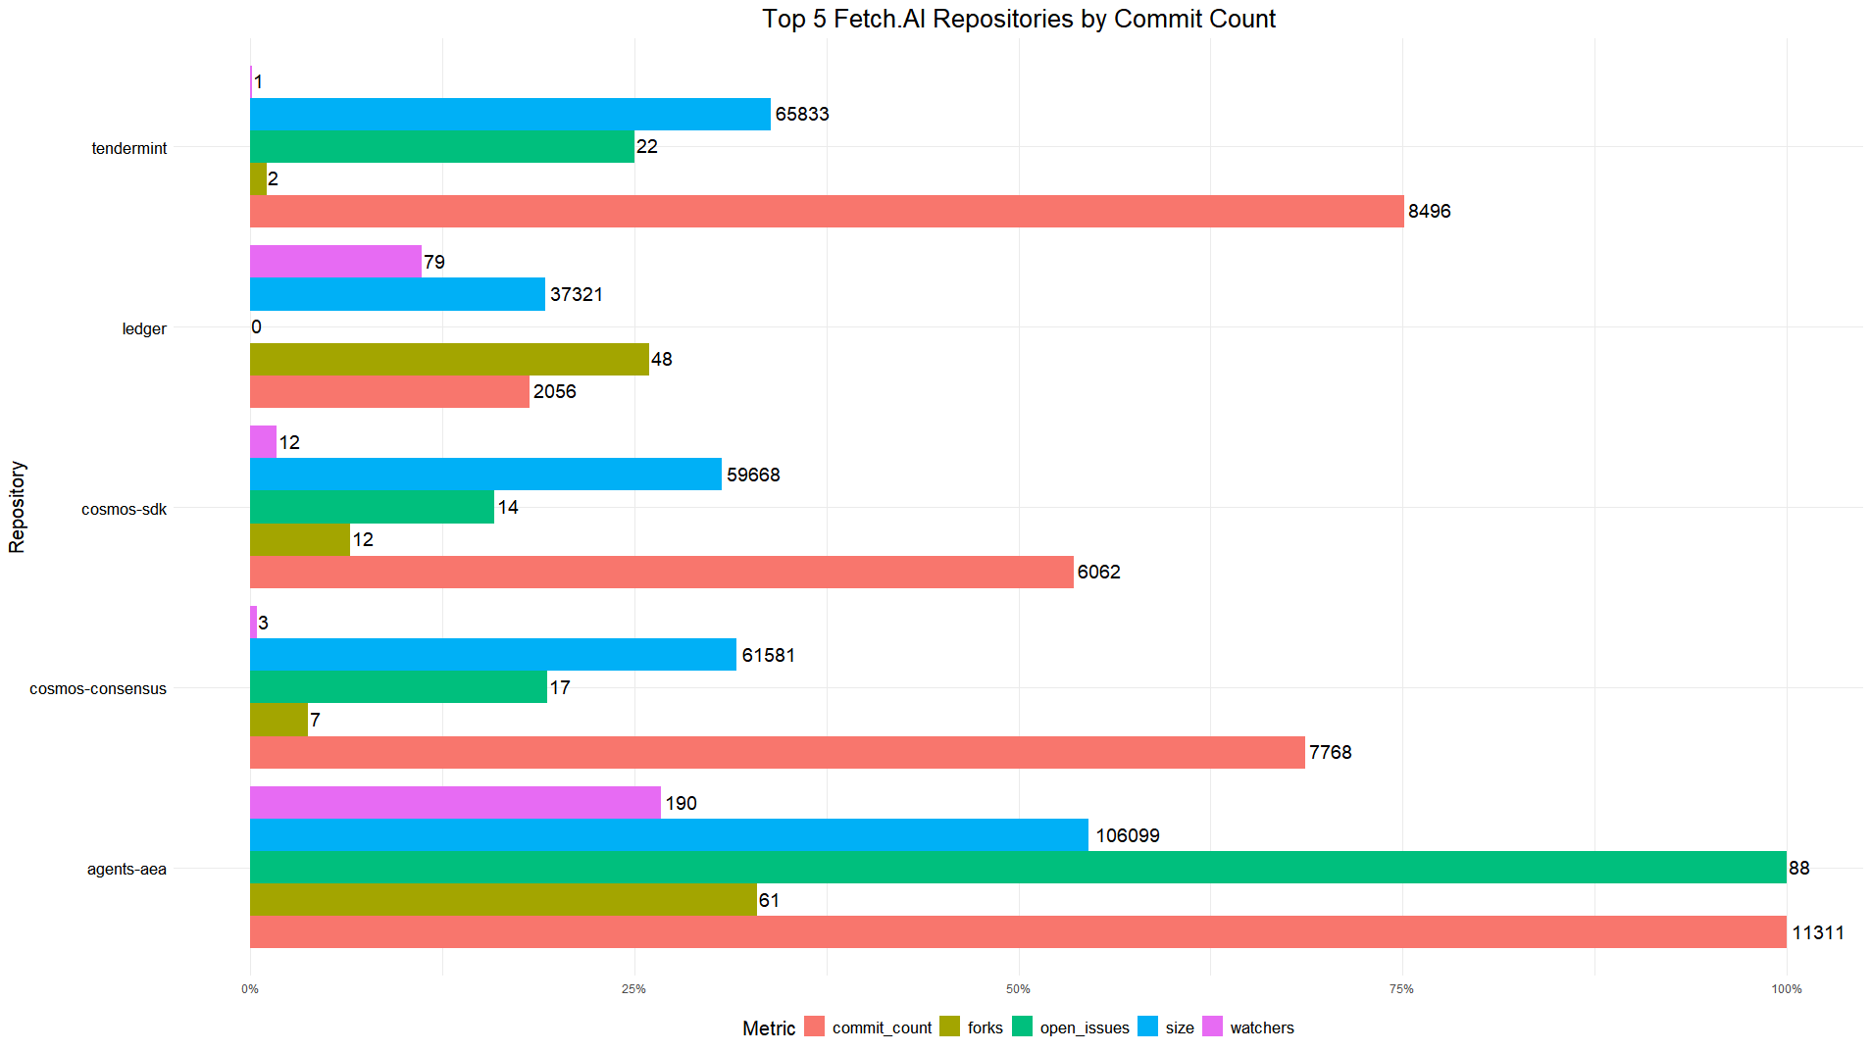

“agents-aea” has the most commits and opened issues, but “uAgents” is the leader by amount of forks (185) and watchers (710) and “docs” is the leader by the size amount (194453 KB).

Most active developers

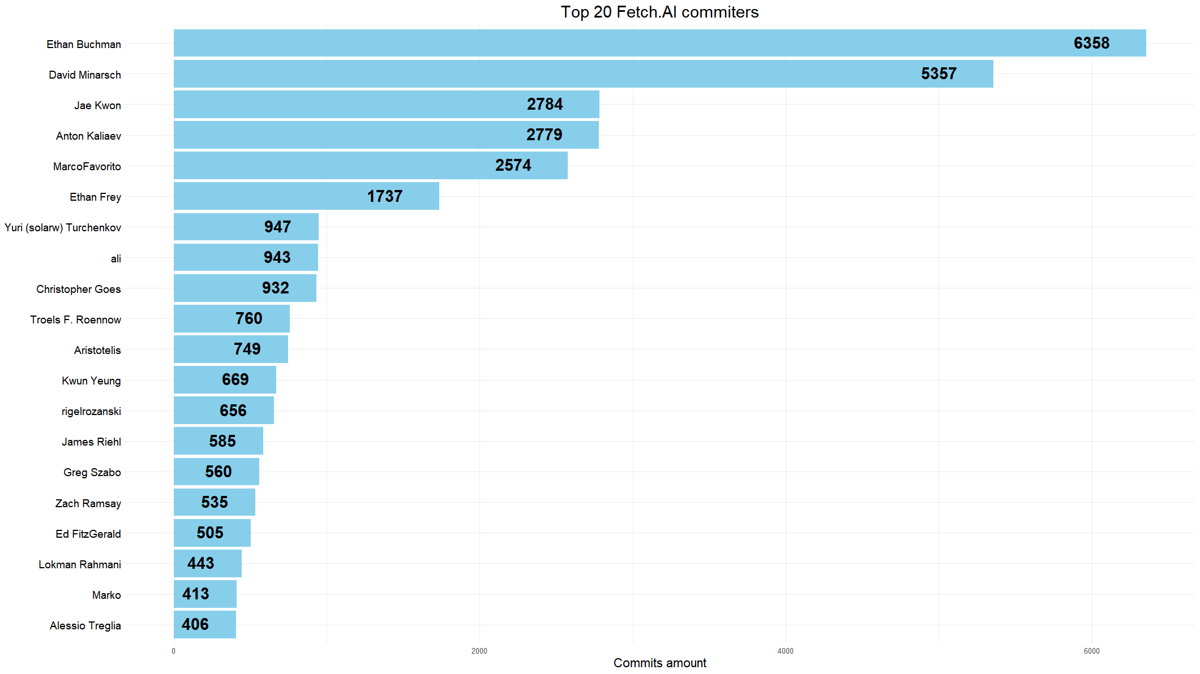

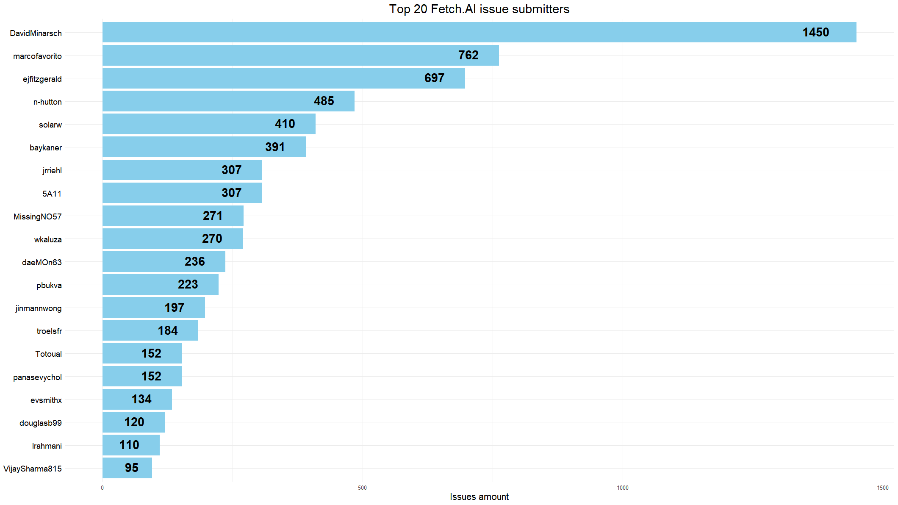

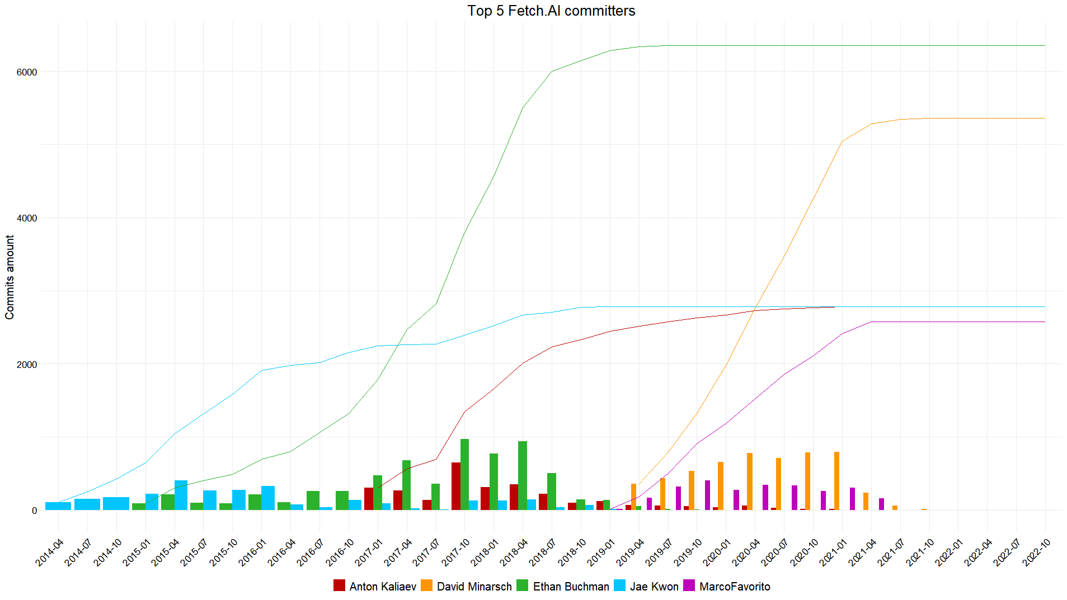

Numer.AI

Description

Numer.AI is a decentralized artificial intelligence network that crowdsources machine learning models to power a hedge fund. It incentivizes data scientists globally to contribute their models by staking the cryptocurrency NMR, where well-performing models earn rewards and poorly-performing ones get their stake burned. The project aims to create an open economic framework driven by autonomous AI agents that can execute processes and transactions across various industries.

Developer activity

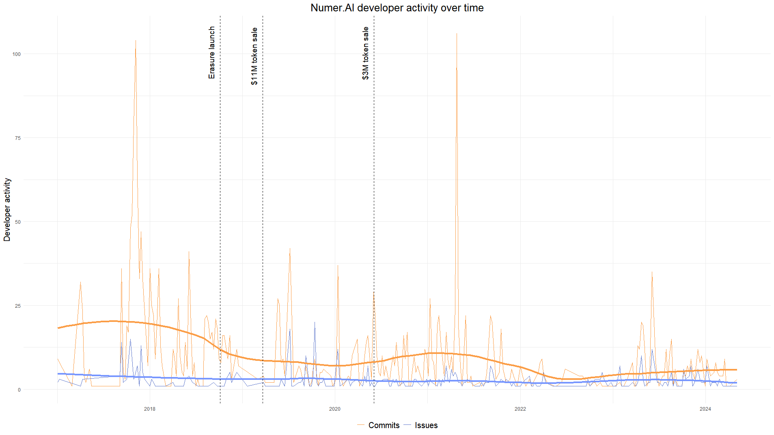

Unfortunately, I was unable to determine the reasons behind the spikes in development activity on November 5, 2017 and April 25, 2021. Overall, the activity of the developers is declining.

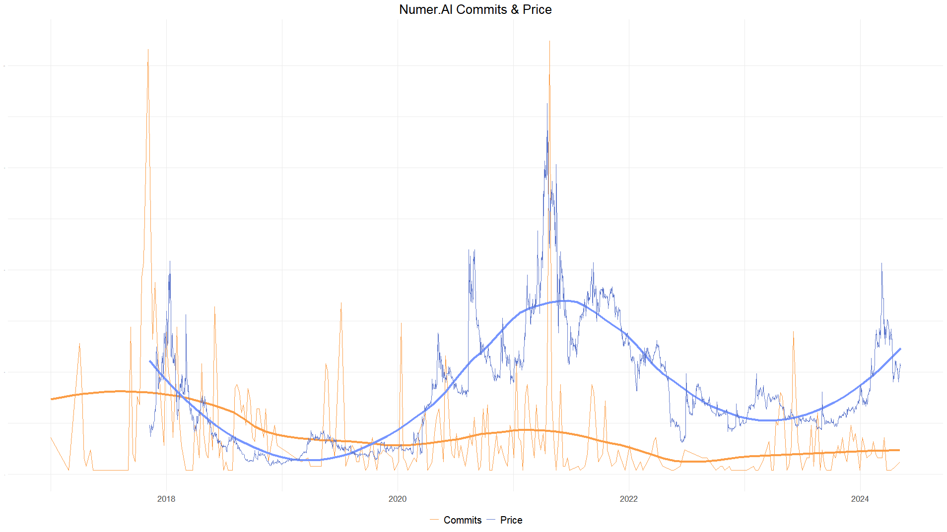

Activity fluctuations could be explained by price variations—developers tend to be more active when the price goes up and less active when the price goes down.

Repositories activity

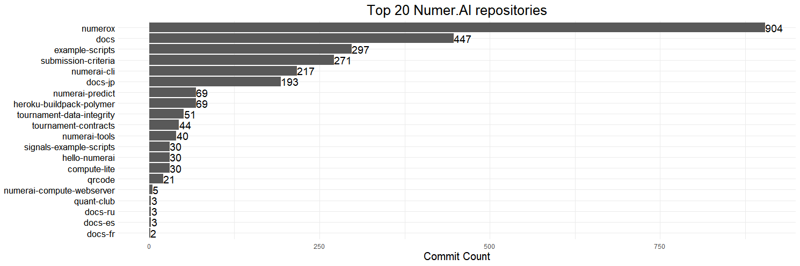

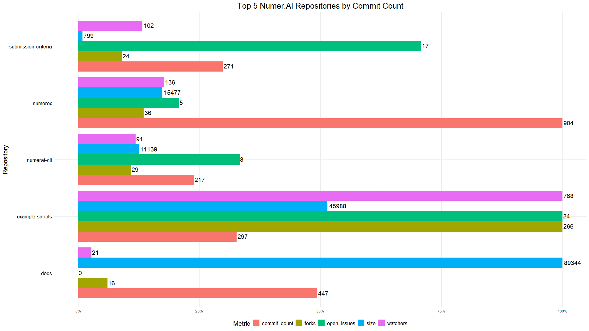

Most active developers

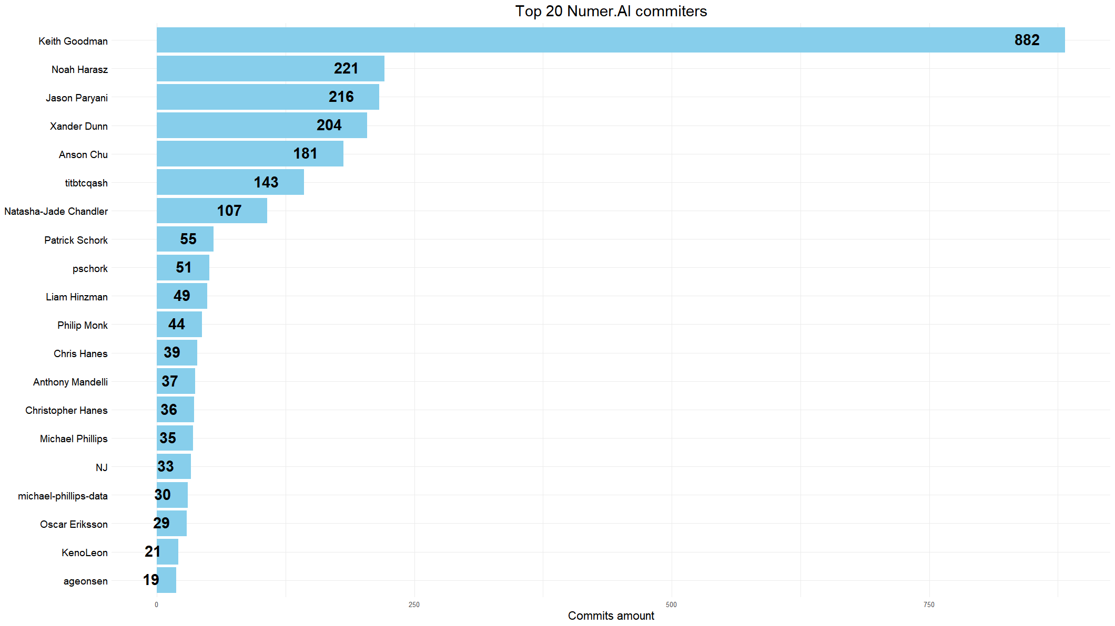

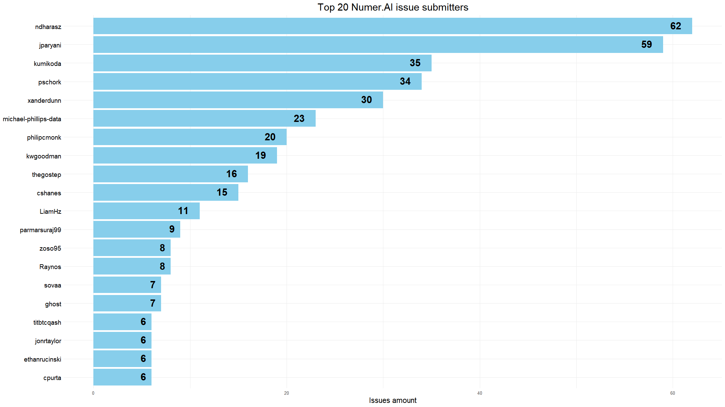

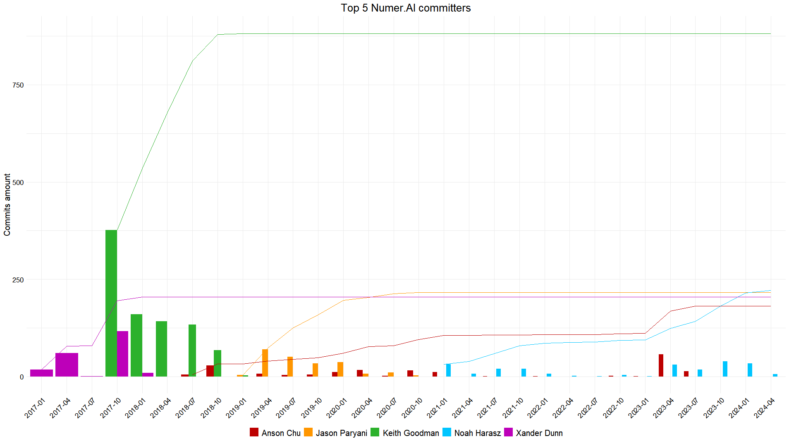

Ocean Protocol

Description

Ocean Protocol is a decentralized data exchange protocol that allows individuals and organizations to share and monetize data securely and transparently. It tokenizes datasets as ERC-20 tokens called "datatokens" which can be bought and sold on Ocean's decentralized data marketplace using the OCEAN utility token. The project aims to unlock data for AI applications by enabling compute-to-data capabilities, where algorithms can be run on data without needing to transfer it, while ensuring data providers retain control over their assets.

Developer activity

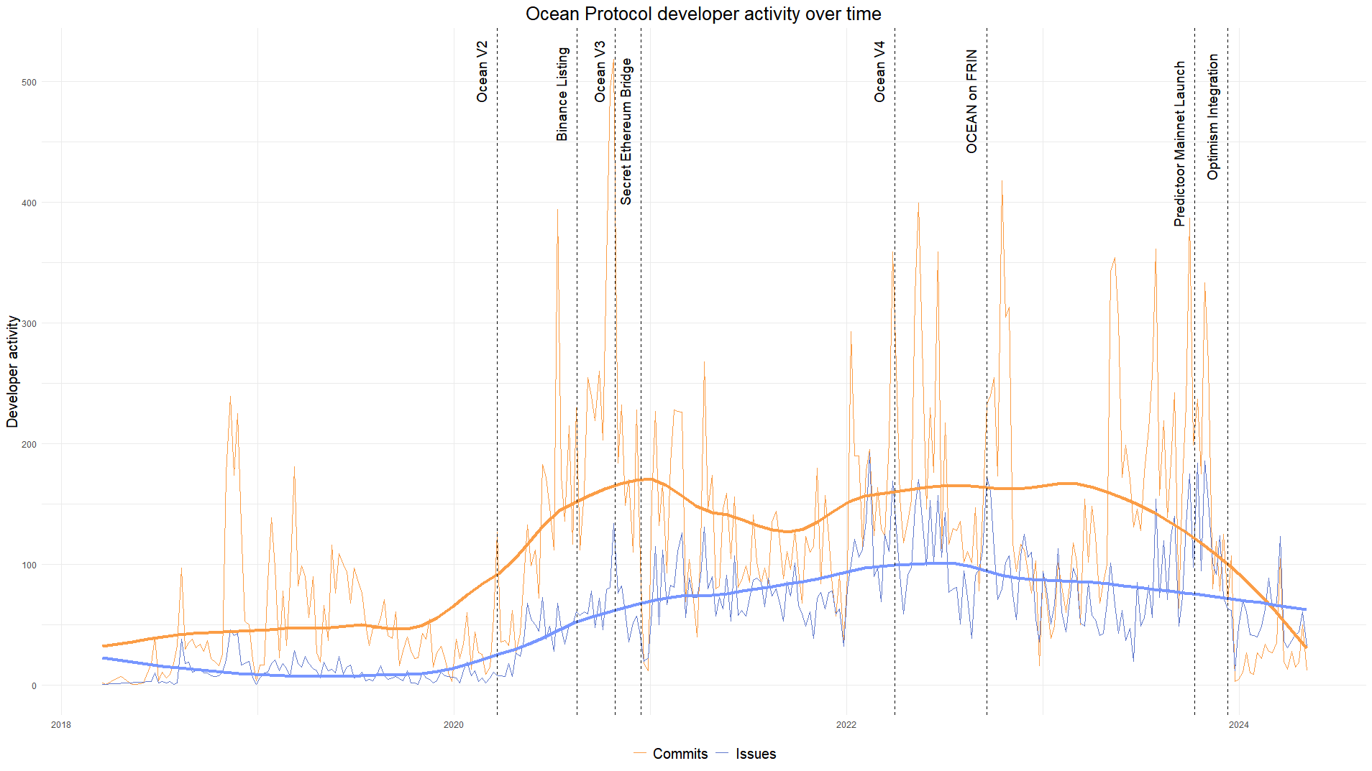

Releases of Ocean V2, V3 and V4 are accompanied by a huge spike in commits amount.

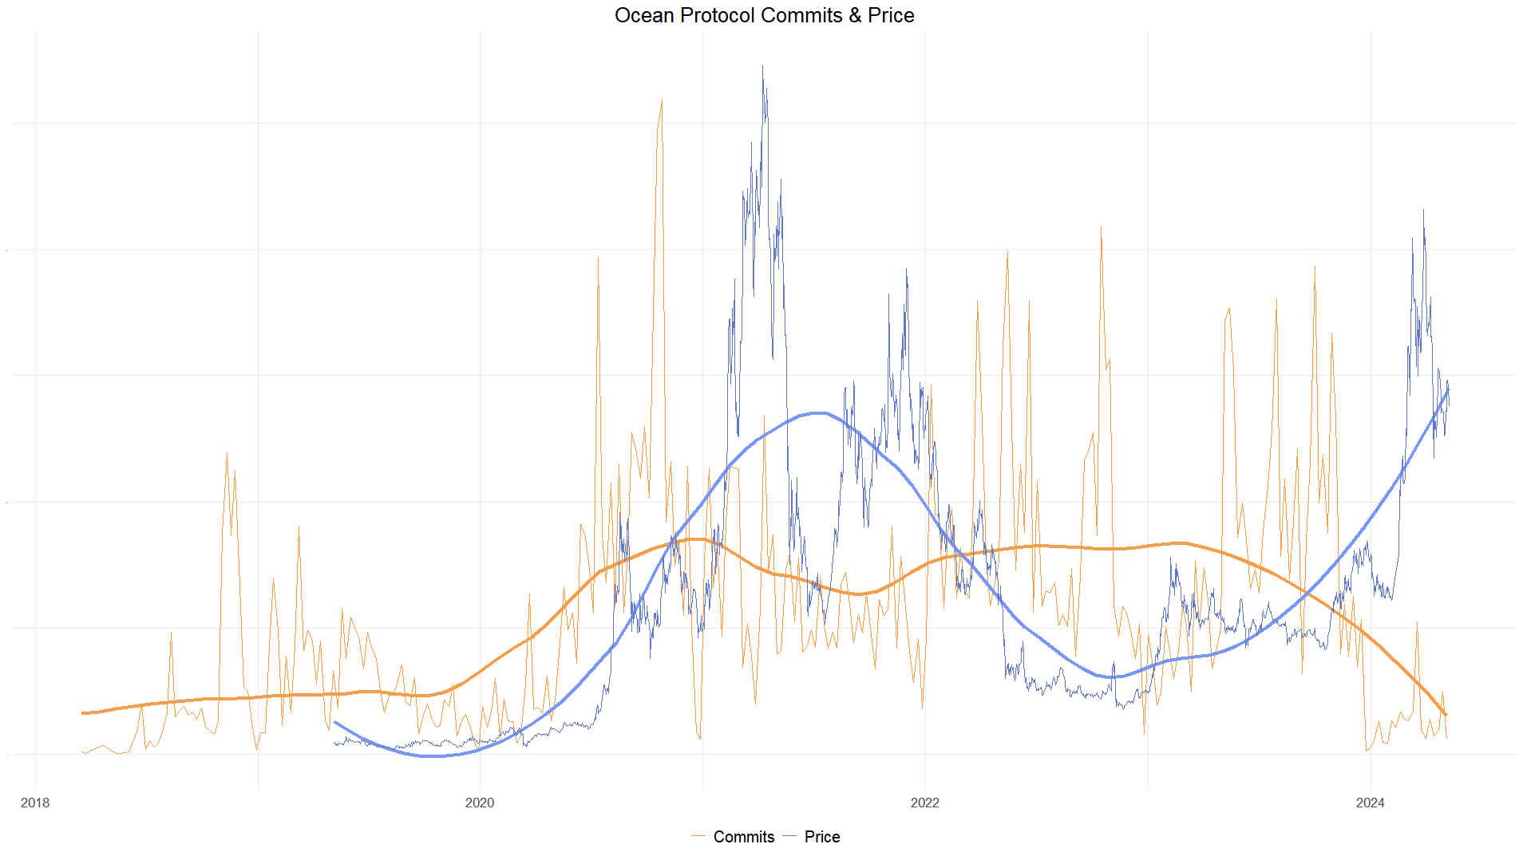

Repositories activity

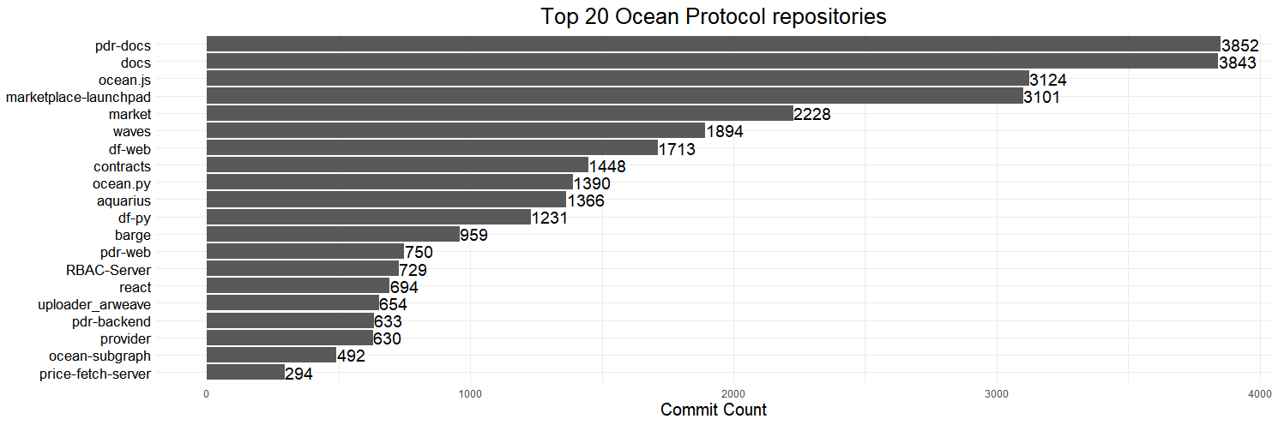

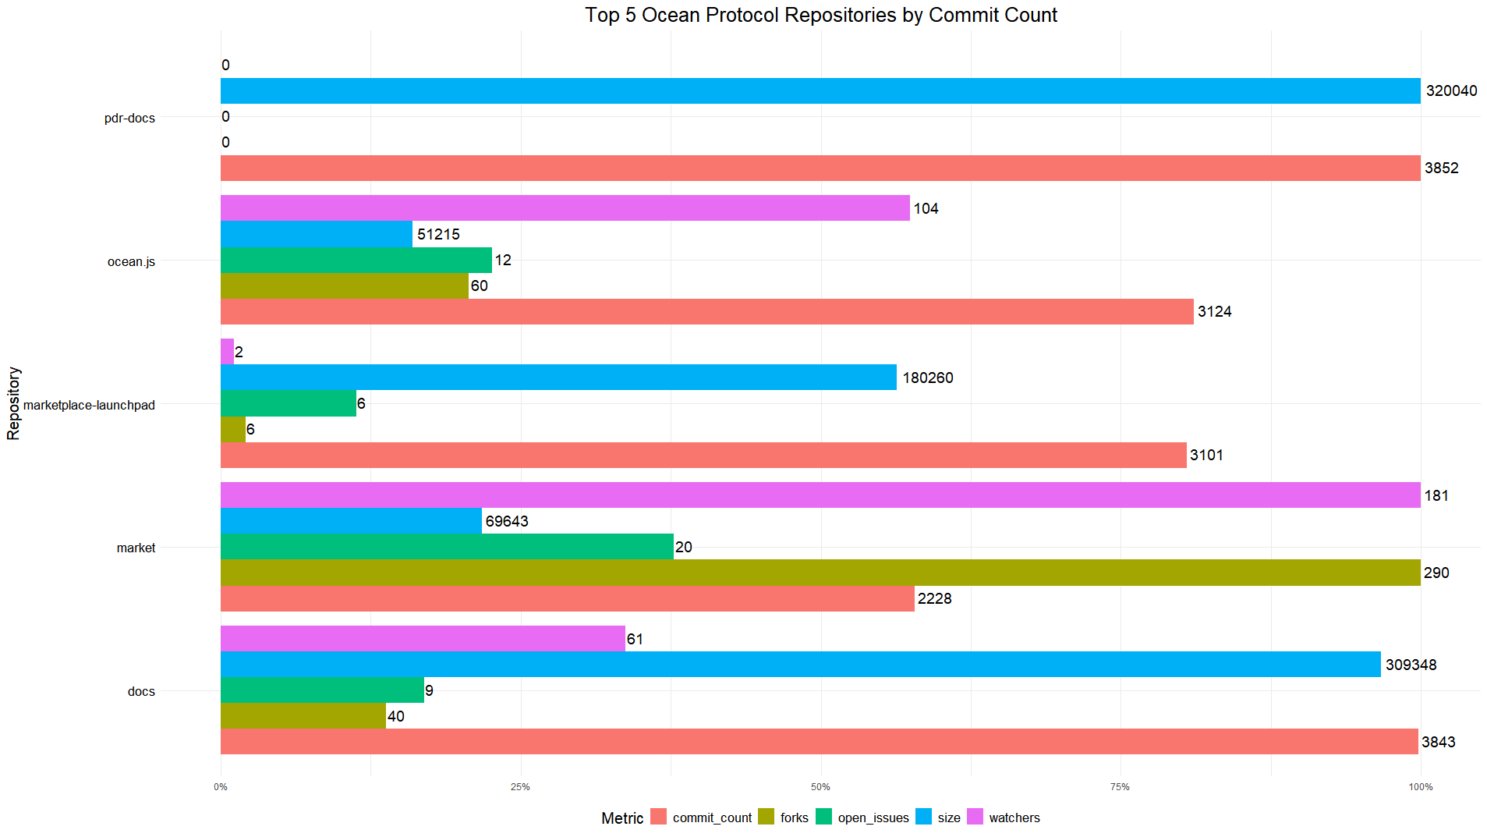

Most active developers

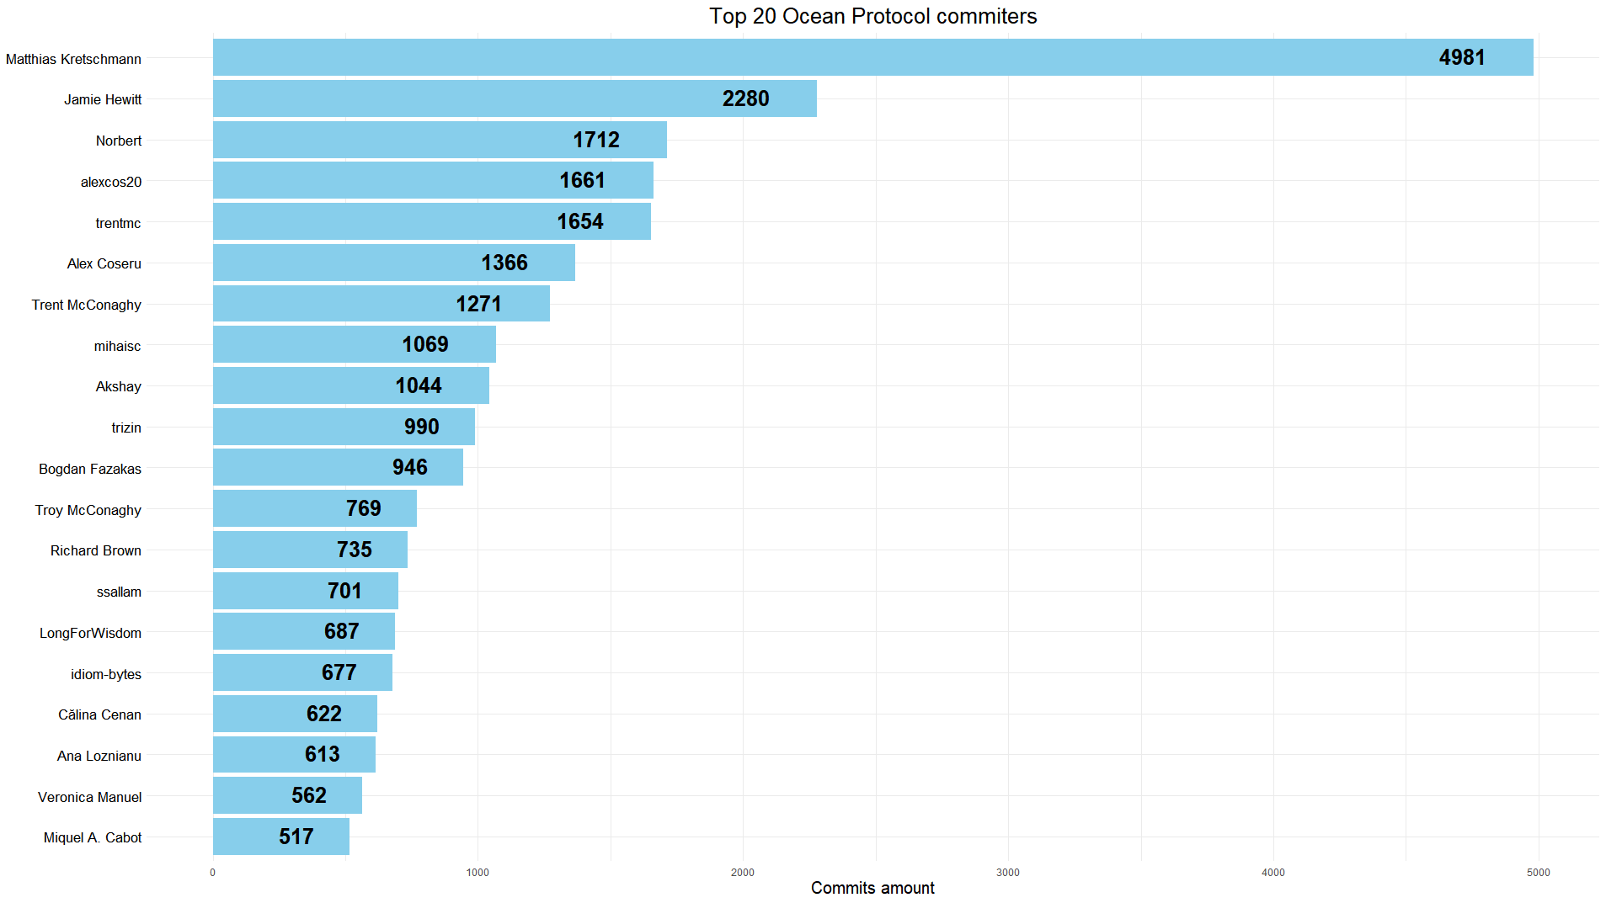

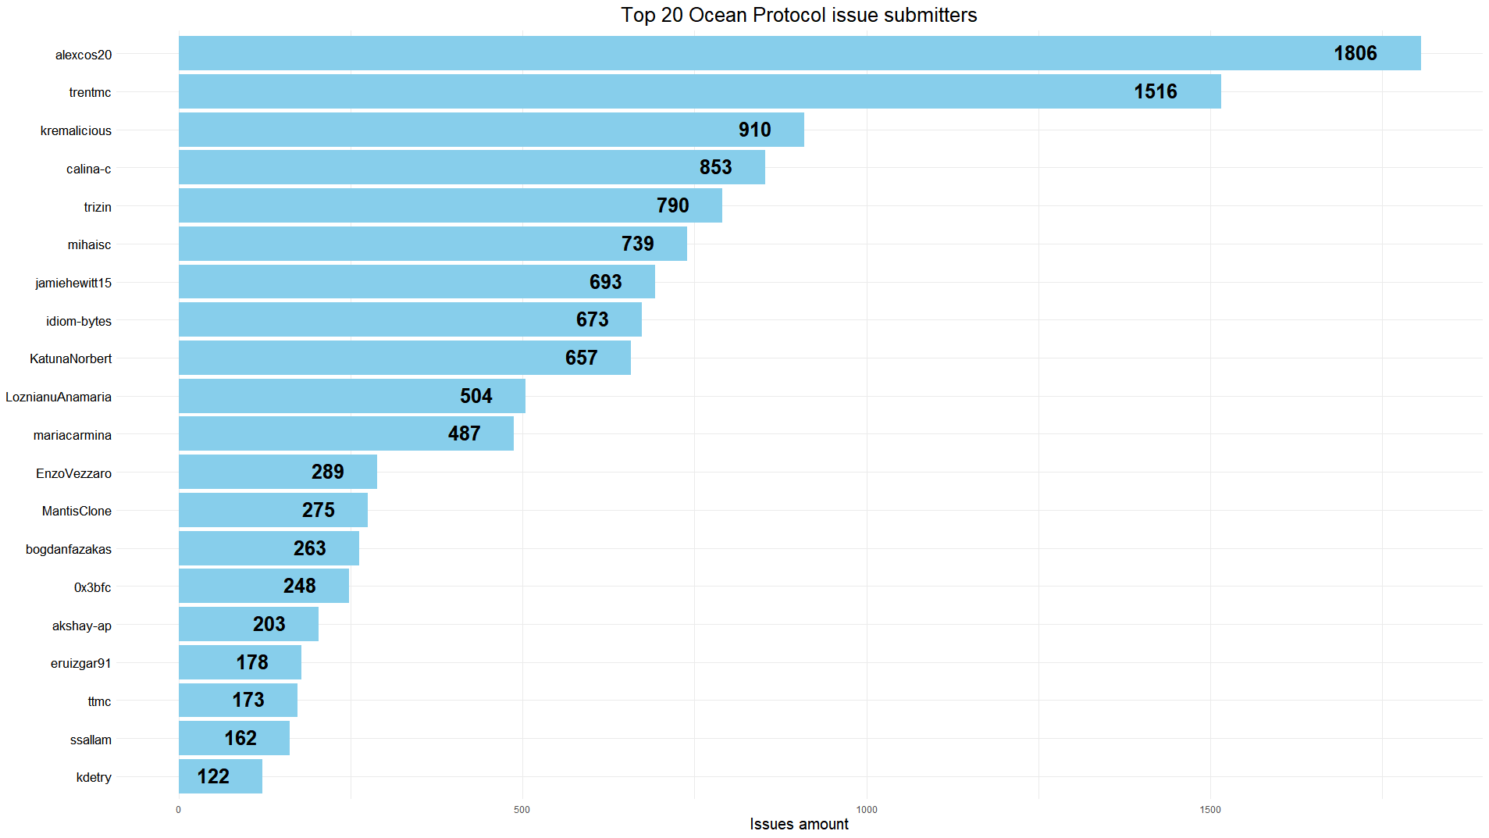

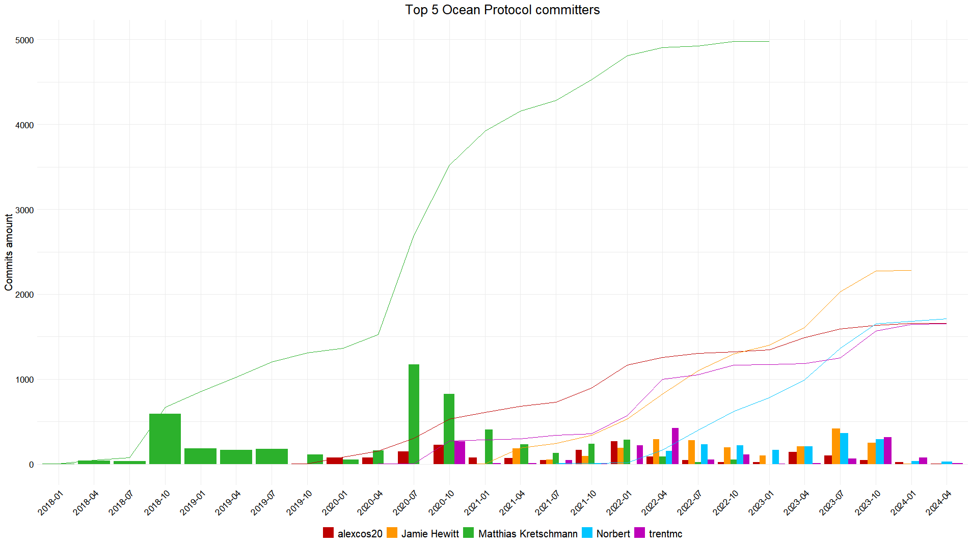

Orachain

Description

Oraichain is a layer 1 blockchain that aims to enable the integration of artificial intelligence with decentralized applications through its AI oracle system. It provides a decentralized marketplace for AI services, allowing developers to access and monetize AI models, while ensuring transparency and trust through on-chain verification. Oraichain's ecosystem includes features like GPU staking, where users can earn rewards for contributing computing power to run AI workloads, and tools for AI model training, publishing, and integration with smart contracts.

Developer activity

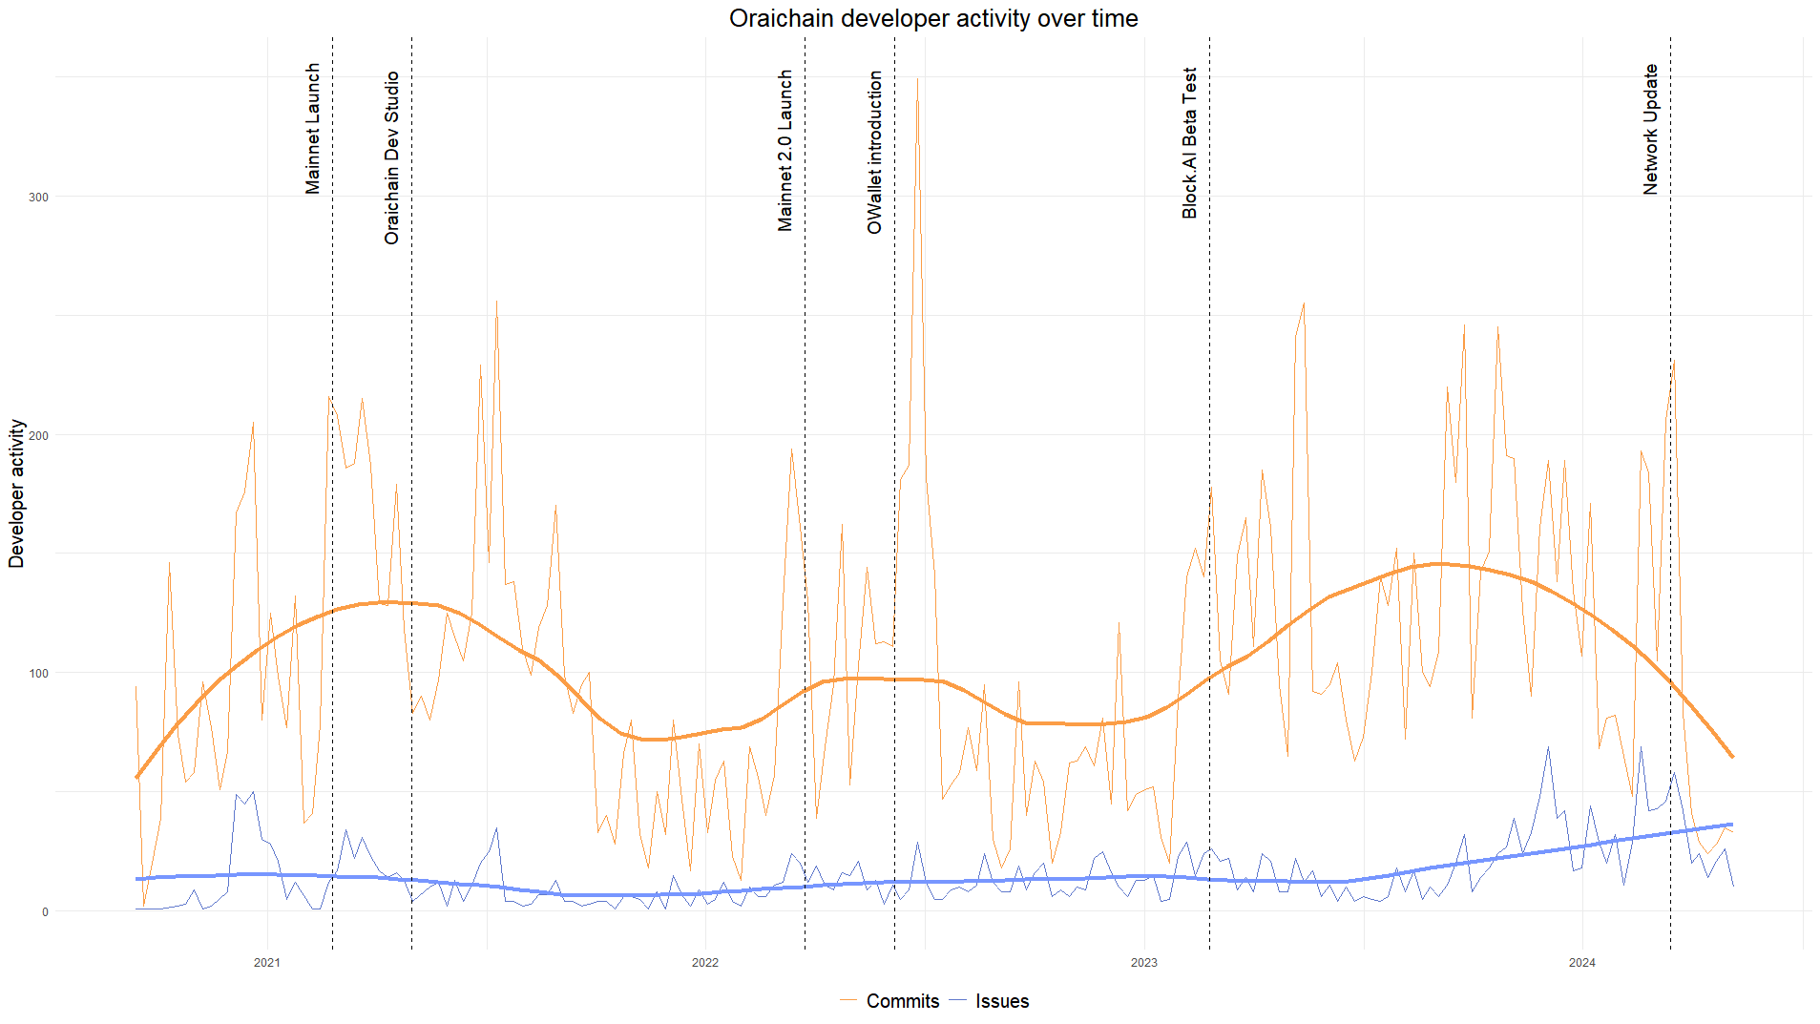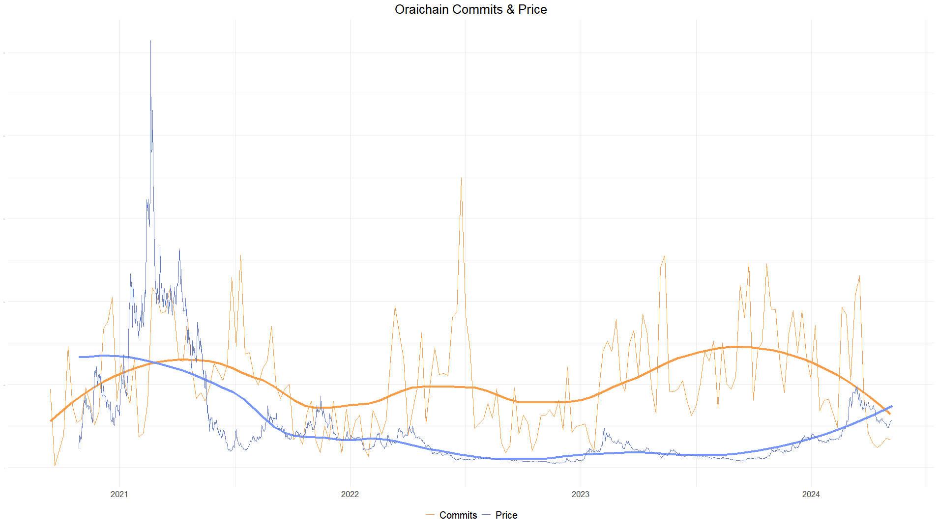

Repositories activity

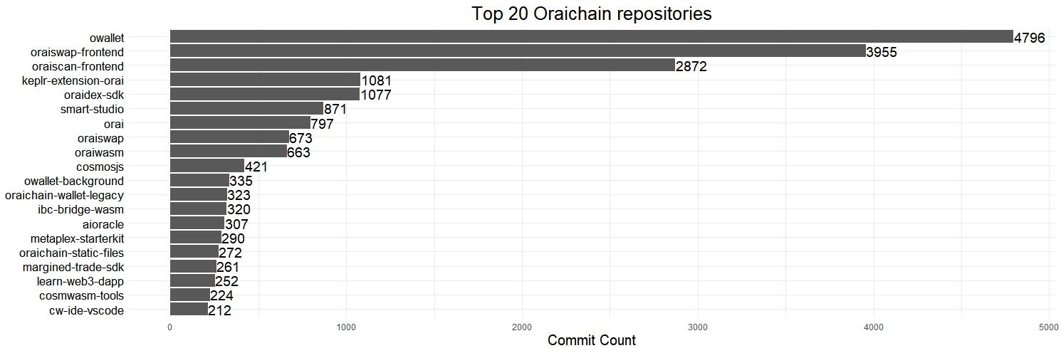

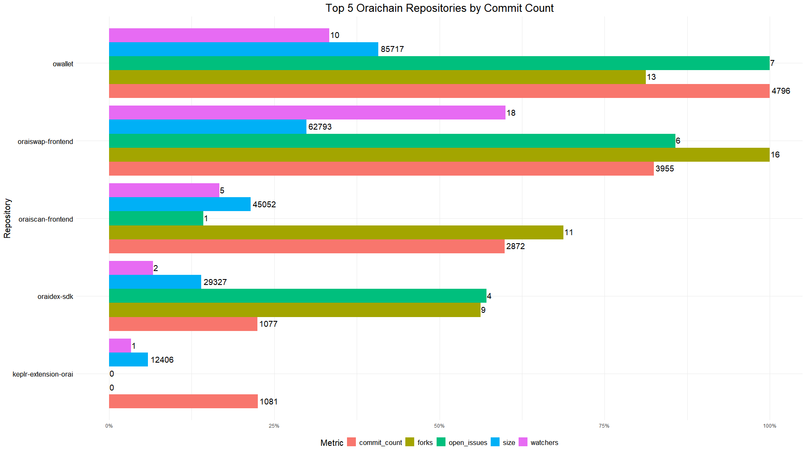

Most active developers

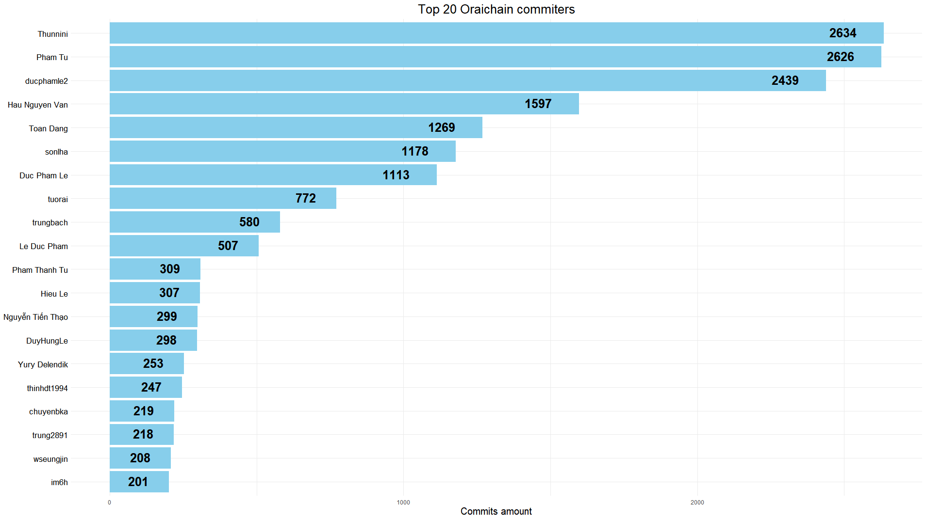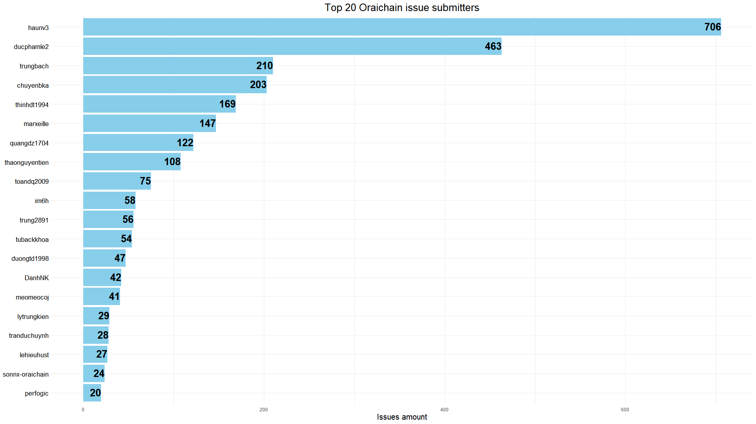

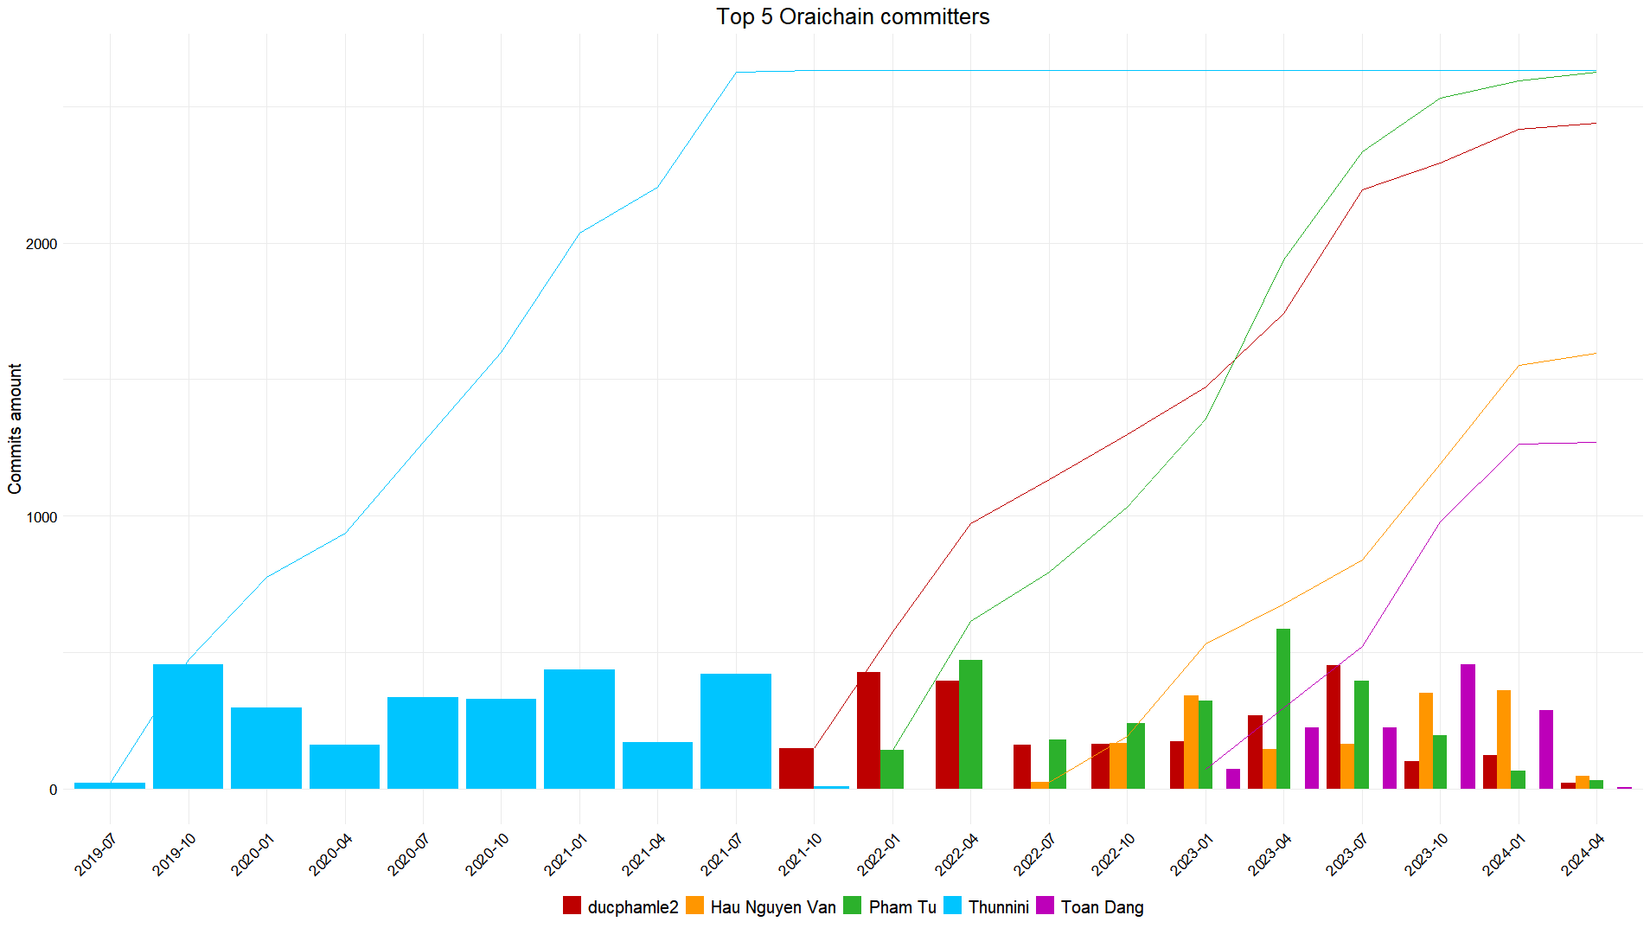

SingularityNET

Description

SingularityNET is a decentralized artificial intelligence (AI) platform that aims to create a global marketplace for AI services and algorithms. It allows developers and organizations to publish, share, and monetize their AI models and services on the platform, while users can access and integrate these AI capabilities into their applications. The platform is built on blockchain technology and utilizes the AGIX token for transactions, governance, and incentivizing the network participants

Developer activity

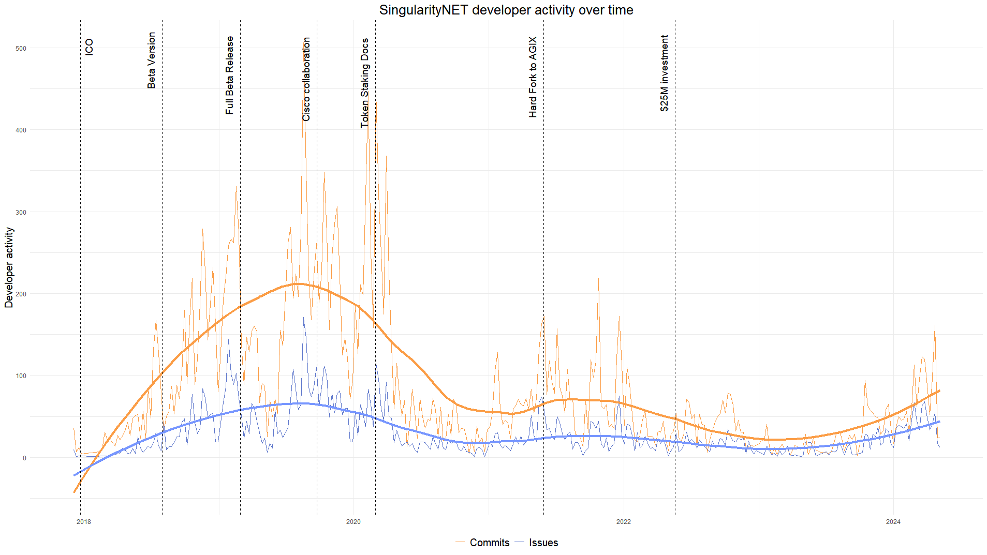

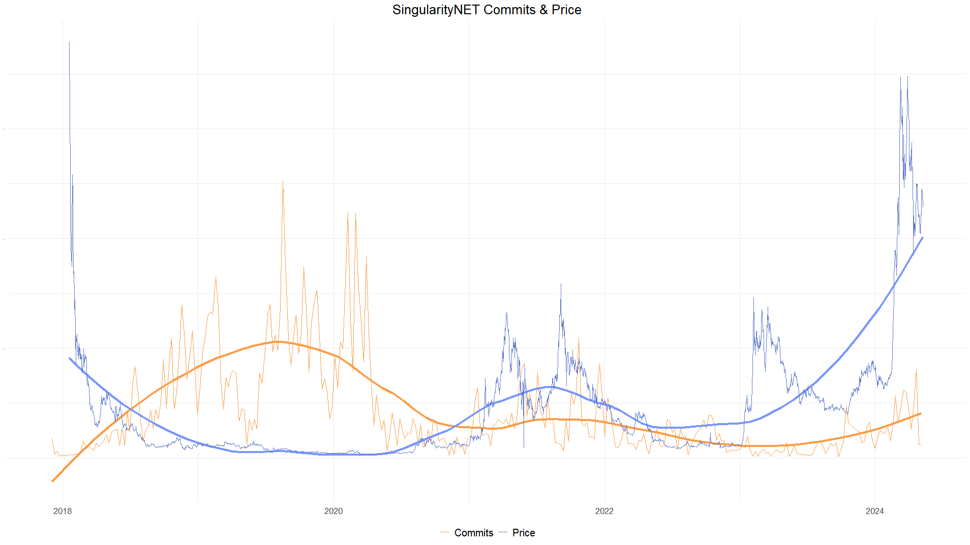

Repositories activity

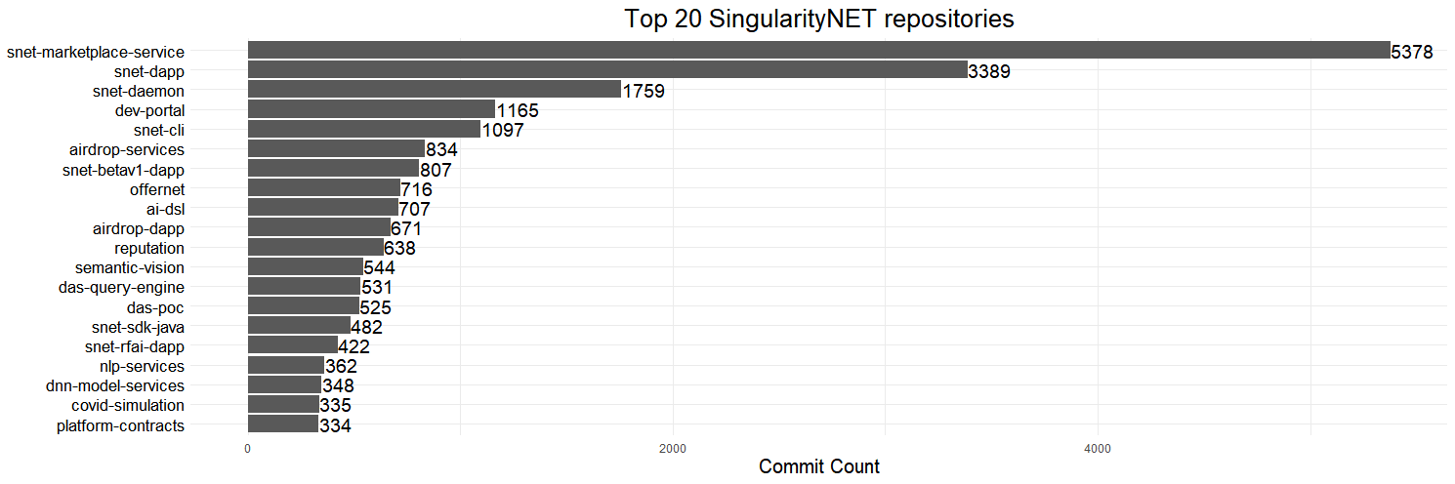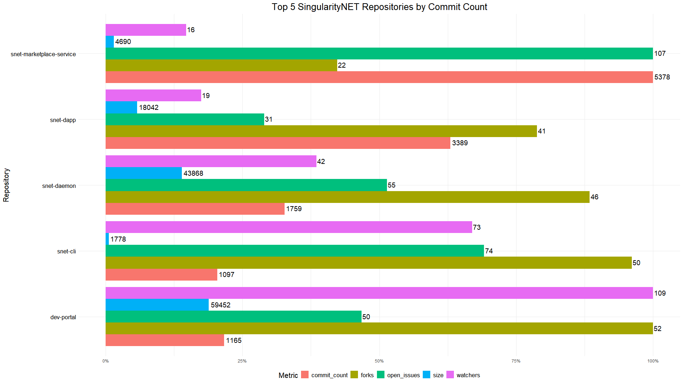

Most active developers

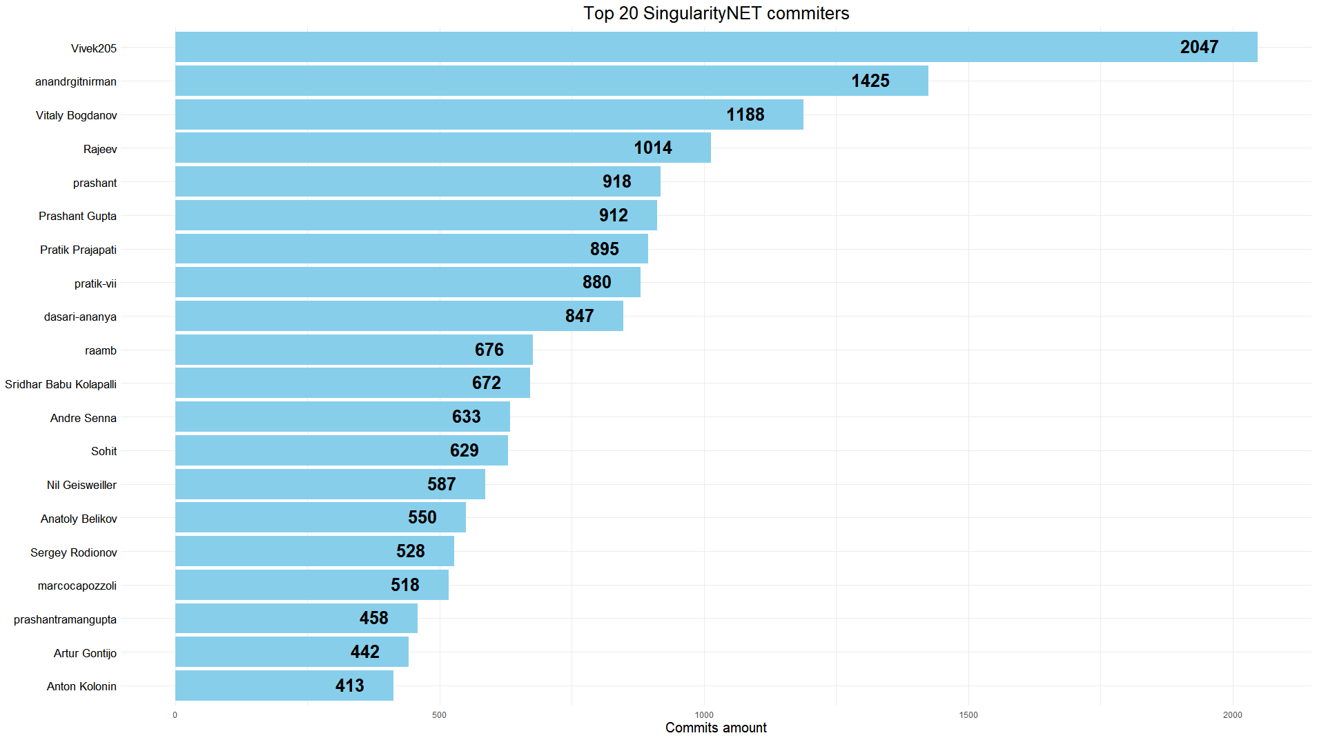

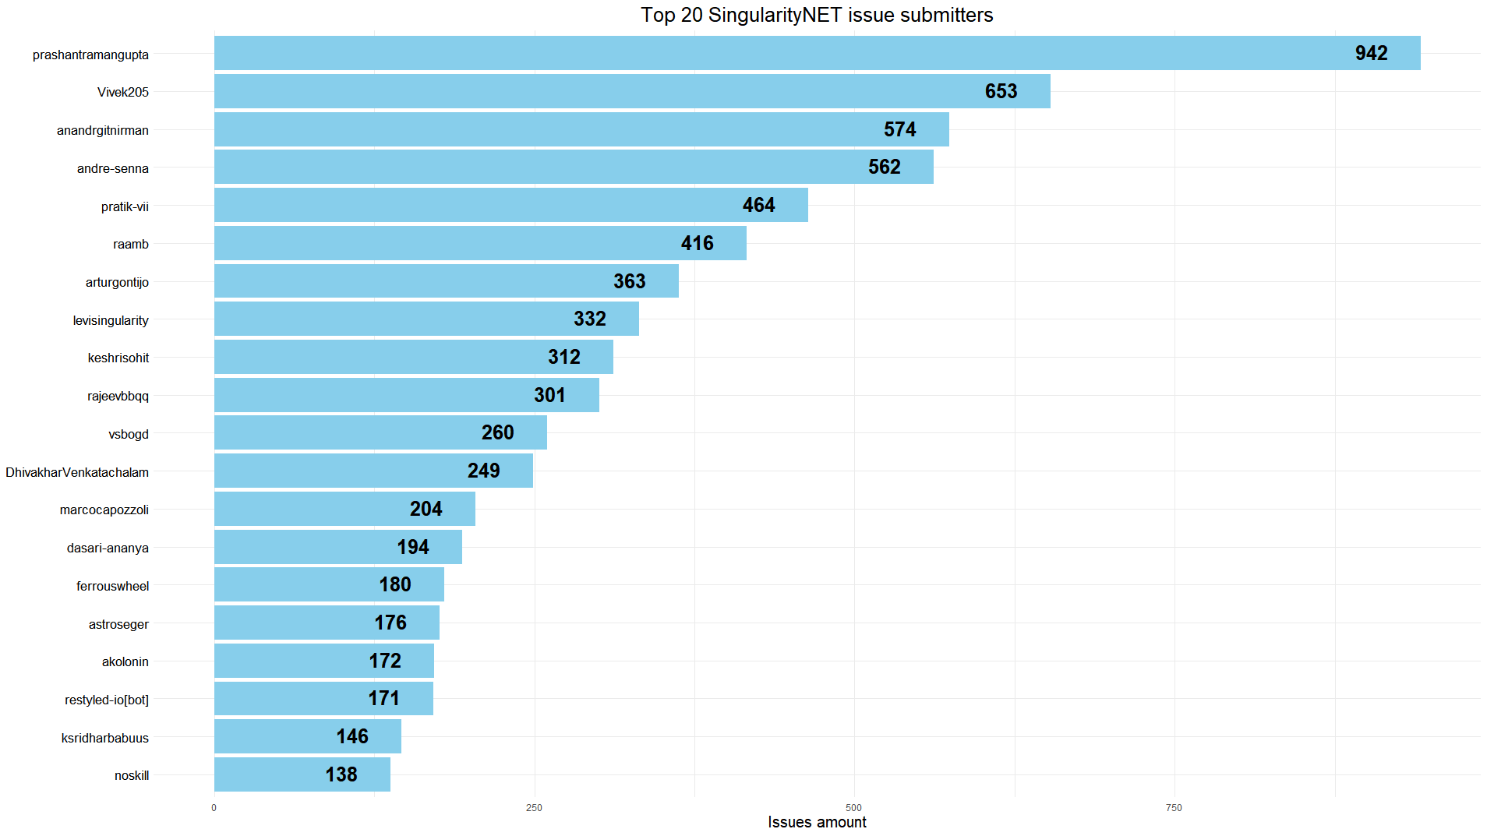

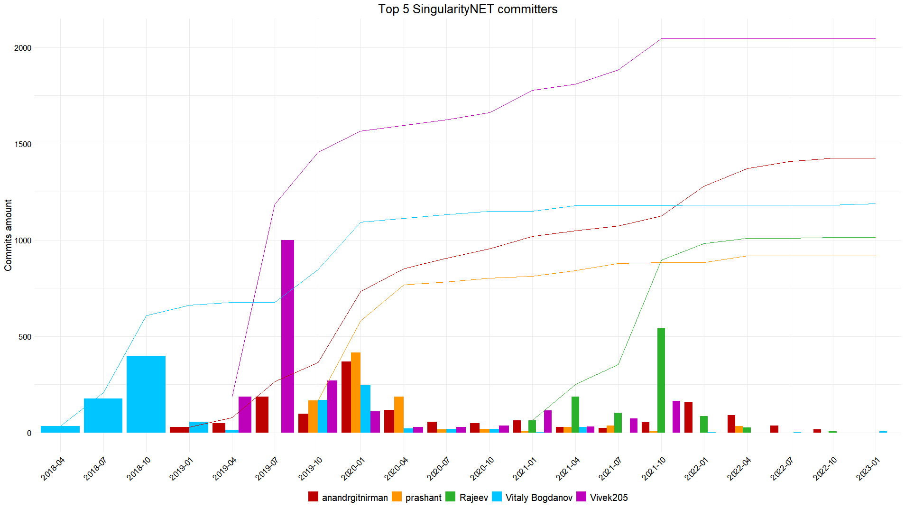

Project activity rating

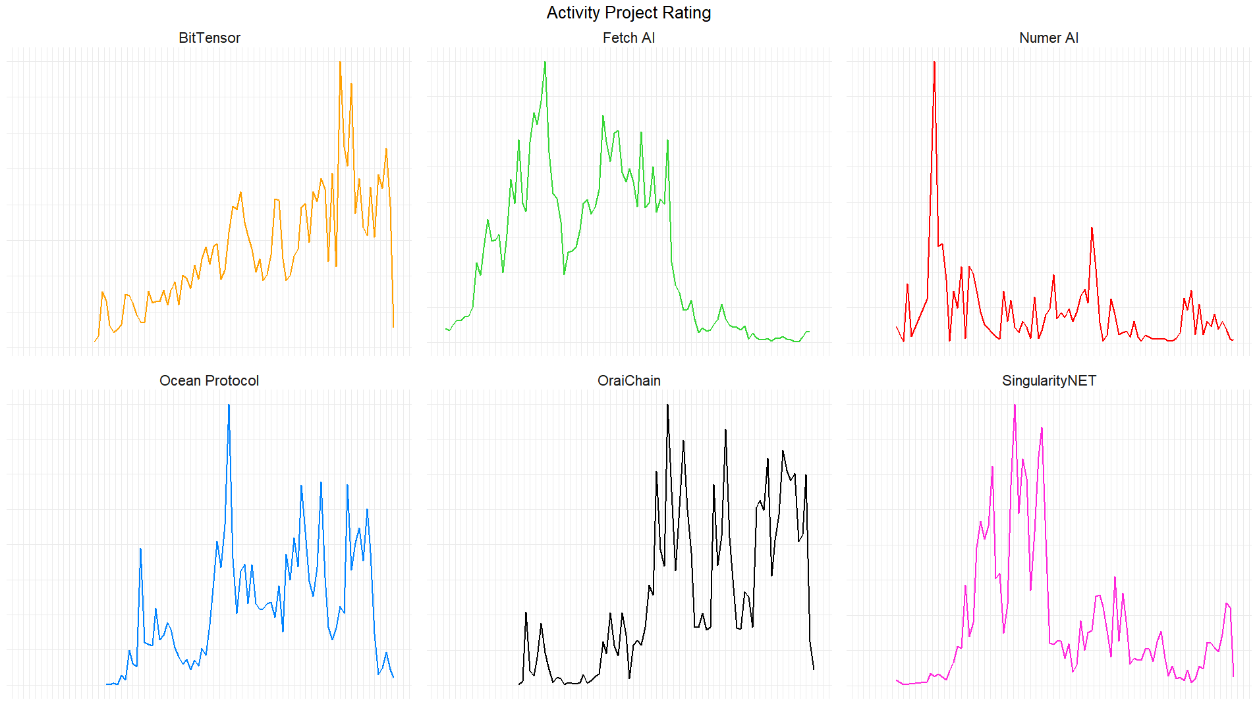

The metric for rating the activity of projects includes three parameters: the number of commits, issues, and repositories created per month. These parameters are normalized on a scale of 0 to 1 and then summed and normalized to provide a comprehensive activity score.

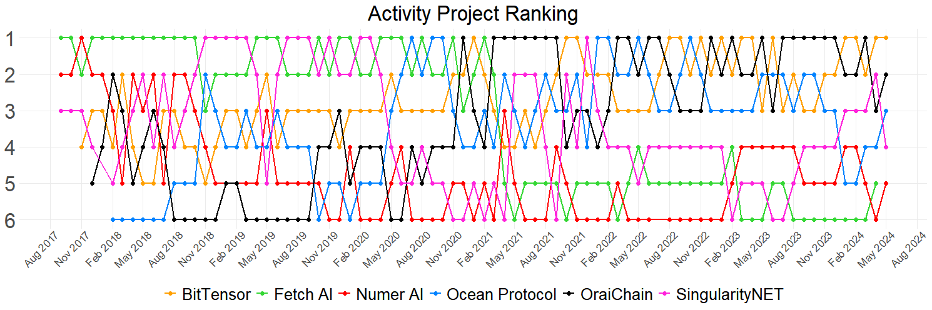

Ranking is dynamic and changes almost every month with the average rating:

|  |  |
| --- | --- |
| BitTensor | 0.339 |
| Orachain | 0.322 |
| Ocean Protocol | 0.279 |
| Fetch.AI | 0.268 |
| SingularityNET | 0.234 |
| Numer.AI | 0.105 |

Meaning that BitTensor is the most actively developed project based on the number of commits, issues, and repositories created per month.

Correlations

To better understand the relationship between developer activity and token prices, I conducted a correlation analysis using various metrics such as the number of commits, issues (opened, closed, and unresolved), and token prices. By examining the correlations between these factors on both a weekly and monthly basis, I aim to identify potential patterns and trends that could inform investment decisions.

Heatmaps

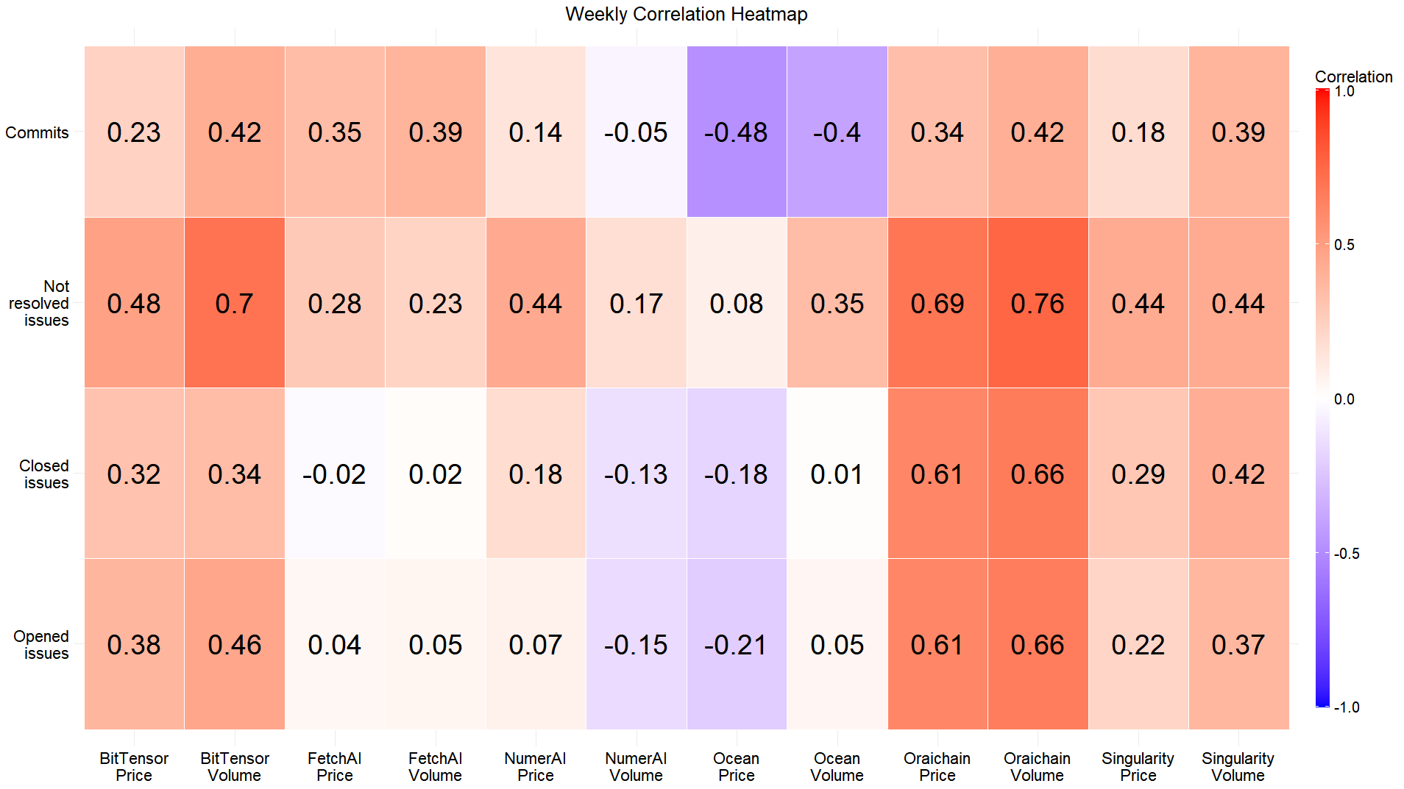

Oraichain's price and volume have the highest correlation with closed, open, and unresolved issues on a weekly basis.

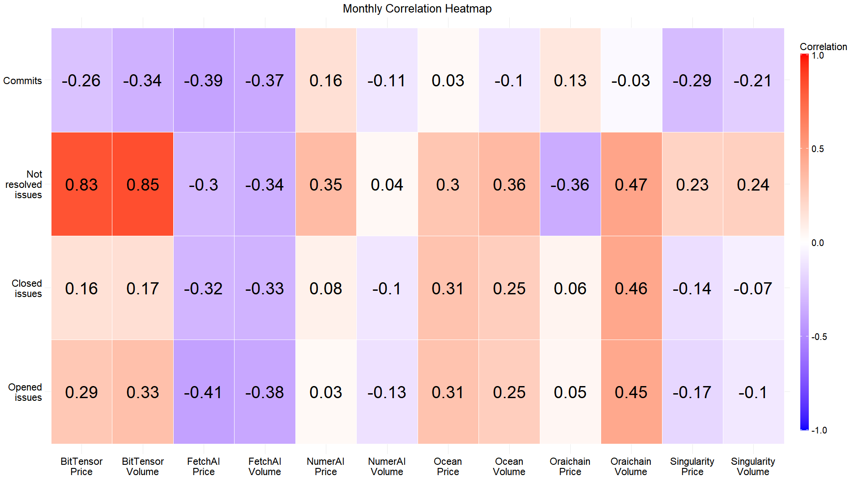

Fetch.AI has the lowest correlation between price and volume on a monthly basis.

Rolling Correlations

Rolling correlations are calculated over a specified window of time, allowing me to observe how the relationship between variables changes over time. By analyzing rolling correlations, I can identify periods where developer activity and token prices are more strongly or weakly correlated, providing insights into the dynamic nature of their relationship.

BitTensor

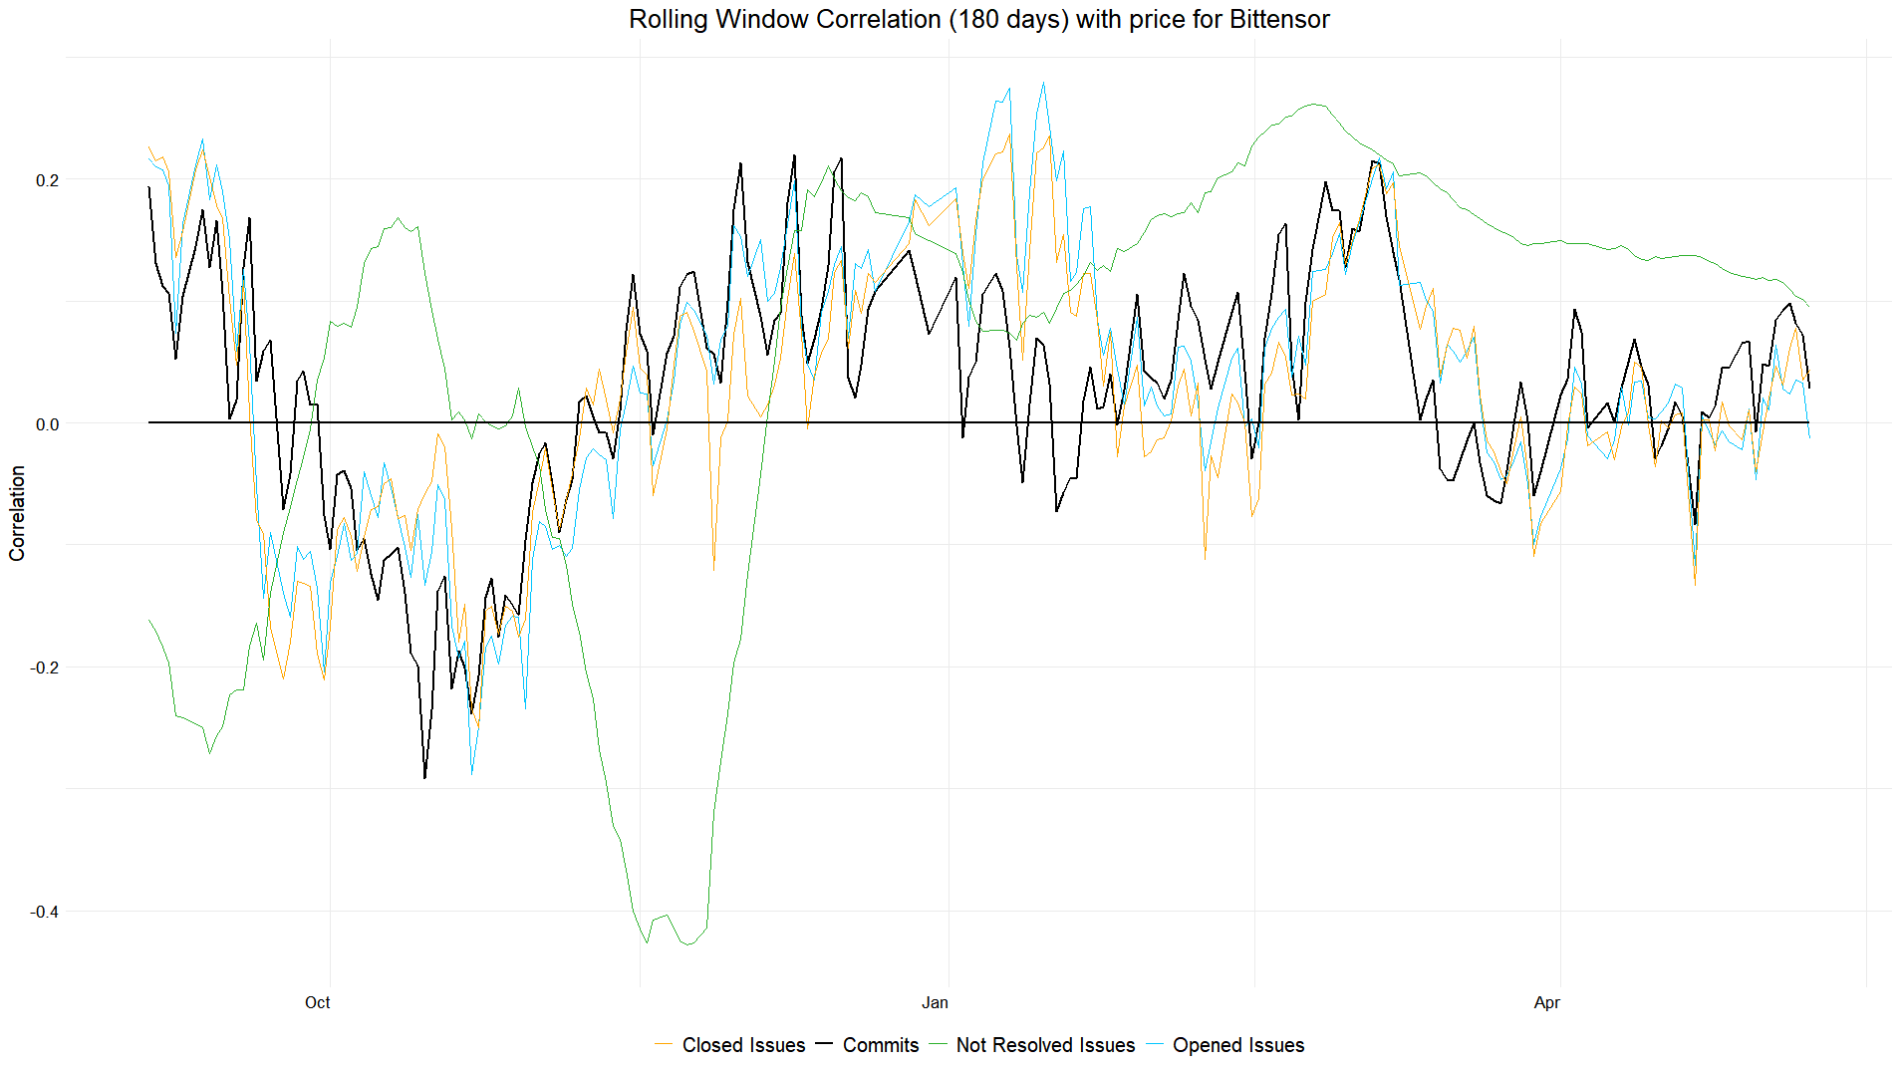

The correlations between the number of commits, closed issues, and opened issues are oscillating around zero, indicating that there is no consistent trend or defined correlation with the price.

Fetch.AI

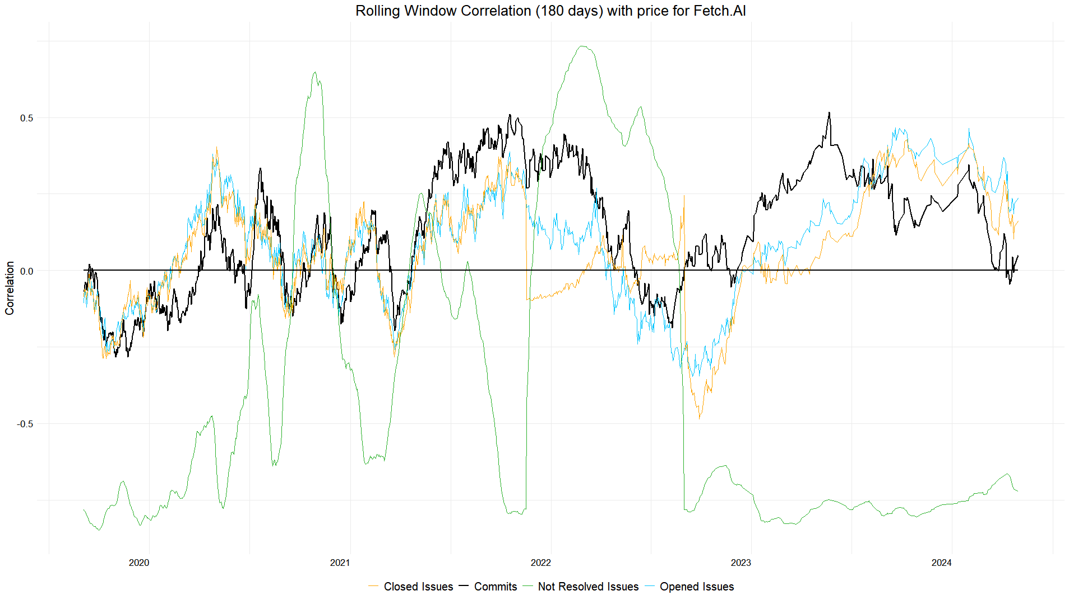

The number of commits, as well as closed and opened issues, are not very useful indicators. However, the number of unresolved issues tends to remain negatively correlated, which could be used for predictions.

Numer.AI

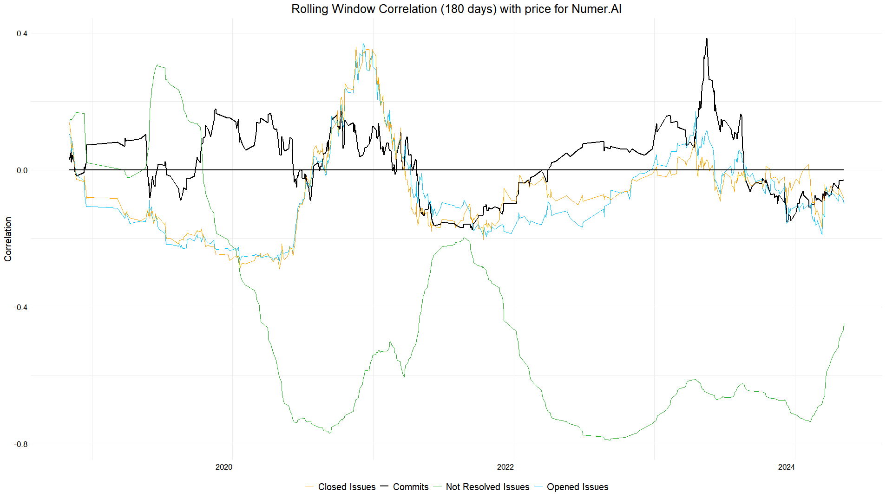

The number of commits, as well as closed and opened issues, are not very useful indicators. However, the number of unresolved issues tends to remain negatively correlated, which could be used for predictions.

Ocean Protocol

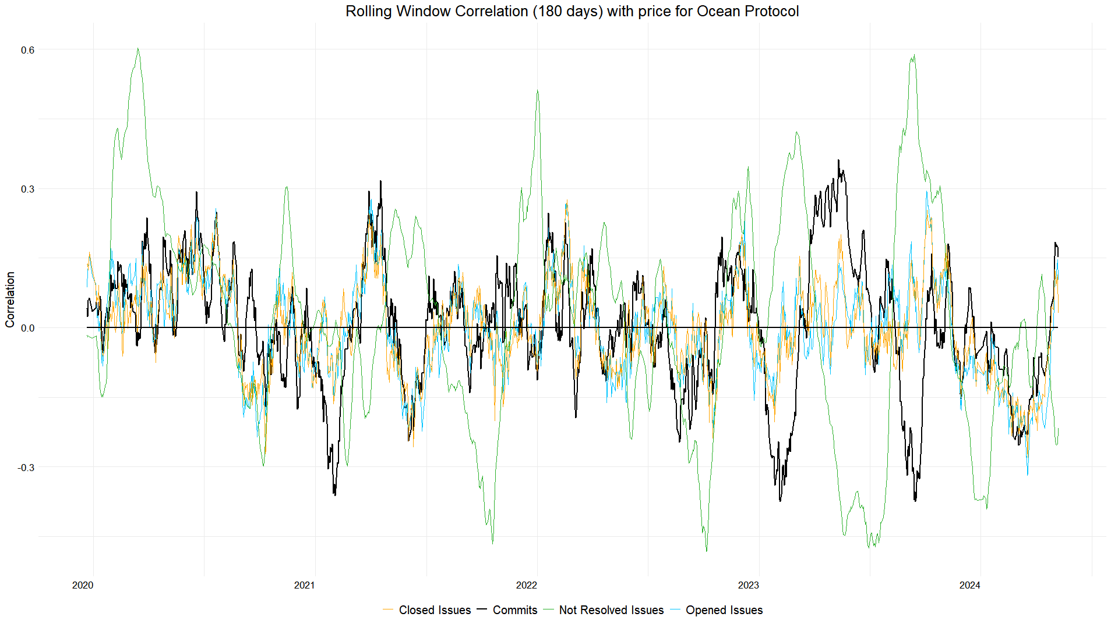

All of the metrics oscillate around zero, rendering them ineffective as indicators.

Orachain

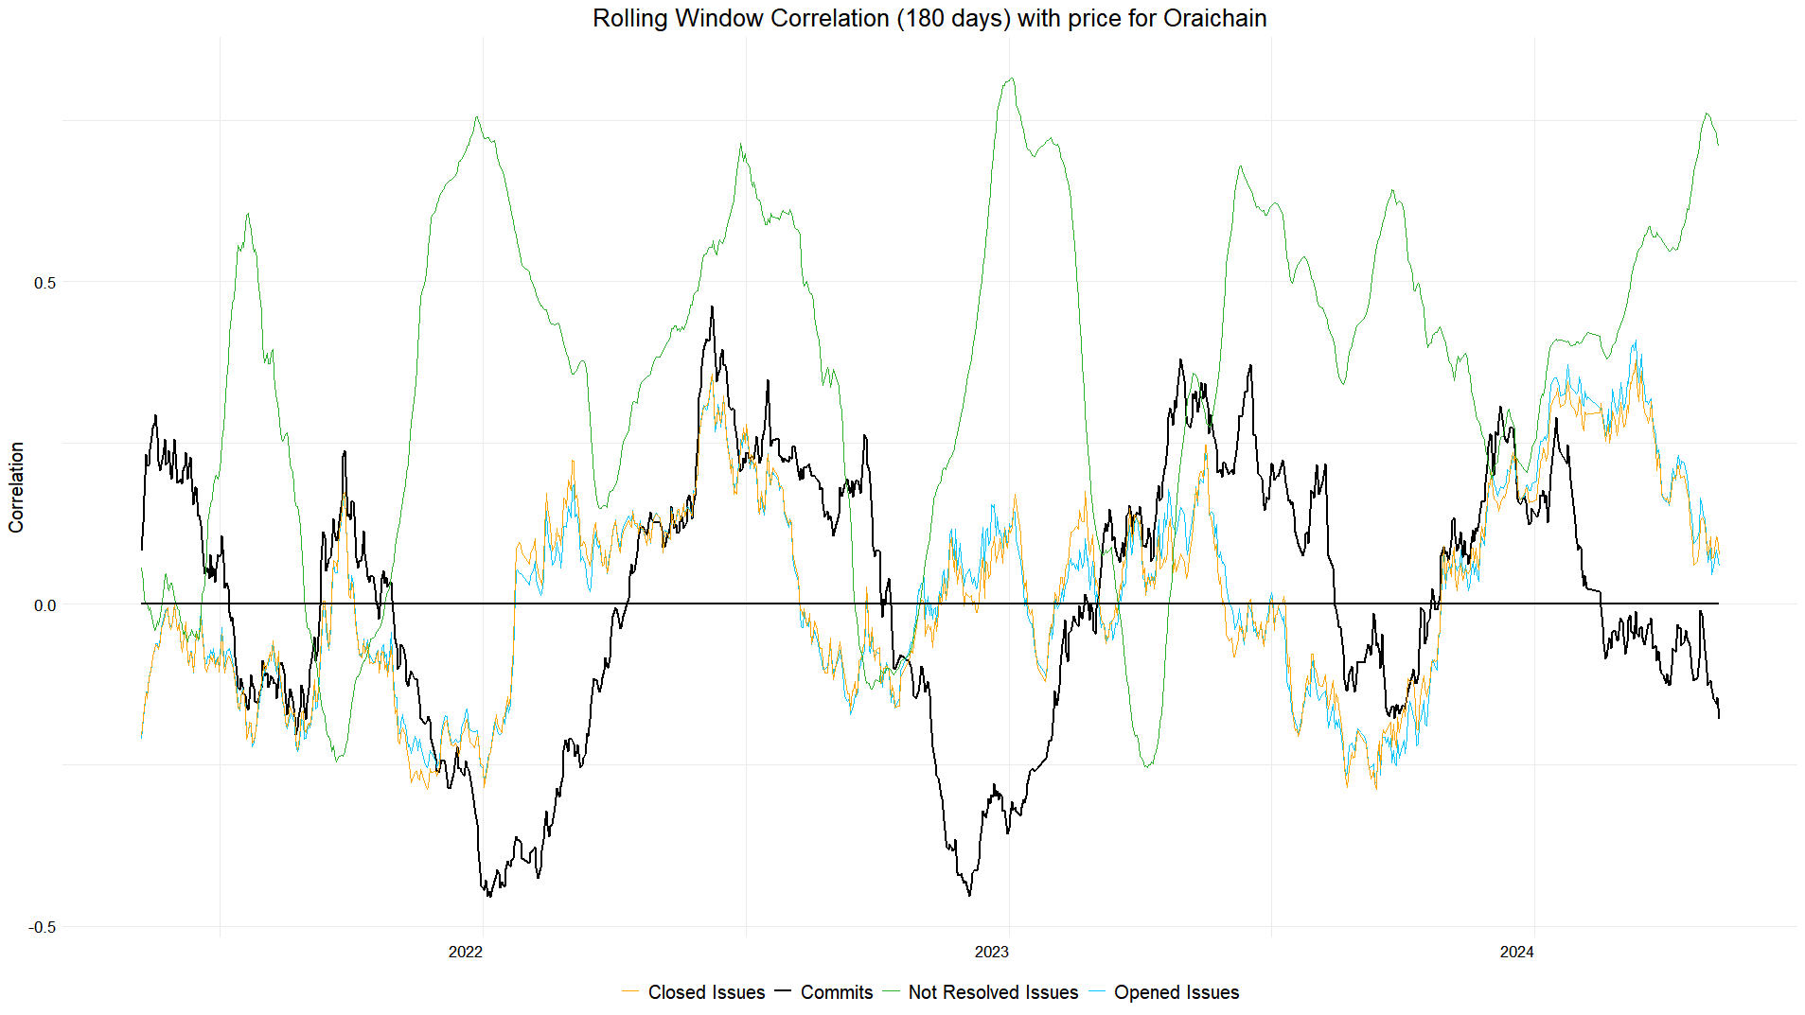

Unresolved issues tend to stay positively correlated, but their correlation fluctuates significantly, making them unstable and not particularly useful as indicators.

SingularityNET

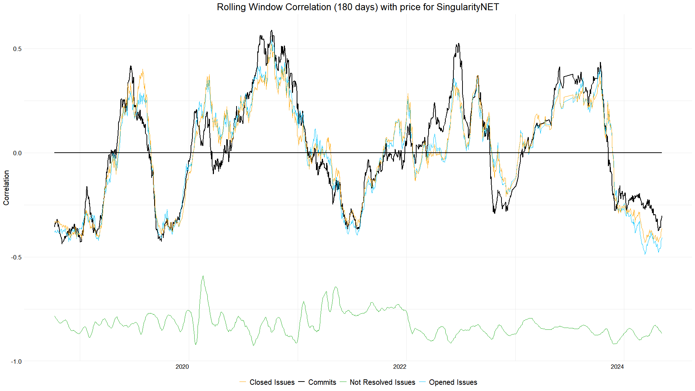

Not resolved issues tend to remain consistently low, which can be used as an indicator for this particular currency.

Correlation time lags

Time lags refer to the delay between a change in one variable (e.g., developer activity) and its potential impact on another variable (e.g., token prices). By examining correlation time lags, I can determine if there is a consistent delay between increased developer activity and token price movements, which could be useful for predicting future price changes.

The metric for rating the activity of projects includes three parameters: the number of commits, issues, and repositories created per month

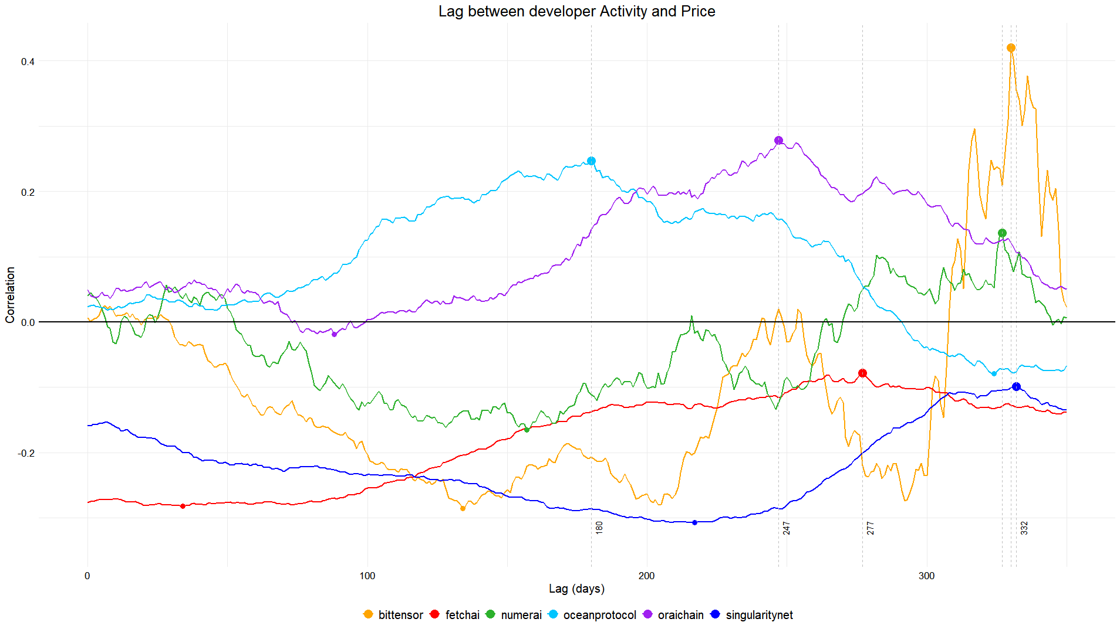

On a 350-day window, there's no consistent time lag in developer activity among all projects. The highest correlation, at 0.42 for BitTensor, is not significant enough and has an enormous time lag of 330 days, making it impractical to use as an indicator.

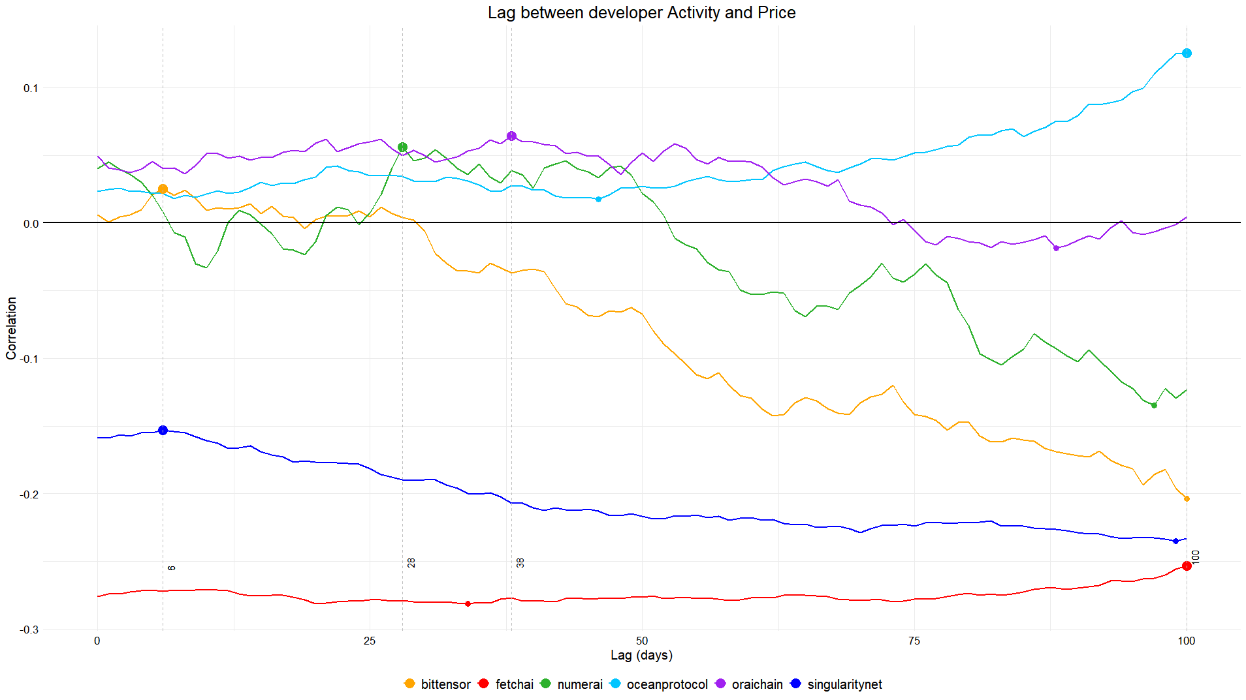

Same correlation metric, but it's limited to 100 days.  
All projects display varying time lags, ranging from as short as 6 days to a maximum of 100 days. This indicates that there is no consistent time lag across all projects, and the correlation increase with the lag is not significant.

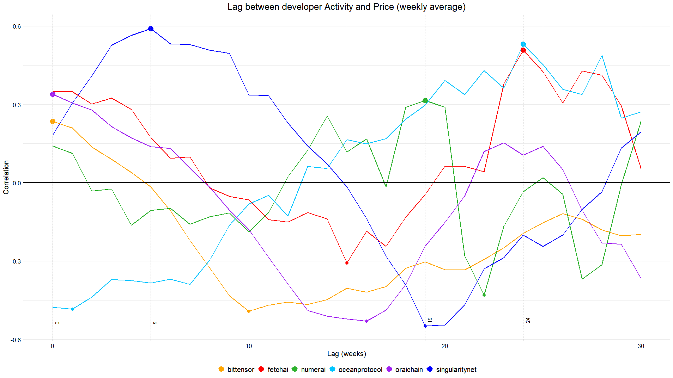

On this correlation graph data is averaged weekly and there’s also no sign of similar lag patterns across all projects, only Ocean Protocol and Fetch.AI are having a peak correlation on 24th week (168 days), which seems like a way to long for a delayed developers activity to take place.

Conclusion

After an in-depth analysis, it has become evident that developer activity alone is not a reliable predictor of cryptocurrency price changes across projects. While an active developer community is undoubtedly crucial for a project's growth and development, the correlation between GitHub activity metrics and token prices varies significantly among the examined projects.

One noteworthy finding was that, in certain instances, an increase in developer activity preceded important project milestones or updates, which could potentially lead to positive token price movements. However, this pattern was not consistent across all projects, and the time lag between the activity spike and any subsequent price impact differed.

A key insight from this analysis is the highly individualized nature of the relationship between GitHub activity and token prices for each project. Some projects exhibited stronger correlations during specific timeframes, while others displayed little to no discernible link between the two factors.

The key takeaway is that there is no universal, consistent correlation between GitHub activity metrics and token prices that applies to all cryptocurrency projects. Each project's dynamics are unique, influenced by various factors such as project roadmaps, partnerships, market sentiment, and broader industry trends.

While developer activity alone may not be a definitive price predictor, monitoring it in conjunction with other data sources, such as social media activity, partnership announcements, and broader market trends, could help identify potential project milestones or updates that could influence token valuations. A more comprehensive analysis incorporating these additional factors might yield more robust insights into the multifaceted drivers of project success and token price movements.

Additional data sources

BitTensor

BitTensor winning Polkadot Auction

<https://x.com/parachains/status/1610429718003867648>

Roadmap Announcement

<https://x.com/opentensor/status/1768734382238363945>

Fetch.AI

$15M investment

<https://fetchai.wordpress.com/wp-content/uploads/2018/06/fetch-ai-raises-15-million3.pdf>

$5M investment

<https://www.coindesk.com/markets/2021/03/10/fetchai-nabs-5m-in-institutional-investment-fireblocks-to-add-support-for-fet-token/>

$40M investment

<https://www.coindesk.com/business/2023/03/29/ai-focused-crypto-protocol-fetchai-raises-40m-to-deploy-decentralized-machine-learning/>

Mainnet Bridge Expansion  
<https://medium.com/fetch-ai/how-to-stake-on-mainnet-2-using-cosmostation-wallet-e7e1a4e0ba23>

Mainnet Launch

<https://medium.com/fetch-ai/pathway-to-mainnet-v2-0-2021-q1-roadmap-23dc932a15ff>

Mainnet Upgrade

[https://x.com/Fetch_ai/status/1410619268845113358](https://twitter.com/Fetch_ai/status/1410619268845113358)

Mainnet Gravity Bridge

<https://medium.com/fetch-ai/how-to-stake-on-mainnet-2-using-cosmostation-wallet-e7e1a4e0ba23>

Mettalex Open Beta

<https://coinmarketcal.com/en/event/mettalex-open-beta-39615>

Mainnet Upgrade

[https://x.com/Fetch_ai/status/1743671107423502767](https://twitter.com/Fetch_ai/status/1743671107423502767)

Mainnet Launch

[https://x.com/Fetch_ai/status/1203989659984027649](https://twitter.com/Fetch_ai/status/1203989659984027649)

Public Testnet

<https://fetch.ai/blog/fetch-ais-2019-technical-roadmap/>

Numer.AI

Erasure launch

<https://www.coindesk.com/markets/2018/10/04/numerai-opens-crypto-powered-stock-betting-market-to-the-public/>

$11M token sale

<https://www.coindesk.com/markets/2019/03/21/numerai-token-sale-raises-11-million-from-vc-firms-paradigm-placeholder/>

$3M token sale

<https://www.coindesk.com/tech/2020/06/03/numerai-raises-3m-in-another-nmr-token-sale-with-union-square-ventures-placeholder/>

Ocean Protocol

V4

<https://blog.oceanprotocol.com/ocean-v4-overview-1ccd4a7ce150>

V3

<https://blog.oceanprotocol.com/ocean-v3-is-now-live-b47c0e73f52a>

V2

<https://medium.com/oceanprotocol/v2-ocean-compute-to-data-release-b856131f1ad8>

OCEAN Collateral on FRIN

<https://fringefinance.medium.com/fringe-to-list-ocean-protocols-ocean-as-a-lending-collateral-asset-on-sept-19th-b9e5f552583c>

Predictoor Mainnet Launch

[https://x.com/oceanprotocol/status/1710273002867216706](https://twitter.com/oceanprotocol/status/1710273002867216706)

Secret Ethereum Bridge

[https://x.com/SecretNetwork/status/1334565374239649797](https://twitter.com/SecretNetwork/status/1334565374239649797)

Binance Listing

[https://x.com/binance/status/1295224149019734017](https://twitter.com/binance/status/1295224149019734017)

Ocean & Optimism

[https://x.com/oceanprotocol/status/1734166141973524642](https://twitter.com/oceanprotocol/status/1734166141973524642)

Orachain

OWallet introduction

<https://blog.orai.io/introducing-owallet-a-major-step-towards-the-completion-of-oraichains-ecosystem-f50a3f82c732>

Mainnet 2.0 Launch

[https://x.com/oraichain/status/1494699339461332992](https://twitter.com/oraichain/status/1494699339461332992)

Network Update

[https://x.com/oraichain/status/1763513427010740416](https://twitter.com/oraichain/status/1763513427010740416)

Oraichain Dev Studio

<https://medium.com/oraichain/oraichain-q1-recap-and-q2-strategic-overview-aa116a398470>

Block.AI Beta Test

[https://x.com/oraichain/status/1626184246128955396](https://twitter.com/oraichain/status/1626184246128955396)

Mainnet Launch

[https://x.com/oraichain/status/1352671181921464320](https://twitter.com/oraichain/status/1352671181921464320)

SingularityNET

$25M investment

<https://www.coindesk.com/business/2022/05/19/singularitynet-singularitydao-receive-25m-to-accelerate-ai-backed-defi/>

Cisco collaboration

<https://www.coindesk.com/markets/2019/09/23/cisco-singularitynet-to-decentralize-artificial-intelligence-via-blockchain/>

Hard Fork to AGIX

<https://blog.singularitynet.io/singularitynet-phase-ii-launch-sequence-activated-agi-token-to-be-hard-forked-to-10ede4b6c89>

Token Staking Documentation

<https://blog.singularitynet.io/singularitynet-releases-updated-roadmap-for-h1-2020-c55c8590f46c>

Beta Version

<https://public.singularitynet.io/whitepaper.pdf>

Full Beta Release

[https://x.com/singularity_net/status/1081596951370567680?s=19](https://twitter.com/singularity_net/status/1081596951370567680?s=19)