Analyzing sushi prices in Warsaw

**TL;DR**I analyzed sushi prices from **121 unique** restaurants on Bolt Food and discovered that the target restaurant had prices for sushi rolls that were **10% lower** than the average prices across all restaurants. This insight allowed the restaurant to increase its prices and resulted in an **8%** **increase** in profits the following month.

**Task:**

Compare prices of the target restaurant to prices across the market.

**Steps to achieve it:**

1. Collect prices from site (https://food.bolt.eu/pl-PL/307-warsaw?tag=6-🍣-sushi)
   1. Write a python code using requests library
   2. Store data in CSV format
2. Clean the data
   1. Open in Excel
   2. Remove duplicates
   3. Filter it to exclude any unwanted data like sushi sets
3. Analyze the data
   1. Use word search to separate it in categories
   2. Find average price for categories
   3. Build graphs representing the data
   4. Write a report

**Results**

In the table below you find average prices for different types of dishes  
(green – cheapest, red – most expensive)

|  |  |  |  |  |  |  |  |  |  |  |
| --- | --- | --- | --- | --- | --- | --- | --- | --- | --- | --- |
|  | No type | Łosoś | Tuńczyk | Węgorz | Krewetka | Awokado | Ogórek | Surimi | Wege | Unagi |
| Sashimi | 63,25 | 46,51 | 51,32 | 36,25 | 32,62 | - | - | - | - | 32,60 |
| Nigiri | 22,80 | 21,43 | 23,76 | 26,13 | 22,44 | 14,70 | 11,00 | 18,50 | 12,40 | 27,10 |
| Hosomaki | 19,11 | 23,03 | 23,89 | 28,11 | 23,80 | 17,85 | 17,59 | 18,08 | 18,23 | 25,00 |
| Philadelphia | 38,53 | 39,04 | 39,82 | 57,86 | 39,33 | 57,67 | 33,00 | - | 26,50 | 43,00 |
| California | 40,30 | 41,98 | 43,15 | 52,48 | 42,26 | 38,05 | 37,50 | 30,03 | 31,32 | 38,14 |
| Futomaki | 35,16 | 38,64 | 41,06 | 40,16 | 38,59 | 32,65 | 33,25 | 28,62 | 29,74 | 34,00 |

No type – specific column, showing that in the name of the dish ingredients weren’t specified or they do not belong to any group mentioned above (ex. Futomaki Kalmar, California Gold)

In the table below number of data points used to calculate average  
(green – more, red – less)

|  |  |  |  |  |  |  |  |  |  |  |
| --- | --- | --- | --- | --- | --- | --- | --- | --- | --- | --- |
|  | No type | Łosoś | Tuńczyk | Węgorz | Krewetka | Awokado | Ogórek | Surimi | Wege | Unagi |
| Sashimi | 148 | 42 | 25 | 4 | 13 | - | - | - | - | 3 |
| Nigiri | 319 | 129 | 95 | 61 | 65 | 38 | 1 | 2 | 5 | 19 |
| Hosomaki | 341 | 120 | 65 | 36 | 58 | 52 | 49 | 26 | 13 | 3 |
| Philadelphia | 92 | 36 | 11 | 7 | 9 | 3 | 3 | - | 4 | 5 |
| California | 423 | 167 | 82 | 34 | 84 | 17 | 4 | 22 | 46 | 7 |
| Futomaki | 324 | 223 | 135 | 38 | 102 | 4 | 12 | 27 | 69 | 9 |

Prices in the target restaurant

|  |  |  |  |  |  |  |  |  |  |
| --- | --- | --- | --- | --- | --- | --- | --- | --- | --- |
|  | Łosoś | Tuńczyk | Węgorz | Krewetka | Awokado | Ogórek | Surimi | Wege | Unagi |
| Sashimi | 17 | 19 | 22 | 16 | - | - | - | - | - |
| Nigiri | 19 | 20 | 25 | 19 | 16 | - | - | - | - |
| Hosomaki | 19 | 20 | - | - | 17 | 13 | - | - | - |
| Philadelphia | 35 | 38 | 40 | 36 | - | - | - | - | - |
| California | 35 | 38 | 40 | 34 | - | - | - | 27 | - |
| Futomaki | 34 | 35 | 38 | 30 | - | - | 27 | 27 | 37 |

Price difference between target restaurant and average  
(green – highest, red – lowest)

|  |  |  |  |  |  |  |  |  |  |
| --- | --- | --- | --- | --- | --- | --- | --- | --- | --- |
|  | Łosoś | Tuńczyk | Węgorz | Krewetka | Awokado | Ogórek | Surimi | Wege | Unagi |
| Sashimi | 63% | 63% | 39% | 51% | - | - | - | - | - |
| Nigiri | 11% | 16% | 4% | 15% | -9% | - | - | - | - |
| Hosomaki | 17% | 16% | - | - | 5% | 26% | - | - | - |
| Philadelphia | 10% | 5% | 31% | 8% | - | - | - | - | - |
| California | 17% | 12% | 24% | 20% | - | - | - | 14% | - |
| Futomaki | 12% | 15% | 5% | 22% | - | - | 6% | 9% | -9% |

Price distribution

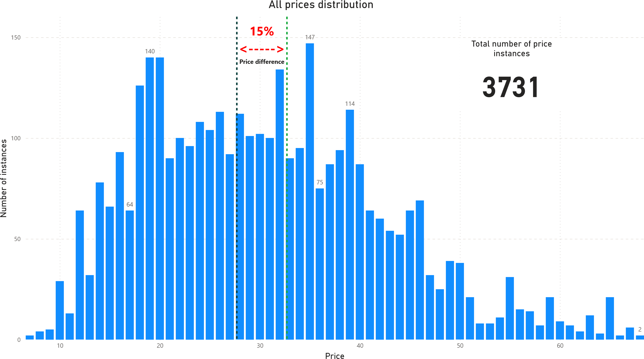

Green dashed line – Average price for the market  
Dark blue dashed line – Average price for the target restaurant

The graph above shows how much price instances there are in the price range. The most common ranges are 18-20 PLN and 34-35 PLN. The first range mostly consists of nigiri and hosomaki.

 Nigiri

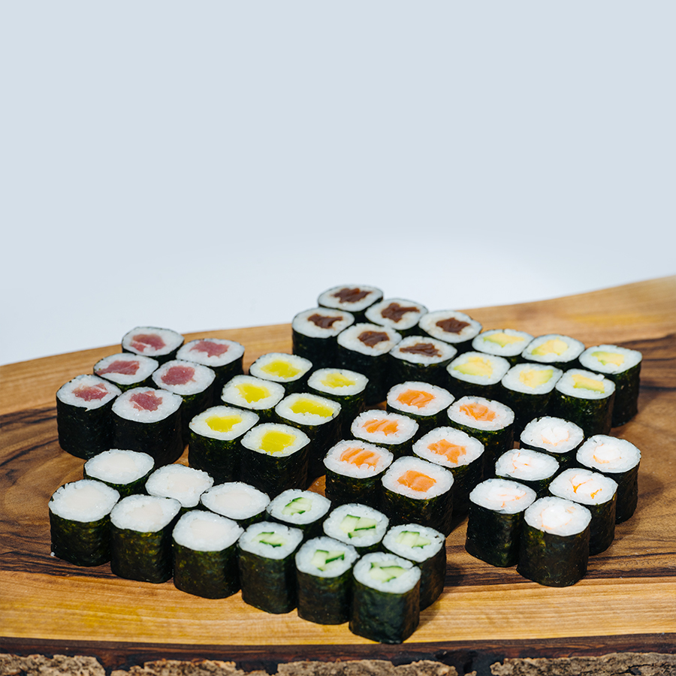Hosomaki

They are the cheapest because they require the least amount of products to make.

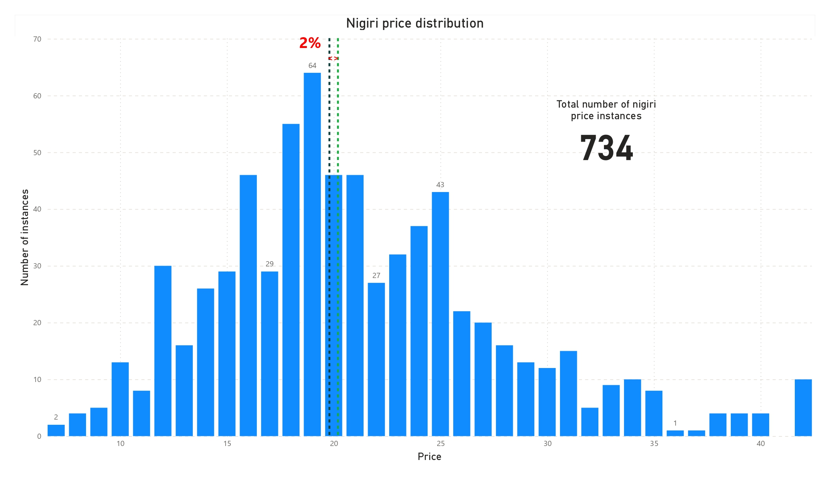

There is no need for changing nigiri prices because price difference is only 2%.

Prices for hosomaki could be raised up to 10-20%.

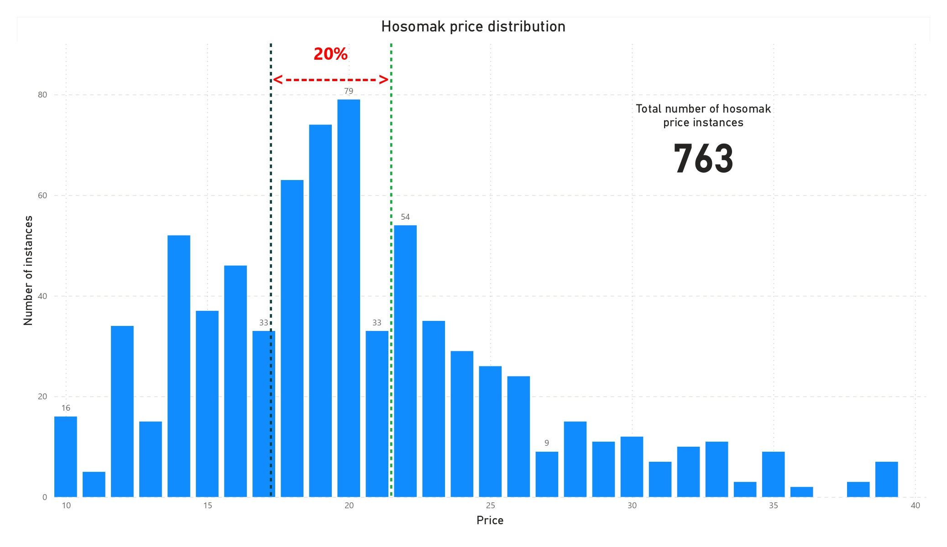

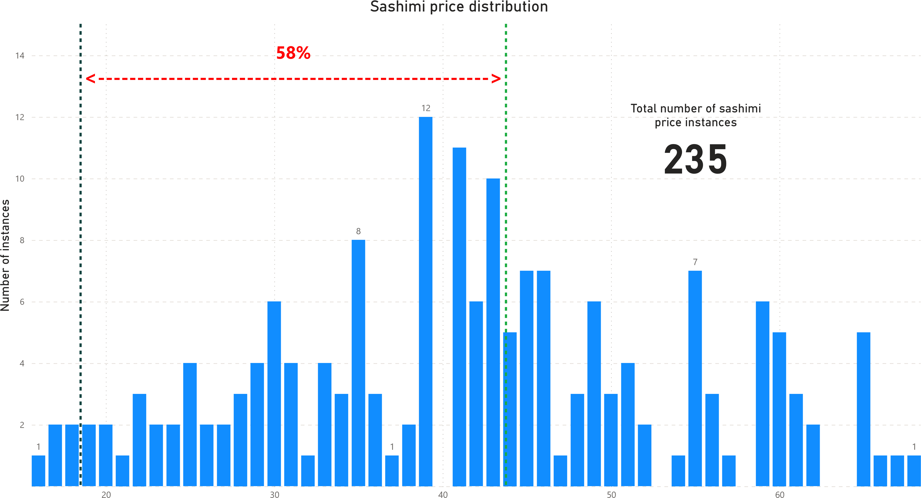

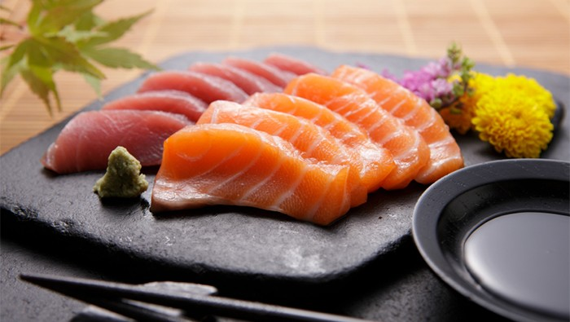 Sashimi

Sashimi is consisting of thinly sliced fresh raw fish or meat so the size of the portions could vary, which explains such unequal distribution and huge price difference. **I suggest adding more size options for the clients.**

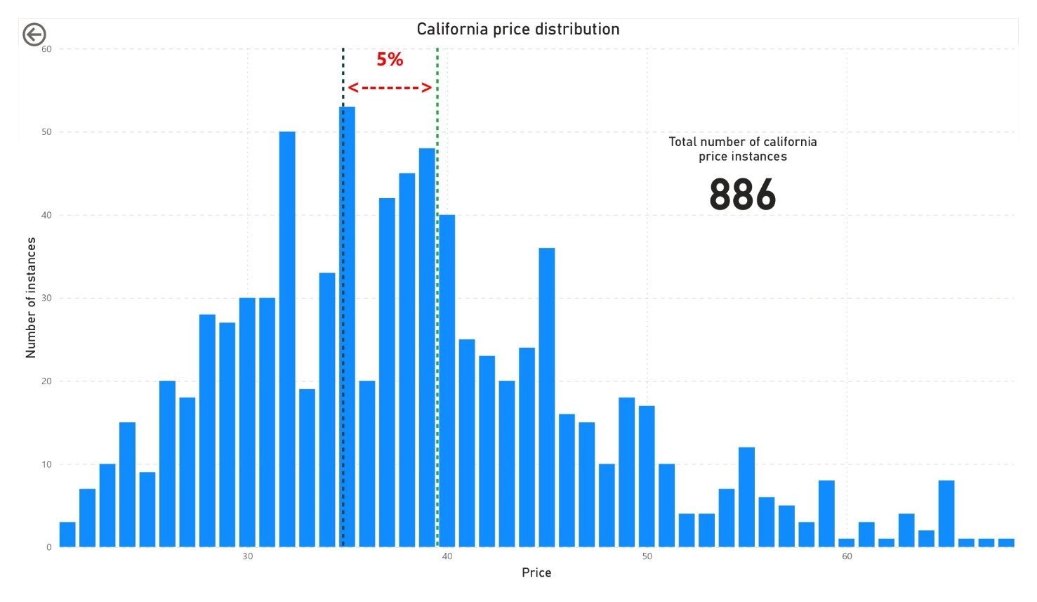

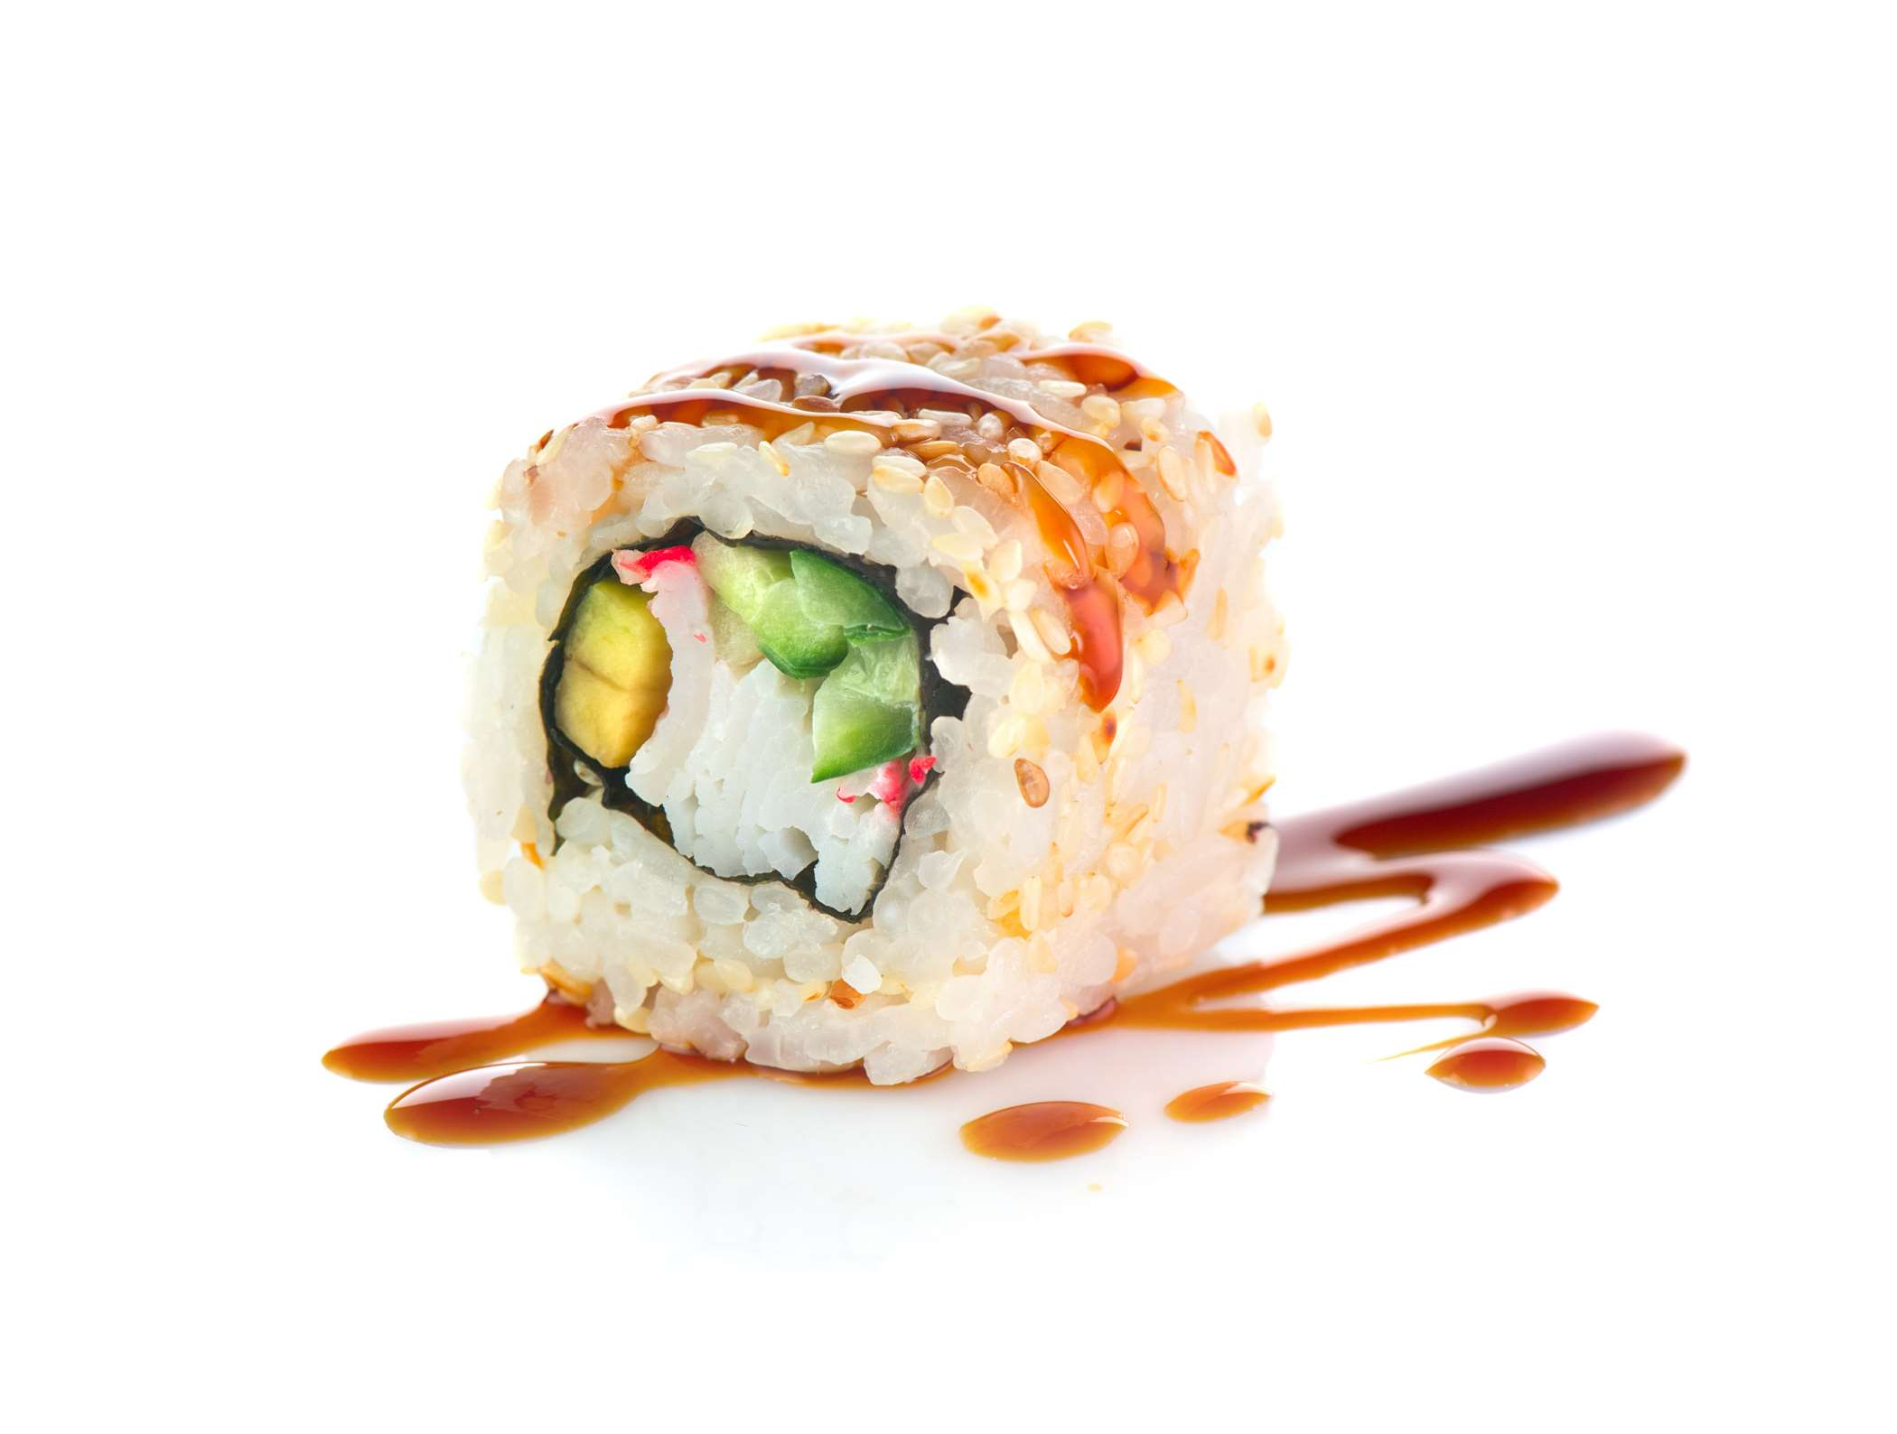

California

Considering that the target restaurant's average price for a California roll is 34.8 PLN, **I would recommend maintaining the current price point.** This is because 34-35 PLN is the most commonly accepted price range for California rolls, and raising prices may negatively impact sales.

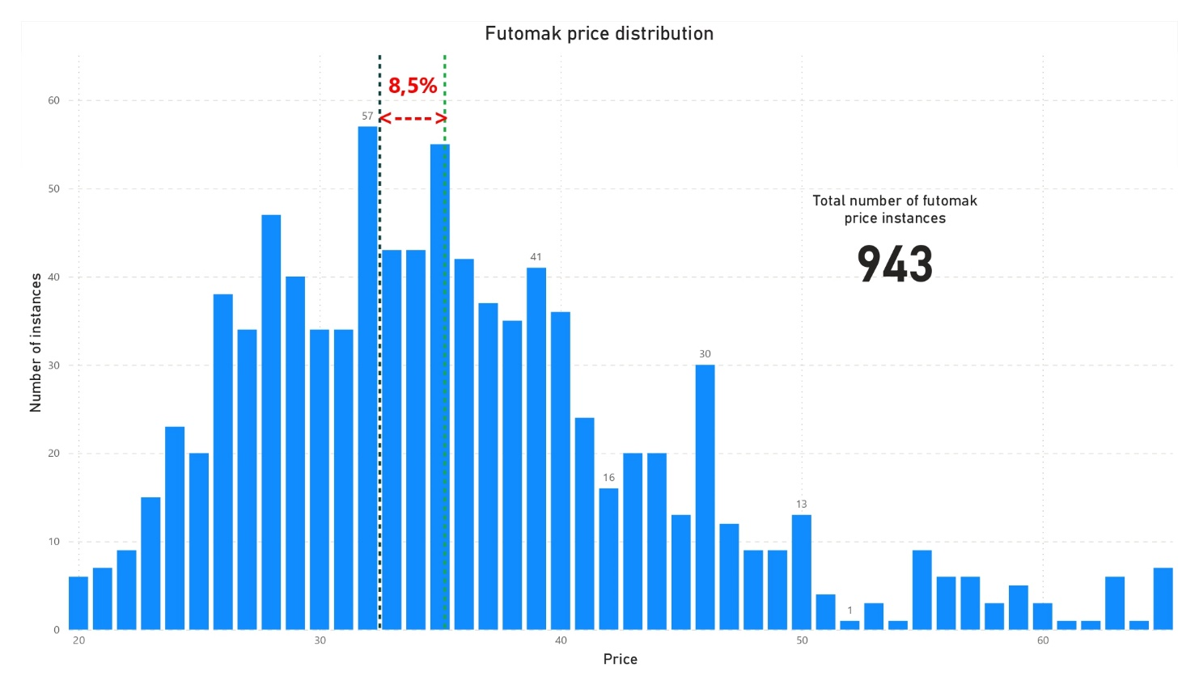

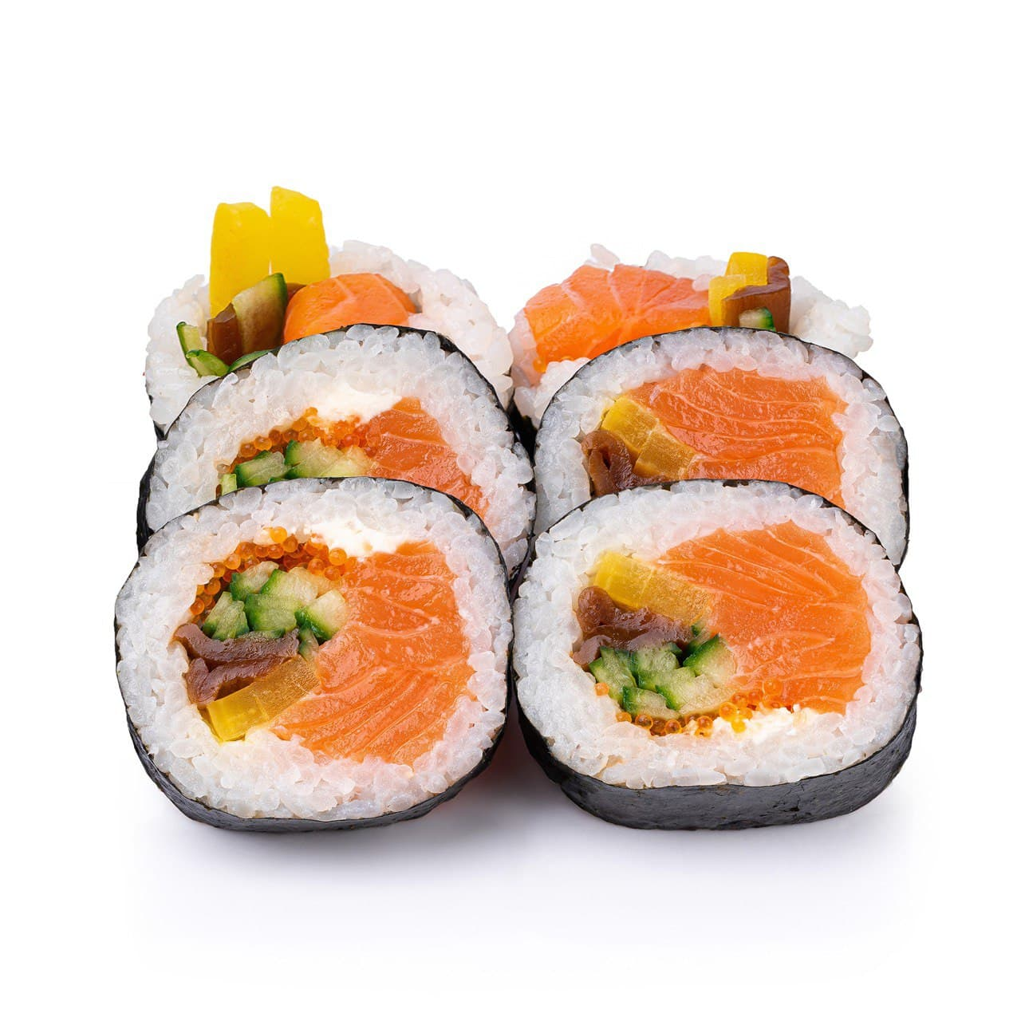

Futomaki

Prices for futomaki could be raised up to 8,5%.

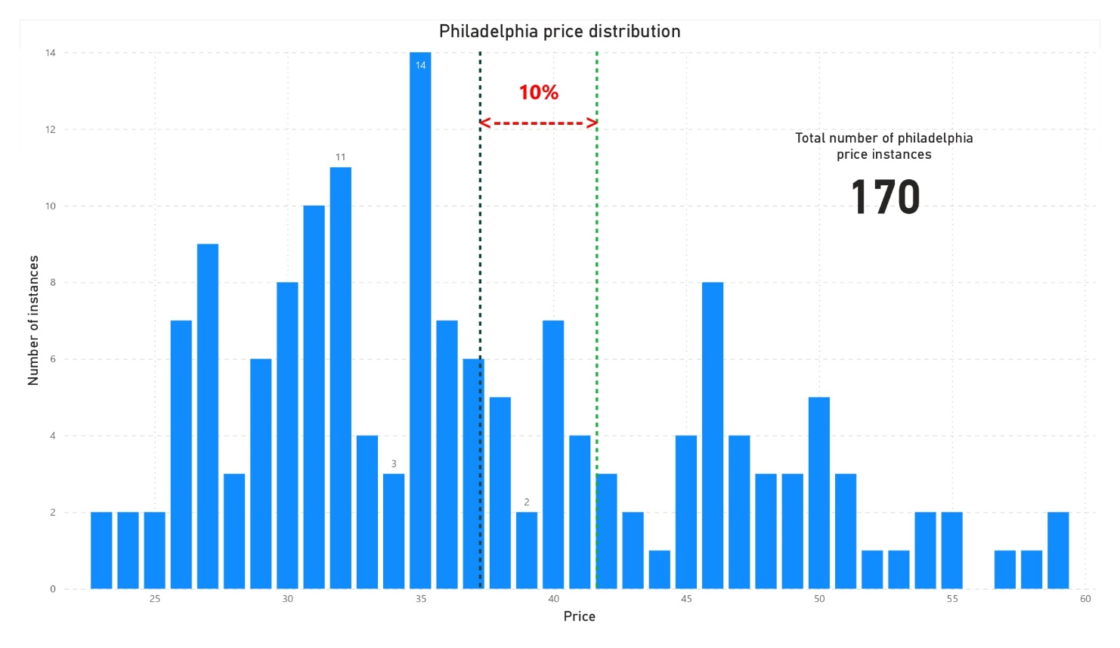

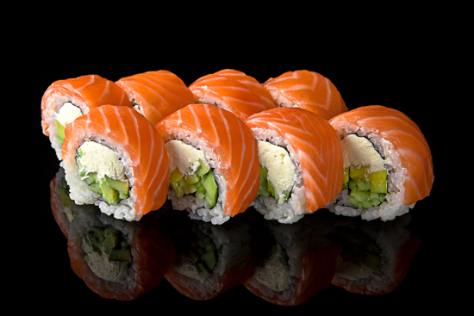

Philadelphia

Due to the limited sample size of only 170 data points for Philadelphia rolls, it is important to approach any potential price changes for this type of roll with caution.