📈 PyStart  LEARN  Practice  Visualize  Understand | Matplotlib for Beginners  10 Real-Life Practice Tasks  Task, Solution & Step-by-Step Explanation

How to Use This Practice Set
Each task below starts from a small real-life situation you already understand — weekly temperature, a monthly budget, a stock price — and shows how matplotlib turns it into a chart in just a few lines. For every task you get: the Task Brief (the everyday scenario), the full Code with its Expected Chart, and a Step-by-Step Explanation that walks through exactly what each line does and why.
Suggested approach: read the Task Brief and try to guess what chart type would fit before checking the Solution. Then read the code slowly, line by line, and only after that compare your understanding against the Step-by-Step Explanation box. Typing the code out yourself and running it will teach you far more than just reading it.

Task Index
# | Task | Real-Life Scenario | Level
1 | Basic Line Plot | Tracking weekly temperature | Beginner
2 | Bar Chart | Comparing product sales | Beginner
3 | Scatter Plot | Height vs weight relationship | Beginner
4 | Pie Chart | Monthly budget allocation | Beginner
5 | Multiple Lines on One Chart | Comparing two students' scores | Beginner
6 | Histogram | Distribution of exam scores | Beginner
7 | Styling a Chart | A polished monthly expense report | Beginner
8 | Subplots (Side-by-Side Charts) | Sales and profit in one figure | Beginner+
9 | Saving a Chart to a File | Exporting a website-visitors report | Beginner
10 | Custom Colors & Markers | Visualizing a stock price trend | Beginner

Task 1. Basic Line Plot
Line Plot • Difficulty: Beginner
📌 Task Brief (Real-Life Scenario)
A weather app logged your city's temperature for each day of the week. You want a simple visual so you can see the trend at a glance, instead of just staring at a list of numbers.

⌨ Code | 📈 Expected Chart
import matplotlib.pyplot as plt  days = ['Mon','Tue','Wed','Thu','Fri','Sat','Sun']  temp = [30, 32, 29, 31, 33, 28, 27]  plt.plot(days, temp)  plt.title('Weekly Temperature')  plt.xlabel('Day')  plt.ylabel('Temperature (C)')  plt.show() | 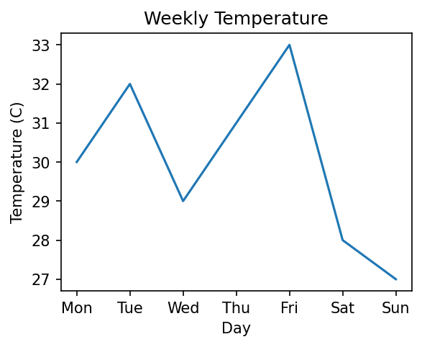

🔍 Step-by-Step Explanation
Step 1: plt.plot(days, temp) draws a line connecting each day (x-axis) to its temperature (y-axis), in the exact order the lists were given.
Step 2: plt.title(), plt.xlabel(), and plt.ylabel() add readable labels around the chart — without these, a viewer wouldn't know what the numbers mean.
Step 3: plt.show() opens a window (or renders inline in a notebook) displaying the finished chart.
Step 4: Because the days list came first and temp second, matplotlib automatically matches them position-by-position: Mon->30, Tue->32, and so on.

💡 Beginner Tip
plt.plot() is matplotlib's default chart type and is best for showing a trend over an ordered sequence (like days, months, or time) — if your x-axis isn't naturally ordered, a bar chart usually communicates better.

Task 2. Bar Chart
Bar Chart • Difficulty: Beginner
📌 Task Brief (Real-Life Scenario)
A small business sold four products this month and wants to instantly compare which product sold the most — bar charts are the standard way to compare separate categories.

⌨ Code | 📈 Expected Chart
import matplotlib.pyplot as plt  products = ['A', 'B', 'C', 'D']  sales = [250, 400, 300, 150]  plt.bar(products, sales, color='steelblue')  plt.title('Product Sales')  plt.xlabel('Product')  plt.ylabel('Units Sold')  plt.show() | 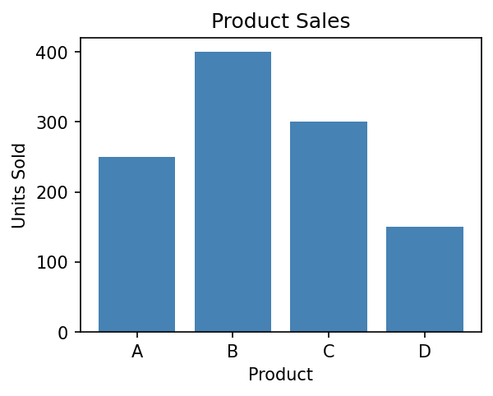

🔍 Step-by-Step Explanation
Step 1: plt.bar(products, sales, color='steelblue') draws one vertical bar per product, with the bar's height equal to its sales figure, all colored steel-blue.
Step 2: Because products are category names (not numbers), matplotlib automatically spaces them evenly along the x-axis.
Step 3: Product B's bar is visibly the tallest, instantly showing it's the best seller (400 units) without reading a single number.
Step 4: The title and axis labels make the chart understandable on its own, even if someone sees it without the code.

💡 Beginner Tip
Use a bar chart (not a line chart) whenever your x-axis is a set of separate categories (products, cities, names) rather than something continuous like time — connecting unrelated categories with a line would be misleading.

Task 3. Scatter Plot
Scatter Plot • Difficulty: Beginner
📌 Task Brief (Real-Life Scenario)
A gym trainer recorded the height and weight of 8 clients and wants to see if there's a visible relationship between the two — scatter plots are the go-to chart for spotting relationships between two numeric variables.

⌨ Code | 📈 Expected Chart
import matplotlib.pyplot as plt  heights = [150, 160, 165, 170, 175, 180, 185, 190]  weights = [50, 55, 60, 65, 70, 75, 80, 85]  plt.scatter(heights, weights, color='crimson')  plt.title('Height vs Weight')  plt.xlabel('Height (cm)')  plt.ylabel('Weight (kg)')  plt.show() | 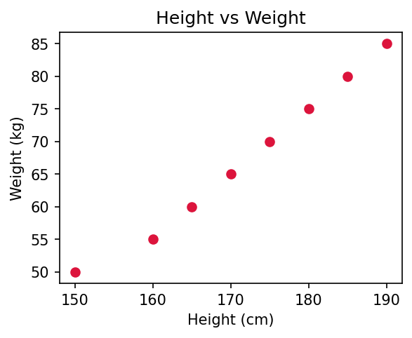

🔍 Step-by-Step Explanation
Step 1: plt.scatter(heights, weights, ...) plots one dot per person: the dot's x-position comes from their height, and its y-position from their weight.
Step 2: Unlike plt.plot(), scatter does NOT connect the dots with a line — each point stays independent, which is exactly right when you're checking for a pattern, not a sequence over time.
Step 3: Looking at the dots, they rise together in a fairly straight diagonal pattern, suggesting taller clients in this small sample tend to weigh more.
Step 4: Because heights[0] pairs with weights[0], heights[1] with weights[1], and so on, the two lists must always be the same length and in matching order.

💡 Beginner Tip
Reach for a scatter plot whenever you're asking 'does X relate to Y?' — it's one of the fastest ways to visually spot a correlation before running any formal statistics.

Task 4. Pie Chart
Pie Chart • Difficulty: Beginner
📌 Task Brief (Real-Life Scenario)
You want to see how your monthly salary is split across categories like rent, food, and savings — as percentages of the whole, which is exactly what a pie chart is designed to show.

⌨ Code | 📈 Expected Chart
import matplotlib.pyplot as plt  categories = ['Rent','Food','Transport','Savings','Other']  amounts = [12000, 6000, 3000, 5000, 2000]  plt.pie(amounts, labels=categories, autopct='%1.1f%%')  plt.title('Monthly Budget Allocation')  plt.show() | 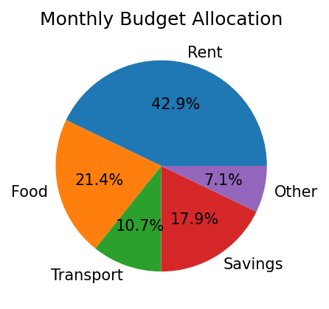

🔍 Step-by-Step Explanation
Step 1: plt.pie(amounts, labels=categories, ...) automatically adds up all 5 amounts (28,000 total) and slices the circle so each category's slice is proportional to its share of that total.
Step 2: labels=categories attaches the category name directly next to each slice.
Step 3: autopct='%1.1f%%' tells matplotlib to also print each slice's percentage of the whole, rounded to 1 decimal place, right on the chart.
Step 4: Rent (12,000 out of 28,000) becomes the largest slice at roughly 42.9%, immediately visible as the biggest piece of the pie.

💡 Beginner Tip
Pie charts work best with a small number of categories (roughly 2-6) that add up to a meaningful 'whole', like a budget or a vote count. For comparing many categories or exact values, a bar chart is usually easier to read accurately.

Task 5. Multiple Lines on One Chart
Line Plot • Difficulty: Beginner
📌 Task Brief (Real-Life Scenario)
A teacher wants to compare two students' scores across 5 tests on a single chart, so parents can immediately see who is improving faster — without printing two separate charts.

⌨ Code | 📈 Expected Chart
import matplotlib.pyplot as plt  tests = [1, 2, 3, 4, 5]  riya = [65, 70, 75, 80, 85]  kabir = [60, 68, 74, 78, 90]  plt.plot(tests, riya, label='Riya', marker='o')  plt.plot(tests, kabir, label='Kabir', marker='s')  plt.title('Test Score Comparison')  plt.xlabel('Test Number')  plt.ylabel('Score')  plt.legend()  plt.show() | 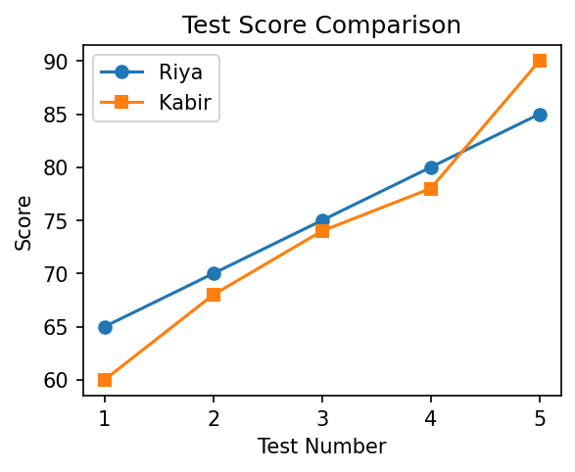

🔍 Step-by-Step Explanation
Step 1: Calling plt.plot() twice, before plt.show(), draws both lines on the same set of axes rather than opening two separate charts.
Step 2: label='Riya' and label='Kabir' tag each line with a name; marker='o' and marker='s' give each line a different point shape (circle vs square) so they're distinguishable even in black and white.
Step 3: plt.legend() reads those label= values and draws a small key on the chart so viewers know which line belongs to which student.
Step 4: Both lines trend upward, but Kabir's line overtakes Riya's by test 5 — a pattern that's obvious visually but would take much longer to notice from two lists of numbers.

💡 Beginner Tip
Always add label= to each plt.plot() call and finish with plt.legend() whenever you're comparing more than one line — without it, a viewer has no way to tell the lines apart.

Task 6. Histogram
Histogram • Difficulty: Beginner
📌 Task Brief (Real-Life Scenario)
A teacher has the exam scores of 30 students and wants to see the overall spread — how many scored low, medium, or high — rather than each individual score. This is exactly what a histogram is for.

⌨ Code | 📈 Expected Chart
import matplotlib.pyplot as plt  scores = [45,55,60,65,70,72,75,78,80,82,85,88,90,  92,95,50,58,62,68,73,77,81,84,87,91,94,  97,49,63,76]  plt.hist(scores, bins=6, color='mediumseagreen',  edgecolor='black')  plt.title('Exam Score Distribution')  plt.xlabel('Score')  plt.ylabel('Number of Students')  plt.show() | 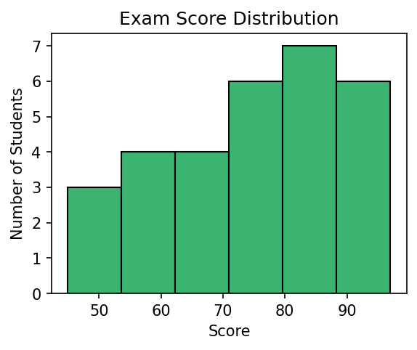

🔍 Step-by-Step Explanation
Step 1: plt.hist() does not plot each of the 30 scores as its own point. Instead, it first divides the full score range into 6 equal-width groups (because bins=6), called 'bins'.
Step 2: It then counts how many students' scores fall into each bin, and draws one bar per bin, with the bar's height equal to that count.
Step 3: edgecolor='black' just outlines each bar so neighbouring bars are visually separated instead of blending together.
Step 4: The result shows the shape of the whole class's performance at a glance — for example, whether most students clustered around the middle or scores were spread evenly.

💡 Beginner Tip
A histogram groups continuous numeric data into ranges (bins) and counts frequency — this is different from a bar chart, which compares separate named categories. If you're plotting a distribution of many raw numbers, you want a histogram.

Task 7. Styling a Chart
Customization • Difficulty: Beginner
📌 Task Brief (Real-Life Scenario)
You made a basic expenses chart earlier, but for a report you want it to look more polished — bold title, gridlines, a labelled legend, and a custom line color — so it reads like something you'd actually share with someone else.

⌨ Code | 📈 Expected Chart
import matplotlib.pyplot as plt  months = ['Jan','Feb','Mar','Apr','May']  expenses = [4500, 3200, 5100, 2900, 6000]  plt.plot(months, expenses, color='darkorange',  marker='o', linewidth=2, label='Expenses')  plt.title('Monthly Expenses', fontsize=14,  fontweight='bold')  plt.xlabel('Month')  plt.ylabel('Amount (Rs)')  plt.grid(True, linestyle='--', alpha=0.6)  plt.legend()  plt.show() | 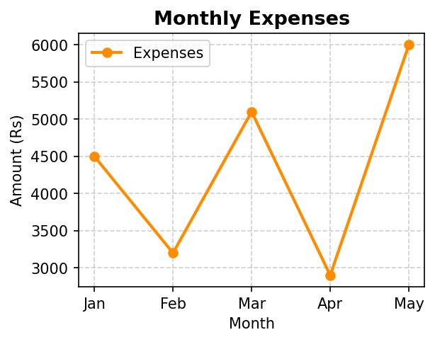

🔍 Step-by-Step Explanation
Step 1: color='darkorange', marker='o', and linewidth=2 together change the line's color, add a round marker at every data point, and make the line thicker and easier to see.
Step 2: fontsize=14, fontweight='bold' on the title make it stand out more than the default plain text title.
Step 3: plt.grid(True, linestyle='--', alpha=0.6) adds light dashed gridlines behind the chart (alpha controls transparency, so 0.6 keeps them subtle rather than distracting).
Step 4: label='Expenses' plus plt.legend() adds a small labelled key, which matters more once a chart has multiple lines but is still good practice even with just one.
Step 5: None of these styling options change the underlying data — they only change how the same numbers are presented.

💡 Beginner Tip
Start every chart with the simplest version (plain plt.plot()) to make sure the data and logic are correct, and only add styling like color, grid, and fontweight afterwards — mixing the two while debugging makes errors harder to spot.

Task 8. Subplots (Side-by-Side Charts)
Subplots • Difficulty: Beginner+
📌 Task Brief (Real-Life Scenario)
A quarterly business report needs to show Sales and Profit as two separate charts placed side by side in one image, so both stories are visible together without scrolling between two files.

⌨ Code | 📈 Expected Chart
import matplotlib.pyplot as plt  quarters = ['Q1','Q2','Q3','Q4']  sales = [200, 250, 300, 280]  profit = [40, 55, 70, 60]  fig, axes = plt.subplots(1, 2, figsize=(8, 4))  axes[0].bar(quarters, sales, color='skyblue')  axes[0].set_title('Sales')  axes[1].bar(quarters, profit, color='salmon')  axes[1].set_title('Profit')  plt.tight_layout()  plt.show() | 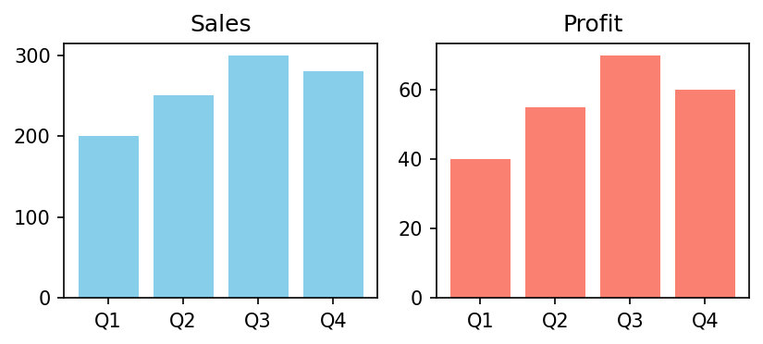

🔍 Step-by-Step Explanation
Step 1: plt.subplots(1, 2, figsize=(8, 4)) creates one figure (the whole image) containing a 1-row-by-2-column grid of separate chart 'axes', and returns them as the list-like object axes.
Step 2: axes[0] refers to the first (left) chart area, and axes[1] refers to the second (right) chart area — each behaves like its own independent mini-chart.
Step 3: axes[0].bar(...) and axes[0].set_title('Sales') build the Sales bar chart specifically on the left axes, without touching the right one at all.
Step 4: axes[1].bar(...) and axes[1].set_title('Profit') do the same for the right side, using the profit data instead.
Step 5: plt.tight_layout() automatically adjusts spacing so the two titles and labels don't overlap or get cut off, and plt.show() displays both charts together as one image.

💡 Beginner Tip
Notice the switch from plt.bar() (used directly in earlier tasks) to axes[0].bar() here — once you're working with subplots, you call chart methods on the specific axes object you want to draw on, not on plt directly.

Task 9. Saving a Chart to a File
Exporting • Difficulty: Beginner
📌 Task Brief (Real-Life Scenario)
You built a chart of this week's website visitors and need to email it to your manager as an image file, rather than just viewing it on your own screen.

⌨ Code | 📈 Expected Chart
import matplotlib.pyplot as plt  days = ['Mon','Tue','Wed','Thu','Fri']  visitors = [120, 150, 170, 130, 200]  plt.plot(days, visitors, marker='o', color='purple')  plt.title('Website Visitors This Week')  plt.xlabel('Day')  plt.ylabel('Visitors')  plt.savefig('visitors_chart.png', dpi=150,  bbox_inches='tight')  plt.show() | 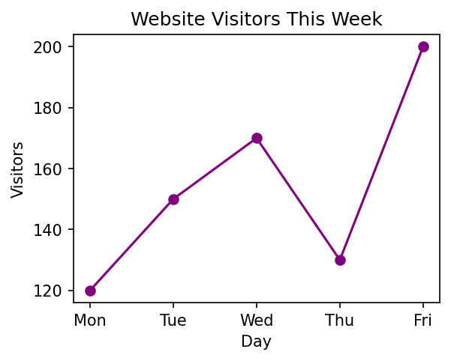

🔍 Step-by-Step Explanation
Step 1: The chart is built exactly as in Task 1 — a line plot connecting each day to its visitor count.
Step 2: plt.savefig('visitors_chart.png', ...) must be called BEFORE plt.show(), because in some environments plt.show() clears the current figure once the window closes — saving first guarantees you don't end up with a blank file.
Step 3: dpi=150 controls the image resolution (dots per inch); a higher number gives a sharper, larger image file, useful for reports or printing.
Step 4: bbox_inches='tight' trims excess white space around the chart so labels and titles aren't cut off at the edges of the saved image.
Step 5: After running this code, a file named visitors_chart.png appears in your working folder, ready to attach to an email or embed in a document.

💡 Beginner Tip
Always call plt.savefig() before plt.show() in a script — this ordering habit prevents the common beginner mistake of ending up with an empty or blank saved image.

Task 10. Custom Colors & Markers
Customization • Difficulty: Beginner
📌 Task Brief (Real-Life Scenario)
You're tracking a stock's closing price over 10 days and want a chart that clearly highlights each day's exact price point, using a distinct color, marker shape, and dashed line style rather than the plain default look.

⌨ Code | 📈 Expected Chart
import matplotlib.pyplot as plt  days = list(range(1, 11))  prices = [102, 105, 101, 108, 110, 107,  112, 115, 113, 118]  plt.plot(days, prices, color='green', marker='D',  linestyle='--', markersize=6)  plt.title('Stock Price Trend (10 Days)')  plt.xlabel('Day')  plt.ylabel('Price (Rs)')  plt.show() | 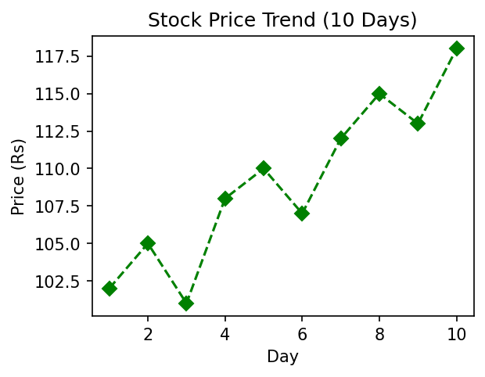

🔍 Step-by-Step Explanation
Step 1: color='green' sets the line's color; marker='D' places a diamond shape at every single data point (other common options include 'o' for circle and 's' for square).
Step 2: linestyle='--' switches the connecting line from solid to dashed, and markersize=6 controls how big each diamond marker appears.
Step 3: list(range(1, 11)) generates the whole-number sequence 1 through 10 for the x-axis, one entry per day, without typing each number by hand.
Step 4: Together, these options make each day's exact price easy to pinpoint on the chart, rather than just seeing a smooth, featureless line.

💡 Beginner Tip
color, marker, linestyle, and markersize are just a few of many optional keyword arguments plt.plot() accepts — you don't need to memorise them all; searching 'matplotlib plot marker styles' when needed is completely normal, even for experienced developers.

📈 PyStart Learn | Matplotlib for Beginners | Practice • Visualize • Understand

