**前言：**

有Ethernet網路應用的產品，建議最好都能掃過window，得到最佳clock delay設定值。

1. **測試方式和硬體環境**

測試會將所有的clock正反向及delay設定值全掃過一輪，且針對每一組設定值會測試10000筆封包，封包會經由RMII介面傳送至PHY，再經由PHY的PCS loopback回來，10000筆封包全正確才算成功。

板端無需接網路線。

1. **Kconfig設定**
2. 進到project\test_mac，根據板子選擇正確的Kconfig，如9856控制板則將Kconfig.phy.ctrlboard.9856 改名為 Kconfig；如果是客戶自己的板子，就需要做一下merge確認Ethernet GPIO是否正確

config GPIO_ETHERNET

default "96, 34, 35, 36, 90, 91, 92, 93, 94, 95"

config GPIO_ETHERNET_LINK

default "97"

1. **測試結果**
2. 以SPI booting的方式執行,點選綠色箭頭run

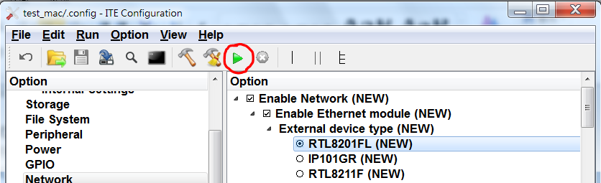

1. 點選黑色Console按鈕叫出檔案總管

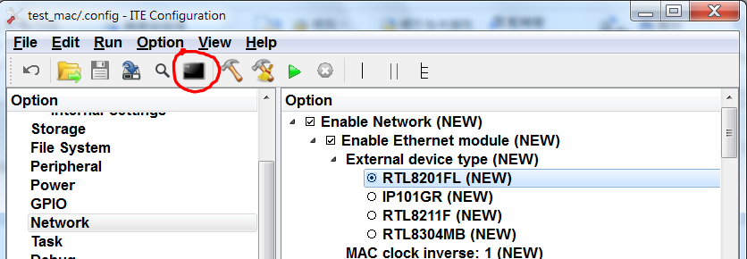

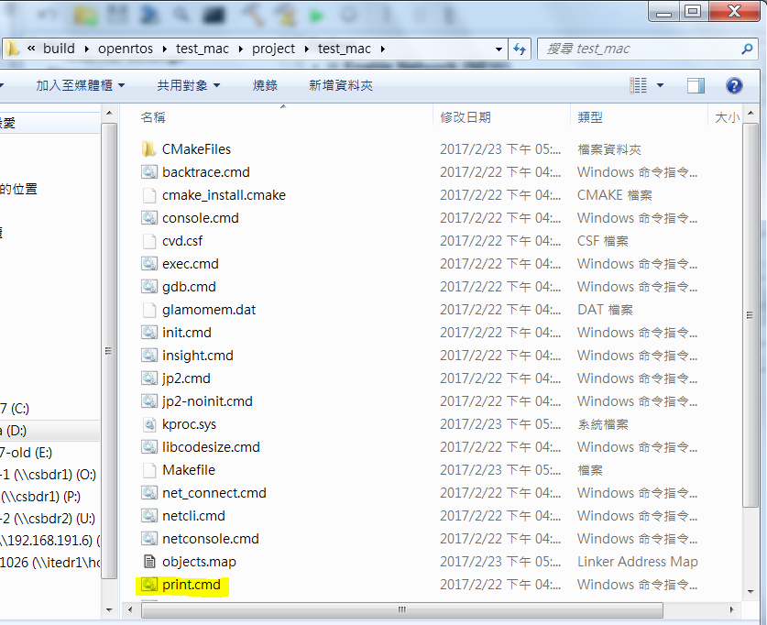

1. 執行print.cmd會看到如下訊息

GLAMO memory reader/writer V2.0.1 (C) 2011 ITE Tech. Inc.

target info <test_mac>

target mcu <castor3> family <9070>

GLAMO device id <0x9070> revision id <0x0001>

=============== start of print message ===============

ITE Castor3/test_mac ver 1.2.1.0.

0xD090002C: 00000000 00000000 00000000 00000000

0xD090003C: 00000000 00000000 00000000

booting time: 0ms

PHY PCS 100 loopback!

eth mode: 4

Link On 100Mbps full

link gpio 44

phy: link change!

Link On 100Mbps full

wait link up......

link up!

Try clock...

clock: Normal, delay: 0x00 => Fail! (42/10000 pass)

clock: Inverse, delay: 0x00 => Success!

Start Scan......

clock: Normal, delay: 0x00 => Fail! (26/10000 pass)

clock: Normal, delay: 0x01 => Fail! (0/10000 pass)

clock: Normal, delay: 0x02 => Fail! (0/10000 pass)

clock: Normal, delay: 0x03 => Fail! (0/10000 pass)

clock: Normal, delay: 0x04 => Fail! (0/10000 pass)

clock: Normal, delay: 0x05 => Fail! (0/10000 pass)

clock: Normal, delay: 0x06 => Fail! (0/10000 pass)

clock: Normal, delay: 0x07 => Fail! (0/10000 pass)

clock: Normal, delay: 0x08 => Fail! (0/10000 pass)

clock: Normal, delay: 0x09 => Fail! (0/10000 pass)

clock: Normal, delay: 0x0A => Fail! (0/10000 pass)

clock: Normal, delay: 0x0B => Fail! (0/10000 pass)

clock: Normal, delay: 0x0C => Fail! (0/10000 pass)

clock: Normal, delay: 0x0D => Fail! (0/10000 pass)

clock: Normal, delay: 0x0E => Fail! (2/10000 pass)

clock: Normal, delay: 0x0F => Fail! (9526/10000 pass)

clock: Normal, delay: 0x1F => Success!

clock: Normal, delay: 0x2F => Success!

clock: Normal, delay: 0x3F => Success!

clock: Normal, delay: 0x4F => Success!

clock: Normal, delay: 0x5F => Success!

clock: Normal, delay: 0x6F => Success!

clock: Normal, delay: 0x7F => Success!

clock: Normal, delay: 0x8F => Success!

clock: Normal, delay: 0x9F => Success!

clock: Normal, delay: 0xAF => Success!

clock: Normal, delay: 0xBF => Success!

clock: Inverse, delay: 0x00 => Success!

clock: Inverse, delay: 0x01 => Success!

clock: Inverse, delay: 0x02 => Success!

clock: Inverse, delay: 0x03 => Success!

clock: Inverse, delay: 0x04 => Success!

clock: Inverse, delay: 0x05 => Success!

clock: Inverse, delay: 0x06 => Success!

clock: Inverse, delay: 0x07 => Success!

clock: Inverse, delay: 0x08 => Success!

clock: Inverse, delay: 0x09 => Success!

clock: Inverse, delay: 0x0A => Success!

clock: Inverse, delay: 0x0B => Success!

clock: Inverse, delay: 0x0C => Success!

clock: Inverse, delay: 0x0D => Success!

clock: Inverse, delay: 0x0E => Success!

clock: Inverse, delay: 0x0F => Success!

clock: Inverse, delay: 0x1F => Success!

clock: Inverse, delay: 0x2F => Success!

clock: Inverse, delay: 0x3F => Success!

clock: Inverse, delay: 0x4F => Success!

clock: Inverse, delay: 0x5F => Success!

clock: Inverse, delay: 0x6F => Success!

clock: Inverse, delay: 0x7F => Success!

clock: Inverse, delay: 0x8F => Success!

clock: Inverse, delay: 0x9F => Success!

clock: Inverse, delay: 0xAF => Success!

clock: Inverse, delay: 0xBF => Success!

Scan DONE!

Safe setting => clock:1, delay:0x08

1. 將訊息最後一行的建議值回填至所需project的Kconfig 欄位

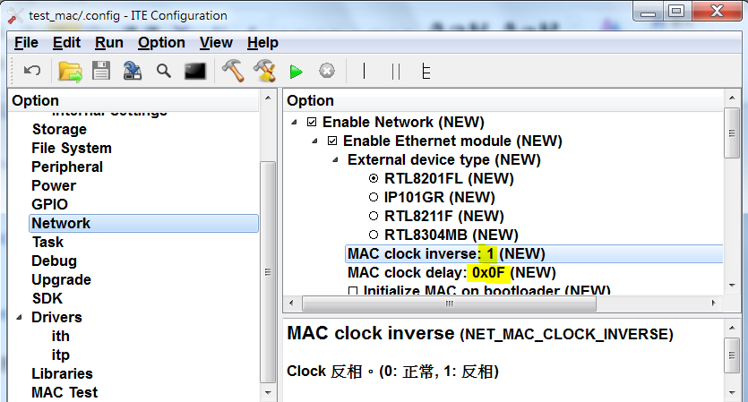

1. **注意事項**

只支援10/100Mbps的PHY，不支援RTL8304MB交換器。

理論上訊息會看到連續的Success和連續的Fail，若看到連續的Success中間穿插了Fail則表示有異常，需進一步做板端線路確認。