1. Download Anaconda from Software Catalog on CORP machine

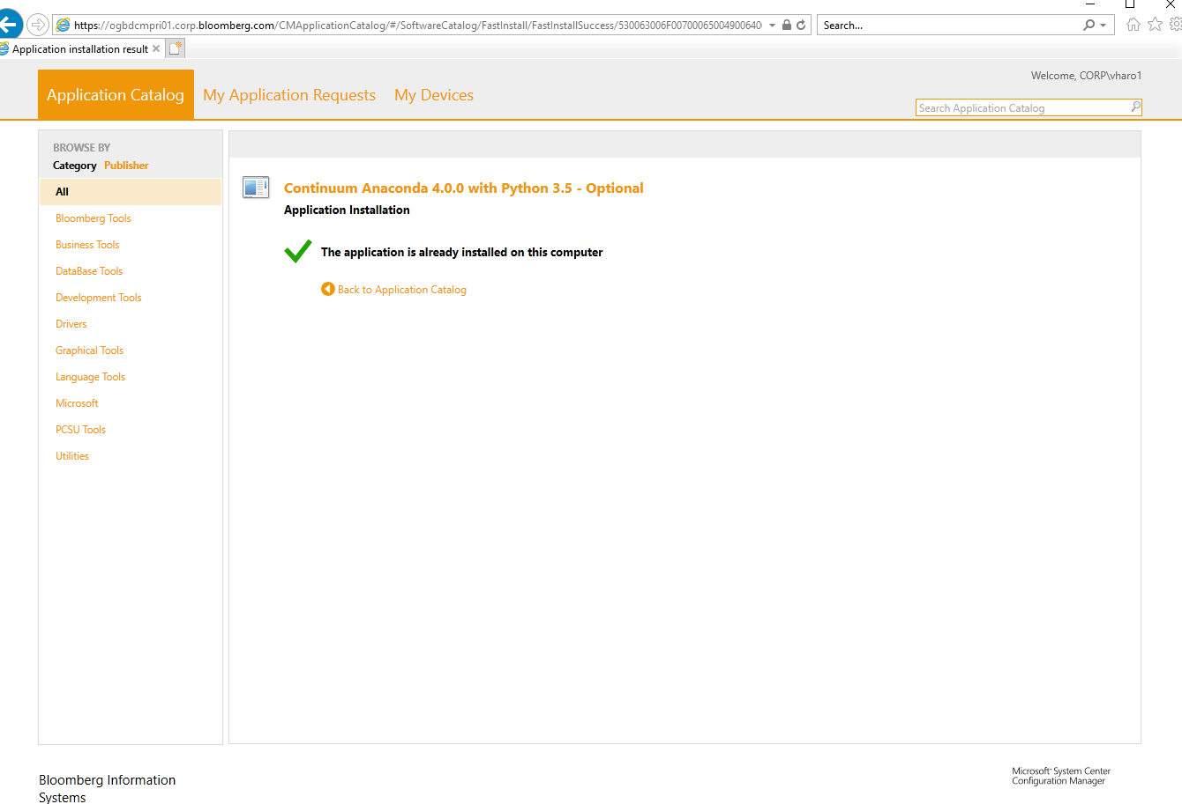

1. Search for jupyter in the windows search bar and click on it to launch jupyter notebook in your browser
2. 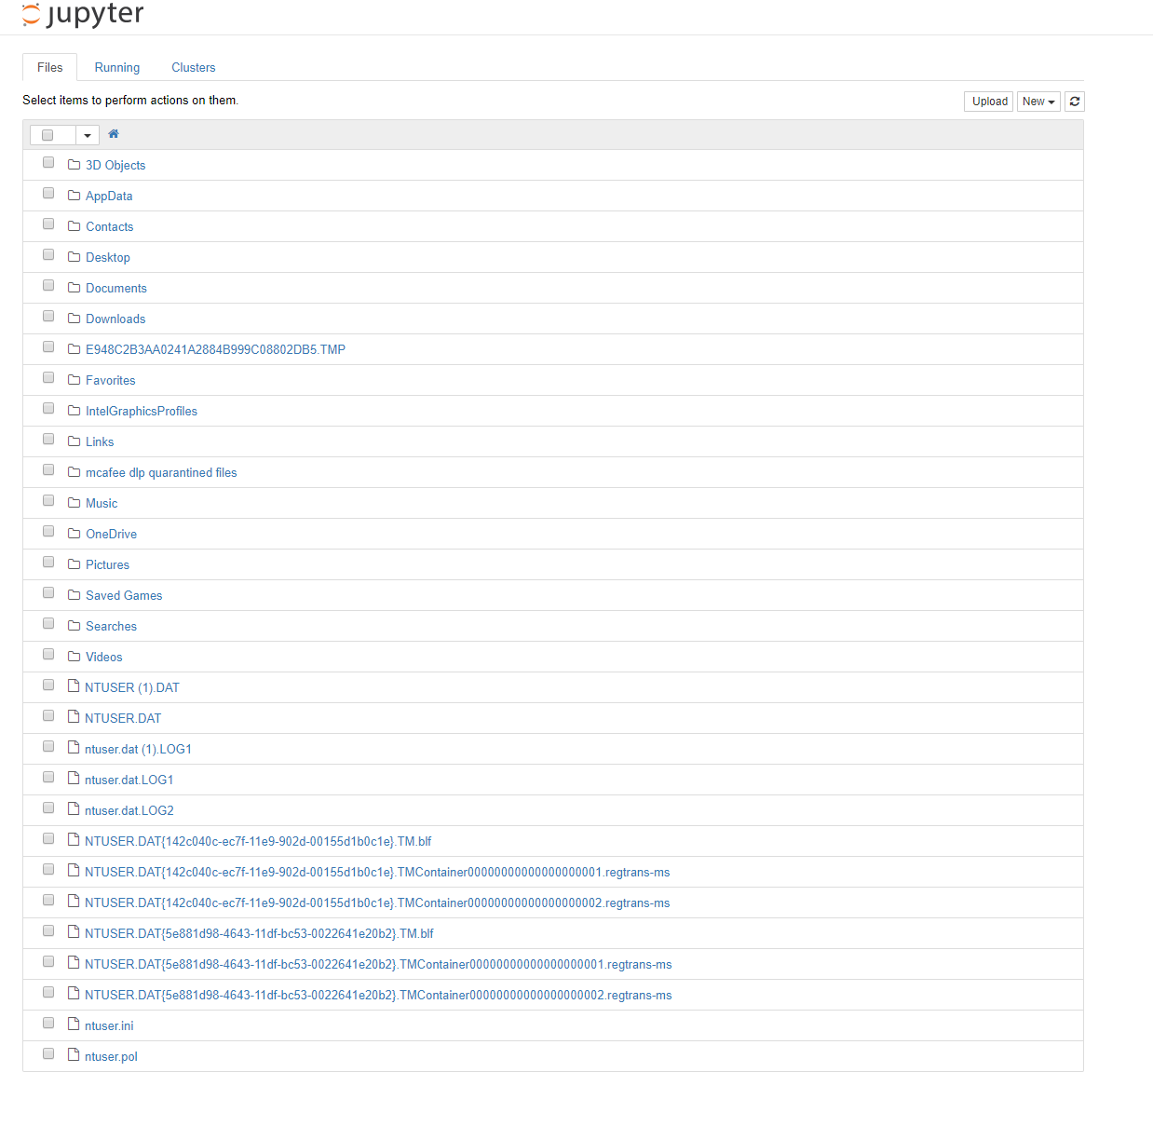
3. Click on “NEW” in the upper right hand corner and pick “Python 3” from the drop down menu.
4. This should open up a new tab with a brand new notebook