**Subject: PRF192- PFC**

**Workshop 06**

**Objectives: Managing arrays**

Program 1:

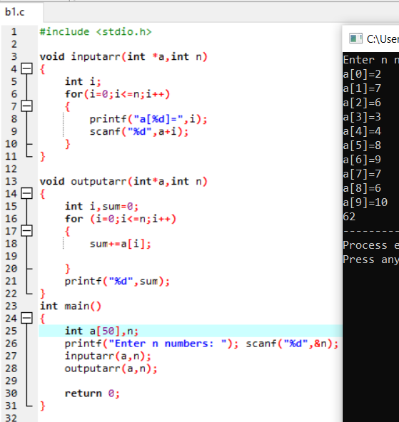

PROGRAM 2:

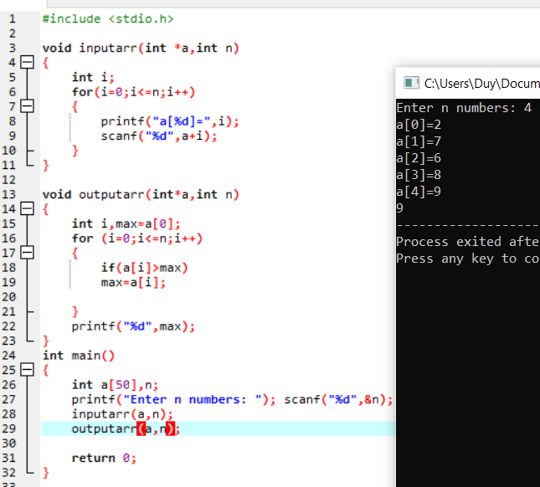

PROGRAM 3:

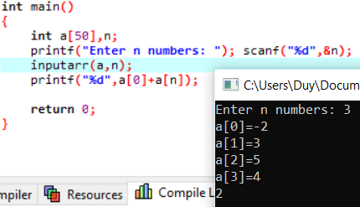

PROGRAM 4:

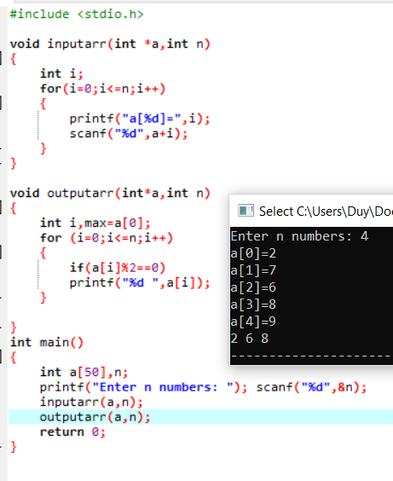

PROGRAM 5:

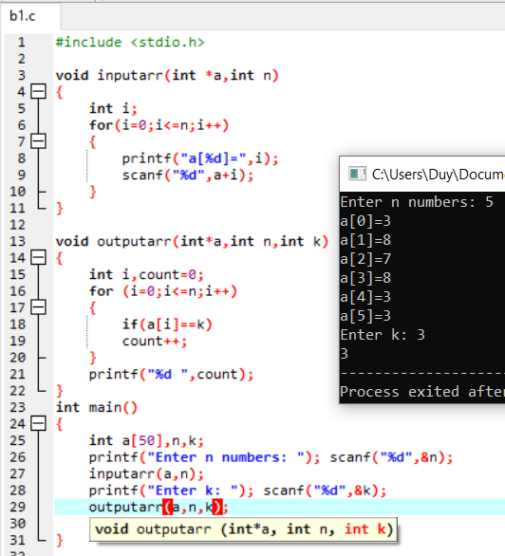

PROGRAM 6:

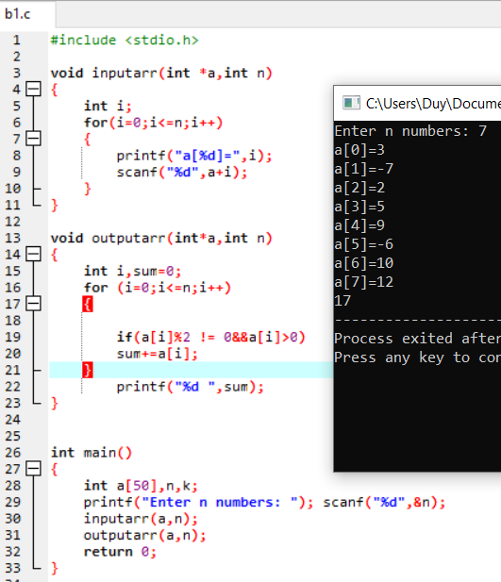

PROGRAM 7:

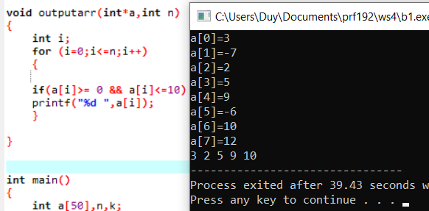

PROGRAM 8:

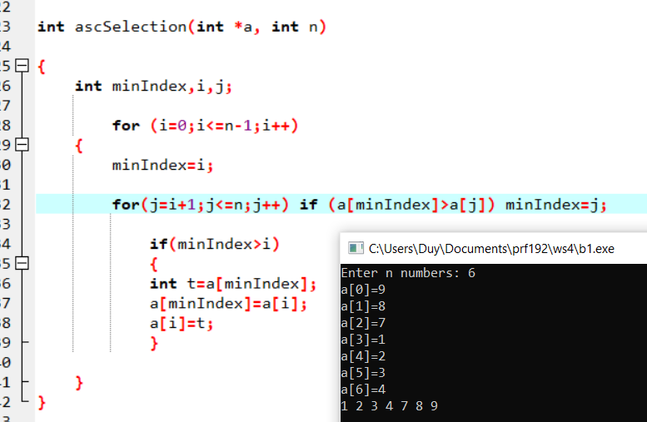

PROGRAM 9:

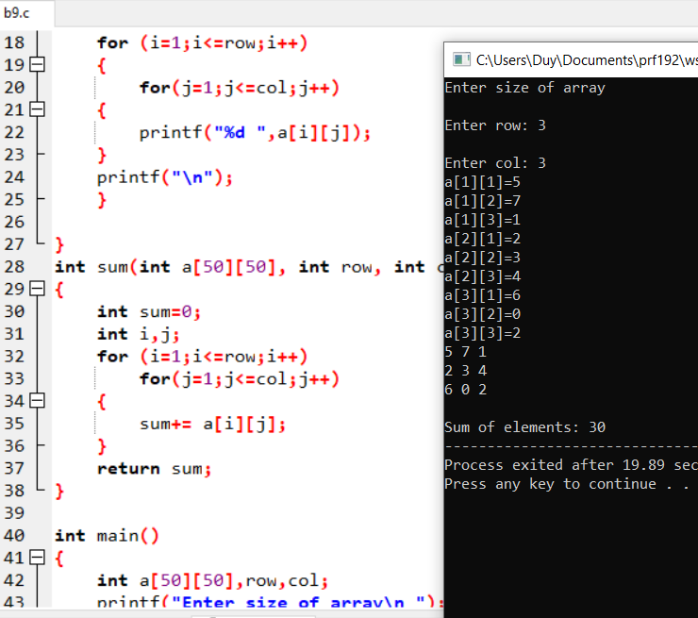

PROGRAM 10:

Develop a C-program that helps user managing an 1-D array of real numbers(maximum of 100 elements) , with initial number of elements is 0, using the following simple menu:

1- Add a value

2- Search a value

3- Print out the array

**4- Print out values in a range**

5- Print out the array in ascending order

Others- Quit

* When the option 1 is selected, user will enters a value then it is added to the array
* When the option 2 is selected, user will enters a value then number of it’s Program istences will be printed out.
* When the option 3 is selected, values in the array will be printed out.
* When the option 4 is chosen, user will enter 2 values, minVal and maxVal, the values in array which are between minVal and maxVal are printed out (minVal <=value<=maxVal)
* When the option 5 is chosen, values in array will be printed out in ascending order but **their position are preserved. ( sorting based their pointers only)**

