This document is a draft specification of the ADS-C application which includes a means for the application users to verify the integrity and the correct delivery of each individual message.

Version | Date | Description of evolution | Modification
V01 / V02 | September 2006 | Initial Version (Word Perfect)
V03 | December 2006 | Translation into MS Word  State tables not updated.  Version sent to SGN2 | All sections
V04 | January 2007 | SGN2 review  Version sent to WGN
V05 | January 2008 | ADG/6 Operational Requirements  Aligned with Doc 9694 Draft 11 | All
V06 | October 2009 | Aligned with RTCA SC-214/EUROCAE WG78 SPR, redlined Doc 9694 Draft 11
V07 – Version H | February 2010 | redlined Doc 9694 Draft 13  Aligned acknowledgements, including adding a positive ack for cancel; added reject reasons; corrected ASN.1; updated state tables; additional user requirements removed; changed timer value t-PC-2 | 3, 4, 5
V08 – DraftVersion I | November 2011 | PDRs 180, 206, 208, 209, 246
V09 – Version I | February 2012 | No change

Table of contents

2.2 AUTOMATIC DEPENDENT SURVEILLANCE CONTRACT APPLICATIONS 6
2.2.1 AUTOMATIC DEPENDENT SURVEILLANCE (CONTRACT) APPLICATION 6
2.2.1.1 Introduction 6
2.2.1.2 General Requirements 18
2.2.1.2.1 ADS-C ASE Version Number 18
2.2.1.2.2 Error Processing Requirements 18
2.2.1.3 The Abstract Service 19
2.2.1.3.1 Service Description 19
2.2.1.3.2 The ADS-C ASE Abstract Service 20
2.2.1.3.3 Conventions 21
2.2.1.3.4 ADS-demand-contract Service 22
2.2.1.3.5 ADS-event-contract Service 25
2.2.1.3.6 ADS-periodic-contract Service 29
2.2.1.3.7 ADS-report Service 32
2.2.1.3.8 ADS-cancel Service 33
2.2.1.3.9 ADS-cancel-all-contracts Service 33
2.2.1.3.10 ADS-user-abort Service 34
2.2.1.3.11 ADS-provider-abort Service 35
2.2.1.4 Formal Definitions of Messages 36
2.2.1.4.1 Encoding/Decoding Rules 36
2.2.1.4.2 ADS-C ASN.1 Abstract Syntax 36
2.2.1.5 Protocol Definition 43
2.2.1.5.1 Sequence Rules 43
2.2.1.5.2 ADS-C Service Provider Timers 56
2.2.1.5.3 ADS-C ASE Protocol Description 57
2.2.1.5.4 Exception Handling 87
2.2.1.5.5 ADS-C ASE State Tables 90
2.2.1.6 Communication Requirements 101
2.2.1.6.1 Encoding Rules 101
2.2.1.6.2 Dialogue Service Requirements 101
2.2.1.7 ADS-user Requirements 102
2.2.1.7.1 General 102
2.2.1.7.2 ADS/IC Data Generation Requirements 103
2.2.1.7.3 The Application Message Integrity Check 105
2.2.1.7.4 ADS/IC Data Receipt Requirements 106
2.2.1.7.5 Establishment and Operation of a Demand Contract 109
2.2.1.7.6 Establishment and operation of an Event Contract 109
2.2.1.7.7 Establishment and operation of a Periodic Contract 109
2.2.1.7.8 Ground Cancellation of Contracts 109
2.2.1.7.9 Operation of Emergency and/or Urgency Mode 109
2.2.1.7.10 Operation of Aborts 109
2.2.1.7.11 ADS-C Data ASN.1 Abstract Syntax 110
2.2.1.8 Subsetting Rules 111
2.2.1.8.1 General 111

Table of figures

Figure 2.2.1.3-1: Functional Model of the ADS-C Application 19
Figure 2.2.1.5-1: Use of demand contract (accepted or rejected) with no dialogue existing 43
Figure 2.2.1.5-2: Use of demand contract (accepted or rejected) with dialogue existing 44
Figure 2.2.1.5-3: Use of demand contract (non compliance notification or 44
Figure 2.2.1.5-4: Use of demand contract (non compliance notification or 45
Figure 2.2.1.5-5: Use of event contract (positive acknowledgement or non compliance notification) with no dialogue existing 45
Figure 2.2.1.5-6: Use of event contract (positive acknowledgement or non compliance notification) with dialogue existing 46
Figure 2.2.1.5-7: Use of event contract (accepted) with no dialogue existing 46
Figure 2.2.1.5-8: Use of event contract (accepted) with dialogue existing 47
Figure 2.2.1.5-9: Use of event contract (positive acknowledgement or 47
Figure 2.2.1.5-10: Use of event contract (rejected) 48
Figure 2.2.1.5-11: Use of event contract (rejected) with dialogue existing 48
Figure 2.2.1.5-12: Use of periodic contract (accepted) with no dialogue existing 49
Figure 2.2.1.5-13: Use of periodic contract (positive acknowledgement) with a dialogue existing 49
Figure 2.2.1.5-14: Use of periodic contract (positive acknowledgement 50
Figure 2.2.1.5-15: Use of periodic contract (rejected) with no dialogue existing 50
Figure 2.2.1.5-16: Use of periodic contract (positive acknowledgement or 51
Figure 2.2.1.5-17: Use of periodic contract (rejected) with a dialogue existing 51
Figure 2.2.1.5-18: Use of ADS-cancel contract service 52
Figure 2.2.1.5-19: Use of ADS-cancel-contract service with only one contract 52
Figure 2.2.1.5-20: Use of ADS-cancel-all-contracts service 53
Figure 2.2.1.5-21: Air user abort service 53
Figure 2.2.1.5-22: Ground user abort service 54
Figure 2.2.1.5-23: Air ASE abort 54
Figure 2.2.1.5-24: Ground ASE abort 55
Figure 2.2.1.5-25: Functional model of the ADS-ground-ASE 57
Figure 2.2.1.5-26: Functional model of the ADS-air-ASE 58

Table of tables

Table 2.2.1.3-1: ADS-demand-contract service parameters 22
Table 2.2.1.3-2: ADS-event-contract service parameters 25
Table 2.2.1.3-3: ADS-periodic-contract service parameters 29
Table 2.2.1.3-4: ADS-report service parameters 32
Table 2.2.1.3-5: ADS-cancel service parameters 33
Table 2.2.1.3-6: ADS-cancel-all-contracts service parameters 34
Table 2.2.1.3-7: ADS-user-abort service parameters 34
Table 2.2.1.3-8: ADS-provider-abort service parameters 35
Table 2.2.1.5-1: ADS-C Service Provider Timers 56
Table 2.2.1.5-2: Request and response primitive to ground module mapping 60
Table 2.2.1.5-3: Indication and confirmation primitive to ground module mapping 60
Table 2.2.1.5-4: Request and response primitive to air module mapping 61
Table 2.2.1.5-5: Indication and confirmation primitive to air module mapping 61
Table 2.2.1.5-6: D-START request parameter values 81
Table 2.2.1.5-7: PDU to ground module mapping 84
Table 2.2.1.5-8: D-START response parameter values 85
Table 2.2.1.5-9: PDU to air module mapping 86
Table 2.2.1.5-10: ADS-C ground DC module state table 91
Table 2.2.1.5-11: ADS-C air DC module state table 92
Table 2.2.1.5-12: ADS-C ground EC module state table 93
Table 2.2.1.5-13: ADS-C air EC module state table 95
Table 2.2.1.5-14: ADS-C ground periodic-contract state table 96
Table 2.2.1.5-15: ADS-C air PC module state table 98
Table 2.2.1.5-16: Ground ADS-C LI module state table 99
Table 2.2.1.5-17: Air ADS-C LI module state table 100
Table 2.2.1.6-1: Mapping between class of communication and routing class abstract values 101
Table 2.2.1.8-1: ADS-C Protocol Versions Implemented 111
Table 2.2.1.8-2: ADS-C Protocol Functional Units 111
Table 2.2.1.8-3: ADS-ground-ASE Conformant Configurations 112
Table 2.2.1.8-4: ADS-air-ASE Conformant Configurations 112

AUTOMATIC DEPENDENT SURVEILLANCE CONTRACT APPLICATIONS

Note.— Structure of 2.2: 2.2.1 defines the air-ground communication aspects of ADS-C. 2.2.2 defines the ground-ground (i.e. ADS-C report forwarding) aspects of ADS-C.

AUTOMATIC DEPENDENT SURVEILLANCE (CONTRACT) APPLICATION

Introduction

The ADS-C air ground application will allow users to obtain positional and other information from suitably equipped aircraft in a timely manner in accordance with their requirements. The ADS-C application is designed to give automatic reports about aircraft to a user. The ADS-C reports give positional as well as other information likely to be of use to the air traffic management function, including air traffic control. The aircraft provides the information to the user under the following circumstances:

a) under a contract (known as a demand contract) agreed with the ground system, the aircraft provides the information immediately and once only;

b) under a contract (known as a periodic contract) agreed with the ground system, the aircraft provides information on a regular basis;

c) under a contract (known as an event contract) agreed with the ground system, the aircraft provides information when certain events are detected by the avionics;

Note 1.— Structure of 2.2.1: this chapter defines the air-ground communication aspects of the ADS-C application only.

a) 2.2.1.1: INTRODUCTION contains 2.2.1's purpose, structure, and a summary of the functions of the ADS-C application.

b) 2.2.1.2: GENERAL REQUIREMENTS contains backwards compatibility and error processing requirements.

c) 2.2.1.3: THE ABSTRACT SERVICE contains the description of the abstract service provided by the application service elements (ASE) defined for the ADS-C application.

d) 2.2.1.4: FORMAL DEFINITION OF MESSAGES contains the formal definition of Application Protocol Data Unit exchanged by ADS-C ASEs using Abstract Syntax Notation Number One (ASN.1).

e) 2.2.1.5: PROTOCOL DEFINITION describes the exchanges of messages allowed by the ADS-C protocol, as well as time constraints and the exception handling procedures associated with these exchanges. 2.2.1.5 describes also the ADS-C protocol in terms of state tables.

f) 2.2.1.6: COMMUNICATION REQUIREMENTS contains the requirements that the ADS-C ASE application imposes on the underlying communication system.

g) 2.2.1.7: ADS-USER REQUIREMENTS outlines the requirements that a user of an ADS-C ASE must meet.

h) 2.2.1.8: SUBSETTING RULES provides rules for subsetting the ADS-C application.

Note 2.— General Functionality

a) The avionics are capable of supporting contracts with at least four ATC ground systems simultaneously; they are also capable of supporting one demand, one event and one periodic contract with each ground system simultaneously.

b) It will be necessary for an implementation to provide information which is both accurate and timely in the ADS-C reports; however, quantification of the age and accuracy of the information is beyond the scope of 2.2.1.

c) The ground system can request that authentication and data integrity services be performed to ensure the identity of participating entities is as claimed and to ensure that ADS-C data is not altered or destroyed in an unauthorized manner.

Note 3.— Establishment and Operation of a Demand Contract

a) Functional Description

1) This function allows the ground system to establish a demand contract with an aircraft, and then for the conditions of that contract to be realised. Realisation of the contract involves the sending of a single report from an aircraft to the ground system.

2) Any number of demand contracts may be sequentially established with an aircraft. Basic information is sent with the report. Optionally, at the request of the ground system, other information may also be sent. Under emergency and/or urgency conditions, additional information are sent.

3) The ground system sends a demand contract request message to the avionics. This contains an indication of which optional information blocks are required. The avionics then determines whether or not there are errors in the request, and if there are no errors, whether or not it is able to comply with the request. If the avionics can comply with the demand contract request it sends the ADS-C report in a contract accept message as soon as possible. If there are errors in the contract request, or if the avionics cannot comply with the request, it sends a contract reject message to the ground system indicating the reason for its inability to accept the contract. If the avionics can partially comply with the request, it sends a non-compliance notification message indicating those parts of the contract with which it cannot comply, and then it sends an ADS-C report message.

4) If the avionics cannot send the report within 0.5 seconds, it sends a positive acknowledgement message first to indicate its acceptance of the contract.

b) Message Descriptions

1) The demand contract request message stipulates which of the optional information fields are to be included in the ADS-C report.

2) Each ADS-C report message always contains the following basic information:

i) the 3-D position of the aircraft;

ii) the time;

- an indication of the accuracy of the positional information (figure of merit);

iv) the contract number identifying which request the report is dedicated to.

3) Optionally, an ADS-C report message contains an indication of:

- the aircraft address;

- the aircraft identification;

ii) the projected profile, indicating the position and predicted time of the next way point, and the position of the following way point;

iii) the ground vector, indicating the track, ground speed and vertical rate;

iv) the air vector, indicating the heading, air speed and vertical rate;

v) meteorological information, indicating wind direction, wind speed, wind quality flag, temperature, turbulence and humidity;

vi) the extended project profile, indicating when available the predicted position, level, time, speed, type of way point, level constraint, required time of arrival and speed restriction for the next several way points (as indicated in the demand contract), as well as the current and predicted gross mass and the speed schedule; and

vii) an indication of the emergency and/or urgency status, if the avionics is in the emergency and/or urgency mode.

4) A contract accept message indicates acceptance of the contract and contains an ADS-C report.

5) A positive acknowledgement message indicates acceptance of the contract and contains no further information.

6) A contract reject message contains an indication of the reason why the contract has not been accepted.

7) A non-compliance notification message contains an indication of which optional information fields cannot be sent.

Note 4.— Establishment and Operation of an Event Contract

a) Functional Description

1) This function allows the ground system to establish an event contract with the aircraft, and then for the conditions of that contract to be realised. Realisation of the contract involves the sending of reports from the aircraft to the ground system when certain agreed events occur.

2) Only one event contract may exist between the ground system and avionics at any one time, but this may contain multiple event types. A set of basic information is sent with every report, and depending on the event that triggered the sending of the report, other information blocks may also be included. The contract that is agreed states the event types that are to trigger reports and also any values needed to clarify those event types. Under emergency and/or urgency conditions, additional information are sent.

3) It is possible to request one or more of the following event types:

i) Vertical rate change. This can be triggered in two ways. If the vertical rate threshold is positive, then the event is triggered when the aircraft’s rate of climb is greater than the vertical rate threshold. If the vertical rate threshold is negative, then the event is triggered when the aircraft’s rate of descent is less than the vertical rate threshold.

ii) Way point change. This is triggered by a change to the next way-point. This change is normally due to routine way point sequencing, but could be triggered by a way point which is not part of the ATC clearance but is entered by the pilot for operational reasons.

iii) Lateral deviation change. This is triggered when the absolute value of the lateral distance between the aircraft’s actual position and the aircraft’s expected position on the active flight plan becomes greater than the lateral deviation threshold.

iv) Level range deviation. This is triggered when the aircraft’s level becomes greater than the level ceiling or less than the level floor.

v) Airspeed change. This is triggered when the aircraft’s airspeed differs negatively or positively from its value at the time of the previous ADS-C report containing an air vector, by an amount which is equal to the airspeed change threshold which is specified in the event contract request. If there has been no previous such report, one is sent immediately.

vi) Ground speed change. This is triggered when the aircraft’s ground speed differs negatively or positively from its value at the time of the previous ADS-C report containing a ground vector, by an amount which is equal to the ground speed threshold which is specified in the event contract request. If there has been no previous such report, one is sent immediately.

vii) Heading change. This is triggered when the aircraft’s heading differs negatively or positively from its value at the time of the previous ADS-C report containing an air vector, by an amount which is equal to the heading change threshold which is specified in the event contract request. If there has been no previous such report, one is sent immediately.

viii) Extended projected profile change. This is triggered by a change to any of the set of future way points that define the active route of flight. The number of way points covered in the contract is either defined by a time interval (i.e. any way point planned to be achieved in the next N minutes), or by number of way points (i.e. any way point in the next N). A change to the extended projected profile occurs whenever there is a change in the way points sequence or in the computation of a particular way point.

ix) FOM (Figure of Merit) change. This is triggered by a change in the navigational accuracy, navigational system redundancy or airborne collision avoidance system (ACAS) availability.

x) Track angle change. This is triggered when the aircraft’s track angle differs negatively or positively from its value at the time of the previous ADS-C report containing a ground vector, by an amount which is equal to the track angle change threshold which is specified in the event contract request. If there has been no previous such report, one is sent immediately.

xi) Level change. This is triggered when the aircraft’s level differs negatively or positively from its value at the time of the previous ADS-C report, by an amount which is equal to the level change threshold which is specified in the event contract request. If there has been no previous such report, one is sent immediately.

xii) Vertical deviation change. This is triggered when the absolute value of the vertical distance between the aircraft’s actual position and the aircraft’s expected position on the active flight plan becomes greater than the vertical deviation threshold which is specified in the event contract request. If there has been no previous such report, one is sent immediately.

xiii) Aircraft out of boundaries change. This is triggered when the aircraft vertical position is out of the vertical portion of space defined by altitude constraints by more than the value of the out of vertical boundaries threshold which is specified in the event contract request. The altitude constraints have been sent earlier to the aircrew by data link or voice.

4) Acceptance of an event contract request implicitly cancels an existing event contract, if one exists.

5) The ground system sends an event contract request to the avionics. This contains the types of event to be reported on and the necessary parameters for that event (e.g. if the event is a level range deviation, then the upper and lower thresholds must be sent). The avionics then determines whether or not there are errors in the request, and if not, whether or not it is able to comply with the request. If the avionics can comply with the event contract request it sends any required baseline ADS-C report in a contract accept message. If the contracted event occurs, an ADS-C report is sent.

6) If there are errors in the event contract request, or if the avionics cannot comply with the request, it sends a contract reject message to the ground system indicating the reason for its inability to accept the contract within 0.5 seconds.

7) If the avionics can partially comply with the request, it sends a non-compliance notification indicating those parts of the contract with which it cannot comply. If a contracted event occurs with which it can comply, an ADS-C report is sent.

8) For lateral and vertical deviation change, level range and vertical rate change, and aircraft out of boundaries change, if the event occurs, a report is sent every 60 seconds while the limit(s) specified in the contract are exceeded. For all other events, a single report is sent every time the event occurs.

b) Message Descriptions

1) The event contract request message contains an indication of the events to be reported on, together with clarifying information as follows:

i) lateral deviation change - containing the lateral deviation threshold;

ii) vertical rate change - containing the vertical rate threshold;

iii) leaving a given level range - containing the upper and lower level thresholds;

iv) way-point change - containing no further clarifying information;

v) air speed change - containing the airspeed change threshold;

vi) ground speed change - containing ground speed change threshold;

vii) heading change - containing heading change threshold;

viii) extended projected profile change - containing either a projected time or a number of way points;

ix) figure of merit change - containing no further clarifying information;

x) track angle change - containing the track angle change threshold;

xi) level change - containing level change range;

xii) vertical deviation change - containing the vertical deviation threshold;

xiii) aircraft out of boundaries change - containing the vertical deviation threshold.

2) The ADS-C report message has the same structure as in the operation of a demand contract, containing position, time and FOM. However the choice of additional optional information blocks is made as follows:

i) if the triggering event is a vertical rate change, a lateral deviation change, a vertical deviation change, a level deviation change, a ground speed change, a track angle change, a level change or aircraft out of boundaries, then the ADS-C report will contain the ground vector;

ii) if the triggering event is a way point change, then the ADS-C report will contain the projected profile;

iii) if the triggering event is an air speed change or heading change, then the ADS-C report will contain the air vector;

iv) if the triggering event is an extended projected profile change, then the ADS-C report will contain the extended projected profile;

v) if the triggering event is a FOM change, then the ADS-C report will contain no additional information other than the basic information contained in every ADS-C report);

vi) if the avionics is in the emergency and/or urgency mode, then the ADS-C report will contain an indication of the emergency and/or urgency status.

3) A contract accept message indicates acceptance of the contract and contains an ADS-C report.

4) A positive acknowledgement message indicates acceptance of the contract and contains no further information.

5) A contract reject message contains an indication of the reason why the contract has not been accepted.

6) A non-compliance notification message contains an indication of the events which the avionics cannot detect.

Note 5.— Establishment and Operation of a Periodic Contract

a) Functional Description

1) This function allows the ground system to establish a periodic contract with the aircraft, and then for the conditions of that contract to be realised. Realisation of the contract involves the sending of reports from the aircraft to the ground system at regular intervals (the reporting rate).

2) Only one periodic contract may exist between a ground system and the avionics at any one time. A set of basic information is sent with every report. Optionally, at the request of the ground system, other information blocks may also be sent; they may only be sent at a time interval which is a multiple of the reporting rate. The contract that is agreed includes the reporting rate, the optional blocks of information to be sent and the rate at which they are to be sent.

3) The ground system sends a periodic contract request message to the avionics. This message contains the basic reporting rate and an indication of which optional information blocks are required and how often they are to be sent relative to the basic rate (i.e. every time, every second report, every third report etc.). The avionics then determines whether or not there are errors in the request, and if not, whether or not it is able to comply with the request. If the avionics can comply with the periodic contract request it sends its first report in a contract accept message, and then sends other ADS-C reports at the intervals requested. If it cannot send the first report within 0.5 seconds, it sends a positive acknowledgement message first to indicate its acceptance of the contract.

4) Acceptance of a periodic contract request implicitly cancels any existing periodic contract.

5) If there are errors in the periodic contract request message, or if the avionics cannot accept the contract, it sends a contract reject message to the ground system indicating the reason for its inability to accept the contract within 0.5 seconds.

6) If the avionics can partially comply with the request, it sends a non-compliance notification message indicating those parts of the contract with which it cannot comply. It then sends ADS-C reports at a rate with which it can comply, and containing information requested with which it can comply. Non-compliance can be caused by either inability to meet the requested reporting rate, and/or inability to supply the requested information.

b) Message Descriptions

1) The periodic contract request message may optionally contain any of the following information:

i) reporting interval;

- aircraft address modulus;

- aircraft identification modulus;

iii) projected profile modulus;

iv) ground vector modulus;

v) air vector modulus;

vi) meteorological information modulus;

vii) extended projected profile modulus.

Moduli indicate the multiple of the reporting rate that the information block is sent at (e.g. meteorological information modulus of 5 means that the meteorological information block is sent with every 5th report).

2) The ADS-C report message has the same structure as in the operation of a demand contract.

3) A contract accept message indicates acceptance of the contract and contains an ADS-C report.

4) A positive acknowledgement message indicates acceptance of the contract and contains no further information.

5) A contract reject message contains an indication of the reason why the contract has not been accepted.

6) A non-compliance notification message contains an indication of which optional information fields cannot be sent, and/or indicates that the requested periodic report cannot be met.

Note 6.— Cancellation of Contracts

a) Functional Description

1) This function allows the ground system explicitly to cancel a contract that is in operation. The ground system sends a cancel contract message to the avionics. The avionics cancels the contract and acknowledges the cancellation.

2) Implicit cancellation occurs when a periodic contract is in place, and then the ground system establishes a new periodic contract - the first one is implicitly cancelled on the establishment of the second; similarly with event contracts. Demand contracts are implicitly cancelled when the report is sent. There are no additional information flows associated with implicit cancellation.

3) The ground system may also cancel all contracts in a single cancel all contracts message. The avionics cancels all contracts and acknowledges the cancellation.

b) Message Descriptions

1) The cancel contract message contains an indication of the contract to be cancelled.

2) The cancel all contracts message contains no additional information.

- A positive acknowledgement message contains no additional information.
- A negative acknowledgement message contains an indication that no such contract existed (i.e. if a periodic contract was attempted to be cancelled when no periodic contract was active).

Note 7.— Operation of an Emergency and/or Urgency Alert

a) Functional Description

1) This function allows the avionics to provide all ground systems with which it has existing contracts (established or being established) with an emergency and/or urgency alert (either on instruction from the pilot or on its own initiative).

2) For a demand contract, the avionics sends the ADS-C report with the emergency and/or urgency condition included.

3) Any existing periodic and event contract remains in force with the same contract terms. The avionics sends an unsolicited ADS-C report containing the baseline information and the emergency and/or urgency condition. Then the avionics includes the emergency and/or urgency condition in all the ADS-C report it sends to all ground systems with which it has event or periodic contracts.

b) Message Descriptions

1) The ADS-C report messages sent when the aircraft in emergency and/or urgency condition has the same structure as in the operation of a demand, event or periodic contract, containing position, time and FOM. However the emergency and/or urgency condition is always included.

Note 8.— Modification of the Emergency and/or Urgency Condition

a) Functional Description

1) This function allows the aircraft to inform the ground systems with which it has a periodic or an event contract that the emergency and/or urgency condition has changed.

2) The avionics sends an unsolicited ADS-C report containing the baseline information with the new emergency and/or urgency condition.

b) Message Descriptions

1) The ADS-C report messages sent when the aircraft has modified the emergency and/or urgency condition has the same structure as in the operation of a demand, event or periodic contract, containing position, time and FOM. However the emergency and/or urgency condition is always included.

Note 9.— Cancellation of the Emergency and/or Urgency Condition

a) Functional Description

1) This function allows the aircraft to inform the ground systems with which it has a periodic or an event contract that the emergency and/or urgency condition has been cancelled.

2) The avionics sends an unsolicited ADS-C report containing the baseline information with no emergency and/or urgency condition.

b) Message Descriptions

1) The ADS-C report messages sent when the aircraft has cancelled the emergency and/or urgency condition has the same structure as in the operation of a demand, event or periodic contract, containing position, time and FOM. However the emergency and/or urgency condition is always included.

General Requirements

ADS-C ASE Version Number

The ADS-air-ASE and the ADS-ground-ASE version numbers shall both be set to one.

Error Processing Requirements

In the event of information input by the ADS-user being incompatible with that able to be processed by the system, the user shall be notified.

In the event of an ADS-user invoking an ADS-C service primitive, when the ADS-C ASE is not in a state specified in 2.2.1.5, the user shall be notified.

The Abstract Service

Service Description

An implementation of either the ADS-C ground based service or the ADS-C air based service shall exhibit behaviour consistent with having implemented an ADS-ground-ASE, or ADS-air-ASE respectively.

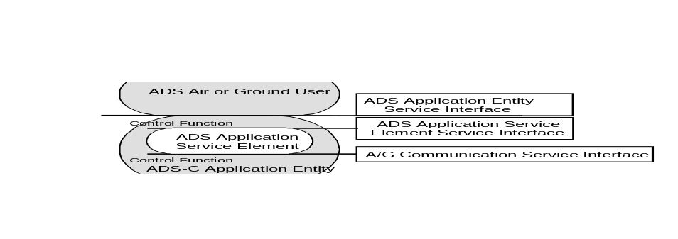
Figure 2.2.1.3-1: Functional Model of the ADS-C Application

Note 1.— 2.2.1.3 defines the abstract service interface for the ADS-C service. The ADS-C ASE abstract service is described in 2.2.1.3 from the viewpoint of the ADS-C ASE-air-user, the ADS-C ASE-ground-user and the ADS-C service-provider.

Note 2.— 2.2.1.3 defines the static behaviour (i.e. the format) of the ADS-C service. Its dynamic behaviour (i.e. how it is used) is described in 2.2.1.7.

Note 3.— Figure 2.2.1.3-1 shows the functional model of the ADS-C Application. The functional modules identified in this model are the following:

a) the ADS-user,

b) the ADS-C Application Entity (ADS-AE) service interface,

c) the ADS-AE,

d) the ADS-C Control Function (ADS-CF),

e) the ADS-C Application Service Element (ADS-C ASE) service interface,

f) the ADS-C ASE, and

- the air/ground communication interface, as for instance the ATN Dialogue Service (DS) interface.

Note 4.— The ADS-user represents the operational part of the ADS-C system. This user does not perform the communication functions but relies on a communication service provided to it via the ADS-AE through the ADS-AE service interface. The individual actions at this interface are called ADS-AE service primitives. Similarly, individual actions at other interfaces in the communication system are called service primitives at these interfaces.

Note 5.— The ADS-AE consists of several elements, including the ADS-C ASE and the ADS-CF. The air/ground communication service interface is made available by the ADS-CF to the ADS-C ASE for communication with the peer ADS-C ASE.

Note 6.— The ADS-C ASE is the element in the communication system which executes the ADS-C specific protocol. In other words, it takes care of the ADS-C specific service primitive sequencing actions, message creation, timer management, error and exception handling.

Note 7.— The ADS-C ASE interfaces only with the ADS-CF. This ADS-CF is responsible for mapping service primitives received from one element (such as the ADS-C ASE and the ADS-user) to other elements which interface with it. The part of the ADS-CF which is relevant from the point of view of these specifications, i.e. the part between the ADS-user and the ADS-C ASE, will map ADS-AE service primitives to ADS-C ASE service primitives transparently.

Note 8.— The DS interface is the interface between the ADS-C ASE and part of ADS-CF underneath, the ADS-C ASE and provides the ATN dialogue service. The ADS-C ASE is designed to move on top of another communication service with no impact on the application protocol.

The ADS-C ASE Abstract Service

Note.— There is no requirement to implement the service in an ADS-C product; however, it is necessary to implement the ground based and air based system in such a way that it will be impossible to detect (from the peer system) whether or not an interface has been built.

The ADS-C ASE abstract service shall consist of a set of the following services as allowed by the subsetting rules defined in 2.2.1.8:

a) ADS-demand-contract service as defined in 2.2.1.3.4;

b) ADS-event-contract service as defined in 2.2.1.3.5;

c) ADS-periodic-contract service as defined in 2.2.1.3.6;

d) ADS-report service as defined in 2.2.1.3.7;

e) ADS-cancel service as defined in 2.2.1.3.8;

f) ADS-cancel-all-contracts service as defined in 2.2.1.3.9;

j) ADS-user-abort service as defined in 2.2.1.3.10;

k) ADS-provider-abort service as defined in 2.2.1.3.11.

Note 1.— ADS-demand-contract, ADS-event-contract, ADS-periodic-contract, ADS-cancel and ADS-cancel-all-contracts are services only initiated by the ADS-ground-user.

Note 2.— ADS-report is a service only initiated by the ADS-air-user.

Note 3.— ADS-user-abort is a service initiated by an ADS-air-user or an ADS-ground-user.

Note 4.— ADS-provider-abort is a service only initiated by the ADS-C service-provider.

Note 5.— An abstract syntax is a syntactical description of a parameter which does not imply a specific implementation. Only when the ADS-C ASE maps a parameter onto an APDU field, or vice-versa, is the abstract syntax of the parameter described by using the ASN.1 of 2.2.1.4 for this field.

Conventions

Note 1.— For a given primitive, the presence of each parameter is described by one of the following values in the parameter tables in 2.2.1.3:

a) blank not present;

b) C conditional upon some predicate explained in the text;

c) C(=) conditional upon the value of the parameter to the immediate left being present, and equal to that value;

d) M mandatory;

e) M(=) mandatory, and equal to the value of the parameter to the immediate left;

f) U user option.

Note 2.— The following abbreviations are used in this document:

a) Req request; data is input by an ADS-user initiating the service to its respective ADS-CASE;

b) Ind indication; data is indicated by the receiving ADS-CASE to its respective ADS-user;

c) Rsp response; data is input by receiving ADS-user to its respective ADS-CASE;

d) Cnf confirmation; data is confirmed by the initiating ADS-CASE to its respective ADS-user.

Note 3.— An unconfirmed service allows just one message to be transmitted, in one direction.

Note 4.— A confirmed service provides end-to-end confirmation that a message sent by one user was received by its peer user.

ADS-demand-contract Service

Note.— The ADS-demand-contract service allows the ADS-ground-user to request a demand contract with the aircraft. It is a confirmed service, initiated by the ADS-ground-user.

The ADS-demand-contract service shall contain primitives and parameters as presented in Table 2.2.1.3-1.
Table 2.2.1.3-1: ADS-demand-contract service parameters
Parameter Name | Req | Ind | Rsp | Cnf
Aircraft Identity | M
Class of Communication Service | U
ICAO Facility Designation | C | C(=)
Security Required | C
ADS/IC Contract Data | M | M(=)
Result |  |  | M | M(=)
ADS/IC Positive Acknowledgement |  |  | C | C(=)
ADS/IC Report Data |  |  | C | C(=)
ADS/IC Non Compliance Data |  |  | C | C(=)
ADS/IC Reject Data |  |  | C | C(=)

Aircraft Identity

Note.— This parameter contains the 24 bit ICAO aircraft address of the aircraft or the aircraft identification with which the contract is being made.

When an aircraft address is used to identify the aircraft, the Aircraft Identity parameter value shall conform to an abstract value corresponding to a 24-bit ICAO aircraft address.

When an aircraft identification is used to identify the aircraft, the Aircraft Identity parameter value shall conform to an abstract value corresponding to a 2 to 7 character aircraft identification.

Class of Communication Service

Note.— This parameter contains the value of the required class of communication service, if specified by the ADS-ground-user.

Where specified by the ADS-ground-user, the Class Of Communication Service parameter shall have one of the following abstract values: “A”, “B”, “C”, “D”, “E”, “F”, “G” or “H”.

Note 1.— If contracts are currently in place, the Class Of Communication Service parameter is not used by the ADS-C service provider.

Note 2.— Where not specified by the ADS-ground-user, when there are no contracts already in force, this indicates that there will be no routing preference.

ICAO Facility Designation

Note.— This parameter contains the 4 to 8 character ICAO Facility Designation of the ICAO facility which is initiating the contract. If contracts are currently in place, this parameter is not used by the ADS-service-provider.

The ICAO Facility Designation parameter value shall conform to an abstract value corresponding to a 4 to 8 character ICAO Facility Designation.

The ICAO Facility Designation parameter value shall be provided when the ADS-ground-user has no other contracts in place with the aircraft.

Security Required

Note 1.— This parameter contains the value of the required level of security, if specified by the ADS-ground-user.

Note 2.— If the received Security Required parameter is not as expected per the local security policy, the receiving ADS-air-ASE will abort.

Where specified by the ADS-ground-user, the Security Required parameter shall have one of the following abstract values: “no security” or “secured exchange”.

Note.— If contracts are currently in place, the Security Required parameter is not used by the ADS-C service provider.

ADS/IC Contract Data

Note 1.— This parameter contains the details of the demand contract as requested by the ADS-ground-user.

Note 2.— This parameter contains an Application Message Integrity Check.

The ADS/IC Contract Details parameter value shall conform to the ASN.1 abstract syntax ICContractRequest.

Result

Note 1.— This parameter indicates the extent to which the demand contract request can be complied with:

a) if it has the value “positive acknowledgement”, it indicates that the demand contract has been accepted but the ADS-C report will be sent later, and the parameter ADS/IC Positive Acknowledgement indicates the contract type,

b) if it has the value “accepted”, it indicates that the demand contract has been accepted and the parameter ADS/IC Report Data contains the report,

c) if it has the value “rejected”, it indicates that the demand contract has been rejected and the parameter ADS/IC Reject Data gives reasons,

d) if it has the value “non compliance notification”, it indicates that only some parts of the demand contract can be complied with and the parameter ADS/IC Non Compliance Data indicates which ones have been rejected.

Note 2.— If it has the value “positive acknowledgement”, this indicates that the contract has been accepted but cannot be satisfied immediately because the information is not available with the 0.5 second turnaround time.

The Result parameter value shall conform to one of the following abstract values: “accepted”, “rejected”, “positive acknowledgement”, or “non compliance notification”.

ADS/IC Positive Acknowledgement

Note 1.— This parameter contains the details of the ADS-C positive acknowledgement.

Note 2.— This parameter contains an Application Message Integrity Check.

The ADS/IC positive acknowledgement parameter value shall conform to the ASN.1 abstract syntax ICPositiveAck.

The ADS/IC positive acknowledgement parameter value shall be present if and only if the Result parameter contains the abstract value “positive acknowledgement”.

ADS/IC Report Data

Note 1.— This parameter contains the details of the ADS-C report.

Note 2.— This parameter contains an Application Message Integrity Check.

The ADS/IC Report Data parameter value shall conform to the ASN.1 abstract syntax ICReport.

The ADS/IC Report Data parameter value shall be present if and only if the Result parameter contains the abstract value “accepted”.

ADS/IC Reject Data

Note 1.— This parameter contains the reason of the contract rejection.

Note 2.— This parameter contains an Application Message Integrity Check.

The ADS/IC Reject Data parameter value shall conform to the ASN.1 abstract syntax ICReject.

The ADS/IC Reject Data parameter value shall be present if and only if the Result parameter contains the abstract value “rejected”.

ADS/IC Non Compliance Data

Note 1.— This parameter contains an indication of which optional information fields cannot be sent.

Note 2.— This parameter contains an Application Message Integrity Check.

The ADS/IC Non Compliance Data parameter value shall conform to the ASN.1 abstract syntax ICNonCompliance.

The ADS/IC Non Compliance Data parameter value shall be present if and only if the Result parameter contains the abstract value “non compliance notification”.

ADS-event-contract Service

Note.— The ADS-event-contract service allows the ADS-ground-user to request an event contract with the aircraft. It is a confirmed service, initiated by the ADS-ground-user.

The ADS-event-contract service shall contain primitives and parameters as presented in Table 2.2.1.3-2.
Table 2.2.1.3-2: ADS-event-contract service parameters
Parameter Name | Req | Ind | Rsp | Cnf
Aircraft Identity | M
Class of Communication Service | U
ICAO Facility Designation | C | C(=)
Security Required | C
ADS/IC Contract Data | M | M(=)
Result |  |  | M | M(=)
ADS/IC Positive Acknowledgement |  |  | C | C(=)
ADS/IC Report Data |  |  | C | C(=)
ADS/IC Reject Data |  |  | C | C(=)
ADS/IC Non Compliance Data |  |  | C | C(=)

Aircraft Identity

Note.— This parameter contains the 24 bit ICAO address of the aircraft or the aircraft identification with which the contract is being made.

When an aircraft address is used to identify the aircraft, the Aircraft Identity parameter value shall conform to an abstract value corresponding to a 24-bit ICAO aircraft address.

When an aircraft identification is used to identify the aircraft, the Aircraft Identity parameter value shall conform to an abstract value corresponding to a 2 to 7 character aircraft identification.

Class of Communication Service

Note.— This parameter contains the value of the required class of communication service, if specified by the ADS-ground-user.

Where specified by the ADS-ground-user, the Class Of Communication Service parameter shall have one of the following abstract values: “A”, “B”, “C”, “D”, “E”, “F”, “G” or “H”.

Note 1.— If contracts are currently in place, the Class Of Communication Service parameter is not used by the ADS-C service provider.

Note 2.— Where not specified by the ADS-ground-user, when there are no contracts already in force, this indicates that there will be no routing preference.

ICAO Facility Designation

Note.— This parameter contains the 4 to 8 character ICAO Facility Designation of the ICAO facility which is initiating the contract. If contracts are currently in place, this parameter is not used by the ADS-service-provider.

The ICAO Facility Designation parameter value shall conform to an abstract value corresponding to a 4 to 8 character ICAO Facility Designation.

The ICAO Facility Designation parameter value shall be provided when the ADS-ground-user has no other contracts in place with the aircraft.

Security Required

Note 1.— This parameter contains the value of the required level of security, if specified by the ADS-ground-user.

Note 2.— If the received Security Required parameter is not as expected per the local security policy, the receiving ADS-air-ASE will abort.

Where specified by the ADS-ground-user, the Security Required parameter shall have one of the following abstract values: “no security” or “secured exchange”.

Note.— If contracts are currently in place, the Security Required parameter is not used by the ADS-C service provider.

ADS/IC Contract Data

Note 1.— This parameter contains the details of the event contract as requested by the ADS-ground-user.

Note 2.— This parameter contains an Application Message Integrity Check.

The ADS/IC contract data parameter value shall conform to the ASN.1 abstract syntax ICContractRequest.

Result

Note.— This parameter indicates the extent to which the event contract request can be complied with:

a) If it has the value “rejected”, it indicates that the event contract has been rejected and the parameter ADS/IC Reject Data gives reasons,

b) If it has the value “accepted”, it indicates that the event contract has been accepted and the parameter ADS/IC Report Data contains the report,

c) If it has the value “non compliance notification”, it indicates that only some parts of the event contract can be complied with, and the parameter ADS/IC Non Compliance Data indicates which ones have been rejected,

d) If it has the value “positive acknowledgement”, it indicates full compliance with the event contract has been accepted but the ADS-C report will be sent later, and the parameter ADS/IC Positive Acknowledgement indicates the contract type.

The Result parameter value shall conform to one of the following abstract values: “accepted”, “rejected”, “positive acknowledgement”, or “non compliance notification”.

ADS/IC Positive Acknowledgement

Note 1.— This parameter contains the details of the ADS-C positive acknowledgement.

Note 2.— This parameter contains an Application Message Integrity Check.

The ADS/IC positive acknowledgement parameter value shall conform to the ASN.1 abstract syntax ICPositiveAck.

The ADS/IC positive acknowledgement parameter value shall be present if and only if the Result parameter contains the abstract value “positive acknowledgement”.

ADS/IC Report Data

Note 1.— This parameter contains the details of the ADS-C report.

Note 2.— This parameter contains an Application Message Integrity Check.

The ADS/IC report data parameter value shall conform to the ASN.1 abstract syntax ICReport.

The ADS/IC report data parameter value shall be present if and only if the Result parameter contains the abstract value “accepted”.

ADS/IC Reject Data

Note 1.— This parameter contains the reason of the contract rejection.

Note 2.— This parameter contains an Application Message Integrity Check.

The ADS/IC reject data parameter value shall conform to the ASN.1 abstract syntax ICReject.

The ADS/IC reject data parameter value shall be present if and only if the Result parameter contains the abstract value “rejected”.

ADS/IC Non Compliance Data

Note 1.— This parameter contains an indication of which optional information fields cannot be sent.

Note 2.— This parameter contains an Application Message Integrity Check.

The ADS/IC non compliance data parameter value shall conform to the ASN.1 abstract syntax ICNonCompliance.

The ADS/IC non compliance data parameter value shall be present if and only if the Result parameter contains the abstract value “non compliance notification”.

ADS-periodic-contract Service

Note.— The ADS-periodic-contract service allows the ADS-ground-user to request a periodic contract with the aircraft. It is a confirmed service, initiated by the ADS-ground-user.

The ADS-periodic-contract service shall contain primitives and parameters as presented in Table 2.2.1.3-3.

Table 2.2.1.3-3: ADS-periodic-contract service parameters
Parameter Name | Req | Ind | Rsp | Cnf
Aircraft Identity | M
Class of Communication Service | U
ICAO Facility Designation | C | C(=)
Security Required | C
ADS/IC Contract Data | M | M(=)
Result |  |  | M | M(=)
ADS/IC Positive Acknowledgement |  |  | C | C(=)
ADS/IC Report Data |  |  | C | C(=)
ADS/IC Reject Data |  |  | C | C(=)
ADS/IC Non Compliance Data |  |  | C | C(=)

Aircraft Identity

Note.— This parameter contains the 24 bit ICAO address of the aircraft or the aircraft identification with which the contract is being made.

When an aircraft address is used to identify the aircraft, the Aircraft Identity parameter value shall conform to an abstract value corresponding to a 24-bit ICAO aircraft address.

When an aircraft identification is used to identify the aircraft, the Aircraft Identity parameter value shall conform to an abstract value corresponding to a 2 to 7 character aircraft identification.

Class of Communication Service

Note.— This parameter contains the value of the required class of communication service, if specified by the ADS-ground-user.

Where specified by the ADS-ground-user, the Class Of Communication Service parameter shall have one of the following abstract values: “A”, “B”, “C”, “D”, “E”, “F”, “G” or “H”.

Note 1.— If contracts are currently in place, the Class Of Communication Service parameter is not used by the ADS-C service provider.

Note 2.— Where not specified by the ADS-ground-user, when there are no contracts already in force, this indicates that there will be no routing preference.

ICAO Facility Designation

Note.— This parameter contains the 4 to 8 character ICAO Facility Designation of the ICAO facility which is initiating the contract. If contracts are currently in place, this parameter is not used by the ADS-service-provider.

The ICAO Facility Designation parameter value shall conform to an abstract value corresponding to a 4 to 8 character ICAO Facility Designation.

The ICAO Facility Designation parameter value shall be provided when the ADS-ground-user has no other contracts in place with the aircraft.

Security Required

Note 1.— This parameter contains the value of the required level of security, if specified by the ADS-ground-user.

Note 2.— If the received Security Required parameter is not as expected per the local security policy, the receiving ADS-air-ASE will abort.

Where specified by the ADS-ground-user, the Security Required parameter shall have one of the following abstract values: “no security” or “secured exchange”.

Note.— If contracts are currently in place, the Security Required parameter is not used by the ADS-C service provider.

ADS/IC Contract Data

Note 1.— This parameter contains the details of the periodic contract as requested by the ADS-ground-user.

Note 2.— This parameter contains the Application Message Integrity Check.

The ADS/IC Contract Data parameter value shall conform to the ASN.1 abstract syntax ICContractRequest.

Result

Note.— This parameter indicates the extent to which the periodic contract request can be complied with:

a) If it has the value “rejected” it indicates that the periodic contract has been rejected and the parameter ADS/IC Reject Data gives reasons,

b) If it has the value “accepted”, it indicates that the periodic contract has been accepted and the parameter ADS/IC Report Data contains the report,

c) If it has the value “non compliance notification”, it indicates that only some parts of the contract can be complied with, and the parameter ADS/IC Non Compliance Data indicates which ones have been rejected,

d) If it has the value “positive acknowledgement”, it indicates that the contract has been accepted but cannot be satisfied immediately, either because there is an emergency contract in place, or because the information is not available within the 0.5 second turnaround time, and the parameter ADS/IC Positive Acknowledgement indicates the contract type.

The Result parameter value shall conform to one of the following abstract values: “accepted”, “rejected”, “positive acknowledgement”, or “non compliance notification”.

ADS/IC Positive Acknowledgement

Note 1.— This parameter contains the details of the ADS-C positive acknowledgement.

Note 2.— This parameter contains an Application Message Integrity Check.

The ADS/IC positive acknowledgement parameter value shall conform to the ASN.1 abstract syntax ICPositiveAck.

The ADS/IC positive acknowledgement parameter value shall be present if and only if the Result parameter contains the abstract value “positive acknowledgement”.

ADS/IC Report Data

Note 1.— This parameter contains the details of the ADS-C report.

Note 2.— This parameter contains an Application Message Integrity Check.

The ADS/IC report data parameter value shall conform to the ASN.1 abstract syntax ICReport.

The ADS/IC report data parameter value shall be present if and only if the Result parameter contains the abstract value “accepted”.

ADS/IC Reject Data

Note 1.— This parameter contains the reason of the contract rejection.

Note 2.— This parameter contains an Application Message Integrity Check.

The ADS/IC reject data parameter value shall conform to the ASN.1 abstract syntax ICReject.

The ADS/IC reject data parameter value shall be present if and only if the Result parameter contains the abstract value “rejected”.

ADS/IC Non Compliance Data

Note 1.— This parameter contains an indication of which optional information fields cannot be sent.

Note 2.— This parameter contains an Application Message Integrity Check.

The ADS/IC non compliance data parameter value shall conform to the ASN.1 abstract syntax ICNonCompliance.

The ADS/IC non compliance data parameter value shall be present if and only if the Result parameter contains the abstract value “non compliance notification”.

ADS-report Service

Note.— The ADS-report service allows the ADS-air-user to send an ADS-C report to the ADS-ground-user. This is an unconfirmed service, initiated by the ADS-air-user.

The ADS-report service shall contain primitives and parameters as contained in Table 2.2.1.3-4.

Table 2.2.1.3-4: ADS-report service parameters
Parameter Name | Req | Ind
Contract type | M | M(= )
ADS/IC Report Data | M | M(= )

Contract Type

Note.— This parameter identifies the type of contract that this report is in response to.

The contract type parameter value shall contain a value conforming to the abstract syntax ContractType.

ADS/IC Report Data

Note 1.— This parameter contains the details of the ADS-C report.

Note 2.— This parameter contains the Application Message Integrity Check.

The ADS/IC Report Data parameter value shall conform to the ASN.1 abstract syntax ICReport.

ADS-cancel Service

Note.— The ADS-cancel service allows the ADS-ground-user to cancel an existing ADS-C contract. It is a confirmed service, initiated by the ADS-ground-user.

The ADS-cancel service shall contain primitives and parameters as contained in Table 2.2.1.3-5.

Table 2.2.1.3-5: ADS-cancel service parameters
Parameter Name | Req | Ind | Cnf
Contract type | M | M(=) | M(=)

Contract Type

Note.— This parameter identifies the type of ADS-C contract that is to be cancelled.

The Contract type parameter value shall conform to the ASN.1 abstract syntax CancelContract.

ADS-cancel-all-contracts Service

Note.— The ADS-cancel-all-contracts service allows the ADS-ground-user to cancel all ADS-C contracts with a particular aircraft. It is a confirmed service, initiated by the ADS-ground-user.

The ADS-cancel-all-contracts service shall contain primitives as contained in Table 2.2.1.3-6.

Table 2.2.1.3-6: ADS-cancel-all-contracts service parameters

Parameter Name | Req | Ind | Cnf

None

ADS-user-abort Service

Note 1.— The ADS-user-abort service allows the ADS-air-user to abort all ADS-C contracts with a particular ground system or ADS-ground-user to abort all ADS-C contracts with a particular aircraft. It is an unconfirmed service, initiated by an ADS-ground-user or the ADS-air-user. Messages in transit may be lost during this operation. It can be invoked at any time that the ADS-user is aware that any ADS-C service is in operation.

Note 2.— If the service is invoked prior to complete establishment of the dialogue, the ADS-user-abort indication may not be provided. An ADS-provider-abort indication may result instead.

The ADS-user-abort service shall contain primitives as contained in Table 2.2.1.3-10.
Table 2.2.1.3-7: ADS-user-abort service parameters
Parameter Name | Req | Ind
Reason | U | M

Reason

Note 1.— This parameter is used to indicate a reason for aborting the ADS-C contracts.

Note 2.— If provided by the ADS-user, the parameter indicated to the peer ADS-user is that provided by the ADS-user, else it is what the ASE supplies.

The reason parameter value shall conform to the ASN.1 abstract syntax UserAbortReason.

When the reason parameter is provided by the ADS-user, the same value shall be indicated to the peer ADS-user.

ADS-provider-abort Service

Note.— The ADS-provider-abort service allows the ADS-service-provider to inform the ADS-ground-user and the ADS-air-user that it can no longer provide the ADS-C service for a particular ADS-ground-user - ADS-air-user pairing. It is initiated by the ADS-service-provider. Messages in transit may be lost during this operation.

The ADS-provider-abort service shall contain primitives and parameters as contained in Table 2.2.1.3-11.

Table 2.2.1.3-8: ADS-provider-abort service parameters
Parameter Name | Ind
Reason | M

Reason

Note.— This parameter identifies the reason for the provider abort.

The reason parameter shall conform to the ASN.1 abstract syntax ProviderAbortReason.

Formal Definitions of Messages

Encoding/Decoding Rules

An ADS-air-ASE shall be capable of encoding [ADSAircraftPDUs] APDUs and decoding [ADSGroundPDUs] APDUs.

An ADS-ground-ASE shall be capable of encoding [ADSGroundPDUs] APDUs and decoding [ADSAircraftPDUs] APDUs.

ADS-C ASN.1 Abstract Syntax

The abstract syntax of the air-ground ADS-C protocol data units shall comply with the description contained in the ASN.1 module PMADSCAPDUVersion1 (conforming to ISO/IEC 8824), as defined below.

PMADSCAPDUVersion1 DEFINITIONS ::=

BEGIN

;

-- ------------------------------------------------------------------------------------------------------------------------
-- Aircraft-generated and Ground-generated Message Choice
-- ------------------------------------------------------------------------------------------------------------------------

ADSAircraftPDUs ::= SEQUENCE
{
timestamp [0] DateTimeGroup,
adsAircraftPdu [1] ADSAircraftPDU
}

ADSAircraftPDU ::= CHOICE
{
aDS-report-PDU [0] Report,
aDS-accepted-PDU [1] Report,
aDS-rejected-PDU [2] Reject,
aDS-ncn-PDU [3] NonCompliance,
aDS-positive-acknowledgement-PDU [4] PositiveAcknowledgement,
aDS-cancel-positive-acknowledgement-PDU [5] RequestType,
aDS-cancel-negative-acknowledgement-PDU [6] CancelRejectReason,
aDS-provider-abort-PDU [7] ProviderAbortReason,
aDS-user-abort-PDU [8] UserAbortReason,
...
}

ADSGroundPDUs ::= SEQUENCE
{
timestamp [0] DateTimeGroup,
adsGroundPdu [1] ADSGroundPDU
}

ADSGroundPDU ::= CHOICE
{
aDS-cancel-all-contracts-PDU [0] NULL,
aDS-cancel-contract-PDU [1] CancelContract,
aDS-contract-PDU [2] ContractRequest,
aDS-provider-abort-PDU [3] ProviderAbortReason,
aDS-user-abort-PDU [4] UserAbortReason,
...
}

-- ------------------------------------------------------------------------------------------------------------------------
-- Ground-generated and Aircraft-generated message components - Protocol Data Units
-- ------------------------------------------------------------------------------------------------------------------------
ContractRequest ::= SEQUENCE
{
contract-type [0] ContractType,
ic-contract-request [1] ICContractRequest
}

ICContractRequest ::= SEQUENCE
{
algorithmIdentifier [0] AlgorithmIdentifier OPTIONAL,
aDSMessage [1] ADSMessage,
-- PER encoded User Data ADSRequestContract
integrityCheck [2] BIT STRING,
...
}

ICPositiveAck ::= SEQUENCE
{
algorithmIdentifier [0] AlgorithmIdentifier OPTIONAL,
aDSPositiveAck [1] ADSMessage,
-- PER encoded User Data ADSPositiveAcknowledgement
integrityCheck [2] BIT STRING,
…
}

PositiveAcknowledgement ::= SEQUENCE
{
contract-type [0] ContractType,
ic-positive-ack [1] ICPositiveAck
}

Report ::= SEQUENCE
{
contract-type [0] ContractType,
ic-report [1] ICReport
}

ICReport ::= SEQUENCE
{
algorithmIdentifier [0] AlgorithmIdentifier OPTIONAL,
aDSMessage [1] ADSMessage,
-- PER encoded User Data ADSReport
integrityCheck [2] BIT STRING,
...
}

Reject ::= SEQUENCE
{
contract-type [0] ContractType,
ic-reject [1] ICReject
}

ICReject ::= SEQUENCE
{
algorithmIdentifier [0] AlgorithmIdentifier OPTIONAL,
aDSMessage [1] ADSMessage,
-- PER encoded User Data ADSReject
integrityCheck [2] BIT STRING,
...
}

NonCompliance ::= SEQUENCE
{
contract-type [0] ContractType,
ic-ncn [1] ICNonCompliance
}

ICNonCompliance ::= SEQUENCE
{
algorithmIdentifier [0] AlgorithmIdentifier OPTIONAL,
aDSMessage [1] ADSMessage,
-- PER encoded User Data ADSNonCompliance
integrityCheck [2] BIT STRING,
...
}

CancelContract ::= ENUMERATED
{
event-contract (0),
periodic-contract (1),
...
}

AlgorithmIdentifier ::= RELATIVE-OID -- root is {icao-arc atn-algorithms(9)}

ADSMessage ::= BIT STRING

RequestType ::= ENUMERATED
{
cancel-event-contract (0),
cancel-periodic-contract (1),
cancel-all-contracts (2),
...
}

CancelRejectReason ::= SEQUENCE
{
requestType [0] RequestType,
rejectReason [1] RejectReason,
…
}

RejectReason ::= ENUMERATED
{
no-such-contract (0),
…
}

ContractType ::= ENUMERATED
{
event-contract (0),
periodic-contract (1),
demand-contract (2)
}

ProviderAbortReason ::= ENUMERATED
{
communications-service-failure (0),
unrecoverable-system-error (1),
invalid-PDU (2),
sequence-error (3),
timer-expiry (4),
cannot-establish-contact (5),
undefined-error (6),
dialogue-end-not-accepted (7),
unexpected-PDU (8),
decoding-error (9),
invalid-qos-parameter (10),
...
}

UserAbortReason ::= ENUMERATED
{
undefined (0),
unknown-integrity-check (1),
validation-failure (2),
unable-to-decode-message (3),
...
}

DateTimeGroup ::= SEQUENCE
{
date Date,
time Time
}

Date ::= SEQUENCE
{
year DateYear,
month DateMonth,
day DateDay
}

DateYear ::= INTEGER (1996..2095)
-- unit = year
-- Range = 1996 to 2095

DateMonth ::= INTEGER (1..12)
-- unit = month
-- Range = January to December

DateDay ::= INTEGER (1..31)
-- unit = day
-- Range = 1 to 31

Time ::= SEQUENCE
{
timeHours [0] TimeHours,
timeMinutes [1] TimeMinutes,
timeSeconds [2] TimeSeconds OPTIONAL
}

TimeHours ::= INTEGER (0..23)
-- Unit = hours
-- Range = midnight to 23.00 (11 PM)

TimeMinutes ::= INTEGER (0..59)
-- Unit = minutes
-- Range = 0 minutes to 59 minutes

TimeSeconds ::= INTEGER (0..59)
-- Unit = seconds
-- Range = 0 seconds to 59 seconds

END

Protocol Definition

Sequence Rules

Only the sequence of primitives illustrated in figures 2.2.1.5-1 to 2.2.1.5-32 shall be permitted.

Note 1.— The following figures define the valid sequences of primitives that are possible to be invoked during the operation of the ADS-C application over the ATN Dialogue. They show the relationship in time between the service request and the resulting indication, and if applicable, the subsequent response and the resulting confirmation.

Note 2.— Abort primitive may interrupt and terminate any of the normal message sequences outlined below.

Note 3.— Primitives are processed in the order in which they are received.

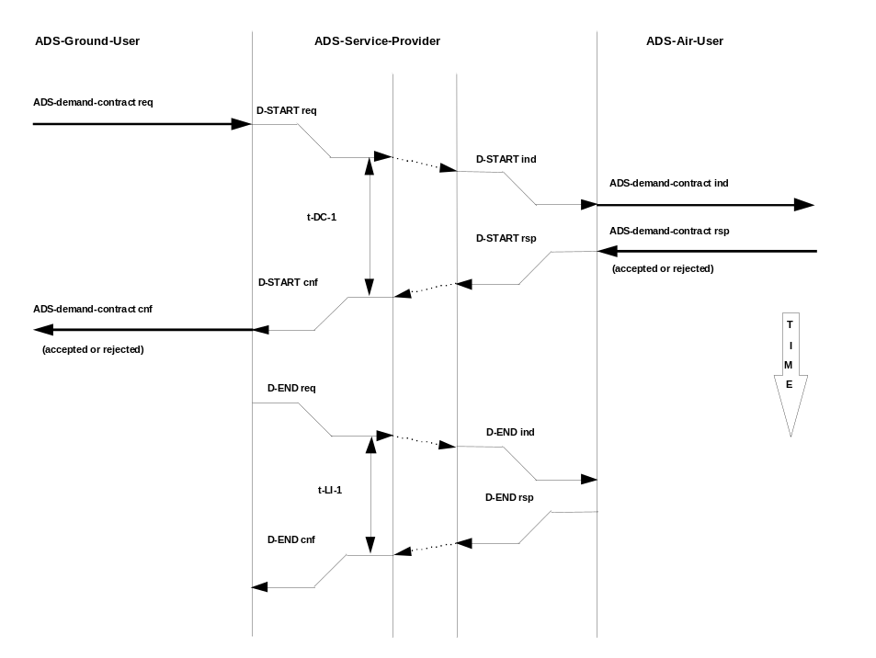
Figure 2.2.1.5-2: Use of demand contract (accepted or rejected) with no dialogue existing

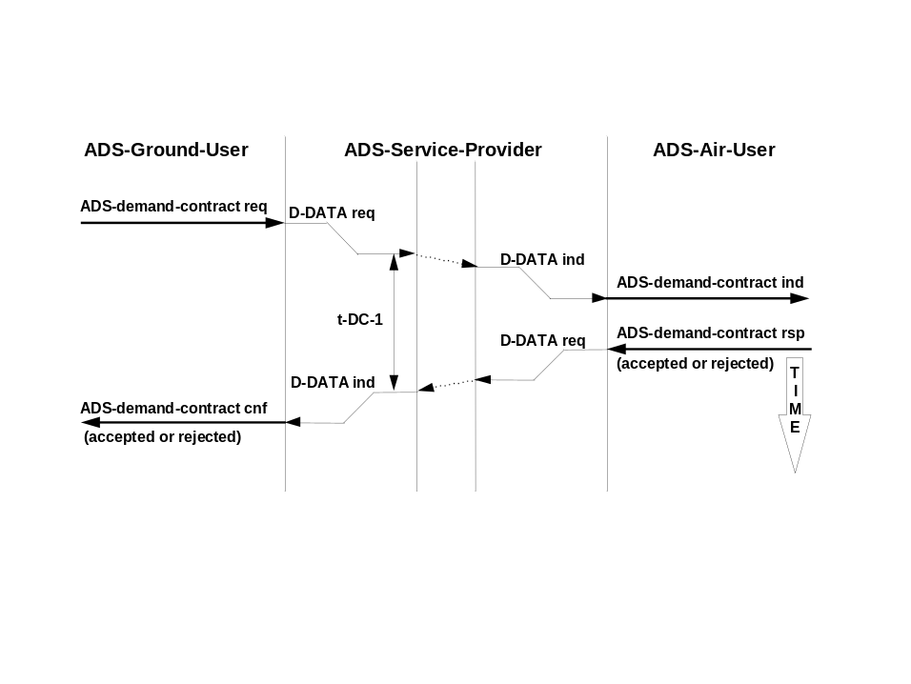
Figure 2.2.1.5-3: Use of demand contract (accepted or rejected) with dialogue existing

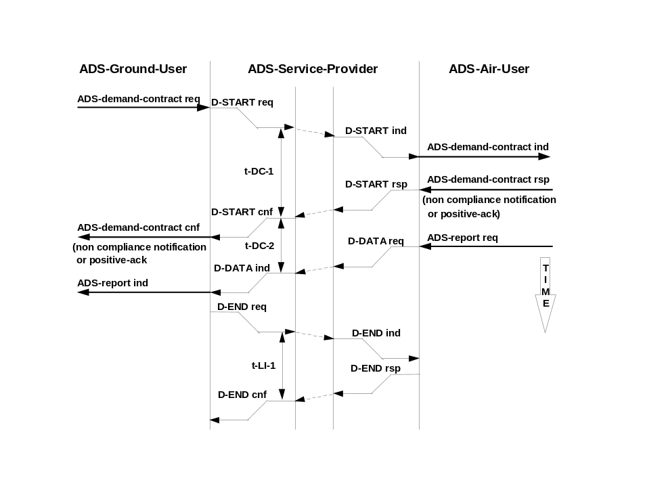
Figure 2.2.1.5-4: Use of demand contract (non compliance notification or
positive acknowledgement) with no dialogue existing
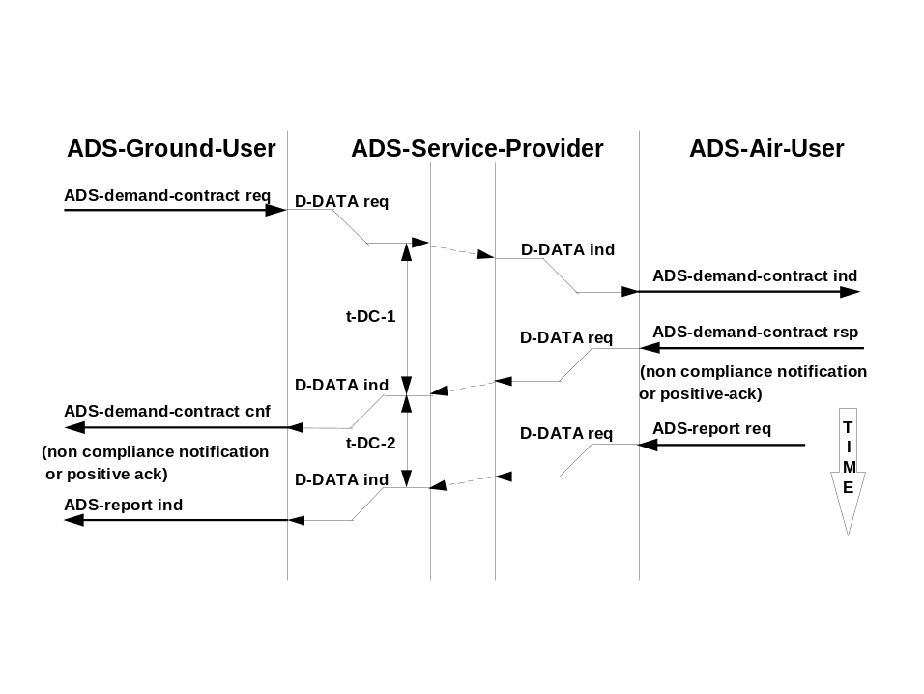
Figure 2.2.1.5-5: Use of demand contract (non compliance notification or
positive acknowledgement) with dialogue existing

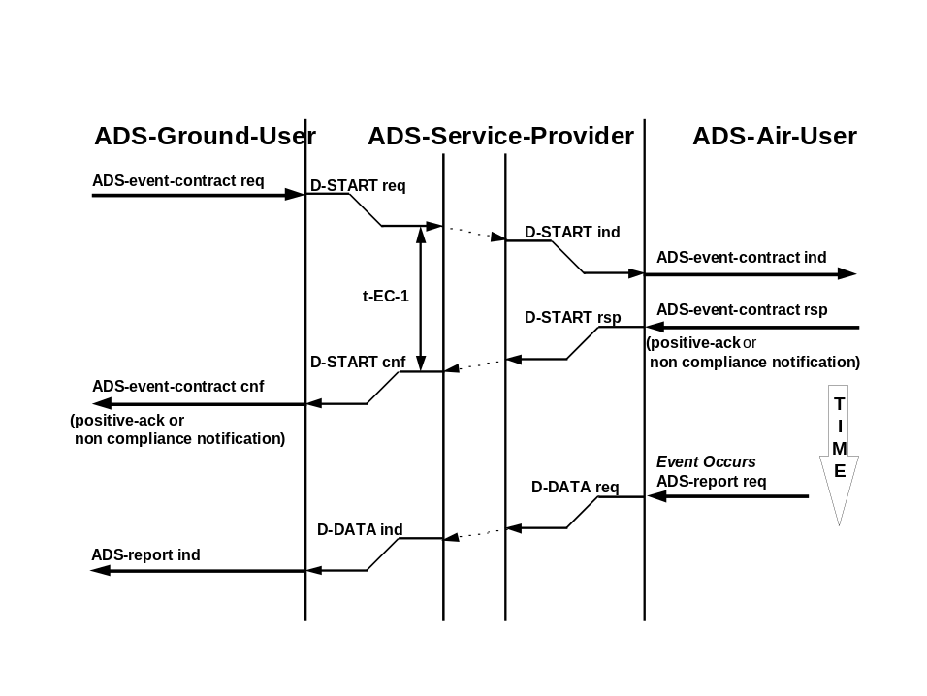
Figure 2.2.1.5-6: Use of event contract (positive acknowledgement or non compliance notification) with no dialogue existing
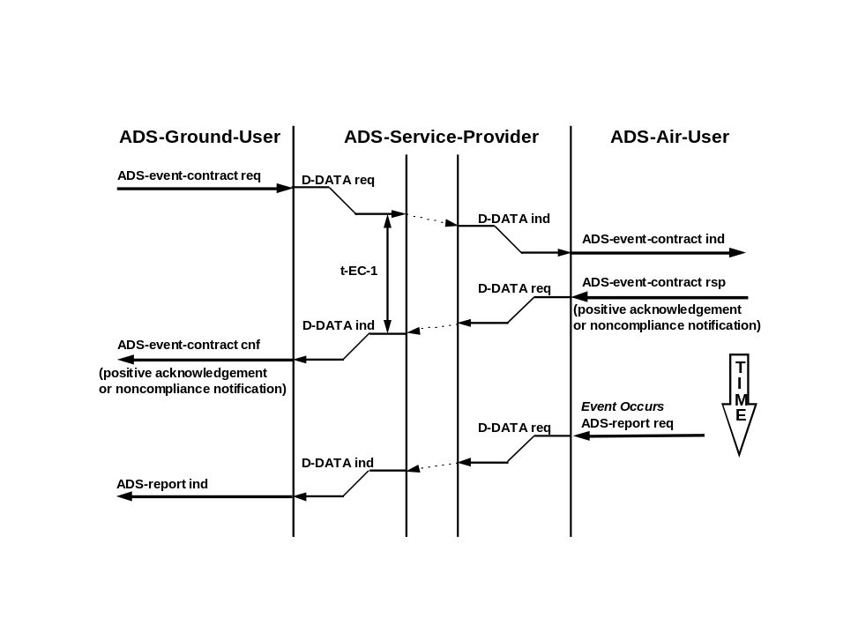
Figure 2.2.1.5-7: Use of event contract (positive acknowledgement or non compliance notification) with dialogue existing

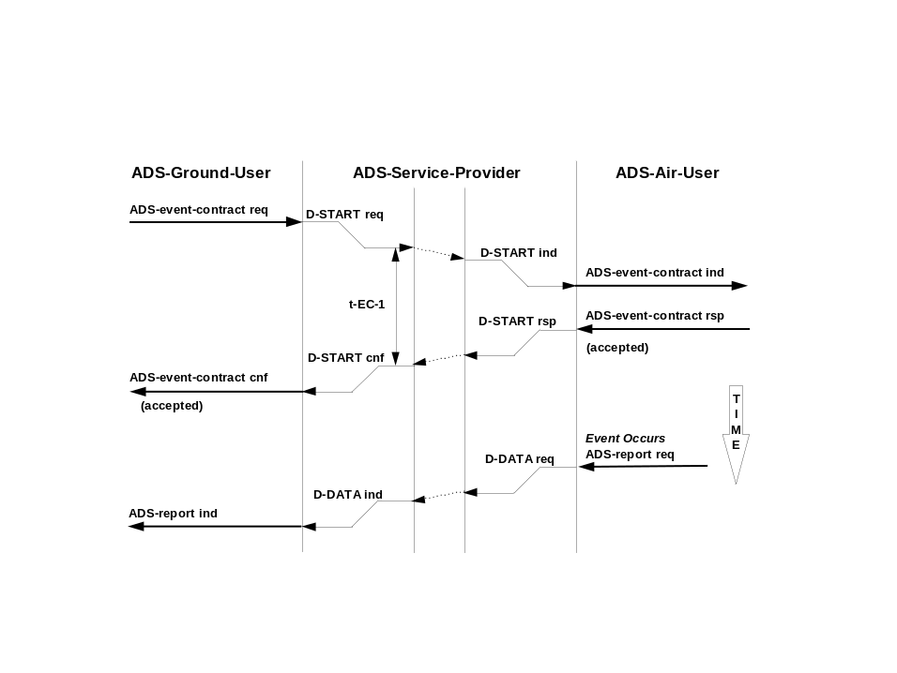
Figure 2.2.1.5-8: Use of event contract (accepted) with no dialogue existing
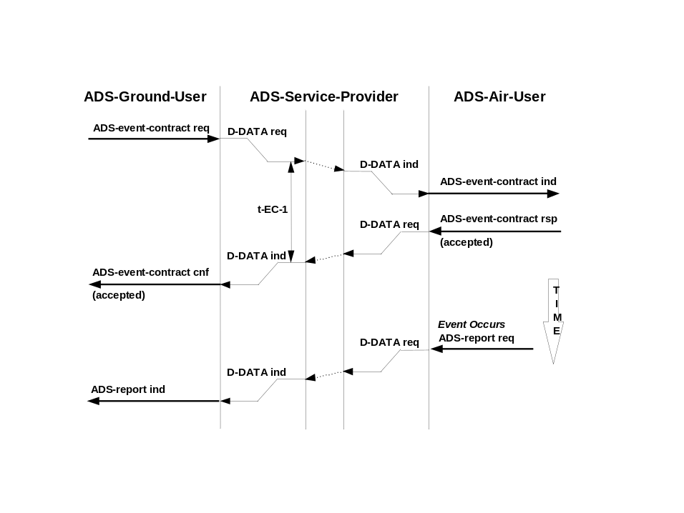
Figure 2.2.1.5-9: Use of event contract (accepted) with dialogue existing

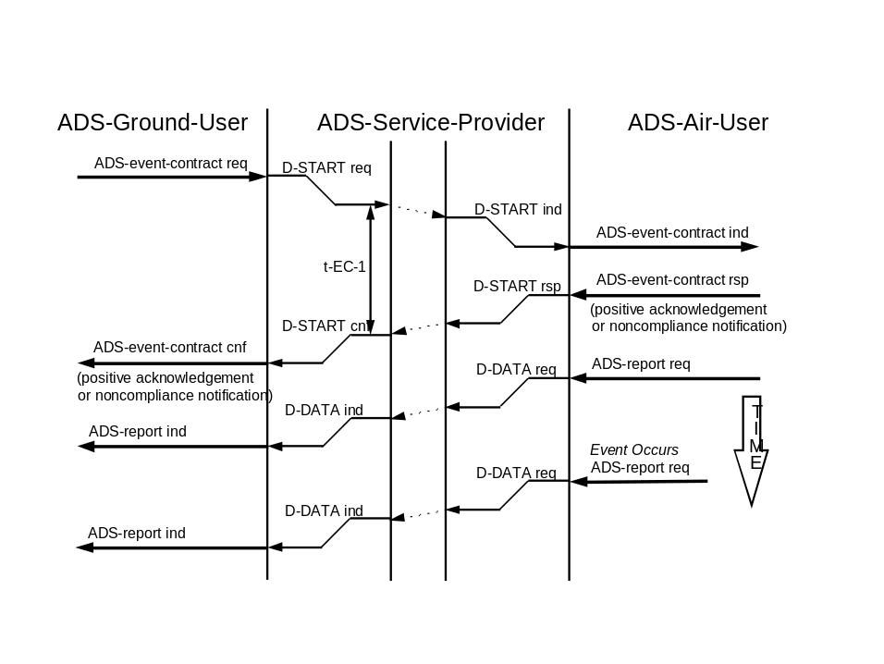
Figure 2.2.1.5-10: Use of event contract (positive acknowledgement or
non compliance notification and immediate report) with no dialogue existing
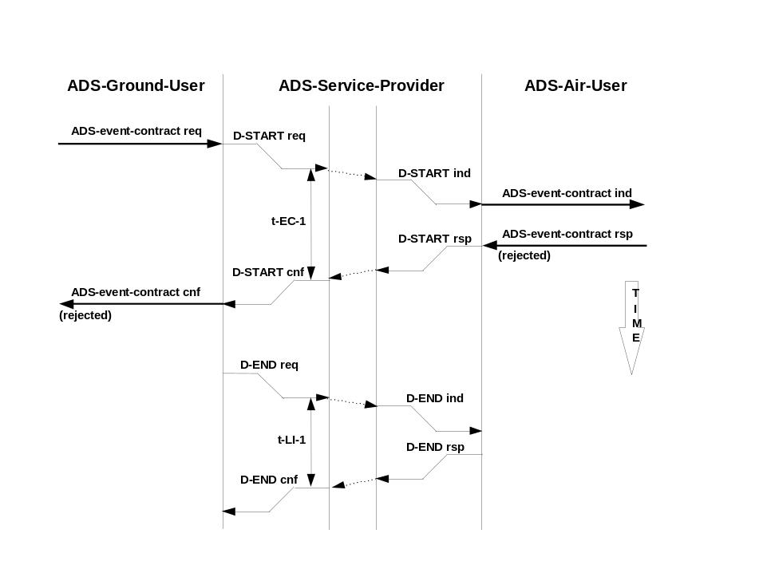
Figure 2.2.1.5-11: Use of event contract (rejected)
with no dialogue existing

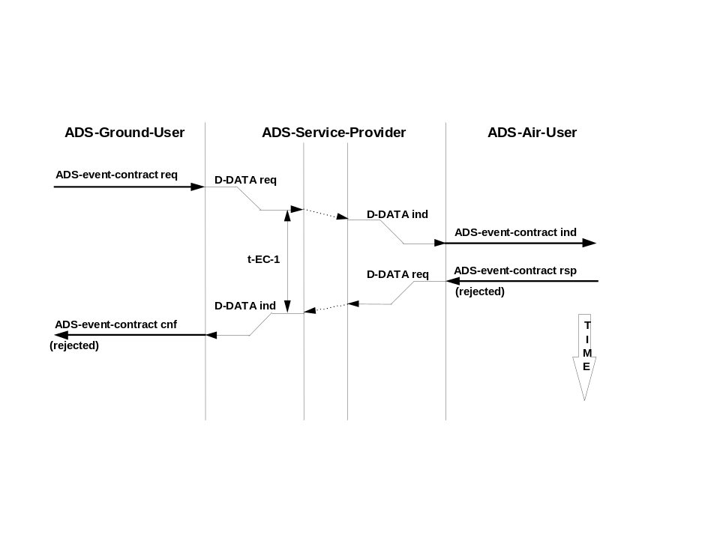
Figure 2.2.1.5-12: Use of event contract (rejected) with dialogue existing
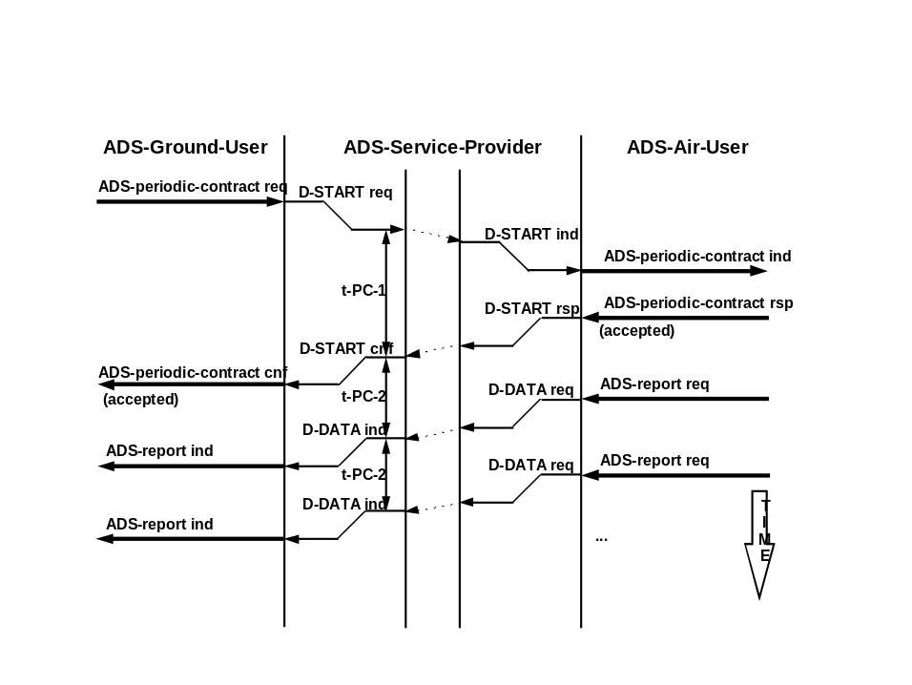
Figure 2.2.1.5-13: Use of periodic contract (accepted) with no dialogue existing

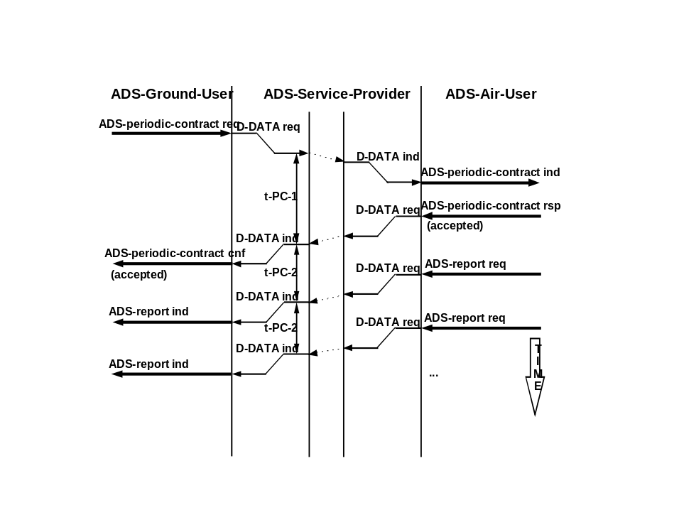
Figure 2.2.1.5-14: Use of periodic contract (positive acknowledgement) with a dialogue existing
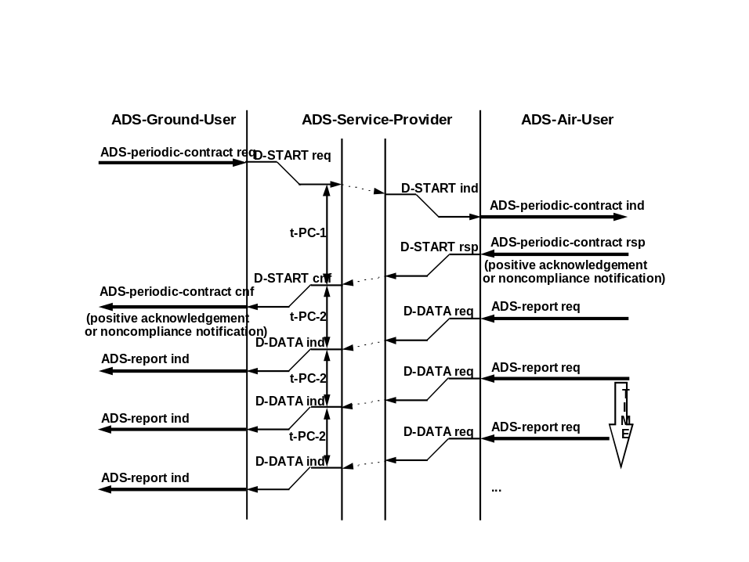
Figure 2.2.1.5-15: Use of periodic contract (positive acknowledgement
or non compliance notification) with no dialogue existing

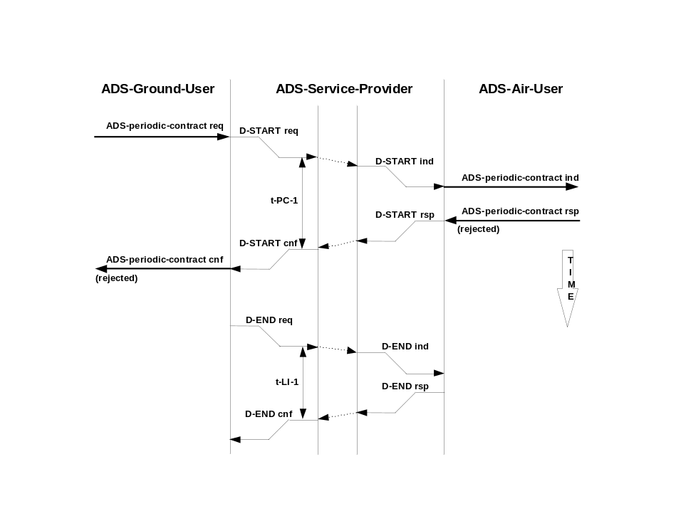
Figure 2.2.1.5-16: Use of periodic contract (rejected) with no dialogue existing
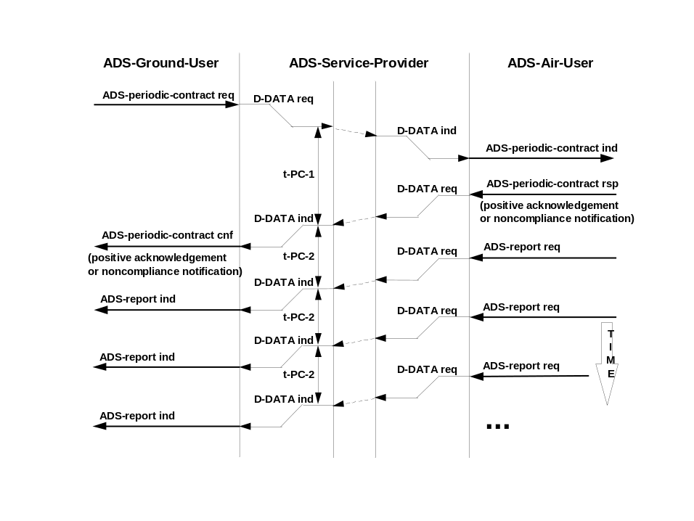
Figure 2.2.1.5-17: Use of periodic contract (positive acknowledgement or
non compliance notification) with dialogue existing

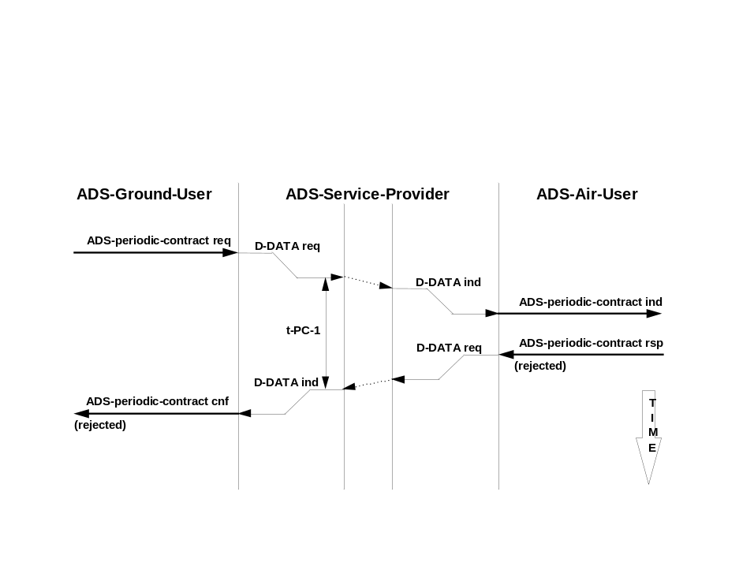
Figure 2.2.1.5-18: Use of periodic contract (rejected) with a dialogue existing
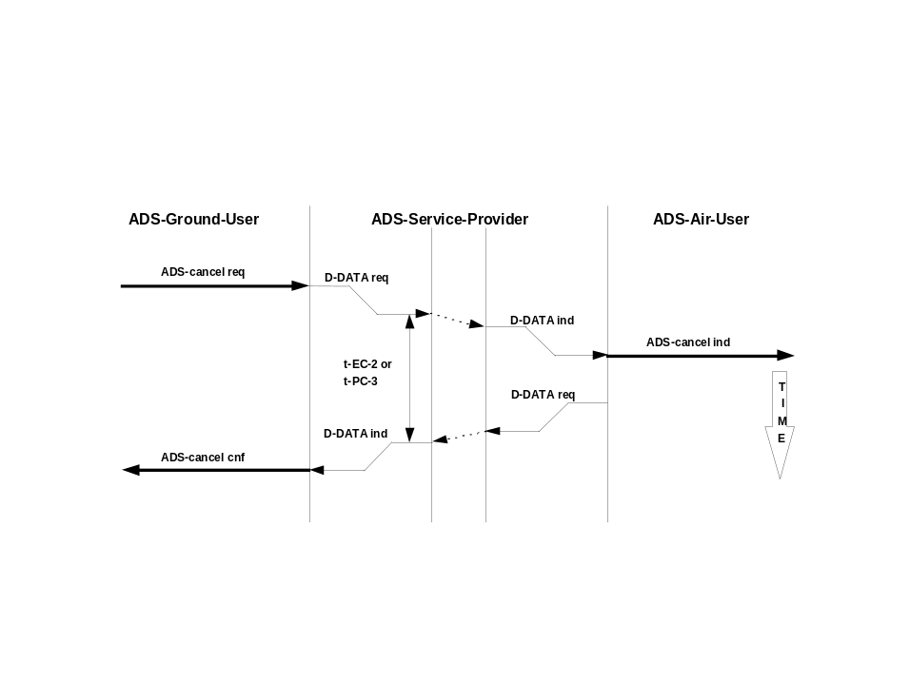
Figure 2.2.1.5-19: Use of ADS-cancel contract service

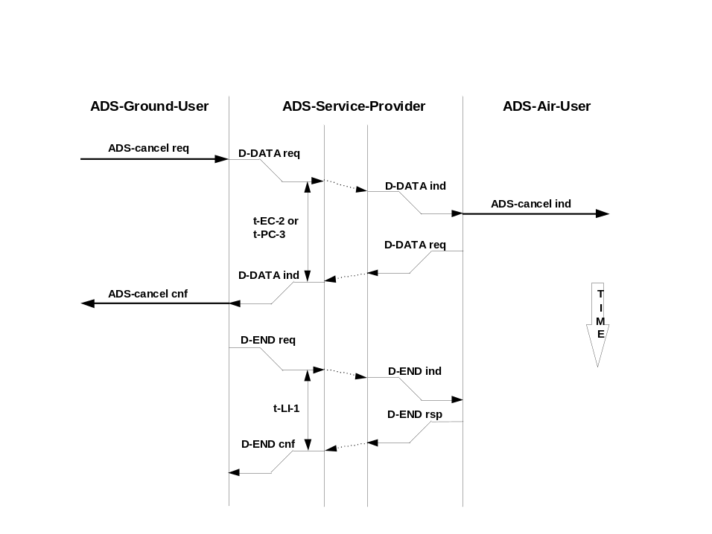
Figure 2.2.1.5-20: Use of ADS-cancel-contract service with only one contract
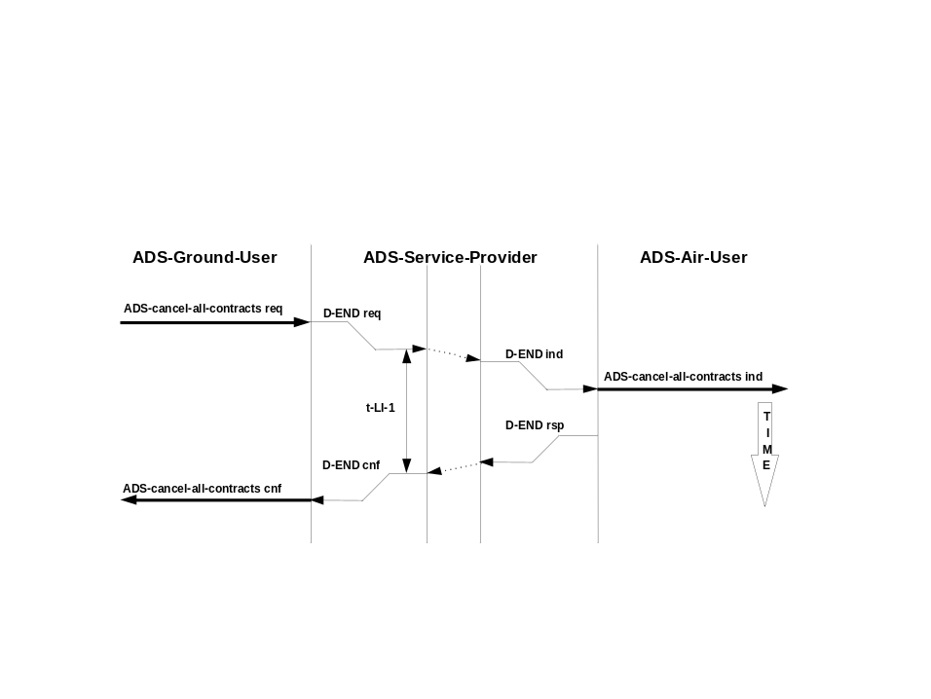
Figure 2.2.1.5-21: Use of ADS-cancel-all-contracts service

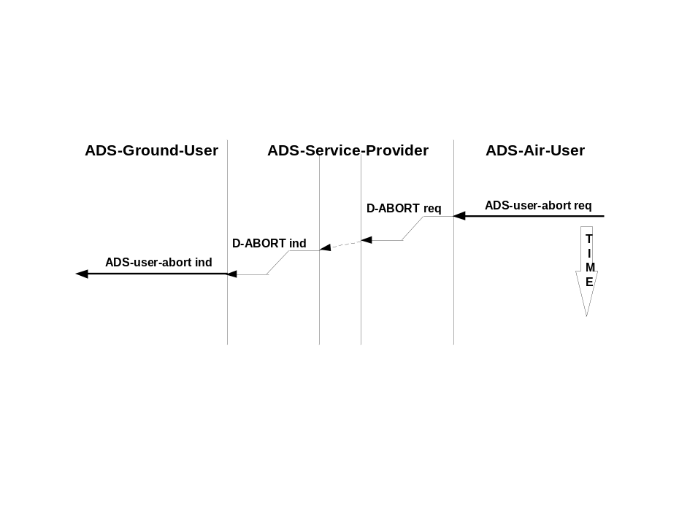
Figure 2.2.1.5-22: Air user abort service

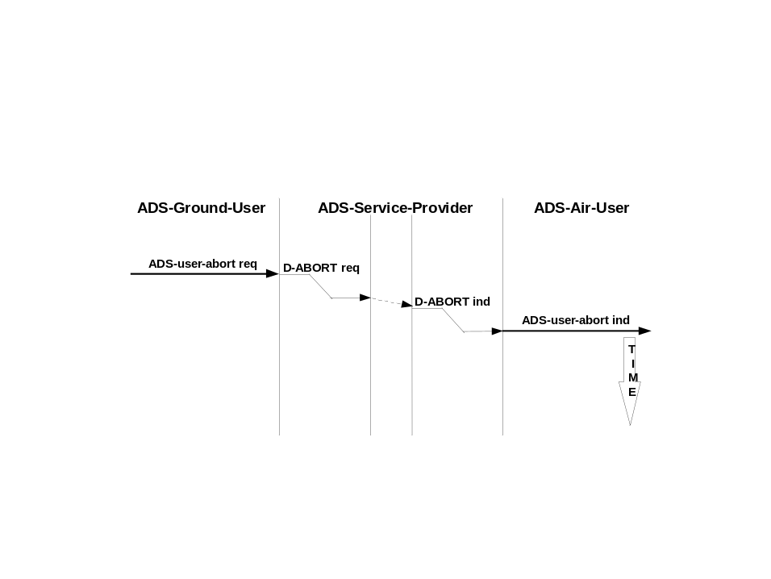
Figure 2.2.1.5-23: Ground user abort service
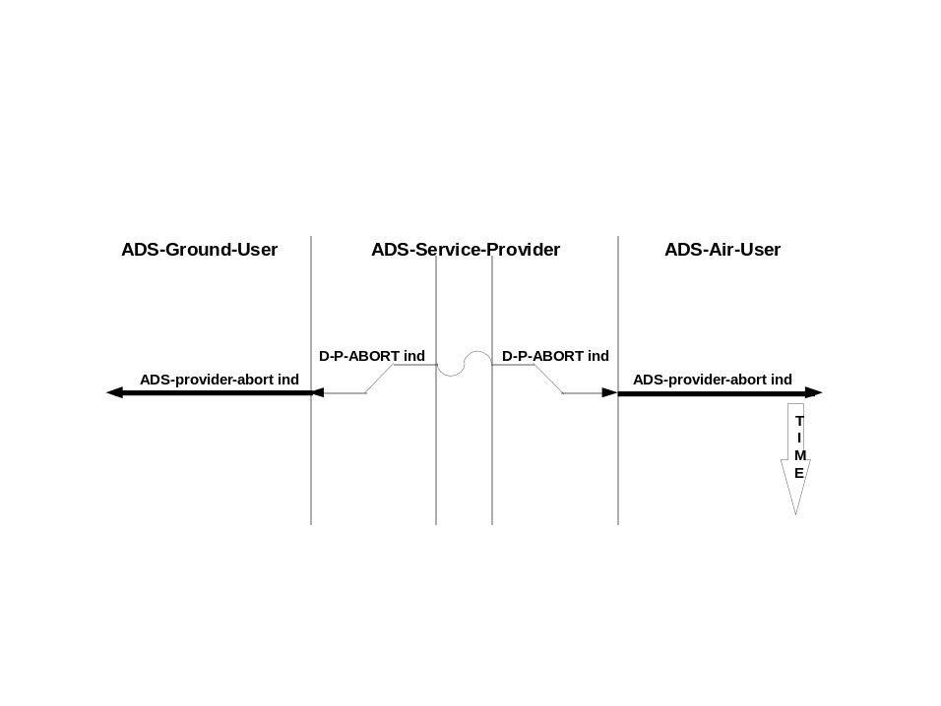
Figure 2.2.1.5-24: Air ASE abort

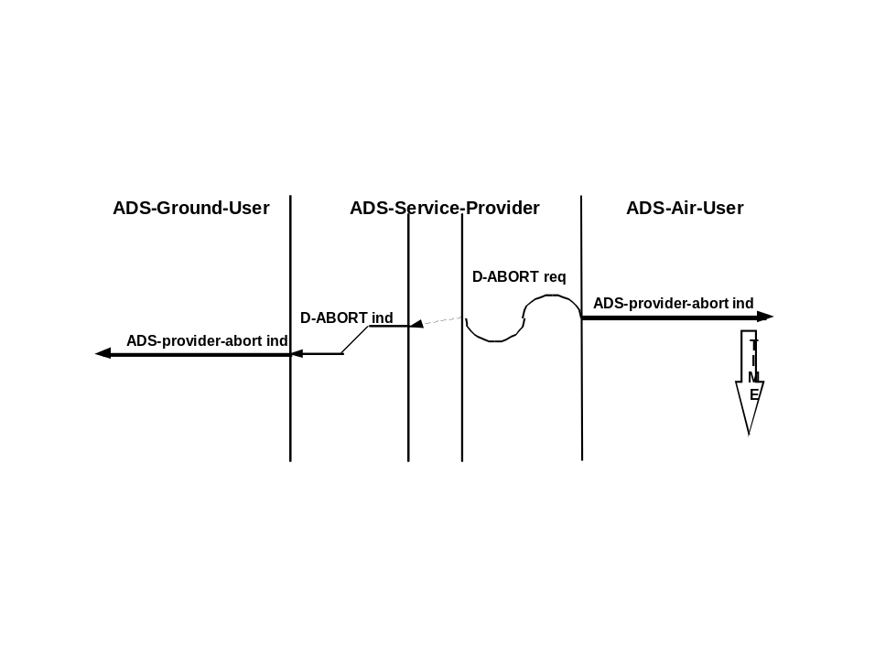
Figure 2.2.1.5-25: Ground ASE abort

ADS-C Service Provider Timers

The ADS-C ASE shall be capable of detecting when a timer expires.

Note 1.— Table 2.2.1.5-1 lists the time constraints related to the ADS-C application. Each time constraint requires a timer to be set in the ADS-C protocol machine.

Note 2.— If the timer expires before the final event has occurred, the ADS-C ASE takes the appropriate action as defined in 2.2.5.4.1.

Recommendation.—The timer values should be as indicated in Table 2.2.1.5-1.

Table 2.2.1.5-9: ADS-C Service Provider Timers
ADS-C service | Timer | Timer Value | Timer Start Event | Timer Stop Event
ADS-demand-contract | t-DC-1 | 6 minutes | ADS-demand-contract request | ADS-demand-contract confirmation
 | t-DC-2 | 3 minutes  30 seconds | ADS-demand-contract confirmation (pos-ack, ncn) | ADS-report indication
ADS-event-  contract | t-EC-1 | 6 minutes | ADS-event-contract request | ADS-event-contract  confirmation
 | t-EC-2 | 6 minutes | ADS-cancel request | ADS-cancel-contract  confirmation
ADS-  periodic-  contract | t-PC-1 | 6 minutes | ADS-periodic-contract request | ADS-periodic-contract  confirmation
 | t-PC-2 | 123 minutes (longest reporting rate + 3 minutes) | ADS-report indication or ADS-periodic-contract confirmation | ADS-report indication
 | t-PC-3 | 6 minutes | ADS-cancel request | ADS-cancel-contract  confirmation
General | t-LI-1 | 6 minutes | D-END request | D-END confirmation

Note.— The receipt of ADS-user-abort request, D-ABORT indication or D-P-ABORT indication are also timer stop events.

ADS-C ASE Protocol Description

Description

ADS-C ASE Functional Model

Note 1.— The ADS-ground-ASE is functionally made of 6 modules as shown in figure 2.2.1.5-32 and the ADS-air-ASE is functionally made of a similar 6 modules as shown in figure 2.2.1.5-33:

a) the ADS-C High Interface Module (ADS-C HI module) interfaces with the ASE-user through the abstract service interface as defined in 2.2.1.3.

b) the ADS-C Demand Contract Module (ADS-C DC module) manages all demand contracts with a single ground system.

c) the ADS-C Event Contract Module (ADS-C EC module) manages event contracts with a single ground system.

d) the ADS-C Periodic Contract Module (ADS-C PC module) manages periodic contracts with a single ground system.

e) the ADS-C Abort Module (ADS-C AB module) handles aborts in case of unrecoverable error.

f) the Low Interface Modules (LI modules) described in this document interfaces the ATN Dialogue Service Provider on behalf of the DC, EC and PC and AB modules.

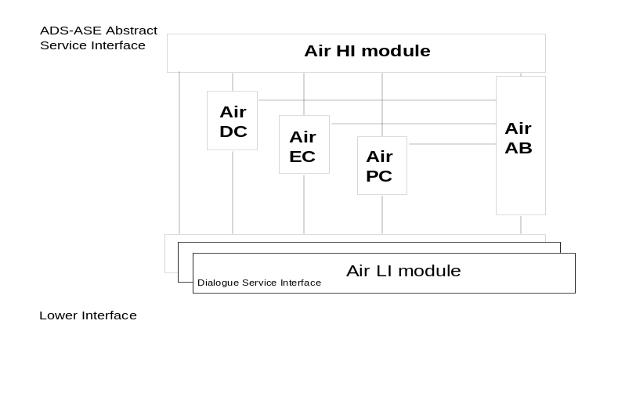

Figure 2.2.1.5-26: Functional model of the ADS-ground-ASE

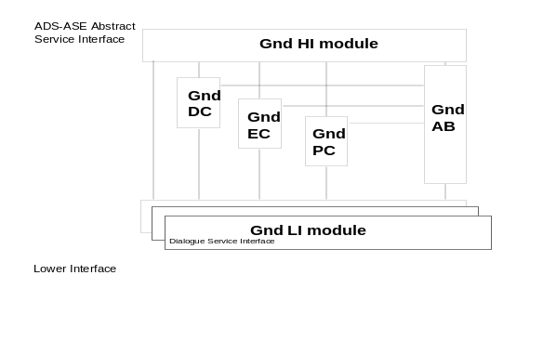

Figure 2.2.1.5-27: Functional model of the ADS-air-ASE

Note 2.— There is no difference between the ADS-ground-ASE and the ADS-air-ASE functional models.

Note 3.— 5.3 describes the actions of the individual modules in both the air and ground systems. 2.2.1.5.6 contains state tables for the individual modules.

Note 4.— The ADS-ground-user is considered an active user from the time at which it invokes the first ADS-demand-contract request, an ADS-event-contract request or an ADS-periodic-contract request until such time that:

a) the ADS-ground-user receives an ADS-cancel-all-contracts confirmation,

b) the ADS-ground-user receives an ADS-cancel confirmation, and there are no other contracts in place,

c) the ADS-ground-user receives an ADS-demand-contract confirmation, an ADS-event-contract confirmation or an ADS-periodic-contract confirmation, with the Result parameter value set to “rejected”, and there are no other contracts in place,

d) the ADS-ground-user receives an ADS-demand-contract confirmation with the Result parameter value set to “accepted” an ADS-report indication, with the Contract type parameter value set to “demand contract”, and there are no other contracts in place,

e) the ADS-ground-user receives an ADS-user-abort indication,

f) the ADS-ground-user receives an ADS-provider-abort indication, or

g) the ADS-ground-user invokes an ADS-user-abort request.

Note 5.— The ADS-air-user is considered an active user from the time at which it receives the first ADS-demand-contract indication, an ADS-event-contract indication or an ADS-periodic-contract indication until such time that:

a) the ADS-air-user receives an ADS-cancel-all-contracts indication,

b) the ADS-air-user receives an ADS-cancel indication, and there are no other contracts in place,

c) the ADS-air-user invokes an ADS-demand-contract response, an ADS-event-contract response or an ADS-periodic-contract response, with the Result parameter value set to “rejected”, and there are no other contracts in place,

d) the ADS-air-user invokes an ADS-demand-contract response with the Result parameter value set to “accepted” an ADS-report request, with the Contract type parameter value set to “demand contract”, and there are no other contracts in place,

e) the ADS-air-user receives an ADS-user-abort indication,

f) the ADS-air-user receives an ADS-provider-abort indication, or

g) the ADS-air-user invokes an ADS-user-abort request.

In 2.2.1.5.3, if no actions are described for an ADS-C service primitive in a particular state, then the invocation of that service primitive shall be prohibited in that state.

Possible errors arising upon Receipt of an APDU or a Dialogue Service Primitive.

If an APDU is not received when one is required, or one is received in an inappropriate dialogue service primitive, then exception handling procedures as described in 2.2.1.5.4.3 shall apply.

Upon receipt of an APDU or dialogue service primitive, if no actions are described for their arrival when in a particular state, then exception handling procedures as described in 2.2.1.5.4.4 shall apply.

Upon receipt of an APDU that cannot be decoded, then exception handling procedures as described in 2.2.1.5.4.7 shall apply.

Ground ADS-C HI Module

Upon receipt of a service primitive, the ADS-C HI module shall pass it to the module as shown in Table 2.2.1.5-10.
Table 2.2.1.5-10: Request and response primitive to ground module mapping
Service Primitive | ADS-ground-ASE Module
ADS-demand-contract request | ADS-C DC
ADS-event-contract request | ADS-C EC
ADS-periodic-contract request | ADS-C PC
ADS-cancel request with contract type “event-contract” | ADS-C EC
ADS-cancel request with contract type “periodic-contract” | ADS-C PC
ADS-cancel-all-contracts request | ADS-C LI
ADS-user-abort request | ADS-C AB

Upon receipt of a request to invoke a service primitive from one of the ground modules in the ADS-ground-ASE as shown in Table 2.2.1.5-11, the ADS-C ground HI module shall do so.
Table 2.2.1.5-11: Indication and confirmation primitive to ground module mapping
ADS-ground-ASE  Module | Service Primitive
ADS-C DC | ADS-demand-contract confirmation
ADS-C EC | ADS-event-contract confirmation
ADS-C PC | ADS-periodic-contract confirmation
ADS-C DC | ADS-report indication with contract type “demand-contract”
ADS-C EC | ADS-report indication with contract type “event-contract”
ADS-C PC | ADS-report indication with contract type “periodic-contract”
ADS-C EC | ADS-cancel confirmation with contract type “event-contract”
ADS-C PC | ADS-cancel confirmation with contract type “periodic-contract”
ADS-C LI | ADS-cancel-all-contracts confirmation

On receipt of a request to invoke ADS-provider-abort indication from the ADS-C ground AB module, the ADS-C ground HI module shall:

a) if the ADS-ground-user is not an active user, take no further action;

b) if the ADS-ground-user is an active user, invoke ADS-provider-abort indication.

On receipt of a request to invoke ADS-user-abort indication from the ADS-C ground AB module, the ADS-C ground HI module shall:

a) if the ADS-ground-user is not an active user, take no further action;

b) if the ADS-ground-user is an active user, invoke ADS-user-abort indication.

The ADS-C ground HI module shall reject requests and responses, apart from ADS-user-abort requests, when the ground LI module is in the LI-G-START state or the LI-G-END state.

Air ADS-C HI Module

Upon receipt of a service primitive, the air HI module shall pass it to the air module as shown in Table 2.2.1.5-12.
Table 2.2.1.5-12: Request and response primitive to air module mapping
Service Primitive | ADS-air-ASE Module
ADS-demand-contract response | ADS-C DC
ADS-event-contract response | ADS-C EC
ADS-periodic-contract response | ADS-C PC
ADS-report request with contract type “event-contract” | ADS-C EC
ADS-report request with contract type “periodic-contract” | ADS-C PC
ADS-user-abort request | ADS-C AB

Upon receipt of a request to invoke a service primitive from one of the air modules in the ADS-air-ASE as shown in Table 2.2.1.5-13, the air HI module shall do so.
Table 2.2.1.5-13: Indication and confirmation primitive to air module mapping
ADS-air-ASE Module | Service Primitive
ADS-C DC | ADS-demand-contract indication
ADS-C EC | ADS-event-contract indication
ADS-C PC | ADS-periodic-contract indication
ADS-C EC | ADS-cancel indication with contract type “event-contract”
ADS-C PC | ADS-cancel indication with contract type “periodic-contract”
ADS-C LI | ADS-cancel-all-contracts indication

On receipt of a request to invoke ADS-provider-abort indication from the ADS-C air AB module, the air HI module shall:

a) if the ADS-air-user is not an active user, take no further action;

b) if the ADS-air-user is an active user, invoke ADS-provider-abort indication.

On receipt of a request to invoke ADS-user-abort indication from the ADS-C air AB module, the air HI module shall:

a) if the ADS-air-user is not an active user, take no further action;

b) if the ADS-air-user is an active user, invoke ADS-user-abort indication.

Ground ADS-C DC Module

Note.— The states defined for the ground ADS-C DC module are the following:

a) DC-G-IDLE

b) DC-G-PENDING

c) DC-G-ACTIVE

On initiation, the ADS-C ground DC module shall be in the DC-G-IDLE state.

Upon receipt of an ADS-demand-contract request:

If in the DC-G-IDLE state, the ADS-C ground DC module shall:

a) create an ADS-contract-PDU with “demand contract” in the contract-type PDU elements and the ADS/IC contract data parameter in the ic-contract-request PDU element,

b) pass it, together with the Aircraft Address parameter value, ICAO Facility Designation parameter value, the Class Of Communication Service parameter value, and the Security Required parameter to the ground LI module,

c) start timer t-DC-1, and

d) enter the DC-G-PENDING state.

Upon receipt of an ADS-accepted-PDU containing the ContractType element set to the abstract value “demand-contract”:

If in the DC-G-PENDING state, the ADS-C ground DC module shall:

a) stop the t-DC-1 timer,

b) request the ADS-C ground HI module to invoke ADS-demand-contract confirmation with “accepted” in the Result parameter and the ic-report element of the ADS-accepted-report-PDU in the ADS/IC Report Data parameter,

c) enter the DC-G-IDLE state.

Upon receipt of an ADS-report-PDU containing the ContractType element set to the abstract value “demand-contract”:

If in the DC-G-ACTIVE state, the ADS-C ground DC module shall:

a) stop the t-DC-2 timer,

b) request the ADS-C ground HI module to invoke ADS-report indication with “demand contract” in the Contract Type parameter and the ic-report element of the ADS-report-PDU in the ADS/IC Report Data parameter, and

c) enter the DC-G-IDLE state.

Upon receipt of an ADS-positive-acknowledgement-PDU containing the ContractType element set to the abstract value “demand-contract”:

If in the DC-G-PENDING state, the ADS-C ground DC module shall:

a) stop the t-DC-1 timer,

b) request the ADS-C ground HI module to invoke ADS-demand-contract confirmation, with “positive-acknowledgement” in the Result parameter and the ic-positive-ack element of the ADS-positive-acknowledgement-PDU in the ADS/IC Positive Acknowledgement parameter,

c) start the t-DC-2 timer,

d) enter the DC-G-ACTIVE state.

Upon receipt of an ADS-rejected-PDU containing the ContractType element set to the abstract value “demand-contract”:

If in the DC-G-PENDING state, the ADS-C ground DC module shall:

a) stop the t-DC-1 timer,

b) request the ADS-C ground HI module to invoke ADS-demand-contract confirmation with “rejected” in the Result parameter and the ic-reject element of the ADS-rejected-PDU in the ADS/IC Reject Data parameter, and

c) enter the DC-G-IDLE state.

Upon receipt of an ADS-ncn-PDU containing the ContractType element set to the abstract value “demand-contract”:

If in the DC-G-PENDING state, the ADS-C ground DC module shall:

a) stop the t-DC-1 timer,

b) request the ADS-C ground HI module to invoke an ADS-demand-contract confirmation with “non compliance notification” in the Result parameter and the ic-ncn element of the ADS-ncn-PDU in the ADS/IC Non Compliance Data parameter,

c) start the t-DC-2 timer, and

d) enter the DC-G-ACTIVE state.

Upon expiry of the t-DC-1 timer or the t-DC-2 timer, the ADS-C ground DC module shall:

a) request the ADS-C ground AB module to abort with reason timer-expiry, and

b) enter the DC-G-IDLE state

Upon receipt of a request from the ground AB or ground LI module to stop operation, the ADS-C ground DC module shall:

a) stop any timers, and

b) enter the DC-G-IDLE state.

Air ADS-C DC Module

Note.— The states defined for the air ADS-C DC module are the following:

a) DC-A-IDLE

b) DC-A-PENDING

c) DC-A-ACTIVE

On initiation, the ADS-C air DC module shall be in the DC-A-IDLE state.

Upon receipt of an ADS-demand-contract response with the Result parameter value set to “rejected”:

If in the DC-A-PENDING state, the ADS-C air DC module shall:

a) create an ADS-rejected-PDU with “demand-contract” in the contract-type element and the ADS/IC Reject Data parameter value in the ic-reject element,

b) pass it to the air LI module, and

c) enter the DC-A-IDLE state.

Upon receipt of an ADS-demand-contract response with the Result parameter value set to “positive-acknowledgement”:

If in the DC-A-PENDING state, the ADS-C air DC module shall:

a) create an ADS-positive-acknowledgement-PDU with “demand-contract” in the contrat-type element and the ic-positive-ack element of the ADS-positive-acknowledgement-PDU in the ADS/IC Positive Acknowledgement parameter,

b) pass it to the air LI module, and

c) enter the DC-A-ACTIVE state.

Upon receipt of an ADS-demand-contract response with the Result parameter value set to “non compliance notification”:

If in the DC-A-PENDING state, the ADS-C air DC module shall:

a) create an ADS-ncn-PDU with “demand-contract” in the contract-type element and the ADS/IC Non Compliance Data parameter value in the ic-ncn element,

b) pass it to the air LI module, and

c) enter the DC-A-ACTIVE state.

Upon receipt of an ADS-demand-contract response with the Result parameter value set to set to “accepted”:

If in the DC-A-PENDING state, the ADS-C air DC module shall:

a) create an ADS-accepted-PDU with “demand-contract” in the contract-type element and the ADS/IC Report Data parameter value in the ic-report element,

b) pass it to the air LI module, and

c) enter the DC-A-IDLE state.

Upon receipt of an ADS-report request containing the ContractType element set to the abstract value “demand-contract”:

If in the DC-A-ACTIVE state, the ADS-C air DC module shall:

a) create ADS-report-PDU with “demand-contract” in the contract-type element and the ADS/IC Report Data parameter value in the ic-report element,

b) pass it to the air LI module, and

c) enter the DC-A-IDLE state.

Upon receipt of an ADS-contract-PDU containing the ContractType element set to the abstract value “demand-contract”:

If in the DC-A-IDLE state, the ADS-C air DC module shall:

a) request the air HI module to invoke ADS-demand-contract indication with the ic-contract-request PDU element in the ADS/IC Contract Data parameter and the Calling peer id PDU element, if provided by the air LI module, in the ICAO Facility Designation parameter, and,

b) enter the DC-A-PENDING state.

Upon receipt of a request from the air AB or air LI module to stop operation, the ADS-C air DC module shall enter the DC-A-IDLE state.

Ground ADS-C EC Module

Note.— The states defined for the ground ADS-C EC module are the following:

a) EC-G-IDLE

b) EC-G-START-PENDING

c) EC-G-ACTIVE

d) EC-G-PENDING

e) EC-G-CANCEL

On initiation, the ADS-C ground EC module shall be in the EC-G-IDLE state.

Upon receipt of an ADS-event-contract request:

If in the EC-G-IDLE state, the ADS-C ground EC module shall:

a) create an ADS-contract-PDU with elements as defined in Table 2.2.1.5-18,

b) pass it, together with the Aircraft Address parameter value, ICAO Facility Designation parameter value, the Class Of Communication Service parameter value, and the Security Required parameter value, to the ground LI module,

c) start timer t-EC-1, and

d) enter the EC-G-START-PENDING state.

If in the EC-G-ACTIVE state, the ADS-C ground EC module shall:

a) create an ADS-contract-PDU with “event-contract” in the contract-type element and the ADS/IC Contract Data parameter in the ic-contract-request element,

b) pass it to the ground LI module,

c) start timer t-EC-1, and

d) enter the EC-G-PENDING state.

Upon receipt of an ADS-cancel request:

If in the EC-G-ACTIVE state, the ADS-C ground EC module shall:

a) create an ADS-cancel-contract-PDU with “event-contract” in the ADS-cancel-contract-PDU element,

b) pass it to the ground LI module,

c) start timer t-EC-2, and

d) enter the EC-G-CANCEL state.

Upon receipt of an ADS-accepted-PDU containing the ContractType element set to the abstract value “event-contract”:

If in the EC-G-PENDING or the EC-G-START-PENDING state, the ADS-C ground EC module shall:

a) stop the t-EC-1 timer,

b) request the ADS-C ground HI module to invoke ADS-demand-contract indication, with “accepted” in the Result parameter and the ic-report element of the ADS-accepted-PDU in the ADS/IC Report Data parameter, and

c) enter the EC-G-ACTIVE state.

Upon receipt of an ADS-report-PDU containing the ContractType element set to the abstract value “event-contract”:

If in the EC-G-ACTIVE, EC-G-PENDING or EC-G-CANCEL state, the ADS-C ground EC module shall

a) request the ADS-C ground HI module to invoke ADS-report indication, with “event contract” in the Contract Type parameter and the ic-report PDU element of the ADS-report-PDU in the ADS/IC Report Data parameter, and

b) remain in the same state.

Upon receipt of an ADS-positive-acknowledgement-PDU containing a ContractType element set to the abstract value “event-contract”:

If in the EC-G-START-PENDING state or the EC-G-PENDING state, the ADS-C ground EC module shall:

a) stop the t-EC-1 timer,

b) request the ADS-C ground HI module to invoke ADS-event-contract confirmation, with “positive- acknowledgement” in the Result parameter and the ic-positive-ack element of the ADS-positive-acknowledgement-PDU in the ADS/IC Positive Acknowledgement parameter, and

c) enter the EC-G-ACTIVE state.

Upon receipt of an ADS-cancel-positive-acknowledgement-PDU containing a RequestType element set to the abstract value “cancel-event-contract”:

If in the EC-G-CANCEL state, the ADS-C ground EC module shall:

a) stop the t-EC-2 timer,

b) request the ADS-C ground HI module to invoke ADS-cancel-contract confirmation, with “event-contract” in the Contract Type parameter, and

c) enter the EC-G-IDLE state.

Upon receipt of an ADS-rejected-PDU containing the ContractType element set to the abstract value “event-contract”:

If in the EC-G-START-PENDING state, the ADS-C ground EC module shall:

a) stop the t-EC-1 timer,

b) request the ADS-C ground HI module to invoke ADS-event-contract confirmation, with “rejected” in the Result parameter and ic-reject element of the ADS-rejected-PDU in the ADS/IC Reject Data parameter, and

c) enter the EC-G-IDLE state.

If in the EC-G-PENDING state, the ADS-C ground EC module shall:

a) stop the t-EC-1 timer,

b) request the ADS-C ground HI module to invoke ADS-event-contract confirmation, with “rejected” in the Result parameter and ic-reject element of the ADS-rejected-PDU in the ADS/IC Reject Data parameter, and

c) enter the EC-G-ACTIVE state.

Upon receipt of an ADS-ncn-PDU:

If in the EC-G-START-PENDING state or the EC-G-PENDING, the ADS-C ground EC module shall:

a) stop the t-EC-1 timer,

b) request the ADS-C ground HI module to invoke ADS-event-contract confirmation, with “non compliance notification” in the Result parameter and the ic-ncn element of the ADS-ncn-PDU in the ADS/IC Non Compliance Data parameter, and

c) enter the EC-G-ACTIVE state.

Upon expiry of the t-EC-1 timer or the t-EC-2 timer, the ADS-C ground EC module shall:

a) request the ADS-C ground AB module to abort with reason timer-expiry, and

b) enter the EC-G-IDLE state

Upon receipt of a request from the ADS-C ground AB module or LI module to stop operation, the EC module shall:

a) stop any timers, and

b) enter the EC-G-IDLE state.

Air ADS-C EC Module

Note.— The states defined for the air ADS-C EC module are the following:

a) EC-A-IDLE

b) EC-A-PENDING

c) EC-A-ACTIVE

d) EC-A-ACTIVE-PENDING

On initiation, the ADS-C air EC module shall be in the EC-A-IDLE state.

Upon receipt of an ADS-event-contract response with the Result parameter value set to the abstract value “positive acknowledgement”:

If in the EC-A-PENDING state or in the EC-A-ACTIVE-PENDING state, the ADS-C air EC module shall:

a) create an ADS-positive-acknowledgement-PDU with “event-contract“ in the contract-type PDU element and the ic-positive-ack element of the ADS-positive-acknowledgement-PDU in the ADS/IC Positive Acknowledgement parameter,

b) pass it to the air LI module, and

c) enter the EC-A-ACTIVE state.

Upon receipt of an ADS-event-contract response with the Result parameter value set to the abstract value “non compliance notification”:

If in the EC-A-PENDING state or in the EC-A-ACTIVE-PENDING state, the ADS-C air EC module shall:

a) create an ADS-ncn-PDU with “event-contract” in the contract-type PDU element and the ADS/IC Non Compliance Data parameter value in the ic-ncn PDU element,

b) pass it to the air LI module, and

- enter the EC-A-ACTIVE state.

Upon receipt of an ADS-event-contract response with the Result parameter value set to the abstract value “rejected”:

If in the EC-A-PENDING state, the ADS-C air EC module shall:

a) create an ADS-rejected-PDU with “event-contract“ in the Contract-Type PDU element and the ADS/IC Reject Data parameter value in the ic-reject PDU element,

b) pass it to the air LI module, and

c) enter the EC-A-IDLE state.

If in the EC-A-ACTIVE-PENDING state, the ADS-C air EC module shall:

a) create an ADS-rejected-PDU with “event-contract“ in the Contract-Type PDU element and the ADS/IC Reject Data parameter value in the ic-reject PDU element,

b) pass it to the air LI module, and

c) enter the EC-A-ACTIVE state.

Upon receipt of an ADS-event-contract response with the Result parameter value set to the abstract value “accepted”:

If in the EC-A-PENDING state or in the EC-A-ACTIVE-PENDING state, the ADS-C air EC module shall:

a) create an ADS-accepted-PDU with “event-contract“ in the request-type PDU element and the ADS/IC Report Data parameter value in the ic-report PDU element,

b) pass it to the air LI module, and

c) enter the EC-A-ACTIVE state.

Upon receipt of an ADS-report request PDU containing the ContractType element set to the abstract value “event-contract”:

If in the EC-A-ACTIVE state, the ADS-C air EC module shall:

a) create an ADS-report-PDU with “event-contract” in the contract-type PDU element and the ADS/IC Report Data parameter value in the ic-report PDU element,

b) pass it to the air LI module, and

c) remain in the EC-A-ACTIVE state.

Upon receipt of an ADS-contract-PDU containing the ContractType element set to the abstract value “event-contract”:

If in the EC-A-IDLE state, the ADS-C air EC module shall:

a) request the air HI module to invoke ADS-event-contract indication with the ic-contract-request PDU element in the ADS/IC Contract Data parameter and the Calling peer id, if provided by the air LI module, in the ICAO Facility Designation parameter, and

b) enter the EC-A-PENDING state.

If in the EC-A-ACTIVE state, the ADS-C air EC module shall:

a) request the air HI module to invoke ADS-event-contract indication with the ic-contract-request PDU element in the ADS/IC Contract Data parameter and the Calling peer id, if provided by the air LI module, in the ICAO Facility Designation parameter, and

b) enter the EC-A-ACTIVE-PENDING state.

Upon receipt of an ADS-cancel-contract-PDU:

If in the EC-A-ACTIVE state, the ADS-C air EC module shall:

a) request the ADS-C HI module to invoke ADS-cancel indication with “event-contract” in the Contract Type parameter,

b) create an ADS-cancel-positive-acknowledgement-PDU with “cancel-event-contract” in the Request type PDU element,

c) pass it to the air LI module, and

- enter the EC-A-IDLE state.

If in the EC-A-IDLE state, the ADS-C air EC module shall:

a) create an ADS-cancel-negative-acknowledgement-PDU with “cancel-event-contract” for the RequestType element and “no-such-contract” for the RejectReason element in the CancelRejectReason PDU element,

c) pass it to the air LI module, and

d) remain in the EC-A-IDLE state.

Upon receipt of a request from the air AB or air LI module to stop operation, the ADS-C air EC module shall enter the EC-A-IDLE state.

Ground ADS-C PC Module

Note.— The states defined for the ground ADS-C PC module are the following:

a) PC-G-IDLE

b) PC-G-START-PENDING

c) PC-G-ACTIVE

d) PC-G-PENDING

e) PC-G-CANCEL

On initiation, the ADS-C ground PC module shall be in the PC-G-IDLE state.

Upon receipt of an ADS-periodic-contract request:

If in the PC-G-IDLE state, the ADS-C ground PC module shall:

a) create an ADS- contract-PDU with “periodic-contract” in the contract-type PDU element and the ADS/IC contract data parameter value in the ic-contract-request PDU element,

b) pass it, together with the Aircraft Address parameter value, ICAO Facility Designation parameter value, the Class of Communication Service parameter value and the Security Required parameter value, to the ground LI module,

c) start timer t-PC-1, and

d) enter the PC-G-START-PENDING state.

If in the PC-G-ACTIVE state, the PC module shall:

a) stop the t-PC-2 timer,

b) create an ADS- contract-PDU with “periodic-contract” in the contract-type PDU element and the ADS/IC contract data parameter value in the ic-contract-request PDU element,

c) pass it to the ground LI module,

d) start timer t-PC-1, and

e) enter the PC-G-PENDING state.

Upon receipt of an ADS-cancel request containing the ContractType element set to the abstract value “periodic-contract”:

If in the PC-G-ACTIVE state, the ADS-C ground PC module shall:

a) stop the t-PC-2 timer,

b) create an ADS-cancel-contract-PDU with “periodic-contract” in the ADS-cancel-contract-PDU element,

c) pass it to the ground LI module,

d) start timer t-PC-3, and

e) enter the PC-G-CANCEL state.

Upon receipt of an ADS-accepted-PDU containing the ContractType element set to the abstract value “periodic-contract”:

If in the PC-G-START-PENDING state, or the PC-G-PENDING state, the ADS-C ground PC module shall:

a) stop the t-PC-1 timer,

b) create the ADS/IC report data parameter of an ADS-periodic-indication,

c) request the ADS-C ground HI module to invoke ADS-periodic-contract indication with “accepted” in the Result parameter and the ic-report PDU element of the ADS-accepted-PDU in the ADS/IC Report Data parameter,

d) start the t-PC-2 timer,

e) enter the PC-G-ACTIVE state.

Upon receipt of an ADS-report-PDU:

If in the PC-G-PENDING state, the ADS-C ground PC module shall:

a) request the ADS-C ground HI module to invoke ADS-report indication with “periodic-contract“ in the Contract Type parameter and the ic-report PDU element of the ADS-report-PDU in the ADS/IC Report Data parameter,

b) remain in the PC-G-PENDING state.

If in the PC-G-ACTIVE state, the ADS-C ground PC module shall:

a) stopt the t-PC-2 timer,

b) request the ADS-C ground HI module to invoke ADS-report indication with “periodic-contract“ in the Contract Type parameter and the ic-report PDU element of the ADS-report-PDU in the ADS/IC Report Data parameter,

c) start the t-PC-2 timer,

d) remain in the PC-G-ACTIVE state.

If in the PC-G-CANCEL state, the ADS-C ground PC module shall:

a) request the ADS-C ground HI module to invoke ADS-report indication with “periodic-contract“ in the Contract Type parameter and the ic-report PDU element of the ADS-report-PDU in the ADS/IC Report Data parameter, and

b) remain in the PC-G-CANCEL state.

Upon receipt of an ADS-positive-acknowledgement-PDU containing a ContractType element set to the abstract value “periodic-contract”:

If in the PC-G-START-PENDING state, or the PC-G-PENDING state, the ADS-C ground PC module shall:

a) stop the t-PC-1 timer,

b) request the ADS-C ground HI module to invoke ADS-periodic-contract confirmation with “positive acknowledgement” in the Result parameter and the ic-positive-ack element of the ADS-positive-acknowledgement-PDU in the ADS/IC Positive Acknowledgement parameter,

c) start the t-PC-2 timer,

c) enter the PC-G-ACTIVE state.

Upon receipt of an ADS-cancel-positive-acknowledgement-PDU containing a RequestType element set to the abstract value “cancel-periodic-contract”:

If in the PC-G-CANCEL state, the ADS-C ground PC module shall:

a) stop the t-PC-3 timer,

b) request the ADS-C ground HI module to invoke ADS-cancel-contract confirmation with “periodic-contract“ in the Contract Type parameter, and

c) enter the PC-G-IDLE state.

Upon receipt of an ADS-rejected-PDU containing the ContractType element set to the abstract value “periodic-contract”:

If in the PC-G-START-PENDING state, the ADS-C ground PC module shall:

a) stop the t-PC-1 timer,

b) request the ADS-C ground HI module to invoke ADS-periodic-contract confirmation with parameter values derived as in Table 2.2.1.5-40, and

c) enter the PC-G-IDLE state.

If in the PC-G-PENDING state, the ADS-C ground PC module shall:

a) stop the t-PC-1 timer,

b) request the ADS-C ground HI module to invoke ADS-periodic-contract confirmation with “rejected” in the Result parameter and the ic-reject element of the ADS-rejected-PDU in the ADS/IR Reject Data parameter,

c) start the t-PC-2 timer,

c) enter the PC-G-ACTIVE state.

Upon receipt of an ADS-ncn-PDU containing the ContractType element set to the abstract value “periodic-contract”:

If in the PC-G-START-PENDING state, or the PC-G-PENDING state, the ADS-C ground PC module shall:

a) stop the t-PC-1 timer,

b) request the ADS-C ground HI module to invoke ADS-periodic-contract confirmation with “non compliance notification” in the Result parameter and the ic-ncn element of the ADS-ncn-PDU in the ADS/IC Non Compliance Data parameter,

c) start the t-PC-2 timer, and

d) enter the PC-G-ACTIVE state.

Upon receipt of a request from the ground AB or ground LI module to stop operation, the ADS-C ground PC module shall:

a) stop any timers,

b) enter the PC-G-IDLE state.

Upon expiry of the t-PC-1 timer, t-PC-2 timer, or t-PC-3 timer, the ADS-C ground PC module shall:

a) request the ADS-C ground AB module to abort with reason timer-expiry, and

b) enter the PC-G-IDLE state.

Air ADS-C PC Module

Note.— The states defined for the air ADS-C PC module are the following:

a) PC-A-IDLE

b) PC-A-PENDING

c) PC-A-ACTIVE

d) PC-A-ACTIVE-PENDING

On initiation, the ADS-C air PC module shall be in the PC-A-IDLE state.

Upon receipt of an ADS-periodic-contract response with the Result parameter value set to the abstract value “positive acknowledgement”, then:

If in the PC-A-PENDING state or PC-A-ACTIVE-PENDING state, the ADS-C air PC module shall:

a) If the Result parameter value contains the abstract value “positive acknowledgement”, create an ADS-positive-acknowledgement-PDU with “periodic-contract“ in the contract-type PDU element and the ic-positive-ack element of the ADS-positive-acknowledgement-PDU in the ADS/IC Positive Acknowledgement parameter,

b) pass it to the air LI module, and

c) enter the PC-A-ACTIVE state.

Upon receipt of an ADS-periodic-contract response with the Result parameter value set to the abstract value “non compliance notification”, then:

If in the PC-A-PENDING state or PC-A-ACTIVE-PENDING state, the ADS-C air PC module shall:

a) If the Result parameter value contains the abstract value “non compliance notification”, create an ADS-ncn-PDU with “periodic-contract” in the contract-type PDU element and the ADS/IC Non Compliance Data parameter value in the ic-ncn PDU element,

b) pass it to the air LI module, and

c) enter the PC-A-ACTIVE state.

Upon receipt of an ADS-periodic-contract response with the Result parameter value set to the abstract value “rejected”, then:

If in the PC-A-PENDING state, the ADS-C air PC module shall:

a) create an ADS-rejected-PDU with “periodic-contract “ in the contract-type PDU element and the ADS/IC Reject Data parameter value in the ic-ncn PDU element,

b) pass it to the air LI module, and

c) enter the PC-A-IDLE state.

If in the PC-A-ACTIVE-PENDING state, the ADS-C air PC module shall:

a) create an ADS-rejected-PDU with “periodic-contract “ in the contract-type PDU element and the ADS/IC Reject Data parameter value in the ic-ncn PDU element,

b) pass it to the air LI module, and

c) enter the PC-A-ACTIVE state.

Upon receipt of an ADS-periodic-contract response with the Result parameter value set to the abstract value “accepted”, then:

If in the PC-A-PENDING state or PC-A-ACTIVE-PENDING, the ADS-C air PC module shall:

a) create ADS- -accepted-PDU with “periodic-contract “ in the contract-type PDU element and the ADS/IC Report Data parameter value in the ic-report PDU element,

b) pass it to the air LI module, and

c) enter the PC-A-ACTIVE state.

Upon receipt of an ADS-report request containing the ContractType element set to the abstract value “periodic-contract”:

If in the PC-A-ACTIVE state, the ADS-C air PC module shall:

a) create ADS-report-PDU with “periodic-contract” in the contract-type PDU element and the ADS/IC Report Data parameter value in the ic-report PDU element,

b) pass it to the air LI module, and

c) remain in the PC-A-ACTIVE state.

Upon receipt of an ADS-contract-PDU containing the ContractType element set to the abstract value “periodic-contract”:

If in the PC-A-IDLE state, the ADS-C air PC module shall:

a) request the air HI module to invoke ADS-periodic-contract indication with the ic-contract-request PDU element in the ADS/IC Contract Data parameter and the Calling peer id, if provided by the air LI module, in the ICAO Facility Designation parameter, and

b) enter the PC-A-PENDING state.

If in the PC-A-ACTIVE state, the ADS-C air PC module shall:

a) request the air HI module to invoke ADS-periodic-contract indication with the ic-contract-request PDU element in the ADS/IC Contract Data parameter and the Calling peer id, if provided by the air LI module, in the ICAO Facility Designation parameter, and

b) enter the PC-A-ACTIVE-PENDING state.

Upon receipt of an ADS-cancel-contract-PDU containing the ContractType element set to the abstract value “periodic-contract”, then:

If in the PC-A-ACTIVE state, the ADS-C air PC module shall:

a) request the air HI module to invoke ADS-cancel indication with “periodic-contract” in the Contract Type parameter,

b) create an ADS-cancel-positive-acknowledgement-PDU with “cancel-periodic-contract” in the RequestType PDU element,

c) pass it to the air LI module, and

d) enter the PC-A-IDLE state.

If in the PC-A-IDLE state, the ADS-C air PC module shall:

a) create an ADS-cancel-negative-acknowledgement-PDU with “cancel-periodic-contract” in the RequestType element and “no-such-contract” in the RejectReason element of the CancelRejectReason PDU element,

b) pass it to the air LI module, and

c) remain in the PC-A-IDLE state.

Upon receipt of a request from the air AB or air LI module to stop operation, the ADS-C air PC module shall enter the PC-A-IDLE state.

Ground and Air ADS-C AB Modules

Note.— All statements in 5.3.14 apply to both the ADS-C ground AB module and the ADS-C air AB module.

Upon receipt of an ADS-user-abort request, the ADS-C AB module shall:

a) request the DC, EC and PC modules to stop operation,

b) create an ADS-user-abort-PDU with the UserAbortReason PDU element derived from the reason parameter, and

c) request the LI module to invoke D-ABORT request with “user” in the originator parameter and the the ADS-user-abort-PDU in the user data parameter.

Upon receipt of a request to abort, the ADS-C AB module shall:

a) request the DC, EC and PC modules to stop operation,

b) create an ADS-provider-abort-PDU with the value provided by DC, EC or PC module in the AbortReason PDU element,

c) request the LI module to invoke D-ABORT request with “provider” in the Originator parameter and the ADS-provider-abort-PDU in the User Data parameter, and

d) request the ADS-C HI module to invoke ADS-provider-abort indication with the value provided by DC, EC or PC module in the Reason parameter.

Upon receipt of a D-P-ABORT indication, the ADS-C AB module shall:

a) request the DC, EC and PC modules to stop operation, and

b) request the ADS-C HI module to invoke ADS-provider-abort indication with “communications-service-failure” in the Reason parameter.

Upon receipt of a D-ABORT indication with the originator parameter value set to the abstract value “user” and with an ADS-user-data-PDU in the User Data parameter, the ADS-C AB module shall:

a) request the DC, EC and PC modules to stop operation, and

b) request the ADS-C HI module to invoke ADS-user-abort indication with the value of the User Data parameter in the Reason parameter.

Upon receipt of a D-ABORT indication with the originator parameter value set to the abstract value “provider” and with data in the User Data parameter, the ADS-C AB module shall:

a) request the DC, EC and PC modules to stop operation, and

b) request the ADS-C HI module to invoke ADS-provider-abort indication with the value of the User Data parameter in the Reason parameter.

Ground ADS-C LI Module

Note.— The states defined for the ground ADS-C ATN LI module are the following:

a) LI-G-IDLE

b) LI-G-START

c) LI-G-ACTIVE

d) LI-G-END

On initiation, the ground LI module shall be in the LI-G-IDLE state.

Upon receipt of an ADS-contract-PDU from the ground DC, EC or PC modules:

If in the LI-G-IDLE state, the ground LI module shall:

a) Invoke D-START request using parameter values as shown in Table 2.2.1.5-14, and

b) enter the LI-G-START state.

Table 2.2.1.5-14: D-START request parameter values
D-START parameter | Source
Called peer Id | Aircraft address parameter value from contract request
Calling peer Id | ICAO Facility Designation parameter value from contract request
DS-user version number | Not used
Security requirements | Security Required parameter value from contract request
Quality of service | Routing class: ATSC, with value from Class of Communication Service parameter value from contract request  Priority: High priority flight safety messages  RER: Low
User data | The contract PDU passed to LI

If in the LI-G-ACTIVE state, the ground LI module shall:

a) Invoke D-DATA request with the PDU as the user data parameter value, and

b) remain in the LI-G-ACTIVE state.

Upon receipt of an ADS-cancel-all-contracts request:

If in the LI-G-ACTIVE state, the ground LI module shall:

a) Invoke D-END req with ADS-cancel-all-contracts-PDU in the user data,

b) start the t-LI-1 timer, and

c) enter the LI-G-END state.

Upon receipt of an ADS-cancel-contract-PDU from the ground EC or PC modules:

If in the LI-G-ACTIVE state, the ground LI module shall:

a) invoke D-DATA req with the PDU in the user data,

b) if the DC module is in the DC-G-IDLE state, and the EC module is in the EC-G-IDLE state, and the PC module is in the PC-G-IDLE state, then:

1) invoke D-END req with no user data,

2) start the t-LI-1 timer, and

3) enter the LI-G-END state; or

c) otherwise, remain in the LI-G-ACTIVE state.

Upon receipt of request to invoke D-ABORT from the ADS-C ground AB module:

If in the LI-G-START state, the LI-G-ACTIVE state or the LI-G-END state, the ground LI module shall:

a) invoke D-ABORT request with the parameter values supplied, and

b) enter the LI-G-IDLE state.

If in the LI-G-IDLE state, the ground LI module shall ignore the request.

Upon receipt of a D-START confirmation with the Result parameter value containing the abstract value “accepted” and the Security Requirements parameter value containing an abstract value equal to the abstract value set in the D-START request Security Requirements parameter:

Note.— If a secure D-START request was issued (i.e. the Security Requirements parameter was set to “secured exchange”) then the D-START confirmation Security Requirements parameter must be equal to that value. If an unsecure D-START request was issued (i.e. the Security Requirements parameter was set to “no security”) then the D-START confirmation Security Requirements parameter will be equal to that value. .

If in the LI-G-START state, the ground LI module shall:

a) pass the user data to the module as defined in Table 2.2.1.5-15,

b) if, after processing the PDU (i.e. the ADS-C ground HI module has issued the appropriate indication or confirmation), the ADS-C ground DC module is in the DC-G-IDLE state, and the ADS-C ground EC module is in the EC-G-IDLE state, and the ADS-C ground PC module is in the PC-G-IDLE state, then:

1) invoke D-END req with no user data, and

2) start the t-LI-1 timer, and

3) enter the LI-G-END state; or

c) if, after processing the PDU, the ADS-C ground DC module is not in the DC-G-IDLE state, or the ADS-C ground EC module is not in the EC-G-IDLE state, or the ADS-C ground PC module is not in the PC-G-IDLE state, then:

1) enter the LI-G-ACTIVE state.

Upon receipt of a D-DATA indication:

If in the LI-G-ACTIVE state, the ground LI module shall:

a) pass the user data to the module as defined in Table Table 2.2.1.5-15,

b) if, after processing the PDU (i.e. the ADS-C ground HI module has issued the appropriate indication or confirmation), the ADS-C ground DC module is in the DC-G-IDLE state, and the ADS-C ground EC module is in the EC-G-IDLE state, and the ADS-C ground PC module is in the PC-G-IDLE state, then:

1) invoke D-END req with no user data, and

2) start the T-LI-1 timer, and

3) enter the LI-G-END state; or

c) otherwise, remain in the LI-G-ACTIVE state.

If in the LI-G-END state, the ground LI module shall:

a) pass the user data to the module as defined in Table 2.2.1.5-15, and

b) remain in the LI-G-END state.

Table 2.2.1.5-15: PDU to ground module mapping
PDU | Subfield | Ground Module
ADS-report-PDU | contract-type
ADS-report-PDU | “demand-contract” | DC
ADS-report-PDU | “event-contract” | EC
ADS-report-PDU | “periodic-contract” | PC
ADS-accepted-PDU,  ADS-rejected-PDU,  ADS-ncn-PDU | contract-type
ADS-accepted-PDU,  ADS-rejected-PDU,  ADS-ncn-PDU | “demand-contract” | DC
ADS-accepted-PDU,  ADS-rejected-PDU,  ADS-ncn-PDU | “event-contract” | EC
ADS-accepted-PDU,  ADS-rejected-PDU,  ADS-ncn-PDU | “periodic-contract” | PC
ADS-cancel-positive-acknowledgement-PDU | RequestType
ADS-cancel-positive-acknowledgement-PDU | “cancel-event-contract” | EC
ADS-cancel-positive-acknowledgement-PDU | “cancel-periodic-contract” | PC
ADS-positive-acknowledgement-PDU | ContractType
ADS-positive-acknowledgement-PDU | “demand-contract” | DC
ADS-positive-acknowledgement-PDU | “event-contract” | EC
ADS-positive-acknowledgement-PDU | “periodic-contract” | PC
ADS-cancel-negative-acknowledgement-PDU | RequestType

Upon receipt of a D-END confirmation with the Result parameter value containing the abstract value “accepted”:

If in the LI-G-END state, the ground LI module shall:

a) stop the t-LI-1 timer,

b) if the user data parameter value contains an ADS-cancel-positive-acknowledgement-PDU (cancel-all-contracts), then request the ADS-C ground HI module to invoke ADS-cancel-all-contracts confirmation,

c) request the DC, EC and PC modules to stop operation, and

d) enter the LI-G-IDLE state.

Upon receipt of a D-ABORT indication, the ground LI module shall:

a) pass the D-ABORT indication to the ADS-C ground AB module, and

b) enter the LI-G-IDLE state.

Upon receipt of a D-P-ABORT indication, the ground LI module shall:

a) pass the D-P-ABORT indication to the ADS-C ground AB module, and

b) enter the LI-G-IDLE state.

Upon expiry of the t-LI-1 timer, the ground LI module shall:

a) request the ADS-C air AB module to abort with reason timer-expiry, and

b) remain in the same state.

Air ADS-C LI Module

Note.— The states defined for the air ADS-C ATN LI module are the following:

a) LI-A-IDLE

b) LI-A-START

c) LI-A-ACTIVE

On initiation, the air LI module shall be in the LI-A-IDLE state.

Upon receipt of an ADS-positive-acknowledgement-PDU, an ADS-accepted-PDU, ADS-rejected-PDU, or an ADS-ncn-PDU from the air DC, EC or PC modules:

If in the LI-A-START state, the air LI module shall:

a) Invoke D-START response using parameter values as shown in Table 2.2.1.5-16, and

b) enter the LI-A-ACTIVE state.

Table 2.2.1.5-16: D-START response parameter values
D-START parameter | Source
DS-user version number | Not used
Security requirements | the Security requirements parameter received in the D-START indication
Quality of service | Not used
Result | “Accepted”
User data | The PDU passed to the air LI module

Upon receipt of an ADS-report-PDU, an ADS-positive-acknowledgement-PDU, an ADS-accepted-PDU, ADS-rejected-PDU, or an ADS-ncn-PDU from the air DC, EC or PC modules:

If in the LI-A-ACTIVE state, the air LI module shall:

a) Invoke D-DATA request using the PDU as the user data parameter value, and

b) remain in the LI-A-ACTIVE state.

Upon receipt of a request to invoke D-ABORT from the ADS-C air AB module:

The air LI module shall:

a) If a dialogue exists, invoke D-ABORT request with the APDU as user data parameter value and the value supplied by the ADS-C AB module as Originator parameter, and

b) enter the LI-A-IDLE state.

Upon receipt of a D-START indication:

If in the LI-A-IDLE state, and the application service priority parameter value is “high priority flight safety messages”, the RER quality of service parameter is the abstract value “low”, the Routing Class parameter identifies the traffic category “Air Traffic Service Communications (ATSC)”, the Calling Peer ID parameter is a valid four to eight character facility designation and the Security Requirements parameter is consistent with the local security policy, the air LI module shall:

a) pass the user data and the calling peer id parameter value to the module as defined in Table 2.2.1.5-17, and

b) enter LI-A-START state.

Upon receipt of a D-DATA indication:

If in the LI-A-ACTIVE state, the air LI module shall:

a) pass the user data to the module as defined in Table 2.2.1.5-17, and

b) remain in the LI-A-ACTIVE state.

Table 2.2.1.5-17: PDU to air module mapping
PDU type | Sub-element | Air Module
ADS-contract-PDU | contract-type
ADS-contract-PDU | “demand-contract” | DC
ADS-contract-PDU | “event-contract” | EC
ADS-contract-PDU | “periodic-contract” | PC
ADS-cancel-all-contracts-PDU |  | HI
ADS-cancel-contract-PDU | CancelContract
ADS-cancel-contract-PDU | “event-contract” | EC
ADS-cancel-contract-PDU | “periodic-contract” | PC

Upon receipt of a D-END indication:

If in the LI-A-ACTIVE state:

If the user data parameter value contains an ADS-cancel-all-contracts-PDU, the air LI module shall:

a) pass it to the air HI module,

b) invoke D-END response with the Result parameter value set to “accepted” and aDS-cancel-positive-acknowledgement-PDU (“cancel-all-contracts”) in the user data,

c) request the DC, EC and PC modules to stop operation, and

d) enter LI-A-IDLE state.

If there is no user data, the air LI module shall:

a) invoke D-END response with the Result parameter value set to “accepted” and no user data, and

b) enter LI-A-IDLE state.

Upon receipt of a D-ABORT indication, the air LI module shall:

a) pass the D-ABORT indication to the ADS-C air AB module, and

b) enter the LI-A-IDLE state.

Upon receipt of a D-P-ABORT indication, the air LI module shall:

a) pass the D-P-ABORT indication to the ADS-C air AB module, and

b) enter the LI-A-IDLE state.

Exception Handling

Timer Expires

When any of the timers in any of the modules stated in 2.2.1.5.2 reaches its maximum time, the module shall request the air or ground AB module to abort with reason timer-expiry.

Unrecoverable System Error

Recommendation.—When any module has an unrecoverable system error, the module should request the air or ground AB module to abort with reason unrecoverable-system-error.

Invalid PDU

When the user data parameter value of a D-START indication is a valid APDU and is not an ADS-contract-PDU, the air LI module shall request the ADS-C AB module to abort with reason invalid-PDU.

When the user data parameter value of a D-START confirmation is a valid APDU and is not an ADS-accepted-PDU, an ADS-positive-acknowledgement-PDU, an ADS-rejected-PDU or an ADS-ncn-PDU the ground LI module shall request the ADS-C AB module to abort with reason invalid-PDU.

When the user data parameter value of a D-DATA indication is a valid APDU and is not an ADS-contract-PDU or an ADS-cancel-contract-PDU, the air LI module shall request the ADS-C AB module to abort with reason invalid-PDU.

When the user data parameter value of a D-DATA indication is a valid APDU and is not an ADS-report-PDU, an ADS-accepted-PDU, an ADS-positive-acknowledgement-PDU, and ADS-rejected-PDU, or an ADS-ncn-PDU, the ground LI module shall request the ADS-C AB module to abort with reason invalid-PDU.

When the user data parameter value of a D-END indication is present, but does not contain an ADS-cancel-all-contracts-PDU, the air LI module shall request the ADS-C AB module to abort with reason invalid-PDU.

When the user data parameter value of a D-ABORT indication is a valid APDU and is not an ADS-provider-abort-PDU or an ADS-user-abort-PDU, the air LI module or the ground LI module shall request the ADS-C AB module to abort with reason invalid-PDU.

When the user data parameter value of a D-END confirmation is present, but does not contain an ADS-positive-acknowledgement-PDU (cancel-all-contracts), the ground LI module shall request the ADS-C AB module to abort with reason invalid-PDU.

Sequence Error

When a PDU is passed to a module for which there are no instructions in 2.2.1.5.3 (i.e. the PDU has arrived out of sequence), the air or ground AB module shall be requested to abort with reason sequence-error.

Upon receipt of a Dialogue service primitive for which there are no instruction in 2.2.1.5.3 (i.e. the primitive was not expected or was expected under other conditions or with other parameter values), the air or ground AB module shall be requested to abort with reason sequence-error.

D-START Rejection

Upon receipt of a D-START confirmation with the Result parameter value containing the abstract value rejected (transient) or rejected (permanent), and the reject source parameter value containing the abstract value “DS user”, the ground LI module shall:

a) request the ADS-C ground AB module to abort with reason sequence-error; and

b) enter the LI-G-IDLE state.

Upon receipt of a D-START confirmation with the Result parameter value containing the abstract value “rejected (transient)” or “rejected (permanent)”, and the reject source parameter value containing the abstract value “DS provider”, the ground LI module shall:

a) request the ADS-C ground AB module to abort with reason “cannot-establish-contact”; and

b) enter the LI-G-IDLE state.

D-END Rejection

Upon receipt of a D-END confirmation with the Result parameter value containing the abstract value rejected, the ADS-C ground AB module shall be requested to abort with reason “dialogue-end-not-accepted”.

Decoding Error

When the air LI module or the ground LI module fails to decode an APDU, the LI module shall request the ADS-C AB module to abort with reason “decoding-error”.

Upon receipt of a D-START indication, a D-START confirmation or a D-DATA indication with no user data, the air or ground AB module shall be requested to abort with reason “decoding-error”.

Invalid QOS

Upon receipt of a D-START indication with the application service priority parameter set to a value other than the abstract value “high priority flight safety messages”, or the RER quality of service parameter set to a value other than the abstract value “low” or the Routing Class quality of service parameter set to a value other than one identifying the traffic category “Air Traffic Service Communications (ATSC)”, the air LI module shall request the ADS-C air AB module to abort with reason “invalid-qos-parameter”.

Invalid Security Parameter

Upon receipt of a D-START indication with the Security Requirements parameter not consistent with the local security policy, the air LI module shall:

a) request the ADS-C air AB module to abort with reason “communications-service-failure”; and

b) enter the LI-A-IDLE state.

Upon receipt of a positive D-START confirmation with the Security Requirements parameter value containing an abstract value no equal to the abstract value set in the D-START request Security Requirements parameter, the ground LI module shall:

a) request the ADS-C ground AB module to abort with reason “communications-service-failure”; and

b) enter the LI-G-IDLE state.

ADS-C ASE State Tables

Priority

If the state tables for the ADS-air-ASE and the ADS-ground-ASE shown below conflict with textual statements made elsewhere in this document, the textual statements shall take precedence.

Note 1.— In the following state tables, the statement “cannot occur” means that if the implementation conforms to this Specification, it is impossible for this event to occur. If the event does occur, this implies that there is an error in the implementation. If such a situation is detected, it is suggested that the ASE aborts with the error “unrecoverable error”.

Note 2.— In the following state tables, the statement “not permitted” means that the implementation must prevent this event from occurring through some local means. If the event does occur this implies that there is an error in the implementation. If such a situation is detected, it is suggested that the ASE performs a local rejection of the request rather than aborting the dialogue.
Table 2.2.1.5-18: ADS-C ground DC module state table

State ⇒ | DC-G-IDLE  (Initial State) | DC-G-PENDING | DC-G-ACTIVE
Event ⇓
Primitive Requests and Responses

ADS-demand-contract req | Send ADS-contract-P DU  Start t-DC-1  DC-G-PENDING | Not permitted | Not permitted
ADS-C downlink PDUs

ADS-accepted-PDU (demand) | request AB to abort | Stop t-DC-1  ADS-demand-contract cnf  DC-G-IDLE | request AB to abort
ADS-report-PDU (demand) | request AB to abort | request AB to abort | stop t-DC-2  ADS-report ind  DC-G-IDLE
ADS-rejectedPDU (demand contract) | request AB to abort | stop t-DC-1  ADS-demand-contract cnf  DC-G-IDLE | request AB to abort
ADS-positive acknowledgementPDU (demand-contract) | request AB to abort | stop t-DC-1  ADS-demand-contract cnfd  DC-G-IDLE | request AB to abort
ADS-report-PDU (demand-contract) | request AB to abort | stop t-DC-1  ADS-demand-contract cnf  start t-DC-2  DC-G-ACTIVE | request AB to abort
Requests from other modules

Request to stop operation | DC-G-IDLE | stop t-DC-1  DC-G-IDLE | stop t-DC-2  DC-G-IDLE
Timer expiry

t-DC-1 | cannot occur | request AB to abort | cannot occur
t-DC-2 | cannot occur | cannot occur | request AB to abort

Table 2.2.1.5-19: ADS-C air DC module state table

State ⇒ | DC-A-IDLE  (Initial State) | DC-A-PENDING | DC-A-ACTIVE
Event ⇓
Primitive Requests and Responses

ADS-demand-contract rsp (rejected) | Not permitted | Send ADS-rejected-PDU  DC-A-IDLE | Not permitted
ADS-demand-contract rsp (non compliance notification) | Not permitted | Send ADS-ncn-PDU  DC-A-ACTIVE | Not permitted
ADS-demand-contract rsp (accepted) | Not permitted | Send ADS-acceptedPDU  DC-A-ACTIVE | Not permitted
ADS-demand-contract rsp (positive acknowledgement) | Not permitted | Send ADS-positive-acknowledement-PDU  DC-A-IDLE | Not permitted
ADS-report req (demand) | Not permitted | Not permitted | Send ADS-report-PDU (demand)  DC-A-IDLE
Requests from other modules

Requests to stop operation | DC-A-IDLE | DC-A-IDLE | DC-A-IDLE
ADS-C uplink PDUs

ADS-contract-PD U (demand) | ADS-demand-contract ind  DC-A-PENDING | request AB to abort | request AB to abort

Table 2.2.1.5-20: ADS-C ground EC module state table

State ⇒ | EC-G-IDLE  (Initial State) | EC-G-START-PENDING | EC-G-ACTIVE | EC-G-PENDING | EC-G-CANCEL
Event ⇓
Primitive Requests and Responses

ADS-event-contract req | Send ADS-contract-PDU (event)  Start t-EC-1  EC-G-START-PENDING | Not permitted | Send ADS-contract–PDU  Start t-EC-1  EC-G-PENDING | Not permitted | Not permitted
ADS-cancel req  (event) | Not permitted | Not permitted | Send ADS-cancel-PDU  Start t-EC-2  EC-G-CANCEL | Not permitted | Not permitted
ADS-C Aircraft PDUs

ADS-positive-acknowledgementPDU  (event) | request AB to abort | Stop t-EC-1  ADS-event-contract cnf  EC-G-ACTIVE | request AB to abort | Stop t-EC-1  ADS-event-contract cnf  EC-G-ACTIVE | request AB to abort
ADS-report-PDU (event) | request AB to abort | request AB to abort | ADS-report ind  EC-G-ACTIVE | ADS-report ind  EC-G-PENDING | ADS-report ind  EC-G-CANCEL
ADS-accept-PDU (event) | request AB to abort | stop t-EC-1  ADS-event-contract cnf  EC-G-ACTIVE | request AB to abort | stop t-EC-1  ADS-event-contract cnf  EC-G-ACTIVE | request AB to abort
ADS-positive-acknowledgement-PDU (cancel-contract-event) | request AB to abort | request AB to abort | request AB to abort | request AB to abort | Stop t-EC-2  ADS-cancel-contract cnf  EC-G-IDLE
ADS-cancel-negative-acknowledgement-PDU (no-such-contract) | request AB to abort | request AB to abort | request AB to abort | request AB to abort | Stop t-EC-2  ADS-cancel-contract cnf  EC-G-IDLE
ADS-rejected-PDU (event) | request AB to abort | stop t-EC-1  ADS-event-contract cnf  EC-G-IDLE | request AB to abort | stop t-EC-1  ADS-event-contract cnf  EC-G-ACTIVE | request AB to abort
ADS-ncn-PDU  (event) | request AB to abort | stop t-EC-1  ADS-event-contract cnf  EC-G-ACTIVE | request AB to abort | stop t-EC-1  ADS-event-contract cnf  EC-G-ACTIVE | request AB to abort
Requests from other modules

Requests to stop operation | EC-G-IDLE | stop t-EC-1  EC-G-IDLE | EC-G-IDLE | stop t-EC-1  EC-G-IDLE | stop t-EC-2  EC-G-IDLE
Timer expiry

t-EC-1 | cannot occur | request AB to abort | cannot occur | request AB to abort | cannot occur
t-EC-2 | cannot occur | cannot occur | cannot occur | cannot occur | request AB to abort

Table 2.2.1.5-21: ADS-C air EC module state table

State ⇒ | EC-A-IDLE  (Initial State) | EC-A-PENDING | EC-A-ACTIVE | EC-A-ACTIVE-PENDING
Event ⇓
Primitive Requests and Responses

ADS-event-contract rsp (positive acknowledgement) | Not permitted | Send ADS-positive-acknowledgement-PDU  EC-A-ACTIVE | Not permitted | Send ADS- positive-acknowledgementPDU  EC-A-ACTIVE
ADS-event-contract rsp (non compliance notification) | Not permitted | Send ADS-ncn-PDU  EC-A-ACTIVE | Not permitted | Send ADS-ncn-PDU  EC-A-ACTIVE
ADS-event-contract rsp (rejected) | Not permitted | Send ADS-rejected-PDU  EC-A-IDLE | Not permitted | Send ADS-rejected-PDU  EC-A-ACTIVE
ADS-event-contract rsp (accepted) | Not permitted | Send ADS-accepted-PDU  EC-A-ACTIVE | Not permitted | Send ADS-accepted-PDU  EC-A-ACTIVE
ADS-report req  (event) | Not permitted | Not permitted | Send ADS-report-PDU  EC-A-ACTIVE | Not permitted
Requests from other modules

Requests to stop operation | EC-A-IDLE | EC-A-IDLE | EC-A-IDLE | EC-A-IDLE
ADS-C Ground PDUs

ADS-contract-PDU(event) | ADS-event-contract ind  EC-A-PENDING | request AB to abort | ADS-event-contract ind  EC-A-ACTIVE-PENDING | request AB to abort
ADS-cancel-PDU  (event) | Send ADS-cancel-negative-  acknowledgement  EC-A-IDLE | request AB to abort | ADS-cancel ind  Send ADS-cancel-positive-  acknowledgement  EC-A-IDLE | request AB to abort

Table 2.2.1.5-22: ADS-C ground periodic-contract state table

State ⇒ | PC-G-IDLE  (Initial State) | PC-G-START-PENDING | PC-G-ACTIVE | PC-G-PENDING | PC-G-CANCEL
Event ⇓
Primitive Requests and Responses

ADS-periodic-contract req | Send ADS-contract-PDU  Start t-PC-1  PC-G-START-PENDING | Not permitted | Stop t-PC-2  Send ADS-contract-PDU  Start t-PC-1  PC-G-PENDING | Not permitted | Not permitted
ADS-cancel req (periodic) | Not permitted | Not permitted | Stop t-PC-2  Send ADS-cancel-PDU  Start t-PC-3  PC-G-CANCEL | Not permitted | Not permitted
ADS-C Aircraft PDUs

ADS-accepted-PDU  (periodic) | request AB to abort | Stop t-PC-1  ADS-periodic-cnf  Start t-PC-2  PC-G-ACTIVE | request AB to abort | Stop t-PC-1  ADS-periodic-cnf  Start t-PC-2  PC-G-ACTIVE | request AB to abort
ADS-report-PDU  (periodic) | request AB to abort | request AB to abort | Stop t-PC-2  ADS-report ind  Start t-PC-2  PC-G-ACTIVE | ADS-report ind  PC-G-PENDING | ADS-report ind  PC-G-CANCEL
ADSaccepted-PDU (periodic) | request AB to abort | stop t-PC-1  ADS-periodic-contract cnf  Start t-PC-2  PC-G-ACTIVE | request AB to abort | stop t-PC-1  ADS-periodic-contract cnf  Start t-PC-2  PC-G-ACTIVE | request AB to abort
ADS-positive-acknowledgement-PDU (periodic) | request AB to abort | stop t-PC-1  ADS-periodic-contract cnf  PC-G-ACTIVE | request AB to abort | stop t-PC-1  ADS-periodic-contract cnf  PC-G-ACTIVE | request AB to abort
ADS-positive-acknowledgement-PDU (cancel-periodic-contract) | request AB to abort | request AB to abort | request AB to abort | request AB to abort | Stop t-PC-3  ADS-cancel-contract cnf  PC-G-IDLE
ADS-cancel-negative-acknowledgement-PDU (no-such-contract) | Request AB to abort | Request AB to abort | Request AB to abort | Request AB to abort | Stop t-PC-3  ADS-cancel-contract cnf  PC-G-IDLE
ADS-rejected-PDU (periodic) | request AB to abort | stop t-PC-1  ADS-periodic-contract cnf  PC-G-IDLE | request AB to abort | stop t-PC-1  ADS-periodic-contract cnf  Start t-PC-2  PC-G-ACTIVE | request AB to abort
ADS-ncn-PDU (periodic) | request AB to abort | stop t-PC-1  ADS-periodic-contract cnf  Start t-PC-2  PC-G-ACTIVE | request AB to abort | stop t-PC-1  ADS-periodic-contract cnf  Start t-PC-2  PC-G-ACTIVE | request AB to abort
Requests from other modules

Request to stop operation | PC-G-IDLE | stop t-PC-1  PC-G-IDLE | Stop t-PC-2  PC-G-IDLE | stop t-PC-1  PC-G-IDLE | stop t-PC-3  PC-G-IDLE
Request to suspend periodic contract |  |  | stop t-PC-2
Request to reinstate periodic contract |  |  | start t-PC-2
Timer expiry

t-PC-1 | cannot occur | request AB to abort | cannot occur | request AB to abort | cannot occur
t-PC-2 | cannot occur | cannot occur | request AB to abort | cannot occur | cannot occur
t-PC-3 | cannot occur | cannot occur | cannot occur | cannot occur | request AB to abort

Table 2.2.1.5-23: ADS-C air PC module state table

State ⇒ | PC-A-IDLE  (Initial State) | PC-A-PENDING | PC-A-ACTIVE | PC-A-ACTIVE-PENDING
Event ⇓
Primitive Requests and Responses

ADS-periodic-contract rsp (positive acknowledgement) | Not permitted | Send ADS-positive-acknowledgement-PDU  PC-A-ACTIVE | Not permitted | Send ADS-positive-acknowledgement-PDU  PC-A-ACTIVE
ADS-periodic-contract rsp (non compliance notification) | Not permitted | Send ADS-ncn-PDU  PC-A-ACTIVE | Not permitted | Send ADS-ncPDU  PC-A-ACTIVE
ADS-periodic-contract rsp (reject) | Not permitted | Send ADS-rejected-PDU  PC-A-IDLE | Not permitted | Send ADS-rejected-PDU  PC-A-ACTIVE
ADS-periodic-contract rsp (accepted) | Not permitted | Send ADS-accepted-PDU  PC-A-ACTIVE | Not permitted | Send ADS-accepted-PDU  PC-A-ACTIVE
ADS-report req  (periodic) | Not permitted | Not permitted | Send ADS-report-PDU  PC-A-ACTIVE | Not permitted
Requests from other modules

Requests to stop operation | PC-A-IDLE | PC-A-IDLE | PC-A-IDLE | PC-A-IDLE
ADS-C uplink PDUs

ADS-contract-PDU (periodic) | ADS-periodic-contract ind  PC-A-PENDING | request AB to abort | ADS-periodic-contract ind  PC-A-ACTIVE-PENDING | request AB to abort
ADS-cancel-contract-PDU  (periodic) | Send ADS-cancel-negative-acknowledgement  PC-A-IDLE | request AB to abort | ADS-cancel ind  Send ADS-positive-  acknowledgement  PC-A-IDLE | request AB to abort

Table 2.2.1.5-24: Ground ADS-C LI module state table

State ⇒ | LI-G-IDLE  (Initial State) | LI-G-START | LI-G-ACTIVE | LI-G-END
Event ⇓
Data and requests passed from other modules
ADS-contract-PDU | D-START req  LI-G-START | Not permitted | D-DATA req  LI-G-ACTIVE | Not permitted
ADS-cancel-all-contracts req | Not permitted | Not permitted | start t-LI-1  D-END req  LI-G-END | Not permitted
ADS-cancel-contract-PDU | Not permitted | Not permitted | D-DATA req  [1] | LI-G-END
ADS-provider-abort-PDU, ADS-user-abort-PDU | LI-G-IDLE | D-ABORT req  LI-G-IDLE | D-ABORT req  LI-G-IDLE | D-ABORT req  LI-G-IDLE
ADS-forward-contract-response-PDU | Not permitted | Not permitted | Not permitted | Not permitted
Primitive Indications and Confirmations

D-START ind | pass user data to appropriate module  LI-G-START-R | cannot occur | cannot occur | cannot occur
D-START cnf | cannot occur | pass user data to appropriate module  [1] | cannot occur | cannot occur
D-DATA ind | cannot occur | cannot occur | pass user data to appropriate module  [1] | pass user data to appropriate module  LI-G-END
D-END-ind | cannot occur | cannot occur | if ADS-end-forward-service-PDU, pass to HI module  D-END rsp  LI-G-IDLE | cannot occur
D-END cnf | cannot occur | cannot occur | cannot occur | stop t-LI-1  ADS-cancel-all-contracts cnf  LI-G-IDLE
D-ABORT ind or D-P-ABORT ind | cannot occur | pass to AB module  LI-G-IDLE | pass to AB module  LI-G-IDLE | pass to AB module  LI-G-IDLE
Timer expiry
t-LI-1 | cannot occur | cannot occur | cannot occur | request AB to abort
[1] If DC, EC and PC modules are all in their idle state then
Invoke D-END req with no user data
LI-G-END
Else
LI-G-ACTIVE

Table 2.2.1.5-25: Air ADS-C LI module state table

State ⇒ | LI-A-IDLE  (Initial State) | LI-A-START | LI-A-ACTIVE
Event ⇓
Data and requests passed from other modules

ADS-accepted-PDU, ADS-rejected-PDU, ADS-ncn-PDU, ADS-positive-acknowledgement-PDU | Not permitted | D-START rsp  LI-A-ACTIVE | D-DATA req  LI-A-ACTIVE
ADS-report-PDU | Not permitted | Not permitted | D-DATA req  LI-A-ACTIVE
ADS-report-  PDU, ADS-negative-acknowledgement-PDU | Not permitted | Not permitted | D-DATA req  LI-A-ACTIVE
Primitive Indications and Confirmations

D-START ind | pass to appropriate module  LI-A-START | cannot occur | cannot occur
D-DATA ind | cannot occur | cannot occur | pass user data to appropriate module  LI-A-ACTIVE
D-END ind | cannot occur | cannot occur | if ADS-cancel-all-contracts-PDU, pass to HI module  D-END rsp  LI-A-IDLE
D-ABORT ind or D-P-ABORT ind | cannot occur | pass to AB module  LI-A-IDLE | pass to AB module  LI-A-IDLE

Communication Requirements

Encoding Rules

The ADS-C application shall use PER as defined in ISO/IEC 8825-2, using the Basic Unaligned variant to encode/decode the ASN.1 message structure and content specified in 4.

Note.— When encoded ADS-C APDUs are treated as bit-oriented values that are not padded to an integral number of octets, the length determinant includes only the significant bits of the encoding, corresponding to the ASN.1 type.

Dialogue Service Requirements

Primitive Requirements

Where dialogue service primitives, that is D-START, D-END, D-ABORT, D-P-ABORT and D-DATA are described as being invoked in 2.2.1.5, the ADS-ground-ASE and the ADS-air-ASE shall exhibit external behaviour consistent with the dialogue service, as described in 2.2.14.2, having been implemented and its primitives invoked.

Quality of Service Requirements

The application service priority for ADS-C shall have the abstract value of “high priority flight safety messages”.

The RER quality of service parameter of the D-START request shall be set to the abstract value of “low”.

The ADS-C ASE shall map the class of communication service abstract values to the ATSC routing class abstract value part of the D-START QOS parameter as presented in Table 2.2.1.6-26.

Table 2.2.1.6-26: Mapping between class of communication and routing class abstract values

Class of Communication Abstract Value | Routing Class Abstract Value
A | Traffic follows Class A ATSC route(s)
B | Traffic follows Class B ATSC route(s)
C | Traffic follows Class C ATSC route(s)
D | Traffic follows Class D ATSC route(s)
E | Traffic follows Class E ATSC route(s)
F | Traffic follows Class F ATSC route(s)
G | Traffic follows Class G ATSC route(s)
H | Traffic follows Class H ATSC route(s)

Note.— ATSC values are defined in 1.3.

ATN Security Requirements

The Security Requirements parameter of the D-START request shall be set to the abstract value of either “secured exchange” or “no security” for the ADS-demand-contract, ADS-event-contract and ADS-periodic-contract services.

ADS-user Requirements

General

General Requirements

The ADS-ground-user shall only establish a demand contract, an event contract or a periodic contract with an ADS-air-user.

The ADS-air-user shall invoke ADS-report requests only at the rate specified and containing only the information required to meet the contract as specified in 2.2.1.7.

General Parameter Requirements

Note 1.— When an ADS-ground-user invokes ADS-demand-contract request, ADS-event-contract request, ADS-periodic-contract request or ADS-forward-contract request and requires a particular class of communication service, it provides the Class of Communication Service parameter.

Note 2.— When an ADS-ground-user invokes ADS-demand-contract request, ADS-event-contract request, ADS-periodic-contract request or ADS-forward-contract request, and does not provide the Class of Communications Service parameter, this indicates no routing preference.

Note 3.— When an ADS-ground-user specifies the Class of Communications Service parameter and there is an ADS-C contract in place, the parameter is ignored.

Note 4.— When a ADS-ground-user requires to establish a secure or unsecure air-ground ADS-C contracts, it sets the Security Required parameter as appropriate.

When providing the air speed (as part of the air vector parameter), the ADS-air-user shall:

d) if available, provide Mach number,

e) if available, provide indicated air speed, or

f) if available, provide both Mach number and indicated air speed.

Timing Requirements

Recommendation.— When an ADS-air-user or ADS-ground-user receives an indication that requires a response, it should invoke the response within 0.5 seconds.

Recommendation.— When a periodic contract is in place, the ADS-air-user should invoke ADS-report request (as described below) within 0.5 second of the reporting interval as measured from the sending of the previous report.

Error Handling Requirements

Recommendation.— If the ADS-air-user or ADS-ground-user has an unrecoverable system error, then it should invoke ADS-user-abort request for each affected peer system.

If the ADS-user receives an ADS-user-abort indication or an ADS-provider-abort indication, then it shall cease operation of all ADS-C contracts with the peer system to which the indication is related.

Miscellaneous Air User Requirements

With the permissible exception of ADS-user-abort and ADS-provider-abort, the ADS-air-user shall respond to indications and confirmations in the order in which they are received.

Miscellaneous Ground User Requirements

With the permissible exception of ADS-user-abort and ADS-provider-abort, the ADS-ground-user shall respond to indications and confirmations in the order in which they are received.

Note.— The ADS-ground-user checks the contents of the ADS-C reports received, for conformance to the contracts in place, and flags any non-conformance.

ADS/IC Data Generation Requirements

Note.— “ADS/IC Data” should be understand as being one of the following data: ADS/IC Contract Data, ADS/IC Report Data, ADS/IC Non Compliance Data, and ADS/IC Reject Data.

Note.— When an ADS-user requires to send an ADS-C data within the ADS/IC Data parameter of a ADS-demand-contract, ADS-event-contract, ADS-periodic-contract or ADS-report, it is implied that the ADS-C data is encoded within an ICContractRequest, ICReport, ICNonComplaince or ICReject as specified in this section.

Downlink ADS/IC Data

The ADS-air-user shall compose a downlink ADS/IC Data from:

a) an optional identifier for the algorithm used to compute the Application Message Integrity Check,

b) a downlink ADS-C Message (ADSReport, ADSNonCompliance, ADSReject), and

c) an Application Message Integrity Check,

Note .— The algorithm identifier identifies both the algorithm used to generate the checksum and the data over which the checksum is generated. In the default case, the algorithm used to compute the checksum is the default ATN Message Checksum generation algorithm and the data over which the checksum is generated is the PseudoProtectedMessage.

Unless it is has been agreed by means outside of this specification that an alternative Application Message Integrity Check generation algorithm is used, the ADS-air-user shall compute the Application Message Integrity Check using the default Application Message Integrity Check generation algorithm.

The default Application Message Integrity Check generation algorithm shall be the computation of the Application Message Integrity Check using the default ATN Message Checksum specified in 4.10.2 over the PseudoADSMessage specified in 2.2.1.7.3.2.

When a downlink ADS-C Message is provided in a ADS/IC Report Data, ADS/IC Reject Data or ADS/IC Non Compliance Data parameter, it shall be created by the ADS-air-user from an ADSReport, ADSReject or ADSNonCompliance as defined in 2.2.1.7.11, and encoded using the Basic Unaligned PER variant.

Note.— When the ADS-C Message is treated as bit-oriented values that are not padded to in integral number of octets, the length determinant includes only the significant bits of the encoding, corresponding to the ASN.1 type.

When the value of the Application Message Integrity Check is computed using the default Application Message Integrity Check generation algorithm specified in 4.10.2, the ADS-air-user shall omit the algorithm identifier on the first downlink ADS/IC Data or set it to the algorithm identifier atn-default-checksum.

When an Application Message Integrity Check generation algorithm other than the default is used, the ADS-air-user shall set the algorithm identifier on the first downlink ADS/IC Data to the value of the relative OID that identifies the Application Message Integrity Check generation algorithm used.

In subsequent downlink ADS/IC Data, the ADS-air-user shall omit the algorithm identifier.

Uplink ADS/IC Data

The ADS-ground-user shall compose an uplink ADS/IC Data from:

a) an optional identifier for the algorithm used to compute the Application Message Integrity Check,

b) an uplink ADS-C Message (ADSContractRequest) and

c) an Application Message Integrity Check.

Unless it is has been agreed by means outside of this specification that an alternative Application Message Integrity Check algorithm is used, the ADS-ground-user shall compute the Application Message Integrity Check using the default Application Message Integrity Check generation algorithm specified in 4.10.2.

When an uplink ADSContractRequest is provided in a ADS/IC Contract Data parameter, it shall be created by the ADS-ground-user from an ADSContractRequest as defined in 2.2.1.7.11, and encoded using the Basic Unaligned PER variant.

Note.— When the ADS-C Message is treated as bit-oriented values that are not padded to in integral number of octets, the length determinant includes only the significant bits of the encoding, corresponding to the ASN.1 type.

When the value of the Application Message Integrity Check is computed using the default Application Message Integrity Check generation algorithm generation algorithm specified in 4.10.2, the ADS-ground-user shall omit the algorithm identifier on the first uplink ADS/IC Data or set it to the algorithm identifier atn-default-checksum.

When an Application Message Integrity Check generation algorithm other than the default is used, the ADS-ground-user shall set the algorithm identifier on the first uplink ADS/IC Data to the value of the relative OID that identifies the Application Message Integrity Check generation algorithm used.

In subsequent uplink ADS/IC Data, the ADS-ground-user shall omit the algorithm identifier.

The Application Message Integrity Check

The message to be used by the sending ADS-user to generate the Application Message Integrity Check shall consist of the unaligned basic PER encoding of the ASN.1 PseudoADSMessage data type, created from:

a) The aircraft Flight Identification assigned to the ADS-air-user, expressed in canonical form as defined in 2.3.7.3.4,

b) The ICAO 24-bit aircraft address assigned to the ADS-air-user,

c) The Ground Facility Designator that identifies the ADS-ground-user for theADS-C contract, being the same as that used for the ICAO Facility Designation parameter of the ADS-demand-contract, ADS-event-contract, or ADS-periodic-contract used to initiate the ADS-C contract,

d) The abstract syntax of the ADS-C Message used for the current ADS-C contract, and

e) The unaligned basic PER encoded value of the ADSContractRequest, ADSReject, ADSNonCompliance or ADSReport, as appropriate.

Note 2.— The PseudoADSMessage is created solely for the purposes of Application Message Integrity Check computation and is never exchanged over a ADS-C contract.

The PseudoADSMessage data type shall comply with the ASN.1 module ATCMessageIntegrityCheckVersion1, as defined in this section.

ATCMessageIntegrityCheckVersion1 DEFINITIONS::=

BEGIN

IMPORTS
AircraftFlightIdentification,
AircraftAddress,
FacilityDesignation FROM ADSMessageSetVersion1;

PseudoADSMessage::= SEQUENCE
{
flightID AircraftFlightIdentification,
aircraftAddress AircraftAddress,
facilityDesignator FacilityDesignation,
aDSMessageAbstractSyntax OBJECT IDENTIFIER,
protectedMessage ADSMessage OPTIONAL,
…
}

ADSMessage::= BIT STRING

END

Aircraft Flight Identification

Note.— The Application Message Integrity Check can only be correctly verified, if both ADS-C ground and air users use the same Aircraft Flight Identification and expressed in exactly the same syntax. Either the Aircraft Registration (Tail Number) or the Flight Identification can be used but, in either case, the form used must be identical to that given in the associated Flight Plan (see ICAO Doc 4444 app 2).

The Aircraft Flight Identification (FlightID) shall be the Aircraft Identification as given in Field 7 of the filed Flight Plan.

When the Aircraft Registration Marking is used as the FlightID, the FlightID shall be the registration marking of the aircraft expressed as a character string (maximum seven characters) using upper case IA5 alphabetic and numeric characters only and without any spaces or hyphens.

When the Flight Identification is used as the FlightID, the FlightID shall be a character string (maximum seven characters) using upper case IA5 alphabetic and numeric characters only and without any spaces or hyphens, and formed from the three letter ICAO Designator for the Aircraft Operating Agency (see ICAO Doc 8585) followed by the flight number expressed as a numeric string with no leading zeroes.

Note.— Although the ASN.1 definition of the AircraftFlightIdentification permits the Flight ID to be expressed as a character string of up to eight characters, ICAO Doc 4444 places a limit of seven characters on the Aircraft Flight Identification in the Flight Plan.

ADS/IC Data Receipt Requirements

Note.— “ADS/IC Data” should be understand as being one of the following data: ADS/IC Contract Data, ADS/IC Report Data, ADS/IC Non Compliance Data, and ADS/IC Reject Data.

Downlink ADS/IC Data

On receipt of a downlink ADS/IC Data, the Application Message Integrity Check verification procedure shall be performed before any other ADS-C Message processing.

On receipt of the first downlink ADS/IC Data, the ADS-ground-user shall verify the Application Message Integrity Check verification procedure using:

a) the ATN Message Checksum verification procedure specified in 4.10.2 if the downlink ADS/IC Data does not contain an algorithm identifier or contains the algorithm identifier atn-default-checksum,

b) the specified algorithm if the downlink ADS/IC data contains any other algorithm identifier.

On receipt of a subsequent downlink ADS/IC Data, the ADS-ground-user shall:

a) ignore the specified algorithm if the downlink ADS/IC Data contains an algorithm identifier,

b) verify the Application Message Integrity Check using the Application Message Integrity Check verification procedure used for the preceding downlink ADS/IC Data.

On receipt of a downlink ADS/IC data containing an unrecognised Application Message Integrity Check algorithm identifier, the ADS-ground-user shall:

a) discard the received downlink ADS/IC data, and

b) invoke the ADS-user-abort request primitive with the reason parameter set to UserAbortReason value “unknown-integrity-check”.

When the Application Message Integrity Check verification procedure fails, the ADS-ground-user shall:

a) discard the received downlink ADS/IC Data, and

b) invoke the ADS-user-abort request primitive with the reason parameter set to UserAbortReason value “validation-failure”.

If the Application Message Integrity Check verification procedure of a downlink ADS/IC Data succeeds, then the ADSMessage element of the downlink ADS/IC Data shall be decoded as an ADSReject, ADSNonCompliance or ADSReport using unaligned basic PER and processed by the ADS-ground-user, as specified from 2.2.1.2.3.7.6.

If the ADS-C Message received in a downlink ADS/IC Data cannot be successfully decoded as an ADSReject, ADSNonCompliance or ADSReport, then the ADS-ground-user shall:

a) discard the received downlink ADS-C Message, and

b) invoke the ADS-user-abort request primitive with the reason parameter set to UserAbortReason value “unable-to-decode-message”.

Uplink ADS/IC Data

On receipt of an uplink ADS/IC Data, the Application Message Integrity Check verification procedure shall be performed before any other ADS-C Message processing.

On receipt of the first uplink ADS/IC Data, the ADS-air-user shall verify the Application Message Integrity Check verification procedure using:

a) the ATN Message Checksum verification procedure specified in 4.10.2., if the uplink ADS/IC data does not contain an algorithm identifier or contains the algorithm identifier atn-default-checksum,

b) the specified algorithm if the uplink ADS/IC Data contains any other algorithm identifier.

On receipt of a subsequent uplink ADS/IC Data, the ADS-air-user shall:

a) ignore the specified algorithm if the uplink ADS/IC Data contains an algorithm identifier,

b) verify the Application Message Integrity Check using the Application Message Integrity Check verification procedure used for the preceding uplink ADS/IC Data.

On receipt of an uplink ADS/IC Data containing an unrecognised Application Message Integrity Check algorithm identifier, the ADS-air-user shall:

a) discard the received uplink ADS/IC Data, and

b) invoke the ADS-user-abort request primitive with the reason parameter set to UserAbortReason value “unknown-integrity-check”.

Note.— This includes the case when a ADS-contract indication is received with an uplink ADS/IC Data that includes an unrecognised algorithm identifier.

When the Application Message Integrity Check verification procedure fails, the ADS-air-user shall:

a) discard the received uplink ADS/IC Data, and

b) invoke the ADS-user-abort request primitive with the Reason parameter set to UserAbortReason value “validation-failure”.

Note.— This includes the case when a ADS-contract indication is received with an uplink ADS/IC Data and the Application Message Integrity Check verification procedure fails.

If the Application Message Integrity Check verification procedure of an uplink ADS/IC Data succeeds, then the PseudoADSMessage element of the uplink ADS/IC Data shall be decoded as an ADSContractRequest using unaligned basic PER and processed by the ADS-air-user as specified from 2.2.1.2.3.7.5.

If the ADS-C Message received in an uplink ADS/IC Data cannot be successfully decoded as an ADSContractRequest, then the CPDLC-air-user shall:

a) discard the received uplink ADS-C Message, and

b) invoke the ADS-user-abort request primitive with the Reason parameter set to UserAbortReason value “unable-to-decode-message”.

Establishment and Operation of a Demand Contract

Note. – The details for the actions taken by the ADS-ground-user and ADS-air-user for the establishment and operation of a demand contract are documented in <<<SC-214/WG78 reference>>>.

Establishment and operation of an Event Contract

Note. – The details for the actions taken by the ADS-ground-user and ADS-air-user for the establishment and operation of an event contract are documented in <<<SC-214/WG78 reference>>>.

Establishment and operation of a Periodic Contract

Note. – The details for the actions taken by the ADS-ground-user and ADS-air-user for the establishment and operation of a periodic contract are documented in <<<SC-214/WG78 reference>>>.

Ground Cancellation of Contracts

Note. – The details for the actions taken by the ADS-ground-user and ADS-air-user for the cancellation of contracts are documented in <<<SC-214/WG78 reference>>>.

Operation of Emergency and/or Urgency Mode

Note. – The details for the actions taken by the ADS-ground-user and ADS-air-user for the operation of emergency/urgency modes are documented in <<<SC-214/WG78 reference>>>.

Operation of Aborts

Note. – The details for the actions taken by the ADS-ground-user and ADS-air-user for the operation of aborts are documented in <<<SC-214/WG78 reference>>>.

ADS-C Data ASN.1 Abstract Syntax

The abstract syntax of the ADS-C data shall comply with the description contained in the ASN.1 module ADSMessageSetVersion1 (conforming to ISO/IEC 8824-1), as defined in <<<RTCA SC-214/WG-78 Reference>>>.

Note. – The ASN.1 definition also includes the parameter value unit, range and resolution.

Subsetting Rules

General

Note.— 2.2.1.8 specifies conformance requirements which all implementations of the ADS-C protocol obey.

An implementation of either the ADS-C ground based service or the ADS-C air based service claiming conformance to 2.2.1 shall support the ADS-C protocol features as shown in the tables below.

Note.— The ‘status’ column indicates the level of support required for conformance to the ADS-C ASE protocol described in the tables are as follows:

a) ‘M’ mandatory support is required;

b) ‘O’ optional support is permitted for conformance to the ADS-C protocol;

c) ‘N/A’ the item is not applicable; and

d) ‘C.n’ the item is conditional where n is the number which identifies the condition which is applicable.

Table 2.2.1.8-27: ADS-C Protocol Versions Implemented

 | Status | Associated Predicate
Version 1 | C | V1
C: a conformant implementation shall support one and only one of these two options

Table 2.2.1.8-28: ADS-C Protocol Functional Units

 | Status | Associated Predicate
The ADS-C system acts as an airborne system | C.1 | ADS/air
The ADS-C system acts as a ground system | C.1 | ADS/ground
The ADS-C ground system can establish demand contract | If (ADS/ground) C.2 else N/A | G-DC-FU
The ADS-C ground system can establish event contracts | If (ADS/ground) C.2 else N/A | G-EC-FU
The ADS-C ground system can establish periodic contracts | If (ADS/ground) C.2 else N/A | G-PC-FU
The ADS-C air system can process demand contracts | If (ADS/air) C.3 else N/A | A-DC-FU
The ADS-C air system can process event contracts | If (ADS/air) C.3 else N/A | A-EC-FU
The ADS-C air system can process periodic contracts | If (ADS/air) C.3 else N/A | A-PC-FU
C.1: a conformant implementation shall support one and only one of these two options.
C.2: a conformant ground implementation shall support at least one of the three options.
C.3: a conformant air implementation shall support at least one of the three options.

Table 2.2.1.8-29: ADS-ground-ASE Conformant Configurations

 | List of Predicates | Functionality Description
I | G-DC-FU + ADS/ground | ADS-ground-ASE supporting demand contract only  Demand contract only can be established with the aircraft
II | G-EC-FU + ADS/ground | ADS-ground-ASE supporting event contracts  Event contracts can be established with the aircraft
III | G-PC-FU + ADS/ground | ADS-ground-ASE supporting periodic contracts  Periodic contracts can be established with the aircraft
IV | G-DC-FU + G-EC-FU + ADS/ground | ADS-ground-ASE supporting demand and event contracts  Demand and Event contracts can be established with the aircraft
V | G-DC-FU + G-PC-FU + ADS/ground | ADS-ground-ASE supporting demand and periodic contracts  Demand and Periodic contracts can be established with the aircraft
VI | G-EC-FU + G-PC-FU + ADS/ground | Event and Periodic contracts can be established with the aircraft
VII | G-DC-FU + G-EC-FU + G-PC-FU + ADS/ground | Demand, Event and Periodic contracts can be established with the aircraft

Table 2.2.1.8-30: ADS-air-ASE Conformant Configurations

 | List of Predicates | Functionality Description
I | ADS/air + A-DC-FU | Demand contracts only can be established with the ground system. A Reject Contract with reason “ADS-service unavailable” is sent when Event or Periodic contracts are requested.
II | ADS/air + A-EC-FU | Event contracts only can be established with the ground system. A Reject Contract with reason “ADS-service unavailable” is sent when contracts are requested.
III | ADS/air + A-PC-FU | Periodic contracts only can be established with the ground system. A Reject Contract with reason “ADS-service unavailable” is sent when Demand or Event contracts are requested.
IV | ADS/air + A-DC-FU + A-EC-FU | Demand and Event contracts can be established with the ground system. A Reject Contract with reason “ADS-service unavailable” is sent when Periodic contracts are requested.
V | ADS/air + A-DC-FU + A-PC-FU | Demand and Periodic contracts can be established with the ground system. A Reject Contract with reason “ADS-service unavailable” is sent when Event contracts are requested.
VI | ADS/air + A-EC-FU + A-PC-FU | Event and Periodic contracts can be established with the ground system. A Reject Contract with reason “ADS-service unavailable” is sent when Demand contracts are requested.
VII | ADS/air + A-DC-FU + A-EC-FU +A-PC-FU | Demand, Event and Periodic contracts can be established with the ground system.
VIII | ADS/air + A-EC-FU | Event contracts can be established with the ground system. A Reject Contract with reason “ADS-service unavailable” is sent when Demand and Periodic contracts are requested.
IX | ADS/air + A-PC-FU | Periodic contracts can be established with the ground system. A Reject Contract with reason “ADS-service unavailable” is sent when Demand and Event contracts are requested.
X | ADS/air + A-DC-FU + A-EC-FU | Demand and Event contracts can be established with the ground system. A Reject Contract with reason “ADS-service unavailable” is sent when Periodic contracts are requested.
XI | ADS/air + A-DC-FU + A-PC-FU | Demand and Periodic contracts can be established with the ground system. A Reject Contract with reason “ADS-service unavailable” is sent when Event contracts are requested.
XII | ADS/air + A-EC-FU + A-PC-FU | Event and Periodic contracts can be established with the ground system. A Reject Contract with reason “ADS-service unavailable” is sent when Demand contracts are requested.
XIII | ADS/air + A-DC-FU + A-EC-FU +A-PC-FU | Demand, Event and Periodic contracts can be established with the ground system.

