**Prefinal Assignment 1**

Instructions

Based on the video lesson posted recently. Create an Application the applies CRUD Operations (Create, Read, Update, Delete) .

with these following data's: Student information, Student No., Student Lastname,, Student Firstname:, Student Middlename:, Student Department:, Student Course:, Address:, Birthday:, Age:, Gender:

**Output**

Design

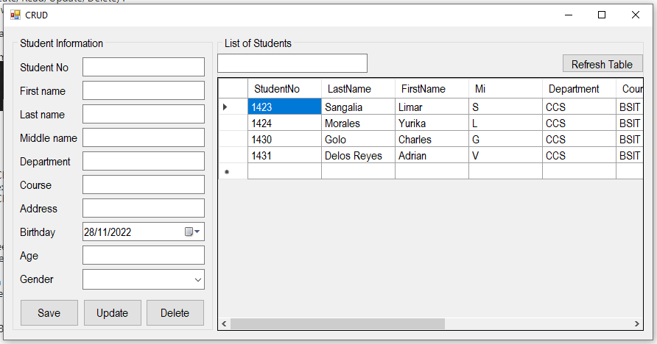

Save Button (Create)

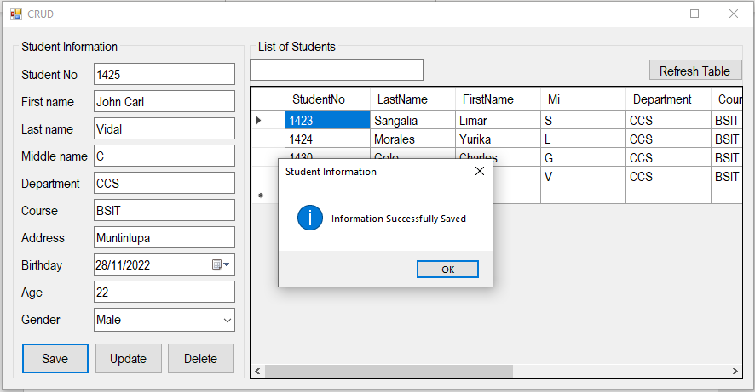

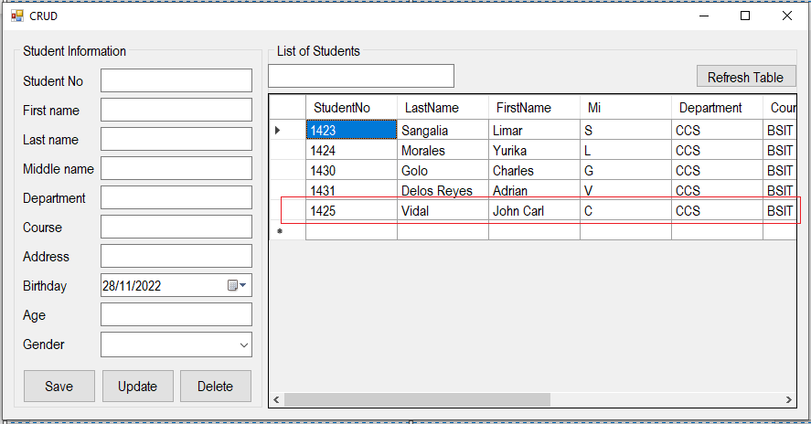

Search

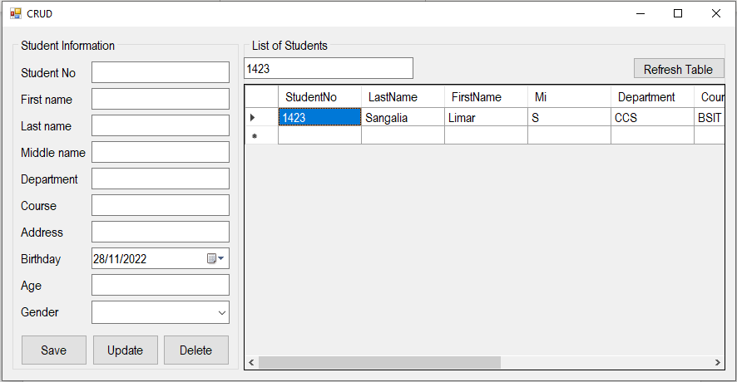

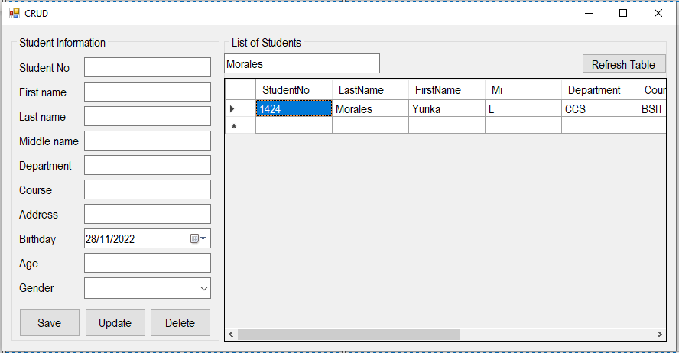

Update

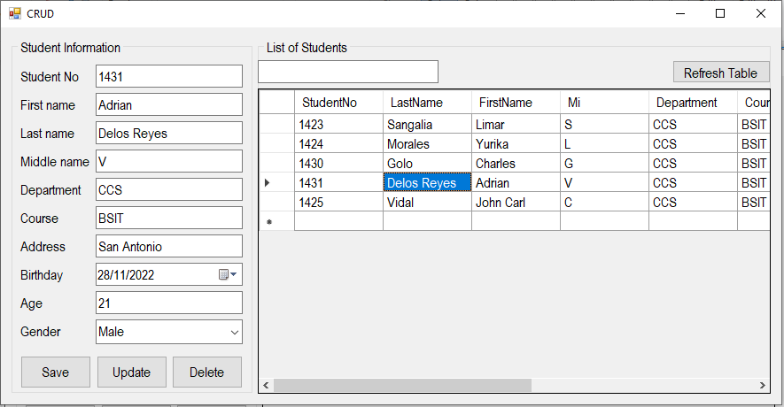

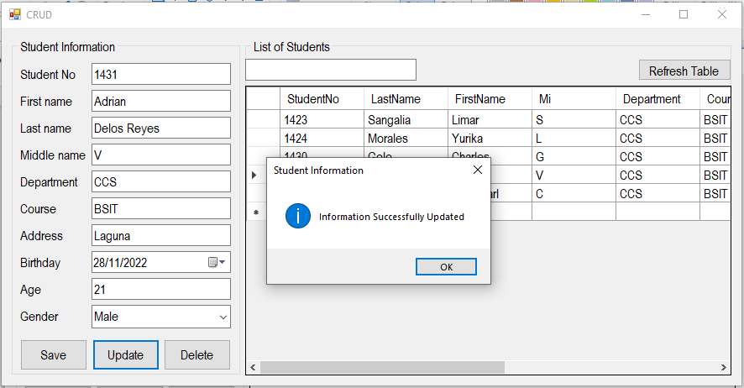

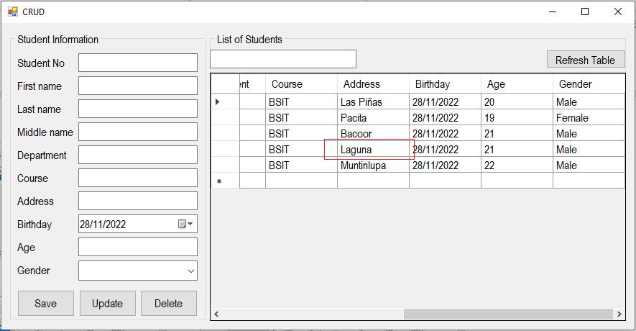

Delete

