INDEPENDENT RESEARCH ARTICLE | Manuscript version 1.0 · September 2026

A Risk-Aware Predictive Maintenance Framework Integrating Statistical Process Control, Failure-Sensitive Machine Learning, and Operating-Policy Optimization
A Sequentially Validated Case Study on the AI4I 2020 Synthetic Manufacturing Dataset
Doyun Shin
Department of Industrial Engineering, Gachon University, Republic of Korea
Independent research

Abstract
Predictive maintenance is not only a classification problem. A useful system must distinguish process signals from distribution shift, make the trade-off between missed failures and false alarms explicit, and translate model output into defensible operating and maintenance choices. This study integrates exploratory data analysis, individuals and moving-range control charts, feature engineering, imbalanced binary classification, threshold selection, constrained operating-point search, and linear programming in one auditable workflow. The analysis uses 10,000 observations from the synthetic AI4I 2020 dataset and preserves observation order in a 70/15/15 train-validation-test split. Gradient Boosting was selected on the validation set, and a failure-sensitive probability threshold of 0.65 was locked before test evaluation. On the held-out test set, the model achieved precision 0.5526, recall 0.7241, F1 0.6269, ROC-AUC 0.9615, and PR-AUC 0.7463, detecting 21 of 29 failures. Torque alarms showed a validation risk lift of 9.38, while a temperature-difference level shift violated the stable-center assumption of a fixed control chart. A constrained grid search identified a feasible low-score operating point with 1.3046% predicted risk, and tool-wear sensitivity plus an eight-hour linear program illustrated decision use. The findings support an integration pattern, not a deployable policy: the dataset is synthetic, probabilities are uncalibrated, validation uses one sequential split, and the optimization is conditional on fixed scenarios.
Keywords predictive maintenance · statistical process control · imbalanced classification · gradient boosting · process optimization · AI4I 2020

Highlights
- Observation order is preserved, and the decision threshold is fixed before the held-out test is opened.
- SPC alarms are evaluated as operational signals rather than assumed to be uniformly useful predictive features.
- The final classifier detects 21 of 29 test failures at a pre-committed threshold of 0.65.
- Optimization outputs are reported with feasibility, tie, calibration, and scenario-dependence caveats.

Graphical abstract
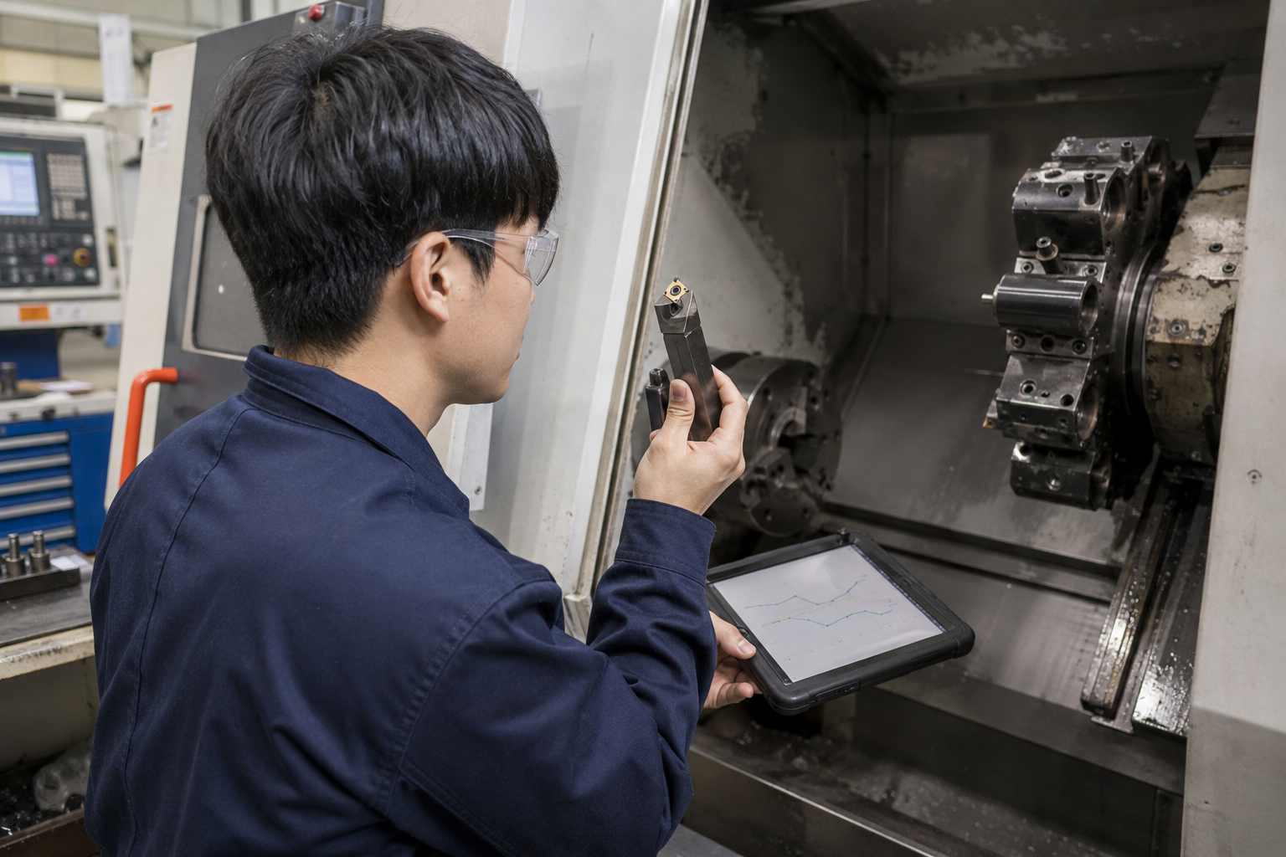
Graphical abstract Human-centered inspection and decision support in a sensor-enabled machining environment. Conceptual image generated with an image-generation tool; not empirical evidence
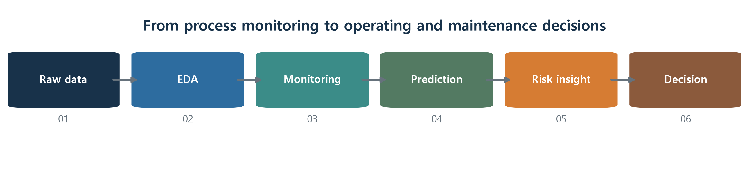
Fig. 1 Analytical workflow from raw process observations to operating and maintenance decisions

1 Introduction
Predictive maintenance is often presented as a supervised-learning task in which a model classifies equipment observations as normal or failing. That framing is useful but incomplete. A deployable decision process must also establish what constitutes a stable operating baseline, decide how aggressively failures should be flagged, recognize when the data distribution changes, and translate a risk score into an action that is physically and economically feasible. A high discrimination score alone does not answer any of those questions.
Statistical process control (SPC) and machine learning address different parts of this problem. SPC provides an interpretable reference for common- and special-cause variation; supervised learning can combine several measurements and nonlinear interactions to rank individual observations. The two approaches can therefore be complementary. A sparse torque alarm may be a strong reason to inspect a machine even if it captures only a minority of failures. Conversely, a temperature alarm that is active for almost an entire future period may indicate a changed baseline rather than a series of isolated faults. Treating every alarm as an interchangeable binary feature would erase that distinction (Montgomery, 2019; NIST/SEMATECH, 2012).
This paper develops a reproducible case study using the AI4I 2020 predictive-maintenance dataset (Matzka, 2020; UCI Machine Learning Repository, 2020). The dataset is intentionally synthetic, which makes it suitable for method integration and reproducibility but not for direct claims about a particular machine population. The analysis connects exploratory data analysis, individuals and moving-range charts, physically motivated feature engineering, imbalanced classification, threshold selection, constrained grid search, tool-wear sensitivity, and a small linear program.
Three research questions guide the study. RQ1 asks whether process-control alarms concentrate failure risk and whether some variables instead reveal a shifted baseline. RQ2 asks whether a failure-sensitive threshold selected on a sequential validation block retains useful performance on a later held-out block. RQ3 asks how a locked predictive model can be used to construct feasible operating and maintenance decision examples without mistaking model scores for causal or calibrated risk.
The contribution is methodological integration rather than a new learning algorithm. Observation order is retained; feature construction and control limits are estimated from the training block; model and threshold choices are completed before test evaluation; and the optimization results are reported together with their ties, fixed-condition assumptions, and scenario dependence. These choices make the work auditable and expose where a seemingly polished predictive-maintenance pipeline can fail.

2 Background

2.1 Process monitoring and predictive classification
An individuals chart estimates the process center from single observations and its short-term variation from adjacent moving ranges. For subgroup size one, the conventional estimate of sigma uses the average moving range divided by d2 = 1.128. The chart is interpretable when the baseline is sufficiently stable, but control limits that move with a trend or are exported across a level shift can become misleading. In this study, I–MR charts are used as exploratory screening devices and feature generators rather than as proof that all classical distributional assumptions hold.
Random Forests aggregate randomized trees to reduce variance (Breiman, 2001), while Gradient Boosting sequentially fits weak learners to improve a differentiable loss (Friedman, 2001). Both can represent nonlinear sensor interactions without requiring a pre-specified parametric form. Logistic regression remains useful as a transparent baseline. Model ranking emphasizes precision-recall performance because failures are rare; ROC curves can remain visually strong even when positive-class performance is operationally weak (Davis and Goadrich, 2006; Fawcett, 2006; Saito and Rehmsmeier, 2015).

2.2 From scores to decisions
A classifier threshold is an operating choice. Lowering it typically increases recall and workload; raising it reduces false alarms but may miss failures. The appropriate point depends on failure severity, inspection capacity, downtime, and repair costs. When those costs are unavailable, the defensible alternative is to state a qualitative preference, lock the threshold on validation data, and report the resulting error counts on untouched data.
Optimization adds another layer of interpretation. A model can score candidate operating points, but its response is conditional on the observed feature distribution and any variables held fixed. Minimizing an uncalibrated score over a finite grid does not establish a causal optimum. It supplies a candidate for engineering review. The same caution applies to maintenance sensitivity and production planning: a tree-model step is not a physical wear limit, and a linear-program solution is only as meaningful as its resource and risk constraints.

3 Data and methods

3.1 Dataset and data-quality audit
The AI4I 2020 dataset contains 10,000 rows and fourteen columns describing product identifiers, quality type, air and process temperatures, rotational speed, torque, tool wear, an overall machine-failure label, and five failure-mode indicators. No missing values or fully duplicated rows were found. The overall target contains 339 failures (3.39%). Failure-mode indicators overlap: 23 observations contain two modes and one contains three. Eighteen observations contain a mode indicator with an overall target of zero, and nine have an overall failure without a recorded mode. All 18 of the first inconsistency involve the random-failure indicator. The original overall target was retained, while mode-specific results were treated as descriptive diagnostics.
Table 1 Sequential data partition and target prevalence
Partition | Observation order | n | Failures | Failure rate
Training | 1–7,000 | 7,000 | 278 | 3.971%
Validation | 7,001–8,500 | 1,500 | 32 | 2.133%
Test | 8,501–10,000 | 1,500 | 29 | 1.933%
Total | 1–10,000 | 10,000 | 339 | 3.390%

No timestamp or asset identifier is available. Row order, equivalent to the UDI sequence, is therefore used as pseudo-time. A 70/15/15 contiguous split avoids random leakage across adjacent observations and creates a more demanding future-block evaluation. It does not reproduce repeated measurements from specific machines, and the falling target prevalence across blocks makes a single split an important source of uncertainty.

3.2 Feature engineering
Two continuous features were added. Temperature difference equals process temperature minus air temperature. Mechanical power combines torque T and rotational speed through angular velocity. The normal and failure groups had mean mechanical power of 6.245 and 7.283 kW, respectively, and mean temperature differences of 10.022 and 9.404 K. The engineered variables were computed after partitioning logic was fixed and were applied identically to all blocks.
PₖW = Tω = T × 2π × RPM / (60 × 1000) | (1)

3.3 SPC feature construction
Training-block I–MR limits were estimated for torque, mechanical power, rotational speed, and temperature difference. For adjacent observations xi and xi−1, the moving range and individual limits are defined in Eq. 2. The lower limit was not mechanically truncated unless required by the physical variable definition.
MRᵢ = |xᵢ − xᵢ₋₁|  UCL = x̄ + 3(MR̄ / 1.128), LCL = x̄ − 3(MR̄ / 1.128) | (2)
The resulting individual limits were 10.060–69.791 Nm for torque, 3.083–9.462 kW for power, and 1,051.979–2,029.187 rpm for rotational speed. A binary alarm equaled one when either an individual value or its moving range exceeded training limits. Torque, power, and speed alarms were retained as model features. Temperature difference was not retained as an SPC feature because its mean shifted from 9.610 K in training to 10.924 K in validation, producing a 96.13% validation alarm rate. The continuous temperature-difference feature remained available to the model.
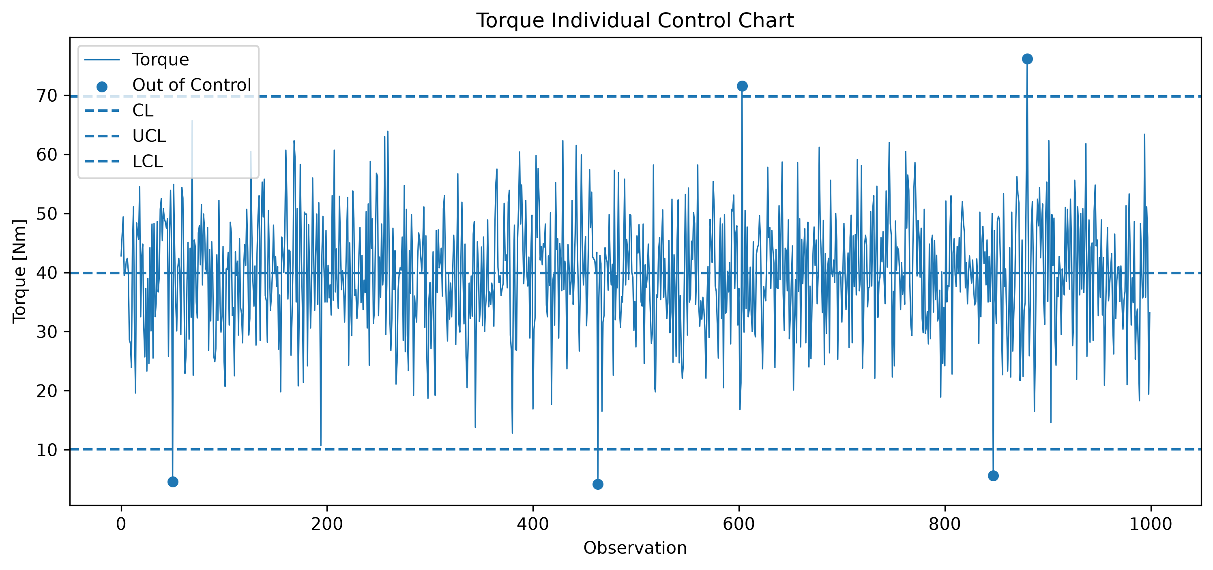 | 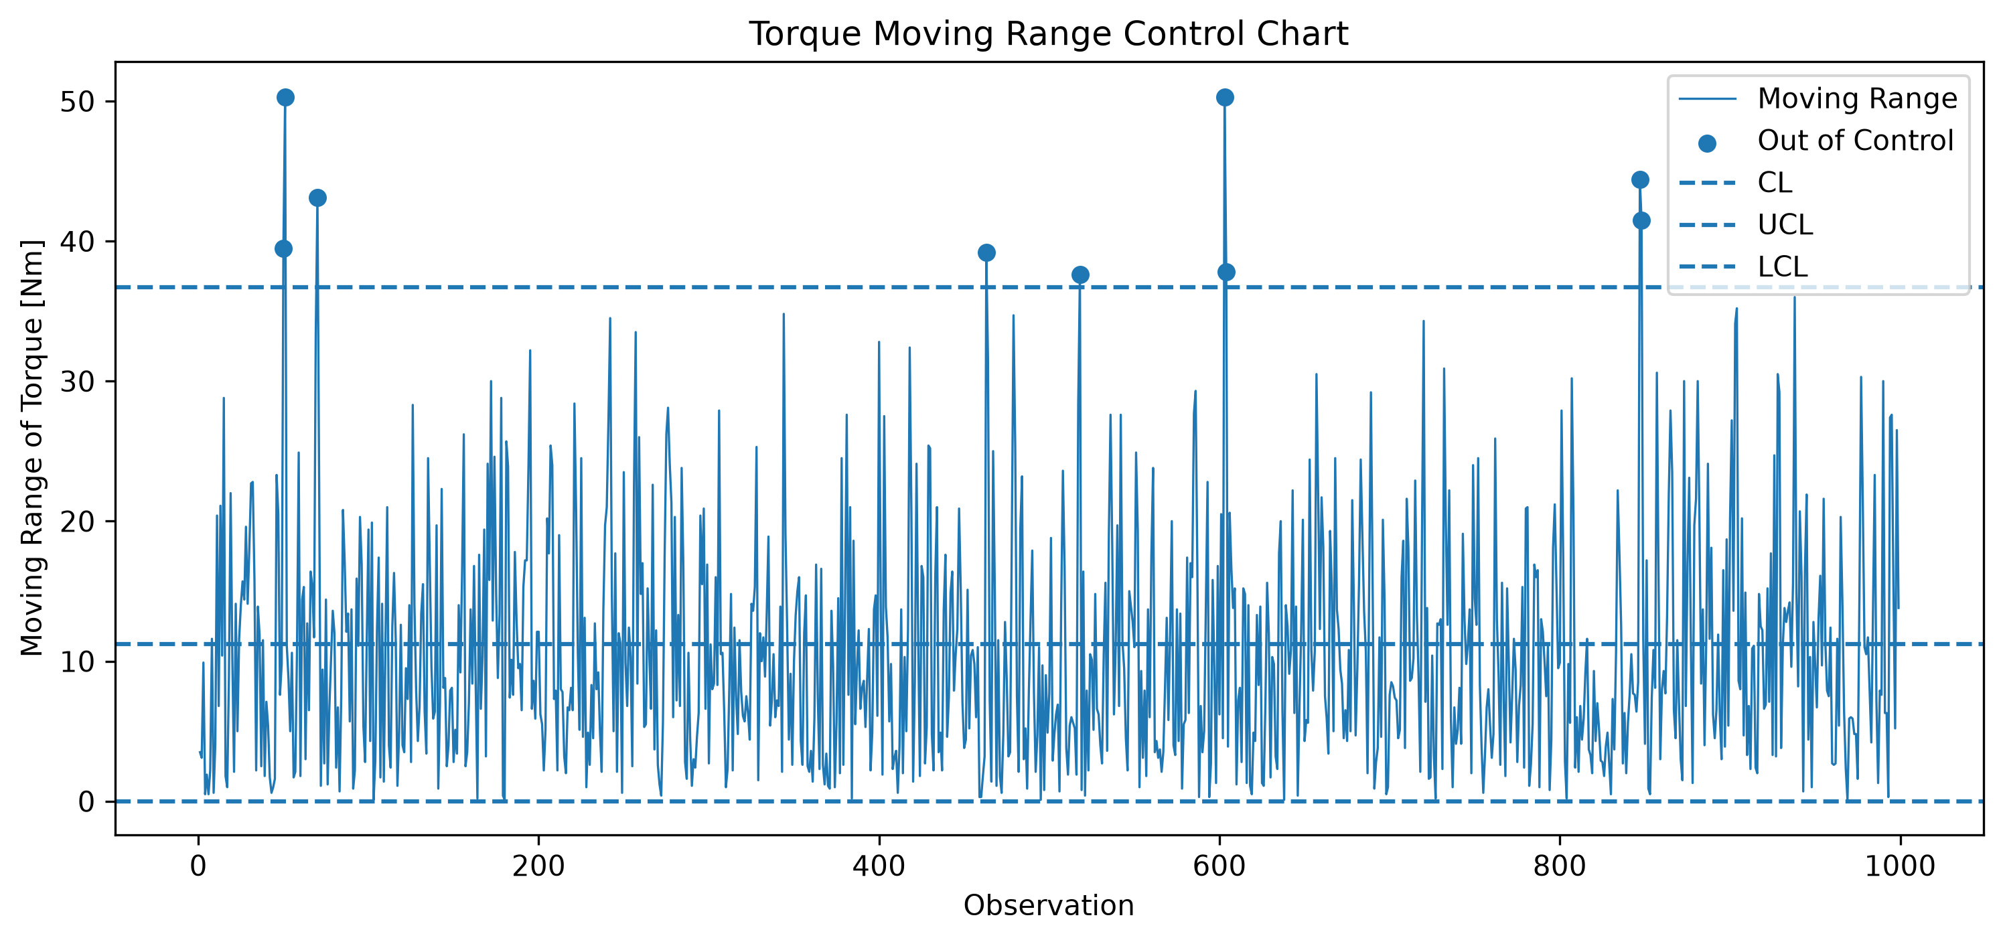
Fig. 2 Training-block torque monitoring: (a) individuals chart and (b) moving-range chart. Markers denote out-of-control observations
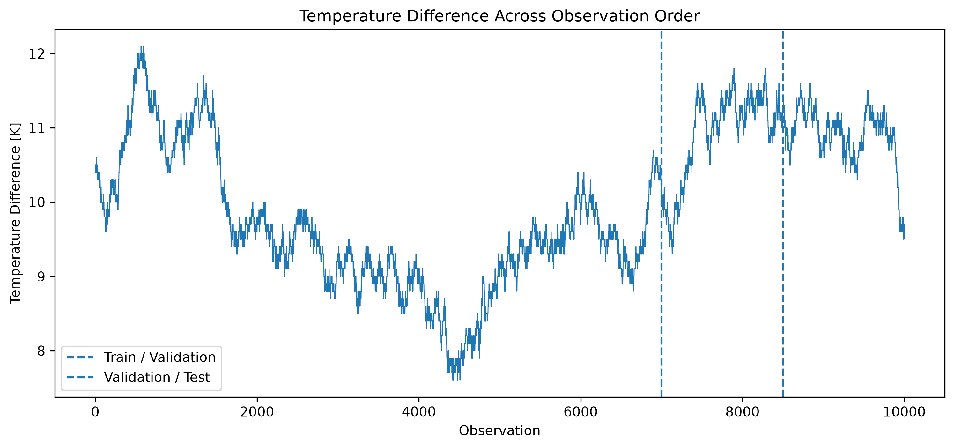
Fig. 3 Temperature difference across pseudo-time. Dashed lines mark the training-validation and validation-test boundaries

3.4 Models, metrics, and threshold protocol
Three nested feature sets were assessed. Set A contained product type and six original process variables. Set B added temperature difference and mechanical power. Set C added the three retained SPC alarms. Categorical type was one-hot encoded, and all transformations were fitted on training data. Logistic regression was first used to compare feature sets. Logistic regression, Random Forest, and Gradient Boosting were then compared using Set C with fixed notebook specifications implemented in scikit-learn (Pedregosa et al., 2011).
Validation reporting included precision, recall, F1, ROC-AUC, PR-AUC, and confusion-matrix counts. Because the practical priority was to avoid missed failures while maintaining usable precision, Gradient Boosting was selected and a threshold of 0.65 was chosen from the validation precision-recall trade-off. A threshold of 0.85 produced a higher validation F1 but reduced recall from 0.781 to 0.656. The model and 0.65 threshold were then frozen before the test block was evaluated once.

3.5 Decision-layer analysis
The operating-point search varied speed and torque over their training 5th–95th percentile ranges, 1,331–1,880 rpm and 23.10–55.90 Nm, on a 60 by 60 grid. Product type was fixed at L; air temperature, process temperature, tool wear, and temperature difference were fixed at 300.7 K, 310.1 K, 109 min, and 9.4 K. Candidates required mechanical power of at least 6.266 kW and zero SPC alarms. The objective minimized the locked model score, as shown in Eq. 3.
min p̂(failure | x)  s.t. PₖW ≥ Pmin, Rᴸ ≤ RPM ≤ Rᵁ, Tᴸ ≤ T ≤ Tᵁ | (3)
Tool-wear sensitivity then varied wear over 100 points spanning the training 1st–99th percentiles while holding the selected operating point fixed. The first grid point at which the model score exceeded 5% was recorded as a model transition, not a maintenance limit. Finally, an eight-hour two-mode production example was expressed as Eq. 4, where x1 and x2 denote hours in low-risk mode A and high-load mode B, P denotes an illustrative production score, and r denotes the model score used in a constructed risk budget.
max Z = Pᴬx₁ + Pᴮx₂  s.t. x₁ + x₂ ≤ 8, rᴬx₁ + rᴮx₂ ≤ Rmax, x₁, x₂ ≥ 0 | (4)

4 Results

4.1 SPC screening behavior
In the training block, 19 of 20 torque individuals-chart alarms were failures. When individual and moving-range alarms were combined, 28 of 83 alarmed observations failed, corresponding to 33.73%, compared with 3.61% among non-alarmed observations. On validation data, the combined torque alarm rate was 1.33%; the failure rate was 20.0% among alarms and 1.89% among non-alarms, a risk lift of 9.38. Its detection rate, however, was only 12.5%. Power showed a similar lift of 8.52, while speed showed a lift of 4.93.
Table 2 Validation screening characteristics of univariate SPC alarms
Variable | Validation alarm rate | Failure detection | Failure rate among alarms | Risk lift
Air temperature | 77.07% | 65.62% | 1.82% | 0.85
Process temperature | 91.13% | 96.88% | 2.27% | 1.06
Rotational speed | 3.80% | 18.75% | 10.53% | 4.93
Torque | 1.33% | 12.50% | 20.00% | 9.38
Mechanical power | 1.47% | 12.50% | 18.18% | 8.52
Temperature difference | 96.13% | 93.75% | 2.08% | 0.98

Temperature difference produced the opposite pattern. Almost every validation observation was flagged, yet the alarm-group failure rate was 2.08% and the risk lift was 0.98. The chart successfully exposed a block-level shift but failed as a selective fault indicator. This result motivated excluding the binary temperature alarm from the final feature set and retaining the continuous measurement.

4.2 Model selection
Table 3 Validation performance with feature Set C at the default threshold of 0.50
Model | Precision | Recall | F1 | ROC-AUC | PR-AUC
Logistic regression C | 0.2500 | 0.6875 | 0.3667 | 0.9023 | 0.4458
Random Forest | 0.7500 | 0.6562 | 0.7000 | 0.9736 | 0.7455
Gradient Boosting | 0.3968 | 0.7812 | 0.5263 | 0.9857 | 0.7718

Gradient Boosting obtained the highest validation recall, ROC-AUC, and PR-AUC at the default threshold. Random Forest produced the highest precision and F1 at 0.50. The selection therefore reflected an explicit preference for failure capture, not dominance on every metric. At the chosen threshold of 0.65, Gradient Boosting produced 25 true positives, 21 false positives, and 7 false negatives on validation data, yielding precision 0.543, recall 0.781, and F1 0.641.
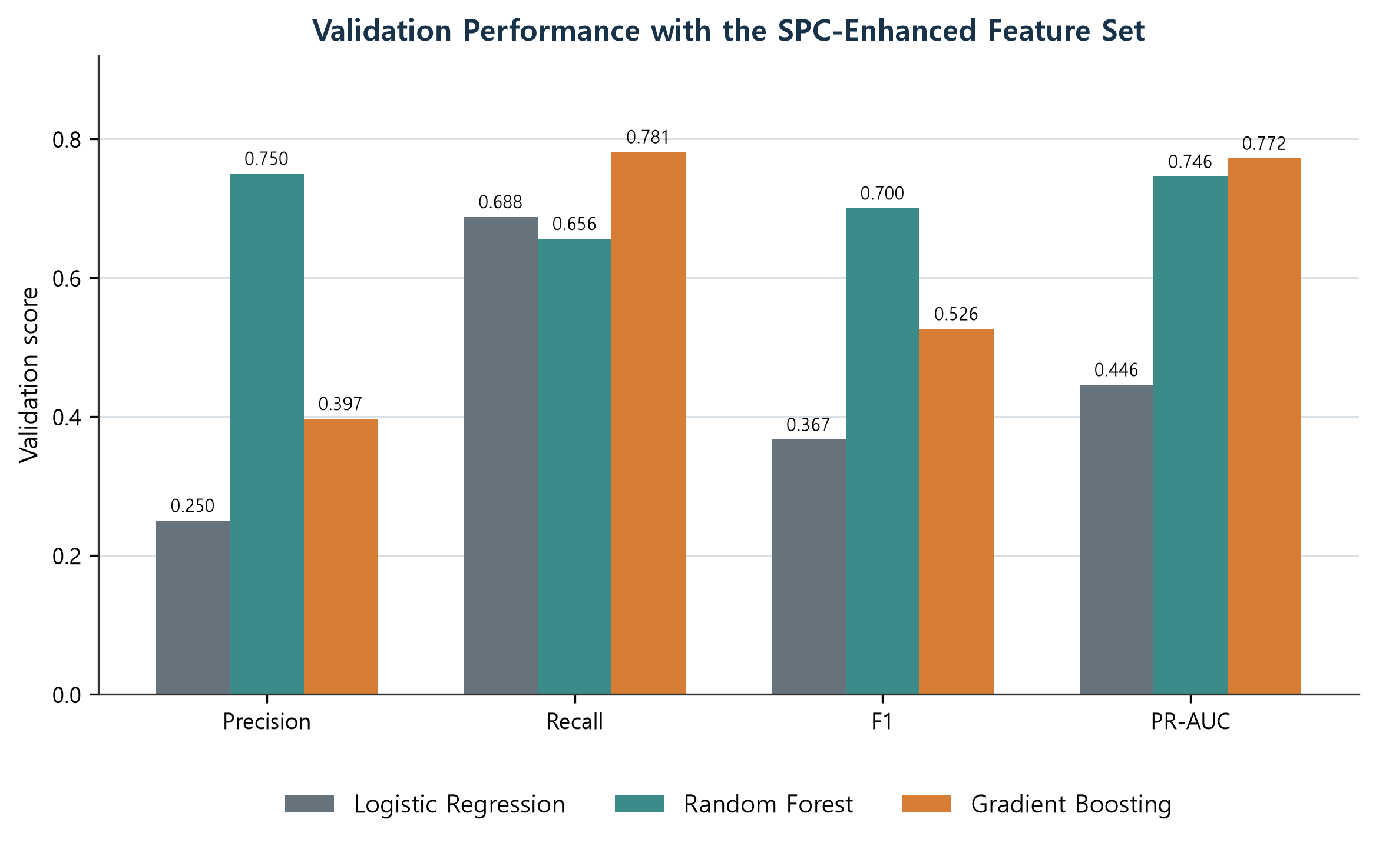 | 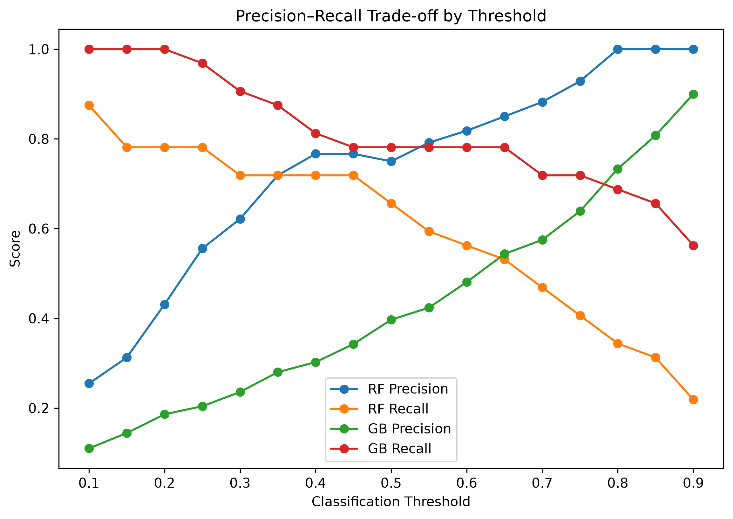
Fig. 4 Validation evidence used for model and threshold selection: (a) default-threshold model comparison and (b) precision-recall trade-off across thresholds

4.3 Locked test performance
At the locked threshold of 0.65, the held-out confusion matrix contained 1,454 true negatives, 17 false positives, 8 false negatives, and 21 true positives. The classifier detected 21 of 29 failures and issued 38 alerts. The results correspond to accuracy 0.9833, precision 0.5526, recall 0.7241, F1 0.6269, ROC-AUC 0.9615, and PR-AUC 0.7463. Validation-to-test recall fell by 0.057, while PR-AUC remained close to the model-selection value.
Table 4 Final held-out test performance at threshold 0.65
Metric | Test value | Operational reading
Accuracy | 0.9833 | Secondary because of class imbalance
Precision | 0.5526 | 21 failures among 38 alerts
Recall | 0.7241 | 21 of 29 failures detected
F1 | 0.6269 | Balance of precision and recall
ROC-AUC | 0.9615 | Ranking across all thresholds
PR-AUC | 0.7463 | Positive-class ranking performance

Mode-specific diagnostics revealed heterogeneous coverage. All seven PWF observations and 16 of 17 OSF observations were detected, but only one of seven TWF observations was detected. Mean model scores were 0.978 for PWF, 0.905 for OSF, and 0.325 for TWF. Neither HDF nor RNF occurred among overall-positive test observations. Two failures had no mode label; one was detected. These sparse strata are not formal subgroup estimates, but they identify tool-wear failure as a concrete weakness hidden by aggregate recall.
Permutation importance measured by validation PR-AUC loss was 0.5909 for mechanical power, 0.3325 for tool wear, 0.1001 for speed, and 0.0859 for torque. The three SPC alarm features were near zero or negative. This does not make the alarms operationally useless. It indicates that once the continuous measurements and their physical interaction are available, the binary alarm flags add little unique information to this fitted ensemble. Correlated-feature permutation effects are not causal contributions and can be shared or masked (Strobl et al., 2008).
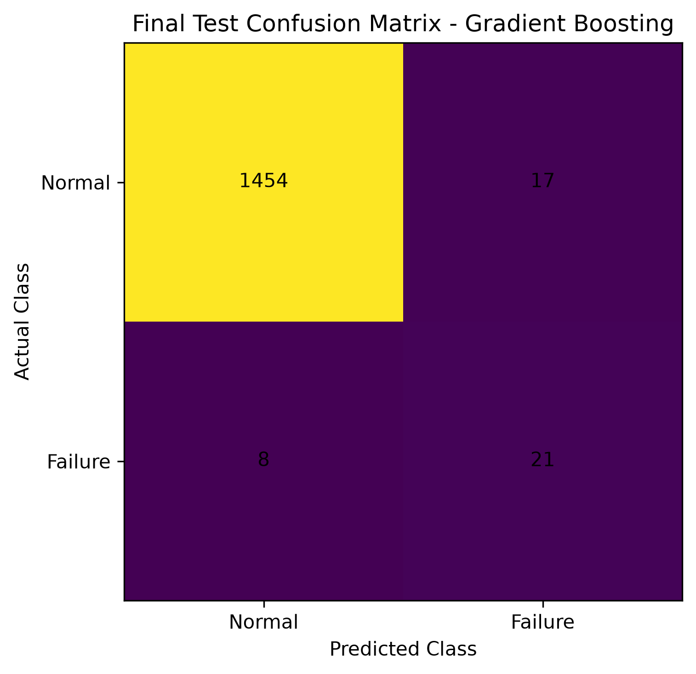 | 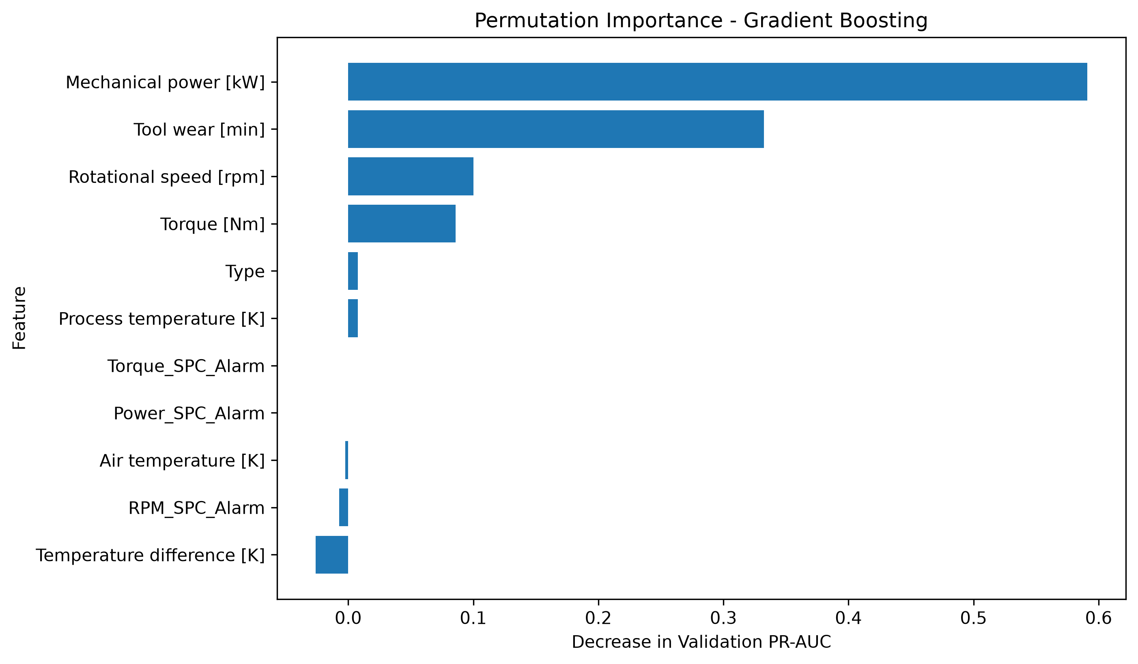
Fig. 5 Locked test evaluation and interpretation: (a) confusion matrix at 0.65 and (b) validation PR-AUC permutation importance

4.4 Operating and maintenance decisions
Of 3,600 candidate speed-torque pairs, 1,999 satisfied the power and SPC constraints. The reported representative point was 1,768.339 rpm and 41.446 Nm, corresponding to 7.675 kW and a model score of 1.3046%. Several grid points shared the minimum score. Accordingly, the result is a feasible low-score candidate within the sampled grid, not a unique continuous optimum.
At this operating point, the first of 100 tool-wear grid values with a score above 5% was 202.727 min, at which the score jumped to 23.401%. The first crossings of 10% and 20% occurred at the same value. This discontinuity reflects tree splits. Later scores were not strictly monotonic, so the transition cannot be interpreted as a causal wear threshold or safe-life estimate.
Mode A used the representative low-score point. Mode B used 1,880 rpm and 55.9 Nm, corresponding to 11.005 kW and a score of 92.635%. Under an eight-hour limit and a risk budget constructed as eight times the 60/40 weighted mode scores, the linear program returned 4.8 h in A and 3.2 h in B, with an illustrative production score of 72.056. Because the risk budget was anchored to the same 60/40 mixture, the solution largely reproduces the scenario assumption. It verifies the transfer mechanism from prediction to planning but does not discover an empirical production policy.
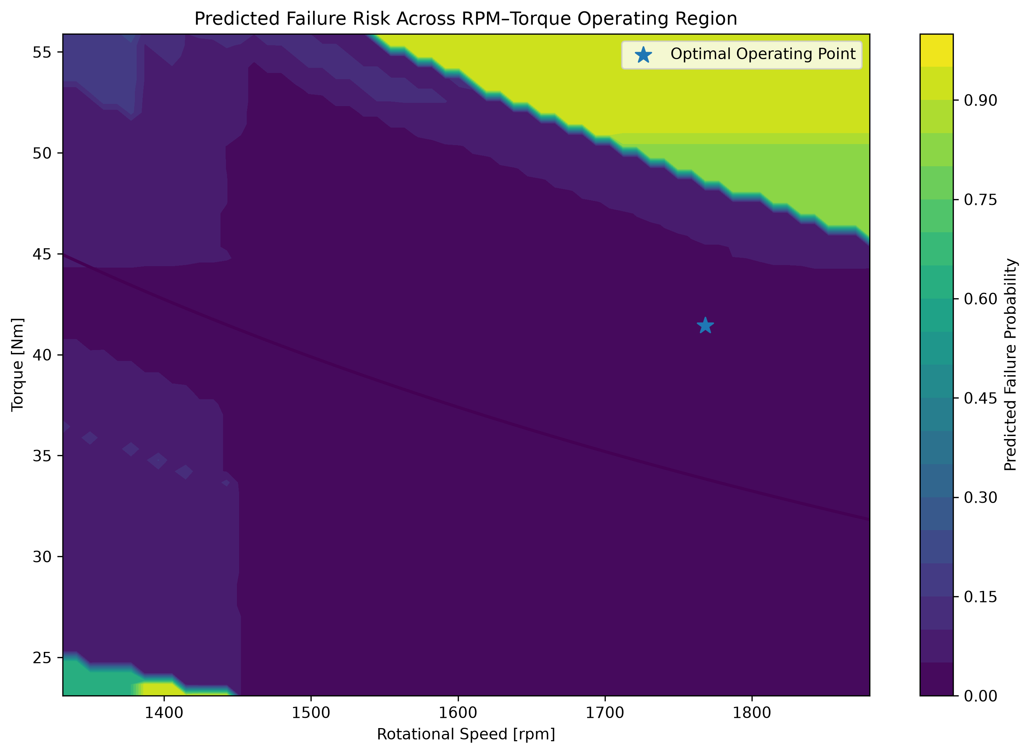 | 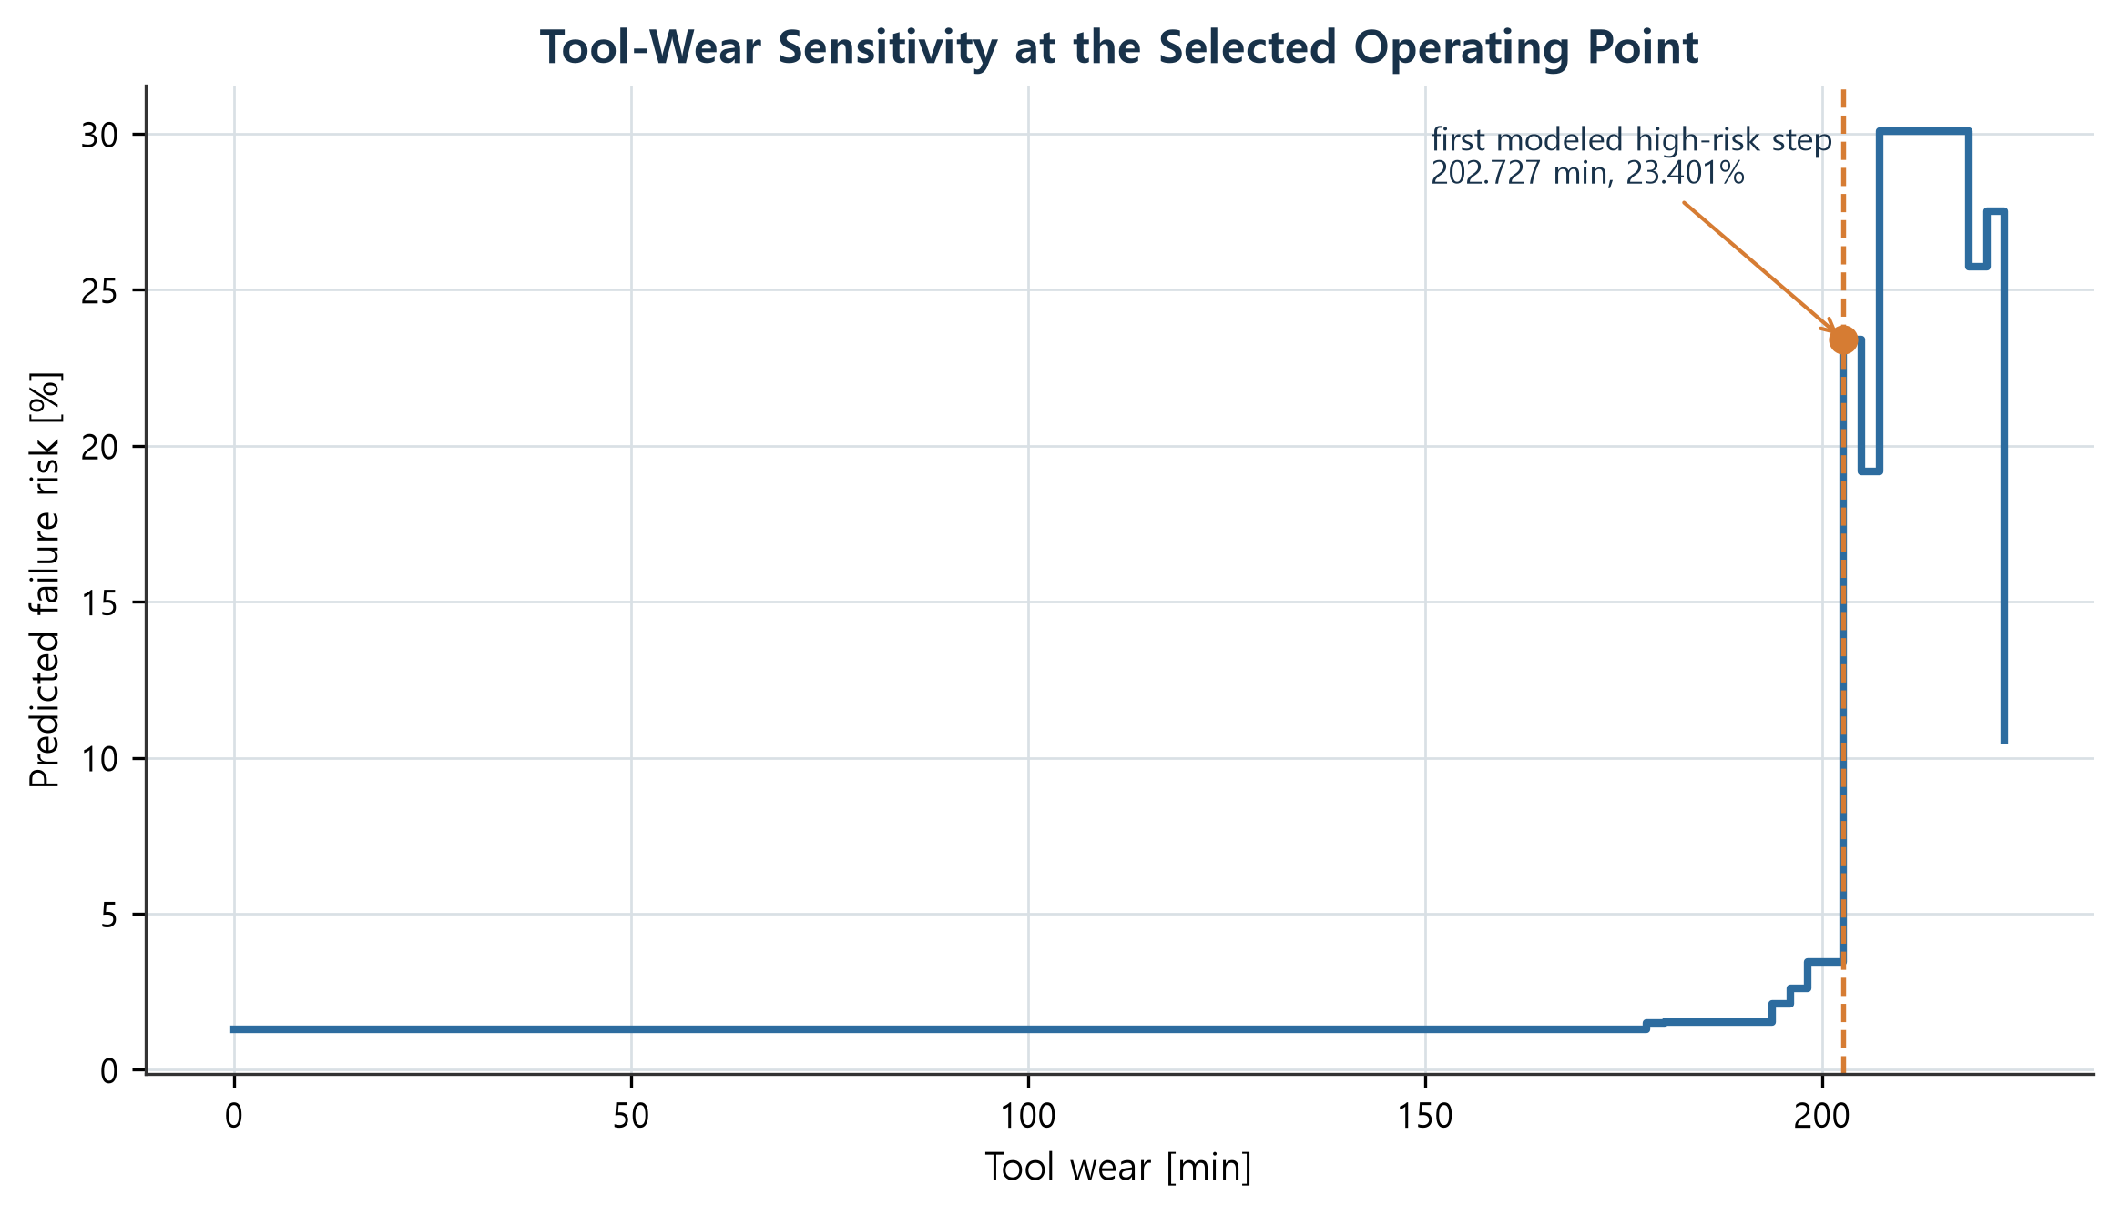
Fig. 6 Decision-layer diagnostics: (a) conditional speed-torque risk surface and selected feasible point and (b) tool-wear sensitivity at that point
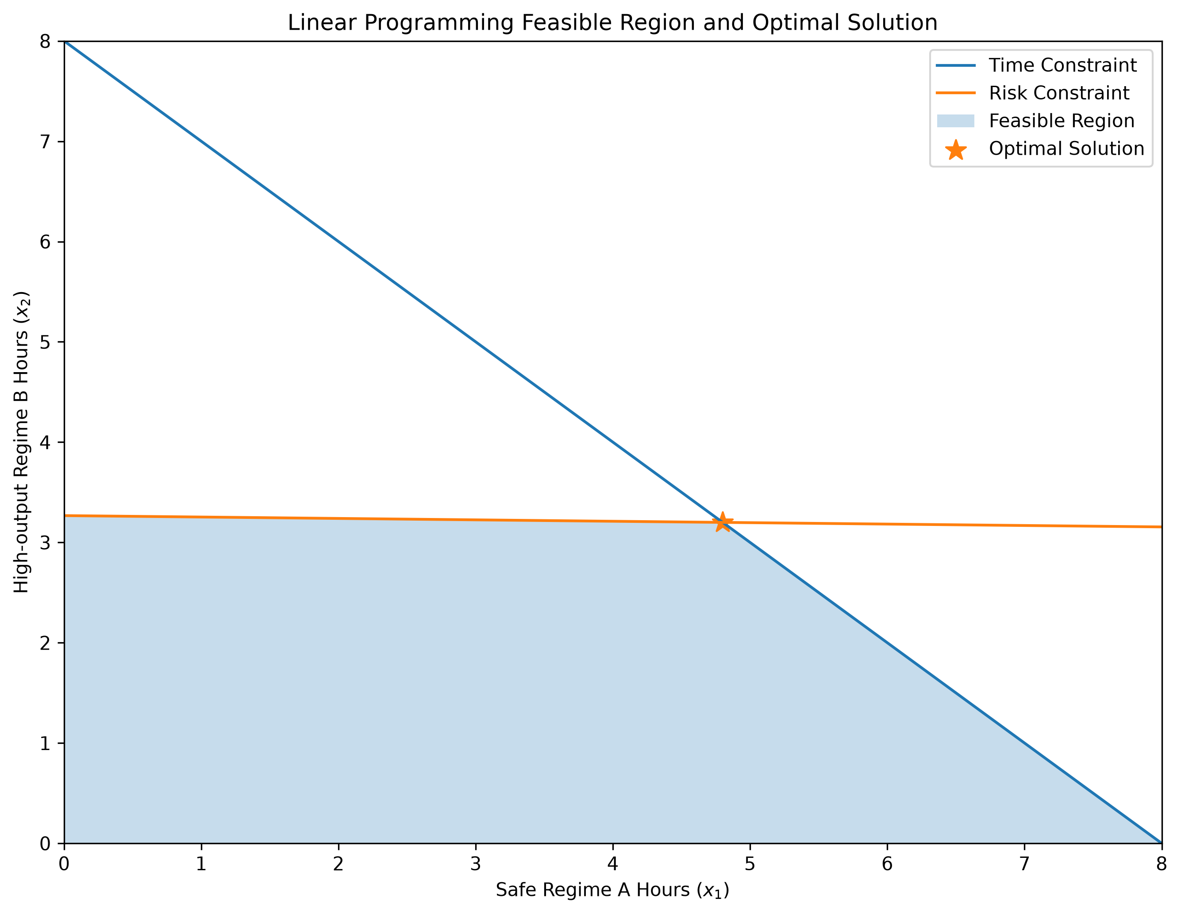
Fig. 7 Feasible region and vertex solution for the illustrative eight-hour two-mode planning problem

5 Discussion
The study shows why predictive maintenance benefits from separating monitoring, prediction, and decision roles. A torque alarm had high conditional relevance but low coverage: it is suitable as a sparse escalation signal, not as a standalone detector. Temperature difference had high alarm coverage but no risk lift: it is better interpreted as a baseline-change signal. The machine-learning model supplied broader coverage by combining continuous features, but the threshold still embodied an operational preference. Finally, optimization transformed the locked score into candidate actions while making its constraints and conditional nature visible.
Mechanical power illustrates the value and risk of physical feature engineering. Removing it from Logistic C reduced validation recall from 0.688 to 0.563 and PR-AUC from 0.446 to 0.308. Replacing torque and speed with power alone was worse, with recall 0.344 and PR-AUC 0.179. The interaction therefore complemented rather than replaced its source variables. This finding also cautions against reading a high importance score as proof that the original sensors are dispensable.
The threshold of 0.65 should not be transported unchanged to another plant. A production deployment would estimate the costs of missed failures, inspections, planned and unplanned downtime, and alert capacity; calibrate probabilities; and evaluate thresholds under rolling-origin and cross-asset validation. A change-detection layer should trigger joint reassessment of control limits, feature distributions, calibration, and subgroup performance.
The practical value of the workflow is its audit trail. The baseline block, label anomalies, feature definitions, validation decision, held-out error counts, operating constraints, tied minima, and constructed planning budget are all stated. Such traceability is more useful for engineering review than a larger collection of unqualified metrics. It also makes the next experiments clear: obtain real timestamped asset histories, record maintenance interventions and costs, and validate the decision policy prospectively.

6 Limitations
- The dataset is synthetic and omits real sensor noise, censored lifetimes, maintenance interventions, and machine-to-machine heterogeneity.
- Row order is only pseudo-time. Results rely on one contiguous split and require rolling-origin and external validation.
- Output probabilities were not calibrated, and operating costs were unavailable. Thresholds and reported percentages are model-score decisions, not field hazard estimates.
- I–MR assumptions were not established for every variable; charts were exploratory screening devices.
- Permutation importance is affected by correlated features and does not identify causal effects.
- The operating search uses a finite grid and fixed surrounding conditions. The linear program uses an illustrative, scenario-derived risk budget.

7 Conclusion
A predictive-maintenance portfolio becomes more credible when it documents not only a classifier but also the baseline, threshold decision, error counts, distribution shifts, and constraints that connect scores to action. In this case study, torque and power alarms concentrated risk, a temperature-difference shift invalidated a fixed alarm as a selective feature, and a locked Gradient Boosting model detected 21 of 29 test failures with a PR-AUC of 0.7463. The operating-point, wear-sensitivity, and planning examples completed the analytical chain without claiming field-ready optimality.
The work should therefore be read as a reproducible decision prototype. Its next stage is not simply a more complex model; it is a real longitudinal dataset with asset identity, maintenance outcomes, economic costs, calibrated scores, and prospective monitoring. Under those conditions, the same SPC–ML–optimization structure can be evaluated as an operating policy rather than a retrospective demonstration.

Statements and declarations
Research status. This manuscript reports independent research by Doyun Shin, Department of Industrial Engineering, Gachon University. It is not presented as accepted or published by any journal.
Funding. The author received no external funding for this study.
Competing interests. The author declares no financial or non-financial competing interests.
Data and code availability. The AI4I 2020 source data are available from the UCI Machine Learning Repository under CC BY 4.0. Reproduction notebooks, serialized model artifacts, figures, and both manuscript versions are provided in the accompanying GitHub repository.
Generative AI assistance. During the project, generative AI was used primarily to assist with selected Python code drafts and debugging and was also used for language and layout support in manuscript preparation. All numerical results, tables, and empirical figures were checked against the stored dataset, notebooks, model artifacts, and generated outputs. The graphical-abstract concept image was generated with an image-generation tool and is not empirical evidence. The author determined the research questions, analytical choices, interpretation, and final content and accepts responsibility for the work.

References
Breiman, L. (2001), Random Forests, Machine Learning, 45, 5-32. https://doi.org/10.1023/A:1010933404324
Davis, J. and Goadrich, M. (2006), The Relationship Between Precision-Recall and ROC Curves, Proceedings of the 23rd International Conference on Machine Learning, 233-240. https://doi.org/10.1145/1143844.1143874
Fawcett, T. (2006), An Introduction to ROC Analysis, Pattern Recognition Letters, 27(8), 861-874. https://doi.org/10.1016/j.patrec.2005.10.010
Friedman, J. H. (2001), Greedy Function Approximation: A Gradient Boosting Machine, The Annals of Statistics, 29(5), 1189-1232. https://doi.org/10.1214/aos/1013203451
Matzka, S. (2020), Explainable Artificial Intelligence for Predictive Maintenance Applications, 2020 Third International Conference on Artificial Intelligence for Industries, 69-74. https://doi.org/10.1109/AI4I49448.2020.00023
Montgomery, D. C. (2019), Introduction to Statistical Quality Control, 8th ed., Wiley, Hoboken, NJ.
NIST/SEMATECH (2012), e-Handbook of Statistical Methods: Individuals Control Charts. https://www.itl.nist.gov/div898/handbook/pmc/section3/pmc322.htm
Pedregosa, F. et al. (2011), Scikit-learn: Machine Learning in Python, Journal of Machine Learning Research, 12, 2825-2830.
Saito, T. and Rehmsmeier, M. (2015), The Precision-Recall Plot Is More Informative than the ROC Plot When Evaluating Binary Classifiers on Imbalanced Datasets, PLOS ONE, 10(3), e0118432. https://doi.org/10.1371/journal.pone.0118432
Strobl, C., Boulesteix, A.-L., Kneib, T., Augustin, T., and Zeileis, A. (2008), Conditional Variable Importance for Random Forests, BMC Bioinformatics, 9, 307. https://doi.org/10.1186/1471-2105-9-307
UCI Machine Learning Repository (2020), AI4I 2020 Predictive Maintenance Dataset. https://doi.org/10.24432/C5HS5C
Virtanen, P. et al. (2020), SciPy 1.0: Fundamental Algorithms for Scientific Computing in Python, Nature Methods, 17, 261-272. https://doi.org/10.1038/s41592-019-0686-2

Appendix A Reproducibility record
Table A1 Locked analysis decisions and reproducibility checkpoints
Item | Locked value or rule
Split | Contiguous 70/15/15 by observation order
Final features | Type, six sensor variables, temperature difference, mechanical power, and three SPC alarms
Model | Serialized Gradient Boosting classifier from the analysis notebook
Decision threshold | 0.65, selected on validation data before test evaluation
Test confusion matrix | TN 1,454; FP 17; FN 8; TP 21
Search domain | Speed 1,331–1,880 rpm; torque 23.10–55.90 Nm; 60 by 60 grid
Reported candidate | 1,768.339 rpm; 41.446 Nm; 7.675 kW; score 1.3046%
Software | Python, pandas, NumPy, SciPy, scikit-learn, Matplotlib, joblib

