EXECUTIVE SUMMARY
Weather Decision Agent
A weather-aware activity and venue recommendation system
Team: Deniz Özmen (2203032), Ömer Şahin (2104101)
Status: Implemented, tested and publicly deployed
Date: June 2026
Executive statement. The project converts a seven-day weather forecast and personal preferences into safe, understandable activity plans. It is available as a public web application and supports real location selection and verified venue results.

The Challenge
Most weather applications provide data but leave the interpretation to the user. Temperature, rain and wind must be considered together, and the same conditions may be acceptable for one activity but unsafe for another. The project addresses this gap as a decision-support problem rather than a weather-display problem.

The Delivered Solution
Users select a city or a point on Google Maps, choose a day and describe their activity preferences. Open-Meteo supplies the forecast. A deterministic decision layer evaluates weather safety, preference fit, comfort and practicality before producing recommendations. Google Places adds verified nearby venues when relevant.
The interface separates a simple User Mode from a technical Developer Mode. User Mode explains why an activity fits and what to watch for. Developer Mode exposes the score breakdown, rule trace, evaluator results and raw weather data.

Why the Architecture Matters
The initial plan placed the language model at the center of activity selection. The final architecture intentionally moved safety and scoring into deterministic code. The LLM is limited to explanation, controlled candidate generation and second-review support. It cannot change safety thresholds, scores or verified venue data.

Evidence of Completion
Area | Result
Product | Public Streamlit application on Hugging Face Spaces
Decision quality | Deterministic safety, fallback and score breakdown
Location | City search and Google Maps coordinate selection
Venues | Google Places provider with verified Maps links
Quality | 159 automated tests plus reusable evaluation scenarios
Delivery | Docker deployment and GitHub Actions synchronization

User-Facing Result
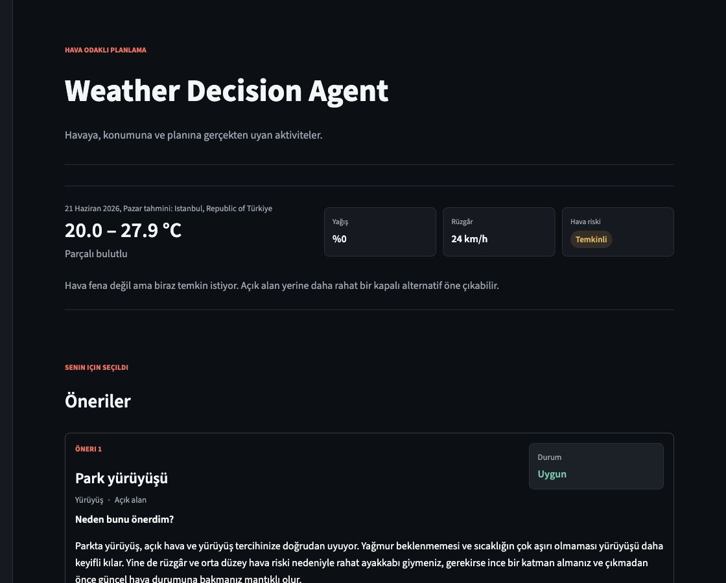
Final recommendation output with weather risk, user-friendly reasoning and a safe activity result.

Current Limits and Next Step
Google Places category quality can vary by location, free hosting may introduce a cold-start delay and personalization currently uses a small feedback-based score adjustment rather than advanced machine learning. The most valuable next step is to observe real usage and improve activity-to-venue matching from evidence rather than expanding scope blindly.

Bottom Line
Weather Decision Agent is a complete small-scale agentic AI product. It is useful to an end user, inspectable by a developer and designed so that the language model supports the decision without controlling safety-critical behavior.
Live demo: Open live demo

