Weather Decision Agent
Practitioner Notes
A concise guide for running, configuring, testing and maintaining the project
Deniz Özmen · Ömer Şahin · June 2026

1. Purpose and Operating Model
These notes are for a developer, evaluator or maintainer who needs to run the application and understand where decisions are made. The core rule is simple: deterministic code owns safety and scoring; external services provide data; the LLM explains an approved result.

2. System Flow
Stage | Responsibility | Main component
1 | Collect location, date and preferences | Streamlit UI
2 | Fetch and normalize seven-day forecast | Open-Meteo service
3 | Calculate risk and reject unsafe options | Rules and scoring
4 | Try exact match, then close fallback | Decision agent
5 | Find verified nearby venues | Venue provider / Google Places
6 | Explain the approved recommendation | Optional LLM services

3. Local Setup
Use Python 3.12 and install the pinned project dependencies.
python3.12 -m venv .venv
source .venv/bin/activate
pip install -r requirements.txt
Copy `.env.example` to `.env` and fill only the services that will be enabled. Never commit `.env` or real API keys.

4. Environment Configuration
Variable | When needed | Purpose
VENUE_PROVIDER | Always | Select `json` or `google_places`
GOOGLE_PLACES_API_KEY | Google Places mode | Server-side venue search secret
GOOGLE_MAPS_BROWSER_API_KEY | Google Maps picker | Referrer-restricted browser key
LLM_ENABLED | Always | Enable or disable LLM assistance
LLM_PROVIDER | LLM enabled | Select the configured LLM provider
LLM_MODEL | LLM enabled | Choose the configured model
LLM_API_KEY | LLM enabled | Private provider credential

5. Running the Application
streamlit run streamlit_app.py
Start in User Mode for the normal recommendation flow. Use Developer Mode only when inspecting rule traces, score components, evaluator results, raw weather data or provider behavior.

6. Decision Behavior

6.1 Risk
Rain, wind, temperature and weather condition are converted into LOW, MODERATE, HIGH or SEVERE risk. User Mode translates these into comfortable, cautious, risky and very risky labels.

6.2 Matching and Fallback
The agent tries an exact activity match first. If that option is unsafe or unavailable, it searches for a close alternative. Outdoor walking should therefore fall back to an indoor walking option before an unrelated activity.

6.3 Scoring
The total score is built from weather safety, preference match, comfort and practicality. A recommendation must pass deterministic safety checks before its score or explanation is shown.

7. Maps and Venue Providers
The venue layer uses a provider interface. JSON data supports deterministic demos and tests; Google Places supports live venues. Keep the Google Places key on the server. Restrict the browser key to Maps JavaScript API and approved HTTP referrers such as localhost and the Hugging Face Space domain.
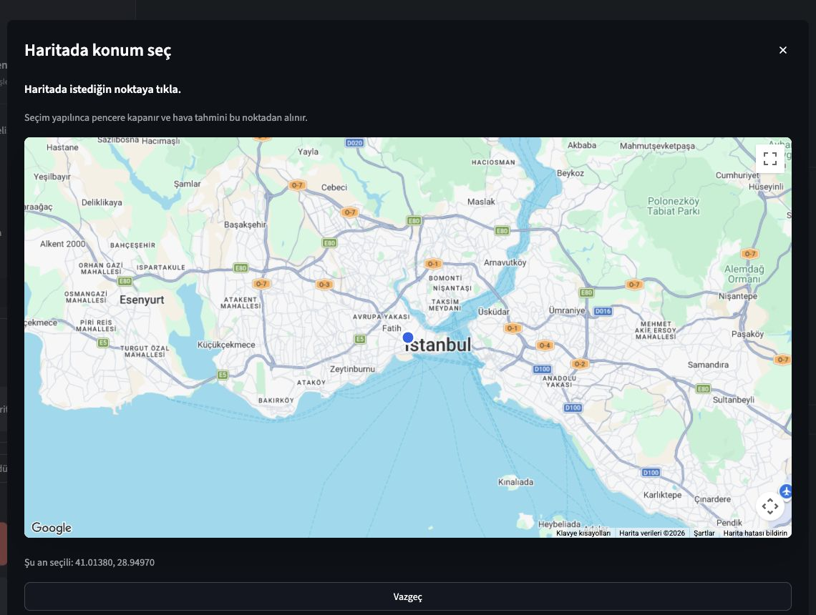
Google Maps picker used to provide coordinates to both weather and venue services.

8. LLM Boundary
The LLM may summarize weather, explain a recommendation, generate controlled catalog candidates and act as a second reviewer. Every candidate is revalidated. The LLM must not change risk levels, safety rules, score components or verified venue identity.

9. Testing and Evaluation
pytest
The current suite contains 159 passing tests. Evaluation scenarios cover thunderstorms, high wind, extreme heat, light rain, exact preference matches, safe stopping, coordinate-based venue sorting and rejection of unsafe or invented LLM output.

10. Deployment Workflow
The repository contains a Docker configuration for port 7860. The public application runs on Hugging Face Spaces. GitHub Actions synchronizes pushes from `main` to the Space repository.
Store Google and LLM credentials as Hugging Face Secrets. Store non-sensitive switches such as `VENUE_PROVIDER`, `LLM_ENABLED`, `LLM_PROVIDER` and `LLM_MODEL` as Variables. A secret or variable change restarts the Space.

11. Operational Notes
Situation | Expected handling
Weather API unavailable | Show a controlled error; do not fabricate weather
No safe activity | Stop safely and explain that no option passed
Google Places unavailable | Keep activity result; omit live venue suggestions
LLM unavailable or invalid | Use deterministic explanation and result
Free Space is sleeping | Allow a short cold-start delay

12. Known Limits
Venue categories depend on Google Places coverage and may occasionally produce a weak match. Forecast selection is limited to the available seven-day window. Public demo history is session-based and temporary. Personalization is intentionally small and feedback-based rather than an advanced machine-learning model.

13. Maintenance Priorities
Priority | Practical action
Activity quality | Review weak activity-to-venue mappings from real examples
Safety | Add an evaluation case before changing a threshold
LLM behavior | Keep prompts short and revalidate every generated candidate
Credentials | Rotate keys when exposed and keep API restrictions narrow
Deployment | Check GitHub Actions and Space logs after a release

14. Quick Reference
streamlit run streamlit_app.py # Run locally
pytest # Run tests
git push origin main # Trigger GitHub/HF sync
Live demo: Open live demo

