Model

We have mentioned above that minority game has several properties.

1. N players game
2. Repeated game
3. Non-cooperated game
4. Minority wins

We need to satisfy all these properties in our model.

We assume the game is inductive reasoning. Agents cannot know the payoff of their strategies by mathematics methods.

N: the number of agents

S: the number of pure strategies each agent has.

m: length of agents’ memory, which means all agents will do their prediction individually based on past **m** weeks.

ai(t): agent i prediction for week t, {-1,+1}. -1 for staying at home/+1 for going to bar.

: attendance of week t.

Ui,s(t): virtual score for the strategy s of agent i at week t.

si(t)=arg maxUi,s(t):the best strategy for agent i at week t.

The model we are using:

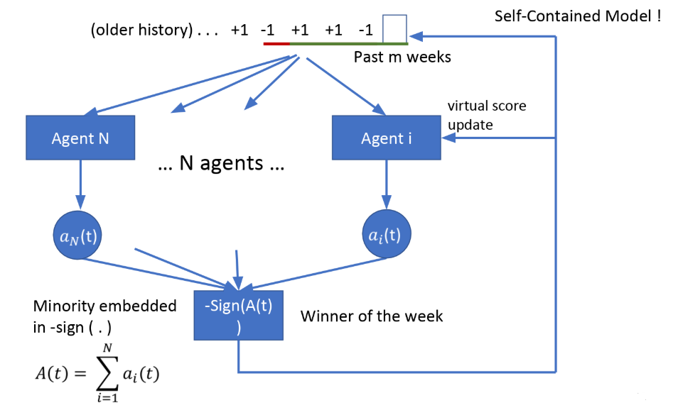

When a new week comes, every agent need to make decision. Each agent will look back on the previous history and make its own prediction. And there will be more than 2 agents. So this satisfy the “N players game” and “Non-cooperated game” .

And after all agents make their decision, we can know who is the winner group of this week by calculating -sign(A(t)), which represents the choice of minority group. This shows our model satisfy the property “Minority wins”.

Knowing the winner group, every agent can update virtual score for each strategy they have. And add the winner group of this week to the history record. When next week comes, agent will repeat all these actions. And game will keep looping. This shows our model has the property of “Repeated game”.

We can see our model is self-contained and satisfy all properties in minority game.

Strategy for per agent

By mapping +1 to 1 and -1 to 0, we can represent previous history by a integer, which is called information \miu.

For example, when m=3

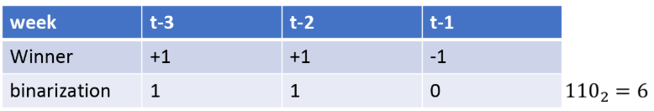

It is easy to see there can be 2^m different information. And a strategy of agent should contain predictions for all these information \miu.

For exampe, when m=3, S=2

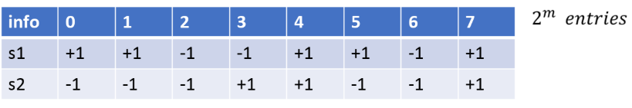The value in table(-1 or +1).represent the winning group strategy predicts when given information \miu.

And there will have virtual score Ui,s to evaluate each strategy agent has. Every time when agent need to make decision, it will pick the strategy with the highest score. After the winner group is calculated, agents will update the virtual score of their strategies.



Agent will add score to the strategies which make the correct prediction and deduct score to error-predicted strategies.