**Free Resources to Continue to Learn Python**

**Learn Python: https://www.learnpython.org/**

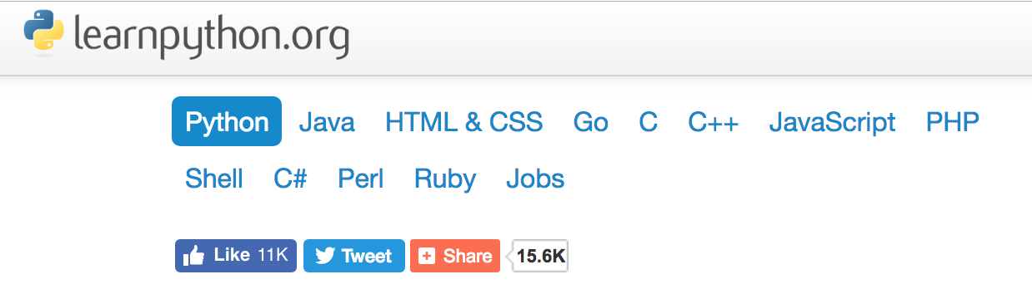

**codeacademy- https://www.codecademy.com/learn/learn-python**

**Note: there is a free version and a paid version**

**Once you have a bit more experience:**

1. Google Python Tutorial https://developers.google.com/edu/python/
2. MIT Open Courseware: https://ocw.mit.edu/courses/electrical-engineering-and-computer-science/6-0001-introduction-to-computer-science-and-programming-in-python-fall-2016/in-class-questions-and-video-solutions/
3. Harvard online courses: https://online-learning.harvard.edu/course/cs50-introduction-computer-science/
4. Hackerrank: https://www.hackerrank.com/