**Help with Computational Biology Workshops for High Schoolers**

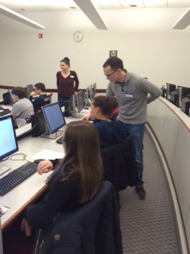

* Help debug (very basic) Python
* Lots of interaction with high school students- get them excited about programming in STEM

**See more at** <https://computational-stem-lab.github.io/>

**To sign up to volunteer**, go to: shorturl.at/jsFIK