Predicting Drive Failure
A Predictive-Maintenance System for Hard Drive Fleets
Built on Real Backblaze Drive Stats Telemetry

IT Capstone Project
Live demo: https://hdd-failure-predictor.onrender.com
Repository: https://github.com/dp2426-NAU/hdd-failure-predictor

Executive Summary
This project trains machine learning models on real hard-drive SMART telemetry, published by Backblaze under their Drive Stats program, to predict which drives are likely to fail within the next 7 days, estimate how much longer each drive is likely to run, and recommend a cost-optimal alert threshold for a given organization's cost structure. Results are served through three Streamlit dashboards covering three distinct audiences -- leadership, field technicians, and decision-makers -- backed by a two-tier automated alerting system, one layer running unattended on a real hourly schedule via GitHub Actions.
The system is intentionally built to go beyond a standard binary classification exercise on this well-known public dataset: it uses early-warning labeling (excluding same-day failure signal as training leakage), a Cox Proportional Hazards survival model for remaining useful life, per-prediction SHAP explainability, and a real cost-sensitivity surface -- all trained and evaluated on a real downloaded Backblaze quarter (2026-01-01 to 2026-03-31, model ST16000NM001G).

1. Problem Statement and Motivation
Unplanned hard-drive failure is a persistent operational cost for any organization running physical storage infrastructure -- data centers, backup providers, and enterprise IT alike. Reactive maintenance (replacing a drive only after it fails) risks data loss and unplanned downtime; blanket proactive replacement wastes budget on drives that would have run fine. A predictive approach -- flagging at-risk drives early enough to act, backed by an estimate of how much time is actually left -- is the standard framing used in real industrial predictive maintenance, and is the goal of this project.

2. What Makes This Project Different
Backblaze's Drive Stats dataset is one of the most common public machine learning case studies available, and plenty of prior student and public projects use it for plain binary classification. Four design decisions make this project substantively different, not just cosmetically different:
- Early-warning labeling, not same-day diagnosis. A drive's SMART readings on the day it fails already look like a failure -- training on that row would be recognizing an already-failed drive, not predicting one. Every row is instead labeled positive only if the drive's actual failure lands within the next 7 days, and the failure-day row itself is excluded from training.
- Remaining useful life, not just yes/no. A Cox Proportional Hazards survival model estimates how many days a drive likely has left, the standard framing in real industrial predictive maintenance, instead of stopping at binary classification.
- Per-prediction explainability. SHAP explains this specific drive's score, using its own real SMART readings, not just which features matter on average across the whole model.
- A genuine decision-support result, not just a risk score. The cost surface shows that the right alert threshold depends on an organization's own cost structure -- there is no single universal answer, which is the actually useful, non-obvious finding.

3. Data
Training data is a real quarterly download from Backblaze's public Drive Stats program (2026-01-01 to 2026-03-31), filtered to a single high-volume drive model, ST16000NM001G. Mixing drive models was avoided deliberately: during model selection, the single highest-volume model in the raw data turned out to report zero values for two of the seven SMART attributes this project's feature set relies on -- a real vendor-level SMART-reporting difference (confirmed to be a Seagate-vs-WD/Toshiba reporting pattern), not a data quality bug. The model ultimately used reports all seven attributes fully.
Metric | Value
Drive model | ST16000NM001G
Date range | 2026-01-01 to 2026-03-31
Real failure-day rows (this model) | 267
Balanced training rows (matched negatives) | 267
Data source | real_backblaze_download (see data/provenance.json)

4. Methodology

4.1 Classifier
A RandomForestClassifier (300 trees, max depth 8, class_weight='balanced') predicts the probability a drive fails within the next 7 days, trained on SMART 5, 9, 187, 188, 194, 197, and 198 (reallocated sectors, power-on hours, reported uncorrectable errors, command timeout, temperature, current pending sectors, and offline uncorrectable sectors).
The train/test split is grouped by drive (StratifiedGroupKFold on serial_number), not by row. A failing drive contributes multiple rows to the positive class -- one per pre-failure day within the horizon -- and a drive's SMART readings are autocorrelated day-to-day, so a naive row-level split can let the same physical drive leak across train and test, inflating held-out metrics. This was caught and fixed during development.

4.2 Survival Model
A Cox Proportional Hazards model (lifelines, penalizer=0.1) estimates remaining useful life per drive, evaluated with the concordance index -- the fraction of comparable drive pairs the model ranks in the correct order of who fails first. A Kaplan-Meier estimator provides the fleet-wide baseline survival curve shown alongside each drive's individual curve.

4.3 Explainability
SHAP's TreeExplainer (exact, not approximated, for tree ensembles) computes per-drive feature contributions, shown on the Operator Lookup dashboard and reused by the automated alert emails to explain why a specific drive was flagged.

4.4 Cost Optimization
A cost simulator sweeps every combination of alert threshold and cost ratio (downtime cost / replacement cost) against the classifier's real held-out test outcomes, showing that the optimal threshold moves with an organization's own cost structure rather than having one universal answer.

5. Results
Classifier (deployed model, grouped held-out test fold):
Metric | Value
Precision (failure class) | 94%
Recall (failure class) | 100%
F1 score | 97%
ROC-AUC | 0.998
Train / test rows | 392 / 142
Train / test drives (grouped, zero overlap) | 230 / 77

Cross-fold stability (all 4 StratifiedGroupKFold folds evaluated, not just the deployed one) -- reported because only about 43 real failing drives underlie every classifier metric, which is genuinely few for a held-out evaluation:
Metric | Mean | Std Dev
Precision | 0.979 | 0.025
Recall | 0.902 | 0.162
F1 | 0.930 | 0.099
ROC-AUC | 0.965 | 0.060

Recall in particular varies substantially fold to fold (a range from roughly 0.62 to 1.00 was observed), depending on which specific failing drives land in a given test fold. This range, not the single deployed fold's point estimate, is the statistically honest answer to 'how good is the model.'
Survival model:
Metric | Value
Concordance index | 0.945
Drives in survival model | 34,729
Failure events observed | 43

6. Dashboards

6.1 Home
Landing page with an accurate, automatically-generated data-authenticity banner (reads data/provenance.json rather than a hardcoded claim), links to all three dashboards, and the real model snapshot.
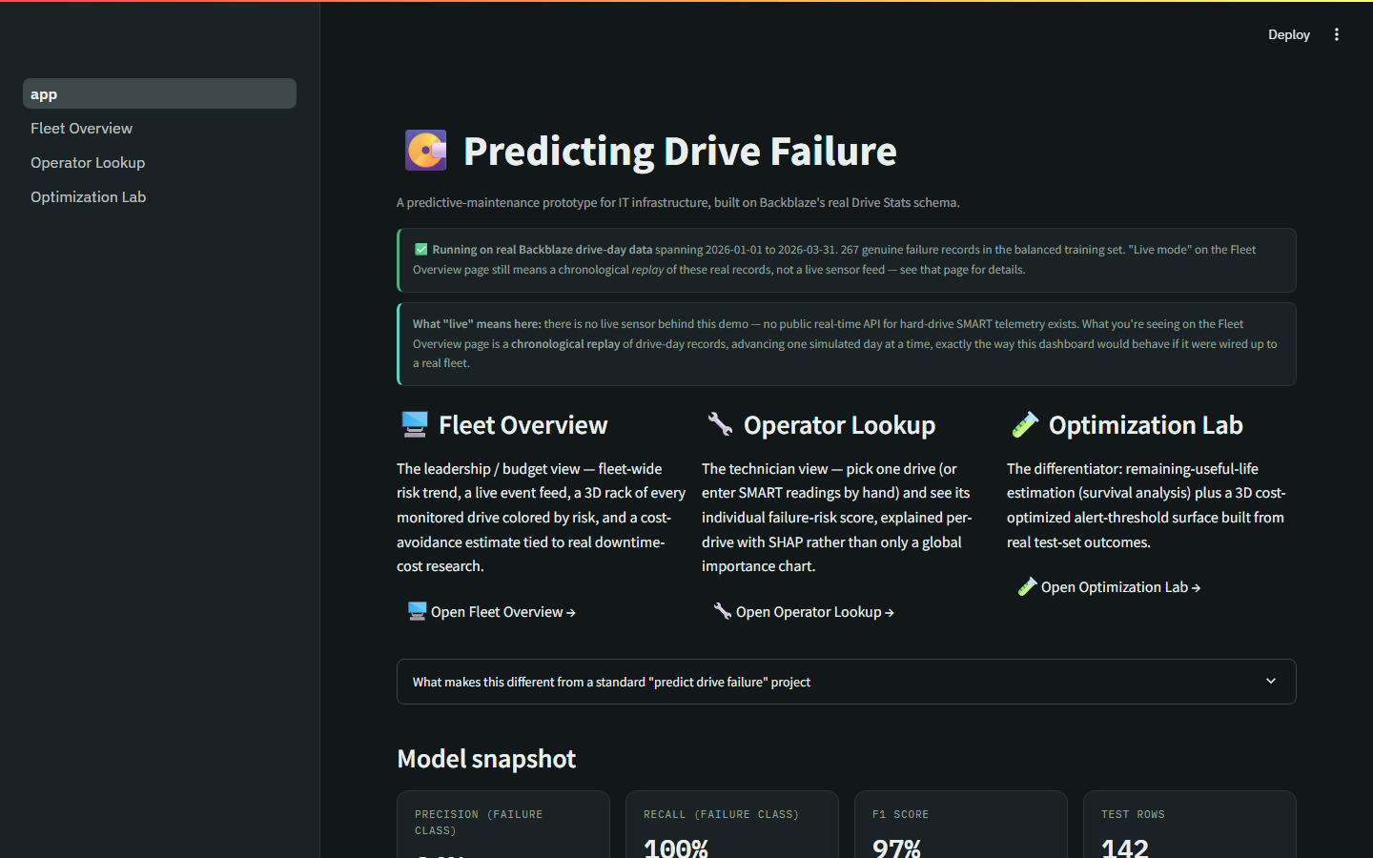
Home page -- real-data banner and model snapshot

6.2 Fleet Overview
The leadership/budget view: a chronological, honestly-labeled replay of the real quarter, a 3D rack of monitored drives colored by risk tier, an event feed, a fleet-risk trend line, and an adjustable cost-avoidance estimate.
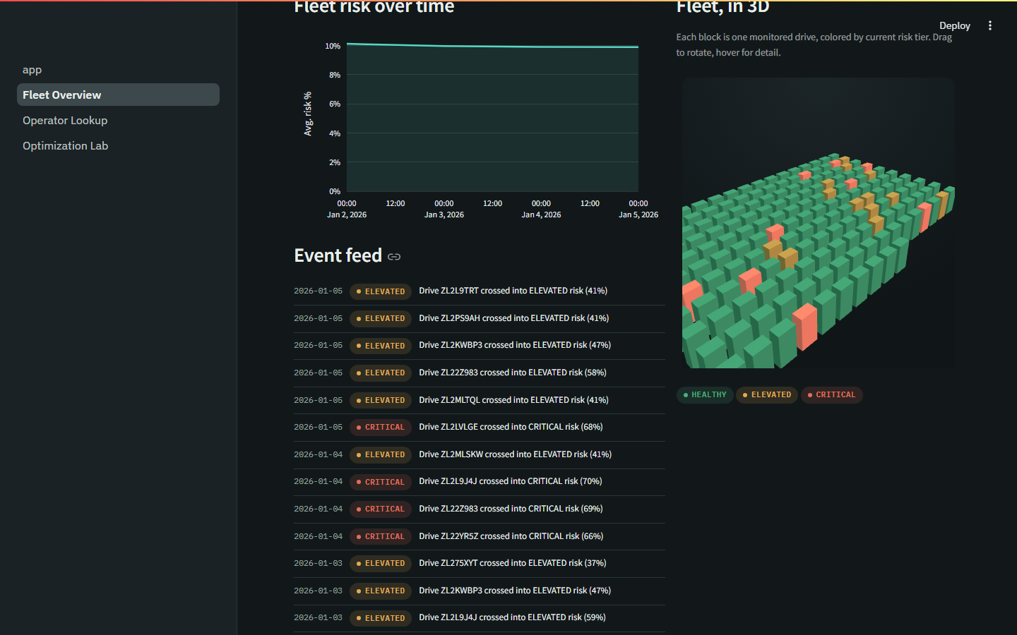
Fleet Overview -- 3D rack and event feed showing both elevated and critical events

6.3 Operator Lookup
The technician view: pick one drive and see its individual risk score, explained with SHAP values specific to that drive.
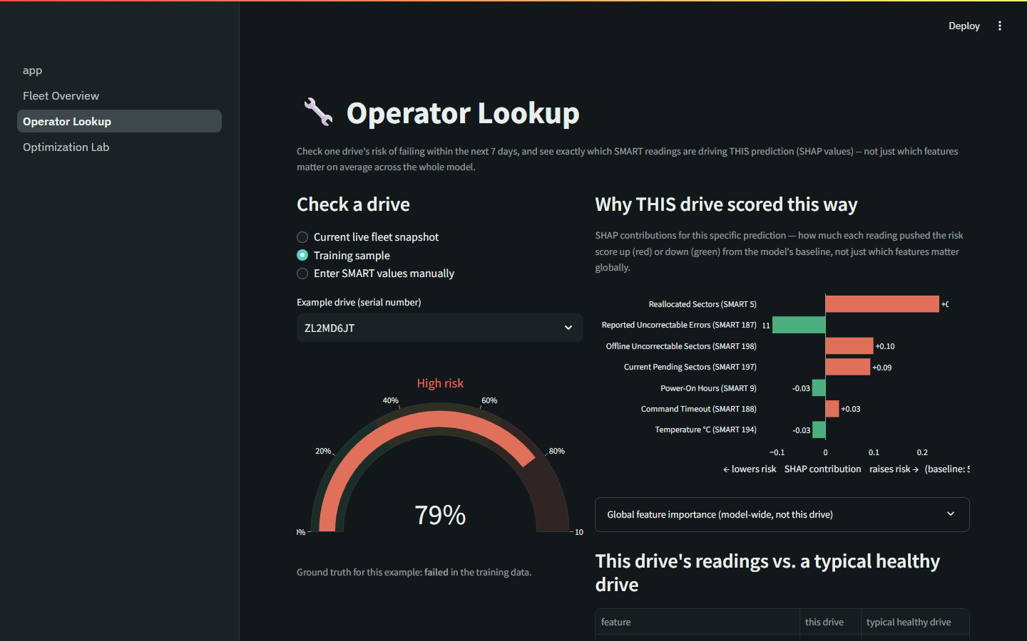
Operator Lookup -- a real high-risk drive with its SHAP explanation

6.4 Optimization Lab
The differentiator dashboard: a remaining-useful-life estimate per drive and a 3D cost-optimized alert-threshold surface built from real held-out test predictions.
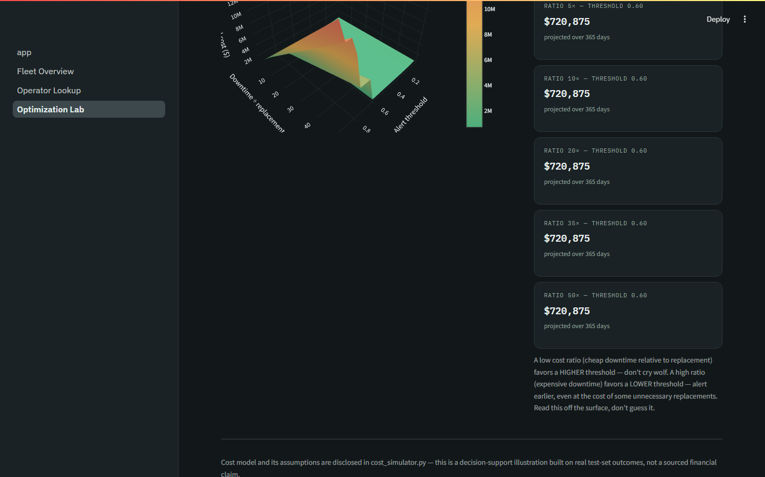
Optimization Lab -- 3D cost surface responding to threshold and cost-ratio sliders

7. Automation
Two email-alert layers, both free (rule-based summaries built from real SHAP output, no external API), covering two severity tiers -- an early warning the moment a drive crosses into elevated risk, and a critical alert if it goes on to cross critical risk:
- In-browser alert: fires instantly while someone is actively stepping through Fleet Overview's replay.
- Scheduled automation: a GitHub Actions workflow running on a real hourly cron schedule, independent of the deployed app or anyone having it open -- free and unlimited on a public repository. State persists in automation/state.json, committed back to the repository after every run.

8. Known Limitations
- Imbalanced, rare-event target. Real drives fail roughly 1.36% of the time annually; precision/recall/F1 are reported, not raw accuracy.
- Only about 43 real failing drives underlie every classifier metric -- genuinely few for a held-out evaluation, addressed by reporting cross-fold stability rather than a single point estimate.
- One vendor's fleet. Backblaze's operating conditions may not match another organization's -- this is a demonstrated method, not a drop-in production tool.
- "Live" is a labeled replay of real historical data, not a live sensor feed -- disclosed directly in the app itself.
- The cost-avoidance figures are adjustable planning assumptions, not sourced statistics.
- The survival model uses static, last-observed covariates, not a full time-varying history -- a standard simplification for a course project.
- The 7-day early-warning horizon is a chosen parameter, not a universal constant.

9. Future Work
- Validate the Cox proportional-hazards assumption (cph.check_assumptions()).
- A calibration curve / Brier score for the classifier's predicted probabilities.
- Extend the existing GitHub Actions automation to periodically retrain the model as new data arrives.
- Data drift detection between training and live data.
- A pytest test suite and CI workflow for the pipeline scripts and alerting logic.

10. References
Backblaze. (2026, January). Backblaze Drive Stats for 2025. Backblaze Blog. https://www.backblaze.com/blog/backblaze-drive-stats-for-2025/

