Jesse | Career Advancement Meeting Playbook
Full updated scripts • November 2026 • Senior Manager first; individual-contributor Lead Data Scientist promotion as a distinct path
USE: Read Step 1, pause, select the scenario that matches Jesse’s answer. Do not read every branch. Step 6 is an on-demand answer, not a required step. If Simon is mentioned, use F–I. No external offer is mentioned in the initial discussion.

STEP 1 | Opening — ask about Senior Manager
“Jesse, there's something I wanted to follow up on. Back in July, we discussed my interest in the Senior Manager position, and you mentioned that we needed to build my case through project ownership, working with contractors, and getting more exposure to senior management.
Since then, I've been independently and proactively leading SAR Intelligence, including overseeing Ashish's work, managing technical development and the data migration to Databricks, leading stakeholder meetings, and addressing their ad hoc requests. I've presented the project to senior management, led knowledge-sharing session, and tech enablement sessions for for the team on Databricks and AI tools, and continued delivering our weekly SAR summaries and monthly SAR topics alongside the project.
I've really enjoyed taking on these responsibilities, and I feel I've made significant progress in the areas we discussed. Since the Senior Manager position is still open, I wanted to revisit our conversation. Would you be open to considering me for this role? I'd really appreciate your perspective.”
NEXT → Pause. Choose A–E; if Jesse invokes Simon, choose F–I. If he asks why you are ready, answer Step 6 and return to the branch.

STEP 2 | Initial responses

A | Jesse is receptive to Senior Manager
Jesse: “You’ve made good progress. We could consider you.”
“Thank you, Jesse. I really appreciate your support. What would the next step be for formally considering me? Would it make sense to discuss my candidacy with Simon or HR?”
NEXT → Concrete action and timing → Step 7. Positive but vague → Step 4. Simon objection → F or G.

B | Jesse says you are not ready for Senior Manager
Jesse: “I think you need more experience for Senior Manager.”
“I understand, Jesse, and I appreciate your feedback.
Aside from the Senior Manager position, I also wanted to discuss another potential career advancement opportunity, which is a promotion on the individual-contributor track to Lead Data Scientist.
Given the technical leadership, project ownership, stakeholder management, and mentoring responsibilities I’ve taken on, I feel that moving into a Lead Data Scientist role could be a natural next step in my career.
I’d really appreciate your perspective on whether you think I’d be ready for that promotion and what the process would look like.”
NEXT → Supports exploring Lead → Step 3. Specific readiness gap → Step 3B. Vague → Step 4. Says Simon opposes it → G or I.

C | Jesse says you need more exposure to Simon / senior leaders
“That makes sense. Since July, I’ve presented SAR Intelligence to senior management and led several stakeholder discussions. I feel I’ve made progress in that area. What additional exposure would you want to see before considering me for the next level?”
NEXT → Specific exposure milestone → Step 3B. If this is only a Senior Manager barrier → B to introduce Lead. Vague → Step 4. Simon objection → F/G.

D | Jesse says production deployment / MRM must finish first
“I understand that bringing SAR Intelligence into production is important. The main development work is substantially complete, but MRM review, stakeholder feedback, testing, and production approvals may take several more months. Would you see production deployment as a strict requirement for promotion, or could we assess my readiness based on the leadership responsibilities and contributions I’ve demonstrated so far?”
NEXT → Hard requirement → Step 3B (define exactly what and when), then B if Lead is a separate path. Not a hard requirement → ask for consideration (A or Step 3). Vague → Step 4.

E | Jesse says they are still interviewing / expect to hire externally
“I understand. I wanted to make sure you knew I remain interested in being considered, given the progress I’ve made since July. If the Senior Manager hiring process is focused on other candidates, I’d also like to discuss a separate promotion on the individual-contributor track to Lead Data Scientist.
Given the technical leadership, project ownership, stakeholder management, and mentoring responsibilities I’ve taken on, I feel that moving into a Lead Data Scientist role could be a natural next step in my career.
I’d really appreciate your perspective on whether you think I’d be ready for that promotion and what the process would look like.”
NEXT → Lead supported → Step 3. Specific gap → Step 3B. Vague → Step 4. Simon objection → F, G or I.

STEP 2A | If Jesse refers to Simon — additional branches

F | Simon does not support Senior Manager specifically
Jesse: “I discussed Senior Manager with Simon; he doesn’t think you’re ready.”
“I understand, Jesse, and I appreciate you discussing it with Simon. I’d really value any feedback on the specific areas Simon thinks I should develop further.
Separately from the Senior Manager position, I’d also like to discuss a promotion on the individual-contributor track to Lead Data Scientist. Given the technical leadership, project ownership, stakeholder management, and mentoring responsibilities I’ve taken on, I feel that could be a natural next step.
Would you be open to discussing that separate possibility with Simon and getting his perspective?”
NEXT → Jesse agrees to raise Lead → H. Says Simon already opposes both → G. Says a Lead position cannot be created → I. Vague → Step 4.

G | Simon does not support either advancement path
Jesse: “Simon doesn’t support a promotion right now.”
“I understand, Jesse, and I appreciate you being transparent. Since July, I’ve taken on additional responsibilities, including directing Ashish’s work, leading SAR Intelligence, presenting to senior management, and managing recurring BAU deliverables. Could you help me understand what specific gaps Simon sees between my current responsibilities and the expectations for Lead Data Scientist? Could we agree on what I would need to demonstrate and when we could revisit it?”
NEXT → Specific gaps → Step 3B. No defined gaps / no timeline → Step 5, then Step 7. Do not ask Jesse to re-pitch an already rejected proposal immediately.

H | Jesse is willing to propose Lead Data Scientist to Simon
Jesse: “Let me discuss the Lead role with Simon.”
“Thank you, Jesse. I really appreciate your support. I think this could recognize the technical leadership and responsibilities I’ve taken on while allowing me to continue contributing to the team. Would it be possible to discuss this with Simon and revisit it in our next one-on-one? I’d appreciate understanding his perspective and what the next steps might look like.”
NEXT → Agree on who contacts Simon and when → Step 7. If approval process is unclear → Step 3. If he withdraws support → I or Step 5.

I | Jesse believes Simon will not approve creating a Lead position
Jesse: “I don’t think Simon would approve a Lead Data Scientist position.”
“I understand. Would you say the main concern is that there isn’t an available position or budget right now, or that you and Simon feel I need more experience before moving to the Lead Data Scientist level? I’d like to understand whether this is an organizational constraint or a readiness concern so I can plan my next steps accordingly.”
NEXT → Readiness concern → Step 3B. Budget/headcount constraint → Step 5 (ask if another promotion mechanism or future review is possible). Still vague → Step 4 once, then Step 5.

STEP 3 | Jesse is open to Lead Data Scientist
“I’d really appreciate your support in exploring a promotion to Lead Data Scientist. What is the internal process, who would need to approve it, and what evidence would you need from me? Could we identify a next step and a reasonable time to revisit it?”
NEXT → Action/owner/date → Step 7. Concrete gap → Step 3B. No commitment → Step 5.

STEP 3B | He identifies a specific milestone or gap
“That’s helpful. To make sure I focus on the right thing, what would successfully meeting that expectation look like, and how would we evaluate it? Could we agree on a review date, even if production approval or the hiring process takes longer?”
NEXT → Criteria and date agreed → Step 7. Cannot define either → Step 4.

STEP 4 | Jesse gives vague encouragement
Jesse: “Keep doing what you’re doing; opportunities will come.”
“Thank you, Jesse. I appreciate the encouragement. Since we first discussed this in July, I’d like to understand the path more clearly. Based on my current responsibilities, do you see me operating at the Lead Data Scientist level? If not, what specific gaps would you want me to address before you could support that promotion?”
NEXT → Specific gap → Step 3B. Supports Lead → Step 3. Still noncommittal → Step 5. Do not repeat Step 4.

STEP 5 | No commitment, approval, or timeline
“I understand that promotions depend on organizational approvals, and I’m not expecting a commitment today. What would help me is understanding whether you’d be supportive of my advancement to Lead Data Scientist or a management role, and whether we could set a time to revisit it after clarifying the requirements with Simon or HR.”
NEXT → If he agrees → confirm action/date in Step 7. If he still cannot commit → Step 7 and evaluate your options privately.

STEP 6 | On-demand: “Why do you think you’re ready?”
“I think I’ve demonstrated leadership in several areas. I’ve independently led SAR Intelligence through its main development work, directed and reviewed Ashish’s deliverables, managed technology enablement and data migration to Databricks, and led stakeholder meetings and ad hoc requests. I’ve also presented to senior management, trained colleagues on our technical tools, and kept up with weekly SAR summary and monthly SAR topics BAU deliverables. I know formal people management and broader portfolio oversight are areas I’d continue developing, but I believe my current responsibilities provide a strong foundation for the next level.”
NEXT → Return to the branch that prompted the question; do not automatically proceed to Step 7.

STEP 7 | Close and confirm next steps
“Thank you, Jesse. I really appreciate your feedback and support. I’m committed to continuing to deliver on our projects and would like to keep moving toward the next level. Just to confirm, our next step is [agreed action], and we’ll revisit this around [agreed date].”
If no action/date was agreed, instead close with: “Thank you, Jesse. I appreciate your perspective and the chance to discuss my career goals. I’ll reflect on what we discussed.”

Decision flowchart | Routing map
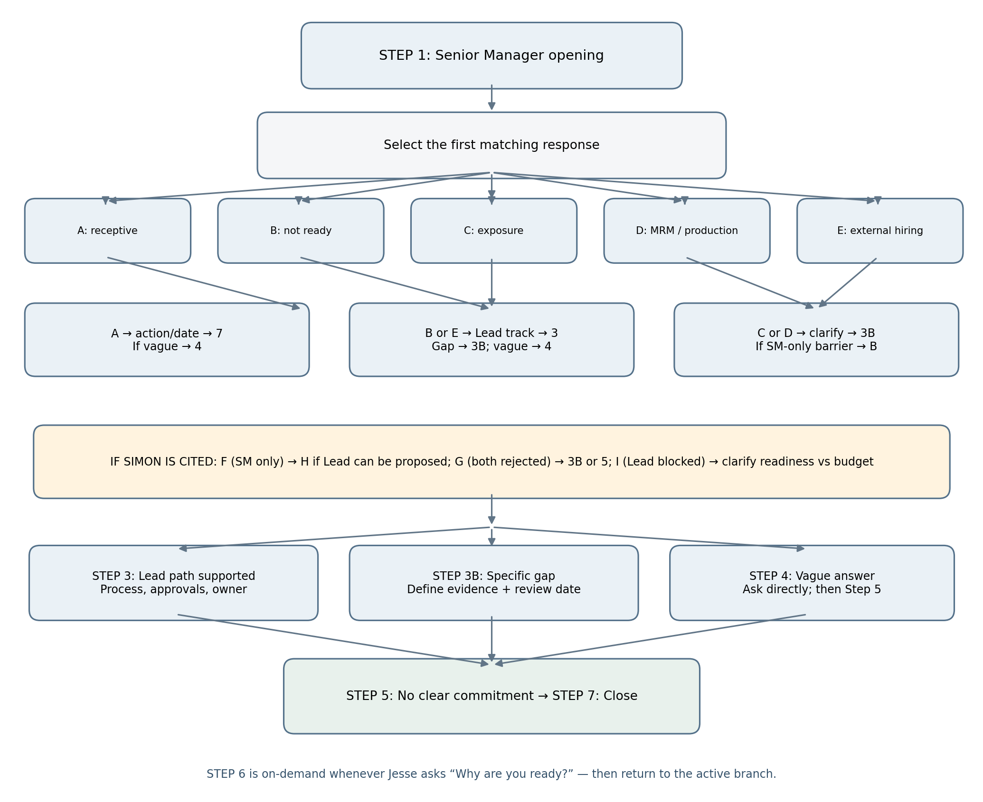

Quick routing reference
• A → Step 7 if action agreed; otherwise Step 4.
• B → Step 3 if Lead supported; Step 3B if gap; Step 4 if vague; G/I if Simon opposes.
• C → Step 3B for concrete exposure; B if only Senior Manager is blocked; Step 4 if vague.
• D → Step 3B to define production-related milestone; B for a separate Lead path; Step 4 if vague.
• E → Step 3 for Lead; Step 3B for gaps; Step 4 for vagueness.
• F → H if Jesse will approach Simon about Lead; G if both rejected; I if Lead role creation blocked.
• G → Step 3B if gaps identified; otherwise Step 5.
• H → Step 7 with follow-up owner/date; Step 3 if process unclear.
• I → Step 3B if readiness issue; Step 5 if budget/headcount; Step 4 if unclear.
• Step 6 → Only when asked; return to the active branch.

Meeting guardrails
Do not say SAR Intelligence is in production; describe development as substantially complete and MRM/testing/approvals as pending. Supervising Ashish’s work is genuine project-level leadership but not the same as formal line management. Keep Senior Manager and Lead Data Scientist as distinct career paths. Ask for one concrete action, owner, and follow-up date; avoid repeating the same request after a clear answer.

