ASSIGNMENT 04

David Pahmer

2022-04-24

# Assignment 4 - Instructions

## Tasks

### YAML Metadata

* ☐ Update the YAML metadata in the template to include your name and the current date.

# Markdown Basics

## Favorite Foods

1. Scalloped potatoes
2. Milk chocolate rum balls
3. Anise flavored oatmeal

## Images

{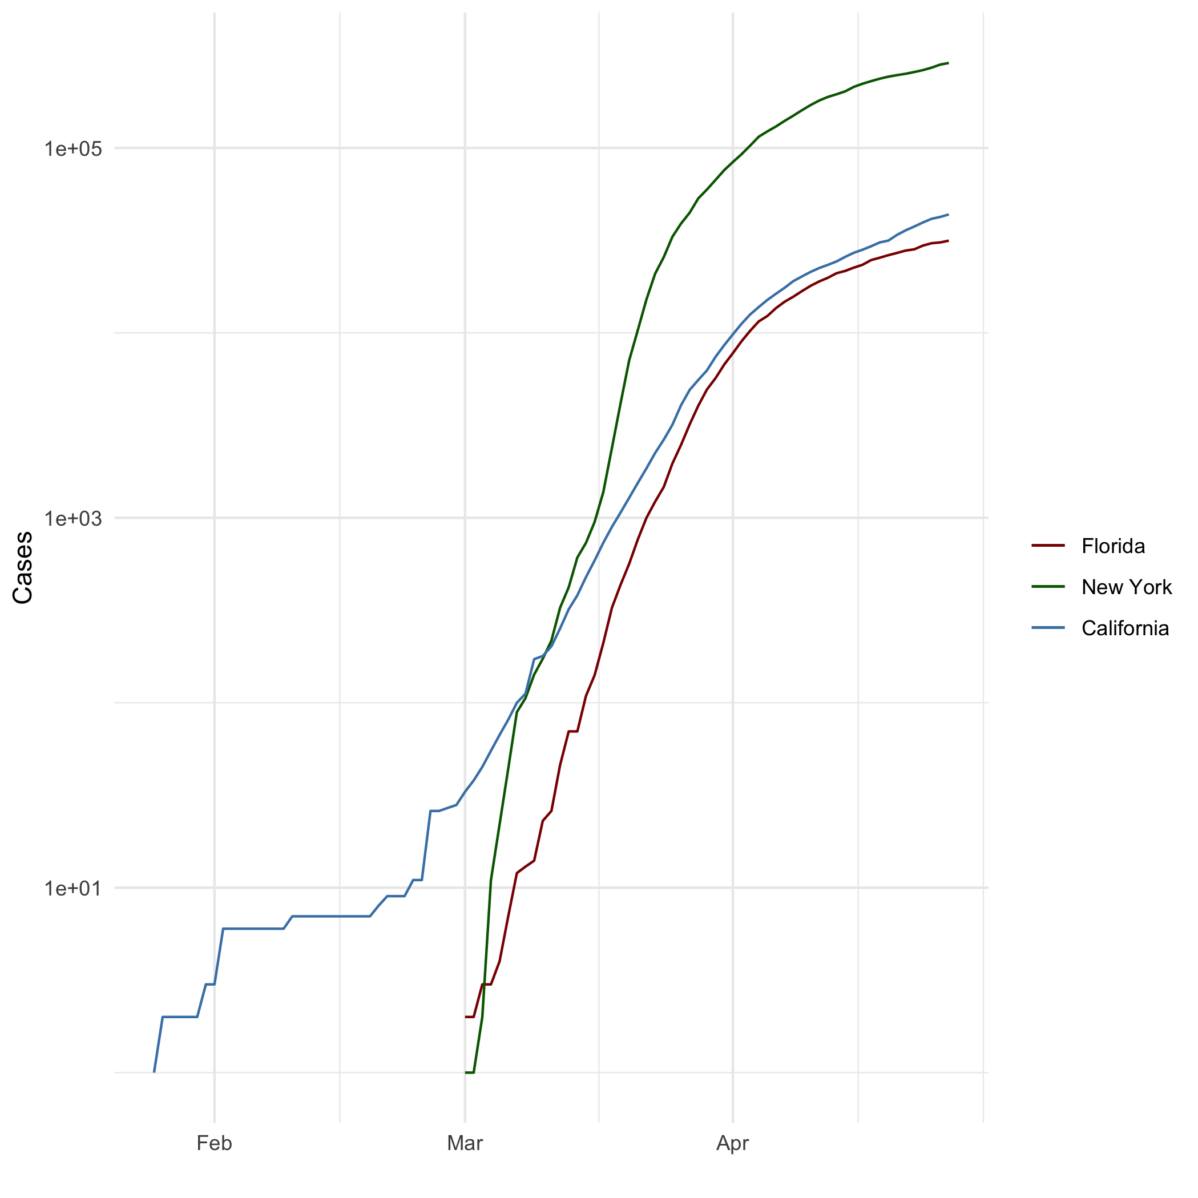}

## Add a Quote

In an argument with your spouse, the first one to say “I’m sorry, you’re right” wins!

## Add an Equation

$$y=\frac{2\sqrt{x}}{3x}$$

## Add a Footnote

For footnote, see below.[1]

## Add Citations

* R for Everyone(Lander 2014)
* Discovering Statistics Using R(Field, Miles, and Field 2012)

# Inline Code

## NY Times COVID-19 Data

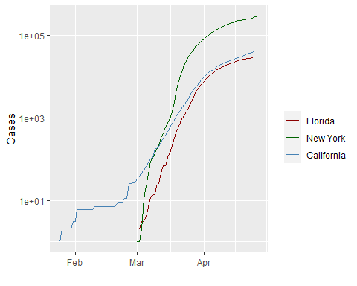

## R4DS Height vs Earnings

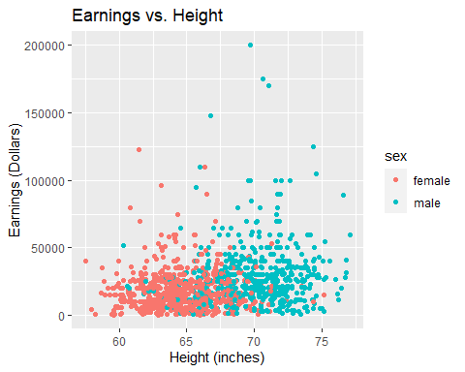

# Tables

## Knitr Table with Kable

One Ring to Rule Them All

| name | race | in_fellowship | ring_bearer | age |
| --- | --- | --- | --- | --- |
| Aragon | Men | TRUE | FALSE | 88 |
| Bilbo | Hobbit | FALSE | TRUE | 129 |
| Frodo | Hobbit | TRUE | TRUE | 51 |
| Galadriel | Elf | FALSE | FALSE | 7000 |
| Sam | Hobbit | TRUE | TRUE | 36 |
| Gandalf | Maia | TRUE | TRUE | 2019 |
| Legolas | Elf | TRUE | FALSE | 2931 |
| Sauron | Maia | FALSE | TRUE | 7052 |
| Gollum | Hobbit | FALSE | TRUE | 589 |

## Pandoc Table

library(pander)  
short_table <- characters_df[c(1:3,5,8),]  
row.names(short_table) <- NULL  
pandoc.table(short_table, style='grid')

##   
##   
## +--------+--------+---------------+-------------+------+  
## | name | race | in_fellowship | ring_bearer | age |  
## +========+========+===============+=============+======+  
## | Aragon | Men | TRUE | FALSE | 88 |  
## +--------+--------+---------------+-------------+------+  
## | Bilbo | Hobbit | FALSE | TRUE | 129 |  
## +--------+--------+---------------+-------------+------+  
## | Frodo | Hobbit | TRUE | TRUE | 51 |  
## +--------+--------+---------------+-------------+------+  
## | Sam | Hobbit | TRUE | TRUE | 36 |  
## +--------+--------+---------------+-------------+------+  
## | Sauron | Maia | FALSE | TRUE | 7052 |  
## +--------+--------+---------------+-------------+------+

### Word and PDF Output

* ☐ Generate Word and PDF output

RStudio should add the following to your YAML metadata

output:  
 pdf_document: default  
 html_document: default  
 word_document: default

# References

Field, A., J. Miles, and Z. Field. 2012. *Discovering Statistics Using r*. SAGE Publications. <https://books.google.com/books?id=wd2K2zC3swIC>.

Lander, J. P. 2014. *R for Everyone: Advanced Analytics and Graphics*. Addison-Wesley Data and Analytics Series. Addison-Wesley. <https://books.google.com/books?id=3eBVAgAAQBAJ>.

1. This is a footnote