**6.2 Commercial Distributor Cooperative Marketing Fund Program (Co-Op)**

The Commercial Disti Co-Op Program is a **marketing reimbursement program** that allows Commercial Distributors to claim reimbursement for marketing expenses under the following three ‘activity buckets’:

* Demand Generation
* Market Development
* Partner Readiness

**Conditions to participate in the Co-Op program**

1. Partner must have a valid Distributor Agreement with Microsoft
2. Company must be authorized to distribute at least one of the following: Full Packaged Products, Open Program, Get Genuine Windows for Small and Medium Organizations or Academic Licensed Software
3. Partner needs to maintain membership in the Microsoft Partner Network (MPN)
4. At least two of the Distributor's employees must pass the Microsoft Certified Professional (“MCP”) exam entitled “Designing and Providing Microsoft Volume License Solutions to Small and Medium Business”
5. In accordance with MS Sales, the Distributor earns Rebates and Co-Op funds as per eligible products list in the Rebate and Co-Op letter
6. Co-Op reimbursements are subject to compliance with the program rules, marketing guidelines and certain approval requirements as part of the marketing/activity plan and claim process

**Product Categories**

Products that are taken into account for earnings calculations are split into two groups, Core and Growth Products. The table below provides a summary of the core products and growth products. A detailed Product Category list will be posted at <http://msops.microsoft.com> and updated on a regular basis.

| Core Products | Growth Products |
| --- | --- |
| Office (all except FPP and PKC) | BizTalk Server |
| Windows Client | Developer Tools ( ALM Solutions and Designer Tools) |
| Windows Server & CAL | Dynamics CRM |
|  | Exchange Server & CALs |
|  | Identity & Security |
|  | IW CAL Suites - Core/BKO CAL |
|  | MDOP - Client |
|  | OCS Servers & CAL |
|  | Other IW apps (Groove, Duet, Performance Point Svr/CAL) |
|  | Project |
|  | System Center Servers |
|  | System Center Client MLs |
|  | S&T CAL Suites - Core/BKO CAL |
|  | S&T CAL Suites - ECAL |
|  | SharePoint Server & CAL |
|  | Windows Server Other (Windows remote desktop services) |
|  | Windows Server Solutions & CALs (Small Business Server & CAL) |
|  | SQL Server & CAL |
|  | SQL Server Enterprise |
|  | Visio |

**Co-Op Fund Earnings**

Partner performance for Rebates and Co-Op Fund earnings is measured against the six performance areas identified in the table below. Each Performance Area is based on its specific Eligible Revenue that takes into account a combination of license types and Product Categories.

The Rebates and Co-Op Fund earnings for each Performance Area are calculated by multiplying Eligible Revenue for the applicable Performance Area by the respective Rebates and Co-Op Funds earnings percentage, these percentages might vary by region.

| Performance Area | Eligible Revenue |
| --- | --- |
| Core Products Revenue | Core Products all revenue sold through NMP through Open, Open Value, Open Value Subscription, Academic and FPP (Office FPP and PKC excluded) Pricing levels |
| Growth Products Revenue | Growth Products all revenue sold through NMP through Open, Open Value, Open Value Subscription, Academic and FPP Pricing levels |
| Office FPP and PKC Revenue | Office FPP products revenue sold to NMP and MP through FPP and PKC License types |
| Annuity Revenue | Open revenue sold through NMP through Open L&SA new, Open SA renewal, Open Value L&SA new, Open Value L&SA renewal, Open Value SA renewal, Open Value Subscription new, Open Value Subscription renewal, Open Academic L&SA, Open Academic SA renewal, School new and renewal license types – excluding all recurring revenue |
| Open Renewal Revenue | Open revenue sold through NMP through Open SA renewal, Open Value L&SA renewal, Open Value SA renewal, Open Value Subscription renewal, Open Academic SA renewal, School renewal license types |
| Office Open Revenue | Office revenue sold through NMP through Open, Open Value, Open Value Subscription and Academic Pricing levels |

**Co-Op Periods**

The Co-Op funds Program Period includes both an earning period and a usage period. Co-Op funds may be used during the Co-Op funds Usage Period to reimburse partners for a portion of qualifying channel demand generation, market development or partner readiness activities. Co-Op Eligible Activities are further described in the Microsoft Commercial Distributor Cooperative Marketing Fund Guidebook available on line at: <https://channelincentives.microsoft.com/> and otherwise available upon request from the partner’s dedicated Microsoft Distribution Partner Account Manager. Co-Op Eligible Activities must occur during the Co-Op Funds Usage Period.

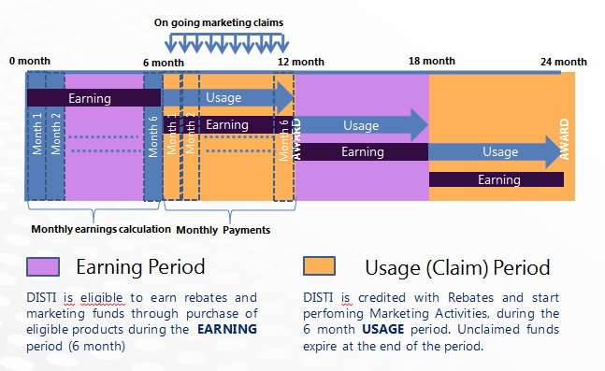

**Co-Op Funds Claims and Approval Procedure**

Eligible Co-Op activity plans need to be pre-approved by the partner’s dedicated Microsoft Distribution Partner Account Manager. Proof of Eligible Co-Op activities execution must be submitted by the partner and approved by Microsoft. The Co-Op funds claim submission and approval procedures and proof of performance process are further detailed in the Coop Guidebook.

**Timing and form of Co-Op fund reimbursement payments**

Co-Op funds reimbursement payments for approved claims will be in the form of a Microsoft purchase credit against the partner’s SAP account with Microsoft issued thirty to forty five (30-45) days from the end of each month of the Co-Op Funds Usage Period depending on region.