# Localization Notes for Office 2010 document

For file: CRM%20Online%20International%20Launch%20Channel%20Partner%20V1.0.pptx

After researching the exported PPTX, I found the reason why miss slides. There are some slides xml (exported) are not well-formed, and PPT 2010 cannot recover these slides.

1. Do not add localized text out of paired tags.
2. Do not move the location of tags.

Problems exists in localization process of file CRM%20Online%20International%20Launch%20Channel%20Partner%20V1.0.pptx

**IT Slide 22:**

Incorrect:

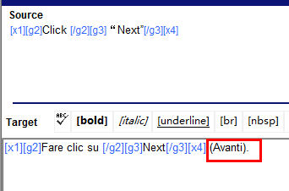

Correct:



**FR slide 9:**

Incorrect:

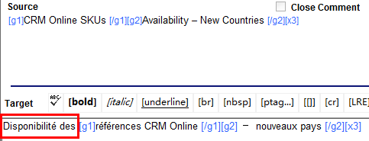

Correct:

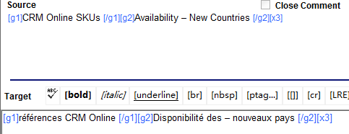

**RU slide 18:**

Incorrect:

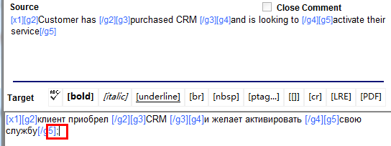

Correct:

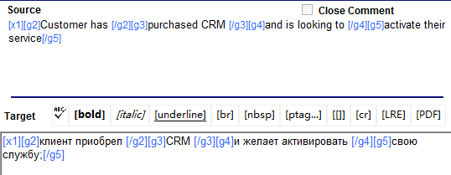

Incorrect:

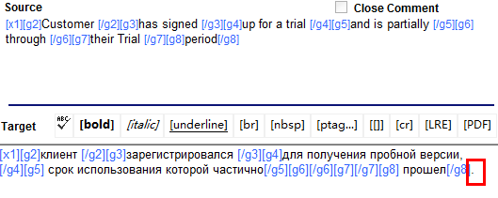

Correct:

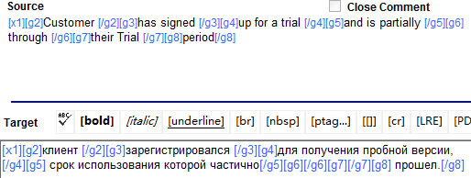

**RU slide 38:**

Do not modify id (a space exists in this segment from exported file):

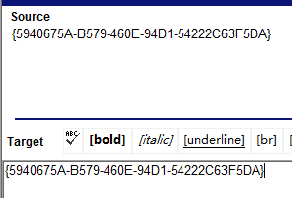

This segment will not be extracted from GlobalSight 8.0.1.

**LAS slide 6:**

Incorrect:

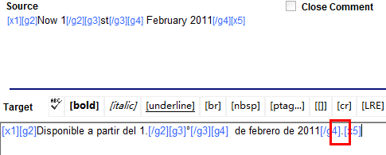

Correct:

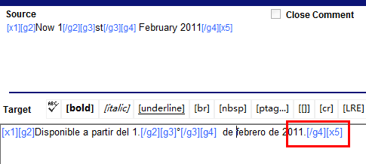

**LAS slide 22:**

Incorrect:

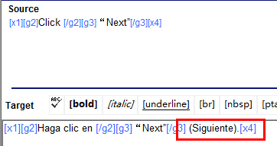

Correct:

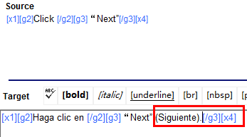

**LAS slide 24:**

Incorrect:

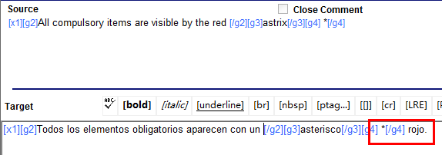

Correct:

